LCBB4004
Marketing Fundamentals Assessment 1
Blogging to communicate
Student Name: Mariya Ilieva Ilieva
Student ID: 2123768
Table of Contents
Blog-1: Background/ History of Chanel 3
Blog-2: Products of Chanel 3
Blog-3: Pricing strategy of chanel 5
Blog-4: Distribution strategy of chanel 6
Blog-5: Place 7
Blog-6: Promotion scheme of chanel 8
References 10

Blog-1: Background/ History of Chanel
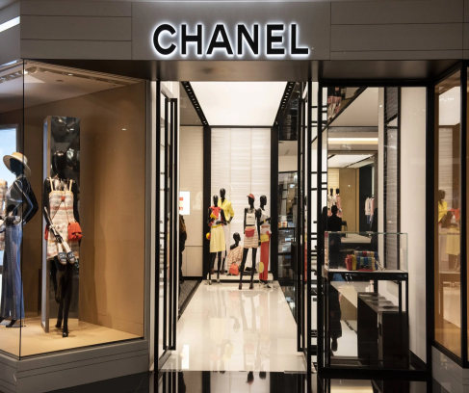

Chanel is a bestselling clothing brand in the world, and it is also one of the biggest fashion apparel international companies. It is a very popular luxury brand, and it is a very valuable brand as well. The company was first established in the year 1909 by Gabriel Chanel and the company is well known for their handbags, shoes, jewellery, perfumes, women's clothes and so on (Thorisdottir and Johannsdottir, 2018). The clothes of the brand are well known for several seasons such as keeping a clean architecture, creating a luxurious aesthetic and so on. Chanel can be considered as a powerhouse fashion brand today. The number of employees in the organisation is close to 20000 (Gazzola et al., 2020). The company made a revenue of 10.1 billion GBP in the year 2021 (Chanel, 2022). The products of the organisation include fragrances, jewellery, accessories, watches, eyewear, skin care and make-up and so on. The organisation Chanel has a large presence in social media, and it has more than 80 million followers across YouTube, Facebook, and Twitter. Chanel is also a well-developed brand, and the organisation also delivers top notch production quality. A sense of trust and loyalty among the customers has also been developed by Chanel and the organisation has also maintained a strong brand image for more than 100 years (Guercini et al., 2019).
Chanel is well renowned for their fashionable and comfortable accessories and clothes with classic and elegant design and style. Chanel provides specialised luxury goods and expensive clothes to their rich and famous elite class consumers (Khandual and Pradhan, 2019). Distinctive personality of the brand has distinguished and differentiated themselves from other familiar brands. Individuals who have a genuine appreciation for exclusive products can be easily attracted towards Chanel for their desirable and excellent product range.

Blog-2: Products of Chanel

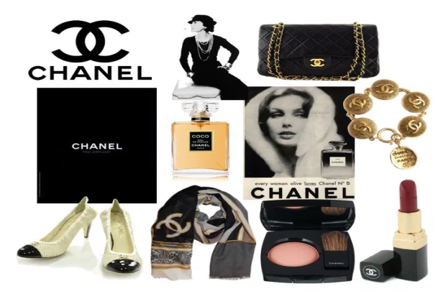
Chanel is a classic bran d with a wide range of products and their products are made for wealthy class people. The organisation has made high standard products for their sophisticated customers. The pricing of the products is also high, and the products of the company are also very expensive and costly (Oniku and Joaquim, 2021).
The products of the organisation are special for their unique and intricating design and outstanding utilisation of technology. The organisation also utilises best quality products in order to effectively provide best products for their consumers. The organisation provides elegant day wear as well as beautiful evening wear with exquisite style and proficiency (Perreault, 2021). These products have effectively added value to the reputation of the brand. The colour palette and the colour combination used by the organisation is really classic. The accessories of the organisation include pump shoes, pearl necklace, leather purse and so on (Thorisdottir and Johannsdottir, 2018). The organisation is also well known for their exquisite collection of jewelleries that contains sparkling diamonds and white gold products (Pedersen et al., 2021).
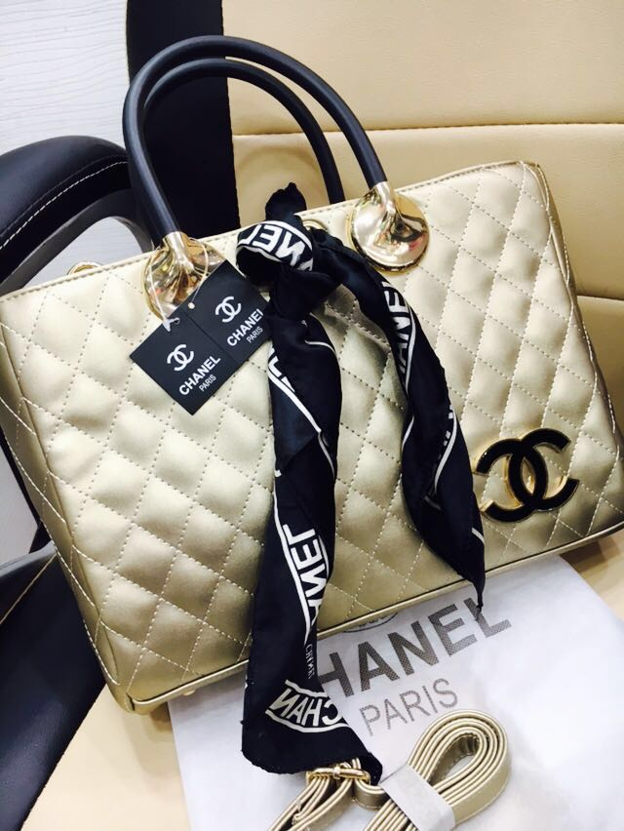
The jewellery products of the organisation include Comete, Ultra, camellia, Baroque and so on. The luxurious jewellery products of the organisation have hit the international market. The organisation also provides exclusive and high-quality bags for both male and females. Several makeup products are also available for the company and the organisation also provides comfortable shoes for their customers (Bertola and Teunissen, 2018). However, Chanel is mainly popular for their fragrance, beauty and fashion products. Chanel is also very much popular among the young women as they are attracted towards the simple designing of the organisation (Wang and Ha-Brookshire, 2021). Chanel is also well aware about developing new products for their organisation as the organisation always prefers to develop products for the young generation. The organisation is also investing in research and development programs in order to understand which products a particular demographic wants the most. It helps the organisation to enhance their products (Khandual and Pradhan, 2019).

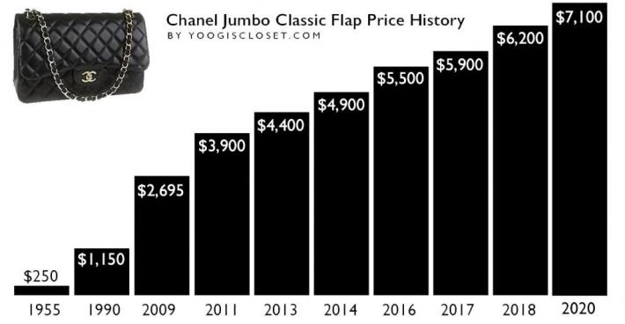
Blog-3: Pricing strategy of chanel

The organisation maintains a premium pricing in their products. Pricing of products plays an essential role for deciding the product value in the market (Thorisdottir and Johannsdottir, 2018). Chanel has set the price of their products extremely high in order to increase their brand awareness and brand values. Premium pricing strategy has helped the organisation to effectively present their premium products. The premium pricing strategy has helped the organisation to increase their overall profits and it has also helped the organisation to effectively maintain a competitive edge over other similar organisation (Loureiro et al., 2019). It has also helped the organisation to effectively increase the awareness of the brand. It is extremely important for the organisation to understand the pricing strategy. Premium pricing strategy has provided hige advantage to the organisation. As Chanel is providing luxurious products with better qualities. The products of the organisation are more expensive than the similar products (Becker-Leifhold and Iran, 2018). The premium pricing of the organisation has helped the organisation to enhance their profits.the pricing strategy used by the organisation is absolutely justified.
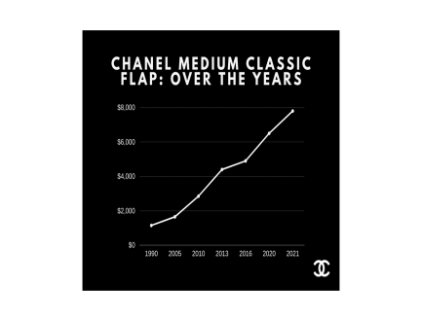
The raw materials that are used for making products for the organisation are extremely rare and exquisite and that is why the price of the product is also very high, the final product of the organisation is also of world class quality and the design, and the making of the products are extremely stylish and elegant (Brydges, 2021). The target segment of the organisation is also very rich and that is why the customers also show desire to buy the products as it is of high quality.
High pricing strategy also allows the organisation to add value in their products and the profit margin of the company can be enhanced. Higher pricing strategy also helps the company to enjoy higher profit (Štefko and Steffek, 2021). By adopting this strategy, the organisation has been able to target a niche market and it has decreased their competition in the market. The organisation has deliberately set high price as it will create an impression in the market

Blog-4: Distribution strategy of chanel
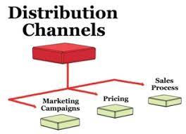
Chanel delivers their offering through various platforms such as ecommerce stores, multi-brand stores, exclusive stores and so on. Exclusive showrooms of the Chanel Boutique and so on. High visibility and brand equity has helped the organisation to increase their overall sales. Both direct and indirect strategy has been utilised by the organisation for their lucrative service and products. Mass distribution has not been implemented by Chanel and it has helped the organisation to increase their brand reputation.
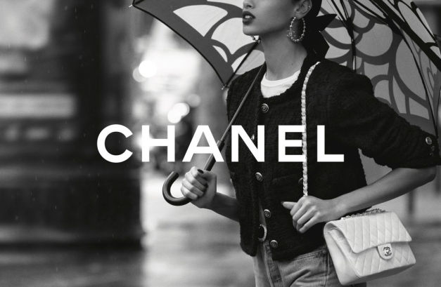
The stores of Chanel are located in luxurious cities as well as in vibrant streets (Thorisdottir and Johannsdottir, 2018). The Chanel stores are in several countries across the globe. An online platform has also been effectively created by Chanel and through that platform the consumers can easily place orders to their products. Through the online platform of Chanel, the consumers can easily order jewellery, perfumes, watches and so on. The organisation also has more than 310 licensed retail outlets across the world (Becker-Leifhold and Iran, 2018). The organisation also utilises multichannel distribution for distributing their products.
This distribution chain includes multi brand stores, online stores, multi brand stores and so on. This strategy has helped Chanel to increase their high volumes. This strategy also helps the organisation to effectively eliminate the risk factors associated with shipping cost, labourcost, storage cost and so on (Loureiro et al., 2019). It has also helped the organisation to effectively enhance their brand promotion and these strategies have also helped the organisation to maintain top notch standards of their products.


Blog-5: Place

The target segment of the organisation Chanel includes high class aristocratic people. The stores of the organisation are also located in big cities. The organisation also has their stores in several airports as many people travel through airports. The products of the organisationare also available in online channels (Loureiro et al., 2019).
The stores of the organisationare not located in many places that is why the organisation is currently focusing on increasing the sales of their products through online portals. The organisation is also planning to increase their skincare and fragrance products as these products are in high demand in the market. Developing their business online will allow the customers to order products from any place. In order to implement an effective place strategy, the organisation first needs to identify their target market. The organisation also needs to effectively study the location for determining the budget of their products (Brydges, 2021). The organisation also has to consult their marketing strategy for making their overall marketing strategy effective. Effective place strategy has helped Chanel to effectively diversify their distribution channel and it has also allowed the organisation to control their production (Becker-Leifhold and Iran, 2018). For effective strategy making the organisation Chanel also needs to calculate the risk factors associated with it.

Blog-6: Promotion scheme of Chanel

Chanel is widely renowned for their effective operation and for promotion effective strategies are utilised by the organisation. For example, the organisation provides Ads in several popular magazines. Chanel has also employed classy stores in order to improve their sales marketing. Chanel has also employed supermodels in order to effectively advertise their products and services.
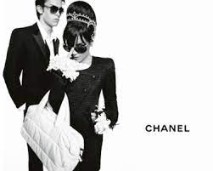
The organisation also creatively utilisesmannequins in order to effectively lure customers in their organisation. The organisation also promotes their products through digital media and online social media platforms. Utilising these strategies has effectively helped the organisation to effectively reach more people. In addition to this the organisation also promotes their products through various channels such as blog posts, television magazines and so on (Becker-Leifhold and Iran, 2018). Sometimes an exclusive preview is also offered by the organisation and Chanel also conducts several social media contests in order to attract more customers to buy their products. The organisation also encourages customer reviews and it also in turn helps the organisation to effectively improve their products (Gazzola et al., 2020).
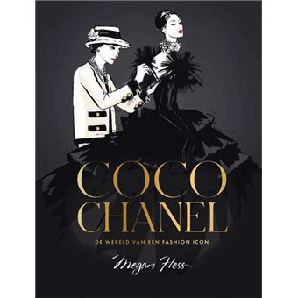
The organisation also provides social media posts about their products and organises several contests and giveaway programs to enhance the sales of their products. Several other strategies have also been implemented by the organisation in order to drive traffic in the online stores of Chanel. The organisation has also boosted their organic social presence in order to enhance their digital engagement. For SEO the organisation has already optimised their sites. In social media the organisation also creates interesting and creative contents so that they can keep their content attractive and engaging (Becker-Leifhold and Iran, 2018). These strategies have helped the organisation to become one of the best luxury fashion organisation in the world.

References
Becker-Leifhold, C. and Iran, S., 2018. Collaborative fashion consumption–drivers, barriers and future pathways. Journal of Fashion Marketing and Management: An International Journal, 22(2), pp.189-208.
Bertola, P. and Teunissen, J., 2018. Fashion 4.0. Innovating fashion industry through digital transformation. Research Journal of Textile and Apparel.
Brydges, T., 2021. Closing the loop on take, make, waste: Investigating circular economy practices in the Swedish fashion industry. Journal of Cleaner Production, 293, p.126245.
Chanel.com. 2022. ONLINE SERVICES. [online] Available at: https://www.chanel.com/gb/ [Accessed 19 April 2022]
Gazzola, P., Pavione, E., Pezzetti, R. and Grechi, D., 2020. Trends in the fashion industry. The perception of sustainability and circular economy: A gender/generation quantitative approach. Sustainability, 12(7), p.2809.
Guercini, S., Bernal, P.M. and Prentice, C., 2018. New marketing in fashion e-commerce. Journal of global fashion marketing, 9(1), pp.1-8.
Khandual, A. and Pradhan, S., 2019. Fashion brands and consumers approach towards sustainable fashion. In Fast fashion, fashion brands and sustainable consumption (pp. 37-54). Springer, Singapore.
Loureiro, A.L., Miguéis, V.L. and da Silva, L.F., 2018. Exploring the use of deep neural networks for sales forecasting in fashion retail. Decision Support Systems, 114, pp.81-93.
Oniku, A. and Joaquim, A.F., 2021. Female sexuality in marketing communication and effects on the millennial buying decisions in fashion industry in Nigeria. Rajagiri Management Journal.
Pedersen, E.R.G., Gwozdz, W. and Hvass, K.K., 2018. Exploring the relationship between business model innovation, corporate sustainability, and organisational values within the fashion industry. Journal of Business Ethics, 149(2), pp.267-284.
Perreault, M., 2021. How Companies Can Overcome the Barriers to Sustainability in the Fashion Industry.
Štefko, R. and Steffek, V., 2018. Key issues in slow fashion: Current challenges and future perspectives. Sustainability, 10(7), p.2270.
Thorisdottir, T.S. and Johannsdottir, L., 2019. Sustainability within fashion business models: A systematic literature review. Sustainability, 11(8), p.2233.
Wang, B. and Ha-Brookshire, J.E., 2018. Exploration of digital competency requirements within the fashion supply chain with an anticipation of industry 4.0. International Journal of Fashion Design, Technology and Education, 11(3), pp.333-342.

