Breaking Barriers: Enhancing Accessibility in the Hospitality Industry

Student name:Ciprian Anghel (2223637)
Tutor name: Kathryn Flynn
Module: Module: International Meetings Management for the Hotel Industry (BMIH6007)

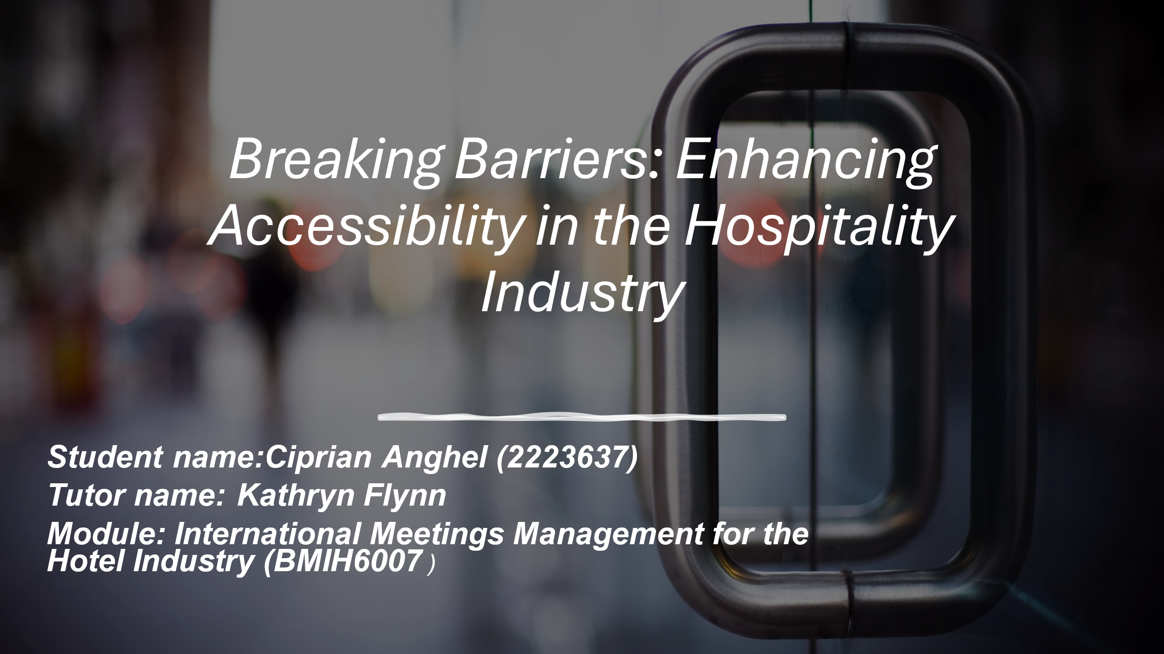

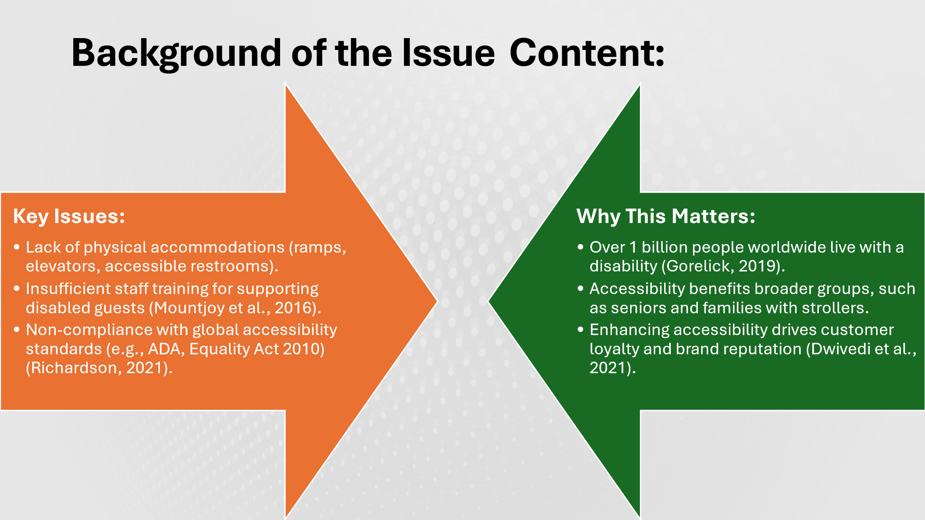

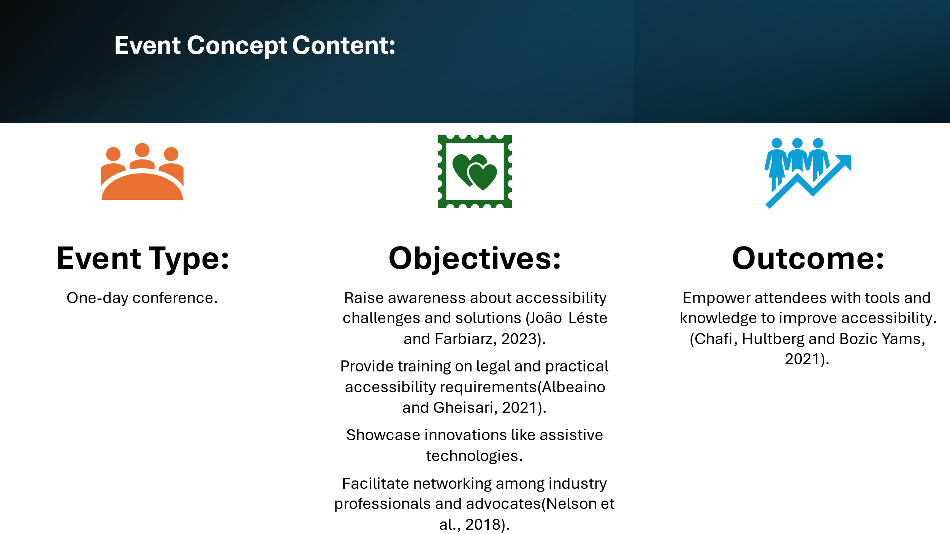

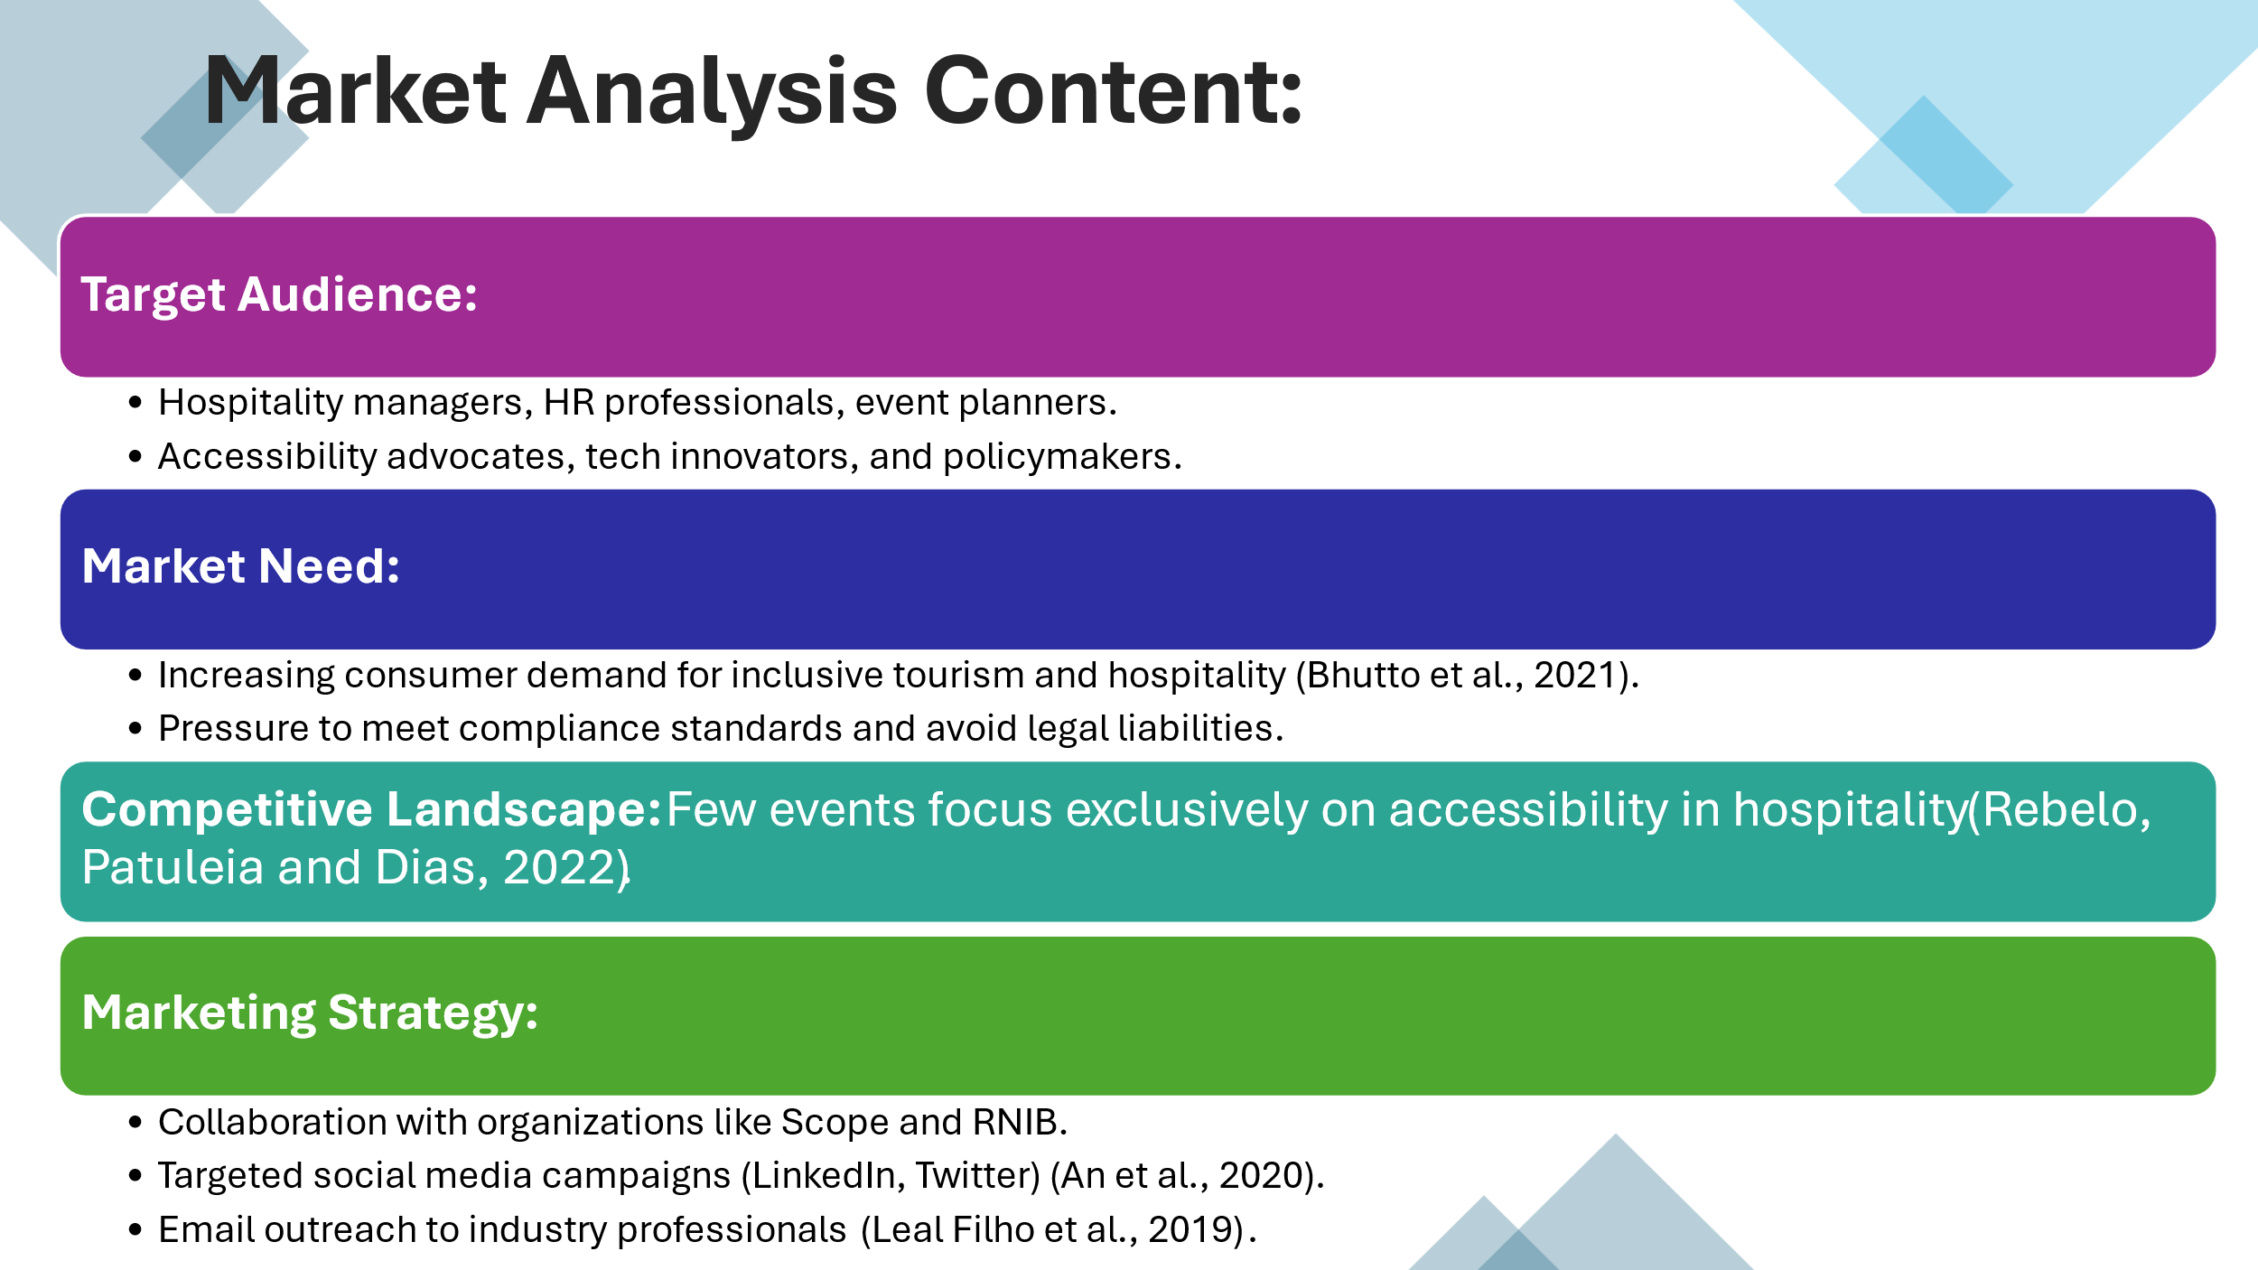

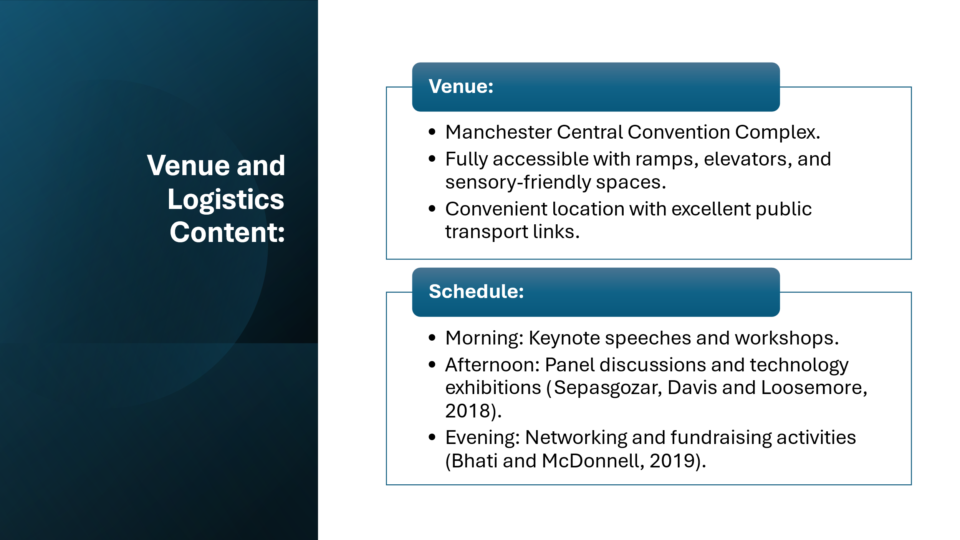

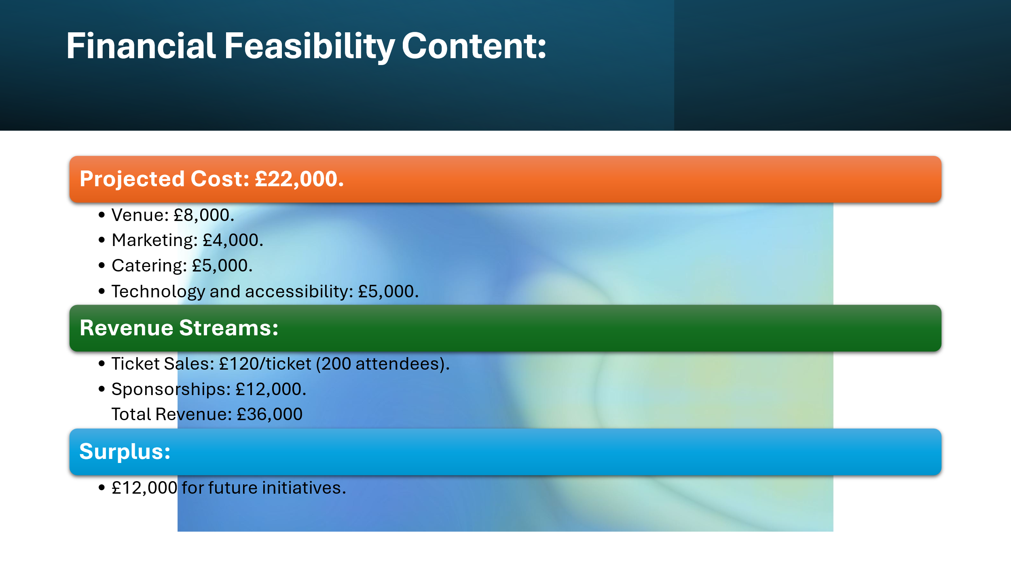

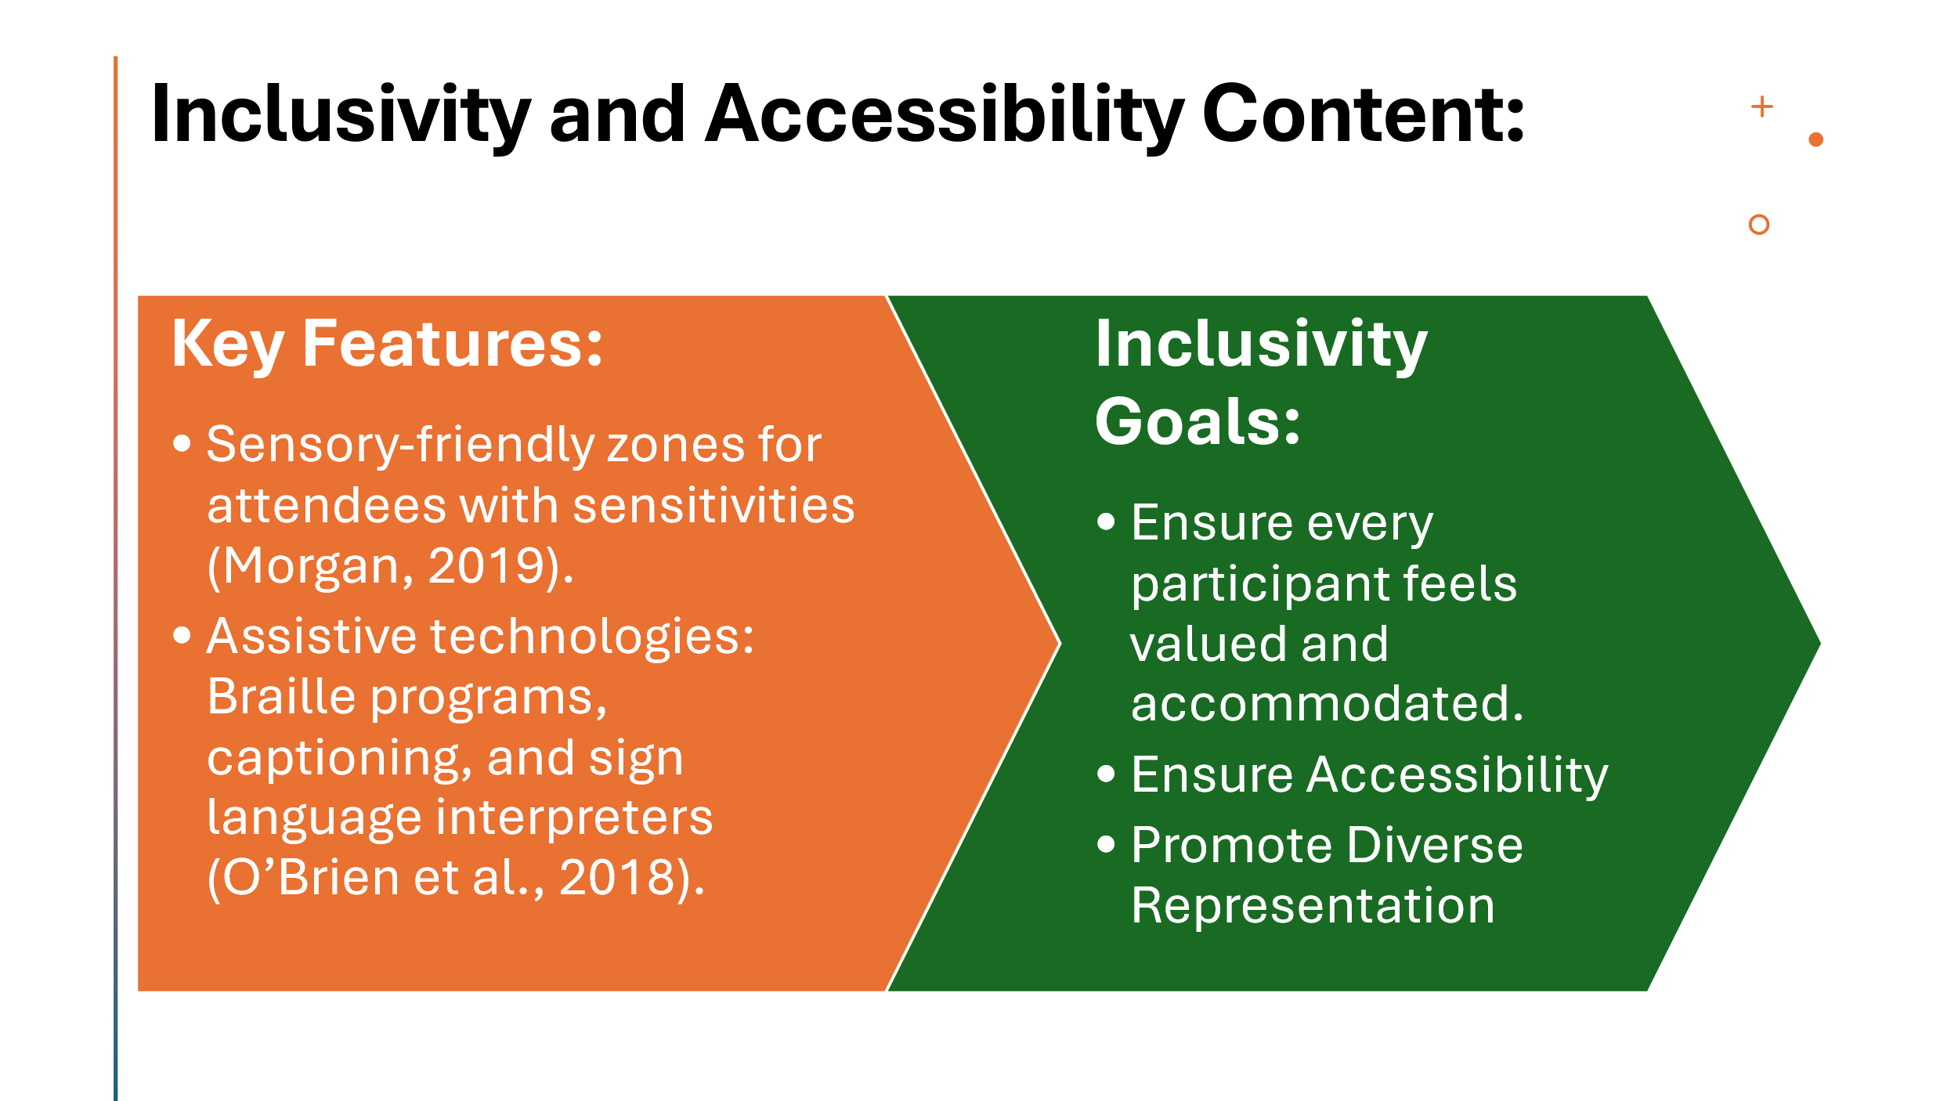
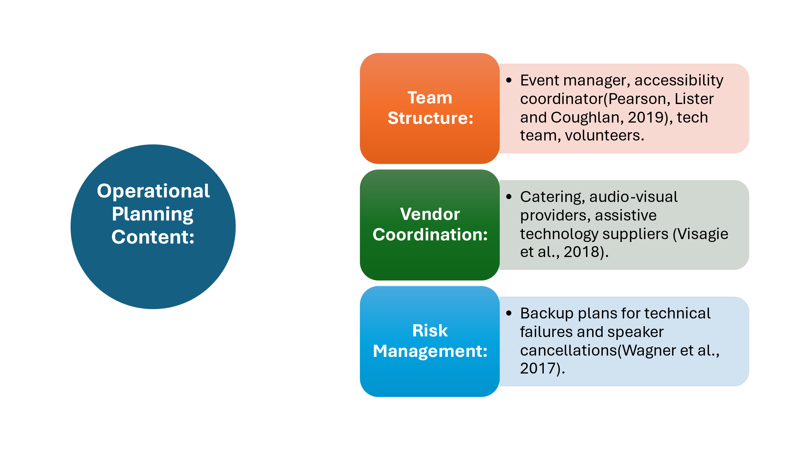
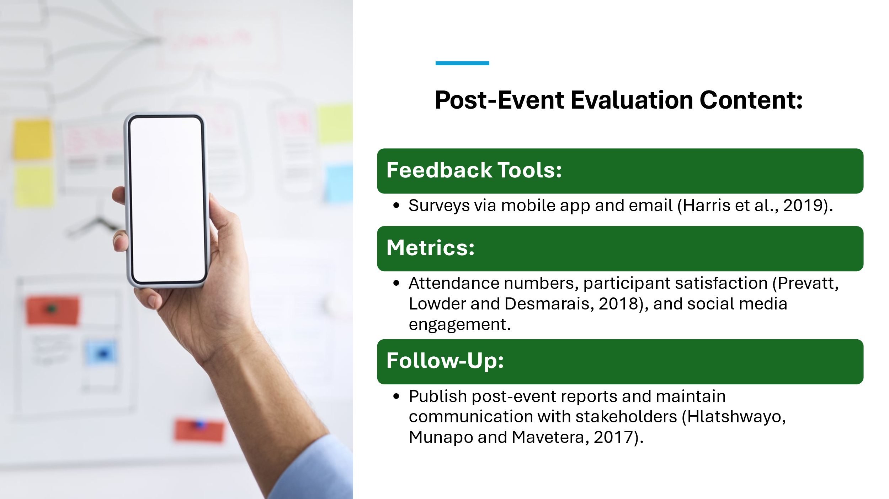
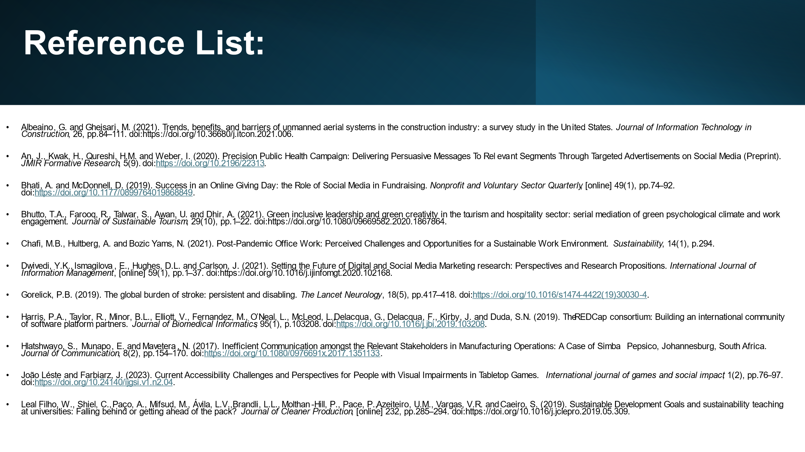
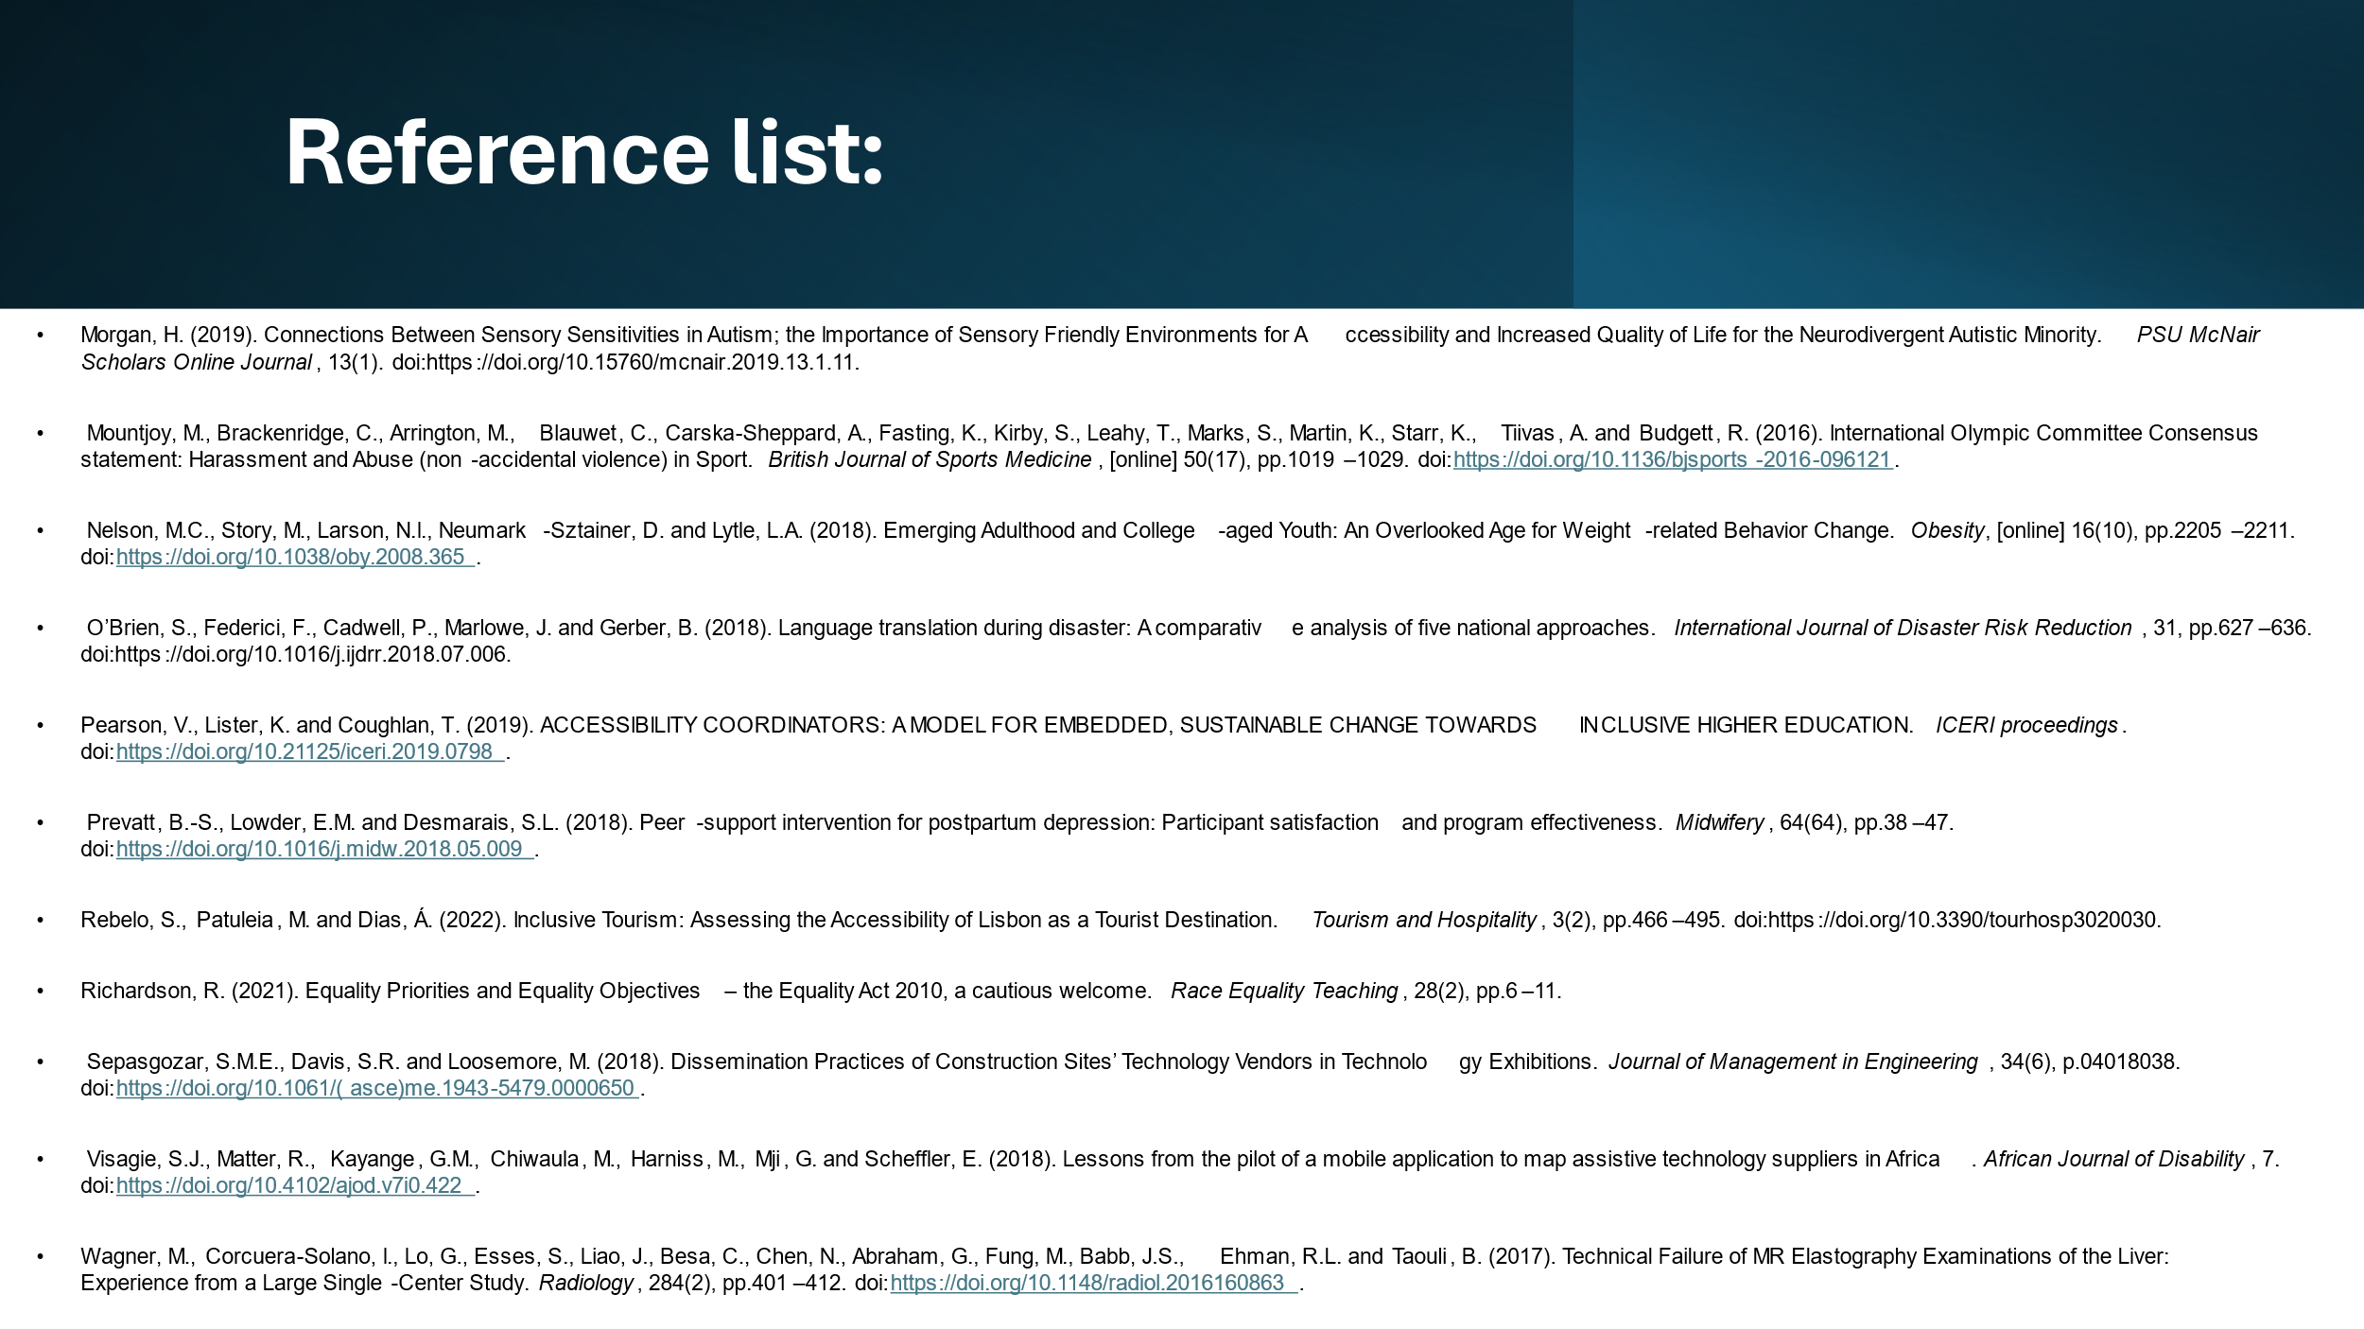

References List:
Albeaino, G. and Gheisari, M. (2021). Trends, benefits, and barriers of unmanned aerial systems in the construction industry: a survey study in the United States. Journal of Information Technology in Construction, 26, pp.84–111. doi:https://doi.org/10.36680/j.itcon.2021.006.
An, J., Kwak, H., Qureshi, H.M. and Weber, I. (2020). Precision Public Health Campaign: Delivering Persuasive Messages To Relevant Segments Through Targeted Advertisements on Social Media (Preprint). JMIR Formative Research, 5(9). doi:https://doi.org/10.2196/22313.
Bhati, A. and McDonnell, D. (2019). Success in an Online Giving Day: the Role of Social Media in Fundraising. Nonprofit and Voluntary Sector Quarterly, [online] 49(1), pp.74–92. doi:https://doi.org/10.1177/0899764019868849.
Bhutto, T.A., Farooq, R., Talwar, S., Awan, U. and Dhir, A. (2021). Green inclusive leadership and green creativity in the tourism and hospitality sector: serial mediation of green psychological climate and work engagement. Journal of Sustainable Tourism, 29(10), pp.1–22. doi:https://doi.org/10.1080/09669582.2020.1867864.
Chafi, M.B., Hultberg, A. and Bozic Yams, N. (2021). Post-Pandemic Office Work: Perceived Challenges and Opportunities for a Sustainable Work Environment. Sustainability, 14(1), p.294.
Dwivedi, Y.K., Ismagilova, E., Hughes, D.L. and Carlson, J. (2021). Setting the Future of Digital and Social Media Marketing research: Perspectives and Research Propositions. International Journal of Information Management, [online] 59(1), pp.1–37. doi:https://doi.org/10.1016/j.ijinfomgt.2020.102168.
Gorelick, P.B. (2019). The global burden of stroke: persistent and disabling. The Lancet Neurology, 18(5), pp.417–418. doi:https://doi.org/10.1016/s1474-4422(19)30030-4.
Harris, P.A., Taylor, R., Minor, B.L., Elliott, V., Fernandez, M., O’Neal, L., McLeod, L., Delacqua, G., Delacqua, F., Kirby, J. and Duda, S.N. (2019). The REDCap consortium: Building an international community of software platform partners. Journal of Biomedical Informatics, 95(1), p.103208. doi:https://doi.org/10.1016/j.jbi.2019.103208.
Hlatshwayo, S., Munapo, E. and Mavetera, N. (2017). Inefficient Communication amongst the Relevant Stakeholders in Manufacturing Operations: A Case of Simba Pepsico, Johannesburg, South Africa. Journal of Communication, 8(2), pp.154–170. doi:https://doi.org/10.1080/0976691x.2017.1351133.
João Léste and Farbiarz, J. (2023). Current Accessibility Challenges and Perspectives for People with Visual Impairments in Tabletop Games. International journal of games and social impact, 1(2), pp.76–97. doi:https://doi.org/10.24140/ijgsi.v1.n2.04.
Leal Filho, W., Shiel, C., Paço, A., Mifsud, M., Ávila, L.V., Brandli, L.L., Molthan-Hill, P., Pace, P., Azeiteiro, U.M., Vargas, V.R. and Caeiro, S. (2019). Sustainable Development Goals and sustainability teaching at universities: Falling behind or getting ahead of the pack? Journal of Cleaner Production, [online] 232, pp.285–294. doi:https://doi.org/10.1016/j.jclepro.2019.05.309.
Morgan, H. (2019). Connections Between Sensory Sensitivities in Autism; the Importance of Sensory Friendly Environments for Accessibility and Increased Quality of Life for the Neurodivergent Autistic Minority. PSU McNair Scholars Online Journal, 13(1). doi:https://doi.org/10.15760/mcnair.2019.13.1.11.
Mountjoy, M., Brackenridge, C., Arrington, M., Blauwet, C., Carska-Sheppard, A., Fasting, K., Kirby, S., Leahy, T., Marks, S., Martin, K., Starr, K., Tiivas, A. and Budgett, R. (2016). International Olympic Committee Consensus statement: Harassment and Abuse (non-accidental violence) in Sport. British Journal of Sports Medicine, [online] 50(17), pp.1019–1029. doi:https://doi.org/10.1136/bjsports-2016-096121.
Nelson, M.C., Story, M., Larson, N.I., Neumark-Sztainer, D. and Lytle, L.A. (2018). Emerging Adulthood and College-aged Youth: An Overlooked Age for Weight-related Behavior Change. Obesity, [online] 16(10), pp.2205–2211. doi:https://doi.org/10.1038/oby.2008.365.
O’Brien, S., Federici, F., Cadwell, P., Marlowe, J. and Gerber, B. (2018). Language translation during disaster: A comparative analysis of five national approaches. International Journal of Disaster Risk Reduction, 31, pp.627–636. doi:https://doi.org/10.1016/j.ijdrr.2018.07.006.
Pearson, V., Lister, K. and Coughlan, T. (2019). ACCESSIBILITY COORDINATORS: A MODEL FOR EMBEDDED, SUSTAINABLE CHANGE TOWARDS INCLUSIVE HIGHER EDUCATION. ICERI proceedings. doi:https://doi.org/10.21125/iceri.2019.0798.
Prevatt, B.-S., Lowder, E.M. and Desmarais, S.L. (2018). Peer-support intervention for postpartum depression: Participant satisfaction and program effectiveness. Midwifery, 64(64), pp.38–47. doi:https://doi.org/10.1016/j.midw.2018.05.009.
Rebelo, S., Patuleia, M. and Dias, Á. (2022). Inclusive Tourism: Assessing the Accessibility of Lisbon as a Tourist Destination. Tourism and Hospitality, 3(2), pp.466–495. doi:https://doi.org/10.3390/tourhosp3020030.
Richardson, R. (2021). Equality Priorities and Equality Objectives – the Equality Act 2010, a cautious welcome. Race Equality Teaching, 28(2), pp.6–11.
Sepasgozar, S.M.E., Davis, S.R. and Loosemore, M. (2018). Dissemination Practices of Construction Sites’ Technology Vendors in Technology Exhibitions. Journal of Management in Engineering, 34(6), p.04018038. doi:https://doi.org/10.1061/(asce)me.1943-5479.0000650.
Visagie, S.J., Matter, R., Kayange, G.M., Chiwaula, M., Harniss, M., Mji, G. and Scheffler, E. (2018). Lessons from the pilot of a mobile application to map assistive technology suppliers in Africa. African Journal of Disability, 7. doi:https://doi.org/10.4102/ajod.v7i0.422.
Wagner, M., Corcuera-Solano, I., Lo, G., Esses, S., Liao, J., Besa, C., Chen, N., Abraham, G., Fung, M., Babb, J.S., Ehman, R.L. and Taouli, B. (2017). Technical Failure of MR Elastography Examinations of the Liver: Experience from a Large Single-Center Study. Radiology, 284(2), pp.401–412. doi:https://doi.org/10.1148/radiol.2016160863.

