

Combating Loneliness & Social Isolation for Veterans & Community

We help service veterans and those in the wider community by getting them engaged in a variety of art projects.

We passionately believe that art and culture can improve health, wellbeing, and overall quality of life.

Portfolio.
Table of Contents.

Reflective Commentary………………………………………………………………….2

References…………………………………………………………………….….5

Portfolio of Evidence…………………………………………………………………….6

Evidence 1: My diary and daily reflections………………………………………6

Evidence 2: Pictures of engagement…………………………………………...…8

Evidence 3: Support from industry and community……………………………...9

Evidence 4: The mission statement …………………………………………….10

References………………………………………………………………………………11

1.
Reflective Commentary.

I will be using Gibb’s Reflective Cycle (1988), to consider my time

spent with the V C Gallery, and the various activities I became involved with. I was enrolled

as a Volunteer and once my Disclosure and Barring Service (DBS) clearance was obtained,

given responsibilities which did not include actual counselling, but the core skills learnt and

practised within the module, became useful and vital tools in the activities I was the lead for.

My initial emotions on being allowed to help in the organisation was

of excitement and a feeling of being useful within the community. During the pandemic, I

had volunteered to help in many ways but was rejected due to my age, although I processed

many useful skills and talents. I did eventually get a role as a car park attendant in a local

surgery which was utilising a drive through vaccination centre. On the first morning at the V

C Gallery, I was invited to attend the weekly planning conference, which I found to be a little

intimidating. It was a well-chosen first contact as I was able to meet all the full-time staff and

hear about the projects that were planned for the immediate future. As time went by and I

got to know the clients who used the drop-in centres, one in Haverfordwest and one in

Pembroke Dock, I realised that there were many lonely people who just needed someone to

listen to them without judgement or criticism and who would spend most of their day at the

centres just for the company.

I found it a little difficult at the beginning as people would often

divulge their innermost feelings and my background prior to the degree had not prepared me

for this and I supposed at first that I might be intruding in their personal lives. After

discussing this with one of the team leaders, I was assured that it wasn’t uncommon and to

attend and empathise, as it usually helped the client by just listening to them. Some of the

older people who turned up had incredibly interesting stories to tell and this gave me a

2.

feeling of wonder and admiration for their deeds of yesterday. Although the centres were set

up for art and culture initially, they had evolved into places which complimented the needs of

anyone who sought sanctuary there.

My time with the V C Gallery was informative but mostly enjoyable.

The experiences were good, and tasks given easily achievable with the volunteers used and

appreciated. I found there was little to criticise and much to emulate. I wondered if my

contribution was up to standard, but was assured by being continually asked to attend and

even asked to take the lead in some of the activities. I suppose I was a fresh face and the

stories I was told had probably been listened to previously by other volunteers but I

suppose it provided some therapy to the narrator just to have someone to listen to them with

genuine interest and congruence.

Focusing on my time with the V C Gallery, I consider it well spent as

I realised that to be able help people gain a better quality of life was not achieved by

technology or monetary means, but by time and patience. By giving your undivided attention

and listening to the conversations was often enough to give the clients that feeling of well-

being. Active or therapeutic listening has been positively endorsed by the leading

professionals within the psychology and counselling fields. This was succinctly stated by

Ralph Waldo Emerson who said “There is a difference between truly listening and waiting

for your turn to talk” (1841). I realised in my past, I was forever trying to get my point of

view across, and can see how that would not matter to someone who was troubled and needed

reassurance, not someone else’s solution to their problems. Without the benefit of the

counselling training prior to and during the placement, I could envisage my time with the

V C Gallery problematic as I would have been of little benefit to the client, who needed to

form their own solutions to their problems.

3.
Working as a placement with the V C Gallery allowed me to see

therapy in action and understand that it is often the simple things that achieve the most. I

have learnt that an hour of active listening can make someone with, in their mind, unsolvable

problems leave with a resolve and a determination to put right those things they perceive to

be awry in their lives. I am aware that at this stage in my development as a client helper, I

must keep within those professional boundaries that enable the client to benefit from my

interaction and to be aware of my knowledge and ability to help, as it would be as easy for an

untutored helper to make a situation worse. I also realised that you need help and aid from

various agencies to initiate such an enterprise and to be credible and it helps to have worthy

supporters to give good repute, and for financial assistance.

My action plan is to continue as a volunteer to the V C Gallery,

probably not as active as I was during placement, to gain the maximum experience I can from

the organisation. They have been active for eight years and I’m sure that mistakes have been

made along the way and if I can use the mentoring skills of the full-time staff to prevent any

repetition of them by me, then time and effort could be saved. If I could choose again an

organisation to have a placement with, it would certainly be this organisation. The staff and

other volunteers have provided me with an example of how care in the community should

work.

4.
References.

Emerson, R. W. (1841). Self-Reliance. Amazon.

Gibbs, G. (1988). Learning by Doing: A guide to teaching and learning methods. Oxford
Polytechnic.

Midwinter, R., & Dickson, J. (2015). Embedding counselling and communication skills: a.
relational skills model. Routledge.

5.
Portfolio of evidence.

Evidence 1. My diary and daily reflections.

During my time with the V C Gallery, I kept a comprehensive diary

of my time and interaction with the charity. I shall give a few extracts of my activities and

experiences during my placement.

28 July. I arrived at 9am. in time for the weekly staff meeting. I was introduced to all the

the members who gave me a short resume of their individual responsibilities. The members

included a therapist, an art teacher, outdoor projects leader, volunteer coordinator and group

leader for short walks, who left shortly after I arrived and who I covered for when I was

available. I was then shown around the day centre and met some of the other volunteers and

centre users. The volunteer coordinator then took me to the art gallery associated with the

centre which was situated in the middle of town and where much of the funding for the centre

was obtained. We went back to the centre to sort out my CRB. In the afternoon I assisted in

the walk and talk therapy, Revell & McLeod (2017), which was a short walk at slow pace

around part of the racecourse on the edge of town (outdoor therapy).

2 August. Today I was involved in a mornings fishing at a small lake near to Haverfordwest.

The facility, tackle, bait, and instruction were provided free of charge by the enterprise

owner. This group was different from the walking group, so I got to know a few more of the

centre users. On returning to the centre for a cup of tea, I was pleased to see a few of the

clients from the walk group, some of whom sought me out for a chat. By now I was

becoming an active listener and I’m sure, with some of the views expressed, some would

have found themselves in an argument but remembering to be non-judgemental was receptive

to their points of view.

5 August. Today I was driven to the allotment site which is on the banks of the Milford

6.
Sound with wonderful views and forming part of the Pembrokeshire Coastal Path. This was

originally an anti-aircraft and search-light base during WW2 and formed part of the defence

of Milford harbour. The bunkers had been converted into a storage room and a well equipped

kitchen with toilet facilities. There were abundant vegetables and flowers, and I took home

some fresh produce with the grace of the gardeners.

I have missed out a few of the days I attended as they were in the main a repeat of the

activities I have already described.

25 August. Today was a special day as we were combining two groups and I was to be the

lead in one of them. The plan was to visit Rosebush quarries and I would take the

photography group around the lower reaches and the outdoor leader would take some of the

fitter clients to the trigonometrical point at the top of the hill, which was the highest point in

Pembrokeshire. We were fortunate to have the services of Dr Sid Howells a local geologist

who gave a step-by-step account of the area and had a film crew who were making a

documentary which would include the centre. Climbing to the top of the hill and back made

me resolve to get a bit fitter and lose some weight.

20 September. Today I was asked to attend the Pembroke Dock centre as they were short

staffed. I meet a different group once again and by now I was able to make a reasonable cup

of tea and listen overtly and honestly enjoy the stories the clients had to tell. Most were of

WW2 vintage and so once the teller gone so will the stories.

I continue to attend the Pembroke Dock centre as it was less well staffed than the centre in

Haverfordwest. These are just a few of my diary pages and much abridged as I religiously

write down the activities of the day and those characters I meet.

7.
Evidence 2. Pictures of engagement.

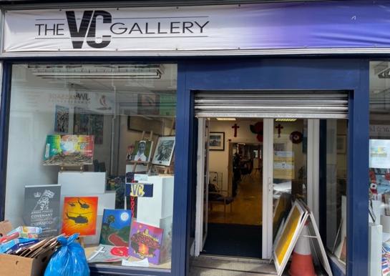

The Haverfordwest V C Gallery drop-in centre.

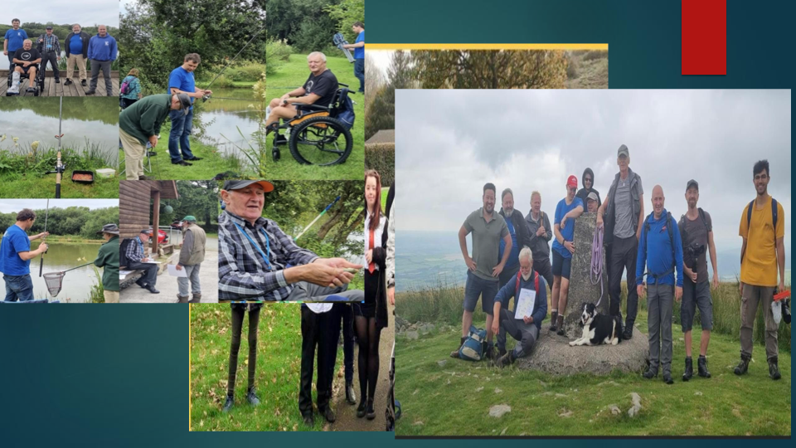

Some of the activities I assisted in.

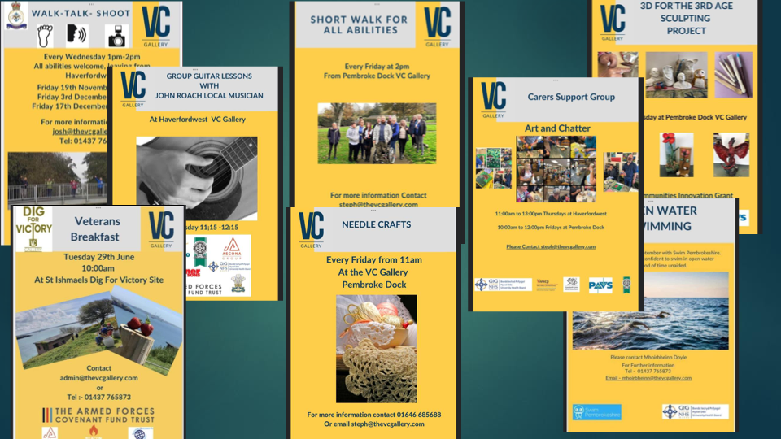

Some of the other activities arranged by the centre.

8.
Evidence 3. Support from industry and the community.



Without the support of the organisations listed above all the good work done by the V C

Gallery would not happen There are also many small businesses who support through food

donations and other necessities to make the centre a welcoming venue.

9

Evidence 4. Mission Statement.

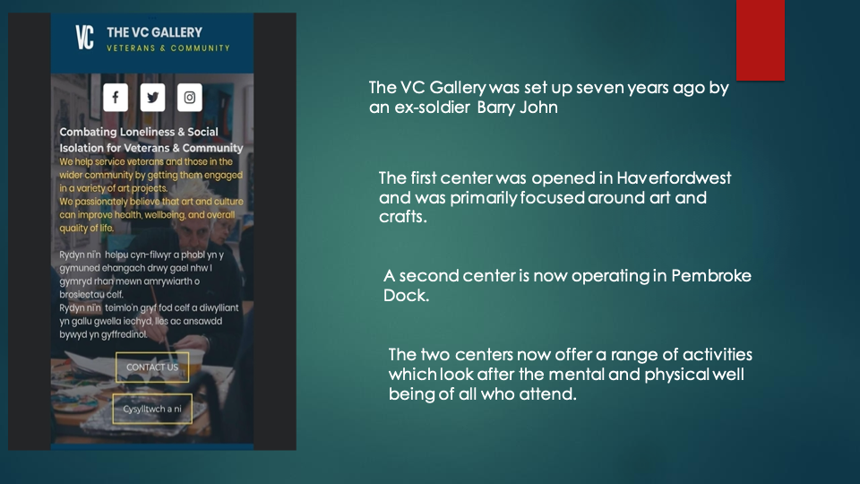

There is no charge for any of the activities on offer as the centre relies on income from the Art Gallery and civil and civic donations.

10.

References.

Codey, S. J., Jones, C., Kautz, A., & Robertson, N. (2020). Into the wild. A meta-synthesis of
talking therapy in natural outdoor spaces. Clinical Psychology Review. 101841.

Gibbs, G. (1988). Learning by Doing: A guide to teaching and learning methods. Oxford
Polytechnic.

Midwinter, R., & Dickson, J. (2015). Embedding counselling and communicating skills: a
relational skills model. Routledge.

Percy, C., & Rogers, M. (2021). The value of Volunteering: Volunteering in Education and
Productivity at Work. Education and Employers.

Revell, S., & McLeod, J. (2017). Therapists’ experience of walk talk therapy. A descriptive
Phenomenological study. European Journal of Psychotherapy & Counselling,
19:3, 267-289, DOI: 10.1080/13642537.2017.13483.

Stuckey, H. L., & Nobel, J. (2010). Integrating the arts into health care. American Public
Health Association. 100(2) p. 254-263.

11.

