DIGITAL SKILLS and RESEARCH METHODS BMSW4003_LON

LILIANA CALIN ID 1818714

TABLE OF CONTENS
1 Introduction
2 Evaluation of the Digital Technologies at the workplace
3 Use of Social Media in marketing
4 Collecting Communications of social media tool
5 Analysis and Discussion
6 Recommendations for future research
7 Conclusion
8 References
9 Appendix

INTRODUCTION
The digital age is growing quickly in our oncoming days. In present the people who working in information sector is not only the must of digital skills , but people who s working in different sector in the country’s need to achieve digital goal skill for the exactly working area to become helpful and needed in their workplace. The difference of the old and the modern technology can be a reason to make digital skills an important factor if we compare with the new jobs increased which are required have that skill. In the UK companies require more than 7000 expert people who are well equipped with digital skills .(Buding,2002).
Modern technology in the 21 st century is so efficient that is been involved in the workplace and businesses with a low level of intelligence .Having a digital skill can increase business productivity. Can provide new ways of a good relationship with customers.

EVALUATION of Digital technology at the workplace
Digital technology is so effective and its become a crucial need in the workplace or any business . Digital technology helps the business to be more efficient and ensure computational accuracy. For the competition on the market having digital skills is a good to posed. The importance of digital tools technology are bellow:
Products | description | effectiveness
Mobile phone | Digital tool | Can be used as a formal or informal communication tool . With this device anybody can be connected in any place. We can send message , video conferencing , and make meetings without being face to face .
E-mail | Is a messaging system communication , can be used in our workplace or business | Can be used to connect to the people messages ,letters, documents.
Social -media | Online platform | Is a web platform which can enable people to socially , interact with one another online, exchange information and ideas virtually.

USE OF SOCIAL MEDIA IN MARKETING
Social marketing is the primary goal of archiving some individual benefits and develop activities to changing or maintaining people`s behaviours. The publication and social media remain focused in the most important factor such as communication. Theory create a specific service to identify a development of social media marketing. Social media scope represents a range from defenders to explorers . Furthermore ,managers can apply the framework to position their organization to create their overall corporate and objectives. Trough social media consumer can be able to share opinions between marketers creating a relationship with their customers. The companies must process a goal using digital tools to develop an effective online relationship .
How social media marketing can help to meet your marketing goals
This is are the following goals in an organization trying to achieve with social media
- Building brands awareness
- Gain customer/ market insights
- Identify crisis and manage communications
- Improve internal communication
- Increase conversation/ sales
In the world population more than 70% are using Facebook, Instagram , social platforms. This is a mode of communication handily to everyone.
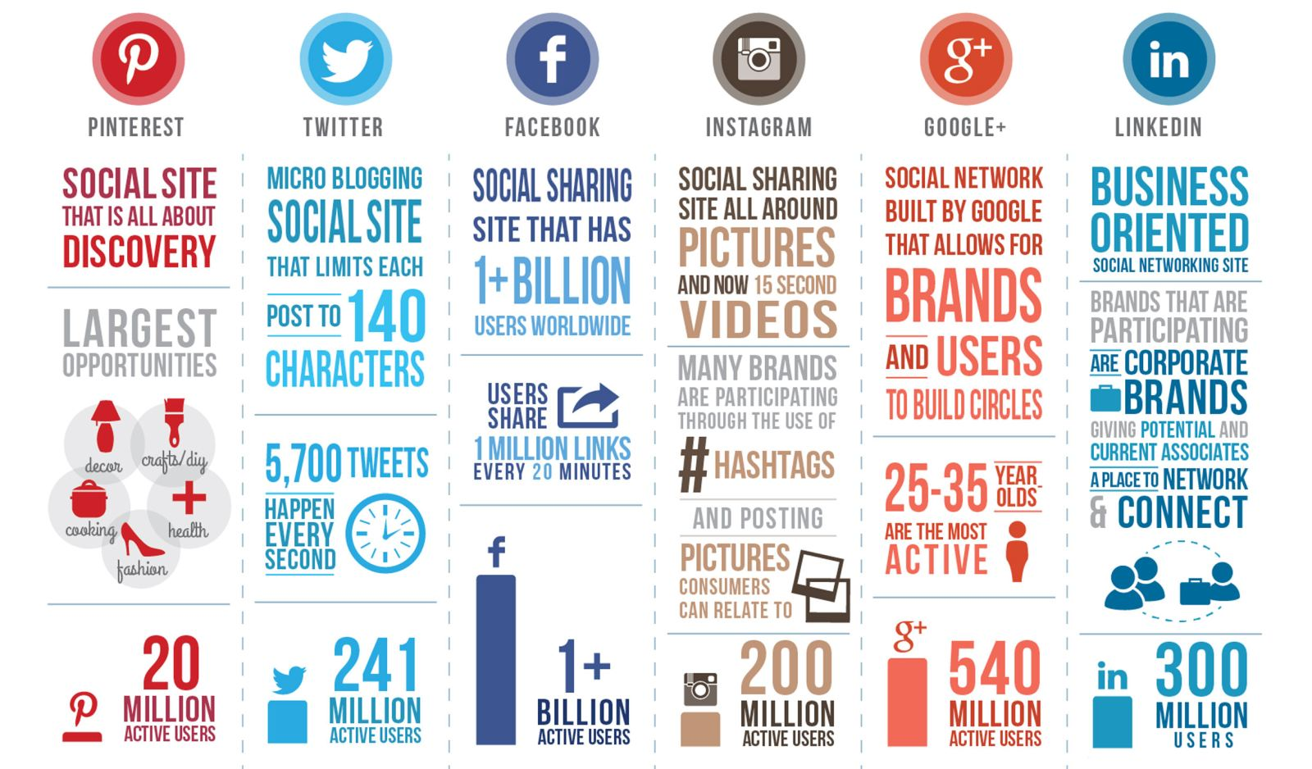
Source http://smmpoint.com

Social media used as a collecting tool
Social media is a result collecting by any business organisation can have information without much effort. With this tool in the modern business the organization can get in touch with their customers and can have the answers immediately. The interactions between helps company to have feedback and know the customers opinions and disagrees about their products and services. These feedback can help companies to grow and open doors to a better way . The purpose will be to satisfy their customers , correcting mistakes, and improve expectations .
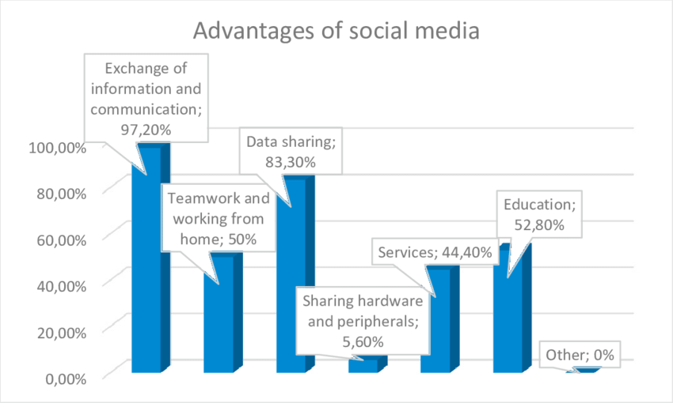
Figure 2 Advantage of social media

Ethical consideration of social media
BENEFITS
The potential benefits and opportunities need to understand in conjunction when using social media to enhance their communities, establish partnerships with the organization for data collection and analyse technology which they result should not be by short term. Engaging with social media most technology reflection and ongoing interrogation is required. This examine the benefits which are considered to undertake evidence using social media platform.
- Establish your brand as a thought leader
- Increase website traffic
- Partner with influencer
- Reputation
- Behaviour
- Image
- Brand values
So the use of modern technology can effectively ensure the efficiency of operation, use of information effectively , ensure proper inventory management and fast and low cost .communication to its partners and consumers which eventually results in increased profitability.
New digital technologies have changed the way people communicate and opened up for new ways of interacting with consumers via social media .
After defining social media and giving a short overview of different medium that exists , the focus will be on two aspects of specific interest
The real time customer`s interactions help the companies to know what there are thinking of the company .
Social media offers an easy and low way for potential customers to express interest in your business that many social networks offer adverting formats specifically designed to collect leads . Social media help us to build our brand image and contents help expose our brand for more people. Social media give us the opportunities to connect in effective way to reach all most half the world`s population. To discover new products on the platform , social media help us to promote the company archive in the brand awareness .

Risk of evidence using social media platforms
The risk have been approve as the most influential factor affecting individual behaviour toward social media platforms. To understand the evidence , to address the problem need to investigate the evidence of 43 studies in information system research between 2006 , 20014 . To finding suggestion that trust and risk both have significant effects on individual behaviour. The use of social media are collecting information during natural disasters and increase recognised . Although considerable progress has being made to understand and determinants the risk of perception and identify the necessary components of effective risk and benefit communication.

Some of these risks noted below pertain exclusively to children and their communities to considerate reflection . Strengths as a accessibility interaction make social media an interesting tool increasing communication. Weaknesses as of low trust , the risk of information and communication are a preference for traditional media are acknowledged .
- Lack of awareness of legal age requirements. The age which children should not access social media services according to the terms and condition any relevant local legislation, should be targeted to for participation in evidence generations programs involving social media.
- Difficult in verifying the age of user’s online calls for significant reflection when considering the sensitive of the subject matter for evidence generation, including children.

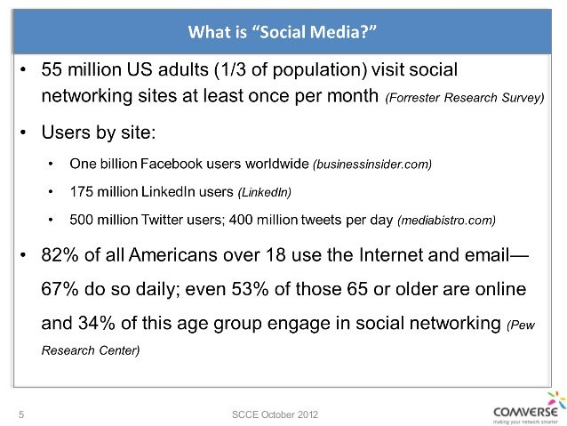
Figure 3 Ethical consideration of social media

Analysis and Discussion
At this point I want to talk about a research , I did among some students of University of Wales Trinity San David about their views on college and the learning environment. I create some questions with their answer’s . I made this table bellow:
Do you find the university and the learning resources useful?  Q1 | Do you think the lecturers have a good knowledge ?  Q2 | In your review ,does the Moodle has enough u  understanding?  Q3 | Does the assignments are difficult to solve them?  Q4 | Does the university has a friendly environment?  Q5 | Do you think the university it’s a little bit strict?  Q6 | In your opinion the university provide a nice harmony to the students?  Q7
Students | 1 | 2 | 3 | 4 | 5
Rates | Strongly disagree | Disagree | Do not know | Agree | Strongly agree
Question 1 |  |  |  | 100% | 20%
Question2 |  |  |  | 80% | 20%
Question3 |  |  |  | 80% | 20%
Question4 |  |  |  | 80% | 20%
Question5 |  |  | 70% | 30%
Question6 |  | 30% | 70%
Question 7 |  |  |  | 80% | 20%

This is the data collection I done from the students of University of Walls Trinity S an David . I will include also the link of the survey which can be found down in the next pages , exactly on appendix.

Recommendation for future research
The initial aim to this research is to identify the factor that are regularly associate with the public effective cost involved in research. Recognising the limitation of the analysis we believe we have archive this theory of public involvement in research. This mechanism lead to the specific outcome to improving the quality of research strategies and data collection tools and methods. We identify a feedback to research contribution leading the improves of confidence of motivation. In term of the initial objectives we successfully recruit diverse case studies, collecting data . Research (2012) has show over the past decade public credibility rating for news across media for all types of sources. With over 800 millions active users Facebook is changing the way of hundreds of millions people relate to one another and share information. In addition, research have recognized the utility of Facebook as a novel tool to observe behaviour and recruit participants. The purpose of this has to identify opportunities as well as a potation of conducting quality research with Facebook users. Finally we consider a ethical issue around the users and protection of Facebook data obtain for participant who research several key consideration.

Conclusion
After all the discussion regarding the effectiveness of digital skills we can say is a necessary tool for any organization. It can increase your visibility enhance relationship, establish way communication with customers, provide a forum for feedback and improve the awareness and reputation of the organization. Follow this can help the organizations effectively and successfully derive the maximum benefit from their social media initiative. Social media is really convenient and important communicate network for all the people nowadays, however there is always advantages and disadvantages for a thing. Our life became more convenient because social media is a very useful tool for us in the 21st century, it could help us to improve our life. However, we have to aware of how we use them. If we could use the social media smartly, having social media will become a good change for us. Organizations around the world can also use social media as their internal communication media. Digital skills have been developed to improve access and skills to all the individual participate of social life, and the same time a great deal of academic work has been done to better understanding of who is and who is not digitally literate. However the internet becomes in every day life for many people to research on digital inclusion. We start with exploration around how digital skills have ben define in research and policy. This report show as to achieve the best condition for development of digital skills. These skills are vital for living, working, studding in an information society.

References
Budig, G. (2002). A game of uncommon skill. Westport, Conn.: ACE.
Dahl, S. (2015). Social Media Marketing. London: Sage.
Schepp, B. and Schepp, D. (2010). How to find a job on Linkedin, Facebook, MySpace, Twitter and other social networks. New York: McGraw-Hill.
Bertha.L(2015). How does social media affect your life .
Chander,A.(2011).Googling Freedom. California law review,99(1).
Drahosova,M. and Blanco,P.(2017). The analysis of advantages and disadvantages of use social media in EU.
SCCE October (2012). Ethical consideration Social media.
Naeem,ak.(2015). Social media Network infographic.
Gronke and Cook,(2007). Institution of news .
Arruda,W.(2013,August 27). Elements off an effective social media strategy. Forbes.
Wilson,O. ,(2016) .IGI Global. Competitive social media marketing strategies.
Yanbo,w.(2016) Computers in human behaviour. 56,34-44
Veflen,N. and Christensen,K.(2015). Current opinion in food science .3,23-26.

Appendix
In this table you can find all the information regarding the data collection about the opinion regarding learning environment. You can also find feedback about the university as I mentioned , you can find the table of helpful question, to promote its products and services through social media. Finally online presence is important for every student to become updates.
https://freeonlinesurveys.com/r/lRNXt7Ah

