

Student Name: Yagnik Nayak
Student ID: 2532710
Master of Business Administration (MBA)

Module Name: Marketing Management
Module Code: LCMB7024
Assessment Component 2: Marketing Strategic Portfolio
(Sony Immersion Room)

Lecturer’s Name: Laila Maazouz
Submission Date: 1st May,2026
Word Count: Approx. 2750

Term 1

Table of Contents
ELEMENT 1:- BRAND EXTENSION POSTER 3
ELEMENT 2:- STDP ANALYSIS – SONY IMMERSION ROOM 4
1. Introduction 4
2. Marketing Segmentation 5
3. Targeting Strategy 6
4. Differentiation Strategy 8
5. Positioning Strategy 10
ELEMENT 3: Marketing Mix (7Ps) – Sony Immersion Room 11
1. Product Strategy 12
2. Price Strategy 13
3. Place Strategy 13
4. Promotion Strategy 14
5. People Strategy 14
6. Process Straetgy 15
7. Physical Evidence Strategy 15
ELEMENT 4:- Reflection 18
References 20

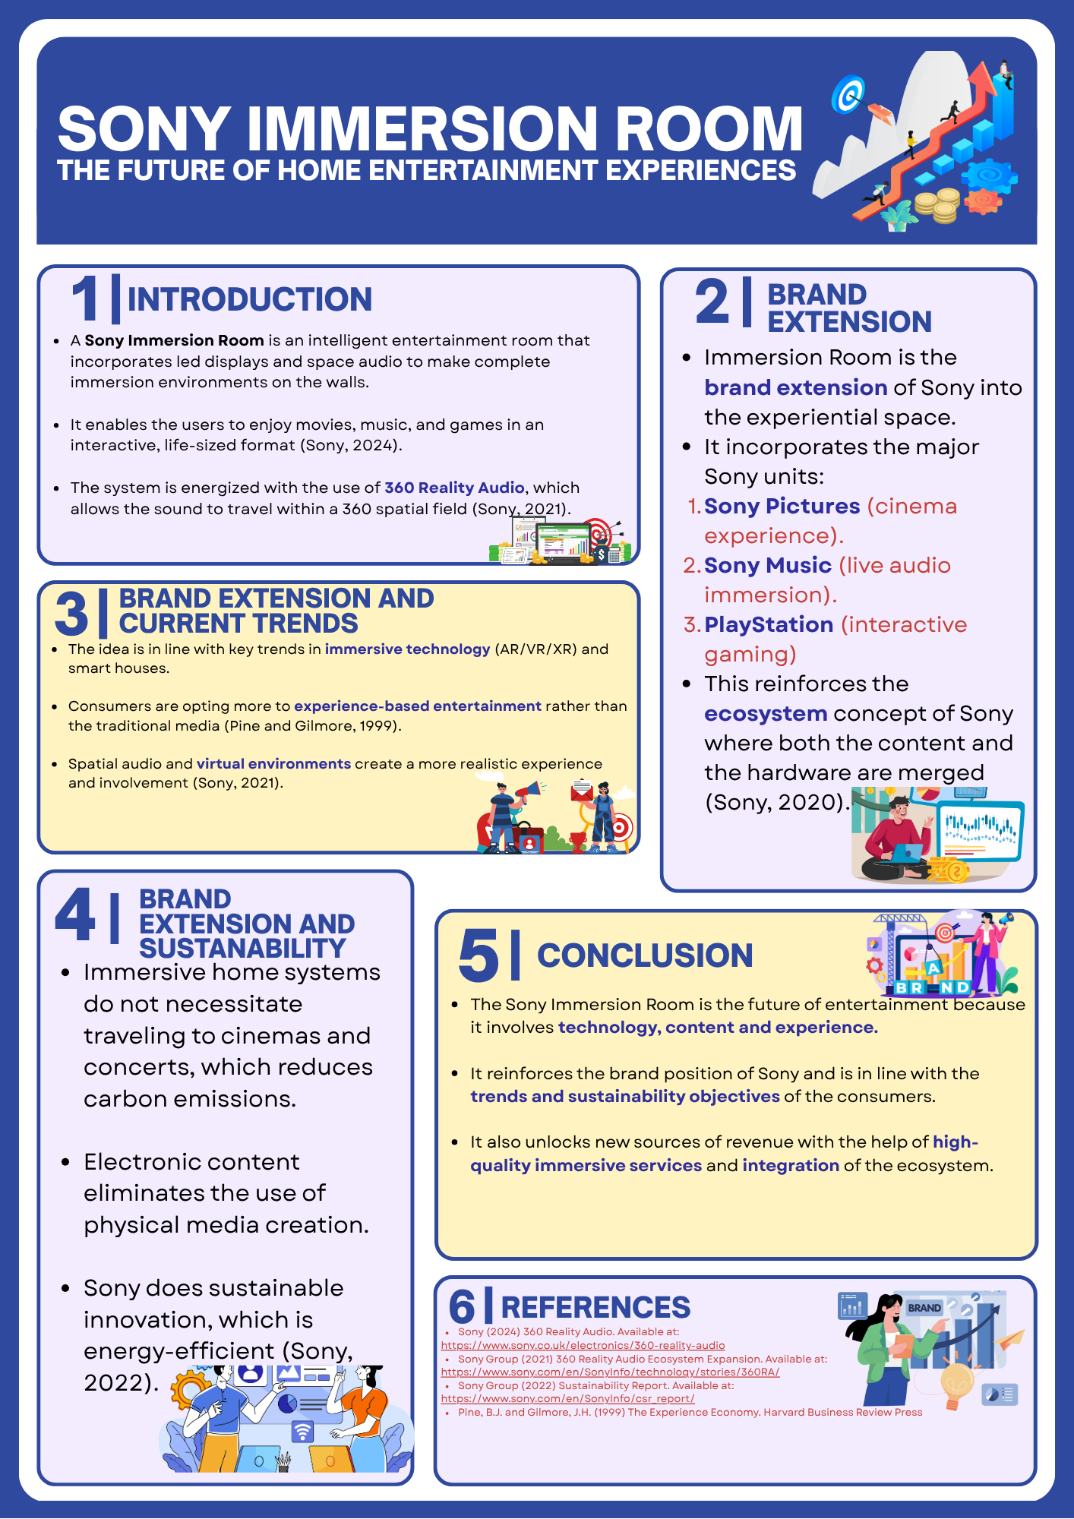
ELEMENT 1:- BRAND EXTENSION POSTER
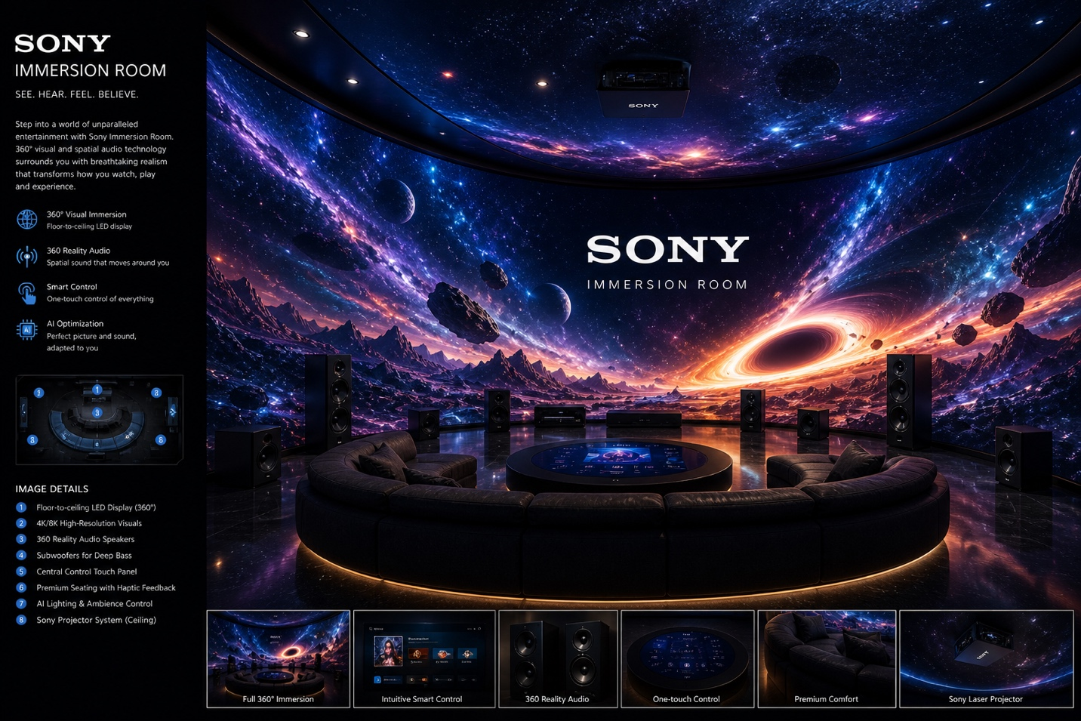
Figure 1: Sony Immersion Room

ELEMENT 2:- STDP ANALYSIS – SONY IMMERSION ROOM

1. Introduction
Segmentation, Targeting, Differentiation, Positioning (STDP) is a strategic marketing model to help determine the most valuable customers and create products or services that provide better value. In the case of the Sony Immersion Room, STDP plays a vital role in making the brand extension coherent with the evolving consumer need to access immersive, experience-based entertainment. In this section, the analysis will examine how Sony can segment and select target markets, differentiate its product and position the Immersion Room as a high-end innovation in the home entertainment sector.

2. Marketing Segmentation
Market segmentation is used to subdivide consumers into groups with distinct characteristics to enhance better targeting and marketing performance.

2.1 Geographic Segmentation
- Sony Immersion Room is mainly targeted at the developed markets such as the United States, United Kingdom, Japan, South Korea and Western Europe. These areas are characterized by a high degree of digital infrastructure, good access to broadband connectivity, and smart home technologies.

- The urban metropolitan region is especially significant because of the increase in disposable income and premium technology consumption as per lifestyle choices. Grand View Research (2024) states that the demand in advanced digital entertainment solutions is growing, which is why the market in the field of immersive technology is growing rapidly worldwide.

2.2 Demographic Segmentation
The most important group of demographics comprises:
- Age: 18–45 years
- Income: Middle-upper to high-income families.
- Profession: Professionals, gamers, creators, and tech enthusiasts. Family Structure:
- Modern families, couples and young professionals.

- This audience is financially well prepared to invest in luxurious entertainment systems and has more chances to embrace new technologies. The younger generation of consumers, especially millennials and Gen Z, exhibit increased use of gaming, streaming, and digital media channels.
2.3 Psychographic Segmentation
Psychographic segmentation is based on lifestyle, interests, and values. The target consumers will be:
- Tech-savvy early adopters
- Experience-oriented individuals
- Futuristic and smart home consumers.
- People who like convenience and personalization.
- It has been shown that immersive technologies boost emotional involvement and user satisfaction, which makes them extremely desirable to customers wanting to experience meaning in their digital lives (Suh and Prophet, 2018).
2.4 Behavioral Segmentation
Behavioral segmentation includes :
- Heavy users of streaming sites (e.g. Netflix, Spotify).
- PlayStation ecosystems users are gamers.
- Consumers in need of interactive and life-like forms of entertainment.
- Brand-loyal Sony users
- Interactivity, realism, and personalization are the key motivators of users of immersive technology that can have a strong impact on purchase decisions (Bennett et al., 2021).

3. Targeting Strategy
Sony implements a differentiated targeting approach, targeting several high-value segments.

3.1 Primary Target Audience
The primary target audience consists of:
- Affluent, tech-savvy urban consumers aged 20–40 who seek premium, immersive entertainment experiences at home.
- This includes:
- Gamers engaged with PlayStation
- Movie enthusiasts seeking cinema-quality experiences
- Music lovers interested in spatial audio
3.2 Secondary Target Audience
- Smart home adopters
- Families investing in home entertainment
- Content creators and digital influencers
3.3 Targeting Justification
- The immersive entertainment market is expanding rapidly, particularly in gaming and digital media sectors. Consumers in these segments demonstrate higher willingness to pay for enhanced experiences, making them ideal for Sony’s premium offering (Grand View Research, 2024).

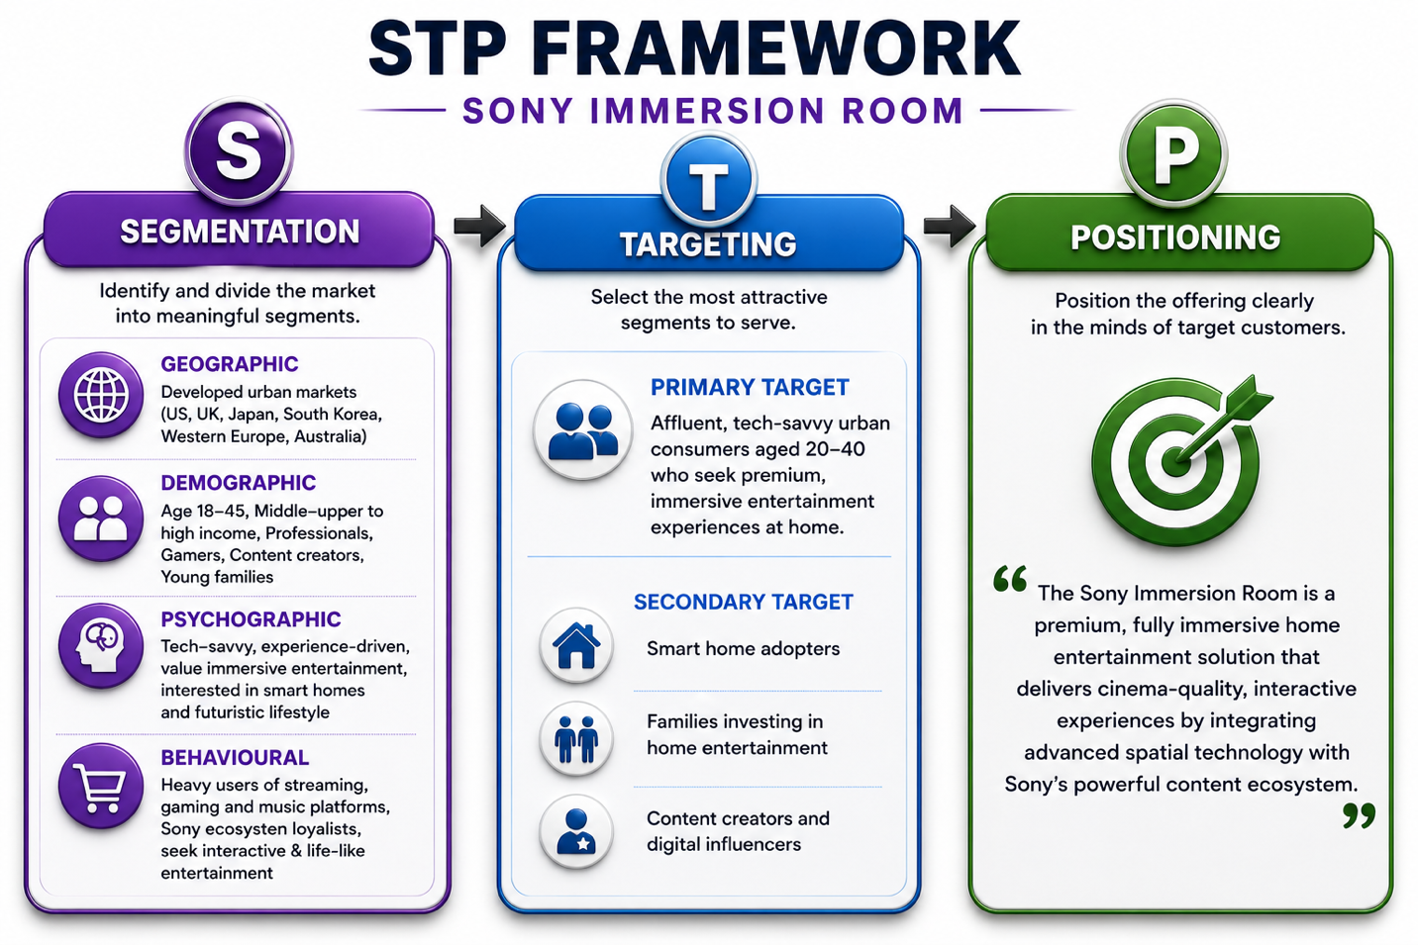
Figure 2: STP FRAMEWORK FOR SONNY IMMERSION ROOM

- This figure illustrates the Segmentation, Targeting, and Positioning process applied to the Sony Immersion Room. It demonstrates how Sony identifies high-value consumer segments, selects affluent tech-savvy users as its primary target, and positions the product as a premium immersive entertainment solution. The structured STP approach ensures alignment between consumer needs and Sony’s integrated ecosystem strategy.

Differentiation Strategy
- Competitive advantage requires differentiation. Sony Immersion Room has differentiated itself with the integration of technology, synergy of ecosystem, and value of experience.
  - Integrated Ecosystem Advantages
Sony uniquely integrates:
- Sony pictures (film content)
- Sony Music (sound recordings)
- PlayStation (gaming platform)
This establishes a smooth ecosystem whereby hardware and content are linked together and make the user experience better.
  - Advanced Immersive Technology
The system incorporates:
- 360 Reality Audio
- Spatial display technology
- Full-room immersion
These technologies make things look more realistic and allow the user to engage more, which greatly increases entertainment experiences (Suh and Prophet, 2018).
  - Competitive Comparison
Compared to competitors:
- Meta Platforms concentrates on VR headsets (individual experience).
- Apple Vision Pro provides personal immersion.
Sony also stands out in terms of providing:
- Group, room-based immersive experiences.
- Content + hardware ecosystem integration.

  - Sustainability Differentiation
- Minimizes commuting to movies and concerts.
- Removes the use of physical media.
- Supports energy-efficient innovation
This is in line with the growing consumer preference towards sustainable solutions.

5. Positioning Strategy
5.1 Positioning Statement
To tech-savvy entertainment consumers, the Sony Immersion Room is a high-end home entertainment experience, which gives a fully immersive, cinema-quality and interactive experience through a combination of high-tech spatial technology and the Sony robust content ecosystem.

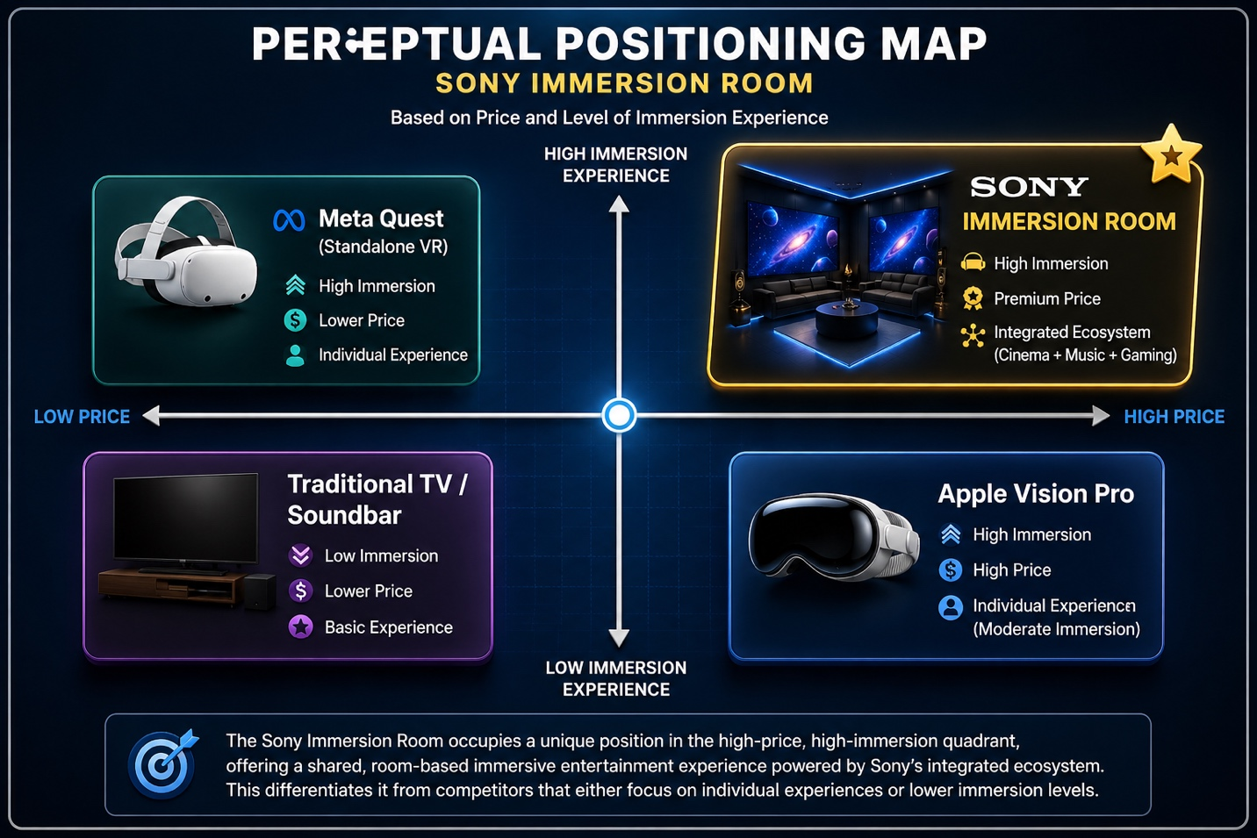
Figure 3: Perceptual Positioning Map of Sony Immersion Room
- This perceptual map is a comparison of the Sony Immersion Room and the major competitors in terms of price and immersion level. The positioning emphasizes that Sony is strategy-oriented towards providing a high-immersion, premium-price experience with its built-in ecosystem. Sony stands out in contrast to its competitors (Meta Platforms and Apple) by not providing device-based experiences but a shared room-based immersive environment.
5.2 Value Proposition
Sony creates value by:
- Technology: State-of-the-art immersive technologies.
- Content: Exclusive Sony ecosystem.
- Experience: Interactive and realistic interaction.

ELEMENT 3: Marketing Mix (7Ps) – Sony Immersion Room
- The marketing mix (7Ps) offers a framework to implement Sony's brand extension to immersive home entertainment. This section examines how each component is consistent with the STDP strategy presented above and Sony's aspirational positioning.

- The diagram below shows the combined 7Ps marketing mix approach to the Sony Immersion Room. It emphasizes the importance of product innovation, premium pricing, selective distribution, and experiential promotion as factors that help Sony position itself as a high-end immersive entertainment solution. The long components, which are people, process, and physical evidence, are also reinforcing the service quality and customer experience to ensure that it is aligned with the target market and the entire brand extension strategy.

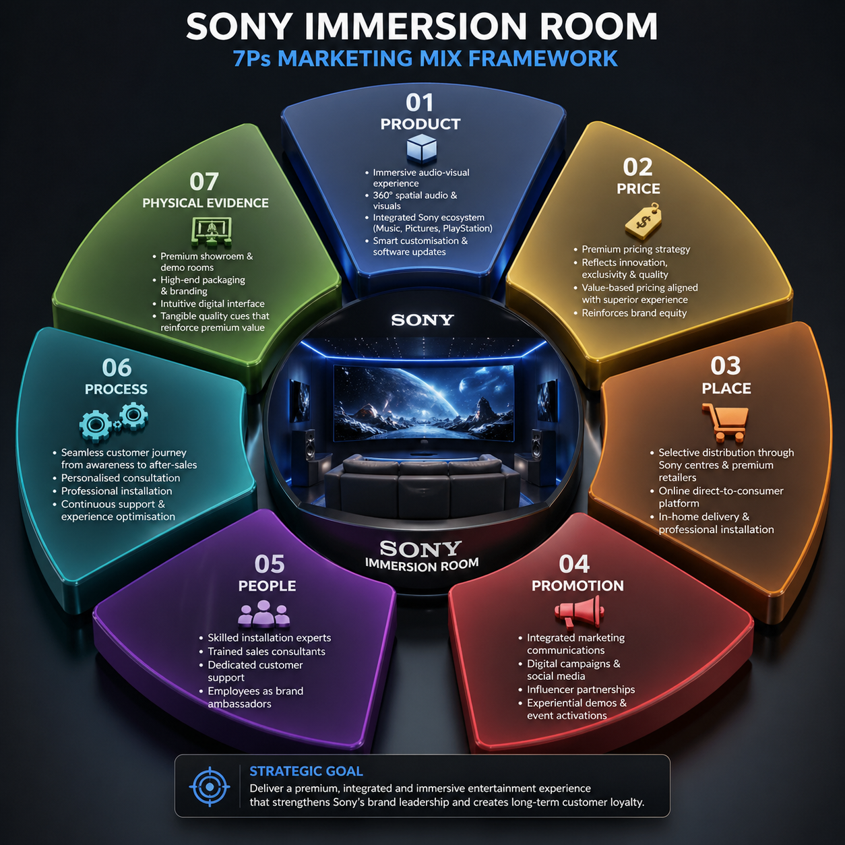
Figure 4: Sony Immersion Room – 7Ps Marketing Mix Framework

1. Product Strategy
Sony Immersion Room is a fundamental, real and imaginary product (Kotler et al., 2019):
- Main product: Cinematic home theater experience.
- Real product: Spatial audio, projection mapping, PlayStation support and Sony content library.
- Added product: Installation and software upgrades, special content.
- This aligns with the experience economy notion, where the customers appreciate experiences and not utilities (Pine and Gilmore, 1999). It adds value to Sony by its ecosystem (Sony Music, Sony Pictures, PlayStation) and this adds value to the competitiveness.
- Notably, the product facilitates the differentiation strategy (Element 2) based on the immersive shared experiences, which other devices such as Virtual Reality headsets do not.

2. Price Strategy
Sony has a skimming (high price) strategy that is based on its brand:
- Bids to affluent tech-savvy.
- Innovation, exclusivity and ecosystem value connote.
- Conveys quality (Keller, 2013)
- Strategically, brand equity is highly propelled by high pricing and is an indicator of technological leadership. However, it may limit sales, and Sony should create value by providing better experience and network effects.
- Lastly, there is value pricing which involves pricing based on perceived value, as opposed to cost of production (Kotler et al, 2019).

3. Place Strategy
Sony has a selective and experience-based distribution strategy:
- Sony experience centers and showrooms.
- Premium electronics retailers
- Online direct-to-consumer platforms In-home installation services
- This aligns with the target customer (urban middle-income to upper income) and high involvement buying process. Experiential retailing brings in engagement and reduction in perceived risk (Verhoeff et al., 2009).
- Notably, the sales are also experienced based as it reflects the immersive product.

4. Promotion Strategy
The integrated marketing communications (IMC) strategy employed by Sony is:
- Online marketing (YouTube, social media)
- Influencer marketing (technology reviewers, gamers)
- Live demonstrations (experimental marketing), pop-up immersive displays. Cross promotion in Sony ecosystem.
- This is aligned to AIDA model (Attention, Interest, Desire, Action) particularly using immersive demo that stirs emotions.
- Experiential marketing works in theory because the immersive technologies enhance customer engagement and loyalty (Suh & Prophet, 2018).

5. People Strategy
The "People" element is necessary due to the service nature of the product:
- Skilled installation teams
- Customer support specialists
- Experience store retail experts.
- Employees are brand ambassadors that influence the perception and experience of customers. According to service marketing research, employee interaction is a key determinant in how the consumers perceive the quality of the service (Zeithaml et al., 2018).
- To maintain brand excellence, Sony should concentrate on training and technical expertise.

6. Process Straetgy
Sony creates outstanding customer experience:
- Awareness → Demo experience
- Consultation → Customization
- Purchase → Professional installation
- After-sales support
- This is a case of customer journey mapping, to ensure that the experience is similar.
- The efficient processes make it easier and better to satisfy the customers, particularly the high involvement products. Integration of Hardware, software and content require formalized service.

7. Physical Evidence Strategy
Tangibles are in support of the intangibles:
- High-end showroom environments
- Immersive demo rooms
- Luxurious packaging and labelling.
- User interface design and digital interfaces.
- The tangibles communicate quality and minimize risk (Bitner, 1992). Theatric interiors of Sony promote its high-quality entertainment brand.
Integration with Brand Extension Strategy
All 7Ps help Sony to extend its brand by:

- Strengthening of premium positioning (Price, Physical Evidence)
- Providing differentiated experience (Product, Process)
- Focus on high value segments (Place, Promotion)
- Having service excellence (People)

- This combined solution will guarantee alignment with the STDP framework and enhance the competitive edge that Sony has in the immersive entertainment market.
Critical Evaluation of the Marketing Mix Strategy
- Although the 7P marketing mix of the Sony Immersion Room shows a lot of alignment to its premium positioning and target market, there are several strategic considerations that need to be critically analyzed to achieve long term success.

- The premium pricing strategy, which is effective in strengthening brand equity, might limit accessibility and scalability to the market, first. Kotler et al. (2019) emphasize that the perceived value must support the premium pricing that must be never-ending. Here, Sony needs to continuously improve and provide high-quality immersive experiences to avoid consumer defection, especially when such competitors like Apple and Meta spend millions of dollars in immersive technologies.

- Second, the product and ecosystem integration strategy offers a highly competitive advantage but at the same time, it can lead to dependency on the proprietary ecosystem of Sony. This may restrict its adoption by consumers who are already integrated in other ecosystems, like the Apple or Android systems. According to Keller (2013), robust brand ecosystems can improve loyalty but might decrease the adaptability of attracting new users.

- Moreover, experiential promotion is a most effective method of conveying value, but it may be quite expensive, particularly when it involves physical demonstrations and immersive showrooms. Verhoff et al. (2009) note that as much as customer experience improves engagement, companies must strike a balance between experiential and cost investment to be profitable.

- The process and people dependency regarding the competent installation and after-sales service provide operational complexity. The lack of consistency in the services may adversely affect customer satisfaction since the quality of service hugely relies on the performance of employees (Zeithaml et al., 2018). As such, Sony should make sure there is strong training and standardization of all touchpoints of the service.

- Lastly, the increasing role of sustainability and ethical consumption is both a chance and a challenge. Although the Immersion Room eliminates the necessity to travel physically to cinemas and events, its technological system might raise the concern about energy consumption and electronic waste. Including sustainable practices may boost the brand perception of those consumers who are eco-conscious.

- All in all, the marketing mix is quite strategically consistent and shows the alignment to the brand extension goals of Sony, however, the success of the marketing mix will be determined by how well Sony manages to strike the balance between innovation, cost, accessibility, and sustainability in a constantly competitive and dynamic market.

ELEMENT 4:- Reflection
- The brand extension of Sony Immersion Room has been a very learning experience and has enabled me to put some of the theoretical marketing concepts into a realistic and strategic environment. During this project, I learned more about the combination of frameworks, including Segmentation, Targeting, Differentiation, and Positioning (STDP) and the 7Ps marketing mix to develop a coherent and competitive brand strategy.

- Among the major lessons learned was the need to focus on consumer-centric marketing. Through the demographic, psychographic and behavioral segmentation, I was able to come up with a well-defined target audience of tech-savvy affluent consumers. This further supported the need to synchronize marketing strategies with the customer needs and expectations as emphasized by Kotler et al. (2019). I also acquired a better insight into the role of differentiation and positioning in creating a differentiated and competitive value proposition in the market.

- The marketing mix also helped me to better understand the need to make strategic decisions interrelated. As an example, product innovation, brand positioning and experiential promotion were directly related to the premium pricing strategy. This is indicative of the need to be consistent in all the elements of the marketing mix to provide a powerful brand experience (Keller, 2013). Moreover, the idea concerning the experience economy gained immense importance since the Sony Immersion Room is aimed at the provision of immersive and involving experiences, but not merely at the functional advantages (Pine and Gilmore, 1999).

- The element of poster presentation was a major contributor to my communication and visualization skills. The process of breaking down and simplifying information to translate complicated marketing theories into a vivid and easy-to-understand poster demanded complex organization. This process enhanced my skills of presenting ideas in an effective and professional manner. Also, the presentation of the poster gave me the confidence to clarify concepts of strategy and respond to criticism, which is a necessary skill in academics and in the workplace.

- Personally, the given project enhanced my critical and analytical thinking skills. I went further than merely explaining marketing theories and started to consider their practical ramifications. As an example, I critically examined the constraints in premium pricing and the dangers of ecosystem dependency. This reflective method is in line with experiential learning theory, which focuses on experience-based learning and critical reflection (Kolb, 1984).

- Nonetheless, there are a few aspects that I need to work on. Time management was also a major problem especially when balancing research, content development and design aspects. I would use a more organized method of planning in the future to enhance efficiency and save time pressure. Moreover, I would also seek to use academic materials more actively to reinforce the theoretical basis of my analysis.

- All in all, the project has greatly helped me in my academic and professional growth as it has enhanced my skills in strategic thinking, creativity, and communication. It has also taught me some important lessons in the application of the marketing theories in the real-world situations which will equip me to take future jobs in marketing and business strategy.

References
- Suh, A. and Prophet, J. (2018) ‘The state of immersive technology research’, Computers in Human Behavior, 86, pp. 77–90.
Available at: https://www.sciencedirect.com/science/article/pii/S0747563218301857
- Bennett, J., et al. (2021) The Story of Immersive Users.
Available at: https://www.researchgate.net/publication/352180633
- Schuir, J., Pöhler, L. and Teuteberg, F. (2022) ‘Segmentation in virtual reality markets’, Electronic Markets.
Available at: https://link.springer.com/article/10.1365/s40702-021-00817-w
- Grand View Research (2024) Immersive Technology Market Size Report.
Available at: https://www.grandviewresearch.com/industry-analysis/immersive-technology-market-report
- Grand View Research (2024) Virtual Reality Market Analysis.
Available at: https://www.grandviewresearch.com/industry-analysis/immersive-virtual-reality-market
- Kotler, P., Keller, K.L., Brady, M., Goodman, M. & Hansen, T. (2019)
Marketing Management, 4th European ed.
Available at: https://scholar.google.com/scholar?q=Marketing+Management+Kotler+Keller
- Pine, B.J. & Gilmore, J.H. (1999)
The Experience Economy.
Available at: https://scholar.google.com/scholar?q=The+Experience+Economy+Pine+Gilmore
- Keller, K.L. (2013)
Strategic Brand Management.
Available at: https://scholar.google.com/scholar?q=Strategic+Brand+Management+Keller
- Suh, A. & Prophet, J. (2018)
‘The state of immersive technology research: A literature analysis’
Available at: https://scholar.google.com/scholar?q=Suh+Prophet+immersive+technology
- Verhoef, P.C. et al. (2009)
‘Customer experience creation: Determinants, dynamics and management strategies’
Available at: https://scholar.google.com/scholar?q=customer+experience+creation+Verhoef
- Zeithaml, V.A., Bitner, M.J. & Gremler, D.D. (2018)
Services Marketing: Integrating Customer Focus Across the Firm
Available at: https://scholar.google.com/scholar?q=Services+Marketing+Zeithaml
- Kolb, D.A. (1984)
Experiential Learning Theory
https://scholar.google.com/scholar?q=Kolb+Experiential+Learning

