

C
WELCO
ME
T
O
OUR
P
R
ES
EN
T
A
TION
JOY
BOTU
•
GIFTY
BOAKYE
(2026626)
•
M
A
R
I
TZA
ES
T
E
F
A
N
I
A
R
A
M
I
R
E
Z
R
I
VE
RA
(292295)
•
KYRSTAL
GARDNER
(2027750)
•
MARIAN
AKPOMON
(2018581)
•
Introduction…
•
Benefits
of
teamwork
…
•
Managing
Conflicts
in
the
workplace…
•
Team
roles…
•
Successful
team
development…
•
Conclusion…
•
References…

I
n
t
rodu
c
t
i
o
n
•
Team
is
a
group
of
people
working
for
meeting
specific
objectives
(
Brooks,
2009
)
.
Team
working
helps
to
perform
tasks
applying
innovative
ideas
and
tools
.
•
The
management
of
East
London
Travel
agency
is
motivating
its
employees
to
work
in
team
for
delivering
customers
services
.
•
Tasks
are
properly
coordinated
when
employees
of
the
company
are
working
in
team
(
LEVI,
2014
)
.
•
Customers
can
be
made
happy
with
innovative
services
which
ensures
organisational
performances
enhancements
.
MARITZA
RAMIREZ
RIVERA
292295

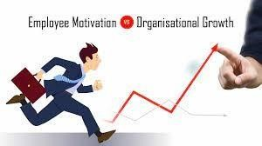
Benefits
of
Team
Working
•
Improving
productivity:
•
Better
collaboration
with various
employees
of East
London
Travel
can
increase productivity of employees (LEVI, 2014).
•
Making all
employees
informed
about new
processes
and
procedures.
•
Increasing
employee's
morale
and
motivation.
•
Employees of East London
Travel
agency can easily make
communication with others and become motivated.
•
Employees
can
understand
ethical
behaviour
making
conversation
with
other employees (Cameron, 2013).
MARITZA
RAMIREZ
RIVERA
292295

MAR
I
TZA
RAMIREZ RIVERA
292295
Benefits
of
Team
working
•
Effective
communication
among
employees:
•
Each
employee
is
communicated
properly.
•
Their
target can be
set up easily
to perform
well.
•
Enhancing
organizational
profitability

Benefits
of
Team
working
•
New
idea
Generation:
•
Employees
of
East
London
Travel
can
share
their
innovative
ideas
with
other
employees.
•
New
ideas and
processes are
introduced to
perform
well.
•
Relieving
Stress
of
employees:
•
Team
working
removes
stress
among
employees
of
East
London
Travel.
•
Assigned responsibilities are
properly understood
MAR
I
TZA
RAMIREZ RIVERA
292295
What is workplace
conflict?
•
Conflict is a disagreement between two or more people when working together however conflicts is very
normal and it happens naturally. Conflicts can happen if two or more people don’t understand each other
due to poor communication as people might have different aims and personal goals as they all want to
compete to be the best.
•
Most conflicts that occurs are not is necessarily negative, but even a minor or small disagreement
between people can suppurate and soar or will raise up if it’s not addressed and resolved at the earliest
opportunity. This research clearly reveals that conflict is very much inclusive in an organizational life, and
it is also a common occurrence at work according to a substantial proportion of both employees, that is,
26
% and employers, that is, 20%.
GIFTY
BOAKYE
2026626

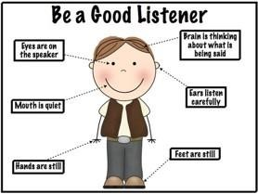
Managing
conflicts
in
the
workplace
•
We
can manage conflict
in
the workplace by
•
Talking
with
the
other
person
•
Listening
carefully
•
Identifying
any
agreement
and
any
disagreement
•
Prioritizing
the
different
areas
where
the
problem
is
coming
from
•
Developing
a
specific
plan on how
to solve
each problem
•
Building
on
your success.
GIFTY
BOAKYE
2026626
Conflicts
in
the
workplace
GIFTY
BOAKYE
2026626
•
Conflicts in the workplace are caused by poor communication because different
employees might have different opinions on how to do something and they
might not come to a good conclusion or an understanding so it might lead to
misunderstanding. There are different types of conflicts that can happen in the
work
-
place and these are
•
Creative idea conflict: This happens when it comes to the workers sharing ideas
everyone tries to give the best opinions. Employee need to recognize the idea of
others and voice out their own opinion.
Benefits
of
resolving
conflicts
in
the
workplace
.
➢
It brings peace and unity
➢
It improves production
➢
It brings harmony around the work area as people will enjoy working together
➢
It reduces tension at the work place and also helps people to share their opinion with other
colleagues at the work place.
➢
Creation of effective working relationship
GIFTY
BOAKYE
2026626
Effective
Team
Roles
Marian
Akpomon
2018581
Team
Role
in Situational
Leadership
•
Situational leadership determines the team's role. Situational leadership is a leadership style in
which a leader adapts their leadership style to the present work environment and/or team
demands. This leadership style is not focused on a leader's abilities; rather, it is based on a
leader's ability to adapt to the needs of a team or organization in order to become a better and
more effective leader. Ken Blanchard and Paul Hersey developed this leadership style, which is
also known as "Situational Leadership Theory" or "Situational Leadership Model."


Marian
Akpomon
2018581
•
What
is
team
role?
•
A team role, according to McShane and Von
Glinow (2003:241), is a "collection of behaviors
that people are expected to do because they
hold certain roles in a team and organization.”

Marian
Akpomon
2018581
Effective
Team
Roles
What
is
a
team?
•
Teams
are defined as small
groups
with
complementary
skills,
committed
to
a
common
purpose, common performance goals, and
a
common
approach for
which
they hold
themselves mutually accountable (Kreitner and
Kinicki (2001))
Marian Akpomon 2018581

Importance of Team Roles in an Organization:A case study of UK Social Care Service
Starting from the time when our ancestors banded together to search for food, lead their families, and protect their society, teams and teamwork have been the most prominent terms in human life (Kozlowski and Ilgen, 2006). Teams have evolved into not only a foundation for social structure but also a hub in the running of companies over the previous four decades (Gibson et al., 2007). Any company that wants to be productive must encourage not only teamwork, but also the assignment of specific roles among team members. The benefits of this are;
•Coordination: The orderly interpersonal activities required to complete complex tasks are referred to as coordination. Every individual in the UK Social Care Service is aware of their responsibilities, which aids in proper coordination.
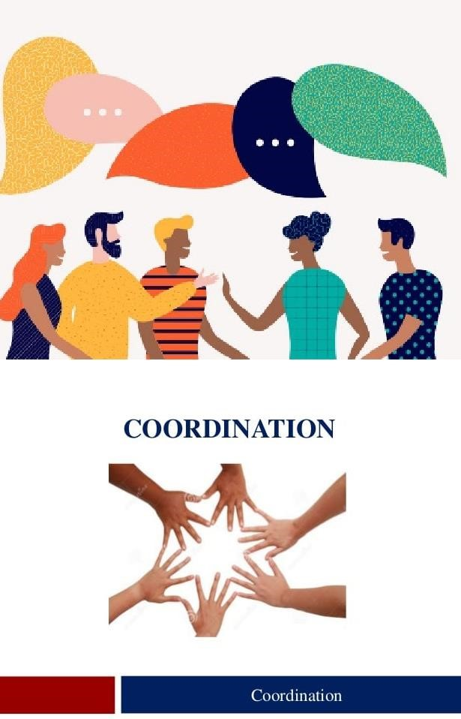
Marian
Akpomon
2018581
Cohesion
:
Members of the UK Social Care Service work
together to achieve team goals by cooperating
interdependently around the team's task
.
•
Conflict
management:
Destructive team conflict is frequently
caused by interpersonal issues in the workplace, as well as
organizational problems. Understanding successful team roles
helps to manage conflicts in the UK Social Care Service
because people are held accountable for their actions based
on their duties.
•
Communication:
Effective teams require dependable
communication methods, well defined responsibilities, and
proper delegation in every operating organization.
Understanding unique duties aids team members in
communicating effectively in the UK Social Care Service
.

Krystal
Gardner
2027750
Successful
Team
Development
•
People gain from good teams because they provide additional support and possibilities for progress.
Effective teams inspire its members to exchange thoughts, find resolutions, and collaborate to tackle
challenges. The following characteristics are found in a successful team: (February 9th, 2021)
•
Mindset that is goal
-
oriented.
•
Their dedication to their jobs.
•
Open to new experiences.
•
Various viewpoints and experiences

Successful
Team
Development
•
Effective management is critical to every company's success. It's tough to define the phrase
"management." The use of people and other resources to achieve a set of goals is
characterised
as management (Boone & Kurtz 4:1992).
•
Teams that are successful are driven to succeed (Bradley & Frederic, 1997)
•
Responsibility
and
accountability.
•
Clear
communication.
•
An
effective
leader
Krystal
Gardner
2027750

Successful
Team
Development
•
Encouraging.
•
Team
members should
remain consistent
and passionate.
•
Communication.
•
Always
be
open
to
feedback.
•
Great communication
Effective
communication.
Krystal
Gardner
2027750
Con
c
l
u
s
i
on
•
Team working is necessary for enhancing
organisational
performances in markets.
Organisations
like East
London Travel can easily make its employees motivated through encouraging team working.
•
Each employees is sharing their understanding with others and thus, they are fostering innovation in
markets (Schein, 2004).
•
Team working is also helping to removing stress among employees and then employees are very much
motivated to perform well in markets (French, 2017).
R
e
f
eren
c
e
s
•
B
r
oo
ks,
I.
,
(
2009
).
O
r
gan
is
at
i
ona
l
beha
vi
our
:
i
nd
ivi
dua
ls,
g
r
oup
s
an
d
o
r
gan
is
at
i
on
.
Pea
rs
o
n
Education.
•
French,
E.
G.
(2017).
Some
characteristics
of
achievement
motivation.
Journal
of
Experimental
Psychology,
50
,
232
-
236.
•
Schein,
E.
H.
(2004).
Organizational
culture
and
leadership
(3
rd
edition.).
San
Francisco,
CA:
Jossey
-
Bass.
•
LEVI,
D.
Group Dynamics
(2014)
for
Teams.
4
th Ed.
London:
•
Cameron,
A.
(2013)
Collaborative
Leadership;
Building
Relationships,
Handling
Conflict
and
Sharing
Control.
2
nd Ed. London: Routledge.
•
https:
//ww
w
.
talenttool
s
.
com.au/articles/th
e
-
s
benefit
-
o
f
-
e
effectiv
-
conflic
t
-
managemen
t
--
-
benefit
s
-
o
f
-
conflict
-
competence.html
.
•
Gibson
(2003).
Quality
of
team
service
-
The
role
of
field
independent
culture,
quality
orientation,
and
quality
improvement
focus.
R
e
f
eren
c
e
s
•
Kozlowski
SWJ,
Bell
B
(2003).
Work
groups
and
teams
in
organizations.
•
McShane
&
Von
Glinow,
2003:241)
Roles
for
Team
Effectiveness
•
https://
www.indeed.com/caree
r
-
advice/caree
r
-
development/step
s
-
t
o
-
buildin
g
-
a
-
l
successfu
-
team

(
Accessed
30
November
2021)
indeed
•
Boone,
L.E.
&
Kurtz,
D.L.
(1992)
Management.
New
York
;
London
:
McGraw
-
Hill
•
Bradley,
J
H,&
Frederic
(1997).
The
effect
of
personality
type
on
team
performance.
Journal
of
Management
Development,
16(5)
,
p
337
-
353.

