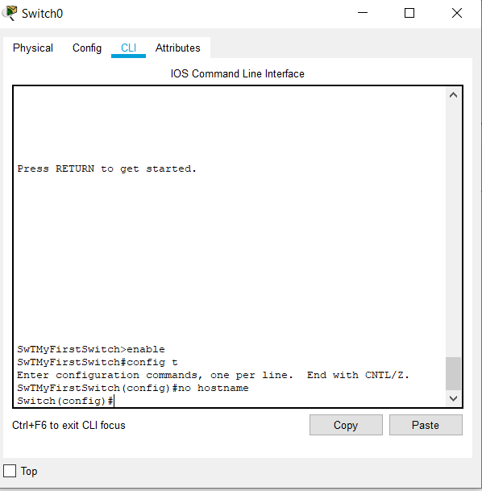 Applied Computing

Wales Institute of Science and Art (WISA)

Networks and Cybersecurity Essentials (ACCA4024)

Lab 4: Design and Implement Home Network.


n.kaliyamurthy@uwtsd.ac.uk 1

Topology:
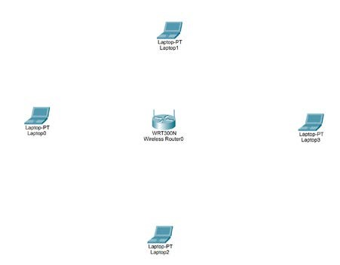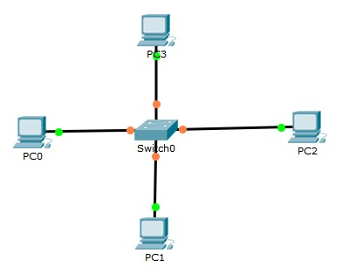
Topology 1 Topology 2
LAB Objectives
After designing the above home network, we have to configure the network and make a successful network.

Topology 1:
- Using Windows Calculator to determine the IP address of the hosts in the network.
- Configure the Intermediate L2 device to the network and test the network. Troubleshoot if required.

Topology 2:
1. Configure wireless network and enhance security.

Requirements
➢ Use Packet Tracer to create the above recommended topology

Use for reading
Intermediate Devices: (Switch, Routers)
The two most common methods to access the command line interface of any intermediate devices are console and SSH. For a console, a PC/ Laptop needs to be directly connected to the console port of the network device to configure. For SSH, a pre-configuration is required to access.
Switch: Layer 2 Device
When the switch is on, the power-on self-test (POST) begins.
During POST, the LEDs blink while a series of tests determine that the switch is functioning properly.
POST is completed when the SYST LED rapidly blinks green. If the switch fails POST, the SYST LED turns amber.

Memory
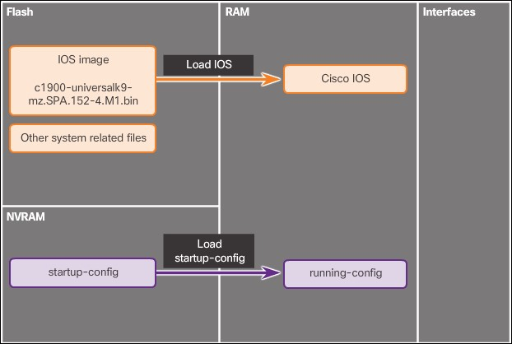

Router
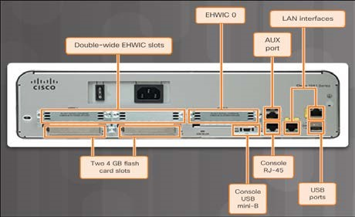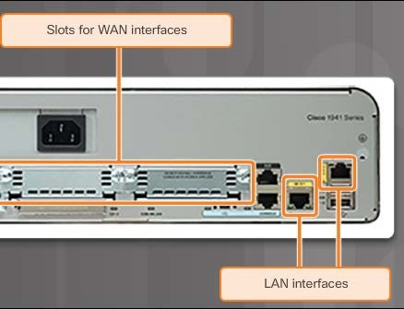

All routers are essentially computers. Just like computers, routers also require operating systems (OS), central processing units (CPU), random-access memory (RAM), read-only memory (ROM), and nonvolatile random-access memory (NVRAM).
Every Cisco router has the same general hardware components, and these connections: console ports, 2 LAN interfaces, and enhanced high-speed WAN interface card (EHWIC) slots.
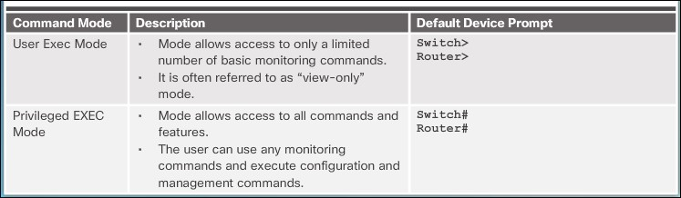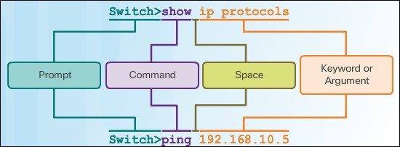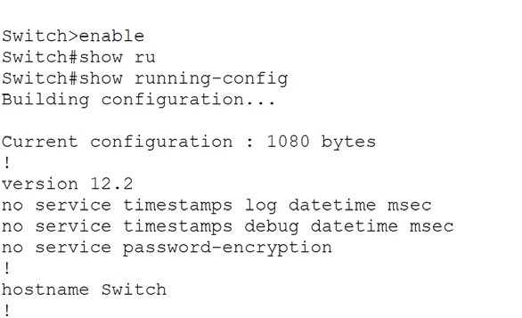

Task 1: Switch Configurations (Use Topology 1) Create the Topology as given in Packet Tracer.
Configure IP Address and Subnet Mask for PC0, 1, 2, 3
Device | Interface | IP Address | Subnet Mask
PC0 | NIC | 11000000.10101000.01001000.00011110 | /24
PC1 | NIC | 11000000.10101000.01001000.00101000 | /24
PC3 | NIC | 11000000.10101000.01001000.00110010 | /24
PC4 | NIC | 11000000.10101000.01001000.01000110 | /24
PC0 | NIC | 192.168.72.30 | 255.255.255.0
PC1 | NIC | 192.168.72.40 | 255.255.255.0
PC2 | NIC | 192.168.72.50 | 255.255.255.0
PC3 | NIC | 192.168.72.70 | 255.255.255.0

Basic Switch Configurations
- User Mode, Privilege Mode, Global Configuration Mode:
- Give a Host Name: SwTMyFirstSwitch
Swt1(config)#hostname SwTMyFirstSwitch

The NO Command 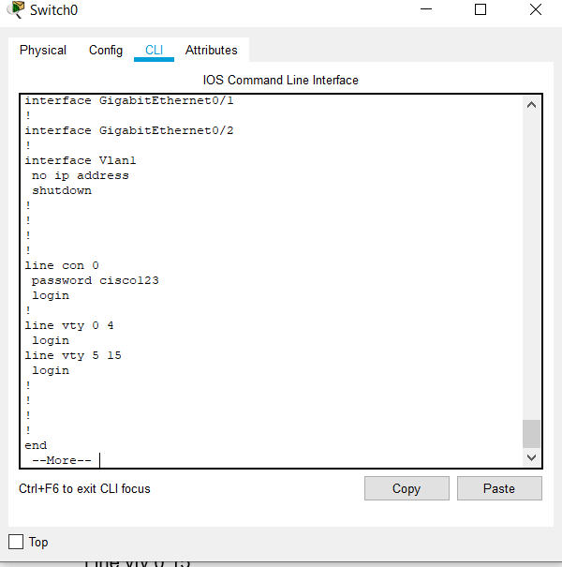
To remove a command, use “no” before the executing command Eg: no hostname
3. Passwords (Basic Security)
Configure console password: cisco123
>enable
# Config t Line console 0 password cisco123
login Exit
#
Configure vty password: 1CiSc3
>enable
# Config t Line vty 0 15 password 1CiSc3
login Exit
#
Enable Privileged Password: Password
>enable
# Config t
Enable password cisco

Observe the running configuration of your switch and note the
configuration

Is your privileged password shown in running-configuration? (Yes/No) If Yes, how is it displayed? Yes. Displayed in plain text 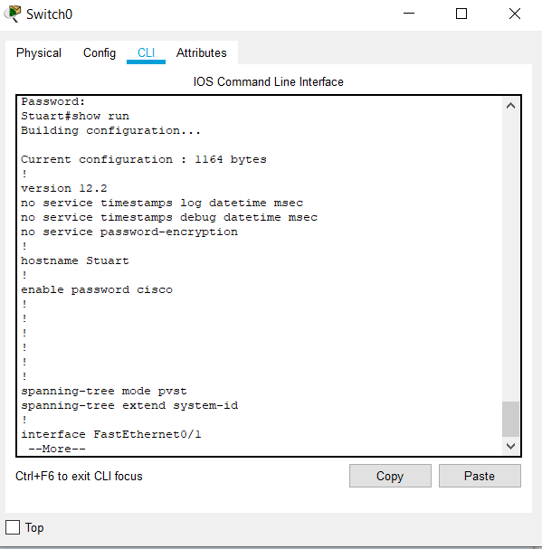

Now, remove the privileged password. To do that, go to config mode
(Privileged Executive mode)
# Config t
No enable password cisco
And Type
enable secret cisco 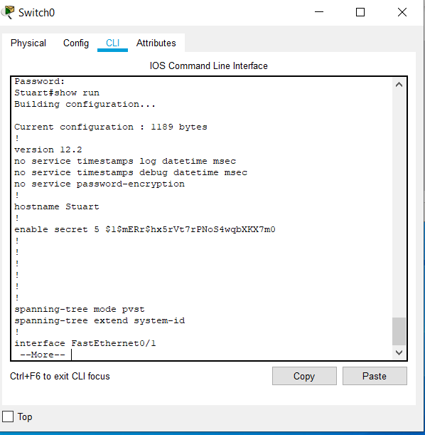

Observe the running configuration of your switch again and note the
difference between password and secret. Password is encrypted.

How are the other passwords?
Not Encrypted or Hidden

Now, go to config mode (Privileged Executive mode) again
# Config t
Service password-encryption
Observe the running configuration of your switch again and note the
difference now: All passwords are encrypted.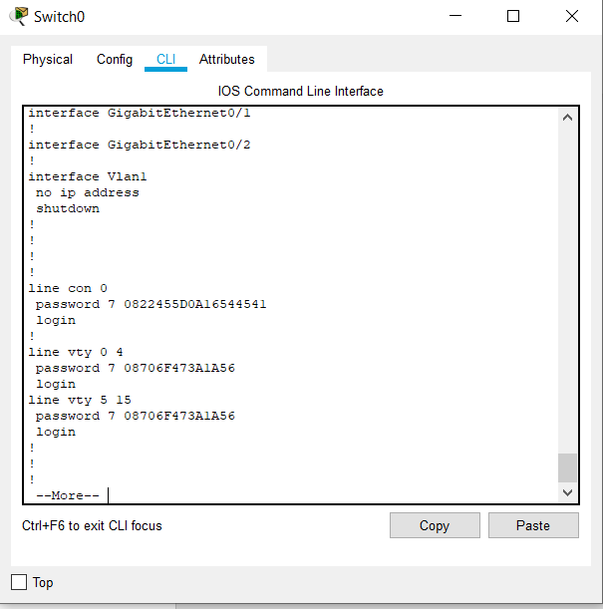

The DO Command
Allows you to execute any EXEC mode command from within any configuration mode Eg:
# Config t
Do show running-configuration
- IP Address
SwTMyFirstSwitch > en
SwTMyFirstSwitch # config t
SwTMyFirstSwitch (config)#interface vlan 1 SwTMyFirstSwitch (config-if)#
ip address 192.168.72.254 255.255.255.0
SwTMyFirstSwitch(config-if)#no shut
SwTMyFirstSwitch(config-if)#exit 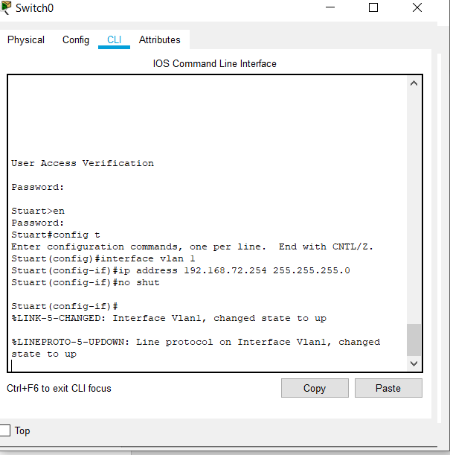

- Show Commands 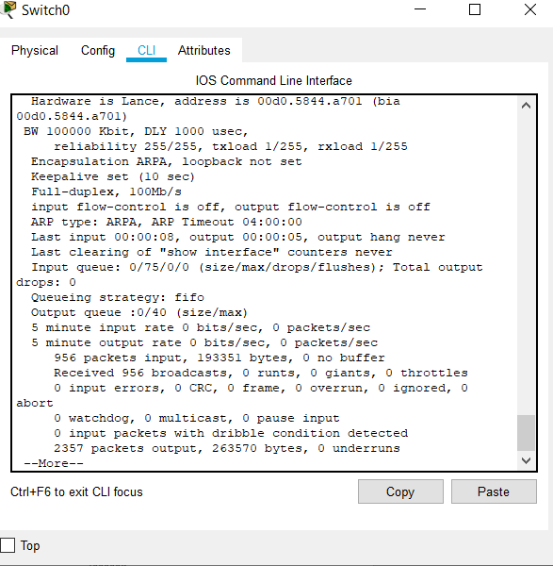
Show running-config show interfaces show arp
show version

Erase startup-config
Reload
The BANNER Display your banner banner motd "
Enter TEXT message. End with the character '"'
Welcome to Switch GF "
- Save the Configurations 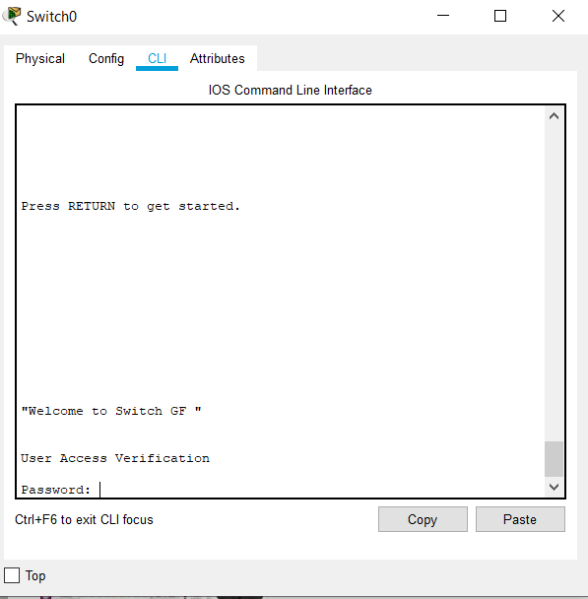
copy run startup write memory

Try out!!!
Add a router to your network and do the same configurations and record your reflections

References:
Ipconfig - ipconfig /all - ipconfig /release and ipconfig /renew ping netstat tracert nslookup
Understand:
If pings to both the name and IP address are successful, but the user is still unable to access the application, then the problem most likely resides in the application on the destination host
If neither ping is successful, then network connectivity along the path to the destination is most likely the problem
If the ping to the default gateway is successful, the problem is not local. If the ping to the default gateway fails, the problem resides on the local network.
A ping may fail due to the firewall on the sending or receiving device, or a router along the path blocking the pings.

Task 2: Wireless Configurations (Use Topology 2) Create the topology using Cisco packet Tracer.
In your wireless router (WRT 300N), do the following configurations
- Set up Router IP Address 192.168.10.1
- Enable DHCP
- Set Start IP as 192.168.10.20 ➢ Maximum No. of users: 3 ➢ Save the configuration.
- Set the Network mode: Mixed
- Name your network: MyNetwork
- Enable Broadcast
- WPA2 Personal Security
- Encryption AES
- Passpharse: 123456789
- Router Password: Cisco
- Enable Remote Management
- 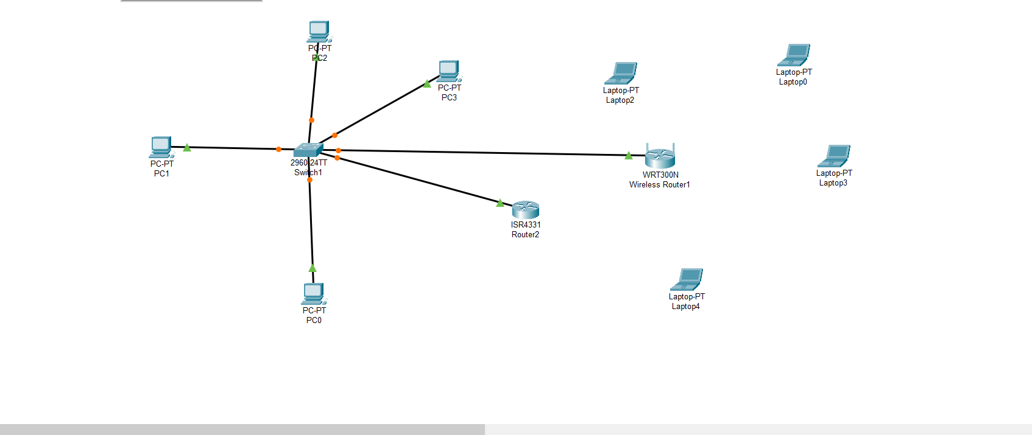
Connect all the end devices as per the topology to the Wireless router.
Did all the laptops successfully connected to the wireless router? | NO  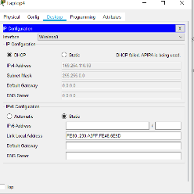
If NO, Troubleshoot until all the hosts successfully connects and record your troubleshooting methods here.

Did all the laptops gain DHCP IP address?

No
Record your understanding, why all the laptops could not get IP address assigned from the DHCP.
The network is set up to only give 3 DHCP address’. The forth computer will get a refusal from the DHCP server and the computer will self assign it’s own APIPA Automatic Private IP Addressing. This is a safeguard should the DHCP server fail.

Disable and enable the DHCP IP Configurations in the Laptop an
d check the status.

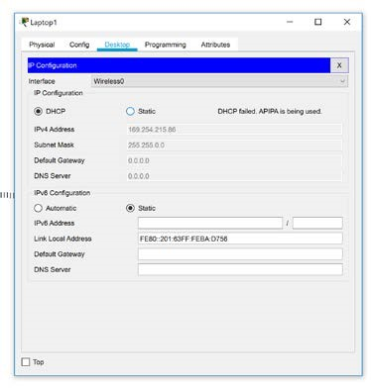

Collect the MAC address of any two laptops and go to wireless mac filter option in the wireless router and set MAC Addressing FILTERING to prevent them to connect the network.
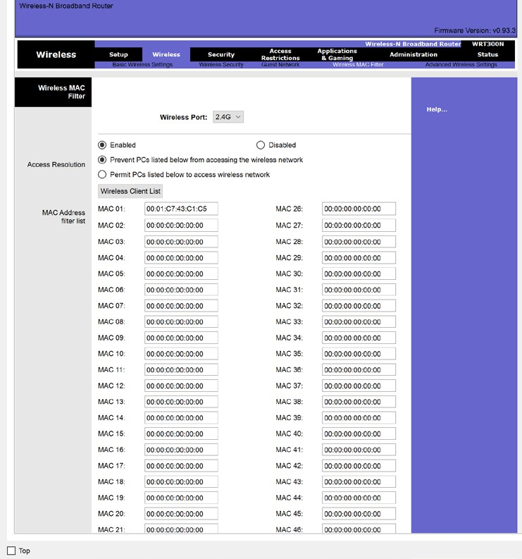

Observe the changes in the network and record your reflections about MAC
Filtering and enhancing the security in Wireless Networks.
A MAC address is assigned to each network card which cannot be changed. A Mac address is fixed to the NIC physical device . Mac address filtering will only permit those devices that are on the whitelist to access the network port and blacklist all other devices by detecting their MAC address as not authorised.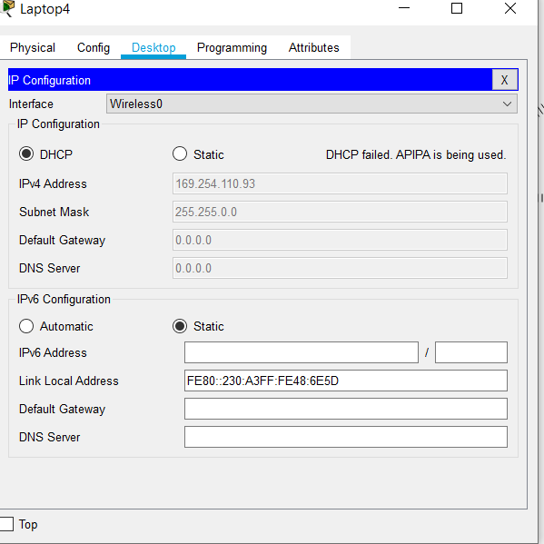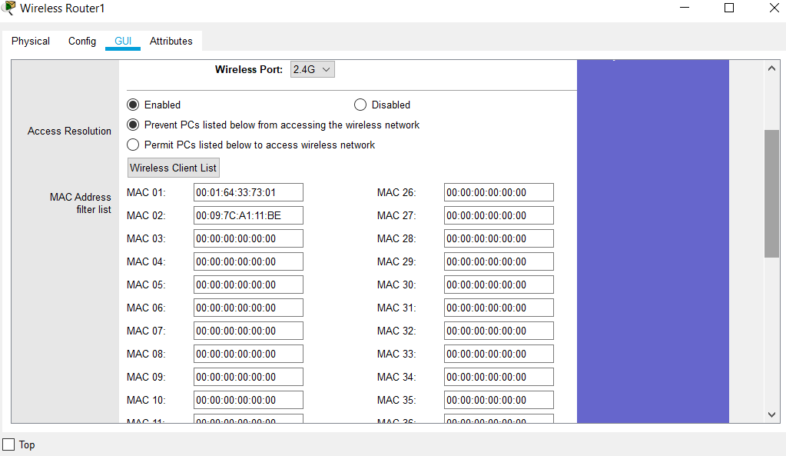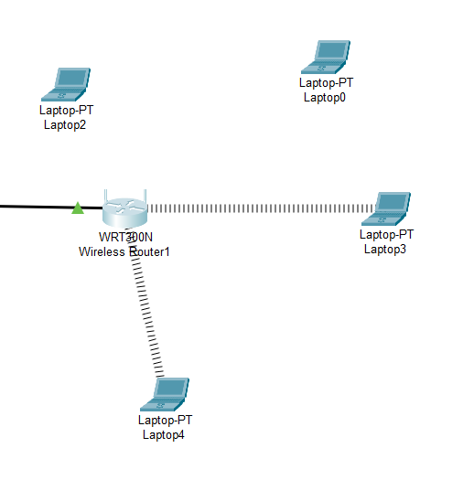

Learnings from this lab:
- Build a home Network
- Understand and configure IP Address
- Use Ping/ Trace route Utility to check the connection status
- Use ipconfig /all command to determine the MAC address of a Windows computer on an Ethernet network.
- Analyze a MAC address to determine the manufacturer.
- Analyze the Wired and Wireless Network connection.
- Analyze Address Resolution Protocol (ARP).
- Connect to a Wireless Router and configure the basic settings in a wireless router and add security features.
- Use nslookup command to understand the url to ip conversion.
- Configure basic connectivity settings in Intermediate devices (Switch/ Router).

