

BMSW5101
DEVELOPING WORKPLACE CRITICAL THINKING

Student: Gyula Zelend – 1814617

Executive Summary
For long-term business sustenance, it is crucial to develop strategies for critical workplace thinking and strategies for managing employee behaviour. The following report developed effective ideas and strategies for potential thinking in selected UK-based firms, with particular emphasis on impacts of prevailing Covid19 pandemic. In this regard, this report underlined and discussed principal and relevant theories of management that can be used amidst a situation of pandemic and importance of applying chosen theories on specified Organisation. This report further made a critical evaluation of selected theories, to reflect upon differences in ways of interpreting the theories amongst people with different values, attitudes and beliefs. Finally, following report provided practicable and appropriate recommendations along with justifications, for crucial organisational changes that needs to implement undertaken for selected organisation based on post-pandemic mindset of employees.
Table of Contents
Introduction 4
Key management theories underpinning the report 5
Beliefs, value systems and attitudes 9
Critical evaluation of theories 12
Recommendations and justifications 15
Conclusion 17
Reference list 19

Introduction
AstraZeneca is a science-based, global pharmaceuticals company, headquartered in Cambridge, England. It has a portfolio of a range of products and medicines for major diseases such as cardiovascular and gastrointestinal diseases, cancer, neuroscience, respiratory ailments, infections and inflammations. People use AstraZeneca’s innovative medicines across the globe (Ryan, 2020). The following report aims to develop effective ideas and strategies for potential thinking in selected UK-based firms, with particular emphasis on impacts of prevailing Covid19 pandemic. In this regard, this report shall underline and discuss principal and relevant theories of management that can be put to use amidst a situation of pandemic and importance of applying chosen theories on specified Organisation. This report shall further make a critical evaluation of selected theories, in order to reflect upon differences in ways of interpreting the theories amongst people with different values, attitudes and beliefs. This report shall eventually, provide practicable and appropriate recommendations along with justifications, for crucial organisational changes that need to be undertaken for AstraZeneca, following post Covid mindset of employees. These recommendations should be able to create effective grounds for employees to confront current challenges, and in turn, make them more resilient for future.
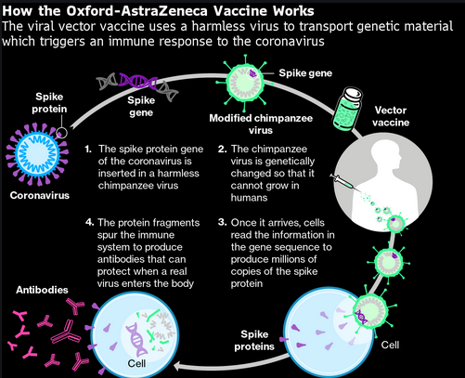
Figure 1: Oxford AstraZeneca vaccine
(Source: Astrazeneca.com, 2019)

Key management theories underpinning the report
Management Theory is something that helps the company and the business to focus, communicate and evolve. It is something that helps the workplace top focus ovr the leadership goals. Whenever a management style or theory gets implemented in the business it streamlines the main priorities for the company. It even allows the managers of the business to communicate better with people of the company that in-return enable the business to run smoothly. In any difficulties or in any unfavourable situations, understanding and implementing the management theories can save time for mitigating such things and it explores new overcoming situations that lead to more applicable directions.Within a matter of seven to eight months, the Covid19 pandemic has brought radical changes and transformations to people’s personal as well as their professional workplaces. Facemasks and sanitizers, today, have almost become a mandatory requirement for preservation of both personal and professional hygiene (Caponecchia and Mayland, 2020). More importantly, physical distancing and social isolation are at present, two crucial protocols that people are abiding by, both in their homes and at their offices. With the onset of the pandemic, professional decorum and workplace scenarios in majority of business Organisations across the globe have been undergoing radical metamorphoses.
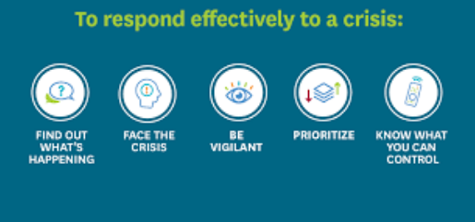
Figure 2: Workplace Response strategies to Covid19 pandemic
(Source: Cletus et al. 2018)
In certain places, outcomes have been devastating. In such a situation, one crucial requirement that global Organisations have been working towards, is, formulation of a powerful workplace management strategy and theory that could simultaneously tackle practical challenges and difficulties that arise daily owing to the pandemic, along with, providing prolonged business sustenance in global economy (Kumar et al. 2020). Needless to mention, that, by virtue of being a biopharmaceutical firm, AstraZeneca, faces rather more critical challenges than other firms, and especially due to the fact that, company provides frontline aid to patients. At core of its business strategy lies a culture that is entrepreneurial and led by innovative science. Company, at present, focuses its fundamental business objectives, towards delivering life-changing medicines and thereby contributing value to a pandemic-driven society.
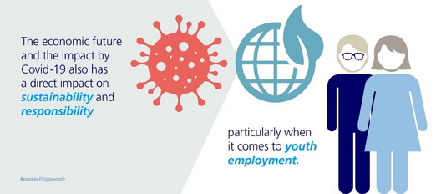
Figure 3: Transformations in global workforces due to pandemic
(Source: Mobo, 2020)
A natural outcome of this prolonged period of change is radical transformation of behaviour and psychology of employees. Mitigating challenges related to pandemic would therefore require a coordinated and very behavioural change for sustaining in long run. Specified company and its management too, require appropriate workplace management theories for purposes of retaining and maintaining workplace coordination (Pacheco et al. 2020). Key theories of management that can prove efficacious for specified company involve the following.
Organisational and ecological Theory of knowledge Management
“Organisational knowledge-management theory” involves designing organisational structures, hierarchically and culturally, for purposes of knowledge and knowledge processes. Knowledge management has emerged as a significant theoretical perspective in current business scenario (Sapkal, 2020). As mentioned earlier, AstraZeneca is a company, at heart of which lies, science and innovation. Thus, managing its intellectual resources and knowledge resources and turning them into actions, is something that has made company thrive for so many years in pharmaceuticals industry. Specified company has a considerably good repute, for its R&D (Research and Development) intensity and it would not be erroneous to designate company as a knowledge intensive organisation. Considering current scenario, AstraZeneca, is counted upon as an important source of information for facts, discoveries and information related to Covid19.
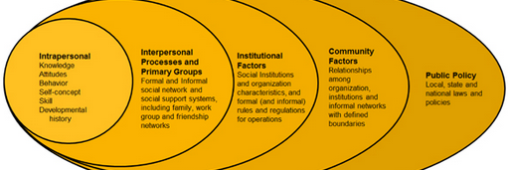
Figure 4: Organisational and ecological Theory of knowledge Management
(Source: Stephens et al. 2020)
Company has been making notable research endeavours to scientifically address challenges and adversities related to ongoing pandemic, both by means of adopting employee-centric solutions along with customer-centric strategies. Senior Vice President of Global Biologics operation, Per Alfreddson, as a part of Covid-19 vaccine programme, has certified that once vaccines are out, employees and frontline workers of pharmaceutical companies shall be treated first. This is primarily because if healthcare providers are not given a healthy environment for sustenance, then they would lose their willingness to work for a cause that company has dedicated itself towards (Xie and Meisenbach, 2020). Covid19 pandemic has left company’s employees on the verge of a crisis that demands a global and united response from scientific community that is harboured by company.
“Therapy area leadership” and delivering growth
Another significant theory that lies at the core of company’s workplace management at present is, delivering growth by means of incorporating innovation and thereby enhancing journey of patients. Such a business objective demands that employees of this organisation work in collaboration (Tripathy, 2020). However, for obvious reasons, workers and employers, currently, remain under fear of contamination and transmission of germs, as novel corona virus has been certified a contagious virus. Significance of business continuity and sustenance through prevailing pandemic has almost made it an ethical responsibility for employers, to reshape workplaces for purposes of providing a safe environment and infrastructure for its employees to work comfortably, free of any risks. The key for employers and leaders of specified company is to design a workplace that could promise to address prevalent anxiety and fear amongst workers, along with doing away with invisible threat of germs (Cerruti and Godoski, 2020). This could primarily be done, by incorporating carefully and strategically, a range of learned behaviours that has evolved through Covid19 pandemic.
“Corporate Social Responsibility” theory
Theory of corporate social responsibility entails that all business organisations have a legal, environmental, economic and ethical responsibility towards community and people it serves. It is something as a specific theory that confirms the business with legal, ethical and economic obligations. It is a concept that attracts many researchers’ attention in the sphere of management. If taking it in a legal way it is the legalised requirements for the business that involves constant commitment towards the general society. With this theory, the goals of the company drive towards increasing the productivity and efficiency of the operations in order to maximise the shareholder’s profits. If taking it in a economical way, it a specific concept that emphasizes over the responsibilities to make money and interact with the community surrounds. In last few months, employers of specified company have given maximum stress upon employee wellness, along with their mental health, as a key to prosperity in business is maintaining a semblance between productivity and happiness. In this regard, management group of AstraZeneca has arranged for workplace assessment, for purposes of identifying areas of physical and structural transformations that can help in fighting with transmission (Astrazeneca.com, 2020). While no definitive solution has been framed yet by global business organisations, a significant fact to be considered at present is that workplaces, currently, need to be specifically centred upon human experiences. By virtue of being a biopharmaceutical, company has a corporate social responsibility towards current environmental downturns arising due to outbreak of pandemic, along with a number other reasons such as global warming, climate changes and rising waste levels. Specified company uses a triple bottom-line theory for purposes of seeking sustainability in environmental, social and economic realms.

Beliefs, value systems and attitudes
Workplace behaviour and management of employees, largely, is dependent upon varied sets of attitudes, value systems and beliefs that are held by different employees. There are certain fundamental differences between employees’ attitudes, their beliefs and principal value systems that they carry.
Beliefs | Value systems | Attitudes
Organisational Beliefs can be defined as convictions and assumptions that employees designate to be true, based on their experiences in an organisation. | Value systems are principally drawn from worthy ideas, concepts and people that together form the backbone of an organisation (Cerruti and Godoski, 2020). | Generic attitudes of employees in an Organisation fundamentally arise out of core beliefs and values that carry within themselves.
Table 1: Differences between Beliefs, value systems and attitudes
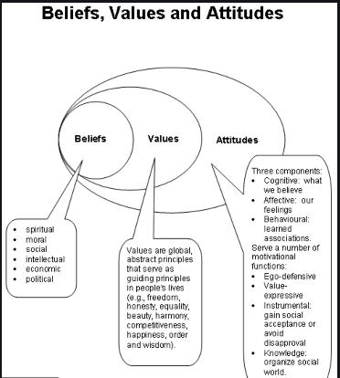
Figure 5: Attitudes, beliefs and value systems
(Source: Cerruti and Godoski, 2020)
Beliefs, value systems and attitudes of AstraZeneca
Beliefs | Value systems | Attitudes
- Contributing value and fuelling growth to society and patients  Fundamentals of Astra Zeneca’s business objectives are:  - Focusing on science and innovation in three principal areas of therapy, namely, Oncology  - Metabolism and Renal, Cardiovascular and Respiratory ailments  - Besides, company has an exhaustive portfolio of primary care and specialty medicines.  - Developing a patient-centric approach along with a considerable involvement in digital aids and technology have also become principal components of company’s business objectives at present (Astrazeneca.com, 2020). | - Science and innovation  Company is focused upon delivering and providing life-changing medicines and treatment. A core component of a specified company’s value system is its commitment towards patients. Dedication towards patient-wellbeing has ever since driven company to formulate patient-focused methods of working. Further, this patient-centric value system enables the company to deliver enhanced healthcare experience (Astrazeneca.com, 2020).  - Growth through innovation  As an environment currently, burdened by diabolic pandemic, company, at present, principally focuses upon innovation and growth. | - Commitment to people  A core component of specified company’s value system is its commitment towards patients. Dedication towards patient-wellbeing has ever since driven company to formulate patient-focused methods of working. Further, this patient-centric value system enables company to deliver enhanced healthcare experience
Table 2: Beliefs, value systems and attitudes of AstraZeneca

Critical evaluation of theories
Within a matter of seven to eight months, the Covid19 pandemic has brought radical changes and transformations to people’s personal as well as their professional workplaces. Face masks and sanitizers, today, have almost become a mandatory requirement for preservation of both personal and professional hygiene. People use AstraZeneca’s innovative medicines across the globe. As mentioned earlier, AstraZeneca is a company, at heart of which lies, science and innovation. Thus, managing its intellectual resources and knowledge resources and turning them into actions, is something that has made company thrive for so many years in pharmaceuticals industry. Specified company has a considerably good repute, for its R&D (Research and Development) intensity and it would not be erroneous to designate company as a knowledge intensive organisation (Astrazeneca.com, 2020). Considering current scenario, AstraZeneca, is counted upon as an important source of information for facts, discoveries and information related to Covid19.
Evaluation of “Therapy area leadership” theory
This is a significant and relevant theory that lies at the core of company’s workplace management. It believes in delivering growth by incorporating innovation and thereby enhancing journey of patients. Such a business objective demands that employees of this Organisation work in collaboration. However, for obvious reasons, workers and employers, currently, remain under fear of contamination and transmission of germs, as novel corona virus has been certified a contagious virus. Significance of business continuity and sustenance through prevailing pandemic has almost made it an ethical responsibility for employers, to reshape workplaces for purposes of providing a safe environment and infrastructure for its employees to work comfortably, free of any risks (Pacheco et al. 2020). The key for employers and leaders of specified company is to design a workplace that could promise to address prevalent anxiety and fear amongst workers, along with doing away with invisible threat of germs. This could primarily be done, by incorporating carefully and strategically, a range of learned behaviours that has evolved through Covid19 pandemic.
AstraZeneca, at present is responding towards outbreak of novel corona virus by clinging on to its earlier business agendas of prioritising patients and customers and following science. During times of such global emergencies, employees of current company cannot afford to stay away from work. This is significant because company has a social and ethical responsibility of continuing serving its patients, with increased effectiveness at present. Company, under all circumstances, has to ensure that patients and customers continue to receive medical supplies.
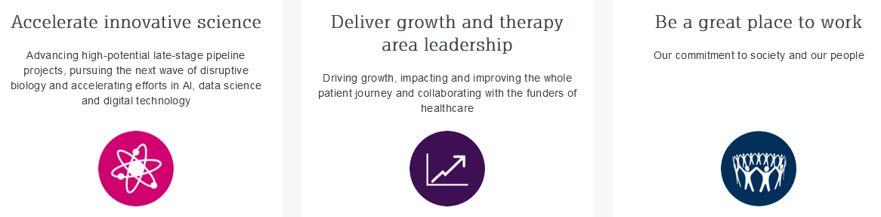

Figure 6: Three pillars of AstraZeneca During Covid19 pandemic
(Source: Mobo, 2020)
In order to preserve wellbeing of around 70,000 employees across the globe that are associated with specified company, employers, leaders and managers have incorporated temporary measures for reducing risks of infection. These measures primarily include:
- Leveraging digital technologies for introducing and supporting work-from-home
- Curtailing and restricting number of business travels.
- Restricting external visitors and off-site meetings to sites of company itself (Kumar et al. 2020)
- Conforming to and aligning with Covid19 guidelines provided by UK government
Evaluation of “Corporate Social Responsibility” theory
Theory of corporate social responsibility entails that all business Organisations have a legal, environmental, economic and ethical responsibility towards community and people it serves. In last few months, employers of specified company have given maximum stress upon employee wellness, along with their mental health, as a key to prosperity in business is maintaining a semblance between productivity and happiness (Caponecchia and Mayland, 2020). By virtue of being a biopharmaceutical, company has a corporate social responsibility towards current environmental downturns arising due to outbreak of pandemic, along with a number other reasons such as global warming, climate changes and rising waste levels. Specified company uses a triple bottom-line theory for purposes of seeking sustainability in environmental, social and economic realms. In this regard, management group of AstraZeneca has arranged for workplace assessment, for purposes of identifying areas of physical and structural transformations that can help in fighting with transmission.
While no definitive solution has been framed yet by global business Organisations, a significant fact to be considered at present is that workplaces, currently, need to be specifically centred upon human experiences. Specified company, at present has formulated strategies of engaging with governments and international health authorities. Further, the company has provided technological and scientific expertise to international authorities such as European Federation of Pharmaceutical Associations and Industries (EFPIA) along with World Health Organisation (WHO) (August and Trostle, 2018). In fact, recent reports claim that company, through their scientific projects and endeavours, have made use of their unique expertise in infectious diseases along with proprietary technologies of antibody discovery, for developing their current research efforts regarding prevailing pandemic. One key research endeavour that has yielded considerable success to company is discovery of corona virus-neutralising antibodies. In fact, scientific experts of concerned company are, at present concentrating on discovering mono colonial antibodies for progressing into next step, that is, clinical trial evolution.
Evaluation of Organisational and ecological Theory of knowledge Management
Specified company has provided around nine million facemasks for supporting its employees and healthcare workers. Besides, company has also entered into partnerships with Oxford University, and in turn, have merged University’s unique expertise in vaccinology with company’s global manufacturing and development capabilities (Xie and Meisenbach, 2020).
AstraZeneca is a company, at heart of which lies, science and innovation. Thus, managing its intellectual resources and knowledge resources and turning them into actions, is something that has made company thrive for so many years in pharmaceuticals industry. Specified company has a considerably good repute, for its R&D (Research and Development) intensity and it would not be erroneous to designate company as a knowledge intensive organisation. Considering current scenario, AstraZeneca, is an important source of information for facts, discoveries and information related to Covid19. “Organisational knowledge-management theory” involves designing Organisational structures, hierarchically and culturally, for purposes of knowledge and knowledge processes. Knowledge management has emerged as a significant theoretical perspective in current business scenario (Cerruti and Godoski, 2020). Company has been making notable research endeavours to scientifically address challenges and adversities related to ongoing pandemic, both by means of adopting employee-centric solutions along with customer-centric strategies. Senior Vice President of Global Biologics operation, Per Alfreddson, as a part of Covid-19 vaccine programme, has certified that once vaccines are out, employees and frontline workers of pharmaceutical companies shall be treated first. This is primarily because if healthcare providers are not given a healthy environment for sustenance, then they would lose their willingness to work for a cause that company has dedicated itself towards. Covid19 pandemic has left company’s employees on the verge of a crisis that demands a global and united response from scientific community that is harboured by company.

Recommendations and justifications
It is an undeniable fact that organisational attitudes, beliefs and value systems have a considerable impact on workplace behaviour of employees. In this regard, recent mandates on physical isolation and social distancing have put a tremendous amount of pressure on employees of specified company and have a number of changes and modifications in their workplace behaviour (Astrazeneca.com, 2020). Strategies that have been mentioned above have helped applying workplace changes in Organisation to some extent. However, in order to build a more resilient future for company and to facilitate effective workplace behaviour, a few other things need to be kept in mind. Some key aspects that may prove efficacious for company include:
- Learning from past
Year 2003, imparted to Singapore, a crucial lesson with outbreak of Severe Acute Respiratory Syndrome (SARS). Companies learnt significant lessons regarding crisis management for sustenance of their employees. Singapore consequently introduced an effective response plan that proved effective with onset of Covid19 pandemic (Stephens et al. 2020). Likewise, companies across globe are currently in need of a standardised crisis management and response plan that could safety of its employees and workers, sanctioned by WHO.
- Enabling transparent communication for employees
Specified Organisation needs to facilitate regular, transparent and clear communication from leaders and managers of the current company to its employees, to ensure trust and reliability within company, drawing times of global crisis. Transparent and clear communication is positively related to the employee’s openness to change. This helps the business an honest and two-way openness in the workplace between the management and the employees. When transparent communication becomes a culture of workplace then it builds communication, trust and advocacy at greater level of employee engagement. The More importantly, employers of companies need to ensure that they inform workers regarding updates on government’s response to ongoing pandemic. In this situation, the leaders of the company can act with transparency through assuring that employees are kept in a loop for the company’s matters it may be big or small. It basically encourages the management for honest communication without making an employee to feel underappreciated for their future employment. This workplace culture creates conscious efforts in the minds of employees that even provides correct level transparency with trust and respect with the management.
In order to preserve wellbeing of around 70,000 employees across the globe that are associated with specified company, employers, leaders and managers have incorporated temporary measures for reducing risks of infection (Astrazeneca.com, 2019). These measures primarily include:
- Restricting external visitors and off-site meetings to sites of company itself (Cletus et al. 2018)
- Conforming to and aligning with Covid19 guidelines provided by UK government
- Leveraging digital technologies for introducing and supporting work-from-home
- Curtailing and restricting number of business travels.
Recent reports about AstraZeneca claim that company, through their scientific projects and endeavours, have made use of their unique expertise in infectious diseases along with proprietary technologies of antibody discovery, for developing their current research efforts regarding prevailing pandemic. One key research endeavour that has yielded considerable success to company is discovery of corona virus-neutralising antibodies. In fact, scientific experts of concerned company are, at present concentrating on discovering mono colonial antibodies for progressing into next step, that is, clinical trial evolution (Ryan, 2020). While no definitive solution has been framed yet by global business Organisations, a significant fact to be considered at present is that workplaces, currently, need to be specifically centred upon human experiences. Specified company, at present has formulated strategies of engaging with governments and international health authorities. Further, the company has provided technological and scientific expertise to international authorities such as World Health Organisation (WHO) and European Federation of Pharmaceutical Associations and Industries (EFPIA).
- Adaptability to changes
Within a matter of seven to eight months, the Covid19 pandemic has brought radical changes and transformations to people’s personal as well as their professional workplaces. Face masks and sanitizers, today, have almost become a mandatory requirement for preservation of both personal and professional hygiene. Most radical change that any Organisation has faced so far, since onset of pandemic, is policy of working from home (WFH). Working remotely from home, has affected employees’ beliefs, morals and value systems (August and Trostle, 2018). However, in spite of initial hurdles arising from WFH policies, several key positive results are now being observed. These include increased productivity, engagement, performance, profitability and retention. More importantly, physical distancing and social isolation are at present, two crucial protocols that people are abiding by, both in their homes and at their offices. With the onset of the pandemic, professional decorum and workplace scenarios in majority of business Organisations across the globe have been undergoing radical metamorphoses.

Conclusion
Widespread impacts that current pandemic has inflicted upon professional workplace behaviour, is not something new. Past pandemics too brought massive changes to professional infrastructures, starting from city designs to bathroom structures. Yet, the kind of urgency that has befallen corporate offices to adapt to rapid changes was never witnessed before. It has become a call of the hour to tailor workplaces according to post-pandemic mindset. AstraZeneca is a science-based, global pharmaceuticals company, headquartered in Cambridge, England. It has a portfolio of a range of products and medicines for major diseases such as cardiovascular and gastrointestinal diseases, cancer, neuroscience, respiratory ailments, infections and inflammations. People use AstraZeneca’s innovative medicines across the globe. The following report aimed to develop effective ideas and strategies for potential thinking in selected UK-based firms, with particular emphasis on impacts of prevailing Covid19 pandemic. In this regard, this report also underlined and discussed principal and relevant theories of management that can be put to use amidst a situation of pandemic and importance of applying chosen theories on specified Organisation. This report further made a critical evaluation of selected theories, in order to reflect upon differences in ways of interpreting the theories amongst employees with different values, attitudes and beliefs. Having done so, report eventually provided practicable and appropriate recommendations along with justifications, for crucial organisational changes that need to be undertaken for AstraZeneca, following post-covid mindset of employees. These recommendations are important for purposes of creating effective grounds for employees to confront current challenges, and in turn, make them more resilient for future.

Reference list
Book
Ryan, J.M. ed., 2020. COVID-19: Volume I: Global Pandemic, Societal Responses, Ideological Solutions. Abingdon: Routledge.
Journals
August, E. and Trostle, J.A., 2018. Using writing assignments to promote critical thinking, learning and professional identity: the epidemiology workplace writing repository. Journal of Public Health, 40(3), pp.e419-e422.
Caponecchia, C. and Mayland, E.C., 2020. Transitioning to job redesign: improving workplace health and safety in the COVID-19 era. Occupational and Environmental Medicine, 77(12), pp.868-868.
Cletus, H.E., Mahmood, N.A., Umar, A. and Ibrahim, A.D., 2018. Prospects and challenges of workplace diversity in modern day Organisations: A critical review. HOLISTICA–Journal of Business and Public Administration, 9(2), pp.35-52.
Kumar, A., Luthra, S., Mangla, S.K. and Kazançoğlu, Y., 2020. COVID-19 impact on sustainable production and operations management. Sustainable Operations and Computers, 1, pp.1-7.
Mobo, F., 2020. The Impact of Human Resources Management Practice amidst COVID-19. International Journal of Multidisciplinary: Applied Business and Education Research, 1(1), pp.1-3.
Pacheco, T., Coulombe, S., Khalil, C., Meunier, S., Doucerain, M., Auger, É. and Cox, E., 2020. Job security and the promotion of workers’ wellbeing in the midst of the COVID-19 pandemic: A study with Canadian workers one to two weeks after the initiation of social distancing measures. International Journal of Wellbeing, 10(3).
Sapkal, R.S., 2020. Saving Jobs and Averting Lay-offs amidst COVID-19 Lockdown. Management Act, 55(19), p.25.
Stephens, K.K., Jahn, J.L., Fox, S., Charoensap-Kelly, P., Mitra, R., Sutton, J., Waters, E.D., Xie, B. and Meisenbach, R.J., 2020. Collective sensemaking around COVID-19: experiences, concerns, and agendas for our rapidly changing Organisational lives. Management Communication Quarterly, 34(3), pp.426-457.
Tripathy, M., 2020. Dimensions of critical thinking in workplace management & personal development: a conceptual analysis. Multidisciplinary Journal for Education, Social and Technological Sciences, 7(2), pp.1-19.
Online article
Cerruti, K and Godoski, L 2020 "Five Post-COVID Behaviors(sic) and Attitudes that will Reshape the Workplace" in Work design Magazine [Online] Available: https://www.workdesign.com/2020/06/five-post-covid-behaviors-and-attitudes-that-will-reshape-the-workplace/ - accessed 9 October 2020
Website
Astrazeneca.com, 2020. AstraZeneca. Viewed on: 10/12/2020 <https://www.astrazeneca.com/>
Astrazeneca.com, 2019. Be a great place to work. Viewed on: 10/12/2020 <https://www.astrazeneca.com/our-company/our-strategy/be-a-great-place-to-work.html>

