

DISSERTATION PROPOSAL

Digital Transformation in UK SMEs: Examining the Adoption of AI, Automation, and Other Digital Technologies.

Student: Petar Konov
Student Number: 1919086

Supervisor: Dr Gladius David Kulothungan

Table of Contents

Introduction. 1
Research aim. 1
Research Objectives. 2
Research Questions. 2
Literature Review. 3
Research principles and approach. 4
Ethical Considerations. 7
Conclusion 8

Introduction.
In recent times, there has been a significant focus on the digital transformation of small and medium-sized firms (SMEs) in the United Kingdom. Small and medium-sized enterprises (SMEs) are a substantial sector of the British economy, contributing significantly to both GDP and employment (Cong et al., 2024). To stay competitive and responsive to shifting market needs, these organisations must embrace new technology and adapt to an increasingly digital world.
Rapid technological breakthroughs have caused significant change in the commercial landscape in recent years. Automation, artificial intelligence (AI), and other digital technologies have completely changed how businesses function, compete, and deliver value to their customers (Verhoef et al., 2021). Despite their potential to improve development, efficiency, and competitiveness, small and medium-sized firms (SMEs) in the UK have been slower to adopt digital technology than large businesses, which have led the way in this transformation. The corporate environment went through significant change as a result of technological innovations. For example, automation and artificial intelligence have helped businesses increase productivity, cut expenses, and streamline processes.AI-driven analytics enable firms to make data-driven decisions by offering insightful information about consumer behaviour, industry trends, and operational efficiency (Deloitte, 2024). On the other hand, boring and repetitive jobs have been replaced by automation, freeing up human resources for more strategic and creative initiatives. These technologies have been used by big businesses to obtain a competitive advantage. To enhance product offerings, customise consumer experiences, and optimise supply chains, they have made significant investments in artificial intelligence and automation. This has increased their capacity to react quickly to changes in the market and client demands, in addition to increasing their operational efficiency (Uzialko, 2024).

Research aim.
The objective of this study is to evaluate the current state of digital transformation in UK SMEs, with a focus on automation, artificial intelligence, and other digital technologies. By analysing the effects, implications, and drivers of digital transformation, the study seeks to identify the best strategies and methods of implementation for SMEs. Despite the recognized benefits of digital transformation, many UK SMEs struggle to implement and leverage these technologies effectively. This research seeks to understand the factors influencing the adoption of digital technologies in SMEs and the impact of this adoption on their performance and competitiveness.

Research Objectives.
- To evaluate how much digital technology is now being adopted by UK SMEs.
- To determine the main forces behind and obstacles preventing digital transformation in UK SMEs.
- To examine the impact of AI, automation, and other digital technologies on SME performance and competitiveness.
- To investigate the difficulties UK SMEs experience when implementing digital transformation plans into practice.

Research Questions.
- To what extent do SMEs in the UK use digital technology?
- What are the primary drivers and barriers to digital transformation, SMEs in the United Kingdom are facing?
- What effects do automation, artificial intelligence, and other digital technologies have on the competitiveness and performance of SMEs?
- What obstacles must SMEs in the UK overcome in order to carry out digital transformation initiatives?
- What methods and practices can SMEs in the UK use to guarantee successful digital transformation?
This research is significant as it addresses a critical gap in the understanding of digital transformation in UK SMEs. By examining the adoption of AI, automation, and other digital technologies, this study will provide valuable insights for policymakers, business leaders, and researchers. The findings will contribute to the development of targeted strategies and policies to support SMEs in their digital transformation journey, ultimately enhancing their competitiveness and contributing to the UK's economic growth.

Literature Review.

1.The idea of digital transformation and its importance.

According to Kraus, (2022), "digital transformation" is the process of incorporating digital technology into every facet of an organisation, drastically changing how it functions, and adding value for clients. It contains implementing many technologies, including automation, cloud computing, data analytics, and artificial intelligence (AI), to enhance overall performance, customer experiences, and business procedures. Numerous studies have emphasised the significance of digital transformation for small and medium-sized enterprises. A study conducted by the European Commission in 2022 found that SMEs with more technological maturity have a higher likelihood of innovating, prospering, and creating jobs than their less technologically advanced competitors. Artificial Intelligence and automation technologies have the potential to significantly impact SMEs by enhancing productivity, reducing costs, and enabling new business models. A study by Deloitte (2023) reported that 250 customer care representatives were replaced by AI, which wrote emails that produced 80% customer satisfaction as opposed to 65% for competent, trained individuals. However, According to the UK Government's AI Readiness Index (2023), only 18% of UK SMEs and 35% of major businesses have used AI technologies. This may be due to the fact that only 27% of corporate executives believe their company has the rules and procedures necessary to fully utilise AI, despite the fact that 94% of them believe AI is essential to their success. The public sector, which contributes around 50% of the GDP of the EU (and hence an important percentage of the GDP of the UK), has a history of adopting new technology slowly. This might be the result of things like high unionisation rates, competing policy objectives, and a lack of competitive pressure. For example, train drivers on the London Underground are paid nearly twice the national median income, despite the fact that technology to replace them entirely or in part has been around for decades (Johannson, 2023).

2. Drivers and Barriers to Digital Transformation.

According to Li et al., (2021), the need for operational efficiency, consumer expectations, and competitive pressure are some of the elements driving digital transformation in SMEs. A survey by TechUK (2023) identified, improved customer experience (50%), increased productivity (54%) and growing revenue (47%) as the top motivators for digital transformation among UK SMEs. As stated in Brink & Packmohr (2023), nearly a third (28%) of small enterprises want assistance with implementation, non-financial incentives should also be available. More than a quarter (26%) believe they need more people with the right skills, and a similar percentage (24%) believe they need better support and information. Additionally, barriers to digital transformation include a lack of funding, a lack of technological know-how, and a resistance to change. In 2023, The Federation of Small Businesses (FSB) found that 45% of UK SMEs cited lack of funding as the primary barrier to digital adoption, followed by skills shortage (38%) and cybersecurity concerns (32%).

3. Digital Transformation's effect on SME Performance.

Research has shown that successful digital transformation can lead to improved SME performance across various metrics. A study by McKinsey & Company (2024) found that in every area examined, businesses with cutting-edge digital and AI skills outperformed slow adopters by a factor of two to six in terms of total shareholder returns (TSR). Moreover, digital transformation can enhance SMEs' resilience to economic shocks. The COVID-19 pandemic highlighted the importance of digital capabilities, with digitally advanced SMEs adapting more quickly to changing market conditions (Skare et al., 2023).
SMEs encounter many difficulties when putting digital transformation plans into practice. These include cultural aversion to change, limited access to technology and experience, and challenges in calculating return on investment (Saeed et al., 2023). According to research by the UK Department for Business and Trade (2023), the three biggest obstacles facing UK SMEs undergoing digital transformation are legacy system integration, cybersecurity threats, and data protection issues.

Research principles and approach.

Research philosophy.

According to Collis (2014), the framework for conducting research based on presumptions about reality and the nature of knowledge is known as research philosophy. The interpretivist research philosophy, which emerged in reaction to positivism's alleged shortcomings in meeting the criteria of social scientists, serves as the foundation for this study. This method is especially useful for analysing the complicated and elusive process of digital transformation in UK small and medium-sized enterprises. Using data from relatively small sample sizes, interpretivism focuses on analysing human behaviour by encouraging empathy with the worldviews of study participants. This is in line with the requirement to comprehend SME leaders' decision-making procedures and experiences as they manage the deployment of automation, artificial intelligence, and other digital technologies.

Research approach.

A mixed-methods approach will be used in this study to combine quantitative and qualitative research techniques in order to provide a deeper understanding of the digital transformation of UK SMEs. There will be two stages to the research:
- Quantitative survey – a comprehensive online survey will be carried out regarding the use of digital technology by UK SMEs, with a focus on drivers, obstacles, and effects.
- Qualitative case studies - to acquire further insight into the difficulties, tactics, and results of digital transformation projects, in-depth case studies of particular SMEs will be carried out.
According to Saunders (2012), theory development frequently results from this kind of study. In order to achieve complexity in knowledge, this strategy prioritises empirical study and places an emphasis on depth and individual facts above volume and scope. The study's objective is to create a thorough theory on the best methods for successful design adaption in businesses by examining the social phenomena of design-driven strategy in organisations. Interpretivism, as seen in Figure 1, has been chosen as the research approach since it is thought to be the most successful method for accomplishing the goals of the study. Mixed methods of investigation and inductive analytical techniques will be used to support this strategy.

Research Design.

As stated in Collis (2014), careful participant selection is possible with interpretivist research. Therefore, the primary technique employed in this study to identify and select research participants with first-hand professional experience using design as a business strategy instrument (Blaxter, 2010). Snowball sampling may be employed in some circumstances if study participants identify other, more qualified potential research volunteers inside their company and indicate they individually lack the relevant experience.

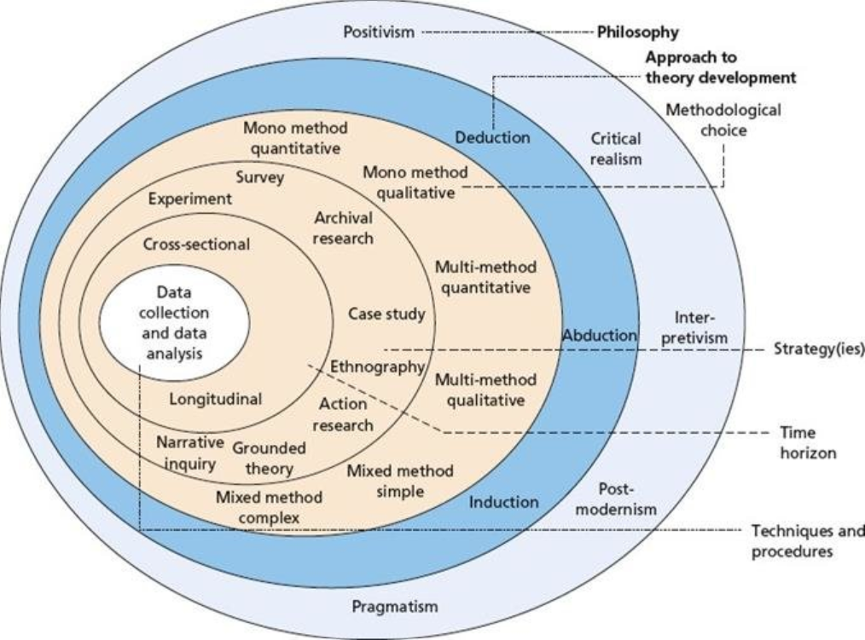
Figure 1. Research onion for futures studies Source: author following Saunders et al. (2016)

Data analysis method.

Developing a hypothesis based on the study findings will be the main objective of the inductive analysis of the qualitative data obtained from the interviews. In order to generate concepts directly from raw data, this study will use thematic analysis, an inductive analytical method. According to Boyatzis (1998), creating concepts from the raw data is the process of inductive analysis, or thematic analysis. The adaptability of qualitative research methods, semi-structured interviewing, and thematic analysis enables researchers to customise the method of data analysis to their own goals when it comes to capturing the complexity of meaning inside a data collection, thematic analysis is ideal (Guest, 2012). In order to find patterns in the data, the study will compare different points of view, descriptions, and reflections of the research participants using thematic analysis.
 | June 2024 | July 2024 | August 2024 | September 2024 | October 2024
Preparation of
research
proposal
Research
Proposal
Preparation
and release of
the survey
Literature
review
analysis
Data
collection and
analysis
Preparation of
the
dissertation
paper
Meeting with
supervisor for
final
correction
Submission
of
dissertation

Ethical Considerations.

The researcher will take into account in order to safeguard participants and maintain the integrity of the research. Before participation, the researcher will obtain informed consent, ensuring voluntary involvement, and protecting anonymity and privacy of the participants. Data security protocols will be employed to reduce the participants exposure. Participants may discontinue participation at any moment. In order to accommodate a variety of demographics and prevent prejudice, the surveys will be designed with fairness and inclusivity in mind. Appropriate procedures, such as identifying limitations, will be followed when revealing results. By abiding by these moral guidelines, the study protects the rights and well-being of the participants while generating insightful results. This methodology is expected to promote a sense of confidence in the research efforts and guarantee that the pursuit for knowledge does not violate personal integrity or cultural standards.

Conclusion

The main conclusions of the study will be outlined in the conclusion, along with their implications for UK SMEs, legislators, and the larger business community. It will restate how crucial the digital transformation is to the growth and competitiveness of SMEs and emphasise the need for focused assistance and approaches to get beyond adoption obstacles. In addition to discussing the research's shortcomings, the conclusion will offer ideas for future research topics, like follow-up studies to monitor the long-term effects of digital transformation on the performance of SMEs in UK.

References

Blaxter, L., Hughes, C. and Tight, M. (2010). How to research. 4th ed. Maidenhead:
Boyatzis, R.E., (1998), Transforming qualitative information: Thematic analysis and code development. sage.
Brink, H., Packmohr, S. (2023). Barriers to Digital Transformation in SMEs: A Quantitative Study.
Collis, J. and Hussey, R., (2014). Writing up the Research. In Business Research (pp. 297-330). Palgrave, London.
Cong, L.W., Yang, X. and Zhang, X., (2024). Small and medium enterprises amidst the pandemic and reopening: Digital edge and transformation. Management Science.
Deloitte (2024). AI-Powered Employee Experience: How Organisations Can Unlock Higher Engagement and Productivity,
European Commission, (2022). Digital Economy and Society Index (DESI) 2022.
Federation of Small Businesses. (2023). Unleash investment in tech adoption and innovation for small firms to kick-start economic growth, Government told,
Johannson, E. (2023), Why don’t we have driverless trains on the Tube yet?
Kraus,S., Durst,S.,Ferreira,J., Veiga,P., Kailer,N., Weinmann,A.,(2022), Digital transformation in business and management research: An overview of the current status quo.
Li, L., Su, F., Zhang, W., & Mao, J. Y. (2021). Digital transformation by SME entrepreneurs: A capability perspective. Information Systems Journal, 31(2), 287-317.
McKinsey & Company (2024). Rewired and running ahead: Digital and AI leaders are leaving the rest behind.
Saeed, S., Altamimi, S.A., Alkayyal, N.A., Alshehri, E., Alabbad, D.A. (2023) Digital Transformation and Cybersecurity Challenges for Businesses Resilience: Issues and Recommendations.
Saunders, M.N. and Townsend, K., 2016. Reporting and justifying the number of interview participants in organization and workplace research. British Journal of Management.
Skare, M., de Obesso, M.D.L.M. and Ribeiro-Navarrete, S., (2023). Digital transformation and European small and medium enterprises (SMEs): A comparative study using digital economy and society index data.
UK Department for Business and Trade. (2023). Digital Readiness of UK SMEs: 2023 Report.
Uzialko, A., (2024), How Artificial Intelligence Will Transform Businesses.
Verhoef, P., Broekhuizen, T., Bart,Y., Bhattacharya, A., Dong, J., Fabian,N., Haenlein, M.(2021), Digital transformation: A multidisciplinary reflection and research agenda.

