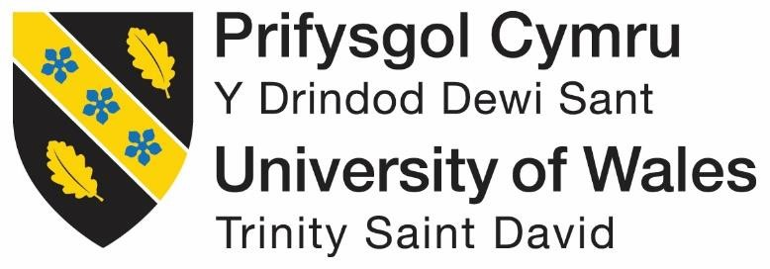

Individual Essay (Assessment 1)

Corina Bardan
Student’s Number 1813607
Module Lecture’s Name
Kenny Tang
Structure and Culture of


Table of Contents
Introduction: 2
Structure: 2
Nature of structure: 2
Application of structure in Syngenta: 2
Product: 4
Geographic location: 4
Culture: 4
Cultural dimensions: 5
Functions or Operations to operate people: 6
HR of Syngenta: 6
Roles of a leader: 6
People management: 7
Organizational performance: 8
Conclusion: 9
References: 10

Introduction:
An organization consists of several factors which have a great impact on its performances. Organizational structure, people and culture are some core organizational factor playing a great influence in shaping the organizational performances. So, there must be a close relationship between these organizational elements.
Besides, the nature of the managerial role and the role of leadership have direct impact one the individual’s behavior within the organization. Such influences can direct employees either positively or negatively.
All of these things and their impact in an organization will be discussed focusing on a renowned plant science business named Syngenta.

Structure:
Organizational culture and structure are connected to the performances of an organization. It is said that if managers and all the employees within an organization share a common belief, morals, and principles, such cooperation and coherence will bring positive consequences for the organization. Organizational structure is another factor that influences organizational performances (Puranam and Maciejovsky, 2017). Organizational structure can be categorized in different forms.
Organization structure refers to the environment in which an organization is doing its businesses and also refers to the types of activities it carries out. Two types of structures are formal and informal.
A business needs to identify the best suites structure for them to operate their business smoothly. Besides, based on the flow of the organizational order authority, the structure can be hierarchical or flat.

Nature of structure:
In a hierarchical structure, management follows a chain of order where instructions move from upward to downward. Management follows a chain and a span of command. So, they keep representative to carry out the responsibility effectively. This structure ensures an easy flow of information and communication. So, problems can be solved easily.

Application of structure in Syngenta:
Syngenta is an innovative organization. It aims at employing as many staffs as possible to meet the growing demands of the people around the world. The company is serving in both national and international projects. So, the company does not follow the hierarchical form of structure.
Rather it operates following matrix structure (Syngenta.com, 2019). Under matrix structure, employees from the different departments work in a team together for a specific project. Matrix structure takes out workers from the usual function and introduces them with different expertise. It ensures that a project can have the coordination of all the skills to accomplish its target. So, a team is formed with all the specialists.
The team can be formed to perform a particular task for a short period and is disbanded when the tasks are done.

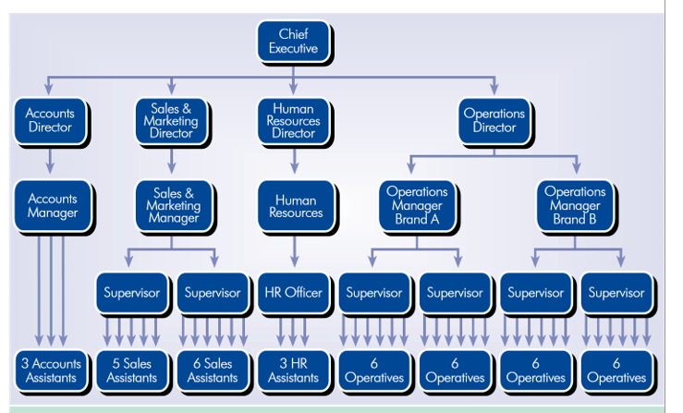
Figure: Organizational Structure of Syngenta

Syngenta has many departments they are: research and development, global supply, sales, and global support system. All of these functional departments is independent because the company follows the matrix management style which ensures that all areas of the company can play a significant role in completing any projects at any time.
Syngenta makes the best usage of the skills and competencies it has to connect the functional department. People is another element which requires to be taken care of to ensure good organizational performance. Syngenta needs employees with specific knowledge in science and with expertise so that they can lead the team in every functional area and ensure better interpersonal communication.

Product:
The company is basically promoting innovative researches in ensuring sustainable development in the agricultural sector. Syngenta was formed in 2000 and its product line is vested crop protection, professional products, seed and garden plants.
The company has a well-organized research team who are researching to develop products to meet the demand for agricultural products worldwide at a fair and competitive price. Its customers range from farmers to the government and it has employed more than 24000 employees over 90 countries (Syngenta.com, 2019).

Geographic location:
The company has a widespread office in the world doing the research to enrich the agricultural activities.
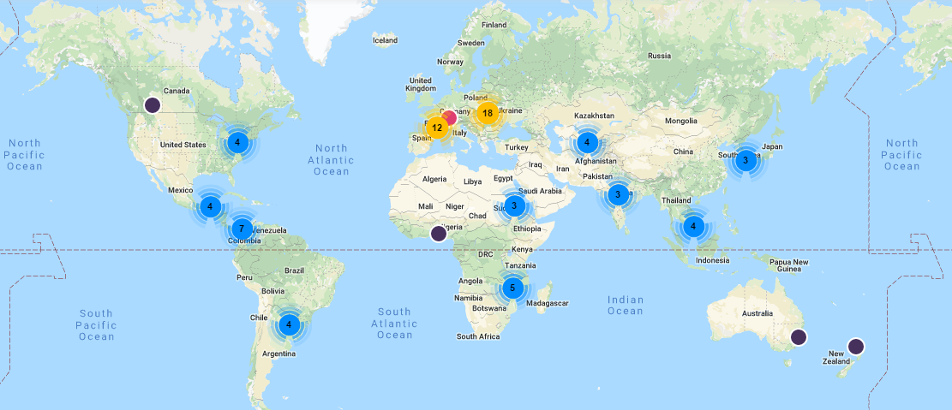

Culture:
At Syngenta, many female employees play a significant role in different areas of the organization. Here the cultural dimensions of Hofstede play an important role. Melanie Wardle works in the marketing department.
Her works include the communication planning the products especially crops and seeds (Syngenta.com, 2019), advertising and campaigning the products to meet the marketing objective of the organization. Kathryn Brocklehurst is another devoted employee of the organization (Syngenta.com, 2019). So, many employees are working for Syngenta to ensure that quality products are produced and supplied to the people. Such cooperation is essential for a company to increase the performances of the organization.

Cultural dimensions:
The culture of Syngenta is analysed based on the Hofstede’s’ cultural dimensions below:
Low | Hofstede’s cultural dimensions | High
 | Power Distance | √
√ | Collectivism vs Individualism
√ | Masculinity Versus Femininity.
 | Uncertainty Avoidance Index | √
 | Long- Versus Short-Term Orientation | √
√ | Indulgence Versus Restraint.

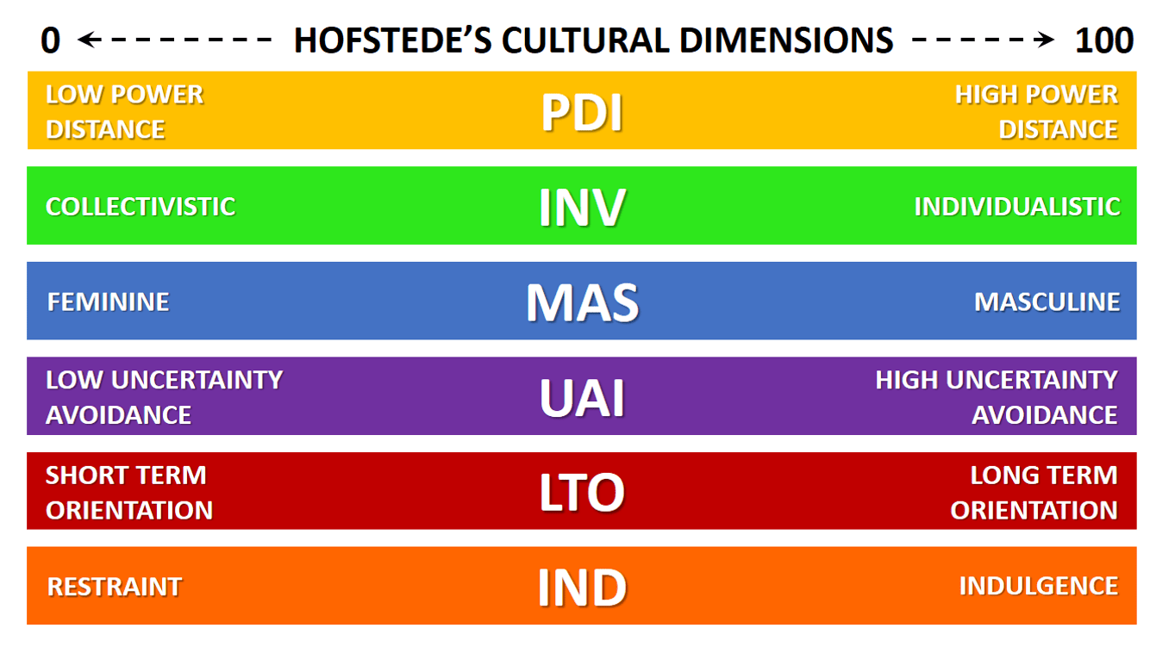

As a result, the company is optimistically short term oriented, high power distant with collective feminine dominance (Chan, and Clegg, 2015).

Functions or Operations to operate people:
The nature of the managerial works is meant to both functional and process level tasks. A manager must be effective and efficient and run the managerial process. Management has different functions to do such.
These functions are planning, organizing, staffing, coordinating and control (Anderson and Pulich, 2014). Planning is a basic managerial function which is a course of action to be followed o accomplish the goal. Planning directs the people to a specific goal and so people work accordingly and make coherence of their work. Organizing is to arrange, guide, direct and coordinate the man, material, machine, money, and market to achieve the goal of the organization.
Staffing is related to human resources and it means empowering and employing the right people or the right job to ensure the quality of the work. Directing refers to give proper guidance to all employees so that they can understand what they need to do. Here, managers evaluate the performances. In the process levels, the nature of managerial work can be featured as a social, continuous, universal, iterative and composite process.
The entire managerial functions are run by people. So, it is called a social process. Besides, the managerial process is an ongoing process. It is a universal process because the manager has to perform irrespective of the size and nature of the organization.

HR of Syngenta:
Syngenta is an advanced company. The HR team of the company provides training and development opportunities for the employees. Thus, employees can achieve technological and technical training from such opportunities provided by the company and can become a specialist in various aspects. The company has been fantastic in supporting the personal development of the employees. Thus, it can take itself to one of the leading companies in the world.

Roles of a leader:
All the managers’ functions are integrated and also dependable as the next function cannot start the work unless the previous one is finished. Syngenta wants its employees to be passionate to achieve its goal and so it tries to develop the skills and creativities of the employees and make them home and give their best for the company. The role of a leader also can execute the employees on the right path (Kaye, 2012). Defining the role of a leader is not easy.
Good leadership is a virtue a leader needs to adopt it by practicing. For an organization, the most important factor is how skilled the leader is and how tactfully he tackles all the problems. For a company like Syngenta, a leader must recognize the new skills and ensure that the highest standards are maintained and so he has to take care of the essential areas to improve the standards of the products.

People management:
There are some variables that measure the effective leadership and management. Managers can adopt some characteristics that bring benefit to the organizations and also for the employees (Chan and Clegg, 2015). For all the leaders and managers, it is mandatory to be employee-friendly. They must communicate their ideas and visions with the members of the team and also must have the tendency to listen to the opinions of others.
Such cooperation can make a good working environment for the employees. Participative leadership style can bring a positive result for the company’s performances. Managers and leaders should take care of the employees and also enable their subordinates committed to the company. This is possible when a leader can go closer to their employees.
A sense of accountability needs to be introduced from the side of both leaders and employees (Pettersen and Tobiassen, 2012). Thus, one can remain loyal to the organization. As Syngenta is an innovative and customer-oriented organization, its leaders and managers must focus on customer satisfaction and also on organizational learning and innovations.
The leaders of Syngenta have been very careful in the personal development aspects of the employees. They ensure that every team should maintain good communication with the other teams by developing interpersonal communication among the team members. They are careful of the organizational growth and so they are focused on continuous self-development. Thus, proper management and leadership can ensure organizational growth and positive environment for the employees to work.

Organizational performance:
Managers can influence the behaviors of the individual through their attitude and behavioral approaches. There are some behavioral approaches that managers used to follow. The individual behavioral approach is directly linked with the group behaviors. The group influence in the changes within the manager’s behavior.
Every member of the group follows a specific work standard. Informal leadership style gives the freedom to the leader to encourage and influence the group standard. Such behavioral approach will be more effective when leaders promote democratic style within the organization (GBADAMOSI, 2013). Participative leadership styles ensure the participation of all the members of the group to the work.
All the members are given the right to express their opinion and ideas regarding any issues and leaders listen to all of them attentively make them feel comfortable working within the organization. Subordinates are encouraged to even establish the goal sometimes. Behavioral scientists have defined that most of the people are motivated by self-development and self-control
. So, the managers should give necessary emphasize in proper utilizing of the skills and potentials of the members of the group. A group consists of various types of member. It is the duty of the leader to coordinate the group members and make them ambitious to their work.

Conclusion:
In the modern competitive world of business, no company can ignore the importance of positive cultures, structures, people and organizational functions in improving the performances of the company. So, every company is taking insight care of these elements.
Syngenta, a leading plan science organization, is also taking care of these element by making the best utilization of these factors in ensuring the best products in the market (Cliffsnotes.com, 2019). Managers and leaders play an essential role in connecting the different teams and members and in directing them to a defined target. Participative leadership style can motivate employees so that they can work spontaneously for the company’s betterment.
Syngenta patronizes innovation and creativity among the employees and provides them training opportunities to develop their knowledge and skill levels. Thus, the company is creating an example that other company can follow.

References:
Anderson, P. and Pulich, M. (2014). Making Performance Appraisals Work More Effectively. The Health Care Manager, 16(4), pp.20-27.
Chan, A. and Clegg, S. (2015). History, Culture and Organization Studies. Culture and Organization, 8(4), pp.259-273.
Chan, A. and Clegg, S. (2015). History, Culture and Organization Studies. Culture and Organization, 8(4), pp.259-273.
Cliffsnotes.com. (2019). Behavioral Management Theory. [online] Available at: https://www.cliffsnotes.com/study-guides/principles-of-management/the-evolution-of-management-thought/behavioral-management-theory [Accessed 22 Jul. 2019].
GBADAMOSI, G. (2013). A Behavioural Approach to Effective Management. IFE PsychologIA, 10(1).
Kaye, B. (2012). The leader's role in growing new leaders. Leader to Leader, 2004(32), pp.16-19.
Pettersen, I. and Tobiassen, A. (2012). Syngenta Inc. Journal of International Entrepreneurship, 10(2), pp.117-141.
Puranam, P. and Maciejovsky, B. (2017). Organizational Structure and Organizational Learning. SSRN Electronic Journal.
Syngenta.com. (2019). Syngenta. [online] Available at: https://www.syngenta.com/ [Accessed 22 Jul. 2019].

