

Report Title
  - REPORT SUBTITLE
Name | Course Title | Date
Jasminara Ahmed
Project Management
BMSK5004

Introduction
The main aim of this report is to analyse the use of project management tools that has been used within the work placement and how it has helped to complete the project management. It will show a clear view to how the tools have been used to guide, and by following the structure of the project and task was made clear to accomplish. This will in return give overall view to how to manage and improve a project with ease using the right managements tools and structures.
This report is based on project management, and how management project has different levels of planning that needs to be implemented in the work that needs doing.
In this project the team will be on work placement for community for work the organization has been established in 2016 and helps individuals to find work and one to one support as well as other support systems available within the organization like advice on debt, the organisation consists of various projects to help the public example IT services, English classes, CV and Covering letters and one to one support to build confidence. All service are free, if any reason the Centre is unable to help then they direct the individuals to other organisations which can help like Advice Bureau. The organization has two parts to their project, one being community for work funded by the Welsh Goverment and the other community for work plus funded by the EU.
Community of work run four Centres in Swansea, the Placement chosen for the team members was Differty Centre.

To complete the project team members had to create a team of four and had to find out the strength and weaknesses of all the chosen candidates by doing a Belbin test each, to find out the type of role they are so they could be allocated the right task that would suit them best.
Belbin Team Roles
When a team is performing at its best, each person has a clear responsibilities, equally as important each role need to achieveve the teams goal and needs performed fully and well. Belbi’s team roles are based on obseved behaviour and interpersonal style and how people adapt to a particular team role. (mindtool.com, 2019).

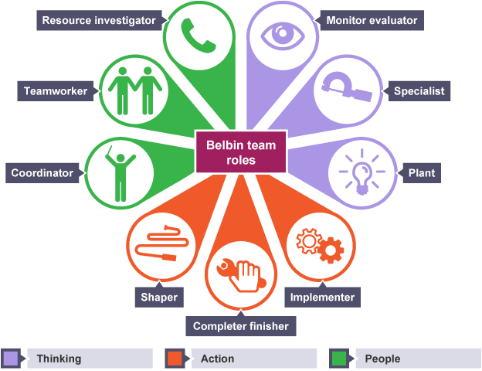

Each team member has to take on board their role and task and complete it within the deadline set for the project to bring success to a project. For this project following members were involved and their team roles are: Project manager: Hena, IT/Implementer: Sima, Coordinator: Jasminara, Team leader: Jahanara.
Belbin (2019) Belbin Team Roles [online] available at: https://www.belbin.com/about/belbin-team-roles/ [accessed: 03.07.19]
According to Association for project management UK’s largest professional body for project management, 2004 “Projects are unique” transient endeavours undertaken to achieve a desired outcome. Project management is a method that is used to apply specific processes and principles to initiate, plan, execute and manage the way the initiatives or changes are implemented within an organisation. The key components are time, cost, scope and quality. (Businessballs.com, 2019).
All projects have a mission and is temporary in that it has a defined beginning and end in time, and therefore defined scope and resources. Organisations have projects to create something unique and specific mission to create value directly or indirectly to the business with a time scale attached. Each project is unique and will be managed differently, and all projects have specific budgets, deadlines and definable goals and often are done only once if done properly. Projects are managed by a group of people getting together and working towards to accomplish the goal. Sometimes projects can fail due to lack of understanding of the project itself or the management tools used, it can also fail due to lack of communication problems within the team members. (Maund, 2018).
For the team members the most important to their project was time and product. As the team had cancelations of events and meetings due to staff absence and weather conditions, which was making them behind schedule due dates, so the team had to invest extra time to maintain and make sure they are up to date with all the work that needs doing so it doesn’t affect the quality of the product of work achieved.

Findings

Project scope
Project scope is the part of any project planning that involves shaping and verifying a list of certain project goals, deliverables, tasks, cost and deadlines (Rouse, 2019). The term scope has two key elements project scope and product scope. Project scope involves information required to start a project, and the features the product would meet its stakeholders requirements. (Projectmanager.com, 2019).

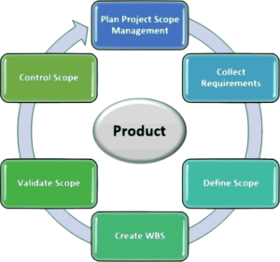

Quad Chart
Quad chart is a standard marketing tool, it is easy and also has a quick technique to promote organisational products, capabilities and services. Quad chart is divided into four sections as stated below:
Aims/objectives
Stakeholders
Critical success factors
Key Performance indicators. (business.gov.au. 2018).
Business.gov.au (2018). Quad charts [online] available at: https://www.business.gov.au/centre-for-Defence-industry-Capability/International-support-and-exports/Quads-charts[accssed [on 03.07.19].

This is the Quard chart of the project the team members are worked on.
What the aims are, the customers, goals and the success they are heading for.
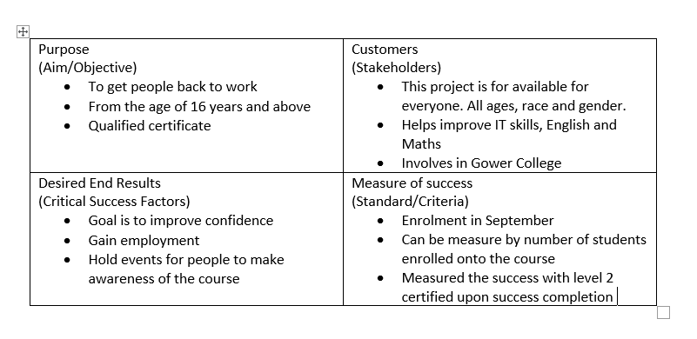

Project cycle
Project management cycle also knowm as PCM is a approach that addresses the complexeities of a project through all of its phases while maintaining alighnment with the stretegy and objrctives agreed of stakeholders. It also is used in organisations that needs a structured way to manage projects. (brighthubpm.com, 2019).
The cycle is broken into five key elements:
- Programming
- Identification
- Formulation
- Implementation
- Evaluation & Audit

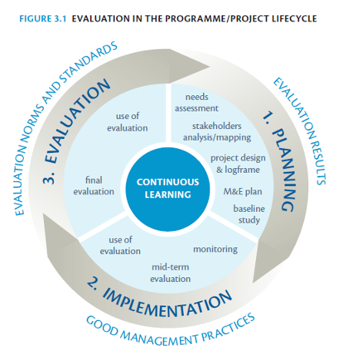

Work placement experience of team members
The team members used project cycle to promote the information to the community for community for work via the leaflets for updating skills and knowledge in order to boast confidence to go back to work in their own comfort.
In the planning stage there are three key steps conception, definition, initiation, in the con caption stage the team had meetings where they had to brainstorm ideas and funnel out the best way to promote the information. Defination stage was to meet up and help team members understand to complete the event and how the team will create the leaflets in such a manner so it will attract attention and public will be interested in it. The team also needed to go through a risk assessment form and find out the main risk that they will be facing on the event and how to overcome the risk. The understanding of the information that the team was promoting was very crusial as they were going to work face to face with the public and if there are any questions asked needed to answer them appropretly.
In the initiation stage the team decided on a date and location of event which was on 11th June 2019. Location was Swansea town Centre. The location was hired for 2 hour and paid £40 to Swansea Council it was Payed by the Manager of communities for work, placement of team members.
The implementation stage was for the team members when they carried out activities and tasks, the team had fallen behind schedule due to lack of staff absence and Ramadan and Eid celebrations, but has picked up swiftly by investing more time and affect towards completing the tasks.
The final stage is the evaluation stage, on the main event due to bad weather, rain and wind there wasn’t a lot of public around so we had to finish early.

Risk Management
Projects, by nature are risky, Risk management is a process that allows individual risks events and overall risk to be understood by whoever is managing the project and optimizing success by minimising treats and maximizing opportunities.
(apm.org.uk, 2019)
This is the risk management of the team member project:

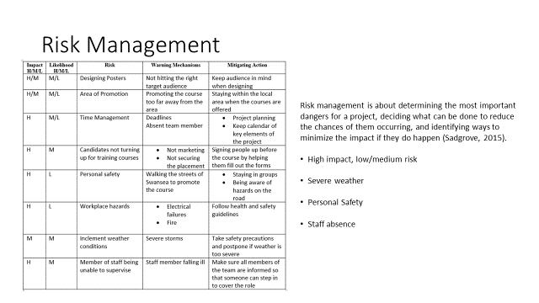

Iron triangle
In the 1980s Dr. Martin Barnes created the Triangle of objectives, this demonstrates that quality cost and time are interrelated, focusing or fixing one point of the tringle impacts the other two points (Lock, 2007, p21). For example if quality is fixed time or cost may need to increase.

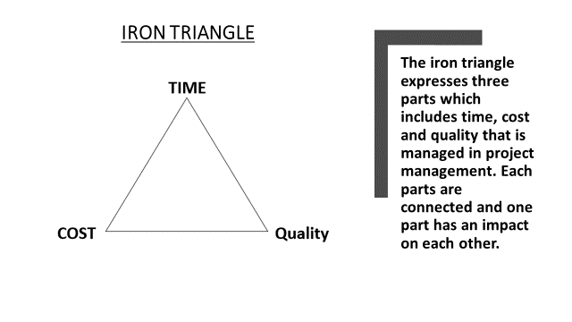

Work breakdown structure (WBS)
WBS is a term used in project management and is a method used to break a project down into hierarchy of deliveries, task and subtasks. WBS is a helpful tool to accomplish a project and defines cost, time, provider, and also used as a guidance for schedule development and control as well as providing an understanding of the work breakdown structure before you create any project or the work you are doing. (Baker & Campbell, 2003).
WBS often takes form of a tree diagram or an outline, and is broken into following levels below.
The total project
Subprojects
Milestones
Major activities
Work packages
The team project used Work breakdown Structure to guide them and provide them the understanding to what they are are doing. On couple of occasion the had to change targets due to weather condition and personal circumstances of team members to overcome this they had to invest extra time and work to achieve their targets and goals that they had set. And by participating with other organisation like Working wales who are doing the same kind of work, they are working on at the placement gave the team a boast and confidence and also an understanding of how the work is done and how its beneficial to the community.

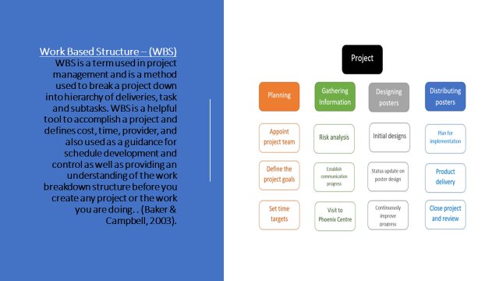
Stakeholder analysis
Stakeholder analysis is a process of assessing a system and has potential changes as they relate to relevant and interesting parties and this information is used to assess how the interests of those stakeholders that should be addressed in project plan, policy program or other action. Stakeholder analysis is a key part of stakeholder management. Stakeholder is first step in stakeholder Management and is key process to bring success and have successful people to give support and get support from others. Managing stakeholder provides and ensures that the project is on the right track and that it will bring success where other projects might fail. (mindtools.com, 2019).
A stakeholder-based approach gives you four key benefits:
- Getting your projects in shape.
- Winning resources.
- Building understanding.
- Getting ahead of the game.

By doing the stakeholders analysis the team understood who and how each person is involved and the roles they have within the organisation of the placement as stated below.
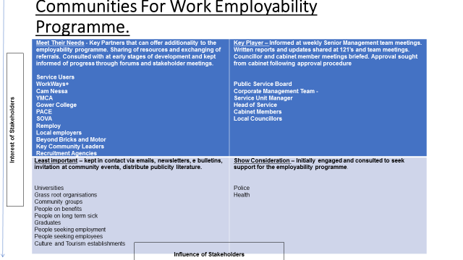
Gantt Chart
A gantt chart is like a bar chart that illustrates a project schedule named after its inventor, Henry Grantt, who designed the chart around 1910-1915. Modern Gantt Charts also show the start and end dates of a project in one simple view point of the activities and current schedules status. (https://www.projectmanager.com/gantt-chart, 03.07.19).

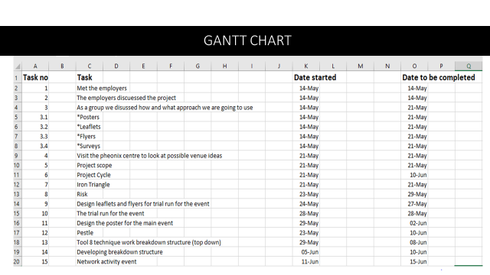

SWOT Analysis
SWOT analysis is a useful tool for understanding and decision making for all sorts of situations in business and organisations. SWOT is also a strategic planning technique used to help a person organise and identify strengths and weaknesses, opportunities and treats related to businesses, completion or project planning. (businessballs.com, 2019).
By doing a SWOT analysis on the project the team was able to find out the strengths and weaknesses and what the threats are if there are any and what opportunities to take up when they are available of the project they are managing. As stated below are their results to the teams SWOT Analysis:

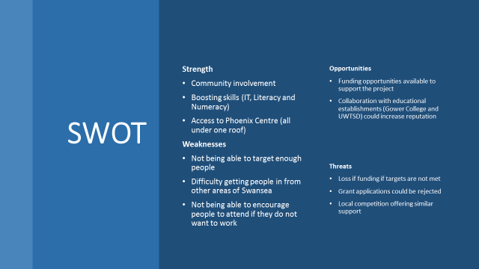

Pestle analysis
All organisations need to use pestle analysis which is used to analyse the external threats and opportunities that can affect the organisation or the project.
PESTLE Analysis, Available at: https://www.cipd.co.uk/Knowledge/stetegy/organisational-development/pestle-analysis-factsheet (Accessed: 16.06.2019).
Pestle analysis of Team Members project
The team done a pestle on the project to find out the external impact they will face doing the project so they have knowledge on hand to deal with the upcoming issues as well as what is going on at the moment of time. There are also legal factors to keep in mind with the other factors.
Below is the team members Pestle analysis chart of their project this includes all six factors that had to be taken in consideration.
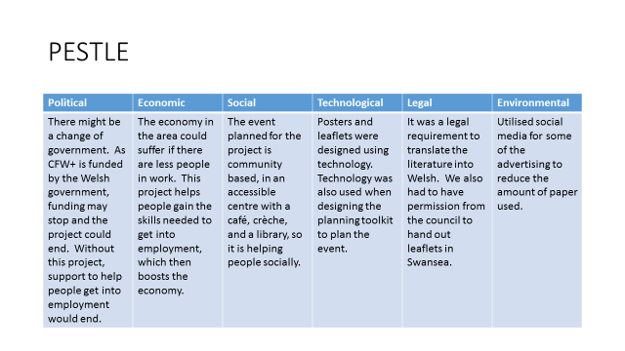
Conclusion
After reviewing our project the team have come to a conclusion that all Management tool are equally important and makes and breaks a project but some are more important according to the project you are doing. In the project the team where doing have found and used all of the relevant tools given by their lecturer to use very useful and beneficial as the tools has provided structure to work on and build their project and help to manage time and cost in return this brought success to their project Management.
Recommendation
It would have been a better experience if the team members had more time and the work placement was notified in advance so they could have been more aware to help and organise them accordingly on what needs doing and give them roles within the work placement to get the real feeling of how the work is done and how to communicate and how work is done with the people after they join the placement, this would of gave the team a wider picture and more knowledge to how project is managed in the real world. Also the team members could experience the real successes and failure within an organisation and by given an opportunity to deal and try to overcome all of the issues would also provide an insight of how real life jobs operate and make the team more confident and ready to face any given task in real work life.

Reference
(https://www.projectmanager.com/gantt-chart, 03.07.19).
(Lock, 2007, p21).
Baker, K & Campbell. M (2003). Project Management. 3rd edition.
Belbin (2019), Belbin Team Roles [online] available at: https://www.belbin.com/about/belbin-team-roles/ [accessed: 03.07.19]
Belbin team roles, [2019}, Available At: Htttps://www.mindtools.com/pages/articles/newlDR-83.htm, Accessed, 03.07.19.
Business.gov.au (2018). Quad charts [online] available at: https://www.business.gov.au/centre-for-Defence-industry-Capability/International-support-and-exports/Quads-charts[accssed [on 03.07.19].
https://www.Businessballs.com, (accessed on 03.07.19).
https://www.mindtools.com accessed[on 03.07.19].
Management, 3rd Ed, Indianapolis: Alpha Books. Campbell, G, Baker, S and Baker, K, (2014), the complete idiot guide to project
Maund, 2018).
Pestle, (2019), Available at: https://www.cipd.co.uk/Knowledge/stetegy/organisational-development/pestle-analysis-factsheet (Accessed: 16.06.2019).
Project cycle, (2019), https://www.Projectmanager.com/blogproject-cycle-management- a-quick-guide, 2019).
Project cycle,(2019), Available at: Https:www.brighubpm.com/project-planning/2433-seven-phases-of-the-project-cycle, accessed. 04.07.19.
Risk management, (2019) Available at: https://www.apm.org.uk/body-of-knowledge-delivery/risk-management, Accessed, 04.07.19.
Stakeholders Analysis, (2019), available at: Https:www.mindtools.compages/article/newppm_accssed, 10.06.19.
SWOT, (2019), Available At: https://www.businessballs.com/strategy-innovation/swot-analisis, accessed 04.07.19.
The phoenix on the hill, Avaailable at: https://thephonixonthehill.com/ (Accessed: 10.06.19).

