Programme: BA (Hons) Leadership and Management Skills in the Workplace
Module: Project Management
Module code: LCLM5003
Wellington Pasquinelli
ID:2416922

Table of Contents
Part A- Project proposal poster 5
Part B: Reflection on Feedback 6
Introduction 6
Key Strengths Identified 6
Areas for Improvement 7
How Feedback Informed Changes to the Final Project Management Plan 7
Part C: Project Management Plan – Central Transport Hub Redevelopment 9
1. Introduction 9
2. Project Description 10
3. Project Scope 11
3.1 In-scope activities 11
3.2 Out-of-scope activities 11
3.3 Constraints and assumptions 12
4. Work Breakdown Structure 13
5. Quad Chart - GOTcha Framework 15
6. Gantt Chart and Critical Path 17
7. Stakeholder Involvement 18
8. Allocation of Resources 21
9. Risk Analysis 23
10. Strategic and Social Value 26
11. Conclusion 26
References 28

List of Figures
Figure 1: Work Breakdown Structure for the Central Transport Hub Redevelopment 14
Figure 2: GOTcha Quad Chart 16
Figure 3: Project Gantt Schedule 17
Figure 4: RACI Model from the Central Transport Hub Project 18

List o Tables
Table 1: Stakeholder Power-Interest Analysis 19
Table 2: Communication Plan 20
Table 3: Human Resource Allocation 21
Table 4: Risk Register 23
Table 5: Triple-Constraint table 25

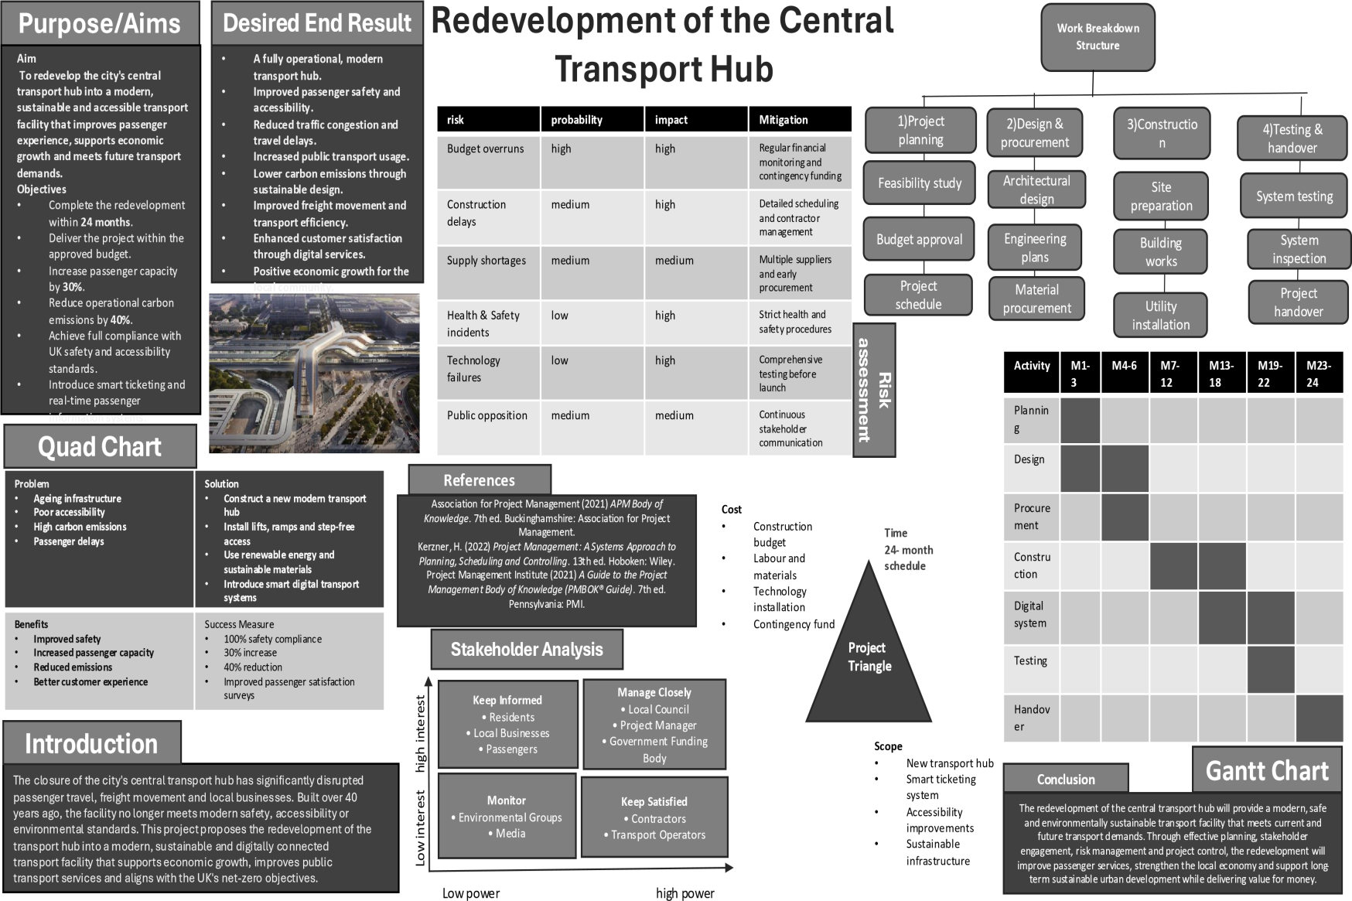
Part A- Project proposal poster

Part B: Reflection on Feedback

Introduction
Feedback is a important element in professional development for project managers, as it helps identify areas for improvement and enhances technical and strategic abilities (Project Management Institute, 2021). This reflection is a critical analysis of the tutor feedback given on the Central Transport Hub redevelopment proposal poster. The first was not well received, the second “much better,” with just some improvements to be done in the visual aspects. It highlights key strengths, weaknesses and subsequent changes to the final project management plan (Kerzner, 2025).

Key Strengths Identified
The feedback pointed out some strengths gained by the project proposal. The strategic case for redevelopment of the Central Transport Hub was clearly explained and showed a good understanding of the need for an urgent redevelopment after the November 2025 closure. It was noted that the project is aligned with the environment targets through the application of sustainable design principles, as per Strategy (2021) Net Zero Strategy, as a key strength.
There was also positive recognition of the use of project management tools. Work Breakdown Structure and Gantt Chart were useful in visualising the scope and time of the project (Lock, 2013). There were a number of construction risks identified in the risk assessment matrix, most importantly construction delays and budget overruns. The Quad Chart employing the GOTcha Framework was praised as an effective way to clearly communicate the goals, objectives, time frame, and constraints of the project (Maylor, 2021).

Areas for Improvement
However, there were a number of areas that needed to be improved. The most main criticism was related to the depth of the stakeholder analysis. Stakeholders were identified, but there was no consideration of the different levels of interest and influence held by the various stakeholders (Freeman, 1984).
Risk analysis was seen as limited in terms of the approach taken to look at risk reduction strategies. Detailed contingency planning and clear accountability for high impact risks were not in place. The triple constraint analysis was poorly developed and presented as three separate considerations instead of showing an interconnection between the three (Atkinson, 1999).
The Gantt Chart was not clear on the dependencies between tasks and failed to identify the critical path. Strategic value part lacked social value and consideration of community benefits – was more economic redevelopment focused. Lastly, the tutor suggested that the poster could be improved visually to be more interesting and professional.

How Feedback Informed Changes to the Final Project Management Plan
This feedback has been a key component in the evolution of the final project management plan, with several key enhancements. The stakeholder section now contains a comprehensive stakeholder analysis matrix, power-interest mapping, and detailed engagement strategies for each stakeholder group that specify the frequency of communication and the channels for communicating with them (Project Management Institute, 2021).
A detailed risk register with probability/impact scoring, risk reduction strategy, contingency plans and owners are now included in the risk analysis. A whole new section analysing the triple constraint trade-offs has been included, showing how choices in one of the three areas affect the other two. The Gantt Chart has been revised to include clear task dependencies and critical path analysis (Lock, 2013).
New social value indicators have been added to the strategic value section, such as community engagement metrics and local employment targets. Last, but not least, the poster's colour schemes, formatting and layout have been adjusted to improve readability and visual impact.

Part C: Project Management Plan – Central Transport Hub Redevelopment

1. Introduction
Commuter travel, freight logistics and local businesses were badly affected by the closure of the Central Transport Hub in November 2025. A "hub" more than 40 years old, it is no longer meeting modern safety and access requirements and urgently needs redevelopment. The project is expected to restore the transport capacity, enhance safety, accessibility, sustainability and digital connectivity, also embodying environmental goals and inclusive urban design principles.
This proposed redevelopment will be finished by December 2027 and will feature a combination of rail, bus and freight related activities, along with upgraded passenger amenities, accessible infrastructure, sustainable building design and digital information systems. Redevelopment is not a short term fix, but a longer-term connectivity and regeneration, tackling the underlying structural and operational issues. It is important to have effective project management as infrastructure projects consist of interdependent activities, multiple stakeholders, resource constraints and uncertainty (Project Management Institute, 2021).
This project management plan defines the scope, Work Breakdown Structure (WBS), timeline, stakeholder approach and resource plan and risk control for successful delivery. It also includes tutor feedback (in terms of enhanced stakeholder analysis, detailed risk reduction and contingency planning, clearer cost-time-quality trade-offs, task dependencies, critical-path analysis and increased consideration for social value).

2. Project Description
The main goal of the project is to transform the Central Transport Hub into a safe, accessible, sustainable and digitally connected multi-modal transport hub by December 2027. The project will be used to restore transport connectivity which will support economic regeneration and community needs and environmental objectives.
The SMART principle has been used to ensure that the project objectives are specific, measurable, attainable, relevant and time-bound (Doran, 1981). The overall goals are to:
- complete redevelopment and commissioning by December 2027;
- ensure that the completed hub meets applicable safety requirements;
- improve accessibility through step-free routes, accessible passenger facilities and inclusive design;
- restore effective rail, bus and freight interchange capacity;
- incorporate sustainable materials, energy-efficient systems and low-carbon infrastructure;
- implement digital passenger-information and logistics-coordination systems;
- support local employment and meaningful community engagement; and
- complete testing, certification and handover before public reopening.
The project is not only a construction programme, but also relies on the relationship between physical infrastructure, technology, people, environmental performance and expectations of various stakeholders. Pinto (2015) posits the importance of linking projects to broader organisational and strategic goals as well as to manage the projects as technical activities. In the same way, Zwikael and Smyrk (2019) differentiate between the delivery of the project outputs and the achievement of the intended outcomes and benefits. Therefore, the performance of the Central Transport Hub must be measured by completion time and cost, but also by safety, accessibility, connectivity, environmental performance and community value.

3. Project Scope

3.1 In-scope activities
Site investigation, detailed engineering and architectural design, planning and regulatory approvals, procurement, construction, accessibility improvements, passenger facilities, sustainable infrastructure and digital systems are the project scope. It also encompasses safety inspections, testing, commissioning, staff training, stakeholder acceptance and handover.
The physical redevelopment works will involve works on structures, works on the different transport modes interchange and works on passenger areas. Accessibility will be designed in, rather than added as a final add-on at the end of the construction process. Energy efficient systems and suitable low carbon materials will be incorporated in the construction of sustainable infrastructure. Digital infrastructure will be used to help with providing passenger information and for logistics coordination (Fischer et al., 2026).

3.2 Out-of-scope activities
No expansion of the wider city railway network, no road development or residential or other commercial development unrelated to the project will be considered. The transport services will also not be directly managed by the project manager for their long-term operation. These boundaries will be required to ensure the scope does not get out of hand.
However, scope management is particularly important as changes in the project requirements can have an impact on cost, time and quality all at once (Atkinson, 1999). Lock (2013) elaborates that establishing project boundaries establishes a foundation on which to control work and allocate resources.

3.3 Constraints and assumptions
These main constraints are the completion deadline of December 2027, funding, planning, construction disruption, supply-chain capacity and safety. The project requires planning approvals to be in place and contractors to be secured and key stakeholders to be willing to work with the redevelopment. The scope of the project is therefore carefully targeted to address infrastructure and systems necessary for the restoration of the hub. This offers a compromise between producing significant long-term benefits and activities that are not needed and would put at risk the schedule.

4. Work Breakdown Structure
A Work Breakdown Structure breaks down the work of a project into manageable work packages in a hierarchical structure (Larson and Gray, 2021). The Central Transport Hub redevelopment WBS is proposed as shown in Figure 1.
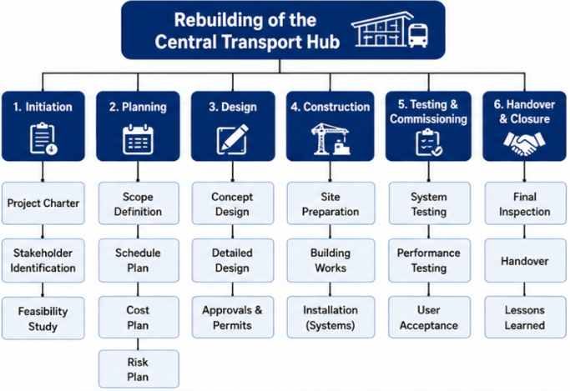
Figure 1: Work Breakdown Structure for the Central Transport Hub Redevelopment
The WBS in Figure 1 is the basis for breaking the Central Transport Hub redevelopment into manageable work packages. In Part C, the project schedule and resource allocation and risk controls provide extra detail to the work that was defined in the original WBS to help maintain consistency with Part A.

5. Quad Chart - GOTcha Framework
The Quad Chart is a summary of the Central Transport Hub redevelopment in four dimensions: Goals, Objectives, Timeline and Constraints. The aims are directed towards ensuring a safe, accessible, sustainable and connected transport hub. The objectives break down goals into measurable outcomes such as completion by December 2027, enhanced accessibility and restored multi modal connectivity and digital systems. SMART objectives increase clearness and responsibility (Doran, 1981). Time frame includes initiation, design, approvals, procurement, construction, testing and handover. Some of the major constraints are budget, regulatory requirements, supply-chain disruption, construction disruption and safety. These constraints need to be managed carefully as alterations in cost, time and quality can have an impact on the success of the project (Atkinson, 1999). The Quad Chart is often used to concisely present complex information about projects to support communication and understanding by stakeholders (Maylor, 2021; Project Management Institute, 2021).
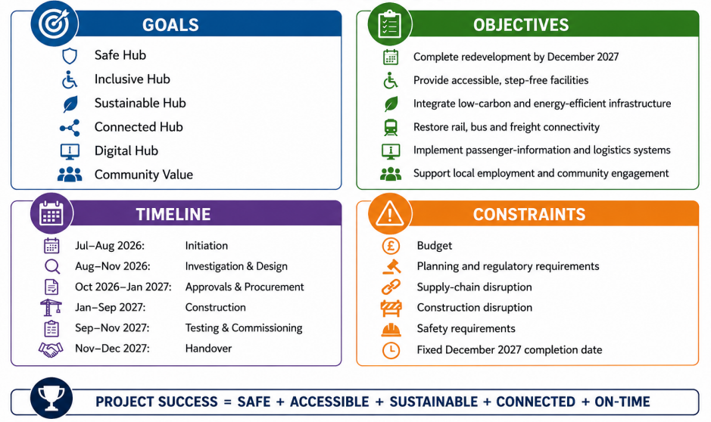
Figure 2: GOTcha Quad Chart

6. Gantt Chart and Critical Path
The Gantt Chart is used to break down the WBS into a time based delivery programme. The schedule contains dependencies – because not all activities can be done independently. It is especially critical if the delay to one activity will impact other work (Larson and Gray, 2021).
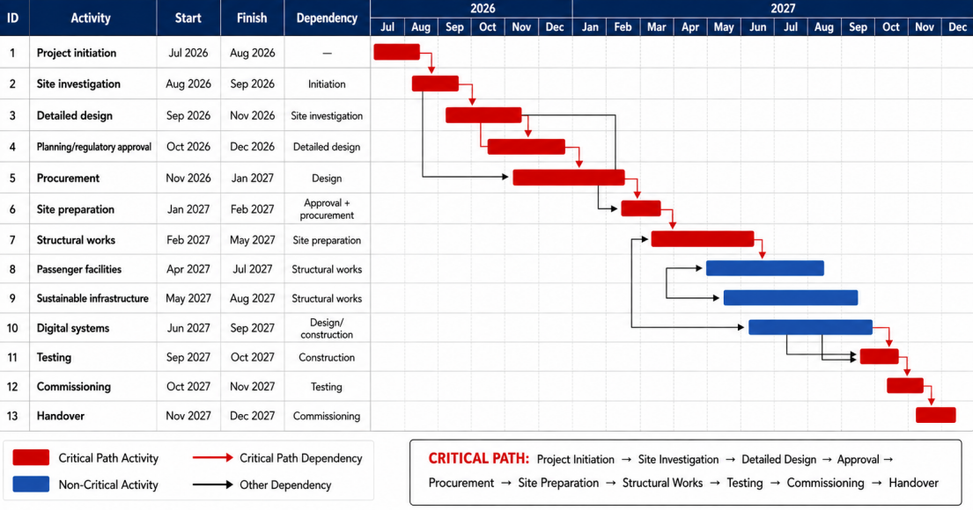
Figure 3: Project Gantt Schedule
The original Gantt Chart from Part A is elaborated in Figure 3 to clearly identify dependency of various activities and the critical path. The improvement is directly in response to the feedback that the original schedule wasn't showing enough task dependencies or identifying the critical path. The on-going operations along this path will be closely tracked, as they have the potential to directly impact the December 2027 completion date. The weakness in the original proposal was that the dependencies between tasks and the critical path was not clear enough in the original schedule and is now addressed in the revised schedule.
Weekly reviews of the schedule will be used to find delay, and the project manager should be responsible for this. Non-critical activities offer some flexibility – can be temporarily moved if critical activities have problems.

7. Stakeholder Involvement
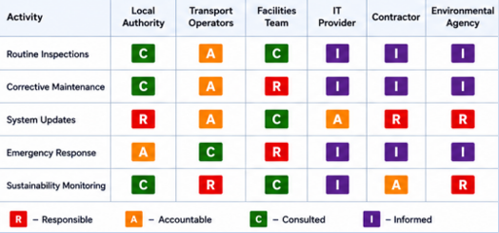
Figure 4: RACI Model from the Central Transport Hub Project
The RACI model from part A is carried over as it helps to define responsibility and accountability on the project. But responsibility assignment does not show which stakeholders should be engaged and to what extent, based on their influence and interest. For this reason, Part C continues the original analysis by adding a Power–Interest Matrix and communication plan.
Stakeholder management is important because it involves groups with different levels of power, interest and expectations to be impacted by infrastructure projects. Freeman's stakeholder approach (1984) highlights the need for looking at those parties who are impacted upon by organisational decisions. PMI (2021) also considers stakeholder engagement to be a critical factor in project delivery.
Table 1: Stakeholder Power-Interest Analysis
Stakeholder | Power | Interest | Engagement Strategy
Local authority | High | High | Manage closely
Project sponsor | High | High | Manage closely
Transport operators | High | High | Manage closely
Main contractors | High | High | Manage closely
Regulatory bodies | High | Medium | Keep satisfied
Local businesses | Medium | High | Consult and involve
Community residents | Medium | High | Consult regularly
Passengers/commuters | Low | High | Keep informed
Freight operators | Medium | High | Consult regularly
Environmental groups | Medium | Medium | Consult
Local employees | Low | Medium | Keep informed
High power and high interest stakeholders like the project sponsor, local authority, transport operators and contractors should be managed closely by having formal, regular project meetings and progress reporting (Mabelo, 2020). Milestone information and early notification of issues that may impact compliance should be provided to regulators.
Lower formal decision-making power for passengers and local residents with high interest due to immediate impacts of construction & transport disruption. Therefore consultation meetings, project updates and communication channels should be part of their involvement. It is also important to consult with local businesses as the project is likely to impact economic activity during construction and upon reopening.
Table 2: Communication Plan
Stakeholder | Communication Method | Frequency
Project sponsor | Progress report/project board | Monthly
Local authority | Governance meeting | Monthly
Contractors | Site/project meeting | Weekly
Transport operators | Coordination meeting | Fortnightly
Regulators | Formal reports | At milestones
Community | Consultation/newsletter | Monthly
Local businesses | Business forum | Monthly
Passengers | Website/public updates | As required
Project team | Internal meeting | Weekly

This approach is directly addressing tutor feedback which asked for greater power-interest mapping and communication frequency/channels. Continuous communication should also minimise opposition and allow any new stakeholder issues to be integrated before they develop into larger project issues.

8. Allocation of Resources
Successful delivery depends on the adequate human, physical, technological and financial resources. The planning of resources should be tied to the WBS to ensure adequate capability for each major work package.
Table 3: Human Resource Allocation
Role | Responsibility
Project Manager | Overall project delivery and governance
Project Sponsor | Strategic decisions and funding
Project Planner | Programme and schedule control
Quantity Surveyor | Cost estimation and monitoring
Architect | Architectural design
Structural Engineer | Structural design and assessment
Construction Manager | Construction coordination
Health and Safety Manager | Safety management
Environmental Specialist | Environmental compliance
Digital Specialists | Passenger and logistics systems
Procurement Team | Contractor and supplier procurement
Community Engagement Officer | Stakeholder/community engagement
Contractors | Construction activities
Commissioning Team | Testing and handover
The physical resources will consist of construction equipment, temporary site facilities, safety equipment, sustainable materials, accessibility equipment, digital infrastructure and testing equipment (Casini, 2021).
Funds should be allocated in the financial plan for design, approvals, construction, digital systems, accessibility, sustainability, as well as testing and contingency (Elmer and Leigland, 2013). The financial figure has been not supported and no budget is specified in the provided Part A or assessment brief for a specific project. Cost monitoring should be based on approved estimates, committed expenditure and forecast final cost instead.
Kerzner (2025) stresses the need for integration of cost, schedule, resources and control. Hence resource utilisation should be viewed in together with progress by project manager and not as a separate activity.

9. Risk Analysis
Construction and regulatory approvals, technology, public stakeholders and a fixed completion deadline are particular factors that make risk management important for the redevelopment. According to PMI (2021), risk management is a continuous identification, assessment and response process. In fact, research suggests that systematic risk management is connected to project success, specifically when project risks are evaluated and managed with respect to project goals (Rodríguez-Rivero et al., 2020).
Risk scores in this plan are calculated using:
Probability × Impact = Risk Score
Table 4: Risk Register
Risk | Probability | Impact | Score | Mitigation | Contingency | Owner
Construction delay | 3 | 3 | 9 | Detailed programme and weekly monitoring | Re-sequence non-critical activities | Project Manager
Budget overrun | 2 | 3 | 6 | Cost monitoring and change control | Use approved contingency | Quantity Surveyor
Planning delay | 2 | 3 | 6 | Early regulator engagement | Revise programme | Project Manager
Supply-chain disruption | 2 | 3 | 6 | Early procurement and supplier checks | Alternative suppliers | Procurement Manager
Stakeholder opposition | 2 | 2 | 4 | Consultation and communication | Mediation/design adjustment | Engagement Officer
Design changes | 2 | 2 | 4 | Design reviews and approval gates | Formal change control | Design Manager
Extreme weather | 2 | 2 | 4 | Weather/resilience planning | Reprogramme activities | Construction Manager
Digital-system failure | 2 | 2 | 4 | Testing and system assurance | Manual backup arrangements | IT Manager
Safety incident | 1 | 3 | 3 | Safety procedures and inspections | Stop work and investigation | H&S Manager
Accessibility failure | 1 | 3 | 3 | Inclusive design review | Corrective works before opening | Design Manager
Environmental non-compliance | 1 | 3 | 3 | Environmental monitoring | Corrective action | Environmental Manager
Construction delay is the highest priority risk, because it could impact the critical path and completion date of December 2027. Early identification of delays should be included in mitigation, including detailed scheduling and contractor monitoring. The non-critical activities can be rescheduled, if there is any delay, to preserve the critical path (Rani et al., 2024). Material costs, unforeseen site conditions or design changes could lead to budget overrun.
Planning and regulatory delays need to be addressed by early engagement with authorities, timely submissions and ongoing communication. To minimise disruption in the supply chain, early procurement and supplier assessment and alternative sourcing can be used (Chowdhury, 2025).
Triple-Constraint Trade-Offs
Cost, time and quality must be taken into account in the project. Although cost, time and quality are important constraints the project success should not be limited to only the traditional triangle of the constraints (Atkinson, 1999). For this project, decisions should be made with the awareness of their interrelationship.
Table 5: Triple-Constraint table
Management Decision | Cost | Time | Quality
Accelerate construction | Increase | Reduce | Possible pressure
Reduce non-essential scope | Reduce | Potentially reduce | Limited effect
Increase accessibility specification | Increase | Possible increase | Improves inclusion
Increase sustainability specification | Increase | Possible increase | Improves environmental performance
Delay procurement | Potential increase | Increase | Supply risk
Risk responses should take into account the inter-relationship amongst cost, time and quality constraints. Additional resources may add to the cost if acceleration is needed to meet the December 2027 deadline. On the other hand, using less non-essential scope can help to manage costs whilst maintaining safety and accessibility. Where trade-offs must be made, therefore, safety and accessibility should be considered first, and other, less critical aesthetic features should be reconsidered.

10. Strategic and Social Value
Beyond the restoration of transport capacity, the project is of strategic importance. The economic benefits will be an improved connectivity for commuters, freight transport and local businesses, and construction can generate local employment and supply chain opportunities (Martinsuo and Killen, 2014). Low carbon goals (Net Zero Strategy 2021) should be addressed through sustainable design, energy efficiency and promotion of public transport. Digital systems can provide better information and logistics coordination for passengers. Success will be achieved via completion by December 2027, safety, accessibility, capacity restoration, stakeholder satisfaction, environmental performance and commissioning of digital-systems, which will include broader project benefits (Zwikael and Smyrk, 2019).

11. Conclusion
The Central Transport Hub redevelopment is a long-term solution to the Central Transport Hub safety, accessibility and connectivity issues that arose as a result of the closure of the existing facility. The project management plan takes an integrated approach to the delivery of the project with scope, work packages, scheduling, stakeholders, resources and risk.
The WBS breaks down the project into a logical structure, and the Gantt Chart shows the interdependencies and the critical path towards meeting the completion deadline of December 2027. Power-interest analysis of stakeholders and communication plan improves stakeholder engagement with authorities, transport operators, businesses, communities & passengers. Resource allocation is the process of allocating the appropriate responsibilities to technical, managerial and operational personnel.
The risk register adds to the original proposal, probability, impact assessment, mitigation, contingency and ownership. Triple-constraint analysis also shows the relationship between cost, time and quality decisions. Significantly, safety and accessibility are still important even when compromises have to be made. Thus, the project also includes operational, economic, social, environmental and digital goals. Given the monitoring and stakeholder engagement, and effective governance, the redevelopment can realise the strategic regeneration benefits of the original proposals whilst being sustainable and inclusive.

References
Atkinson, R. (1999) ‘Project management: cost, time and quality, two best guesses and a phenomenon, its time to accept other success criteria’, International Journal of Project Management, 17(6), pp. 337–342.
Casini, M. (2021). Construction 4.0: Advanced technology, tools and materials for the digital transformation of the construction industry. Woodhead Publishing.
Chowdhury, A.R. (2025). A systematic review of risk-based procurement strategies in retail supply chains: Sourcing flexibility and vendor disruption management. American Journal of Advanced Technology and Engineering Solutions, 1(01), pp.466-505.
Doran, G.T. (1981) ‘There’s a S.M.A.R.T. way to write management’s goals and objectives’, Management Review, 70(11), pp. 35–36.
Elmer, V. and Leigland, A. (2013). Infrastructure planning and finance: A smart and sustainable guide. Routledge.
Fischer, S., Molnár, B., Hermán, B., Madarász, K., Tóth, C. and Titrik, Á. (2026). Sustainability and Smart Systems in Transportation Infrastructure: A Mini-Review. Spectrum of Mechanical Engineering and Operational Research, 3(1), pp.42-64.
Freeman, R.E. (1984) Strategic Management: A Stakeholder Approach. Boston: Pitman.
Kerzner, H. (2025) Project Management: A Systems Approach to Planning, Scheduling, and Controlling. Hoboken, NJ: John Wiley & Sons.
Larson, E.W. and Gray, C.F. (2021) Project Management: The Managerial Process. 8th edn. New York: McGraw-Hill Education.
Lock, D. (2013) Project Management. 10th edn. Farnham: Gower Publishing. Available at: https://books.google.com.pk/books/about/Project_Management.html?id=mipKLwEACAAJ&redir_esc=y (Accessed: 12 August 2026).
Mabelo, P.B. (2020). How to manage project stakeholders: Effective strategies for successful large infrastructure projects. Routledge.
Martinsuo, M. and Killen, C.P. (2014). Value management in project portfolios: Identifying and assessing strategic value. Project Management Journal, 45(5), pp.56-70.
Maylor, H. (2021). Project management. Pearson Higher Ed.
Pinto, J.K. (2015). Project management: Achieving competitive advantage (Vol. 4). New York: Pearson.
Project Management Institute (2021), July. A guide to the project management body of knowledge (PMBOK® guide)–Seventh edition and the standard for project management. Project Management Institute.
Rani, H.A., Syammaun, T., Azzahra, F., Ayob, A., Amlus, M.H., Zakirullah and Aqsha, M.S. (2024), February. Risk management planning by risk register in building construction project. In IOP Conference Series: Earth and Environmental Science (Vol. 1303, No. 1, p. 012034). IOP Publishing.
Rodríguez-Rivero, R., Ortiz-Marcos, I., Romero, J. and Ballesteros-Sánchez, L. (2020). Finding the links between risk management and project success: Evidence from international development projects in Colombia. Sustainability, 12(21), p.9294.
Strategy, N.Z. (2021). Net Zero strategy: Build back greener. UK HM Government.
Zwikael, O., and Smyrk, J. R. (2019). Project Management. Cham: Springer.
https://doi.org/10.1007/978-3-030-03174-9

