Blaenavon a learning report

Regeneration and Distinctiveness

Tutor Anthony Burnes

Robert Connelly 1908153

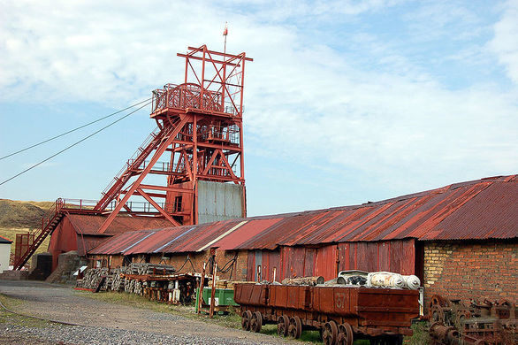
Blaenavon Big Pit
The scene of Blaenavon, at the upper finish of the Avon Llwyd valley in South Wales, gives uncommon declaration to the territory's worldwide significance in iron making and coal mining in the late eighteenth and the mid nineteenth century. The equal improvement of these enterprises was one of the chief powerful powers of the Industrial Revolution. (Centre, 2020)
The major protected destinations of Blaenavon Ironworks and Big Pit, together with the remarkable relict scene of mineral abuse, assembling, transport, and settlement which encompasses them, give an uncommonly extensive image of all the essential components of the industrialisation procedure: coal and metal mines, quarries, a crude railroad framework and channel, heaters, laborers' homes, and the social foundation of the early modern network. The region mirrors the pre-prominence of South Wales in the creation of iron, steel and coal in the nineteenth century. (Centre, 2020)
The Blaenavon Ironworks (around 1789) gave the fundamental force to mineral activities and settlement. The remaining parts of the late eighteenth century heaters, together with later nineteenth century heaters, are the best protected of its period in the United Kingdom. Close to the heaters, two of the first throwing houses can even now be seen. Over the heaters is a scope of destroyed ovens wherein iron metal was calcined or broiled. The remaining parts of the first specialists' lodging gave nearby can at present be seen around the first base of the huge fireplace to the blowing motor house, and the cast-iron columns and sections which conveyed shoot channels to the heaters despite everything endure. The notorious water balance tower of 1839 is a phenomenal case of lift innovation utilizing water to balance loads. (Centre, 2020)
The Big Pit was the last profound coal mineshaft to work in the Blaenavon territory, and the surface structures, including the winding apparatus, remain precisely as they were when coal creation stopped in 1980. The underground operations are still in amazing condition and can be seen on guided visits (Centre, 2020)
The Blaenavon scene reflects manners by which all the crude materials vital for making iron were gotten. The scene incorporates coal, iron mineral, fireclay and limestone activities and transport frameworks including a crude iron-railed railroad, prompting the waterway and later steam railroad tracks which were utilized for the import and fare of materials. (Centre, 2020)
The scene likewise mirrors the advancement of early mechanical society. Near the Ironworks and Big Pit is the town of Blaenavon, the best safeguarded iron town of its period in the United Kingdom. Here can be seen the terraced lodging of the laborers. Generally, the town reflects capably the particular culture that had created in ironworking and coal-mining zones of the South Wales Valleys and gives a total image of support and the social structure of the network. Remarkable structures incorporate St. Diminish's Church, worked by the ironmasters in 1804; the Blaenavon Workmen's Hall, worked by laborers' memberships in 1894; and St. Diminish's School, worked by the ironmaster's sister, Sarah Hopkins, in 1816. The school has been reestablished as the United Kingdom's originally devoted World Heritage Interpretation Centre. (Centre, 2020)
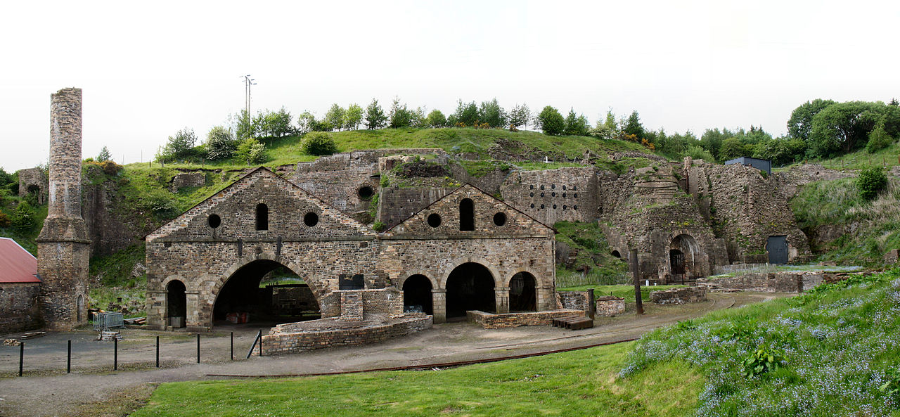The Iron Works
The ironworks, which started creation in 1789, is the best protected impact heater complex of its period and type on the planet and is one of the most significant landmarks to have made due from the early piece of the mechanical upheaval. Blaenavon Ironworks is verifiably critical as during the mid-nineteenth century the ironworks was one of the most significant makers of iron on the planet. (Visitblaenavon.co.uk, 2020)
Today you can see the broad survives from the impact heaters, the cast houses and the stunningly reestablished Water Balance Tower. Through presentations, propelled understanding highlights and recreations, you can find out about the worldwide criticalness of the iron business and the logical procedures associated with the creation of iron. An entrancing understanding into the social history of mechanical Britain can be picked up by witnessing into the past at the recreated organization shop and the repaired laborers' bungalows, at Stack Square and Engine Row. (Visitblaenavon.co.uk, 2020)
Blaenavon Ironworks was taken into Guardianship in 1976, sparing the site from its arranged destruction. It is presently viewed as maybe the most complete protected ironworks of its period and type. At the point when the works was built up in 1788, it was concluded unhesitatingly to incorporate the most recent innovation and mechanical association. Not at all like practically all past ironworks it was worked with three coke-terminated shoot heaters from the beginning, worked with steam power. It was promptly perhaps the biggest ironwork on the planet, delivering 5,400 tons of iron a year by 1796, preceding extending with the expansion of three additional heaters in the nineteenth century. (Coflein.gov.uk, 2020)
Blaenavon is the most agent case of somewhere in the range of 70 coke-terminated ironworks which were made all through the South Wales coalfield in the late eighteenth and mid nineteenth hundreds of years, making it the main iron creating locale in Britain. Blaenavon was later significant as the site of the examinations of Sidney Gilchrist Thomas which in 1878 brought about the Basic Bessemer or Thomas process, which allowed the utilization in mass steelmaking of cast iron produced using phosphoric minerals. The ironworks is striking for the endurance of the greater part of the key structures related with the refining of iron in the Industrial Revolution. (Coflein.gov.uk, 2020)
Clay Ironstone formation
Shale is a fine-grained sedimentary stone that structures from the compaction of residue and mud size mineral particles that we generally call "mud." This sythesis places shale in a classification of sedimentary rocks known as "mudstones." (Moodle.uwtsd.ac.uk, 2020)

Earth ironstone owes its birthplace to the conditions which brought about the arrangement of coal creases. Most shakes contain a modest quantity of iron which regularly goes into arrangement as the stones are endured, and, together with different results of denudation, discovers its way into the waters of waterways. In the marshes where the Coal Measures gathered, and on which were set up the backwoods that gave the material to coal creases, there were numerous transitory shallow tidal ponds in the regularly dormant water of which there was much rotting vegetation which went about as a diminishing operator and forestalled oxidation, with the goal that an apparent measure of the iron stayed in arrangement. This, stored as iron carbonate as the arrangement got concentrated, blended with the mud or other residue that was settling out of the water and offered ascend to the ferruginous earth that currently establishes the ironstone. (Moodle.uwtsd.ac.uk, 2020)

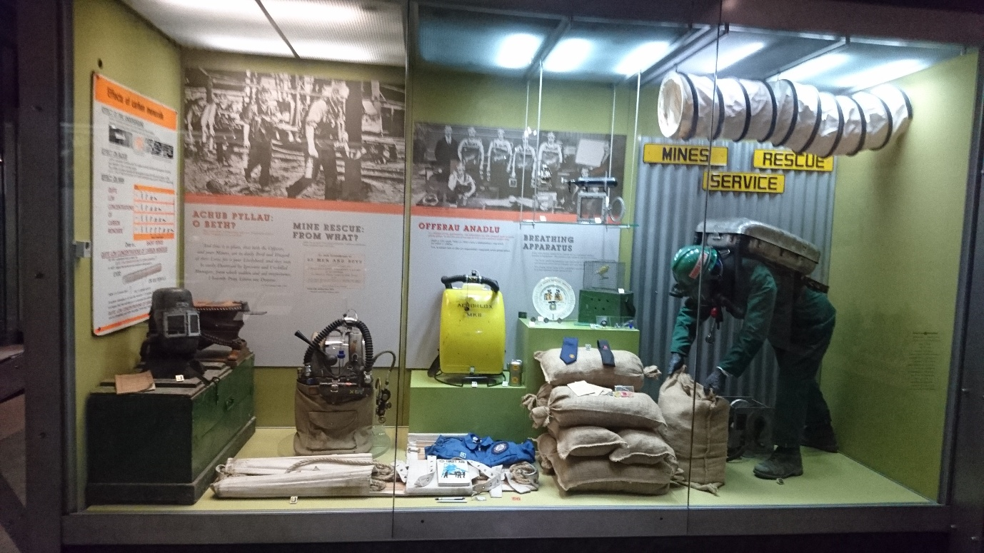
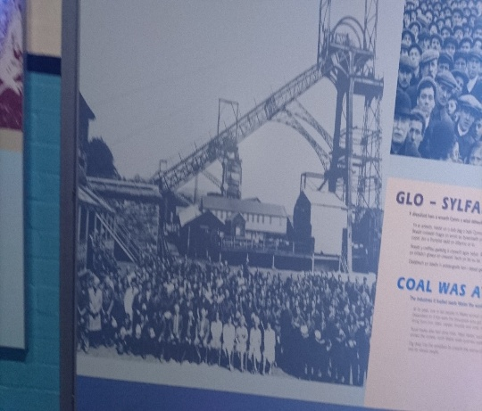

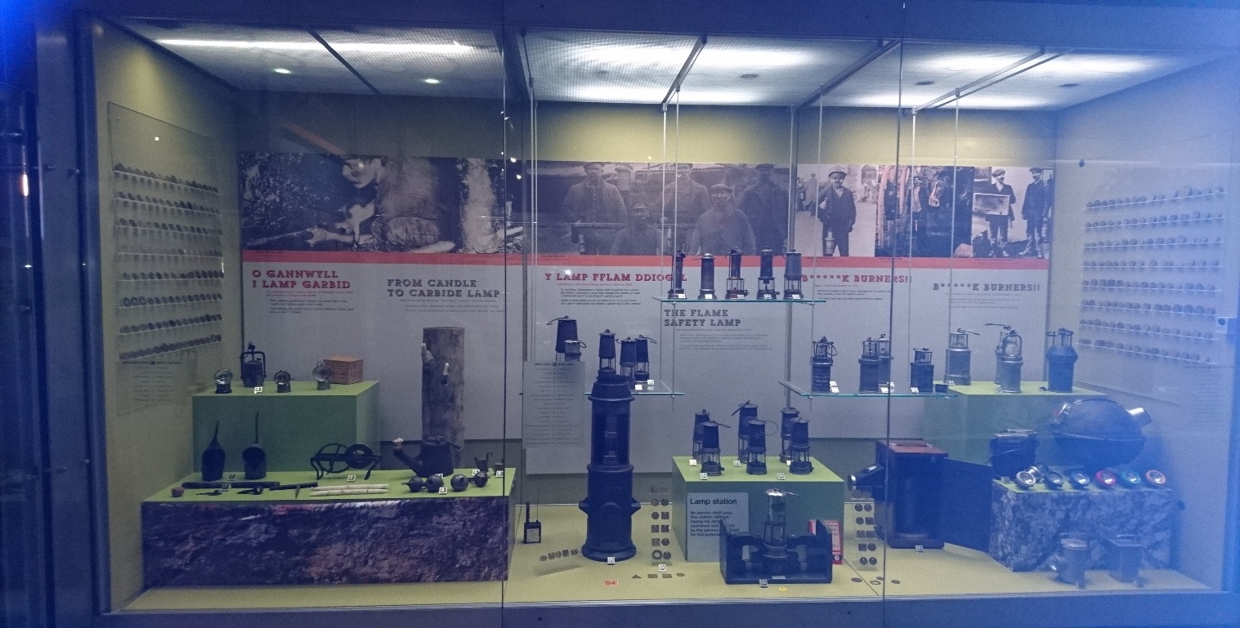
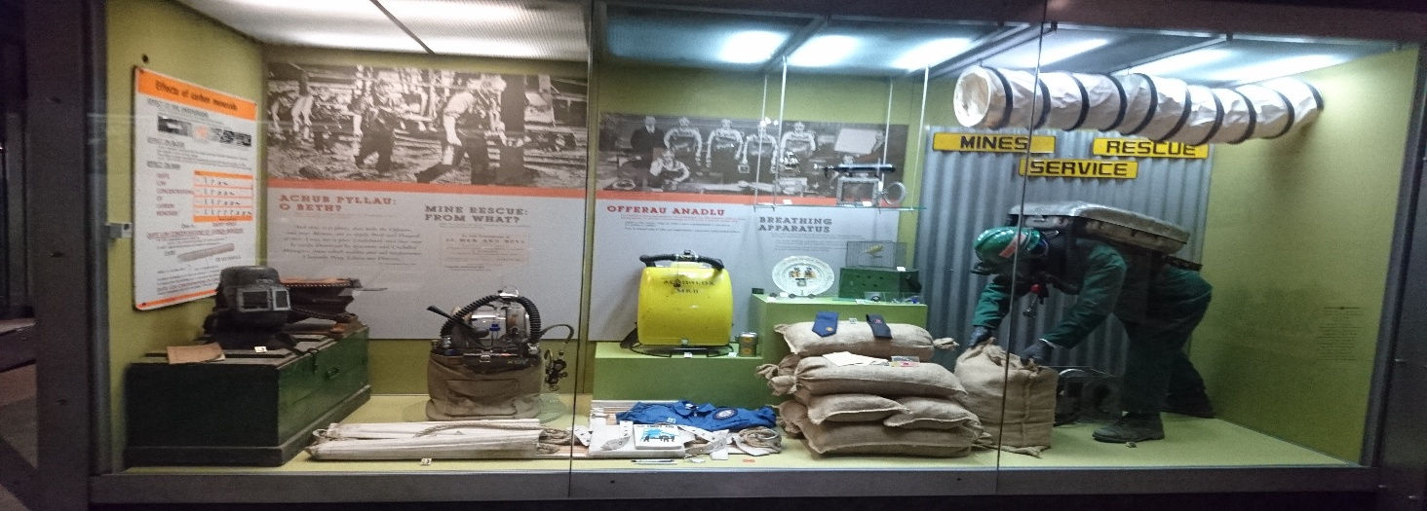
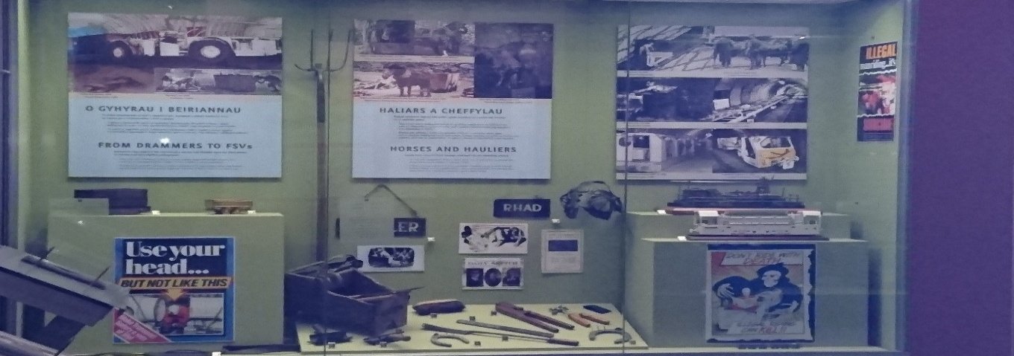
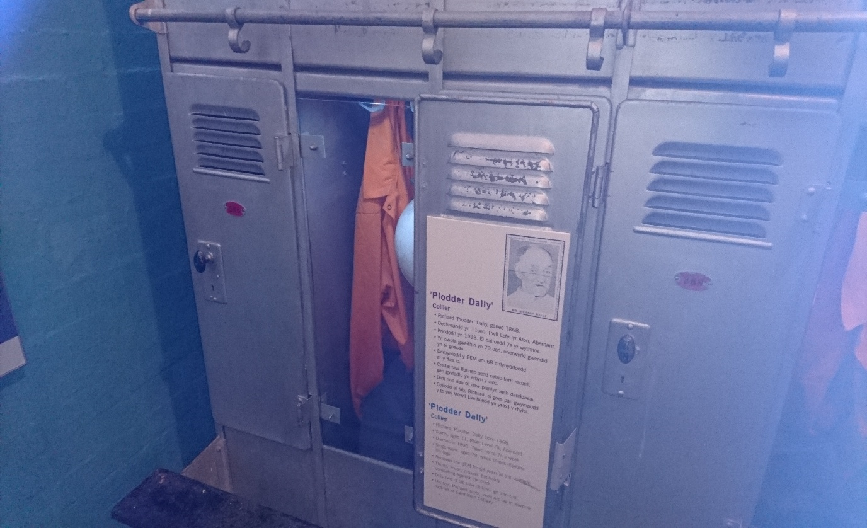

References
Centre, U. (2020). Blaenavon Industrial Landscape. [online] Whc.unesco.org. Available at: https://whc.unesco.org/en/list/984/ [Accessed 6 Mar. 2020].
Coflein.gov.uk. (2020). BLAENAVON IRONWORKS | Coflein. [online] Available at: https://coflein.gov.uk/en/site/34134/details/blaenavon-ironworks [Accessed 6 Mar. 2020].
Moodle.uwtsd.ac.uk. (2020). UWTSD Moodle 2019/20: Log in to the site. [online] Available at: https://moodle.uwtsd.ac.uk/pluginfile.php/346838/mod_resource/content/1/Blaenafon%20Clay%20Ironstone%20lecture_v2_no%20narrative.pptx [Accessed 6 Mar. 2020].
Visitblaenavon.co.uk. (2020). Blaenavon Ironworks - Blaenavon World Heritage Site. [online] Available at: https://www.visitblaenavon.co.uk/en/VisitBlaenavon/ThingsToDo/BlaenavonIronworks.aspx [Accessed 6 Mar. 2020].

