A Guidance Handbook for Key Workers in Early Years during Childhood Development
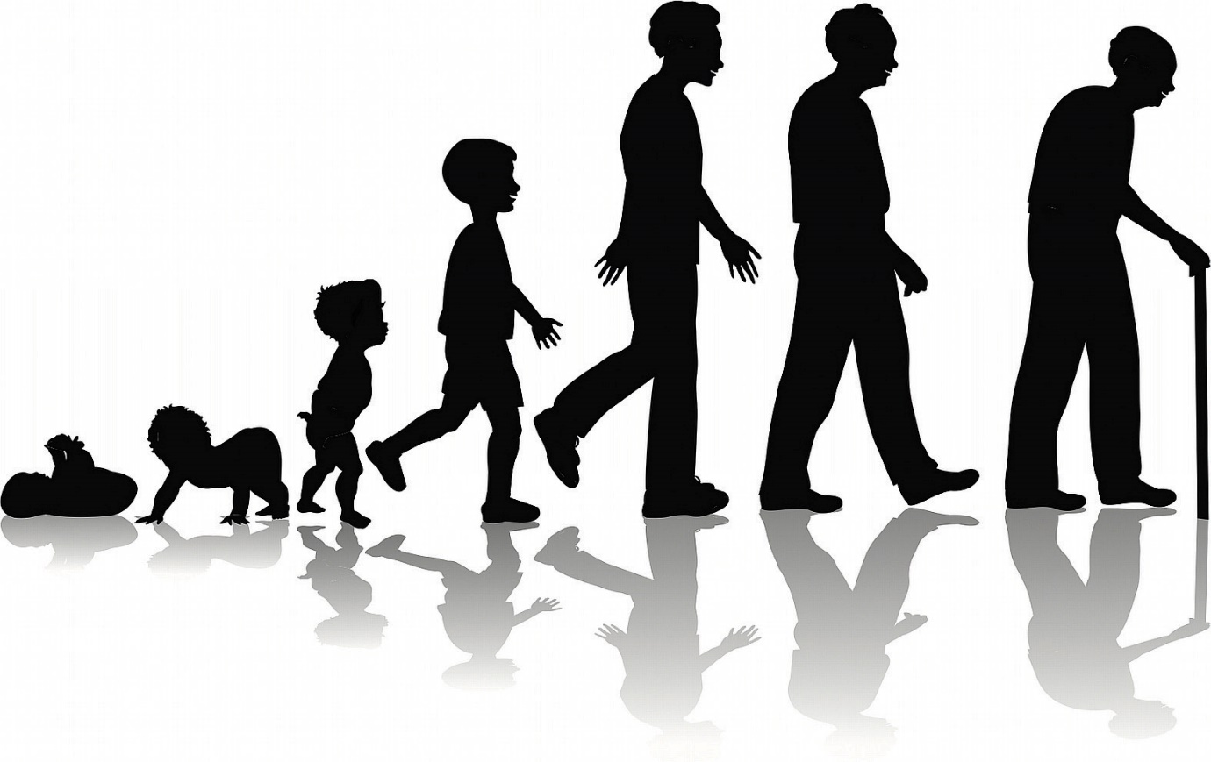
(Virginia Tech Human Development & Family Science, 2015)

Ashleigh Davies 2000495
Human Development
EAEE4003/C

Contents Page No.
- Introduction 3

- How to use the Handbook 3

- Transitions 4

- The need of the child 4

- The role of the practitioner 5

- Interventions 7

- Outcomes 8

- References 10

Introduction
The purpose of this handbook is to provide guidance for key workers to help and assist children and young people when they are going through a transition. It will talk about how we as practitioners can be responsible to provide our attention towards children and focus on maintaining a positive development. This handbook is aimed to help and guide key workers with helping children in the early year’s settings. It is important that we assist and protect children when they are going through a transition. Transitions can be hard and unsettling for children and it is important that we do not let the transition affect their development in a negative way. It can help key workers understand and gain more knowledge about how the child may be feeling and how to help the transition become smoother. This handbook should provide positive and helpful outcomes for the key worker and the child. Providing the key worker with more hands-on experience and the child learning how to deal with a transition and trust those adults within their classroom. It will improve the quality of practice by giving the key works more knowledge and experience to help children who may have any needs in the future. Experience and knowledge will consistently grow throughout a career, and it is important that we do not let our lack of knowledge affect their development and education.

How to use the Handbook
This handbook should be used when helping a child with a difficult transition. The handbook should teach you to that every child is different. Do not approach every child with the same approach, treat them as an individual and recognise their individual needs. Nor is one family the same. Treat every family respectively and speak to them in ways that are kind and beneficial. The knowledge received from this handbook should only be used in the best interest of the child.

Transitions
According to, Anne O’Connor (2018) Transitions can be defined in three different ways. ‘Horizontal, vertical and internal.’ Horizontal transitions are the broadest of the three and will include those within the child experiences. Vertical transitions are the biggest changes made within a child’s life as the child progresses through the early years stage through till they finish education. Internal transitions are when the child moves up within the setting. For example, moving from year one to year two.
Transitions in early years can have a lot of different meanings. For us as practitioners we see children go through life and learning something new all the time. We build bonds with them to enable trust with them to help through things when they need support. Children do not understand how to deal with certain things in life. We may notice changes in behaviour or attitude when dramatic things happen for a child. For example, when introducing a new baby can be a big life change for child. Suddenly, all the attention that used to be theirs, is now having to be shared and sometimes they may need a bit of advise or just sympathy when trying to learn how to adjust to the change in life. Another big life change for a child can be coming to terms with a bereavement. Losing someone they were close with can be hard for a child to understand. It can be harder for them when they do not understand why it has happened. Being a safe place for the child is something we can do as a key worker. Listening to their worries and emotions and acting on them when we feel the need for it to be necessary. As well as the child, the family plays a role. We can play a role in supporting the family alongside. Approaching them with a professional manner and sensitivity. Sometimes with the parents you can offer more experienced external help. For example, councillors when the family has experienced a bereavement. Sometimes a parent may seek a moment of your time to express concerns or problems involving the child. As a professional member of the setting and to help the child the best you can, it can benefit to set a side some time for the parent so you can gather as much information as possible to ensure the best path to take to benefit the child.
The Need of the Child
As a result of a good transition, according to Anne O’Connor (2018), the child should: feel comfort in mind, feel like a fish floating in water and feel like they belong. All of these will contribute to feeling safe and accepted to then enabling them to feel ready and willing to make the most of a situation. when a child and parent walk into the setting they need to feel comforted and be assured they are not alone. It is always good practice to keep it to just familiar faces. A different person every time they meet can feel intrusive and unsettling. Having one key worker involved is trusting and reassuring to the family to know they have one person’s full attention. The needs of the child are the biggest importance when working with an educational setting. Parents trust that we are the right person to care and protect their child or children. Following the policies and procedures.
Freud believe that in order to release negativity energy such as anger or anxiety, children needed to play. His study was of an eighteen-month-old baby in a crib and when he threw his toys, he made an ‘oooh’ sound. Then his mum told the observer that this is how he said ‘go away’ then he got a wooden reel and put it over the side of his crib, he pulled it back with piece of string and this seemed to satisfy the child. The child then repeatedly did this with the wooden reel. Therefore, in Freud’s conclusion, the back and forth movement of the reel was symbolising the coming and going of the mother. When he returned a year later the child was continuing to play with the reel but instead of shouting ‘go away’ he started shouting ‘go to war’. Freud believed that this was because of the child’s father. The child thought he could make his father come and go as he pleased. In conclusion, this observation showed that children like to be control. To gain control and understanding of the negativity and trauma through events, he turned to playing to help him. Both Axline and Freud agreed that this was what their findings present. One study also showed that when repeating a traumatic event, it helps a child come to terms and accept their feelings about a situation.
Vygotsky believed that children were active within their own learning but also adults played a massive role in supporting children and their development. He discussed the ‘zone of proximal development’ and this means that what children can do when they are alone and wheat a child can do when they are supported by an adult or another skilled child.
Piaget was recognised as one of the most influential figures. He was recognised for understanding children’s learning and development. He said that children should be active within their own learning. He published that there are phases for a child’s development and their experiences constructed their ideas. He was known for a constructivists approach.
Froebel understood that there was an importance for play and believed that children should be given opportunities to be outdoors as much as possible and express themselves freely. He did not agree with the traditional methods of teaching. He saw that symbolic play was of importance as they used certain objects and acted out being an adult. For example, using a banana as a phone. He thought that all environments should be appropriate for children to part take in physical and practical work and then designed resources to stimulate children.
Montessori encouraged learning and understanding through ‘meaningful play’. Given them decisions to make, make sure it is fun, make sure its spontaneous, make sure it has their attention and make sure the environment is safe, to express new concepts and ideas.
The Role of the Practitioner
It is completely normal for children to experience changes throughout their lives. Both positive and negative effect can be made on their development. Life changes start from early on. For example, weaning them off the breast on to bottles or weaning them from formula to food. Most children will experience; Changes within the family could be a parental and family divorce or they could be introducing a new sibling into the family, moving home, moving locally around the area and moving far or moving country, a child may become ill it can be short term or long term. Or they could be dealing with a death in the family or dealing with the passing of a pet and when parents go back to work whether it is after maternity leave, they may introduce a new carer/childminder and they have to learn to become comfortable.
A big transition for all children is going from primary to comprehensive. Meeting a lot of new people and finding their way around a new place. They will go through changes to the body, for example going through puberty or going through a gender change and wanting to be identified as he/she. They may experience admission into institution, this may be a family member going to prison or the child themselves going to a youth offender to serve their time for their crime. Or it could be aa family member or themselves being admitted to hospital for long term.
As practitioners we have the role of protecting the child’s development. Making sure they are always receiving the best opportunities to benefit their development. Or even creating opportunities for them to do so.
When it comes to relationships with the children, we need to present ourselves in a trusting and approachable way. A way to provide effective practice is to have these aspects for children’s needs. John Bowlby and Mary Ainsworth developed a theory proving that children and young people’s development thrives when they have a positive and trusting relationship with an adult.
Written by MasterClass (2020), ‘In a 1943 paper titled "A Theory of Human Motivation," American psychologist Abraham Maslow theorized that human decision-making is undergirded by a hierarchy of psychological needs.’ According to, Maslow (1943), children thrive better when they have all of their psychological needs met. He published a hierarchy of needs. Starting from the bottom, children needs all the essential needs met at each stage to be able to reach the top and reach their full potential.
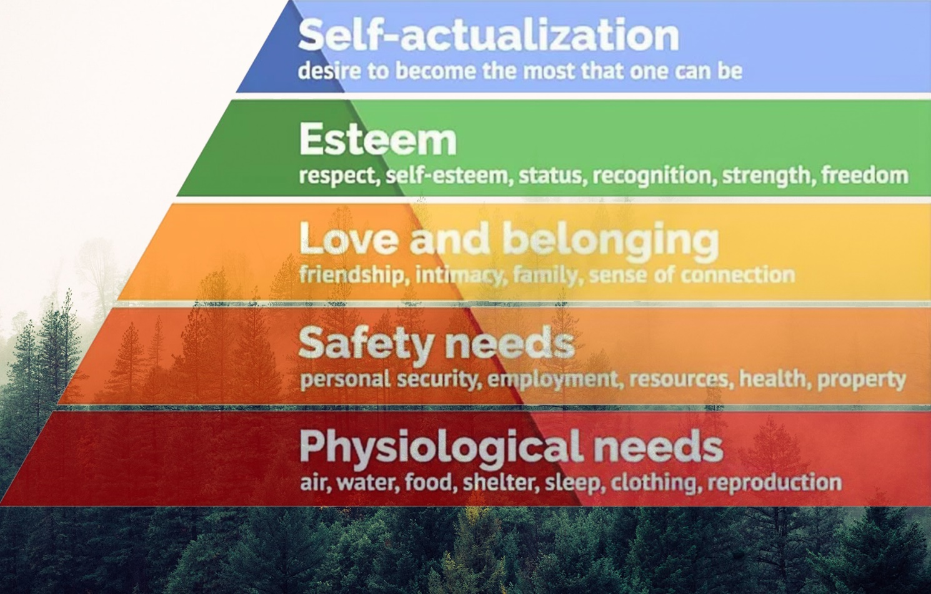
Shelton, S (2020)

Interventions
We as practitioners need to be fully committed in supporting children within the Early Years sector. Providing opportunities and availability to assist them to achieve their full potential.
A Holistic approach is an approach used to view every aspect within a child or young person’s development, or more specifically, ‘Holistic patterns of thought involve attending to both a focal object and the context that it is situated in, and understanding behaviour and causality on the basis of relationships between individual elements’ (Spencer-Rogers, J, Peng, K, 2018). Every aspect is independent, and we cannot think or act holistically if we overlook one aspect. Children need to be pictured as a whole as all these aspects of holistic thinking build who the child or young person is. We can have better understandings when we know more about the child outside of the settings environment. For example, we can develop an understanding of their lives at home, their families, and the community that they are involved in.
Reggio Emilia originated from Reggio Emilia, a city in Northern Italy. Families joined with Loris Malaguzzi to find an individual and unique public system to educate children in the early years of childhood. The approach believes that children have a right to be protagonist of their own learning. It is a child centred approach where parents, teachers and the community are all involved in the child’s journey throughout education. The principles of this approach supports; the rights and opinion of the child, their desire to learn and explore, recognising learning opportunities, teachers listening, observing, working together and reflect on the child’s learning, exploring the environment, providing materials for learning, to understand a child and the way they learn, teaching and educating for all aspect of development and learning and being able to view the learning process. It is believed that through using this approach children are more able to solve problems, welcome new experiences, engage within their community and environment, build better social skills, have confidence to express themselves and to enjoy when learning.
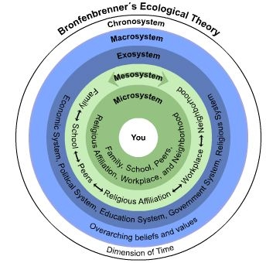
Te Whāriki coming from the Maori language, meaning ‘woven mat’ is a national curriculum originating in New Zealand. Woven mat, symbolising everyone linking together with mutual respect. The approach has 4 principles: Empowerment, Holistic Development, Family and Community and Relationships. The 4 principles are linked to: wellbeing, contribution, belonging, communication, and exploration. The aim of this approach is for children to grow and develop to become confident learners and communicators, healthy in their mind, body and spirit, secure with where they belong, safe that they make a valued and knowledge contribution to the community. From these aims and principles, it is expected that children will recognise the importance of family and the need for respect towards all people. Acquire knowledge that makes the world make sense.
‘Urie Bronfenbrenner’s Ecological Theory’
Urie Bronfenbrenner published his Ecological Theory in 1979. His theory displays five different systems that we encounter throughout our lifetime. It always starts with the child. Then, it is the Micro System, it involves the direct contacts we have within our life such as, family, friends, school, colleagues or within the community. Then is the Mesosystem, it involves the links between your Micro System. For example, your family being involved with your friends or education. or the teacher needing to communicate with your parents. Next, is the Exosystem, is the people you have no contact with but have an active role and participate when necessary for example school governors. After that, is the Macrosystem, this is the culture of someone. The context of culture is ethnicity and race and the environment they are born into such as, third world countries. Influencing the person, the want and strive to become. Lastly, the Chronosystem, includes the transitions and shift throughout someone’s life, such as, a bereavement in the family. It will affect the family emotionally and everyone takes the time to grieve. For children it can affect their behaviour, emotional development, concentration and/or comfort. (Sarah Mae Sincero, 2012)
Outcomes
When caring for children we need to have their best interests in mind. Aiming for the best possible outcomes. Using the set curriculum to support teachers in presenting the best efforts to effectively teach children.
The new curriculum, written by the Welsh Government (2015) and is planned to be used from 2022. It involves 4 purposes: ambitious cable learners, who, enjoy challenges and set themselves high standards, building knowledge and skills, enjoy problem solving, can communicate effectively using both Welsh and English, can explain concepts and ideas, use number effectively, use technology to find and analyse date and are ready to learn throughout their lives. Healthy, confident individuals, who: establish spiritual and ethical beliefs whilst having secure values, build a positive mental and emotional well-being with confidence and empathy, has knowledge about the impact of diet and exercise has on mental and physical health in daily life, take part in exercise, have knowledge on keeping safe and well, make reasonable decisions and manage risk taking, have confidence to take part, from positive relationships with trust ad respect, face and conquer challenges, manage everyday life independently and lead fulfilling lives within the society. Ethical, informed citizens, who: find, understand and use research when forming views, engage with issues using their knowledge, understand their rights and responsibilities, understanding how they make an impact with their choices and actions, know about their culture within the community and world and the history it has, respect the rights and needs of others, show commitment to the plant and be citizens of Wales and the world. Enterprising, creative contributors, who: apply their knowledge and skills towards creativity, think creatively to solve problems, take on all available opportunities, take reasonable risks, play different roles within teams and act effectively, express ideas and emotions through different styles, benefit others with their ideas and skills and be prepared to play full time position in life and work. (Welsh Government, 2015)
The Foundation Phase is designed for children ages three to seven years of age learning in Wales. It aims to encourage children to be creative, imaginative and to enjoy whilst making more effective learning. The foundation phase has seven areas of learning, that are delivered through planned and structured learning; personal and social development, well-being and cultural diversity, language, literacy and communication skills, mathematical development, creative development, physical development, knowledge and understanding of the world and welsh language development. (Welsh Government, 2018)
The policy for Every Child Matters was applied to the well-being of children and young people from new-born until they turn 19 years of age. The idea was based upon that regardless of their individual circumstances or background the child should receive plenty of support throughout their education and throughout life. It is important that no matter the disability of the child, we provide them with an aid in order for them to learn and have the same opportunities. The 5 outcomes of this policy are ‘to be healthy, to stay safe, to enjoy and achieve, to make a positive contribution and to achieve economic well-being.’ (Newcome, 2020)

References

