
Undergraduate assignment feedback form
(to be completed by marker)

Student Name: Dylan Trevett

Module Code: AHMS6004  Module title: Identity and Myth: The Normans and their World | Student number: 1500610
For completion by marker:
Comments:

Marker’s signature: |  | Date:
Provisional mark:
NB. All marks are provisional until confirmed by the final examination board.

This portfolio will look at the image of Roger II of Sicily, and look to see what this image tells us about how the Normans as a people wanted to be represented in such quality artwork, but also to analyse what Roger II thought of himself, in terms of an individual being selected by God. As well as this there will have to be an investigation as to what the image has failed to show us, and how this can impact our understanding on the perceived perspective of both Roger and the Normans in southern Italy.
The image is of Roger II, being crowned the king of Sicily, by Jesus Christ himself. This image has been created in the form of a mosaic, which was a larger part of work found in the church of La Martorana. The materials in the mosaic itself, give us a good indicator on this image’s intended audience. As we can see the mosaic is made out of gold, which clearly indicates that Roger was a wealthy Norman, and that he wanted to be represented in such lavish materials to make a statement of just power and authority in the Kingdom of Sicily.
What we must look into is, what the image represents, and how it can tell us more about Roger and indeed how the Normans viewed themselves. The image itself, can show us the different cultures that were present where this mosaic was made. To begin with the fact that the image is a mosaic rather than a painting signifies the fact that this piece was made by the Byzantines, and the faces of both Christ and Roger are quite Greek looking in terms of their features, which are seen in other Byzantine work of the period. There is also some Greek and Arabic writing present in the image, which further suggests to us that in Sicily there was a mixture of cultures with Byzantines, Franks and Muslims. When we see Roger II being crowned by Christ in this image, it shows us how the Normans in Sicily viewed themselves as being the chosen people by God, something that has been ever present in their histories. The significance of this image is the fact that Roger believed that his Kingdom of Sicily would be a monarchy that is responsible to God, but also this image is used to show the separation the Normans wanted from papal intervention and politics. This is further significant because the Frankish kings saw that direct authority came from God, thus giving us a possible reason as to why Roger is being crowned by Christ rather than that of a pope. There is also evidence to suggest that Roger looks like Christ in this image because in the East the emperor was Gods minister who was arguably earth’s representation of Christ. This makes sense as Roger is obviously showing his authority and his sense of belonging in the image, but also it could again be another form of legitimisation for the Normans as this recurring theme of them being the chosen people by God. We also see Roger in this image wearing the imperial lorum of Byzantium and also clothing that arguably would have been worn by a priest, which again is a further indication of the mixture in culture and also the fact that Roger is being represented as a man of God. There is also an indication that the crown Roger is being presented with is that of a Byzantium traditional crown known as the Eastern basileus, which according Borsook disrespected the Byzantine emperors. This overarching representation of Byzantine customs can be viewed as previously stated a mix in the culture, however it can also be viewed as Roger declaring himself a leader of these people and in some way incorporating their traditions in the way of the Normans. Again, this is arguably used to legitimise themselves, but also it can be viewed as the Normans borrowing various symbolic heritage and applying it themselves.
However, we must now consider what the image is failing to show, in how Roger was represented. The image fails to show further justification from Roger that invokes him as gods minister. As it is known that Roger had built a church like Peter, on a rock, this is showing that Roger was familiar with the importance of the apostles in the bible, which was needed for him to sanctify further clarification of himself being the main authority of God. As well as this the image does not tell us how the papacy felt about Roger being the authority of God, which according to Albu caused friction between both pope and that of the Holy Roman Emperor, with all parties concerned having a claim to such stature in relation to being the chosen representation for God. This in turn led to a rebellion in a 1131.
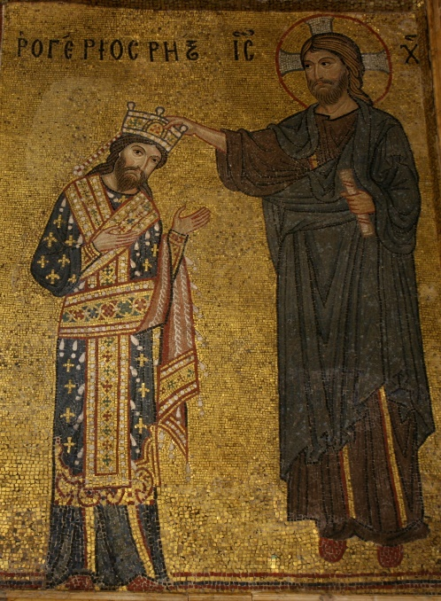
To conclude this image does go a long way in showing us how Roger II wanted to be seen as the King of Sicily and the main authority of God. However, when we look further into the imagery and hidden meaning behind the clothing for example, we begin to see this mix in culture, which the Normans seem to have taken and incorporated it into their works and everyday life. The image in a way does give us enough information on how this Norman and Normans in general saw themselves, however there had to be further analysis and reading around the subject to be able to conclusively say that they wanted to become the chosen people by God. Overall this image is useful to an extent, however it only offers the perspective of the Normans in southern Italy rather than them as a whole, although it could be argued that the Normans of the South and those in Normandy were two separate cultures only relatable by the way in which they incorporated themselves into various cultures and religious beliefs to belong.

Bibliography
Albu, Emily, The Normans In Their Histories: Propaganda, Myth and Subversion, (Woodbridge: The Boydell Press, 2001)
Borsook Eve, Messages In Mosiac: The Royal Programmes of Norman Sicily (1130-1187),(Clarendon Press: Oxford, 1990)
Houbert. Hubert, Roger II : A Ruler between East and West,(Cambridge University Press: Cambridge, 2002),

H. Houbert, Roger II : A Ruler between East and West,(Cambridge University Press: Cambridge, 2002),Page 114.
‘Roger II being crowned by Christ’ in E.Borksook, Messages In Mosiac: The Royal Programmes of Norman Sicily (1130-1187),(Clarendon Press: Oxford, 1990).
E.Borksook, Messages In Mosiac: The Royal Programmes of Norman Sicily (1130-1187),Page 6.
Ibid.
Ibid.
‘Roger II being crowned by Christ’ in E.Borksook, Messages In Mosiac: The Royal Programmes of Norman Sicily (1130-1187).
E.Borksook, Messages In Mosiac: The Royal Programmes of Norman Sicily (1130-1187),Page 3.
Ibid.
E.Borksook, Messages In Mosiac: The Royal Programmes of Norman Sicily (1130-1187),Page 7.
E, Albu, The Normans In Their Histories: Propaganda, Myth and Subversion, (Woodbridge: The Boydell Press, 2001), Page 222.

