Final Report

Research methods and project
Andrew Gibson

Investigation to identify key characteristics for improved engine efficiency for the Ford Sigma naturally aspirated against the turbocharged Sigma engine



Jack Beynon
P146629
BSC MOTORSPORT ENGINEERING

Table of Contents
abstract 3
abstract – technical 3
topic of interst 4
1.0 introduction 4
2.0 literature review 6
2.1engine downsizing 6
2.2 turbocharging 7
2.3 knock detenation 8
2.4 effciency 9
2.5 – Engine Testing 10
2.6 – Ideal Otto Cycle 11
3.0 methodology 12
3.1 data sets 12
3.2 data sets - turbo 13
3.3 theoretical cycles compared to Experimental 14
3.4 Naturally Aspirated Work Data 15
3.5 Sigma 1.6 Naturally aspirated WORK done 16
3.6 - Calculating new volume for Turbo engine 17
4.0 ANALYSIS 18
4.1thermal efficiency calculations – turbo 18
4.2 thermal efficiency graphs – turbo 19
4.3 - Thermal efficiency 1.6 sigma naturally aspirated 20
4.4 Thermal efficiency comparison 21
4.5 - Start and end of combustion – turbo data 22
4.6 ANALYSIS - Start and end of combustion turbo 23
4.7 Start and end of combustion naturally aspirated engine 24
5.0 RESULTS 25
5.1 start and end of combustion 27
5.2 SGTI DATA 28
6.0 Conlusion 29
7.0 Bibliography 31
8.0 Appendices 33
Appendix 2: Naturally aspirated thermal efficiency 38
Appendix 3LogP v LogV graphs – turbo 39

abstract

This project will be looking at two different types of engine, one being the Ford Sigma 1.6 naturally aspirated engine and the other being the turbocharged 1.6 Sigma engine.
Investigations will be made using various data sets which have been collected based on various testing methods. These results will be compared using various graphical techniques and from this the data interpreted and used to support or challenge the assumptions.
From the analysis a person’s knowledge of the subject will be expanded and they will have increased knowledge on how an engine functions under different calibration parameters.

abstract – technical
Ignition control has varied over the years as technology has become much more developed. Before having Electronic Control Units (ECU’s) technology, we would see ignition control being all mechanically controlled and this had many flaws. The report will detail investigations into the various cylinder pressures of an internal combustion engine, one being a naturally aspirated and the other a turbocharged. From various data gathered comparisons will be made on both the engines and comments made and then draw conclusions on what the data shows.
The report will then look at how knock can be prevented in relation to retarding the ignition timing by using a standalone ECU. It is hoped that the findings would be as expected and can be applied to certain gas laws

topic of interst

Investigation to identify key characteristics for improved engine efficiency of the Ford Sigma naturally aspirated against the turbocharged engine.

1.0 introduction

This project will look at the various ways in which engine ignition systems are controlled, with a review of the historical developments in this type of technology.
This report summarises an investigation into identifying the key characteristics required for improved engine efficiency in differing types of engine. The engines selected were from the Ford Sigma model, looking at the naturally aspirated and turbo charged engines.
The report provides calculations, evaluation and analysis of a data set based on dynamometer testing results from the two engines.
The topic and scope of the report was chosen to gain a better understanding of how different engines work and perform and also to gain an understanding of what alters on an engine when a turbo charger is added.
Calibration becomes more important as engines technically improve and it becomes more complex through developments in tighter emission controls and greener technology.
It is necessary to understand how engine calibration has to be developed in order to avoid engine knock. Engine knock occurs when the fuel in the cylinder pre ignites instead of the spark plug igniting the fuel and air/mix, knock limits can be set from various electronic control systems which detect when engine pre combustion is happening and from this alters the ignition timing.
In order to collect the correct data from an engine it has to be put through a dynamometer test. Dynamometer testing is very specialist and in order to get the pressure and various other points a normal set up would not be substantial and was not directly available for me to test and use in the report, Due to this a set of data made available by the Ford Motor company was used.
The data was sourced by putting engines through differing driving conditions dynamometer tests at varying drive cycles replicating a vehicle encountering different road conditions.
The data was used to calculate the following parameters:
- Work done per engine speed.
- Over all work done by revolution per minute (RPM).
which in turn are used to calculate the engines thermal efficiency.
The thermal efficiency of the engine is the efficiency of a heat engine measured by the ratio of the work done by it to the heat supplied to it.
Various Graphical representations of the pressure data were made, which was obtained from Ford Motor Company, these were then used to show pressure v crank angle graph to show the differences in engine types.
Following on, the thermal efficiency of the Ideal Otto Cycle will be calculated through various compression ratios, this will then be compared back to the Theoretical cycles v actual and differences analysed. After this the Work Out per engine speed can be calculated in order to subsequently calculate overall work done
The overall goal of the report is to calculate Thermal Efficiency and compare the engine types. The expectation is that the turbo charged engine is more efficient than the naturally aspirated engine.
In order to understand what to calibrate this report includes a detailed analysis on engine performance and efficiency.

2.0 literature review

2.1engine downsizing

Engine downsizing has been a massive part of the automotive industry, with each manufacturer trying to increase their fuel economy and produce less emissions but at the same time having much smaller engine. Even though downsizing is an effective way to achieve this, it does have its obstacles with the turbocharged engines which could have reduced torque at low engine speeds, and turbocharger lag as these smaller engines are heavily reliant on the turbocharger to push more air into the cylinder. It is not only the technical characteristics of the engines but it’s also the market for them. Most people are used to seeing vehicles with a much larger engines this has traditionally been a close association between the swept volume and desirability for the consumer but also the profitability for the vehicle manufacture. (SceinceDirect, 2017)
Mahle have achieved this and a B.M.E.P of 16 bar by taking advantage of the lower frictional losses and overall weight of a smaller engine and combining turbo-charging, Gasoline Direct Injection (GDi) and variable valve timing technology. Mahle’ research also includes investigation in to the effect of two stage turbo-charging, Exhaust Gas Recirculation (EGR) and a reduction in the weight of the valve train and induction system. Their EGR system can reduce fuel consumption by up to 17% at an engine speed of 5000rpm, and lower the untreated (before any catalytic conversion) emissions of both NOx and, HC and CO by up to 30% and 80% respectively (International, 2007)
Downsizing enables:
- Increasing engine power and torque to respond to new market demands and to compensate for vehicle weight without increasing cylinder capacity
- Reducing engine capacity at the same power
When downsizing, the resultant increase in engine power and torque can have an effect on the fuel consumption i.e pumping losses.
- Less swept volume on each engine revolution
- Higher average intake pressure between drive cycles
Gases to wall heat transfer reduction this reduces the internal surface area. It also gives a shorter flame distance to travel which speeds the combustion process up and gives reduced gases wall head exchange duration.
Highly downsized engines suffer from mechanical friction meaning that their lifespan is less comparable to that of present engines. The same can be said for highly loaded supercharged engines which remain more fragile than naturally aspirated ones. Supercharging is used to provide extreme power and torque for exceptional driving conditions (sport cars), but most of the time (during ordinary driving cycle), these engines operate under similar load levels to those of naturally aspirated engines. (International, 2007)

2.2 turbocharging
Turbochargers increase the air-mass flow for a given engine displacement at a given engine speed therefor increasing the power density (reif, 2014). There can be many different variants of turbochargers, as you can get some that are electronically controlled but the main type which is seen in many different applications is the exhaust gas driven turbocharger. This style of turbocharger works off the exhaust gasses which are produced by the engine.
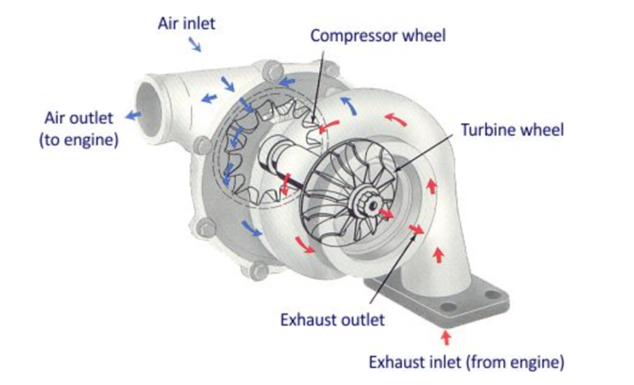

Figure.1 Showing turbocharger design (Schwitzer, 1991)
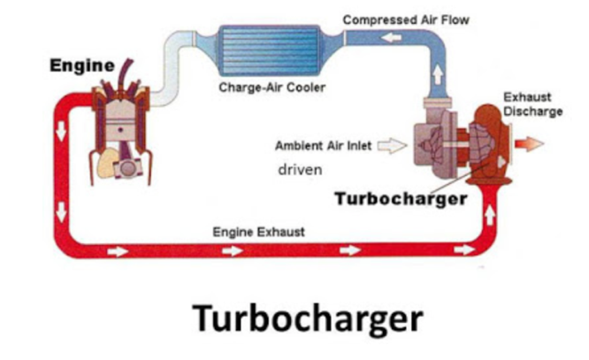
In figure.1 the image of a turbocharger system can be seen. This system contains 6 various components to make it function. This is mounted directly off the exhaust manifold in a way that the gasses can flow directly into the exhaust gas turbine which can be seen as the exhaust inlet on the image. The gasses then flow directly over a turbine wheel which starts to spin, directly opposite on the other side of the charger the compressor wheel which is connected by a shaft to the exhaust outlet then starts to spin compressing the air which is entered in through the air inlet. This air the gets compressed and go through the air outlet, this air is then hot as it has been compressed as it travels to the engine inlet it goes through an intercooler which then cools the air down before entering the engine.

Figure.2 Turbocharger system layout (Study, 2015)

2.3 knock detenation
Engine knock which is also known as premature combustion, pinking or pining is only found in a spark ignition engine.
Knock occurs when the engine is undergoing the compression stroke and is close to hitting Top dead centre, or more commonly known as TDC. In normal circumstances combustion would ignite the air/fuel ratio just before TDC to gain full expansion or constant velocity to push the piston down. However we see knock occur when the cylinder does not result in propagation of the flame which is ignited by the spark plug, but in the cylinder we can see pockets of the A/F ( Air/fuel Ratio) explode outside the normal flame burn pattern. (Bosch, 2016)

Knock creates shock waves and makes a metallic “pining” sound, as of this cylinder pressure increases dramatically. Figure.3 bellow shows a typical example of various shockwaves of what we would see in a cylinder. First, we can see Normal combustion with a smooth combustion curve whereas the slight knock we see the curve oscillate slightly then under intense knock we see the oscillations become very aggressive.
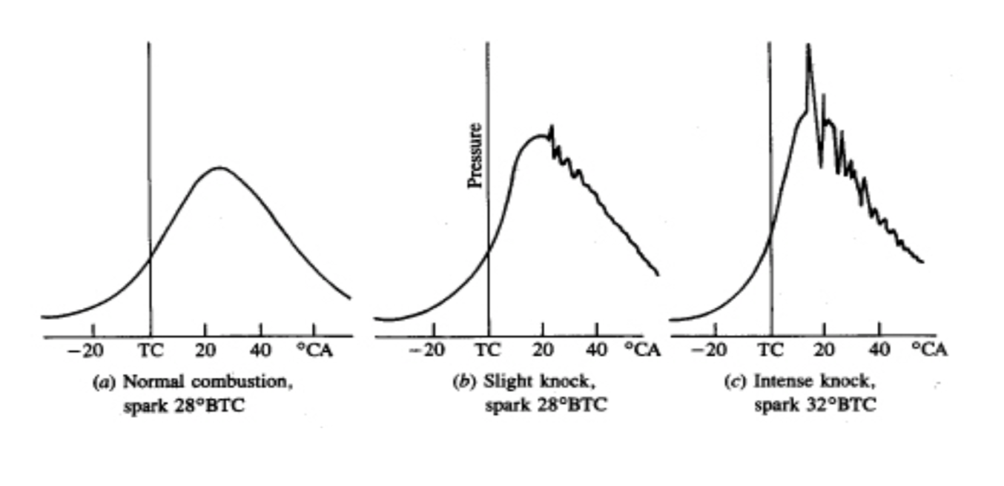
Figure.3 showing knock stages (reif, 2014)
(reif, 2014) (reif, 2014)

With smaller engines that use forced induction, as the cylinder volume is much smaller than a bigger engine when the turbo pushes air into the cylinder this increases the pressure, in which pre combustion of the fuel and air mix can happen.
If there is no knock control, there must still be some means to define a clear safety margin to the knock limit. This margin is necessary to ensure that, even in the most knock-sensitive case regarding engine tolerances, engine aging, environmental conditions and fuel quality, no cylinder can rear or exceed the knock limit (Bosch, 2016)

2.4 effciency
To measure the performance of an internal combustion engine is the proportion of the heat of combustion of the fuel that is burnt and made into useful work at the engine. The thermal efficiency at full load of an internal combustion engine can range from around 20% in a small petrol engine and over 50% for a larger slow running diesel engine, which are the most efficient means currently available for turning the heat of combustion of the fuel into mechanical power (A.J.Martyr, 2007). When building an engine it is very useful to have an idea of the theoretical maximum thermal efficiency as this sets a mark for the designers.
The calorific value of the fuel is determined on the terms of the amount of heat that released when a fuel is burned completely in a calorimeter. Since all hydrocarbons fuels produce water as a bi-product of the combustion, part of the exhaust gas consists of steam. If as this is the case of a calorimeter, these products of combustion are cooled to ambient temperature, the steam condenses and in doing so gives up the latent heat. The corresponding measure of heat that is released is known as the higher or the gross calorific value. If no account is taken of this the latent heat there is no lower or net calorific value which is commonly known as the specific energy. Since there is no possibility of an internal combustion engine making use of the latent heat, it is the invariable practice to define performance in terms of the power calorific value (A.J.Martyr, 2007). Below states a table of the various and density of typical fuels.
Table.1 Showing calorific values for different fuel types (A.J.Martyr, 2007)
Fuel type | Lower calorific value  (MJ/kg) | Stoichiometric air/fuel ratio | Density (Kg/l)
Gasoline | 43.8 | 14.6 | 0.74
Gas oil | 42.5 | 14.8 | 0.84
Methanol | 19.9 | 6.46 | 0.729
Ethanol | 27.2 | 9.94 | 0.79
Light fuel oil | 40.6 |  | 0.925
Medium fuel oil | 39.9 | 14.4 | 0.95
Heavy Fuel oil | 39.7 |  | 0.965
Further on in the report, various thermal efficiency’s will be calculated for the Ford Sigma 1.6 naturally aspirated and also the turbocharger engine. In order to make these calculations correctly the calorific value of the fuel will need to be calculated.

2.5 – Engine Testing
Engine performance is a sign of degree of success, for example the conversion of energy of fuel into helpful work. The engine performance is compared on the basis of certain performance markers known as performance parameters. The most important parameters are the engine load, speed, torque, brake power, brake thermal potency, specific fuel consumption and exhaust emissions. The data relating to different elements of the engine, modifications carried on them, the instrumentation used for conducting experiments to evaluate the performance and emission characteristics are mentioned in this chapter. (Anon., 2015)
The engine dynamometer allows equipment to be used which would not be practical to use in a vehicle test. By using a dynamometer many different values can be calculated and the engine can be put through various drive cycles in which you would not be able to do on the road due to other conditions. It gives the ability to measure key performance characteristics such as fuel flow, air flow, emissions, the dynamometer can also allow you to understand what the shape of the torque and power curves are like this can be then analysed and logged. They can also be used to calibrate and engine as the fuelling and ignition timing can be altered depending on various inputs.
There are various different types of dynamometers –
- Hydraulic dynamometers
- Electric dynamometers
- Eddy current dynamometer
- Rope brake dynamometer
(A.J.Martyr, 2007)
The inertial part of the equation only really happens during the acceleration phase. If the engine speed is constant, there is no inertia. So dyno manufacturers still have to understand what the amount of inertia in their system is and calculate for that. So the dyno can have the most accurate calculation in the world for controlling its own inertia, but if the inertia of the engine itself has not been calculated, these issues will still arise. (IGER, 2018)

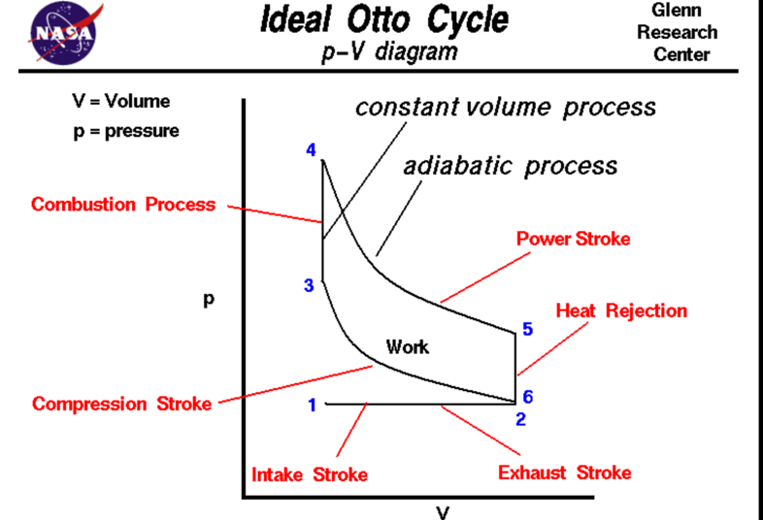
2.6 – Ideal Otto Cycle
Figure.4 Ideal Otto Cycle (NASA, 2016)
Gases have various properties that we can observe with our intellects, including the gas pressure p, temperature T, mass, and volume V that contains the gas. Careful, scientific observation has determined that these variables are related to one another, and the values of these properties determine the state of the gas. A thermodynamic process, such as heating or compressing the gas, changes the values of the state variables in a manner which is described by the laws of thermodynamics. The work-done by a gas and the heat transferred to a gas depend on the beginning and ending states of the gas and on the process used to change the state. It is possible to perform a series of processes, in which the state is changed during each process, but the gas eventually returns to its original state. Such a series of processes is called a cycle and forms the basis for understanding engine operation. (NASA, 2016)
Above in figure.4 the OTTO cycle can be seen this is used in all internal combustion engine. This PV diagram also known as pressure volume states the clear process of the cycle. From the above labelling from 1-6 we can states the various cycles, from the bottom left 1-2 this is the beginning stage which is the intake stroke, the pressure is near atmospheric pressure and the gas volume is at a minimum. Between stage 1 and 2 the piston is being pulled down the cylinder with the intake valve open which the pressure remains at a constant the gas volume is increasing as the air/fuel mixture is being drawn into the cylinder by the intake valve. At stage 2 the compression stroke of the engine is starting with the intake valve closing. At 2 – 3 the piston is travelling up the cylinder and the gas volume is decreasing and the pressure increasing as of the work done on the gas by the piston. At stage 3 the combustion of the cylinder is starting with the air/fuel mixture. This comes very quickly and the volume remains a constant. When the flame starts to burn the heat is released which increases both the temperature and the pressure, according to the equation of state p * V / T = n * Rbar. (NASA, 2016). At stage 4 the power stroke beings and between 4-5 the piston is travelling at constant velocity the pressure is reduced as the work is done by the gas of the piston. At stage 5 the exhaust valve opens and the remaining heat in the gas is exchanged to its surrounds. Stage 6 then beings when the exhaust stroke when the piston starts travelling back up the cylinder, the volume decrease and the pressure remains a constant. At the end of the exhaust stroke the conditions return to stage 1. (NASA, 2016)

3.0 methodology

3.1 data sets

Through the use of data which has been obtained from Ford Motor Company, an investigation will be carried out looking into how two engines act through various engine conditions. These are both the 1.6 Sigma engines one being a forced induction which uses a turbocharger and the other being a naturally aspirated application. In this report would hope to show me complete understanding of how these engines act and how they have to act in the way they do.
By using the data from Ford Motor Company various calculations can be done to determine how they engine is functioning and why it is acting in the way it is. The first step will be to look at the Pressure V Crank Angle. Below in Figure 4 shows the pressure v crank angle of the naturally aspirated 1.6 engine at 1000Rpm.

Cylinder Pressure

BDC
TDC
TDC
BDC
TDC

EXHAUST
COMBUSTION
COMPRESSION
INDUCTION

Figure 4 Showing Pressure V Crank Angle 1000RPM Turbo
When looking into the cylinder pressure v crank angle graph the four stroke cycle is noted below, it is key to make this known as when analysing the graph at each point that is noted needs to be understood and seen what exact part of the cycle it is going through.
Above in Figure 4 the Cylinder pressure against engine rpm is shown. This graph is showing the pressure as it goes through a four stroke cycle, where we see bottom line of the graph being at bottom dead centre and as the piston is travelling upwards in the cylinder and nearly reaching the top dead centre of the cylinder the pressure is reaching a maximum. This graph shows the curve which increases very uniformly and the decreases. Throughout the report by the use of various calculations it will be investigating why this is happening to the engine and how ford have done this.

3.2 data sets - turbo

In section 2.1 the pressure v crank angle was looked into for the naturally aspirated engine, which saw the curve of the pressure increase with a smooth curve then decrease with a smooth curve also, whereas the turbocharged data we see a completely different pattern which the line follows, as related back to figure.1 the four stroke cycle can be seem on the X axis of the graph, just as the piston is traveling up the cylinder bore and is just reaching Top Dead Centre (TDC) there is a pressure drop this will be investigated to see why this is happening.
Crank Angle
Figure 5: Showing Pressure V Crank Angle 1000RPM Naturally aspirated
As these engines that are being investigated are both four stroke cycles, we can refer back to the ideal otto cycle, in Figure 6 the pressure volume graph can be seen. The arrow is showing a clear point in which we see the pressure drop slightly as it shows more clearly in Figure 6.
Figure 6: Showing Pressure v Volume @ 1000Rpm Turbo
Pressure ( Bar)

3.3 theoretical cycles compared to Experimental

Above in section 2.6 the Otto cycle was explained this cycle is applied to any internal combustion application. By taking various compression ratios the thermal efficiency is able to be calculated.
By using the equation -
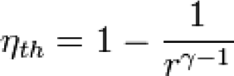 $γ=\frac{CP}{CV}$
(Anon., 2013)
We see the following values taken as
Air = $γ=1.4$
Air & fuel Mix = $γ=1.35$
Rich = $γ=1.3$
Ideal cycle = $γ=1.4$
Table.2 Otto cycle thermal efficiency through different compression ratios
Compression Ratio | Thermal efficiency of Otto cycle %
9 | 0.584756353
10 | 0.601892829
11 | 0.616784624
12 | 0.629892828
13 | 0.641554891
14 | 0.652024405
15 | 0.661496241
16 | 0.670123022
Above in Table.2 a calculation has been done using the equation stated above, by taking various compression ratios it can be seen that the thermal efficiency of the cycle can change a various amount. These efficiencies are taking as a percentage. For example with the Ford Sigma 1.6 turbocharged engine having a compression ratio of 10 (Company, 2016) at the compression ratio of 10 the thermal efficiency of the Otto cycle is around 60% efficient in the next section of the report both the turbocharged and naturally aspirated engines will have their thermal efficiency’s calculated over various RPM points, these will be 1000- 6000 in 500 RPM increments. This will be used to compare the theoretical efficiency to the actually efficiency of both engines.

3.4 Naturally Aspirated Work Data
By using the data collected by Ford Motor Company both the naturally aspirated and turbocharged engines were run on a engine dynamometer, from this various data was collected Below this can be seen.

In figure 7 various data points can be seen from 360 degrees to -360 of crank angle different pressure points have been taken for each cylinder, to make sure the validity of the analysis is good only cylinder one pressure will be used in order to work out various calculations.
Figure 7: N/A Pressure Data (Company, 2016)
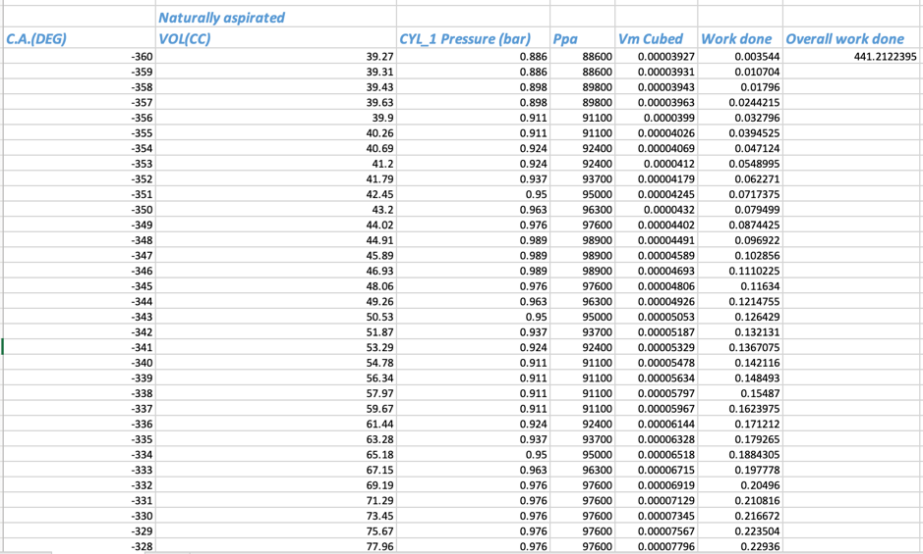
Below is a print screen of the Excel data that has been collected and by using the channels in Excel various calculations can be programmed in to work out the overall work done for that specific cylinder at certain rpm’s in the screen shot below it shows the overall work done for the naturally aspirated work done at 1000rpm. once the work done has been calculated per various engines speeds the thermal efficiency can be calculated in the next section.

Figure 8: N/A Overall work done @ 1000RPM

3.5 Sigma 1.6 Naturally aspirated WORK done

In figure.8 the Excel print screen of the work done calculation can be seen, as this graph has different points in it which have to be formatted correctly for it to be able to calculate the work done. By taking the raw data from Ford itself two various plots can be seen the crank angle and the pressure.
In order to calculate the overall work done by the cylinder the pressure needs to be converted into PA, this is done by multiplying the pressure by $x {10}^{5}$, the pressure can now be seen in Pascal.
The next step is to covert the volume into $M^{3}$ this is done by taking the unit and dividing it by / ${10}^{6}$.
In order to calculate the work done-
$\frac{(P1+P2)}{2} x (V2-V1)$
(stone, 2012)
P = Pressure
V = Volume
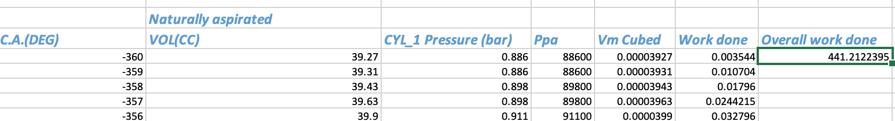
By using this calculation the work done per rpm can be calculated. Once this is done an average of the work done can be taken to find the overall work done for that specific RPM.
Figure.9 Showing excel spread sheet.
This formatted Excel sheet can now be used to calculate the overall work done for each rpm for the turbocharger and the naturally aspirated engines. Once the overall work done is calculated the thermal efficiency is able to be calculated.

3.6 - Calculating new volume for Turbo engine

By using the formatted Excel spread sheet above the work done can be calculated for each RPM, from this the thermal efficiency can be calculated. As the turbocharged sigma engine is the same block but with a different compression ratio this means that the volumes are going to be different. As the volume at TDC of the naturally aspirated is known the new volume is able to be calculated.
Known TDC volume of N/A = 39,27cc
VTDC = Volume @ top dead centre
BTDC = Volume @ bottom dead centre
CR = Compression ratio
CR = $\frac{VBDC}{VTDC}$ = $\frac{400 + 39,27}{39,27}$ = 11,8

Turbo CR = 10
CR = 10 = $\frac{VBDC}{VTDC}$ = $\frac{400+VTDC}{VTDC}$
10 VTDC = 400 + VTDC
10 VTDC – VTDC = 400
9 VTDC = 400
VTDC = $\frac{400}{9}$ = 44,44cc
Turbo VTDC = 44,44 cc
N/A VTDC = 39,27cc
Volume difference per crank angle = 44,44 – 39,27 = 5,17cc (Mcdonald.2019)
The calculation above shows the added volume which will be added to each crank angle increment as the turbocharged version has a bigger volume due to it having forced induction on it. Through the excel data below this can be seen in another column
Table.3 Excel print screen of turbo data

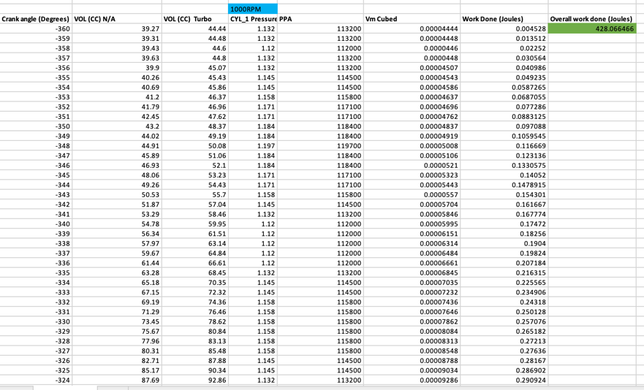

4.0 ANALYSIS

4.1thermal efficiency calculations – turbo
As covered in section 4.4 by formatting the excel spread sheet the work done is able to be calculated for each rpm. these will start at 1000 rpm through to 6000 rpm by calculating the thermal efficiency through the work done the fuel mass per rpm is needed. Below in table.4 is a print screen of the SGTI data which has been obtained from the Ford motor company. These figures calculated will all be before friction.
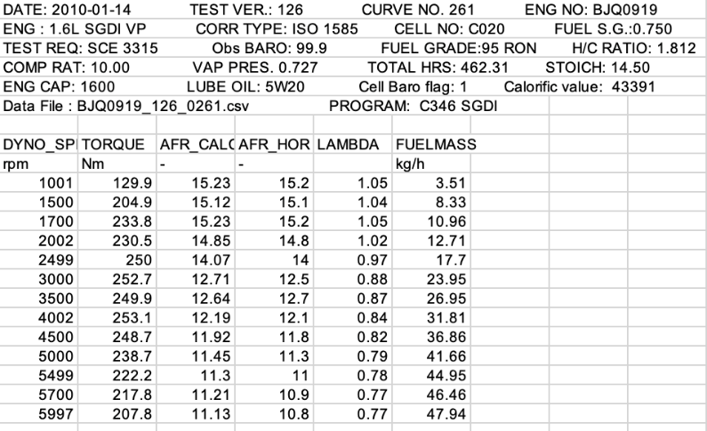
Table.4 SGTI DATA (Company, 2016)

Here is an example of how it is calculated. The following calculations can be seen in Appendix 1
1000RPM
Work out @ 1001 RPM = 428.06
Fuel mass @ 1001 RPM = 3.51 Kg/h
Fuel/Revolution = $\frac{3.51}{60}$
Fuel/ Cylinder = $\frac{3.51 }{2x60x1001}$ = 2.95x${10}^{-5}$
The Calorific value of fuel which is 44${x10}^{6}$ was taken from the SGTI data obtained from ford.
Fuel energy = 2.95x${10}^{-5}$ x 44${x10}^{6}$
= 1284.8
Thermal efficiency = $\frac{work done}{fuel energy }$ = $\frac{428.06}{1284.8 }$
= 0.33
= 0.33 x 100
= 33% (A.J.Martyr, 2007)

4.2 thermal efficiency graphs – turbo

Table.5 Chart showing work done and efficiency’s over various rpms.
RPM | Work Done (J) | Thermal Efficiency % | Lambda
1000 | 428.06 | 33 | 1.05
1500 | 672.72 | 33 | 1.04
2000 | 753.09 | 32 | 1.02
2500 | 830.87 | 32 | 0.97
3000 | 829.23 | 28 | 0.88
3500 | 813.23 | 29 | 0.87
4000 | 843.41 | 29 | 0.84
4500 | 836.05 | 28 | 0.82
5000 | 809.36 | 26 | 0.79
5500 | 754.56 | 25 | 0.78
6000 | 723.15 | 24 | 0.77

The above chart shows the calculated work done and thermal efficiency over various rpms, with a column added in for lambda as the next step is to plot a graph showing efficiency against rpm.

As what can be seen at 1000 rpm the thermal efficiency is at 33% and then drops to 24% by the time the vehicle reaches 6000 rpm, this is a drop by over 10%. The next stage is to see why the efficiency is dropping at a higher rpm.
Figure 10: Thermal efficiency against engine RPM

4.3 - Thermal efficiency 1.6 sigma naturally aspirated

In the last section where the thermal efficiency was calculated for the turbocharger engine the fuel mass was given In the data so the fuel energy was then to be calculated. With the sigma naturally aspirated data the QMAX average has been calculated in the pressure data. The QMAX value is the heat energy which has been produced by the fuel. (stone, 2012)
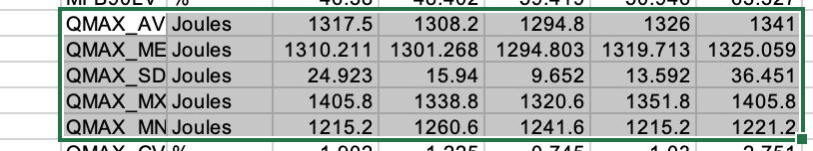
Figure.11 Showing fuel energy.
When looking into the chart there are 4 main columns starting from the left through to the right each section represents a cylinder, for the calculations all the data has been taken off cylinder one. So for this rpm which is 1317.5 joules.
An example of how this is calculated below.
@1000 Rpm
Work done = 87.53 J
Fuel energy = 913.3 J
Thermal Efficiency = $\frac{work done}{fuel energy }$ = $\frac{87.53}{913.4}$ = 0.096 (A.J.Martyr, 2007)

4.4 Thermal efficiency comparison

Table.6 Thermal efficiency of both engines
RPM | Work Done (J) – N/A | Thermal Efficiency % - N/A | Work Done (J) – TURBO | Thermal Efficiency % - TURBO
1000 | 87.53 | 9.6 | 428.06 | 33
1500 | 444.56 | 42 | 672.72 | 33
2000 | 497.49 | 40 | 753.09 | 32
2500 | 501.49 | 41 | 830.87 | 32
3000 | 507.59 | 43 | 829.23 | 28
3500 | 508.03 | 42 | 813.23 | 29
4000 | 523.43 | 42 | 843.41 | 29
4500 | 527.06 | 40 | 836.05 | 28
5000 | 528.04 | 40 | 809.36 | 26
5500 | 512.78 | 38 | 754.56 | 25
6000 | 496.68 | 37 | 723.15 | 24

In the above chart various data points can be seen, both the work done and the thermal efficiency with the naturally aspirated on the left and the turbocharger data on the right. Looking into the work done section on the N/a at 1000 rpm the work done is very low and reaches a max of 528.04J which is at 5000rpm before dropping back down to 496.68. the overall average thermal efficiency of the engine is 37.6%. when looking into the section of the work done of the turbocharged engine the max work done can be seen at 843.41J which is at 4000RPM. The efficiency of the engine can be seen to start at 33% at 1000RPM which it is then at its peak efficiency and by the time the engine has reached 6000 RPM it is at only 24% efficient which is very low considering these engines are known to be one of the most efficient on the market. The average efficiency of this engine is 29% which is just under 8% less efficient than the naturally aspirated engine.

4.5 - Start and end of combustion – turbo data
The next stage of the report was to look into the start and end of combustion to see when the engines were starting the burn process and also ending. This was done by creating an excel spread sheet which had the volume of the turbocharged data and the pressure points also, from this the Log of the pressure was formatted and also the log of the volume. Below shows a screen capture of the formatted spread sheet.
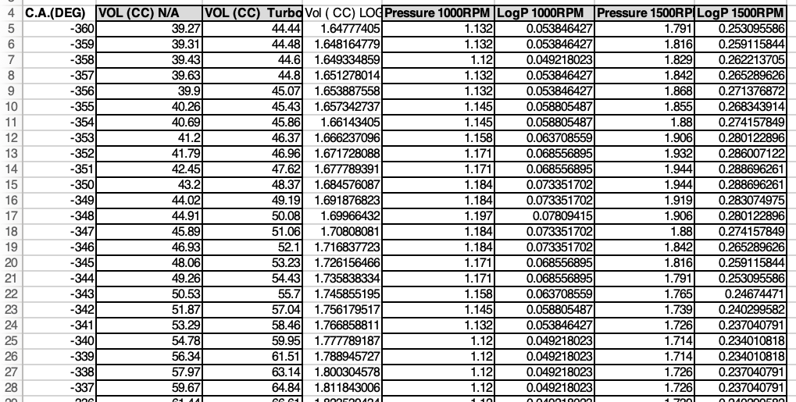

Figure.12 Print screen of excel data sheet of SOC & EOC Turbo
In order to see when the start and end of combustion was occurring a graph is needed to be made so clear points can be taken. Below in figure 13 a graph of the log of the pressure and the log of the volume can be seen, as noted in the first section of the report the drop in pressure from the turbocharged data before the pressure increases. The black arrow shows where the start of combustion is taking place which the point is noted, then the orange arrow shows where our end of combustion is taking place again this is noted. Then next stage is to find these points on the LOG V column and compare back to which crank angle that these point are at. More examples of the LogP & LogV graphs at each rpm can be seen in appendix section 6.8
LogV

LogP

Figure 13 Showing LOG P & LOG V @ 1500RPM turbo

4.6 ANALYSIS - Start and end of combustion turbo
The table below shows the start points of combustion and also the end points. From this the burn duration is able to be calculated in degrees to see how long the fuel is taking to burn.
Table.7 Burn duration of turbocharged Sigma engine.

RPM | SOC (degrees) | EOC (degrees) | Burn duration (degrees)
1000 | -13 BTDC | 32 | 45
1500 | 16 ATDC | 41 | 25
2000 | 15 | 49 | 34
2500 | 18 | 63 | 45
3000 | 15 | 52 | 37
3500 | 11 | 47 | 36
4000 | 15 | 48 | 33
4500 | 14 | 56 | 42
5000 | 11 | 54 | 42
5500 | 7 | 51 | 44
6000 | 9 | 52 | 43
As can be seen in the table above in the last column of the table is the burn duration of the turbocharged engine. By added all these values up and creating an average burn duration of 38.72 degrees, at 1000 Rpm we can see that the flame is starting to move away from the spark plug at -13 which is before top dead centre and finished at 32 degrees after TDC. When the engine starts to increase in the rpm the start of combustion can be seen to start to burn later this time from around 16 degrees after top dead centre.

RPM | SOC (degrees) | EOC (degrees) | Burn duration (degrees)
1000 | -8 BTDC | 34 | 42
1500 | -19 | 46 | 65
2000 | -19 | 45 | 64
2500 | -19 | 35 | 54
3000 | -11 | 39 | 50
3500 | -12 | 39 | 51
4000 | -13 | 39 | 52
4500 | -15 | 38 | 53
5000 | -10 | 34 | 44
5500 | -11 | 37 | 48
6000 | -12 | 38 | 50

4.7 Start and end of combustion naturally aspirated engine
The table below shows the start and end combustion of the naturally aspirated engine. This was done in the same order as the turbocharged data in section 4.5 From these graphs the figures were able to be added into a table.
Table.8 showing start and end of combustion of the naturally aspirated engine

The naturally aspirated data shows that it is starting to burn the air to fuel mixture at a much later time than when the turbocharge one does, this engine is starting to burn the mix at around -19 before top dead centre. As comparing to figure.13 in section 4.5 the graph shows that the pressure peaks before dropping off, with the naturally aspirated it’s a much smoother curve with no drop in pressure before combustion starts, this can be seen in appendix section 8.9.

5.0 RESULTS
Going back to the start of the report where the question was asked to why the turbocharged pressure v crank angle graph looked very different to the naturally aspirated. Below shows both graphs one for the naturally aspirated and the other for the turbocharged.
Cylinder pressure
Figure 14 Pressure V crank Angle n/a Figure 15 Pressure V crank angle turbo
The main differences that would show these engines are operating differently is the trendline of the points. As the n/a data set on the left has a very smooth trendline and the pressure increases smoothly and also decreased smoothly, with the turbocharged data at a certain point we see the pressure drop before the pressure starts to then increase again, this difference was introduced at the start of the report before moving on through various steps to work out why this is happening.
The first step of the report was to calculate the work done per crank angle degree for the turbocharged engine and also the naturally aspirated engine once this was done the overall work done per rpm was calculated. This was then moved forward to look into the thermal efficiency’s for both engines to see the difference between a naturally aspirated engine or a turbocharged engine, as most would expect the turbocharged engine to be the more efficient of the two as it is using the waste exhaust gases to power a charger with pushes compressed gas into the cylinder. Referring back to section 4.5 under figure.13 shows the work done per rpm and also thermal efficiency of the sigma 1.6 N/A and also the 1.6 turbo engine, when looking into the table the efficiency of the naturally aspirated started very low at 9.6% which was at 1000rpm in which the vehicle would be sitting idling and the engine is under no load. The figures in the naturally aspirated column stays relatively high with figures coming in at 42% at 1500, 43% at 3000 then dropping off at 6000rpm to 37% which is expected as the engine is running at maximum rpm and is needing the most amount of fuel it can, this is a trend that would be expected to see.
With the turbocharged engine the trend of its efficiency is much worse again referring back to section 4.4 under table.6 the efficiency of the turbo can be seen, when looking into 1500RPM the efficiency can be seen around 33% which the n/a came in at 42% so at even then the turbocharged engine was 10% less, unlike the naturally aspirated engine in the increase in rpm the efficiency increased slowly, the turbo data decreased with the increase in rpm. By the use of data obtained from Ford Motor Company the lambda value per rpm can be seen which can now be plotted against efficiency.

As that can be seen in table.9 as the engine efficiency is increasing the lambda value is decreasing, this is showing that as the engine starts to pick up on rpm the fuel and air mixture is going much richer, when stoichiometric ratio for the perfect burn the ratio needs to be 14.7:1 (stone, 2012) this engine is running extremely rich just to keep it cool otherwise the engine could undergo major failure as if cylinder temps rise I could cause the metal to fatigue and even break we could see high amounts of carbon fouling the plugs and valves also. Also by running the engine rich it would increase emissions we could see high amounts of carbon monoxide coming out of the exhaust which would result in ford having to bring in new emission control system to monitor this and make it cleaner.
Table.9 Showing Turbo efficiency against lambda
Rpm | Turbo efficiency | Lambda | Air/Fuel Ratio
1000 | 33 | 1.05
  15.2
1500 | 33 | 1.04 | 15.1
2000 | 32 | 1.02 | 14.8
2500 | 32 | 0.97 | 14
3000 | 28 | 0.88 | 12.5
3500 | 29 | 0.87 | 12.7
4000 | 29 | 0.84 | 12.1
4500 | 28 | 0.82 | 11.8
5000 | 26 | 0.79 | 11.3
5500 | 25 | 0.78 | 11
6000 | 24 | 0.77 | 10.8

5.1 start and end of combustion
Looking into the start and end of combustion it clearly shows when the combustion stage is happening, to be able to understand why a pressure drop is happening for the turbocharged engine it is crucial to look into these figures. Referring back to section 4.6 and under table.7 the data is shown at 1000rpm the start of combustion is seen to be at -13 before top dead centre, then following on from 1500 it can be seen that the start of combustion is now starting at 15 after top dead centre.
By the use of the data in section 5.2 under figure.16 spark ignition advance can now be checked to see when it is firing the spark plug.
As can be seen on the X axis on the bottom of the page is the engines RPM and on the Y axis there is various data, the one that will be looked into is the spark advance, by using major lines it is able to work out what its spark advance was.
The arrow below shows the point in which can be recorded for the spark advance at 1500rpm, in which this case is -4.
again looking back in section 4.7 under table 8 at 1500rpm the start of combustion can be seen at 16 after top dead centre which has a burn delay of 20 degrees they are doing this before the pressure changes and the flame can then spread away from the spark plug to ignite the rest of the mixture.
The main reason that Ford are delaying this spark advance is because as the pressure is greater in the cylinder as compared to the naturally aspirated engine due to it being turbocharged and if they do not delay the spark before the pressure drops the cylinder would already encounter knock which is pre combustion, if this was to occur the engine could see major heat issues and cause major failure so if ford delay the combustion process in comparison to starting it early in the naturally aspirated they can burn the air/fuel mix in a bigger volume which aids in the burn process, the only downside to this is that it does not give much chance to cool the gases down before pushing them out of the exhaust, this could see major effects with carbon monoxide and other harmful gasses.

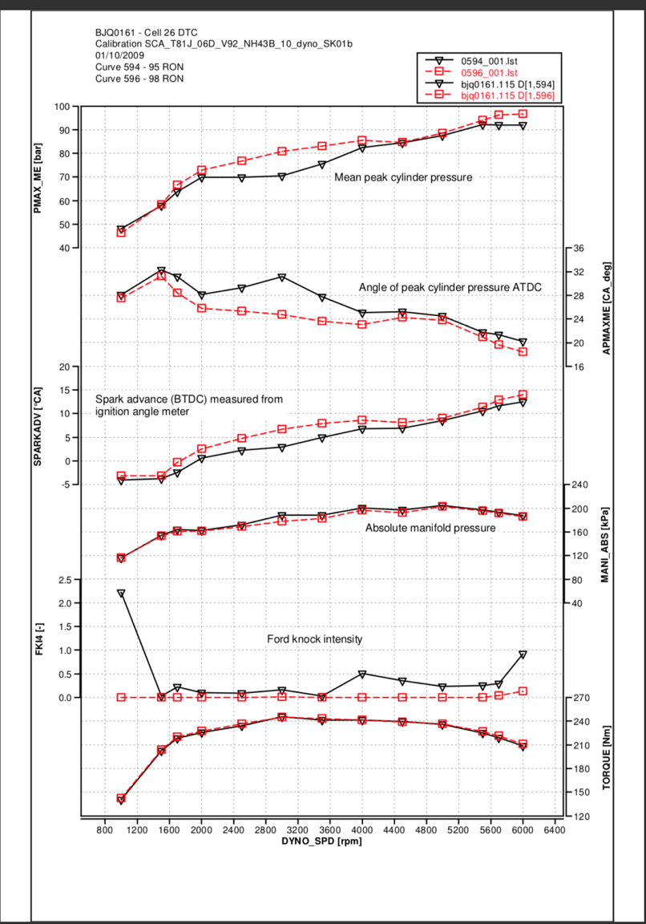
5.2 SGTI DATA
Figure.16 SGTI spark ignition data

6.0 Conlusion
At the start of the investigation the identified goal was to compare the efficiencies of the Ford Sigma naturally aspirated and the turbocharged sigma applications. The expectation was that the turbocharged engine would be seen as the more efficient engine.
The analysis and results show that in fact that turbocharged efficiency was around 10% lower than the naturally aspirated engine. Figures were shown that at 2000 rpm the efficiency of the naturally aspirated engine was at 40% and the turbocharged application was at 32%. As the turbocharged engines are labelled to be the more efficient and better engine this was surprising to see.
Following this, various comparisons between the two engines at various engine speeds were analysed. After the thermal efficiency calculations was complete the start and end of combustion of the was calculated between the two the results show that the naturally aspirated engine started its combustion stage at a much earlier stage than the turbocharged data, the reason for this was as the turbocharged application creates pressure to put into the cylinder if they didn’t start the combustion as the piston was travelling down the cylinder and around 15 degrees after top dead centre this reduces the volume in the cylinder in which the combustion stage is started. If Ford had not decided to start the combustion stage at a later point the engine would encounter knock, by burning later. Ford also retard the ignition timing to counter this.
In order to further and improve this analysis data was analysed in order to determine the SGTI which shows the ignition timing on the naturally aspirated, this could then be compared back to the turbocharged one to see the differences in the ignition timing.
Ford’s engines are losing significant amounts of efficiency by over fuelling and not using the fuels energy fully, by looking into various points to lower the cylinder pressure in order that the burn does not have to start so late, the efficiency of the engine could be improved. Since the engine has major losses with the gases and heat, the solution may be found in the form of an over expansion engine. One example of such is a concept made by Ilmor Engineering called a Five Stroke engine, the internal combustion engine uses a solid cylinder block with electric motors driving the oil and water cooling pump. It uses two overhead camshafts with standard poppet valves, it is turbocharged also. The goal with this engine if to have a higher engine efficiency with a lower fuel use. To increase the efficiency a secondary cylinder is added as an expansion processor to extra more energy from the fuel. (Ilmor, 2015)
If ford were to incorporate the technology that ilmor engineering have produced, they would be able to keep the power in which the turbocharged engine runs but use an over expansion to recover the wasted fuel energy which is going back out of the exhaust and put it through another cycle, this would increase the efficiency massively as the fuel would be going through two different cycles.

The results were not as were assumed at the start of the project, the engine efficiency came out at a much lower unit than expected. With ford branding their engines are cited as super-efficient, however, the calculated figures produced efficiency results that were lower than anticipated.
A big talk on the automotive scene today is when Volkswagens emission scandal, Volkswagen had calibrated their vehicles in a way that when the car was at a certain drive cycle it would recognise that it was going under an MOT inspection and the ECU would alter the vehicles fuelling. This would make the car drive completely different to how it would drive on the road and produce much more emissions. By understanding that the vehicle would be tested the ECU would make the vehicle produce very little emissions such as NoX so it would pass its MOT without any issues This made big news and a lot of people were not happy with how VW have cheated the system, this does not only put a strain on other motor manufactures as more consumers are wondering if they are doing it too. By Volkswagen doing this it put a huge strain on the reliability of how these engines would act and the consumer is not happy to go out and buy one. By ford branding these engines as efficient and economical would the consumer really be happy about knowing that its efficiency is less than the naturally aspirated version?

7.0 Bibliography
A.J.Martyr, 2007. Engine testing. 3 ed. s.l.:Elsveir LTD.
Anon., 2013. Wikipedia. [Online]
Available at: https://www.princeton.edu/ssp/61-tiger-cub/library/efficiency.pdf
Anon., 2015. EXPERIMENTAL SETUP AND TEST PROCEDURE. [Online]
Available at: http://shodhganga.inflibnet.ac.in/bitstream/10603/50051/10/10_chapter%203.pdf
Company, F. M., 2009 . SGTI DATA - Turbp , s.l.: s.n.
Company, F. M., 2016. Ford Sigma 1.6 Turbo pressure data , Bridgend : s.n.
IGER, B., 2018. The Data And Accuracy Implications Of Different Dynamometer Designs. [Online]
Available at: https://www.enginelabs.com/engine-tech/dyno-testing/data-accuracy-implications-different-dynamometer-designs/
International, M., 2007.
NASA, 2016. Nasa.gov. [Online]
Available at: https://www.grc.nasa.gov/www/k-12/airplane/otto.html
reif, P. D.-I., 2014. Bosch automotive handbook. 9 ed. s.l.:Robert Bosch GmbH.
SceinceDirect, 2017. Science.com. [Online]
Available at: https://www.sciencedirect.com/topics/engineering/engine-downsizing
Schwitzer, 1991. Introduction to Turbochargers. s.l.:s.n.
stone, R., 2012. Introduction to internal combustion engine. 4 ed. s.l.:s.n.
Study, M. 4., 2015. Differance between supercharging and turbocharging. [Online]
Available at: https://www.mech4study.com/2016/02/difference-between-supercharger-vs-turbocharger.html
Uk, S., 2012. Engine testing overview. [Online]
Available at: http://users.sussex.ac.uk/~tafb8/eti/eti_03_EngineTestingOverview.pdf

Bosch Automotive Handbook. (2011). 9th ed. [Erscheinungsort nicht ermittelbar]: Robert Bosch, p.633.

Hillier, V. (n.d.). Hillier's fundamentals of motor vehicle technology. 4th ed. p.545.

S.Kuo, P. (2018). Cylinder Pressure in a Spark-Ignition Engine: A Computational Model. Engineering Science. [online] Available at: http://www.gofastforless.com/junk/cylinder-pressure.pdf [Accessed 18 Nov. 2018].

stone, R. (2015). Introduction to internal combustion engines. 4th ed.

Syrimis, M. and Assanis, D. (2003). Knocking Cylinder Pressure Data Characteristics in a Spark-Ignition Engine. Journal of Engineering for Gas Turbines and Power, 125(2), p.494.
Ilmor, 2015. Ilmor engineering. [Online]
Available at: http://www.ilmor.co.uk

8.0 Appendices
Appendix 1: Turbocharged data thermal efficiency calculations
@ 1500 RPM
Work out @ 1500 RPM = 672.72 J
Fuel mass @ 1500 RPM = 8.33 Kg/h
Fuel/Revolution = $\frac{8.33}{60}$
Fuel/ Cylinder = $\frac{8.33 }{2x60x1500}$ = 4.63x${10}^{-5}$
Calorific value of fuel = 44${x10}^{6}$
Fuel energy = 4.63x${10}^{-5}$ x 43391 = 2037.2
Thermal efficiency = $\frac{work done}{fuel energy }$ = $\frac{672.72}{2037.2 }$
= 0.33 x 100 = 33%
@ 2000 RPM
Work out @ 2000 RPM = 753.09 J
Fuel mass @ 2000 RPM = 12.71Kg/h
Fuel/Revolution = $\frac{12.71}{60}$
Fuel/ Cylinder = $\frac{12.71 }{2x60x2000}$ = 5.296x${10}^{-5}$
Calorific value of fuel = 44${x10}^{6}$
Fuel energy = 5.296x${10}^{-5}$ x 44${x10}^{6}$= 2330.24
Thermal efficiency = $\frac{work done}{fuel energy }$ = $\frac{753.09}{2330.24 }$
= 0.323 x 100 = 32%

@ 2500 RPM
Work out @ 2500 RPM = 830.87 J
Fuel mass @ 2500 RPM = 17.7 Kg/h
Fuel/Revolution = $\frac{17.7}{60}$
Fuel/ Cylinder = $\frac{17.7 }{2x60x2500}$ = 5.9x${10}^{-5}$
Calorific value of fuel = 44${x10}^{6}$
Fuel energy = 5.9x${10}^{-5}$ x 44${x10}^{6}$ = 2596
Thermal efficiency = $\frac{work done}{fuel energy }$ = $\frac{830.87}{2596 }$
= 0.32 x 100 = 32%
@ 3000 RPM
Work out @ 3000 RPM = 829.23 J
Fuel mass @ 3000 RPM = 23.95 Kg/h
Fuel/Revolution = $\frac{23.95}{60}$
Fuel/ Cylinder = $\frac{23.95 }{2x60x3000}$ = 6.65x${10}^{-5}$
Calorific value of fuel = 44${x10}^{6}$
Fuel energy = 6.65x${10}^{-5}$ x 44${x10}^{6}$ = 2926
Thermal efficiency = $\frac{work done}{fuel energy }$ = $\frac{829.23}{2926 }$
= 0.28 x 100 = 28%

@ 3500 RPM
Work out @ 3500 RPM = 829.23 J
Fuel mass @ 3500 RPM = 23.95 Kg/h
Fuel/Revolution = $\frac{23.95}{60}$
Fuel/ Cylinder = $\frac{23.95 }{2x60x3500}$ = 6.65x${10}^{-5}$
Calorific value of fuel = 44${x10}^{6}$
Fuel energy = 6.65x${10}^{-5}$ x 44${x10}^{6}$ = 2926
Thermal efficiency = $\frac{work done}{fuel energy }$ = $\frac{829.23}{2926 }$
= 0.28 x 100 = 28%
@ 4000 RPM
Work out @ 4000 RPM = 843.41 J
Fuel mass @ 4000 RPM = 31.81 Kg/h
Fuel/Revolution = $\frac{31.81}{60}$
Fuel/ Cylinder = $\frac{31.81 }{2x60x4000}$ = 6.62x${10}^{-5}$
Calorific value of fuel = 44${x10}^{6}$
Fuel energy = 6.62x${10}^{-5}$ x 44${x10}^{6}$ = 2912.8
Thermal efficiency = $\frac{work done}{fuel energy }$ = $\frac{843.41}{2912.8 }$
= 0.29 x 100 = 29%

@ 4500 RPM
Work out @ 4500 RPM = 836.05 J
Fuel mass @ 4500 RPM = 36.86 Kg/h
Fuel/Revolution = $\frac{36.86}{60}$
Fuel/ Cylinder = $\frac{36.86 }{2x60x4500}$ = 6.83x${10}^{-5}$
Calorific value of fuel = 44${x10}^{6}$
Fuel energy = 6.83x${10}^{-5}$ x 44${x10}^{6}$ = 3005.2
Thermal efficiency = $\frac{work done}{fuel energy }$ = $\frac{836.05}{3005.2 }$
= 0.28 x 100 = 28%
@ 5000 RPM
Work out @ 5000 RPM = 809.36 J
Fuel mass @ 5000 RPM = 41.66 Kg/h
Fuel/Revolution = $\frac{41.66}{60}$
Fuel/ Cylinder = $\frac{41.66 }{2x60x5000}$ = 6.94x${10}^{-5}$
Calorific value of fuel = 44${x10}^{6}$
Fuel energy = 6.94x${10}^{-5}$ x 44${x10}^{6}$ = 3053.6
Thermal efficiency = $\frac{work done}{fuel energy }$ = $\frac{809.36}{3053.6 }$
= 0.26 x 100 = 26%

@ 5500 RPM
Work out @ 5500 RPM = 754.56 J
Fuel mass @ 5500 RPM = 44.95Kg/h
Fuel/Revolution = $\frac{44.95}{60}$
Fuel/ Cylinder = $\frac{44.95}{2x60x5500}$ = 6.81x${10}^{-5}$
Calorific value of fuel = 44${x10}^{6}$
Fuel energy = 6.81x${10}^{-5}$ x 44${x10}^{6}$ = 2996.4
Thermal efficiency = $\frac{work done}{fuel energy }$ = $\frac{754.56}{2996.4 }$
= 0.25 x 100 = 25%

@ 6000 RPM
Work out @ 6000 RPM = 723.15 J
Fuel mass @ 6000 RPM = 47.94 Kg/h
Fuel/Revolution = $\frac{47.94}{60}$
Fuel/ Cylinder = $\frac{47.94}{2x60x6000}$ = 6.65x${10}^{-5}$
Calorific value of fuel = 44${x10}^{6}$
Fuel energy = 6.65x${10}^{-5}$ x 44${x10}^{6}$ = 2926 kg/h
Thermal efficiency = $\frac{work done}{fuel energy }$ = $\frac{723.15}{2926 }$
= 0.24 x 100 = 24%

Appendix 2: Naturally aspirated thermal efficiency
@1500 RPM
Work done = 444.56 J
Fuel energy = 1049.4 J
Thermal Efficiency = $\frac{work done}{fuel energy }$ = $\frac{444.56}{1049.4}$ = 0.42 J
X 100 = 42%
@2000 RPM
Work done = 497.49 J
Fuel energy = 1192.15 J
Thermal Efficiency = $\frac{work done}{fuel energy }$ = $\frac{479.49}{1192.15}$ = 0.40 J
X 100 = 40%
@2500 RPM
Work done = 501.49 J
Fuel energy = 1202.5 J
Thermal Efficiency = $\frac{work done}{fuel energy }$ = $\frac{501.59}{1202.5}$ = 0.41 J
X 100 = 41%
@3000 RPM
Work done = 507.59J
Fuel energy = 1176.15 J
Thermal Efficiency = $\frac{work done}{fuel energy }$ = $\frac{507.59}{1176.15}$ = 0.43 J
X 100 = 43%
@3500 RPM
Work done = 508.03J
Fuel energy = 1206.4 J
Thermal Efficiency = $\frac{work done}{fuel energy }$ = $\frac{508.03}{1206.4}$ = 0.42J
X 100 = 42%
@4000 RPM
Work done = 523.43 J
Fuel energy = 1228.75 J
Thermal Efficiency = $\frac{work done}{fuel energy }$ = $\frac{523.43}{1228.75}$ = 0.42J
X 100 = 42%
@4500 RPM
Work done = 527.06 J
Fuel energy = 1287.5 J
Thermal Efficiency = $\frac{work done}{fuel energy }$ = $\frac{527.06}{1287.5}$ = 0.40J
X 100 = 40%
@5000 RPM
Work done = 528.04 J
Fuel energy = 1297.75 J
Thermal Efficiency = $\frac{work done}{fuel energy }$ = $\frac{528.04}{1297.75}$ = 0.40J
X 100 = 40%
@5500 RPM
Work done = 512.78 J
Fuel energy = 1343.55 J
Thermal Efficiency = $\frac{work done}{fuel energy }$ = $\frac{512.78}{1343.55}$ = 0.38J
X 100 = 38%
@6000 RPM
Work done = 497.58 J
Fuel energy = 1317.5J
Thermal Efficiency = $\frac{work done}{fuel energy }$ = $\frac{497.58}{1317.6}$ = 0.37J
X 100 = 37%

Appendix 3LogP v LogV graphs – turbo

