Cardiff Central Library
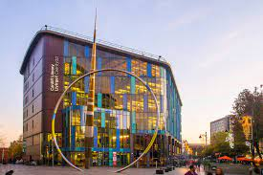
https://www.facebook.com/centrallibraryhub/
History
Cardiff central library is the latest library built in Cardiff, the construction of the library started in May 2007, but opened its doors to the public on the 30th of January 2009 at a cost of £15 million and was completed on time. The client of the build was St David’s Partnership (A partnership between Land Securities and Capital Shopping Centres) and Cardiff County Council¹. The building has won 6 awards among them was the 2010 Royal Society of Architects in Wales (RIBA) Award² and was judged category winner in ‘Sustainability’ and ‘Public Buildings’ in Cardiff’s Building Excellence Awards².

Plan and Sections
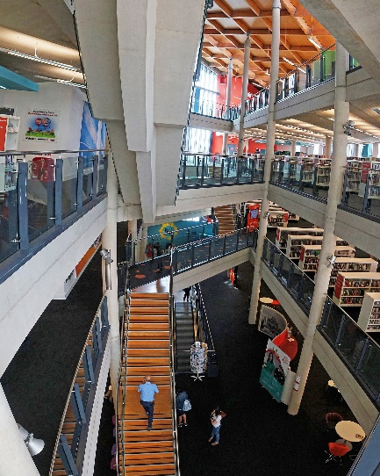
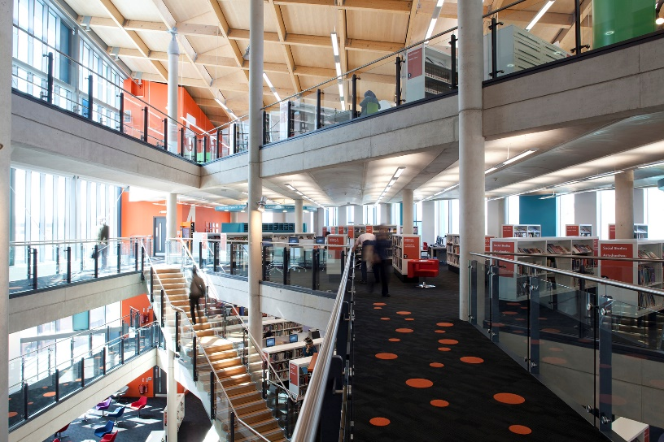
The Cardiff central library is a state-of-the-art 6-story library¹ with a mezzanine that goes all the way to the top floor of the building. As well as this there is a hole that starts on the second floor which goes to the sixth floor, on the inside of the hole is a staircase connecting the rest of the floors together. Unfortunately, I was unable to find the plans or sections of the building. But the size of the library is 5100m² and the building may be more as the building contains external restaurants on the Southeast side.
Unable to find who the photos belong to as they have been used in multiple websites
Materials and Light
The central library is made from mostly concrete and timber glulam as its main frame while the outside of the building is cladded in brass and coloured curtain walling³ and is supposed to resemble the appearance of random books on shelves⁴. While the roof of the building has an insulating green roof which helps biodiversity in the area, unfortunately, the public cannot access the roof. The North and West sides of the building are clad in coloured glass which increases the amount of light coming into the building, as well as this the mezzanine balcony on the inside increases the amount of light as the light is not blocked out by levels above.
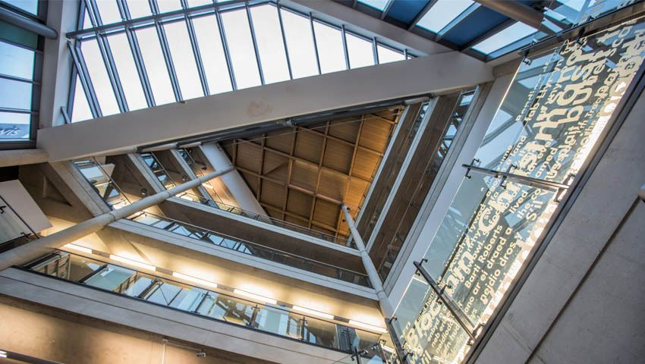
https://www.visitcardiff.com/highlights/cardiff-central-library/
Use of the Building

The building has multiple purposes, the major purpose of the building is to act as Cardiff’s Central Library, one of the other major sections of the building is its restaurants, (Wagamama) and two empty units.
The ground floor of the library is split into three with one area being for teenage use as well as News Events and Services/ Activities for the youth. The second area is the main reception, while the third area is an exhibition/ events space. While the first floor is home to the children’s books and computer space. The second floor is reserved for mostly Languages and Law which also includes staff and the European Direct Information Centre. The third floor is mostly Fiction books as well as workspaces and closed-off meeting rooms. And the fourth-floor hoses books and movie records. While on the final floor of the library is a digital floor which includes a 3D printer and more electronic equipment, and a viewing area.⁵

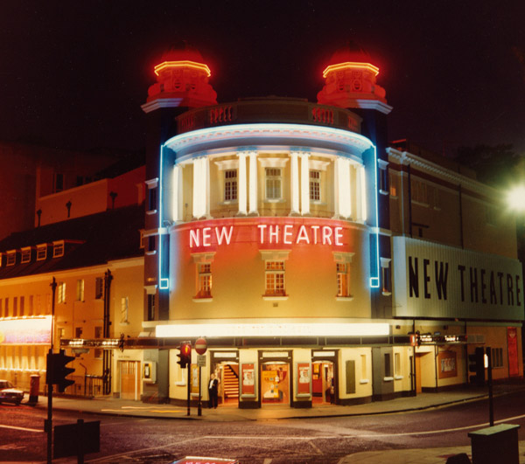
New Theatre
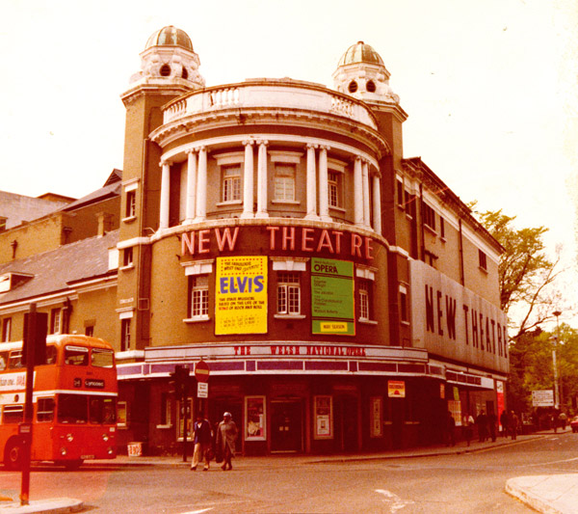
History
The New Theatre in Cardiff has a long history as its construction started on the 29th of March 1906 and the first public performance was held on the 10th of December 1906 which was a William Shakespeare play, Twelfth Night⁶. At the time of being built, it was one of the largest stages in the UK, and those were in the finest London theatres. But in 1931 structural alterations were made to the building so that film shows could be shown, and so the theatre was labelled as a picture house until 1935 when it was then transformed back into a standard theatre. There is much more history, but I don’t believe there will be enough space to mention all of it.⁶
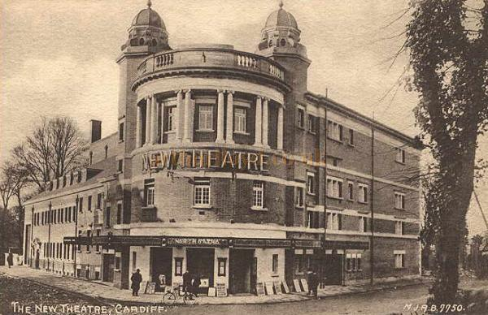
The New Theatre, Cardiff - From an early Postcard. http://www.arthurlloyd.co.uk/Cardiff.htm
Plan and Sections
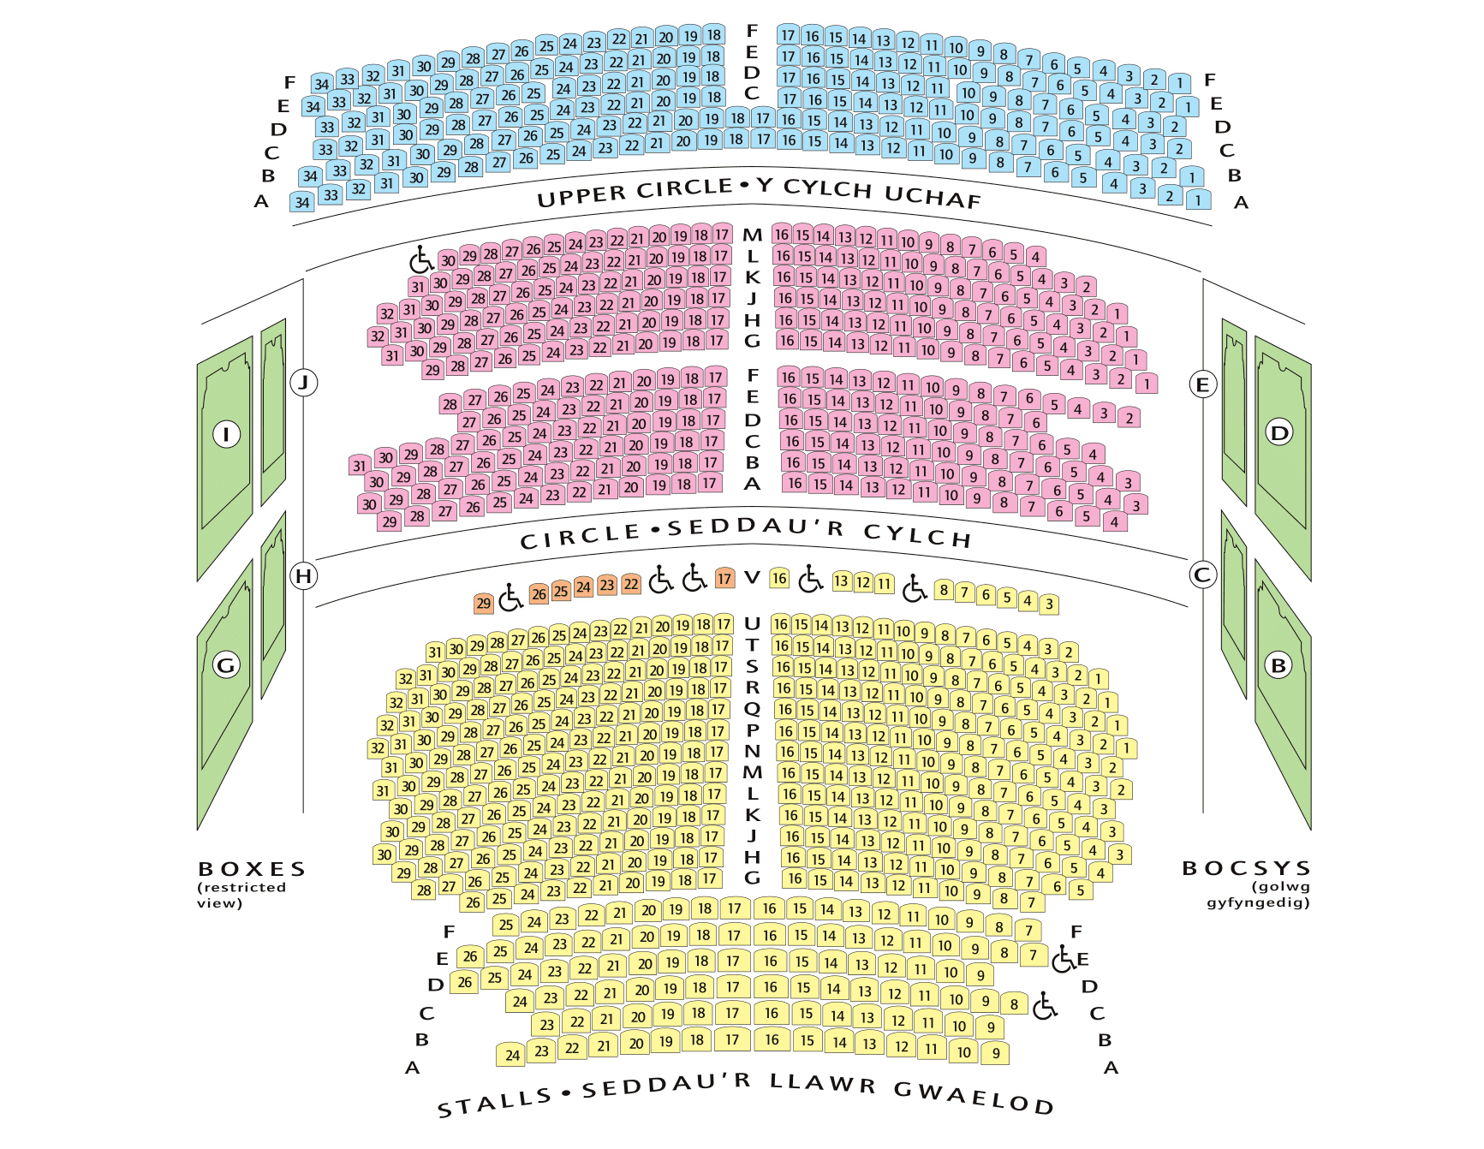
https://newtheatrecardiff.co.uk/Online/seating-plan-new-theatre-cardiff

The New Theatre is accessible to all, but wheelchair users are only able to use boxes for viewing plays. The interior of the building has a square-headed, panelled proscenium arch, the seating of the building consists of three floors as well as balcony boxes on the sides, the boxes are modelled after scrolls. The theatre’s ceiling is divided into two large panels made from plaster which are decorated. The larger panel over the theatre’s main part is decorated with four gilded wreaths and a large rose in the centre.⁷ The theatre had 17 dressing rooms when it was first built and the stage was 76feet in width, 54 feet in depth and a height of 57 feet.
The outside of the building is a curved corner made from brick and three floors tall with pillars appearing on the final floor, the building has two turrets with rounded tops on either side of the curved entrance. The East side of the theatre has very few windows.

Materials and Light
The materials most used in the construction of the building seem to be timber and brick as well as concrete. There would be very little natural light coming into the building as there are no windows within the amphitheatre and therefore not as much of a need. But the lighting within the amphitheatre is up to standard as well as having just for the stage.

Use of the Building
The use of the building has rarely changed its purpose since it was first made, and that is its use as a theatre to perform shows and plays and was the first theatre in Wales to have the performance ‘play for voices’ by Dylan Thomas.⁶ Unfortunately in 1961 the New Theatre was nearly demolished and turned into office buildings as it was losing money. But luckily the theatre is still open and running with weekly shows ongoing.

Conclusion of both

The conclusion I have from doing this essay is that I should look more into the history of buildings and their purpose of them, as well as their functionality. I have learned that I should do more research into the buildings I have chosen as well as find out how to find floor plans and sections of buildings.
If I had done this assignment again, I would choose different buildings, ones with floor plans that are easier to find. Also, I would like to be able to describe things in more detail and be able to sketch the buildings and put them into my essay.

References
- https://www.bdp.com/en/projects/a-e/cardiff-central-library/#:~:text=A%20state%2Dof%2Dthe%2D,development%20scheme%20in%20Cardiff%20city.
- https://stridetreglown.com/projects/cardiff-central-library/
- Cardiff Central Library - Stride Treglown
- https://www.designcurial.com/news/bdp-designed-cardiff-central-library-wins-2010-riba-award
- https://cardiff.moderngov.co.uk/documents/s7429/Item April 2015
- https://newtheatrecardiff.co.uk/Online/about-history-new-theatre-cardiff
- https://www.flickr.com/photos/ell-r-brown/19506848896 June 11, 2015
http://dcfw.org/cardiff-central-library/

