Cover page:


University of Wales Trinity Saint David

Certificate or high education – skills for the workplace

Module
Managing Enterprise in 21st Century
(BMSK4006-CARD)
Business Plan report for final Assignments

Lecturer: Melanie Squair
Student: Mohamed Babeker Osman Ahmed
Student ID: 2112126
November2022

Table of content:
Contents
1.0 Cover page: 1
2.0 Table of content: 2
6.0 Term of reference: 3
7.0 Executive summary: 3
8.0 Introduction: 3
9.0 Finding: 4
9.1 Business Identity. 4
9.2 Physical and location: 5
9.3 Management plan. 6
9.4 Marketing plan: 11
9.5 Sources of Finance: 13
7.0 Conclusion: 14
8.0 References: 15

Term of reference:

I have been asked by Melanie Squair (lecturer of Managing Enterprise in 21st Century) on behalf of University of Wales trinity Saint David. To write a business plan report on the module. I requested to summit this report on July 2022.

Executive summary:

FAST-IMPOTATION FOR BUSINESS AND GENERAL SERVICES

Delivering item as a service enterprise provides, more opportunity to outsource complex on delivery market (Schlauderer and Overhage 2018, P1). On the other hand, it safe time for customer by collecting items from their location and deliver it to the destination they want to send it to, this is international service helping customer to simply send and receive the items and gifts specially the light wights. All global deliveries company are focusing on the heavy wight items, so there is shortage of sending items like personal gifts fast and cheap to their families and friend easy way. your parcel is our responsibility & received it as you would! And as a thoroughly family-owned business, you can trust us to give your family the same attention we give to ours.

Introduction:
Company name:
FAST-IMPORTATION FOR GENERAL BUSINESS.

Company concept: infrastructure
Concept:
. A safe secure trusted importing and exporting all kind of items up to 50kg from Europe to Africa and vice versa. full insurance, compensation and all authorities’ procedures include, with handy price and more convenient
Technical Feasibility:
It is Technically feasible to measure the safety and security through legislations and international low notarizing contracts legally (HERREMANS, and ISAAC, 2005, P 20). Give our customers peace of mind by taking care and responsibility on their item, allowing them to have extra time with our collecting from - to - different locations service

Mission Statement | Delivering the parcels from Europe to Africa safely, fast, and secure. Help reduce the international complex on delivery market and help it to develop.
Business Aims | Create SMART partnerships between producers {service} and consumers {customer} by delivering these products to wholesale retail users, and individuals.
Business Objectives | - Conducting a feasibility study for the business’s project. | To identify markets, segmentation,
Business Objectives | - Making understandings with airplanes company. | analyse PEST and competitive
Business Objectives | - Facilitating fast and guaranteed items and gifts delivery at the lowest cost. | Pricing strategy marketing plan
Business Objectives | - Filling the gap in the continental delivery service for light goods. | Brand and positioning

Finding:

Business Identity.

The business well be identified as a sole trader because it easy to set up and manage, being a sole trader is often considered the simplest way of running a business, at least when the operation is a small one (www.gov.uk). flexibility and full control over how to operate also personally responsible for its success or failure, which can be potentially very costly (Nick Green 2022). The advantages are.
- there is no need to register a company name or complete any Companies House forms, such as the annual Confirmation Statement. The legal requirement is to inform (HMRC) that you’re self-employed and starting as a sole trader, by self-assessment registration. which can be online or by post.
- There is no need to meet the accounting standards as limited companies, which has to have tax returns and annual accounts including balance sheets. All you need to worry about is maintaining a record of your invoices, expenses and sending details of your profits in your annual Self-Assessment tax return. Because of this, your accountant will charge you less than they charge a limited company.
The amount of income tax you pay depends on your income after this personal allowance. The following table is useful cited from Financial Journalist.

Band | Taxable income | Tax rate
Personal allowance | Up to £12,500 | 0 per cent
Basic rate | £12,501 - £50,000 | 20 per cent
Higher rate | £50,001 - £150,000 | 40 per cent
Additional rate | Over £150,000 | 45 per cent

Physical and location:

It is essential that to give the location an attention it deserves. While many start-up mistakes can be corrected later, a wrong choice of location is difficult and sometimes could be impossible to repair (www.unbiased.co.uk). Regardless, to this business the preferred choice is to start it from the home, then move into commercial space as the business grows. Depending on the business some enterprises start at home with no thought or intention of ever moving to commercial places. Running a homebased business from an office in a spare bedroom or a kitchen table, is limited. Finding employees or meetings with clients is a challenge. However, selling to the public or other businesses our service that we provide to customers, the ideal location should be setting a website, a car, van or truck and hot line phone.
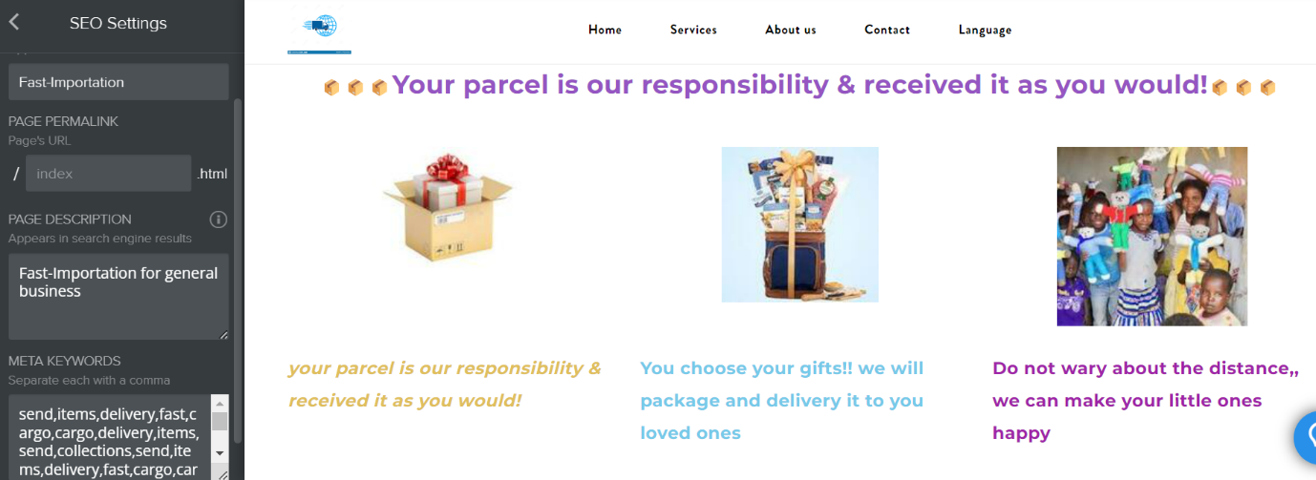
screenshot of the website.
The focus will be on the website as basic and essential location to welcome our clients and customers so they will be able to access to find the services they wish to have and make their order through the website easy if they have an internet access, including advice and provide choices on the live chat. Moreover, the phone line will be an additional way to communicate and place the orders as well.

Management plan.
In this paragraph, we will detail exactly how to organize and highlight the management team. A convenient way to organize this section is to break it into the following:
- Ownership Structure
- Internal Management Team
- External Management Resources
- Human Resources
- ownership structure:
This sector will explain the general management structure for the development of business and methods of implementation. The main responsibility for the leadership is to make etc. Matrix the choices, making decision, encouraging employees, dealing with complains and organizing the report for the evaluation.
In the shape below we can see clearly how the management links to the different sectors.
- Internal Management:
The internal management requires coordination between its resources, funds, and people (PMBOK guide. 5th ed. 2013 P67), the first role of the decision-making sector is implementing all activities that led to achieve the business objectives with specific time sequence. Then, great guidance and leadership after putting the job description for each role which are determined by decision making sector for sure. However, in this paper we are going to discover the important of resources, funds, and people regarding our business plan. Firstly, resources or fixed and variable assets including skills and creativity that decision maker have. Secondly, the fund or capital cost include the direct and variable cost are important to facilitate and influence the decisions. Lastly, people are fundamental to run the business and its control.

we are going to break those categories shown on the shape above to link them in our business in the human resources sector.
External management:
It is a department for coordination and networking with all partners in the process of delivering goods and services to customers through to their locations. It is entrusted with communicating airlines and shipping companies
to determine the cost and programming the deportations for the purpose that are supposed to be delivered and creating a permanent relationship with those companies! In addition, learning about the work of competitors.
Human Resources:
The role of HR practices is to manage the employees within a workplace to achieve our business’s mission. business require 5 employees as flows:
Functional structure table:
No | Occupation | Job Role | Full/part time | Cost
1 | Team Leader | Coordination, networking, and management | Full time | Net profit 30%
1 | Accountant | Keeping financial books | Part time contract | Monthly £500
2 | Delivery drivers | Collecting the orders and take them to the deportation centre | Self-employment  Part time | £10 per hour
1 | External relation and communications | Make the agreement and placing the orders | Full time | Net profit 20%

- HR manager and leadership:
To explain the table above. Effectively, HR managers (ownership) can recruit professionals’ employees who have necessary skills to further the FAST-IMPORTATION FOR GENERAL BUSINESS’S goals as well as aid with the training and development, of current employees to meet objectives (Lin, Y. et al. 2021, P 30). Because, business is only as develop as its employees, making HR a crucial part of maintaining or improving the health of the business. Additionally, HR managers can monitor the state of the job market to help the organization stay competitive. This could include making sure compensation and benefits are fair, events are planned to keep employees from burning out, and job roles are adapted based on the market (TechTarget, Chai, online).
Accountant roles:
Referring to the Functional structure table, the accountant’s work will be summarized in keeping books, receipts, and financial notices. Making accounting procedures with the different parties, determining taxes and the value of contracts with other companies. Calculating revenues, payments, cost of financial services and everything related to finance. The accountant could be an individual (self-employed applicable) or a company, in this case must sign a contract specifying the exact working hours each month. Payment will be paid direct to the company’s bank account.
Delivery driver’s roles:
There are two types of delivery service, they differ in their mission, but the same way of working. For the driver of the seven-passenger car, the main task is to collect parcels from customers and deliver them to the temporary store for review. Make the initial procedures of weighing, packaging suitable for travel, and placing the company's brooch. Then, sending a confirmation message to the customer through his/her preferred means. While the task of the Van driver is to deliver these ready-to-travel parcels to departures point at airports and ports, supervise their organization and reference with airlines and the customs department with listing the labels and send it immediately to the office to send them to customer allowing them to track their packages. Additionally, make sure all procedures related to safe travel are completed and contact the office to reconfirm everything is ok including insurance companies. Drivers should be a self-employed and get their payment direct in to their bank account legally as agreed in (Elizabeth II Equality Act, 2010, chapter 15).
Relations and communications:
This role will be hold online via our website and other communication facilities as a customer service for placing the orders. Communicate with the relevant parties to make the agreements and procedures. Moreover, confirming the requests, distribute tasks to drivers, Make initial receipt statements. Packing data and information about the senders and receivers to prepare work for the next stage. According to the sensitive role the Relation and communication employee carrying out, the payment preferred to be by percentage of net benefit for two reasons.
  - Recognition and appreciation.
  - Work with sincerity dedicated and sense of responsibility.

Marketing plan:

Our vision is to provide customers with a fast and safe delivery service over the course of their need. We do this by providing them with collection parcels from home. We make service that are easy to our customers and have some connection with current location to track their packages.
SMAT Objectives:
- Make 12 flight shipments from Europe to Africa during the first year.
- Increase the flight shipment by 100% next year.
- Reduce the complexity on air fright between Europe to Africa by 1% in the first year.
- Increase the percent of the complexity to reach 5% next year.
Target Markets:
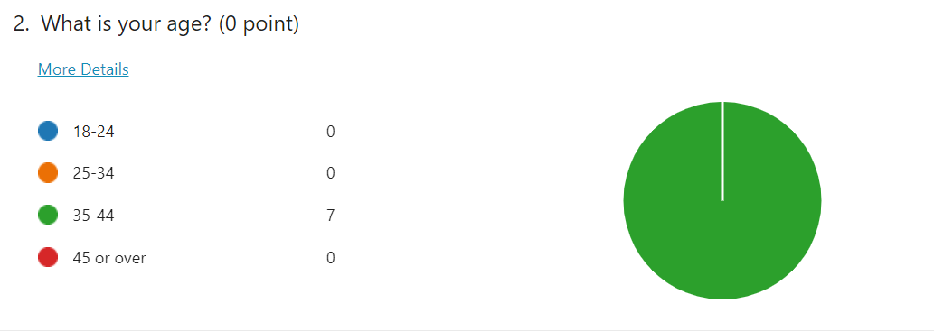
Our ideal customer is between the ages of 35 and 34 who interested in our service. They are live in Europe.

Segmentation:
We target two segments in this sample marketing plan, determine marketing opportunities and provide a better customer service not only for our customer, even to track competitor’s customer as well. (McDonald and Dunbar, 2010, P48)
Competitors:
There are many import and delivery providers. However, few are actual companies. Most services provided by one person who does not have the marketing realization to integrate advertising sponsorships into their service as we have outlined in this sample marketing plan (Blythe, & Martin, 2019, P77). Our unique stand on the types of modern service. This means that we will not have to spend as much time and energy thinking of the import themes.
7 Ps marketing Mix:
Our record show that the focus will be on providing best customer service {product} relay on cost leader strategies with low price toward customer by promoting values on people working with us, as employees or partners to help facilitate smooth process between all the management and the stockholders.
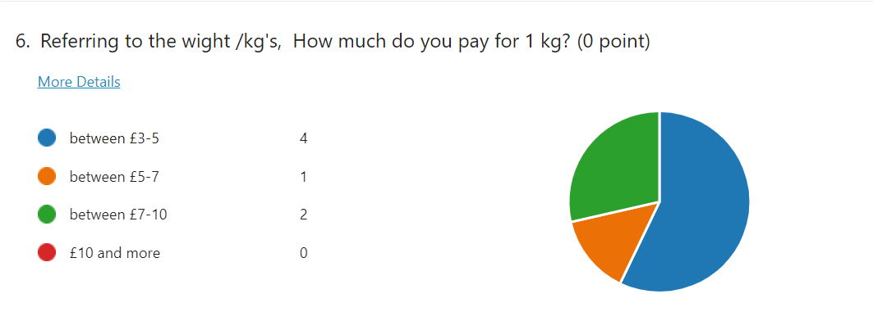

PEST Analysis:
In this sector we will share pest analysis which help to identify our opportunities in the importation and delivery market.
Politically, there is no guarantee in agreements that have been made or that will be make in the future especially on some African countries due to the lack of a clear basic vision in most African countries. However, any business must take risks as conditions with considering flexibilities on the plan.
Economically, almost all economic and financial measures are linked to the commitments of the World Bank and the United Nations. especially regarding companies and businesses low, so relatively there are no major problems even if they occur, the money will be recovered if the reasons are not related to our business work and were from the external environment.
Socially, the basis of the business is closely related to the human being and feelings, so the service provided depends entirely on satisfying the customer’s feelings in conveying the feeling to others. So, there are no problems that will occur in this aspect.
Technology, relying on tech has become essential in all aspects of life. Especially, in this business the reliance on the website and social media. But, on the other hand, there will be a problem in absence of the internet, especially in some African countries.

Sources of Finance:

The proposed budget for this business is not large, but the return requires a long time to reap the benefits.
The following table separates the budget according to need and cost:
No | Fixed assets | Monthly cost | Yearly cost
1 | Van + running cost | £3000
2 | Cars + running cost | £2000
2 | Laptops + insurance | £2000
1 | Website fee | £ 1000
1 | Phone / broadband | £1500
 | Total | £9500 | £114000
 | Direct or variable costs
1 | Airline /50 tons | £40000
1 | Insurance/50 tons | £ 15000
1 | Legal services | £ 15000
1 | Accountant | £ 20000
2 | Drivers | £ 6000
 | General services | £30000
 | Total | £ 224000 | £126000
2 | Management/ leaders | 20%
 | shareholders | 10%
 | Capital cost |  | £240000

7.0 Conclusion:
Relying on tech has become essential in all aspects of life. There are many opportunities out there to help our businesses to grow and develop.
Commitments of the World Bank and the United Nations. Will reduce the risks on aspect of the international agreements.
The basis of the business is closely related to the human being and feelings. The guarantee is unmeasurable so there would be a little threat of changing on the customers behaviours.
Guarantee in agreements on the African countries is warrying and could be a weakness.

8.0 References:

A guide to the project management body of knowledge (PMBOK guide). 5th ed. (2013). Newtown Square, Pennsylvania: Project Management Institute.
Ariu, A. (2016) ‘Services versus goods trade: a firm-level comparison’, Review of world economics, 152(1), pp. 19–41. doi:10.1007/s10290-015-0230-0.
Blythe, J, & Martin, J 2019, Essentials of Marketing PDF EBook, Pearson Education, Limited, Harlow. Available from: ProQuest Ebook Central. [20 June 2022]. Page 77
Drummond, G., Ensor, J. and Ashford, R. (2007) Strategic marketing : planning and control. 3rd ed. Routledge.
HERREMANS, I.M. and ISAAC, R.G., 2005. Management planning and control: Supporting knowledge-intensive organizations. The Learning Organization, 12(4), pp. 313-329.
Hooley, G.J. et al. (2020) Marketing strategy and competitive positioning. Seventh edition. Upper Saddle River: Pearson. Page 59.
Hooley, G.J. et al. (2020) Marketing strategy and competitive positioning. Seventh edition. Harlow, England ;: Pearson.
https://www.gov.uk/set-up-sole-trader
https://www.slidecow.com/powerpoint-tutorials/make-awesome-objectives-slide/ June 2018
https://www.techtarget.com/searchhrsoftware/definition/human-resource-management-HRM
https://www.unbiased.co.uk/life/small-business/what-is-a-sole-trader-and-how-do-i-register-as-one
Lin, Y. et al. (2021) ‘Does institutional quality matter for export product quality? Evidence from China’, The journal of international trade & economic development, 30(7), pp. 1077–1100. doi:10.1080/09638199.2021.1936133.
McDonald, M. and Dunbar, I. (2010) Market segmentation how to do it, how to profit from it. 4th ed. Oxford: Goodfellow Publishers.
Schlauderer, S. and Overhage, S. (2018) ‘BoSDL: An Approach to Describe the Business Logic of Software Services in Domain-Specific Terms’, Business & information systems engineering, 60(5), pp. 393–413. doi:10.1007/s12599-018-0554-0.

