

Assessment 1 – Reading Task Template
PART 1: Upload your photo of your A3 in-class notes here:
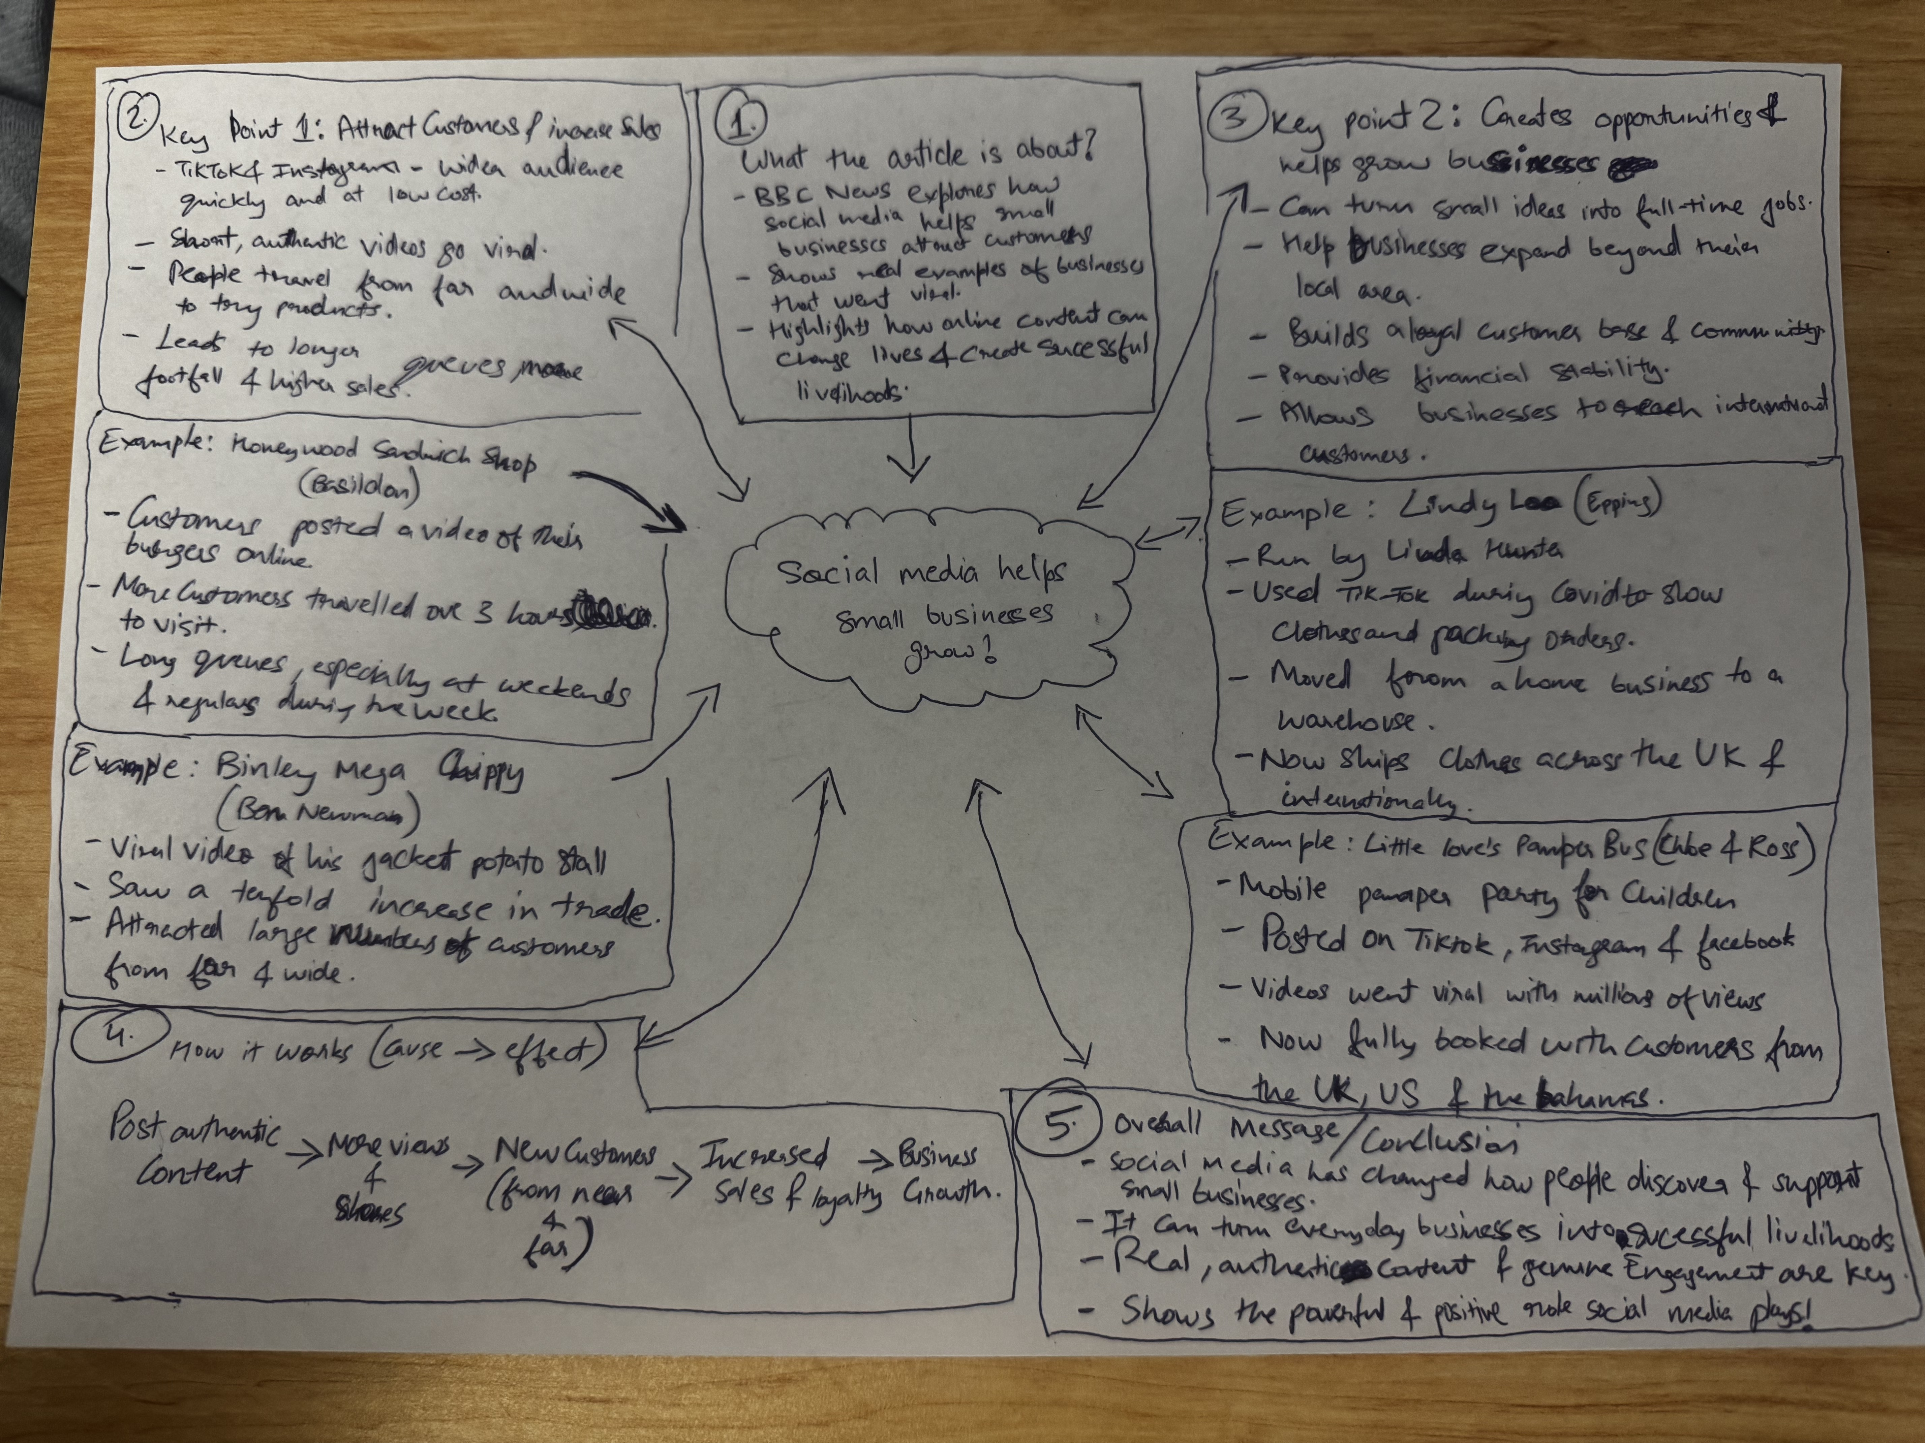

PART 2:
- Answer every question below in 1-3 full sentences.
- Use your own words. Do not use generative AI to answer these questions.
- Include a specific detail from the text when asked.
REMINDER
- The main idea is the overall message of the whole text.
- A key point helps to explain the main idea.
- A specific detail or example from the text shows that the key point is true.

- What is the main idea of the whole text?

The main point of the whole article is how businesses have grown through social media; it gives key factors and examples of small businesses that have gained an audience and clientele far and wide from their local business through media platforms such as Instagram. The article gives phenomenal numbers such as 200 million businesses worldwide are using Instagram to reach its customers. Also gives examples of businesses that wouldn’t have the reach and sales the way they do after going viral on social media, as an example Linda Hunter (Lindy Loo) says all her stock was sitting in her van until in covid her grandson said let post videos online and today she has a combined following of 320,000 people across her platforms.

- What is one key point that supports the main idea, and which specific example from the text shows this?

The key point is supported with phenomenal facts and numbers such as 200 million businesses worldwide are using Instagram to reach its customers. Also gives examples of businesses that wouldn’t have the reach and sales the way they do after going viral on social media, one that stood out to me; Linda Hunter (Lindy Loo), says all her stock was sitting in her van until in covid her grandson said let post videos online and today she has a combined following of 320,000 people across her platforms.

- What is a different key point that supports the main idea, and which specific example from the text shows this?
Another key point I would mention is, it’s not just that businesses get a following and an online presence. It also mentions examples of customers travelling far to go and visit these establishments, such as the viral chicken shop owner who mentioned; people have been travelling over three hours for a chicken burger, just because he went viral on social media. That I believe is a very vital point, as you could have the presence online but not benefit from a new customer base due to travel etc. As for this example the regulars and customers that enjoyed the food, posted it online and that is boosted this customer base and not from the business posting content itself. Which is another key point that supports the main idea of how social media will benefit today.

- Which part of the text do you think is most important, and why?
I personally believe the main point in this text is the fact that it has actual examples as well as factual data to support the point of the text. Examples of people who have seen success from ‘putting themselves out there’. Generally, people shy away from being online and putting themselves in the public eye. Importantly no matter the age or background of the business owner. There is mentions of a 62 year old, 42 years old, it shows you do not have to tech savvy and young to make a mark online.

Reflection:
- What did you find difficult in this task (including in-class components), and why was it difficult?
As I haven’t been able to attend classes so far due to some personal issues, it’s difficult for me to understand exactly what’s required. Such as needing an A3 piece of paper for the other part of this assessment. I also had to catch up on all to do this assessment and was doubting if I understood the assessment fully.

- What helped you with this difficulty, and how did it help you?
I had to work with what I had, so I started on an A4 piece of paper. Then noticed it mentioned it is okay to do it on an A4 paper if you did not attend the class and do not have A3. I went on moodle and completed the interactive book on the assessment to ensure I understood it fully without being in class to clarify my questions.

