

COMPONENT 1: PORTFOLIO (POSTER & ESSAY)

LCHS4003
INTRODUCTION TO HEALTH AND SOCIAL CARE

Student Name: Shazia Bi
Student Number: 2322811

Table of Contents
Task 1: Poster 3
Task 2: Essay 4
Introduction 4
Main Body 4
Origin and historical context of NHS 4
Conclusion 5
References 6

Task 1: Poster
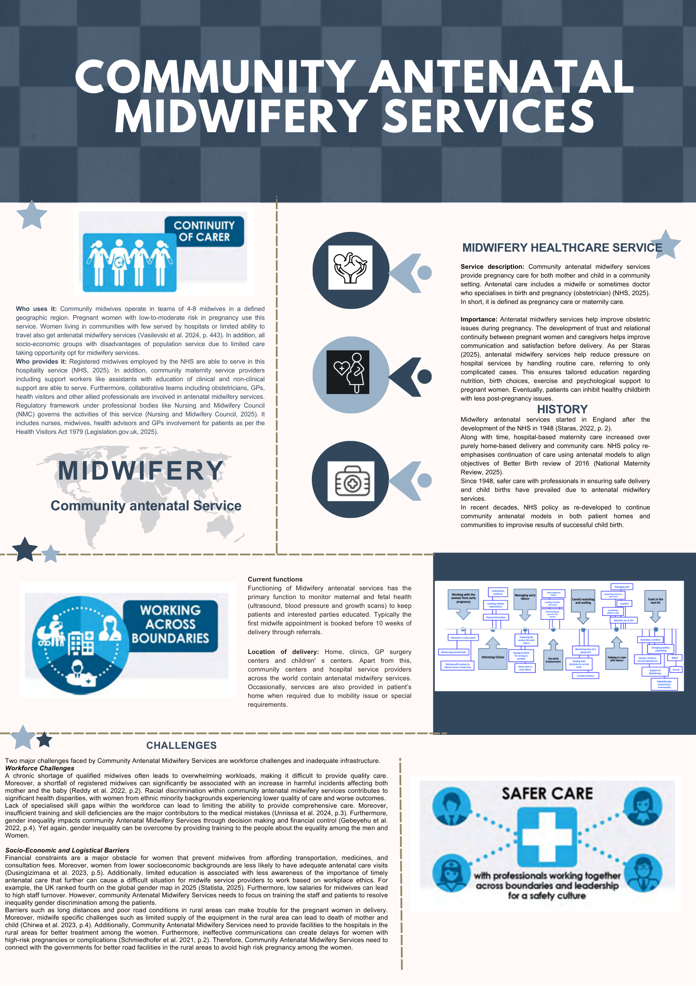

Task 2: Essay

Introduction
The National Health Service (NHS) plays a vital role in the UK healthcare sector, as it is responsible for providing various services from hospitals to GP. The focus of the essay involves analysing the origin of the NHS and the historical context that has led to its current establishment. The essay additionally discusses current structure and functions of the NHS, while highlighting key challenges.

Main Body

Origin and historical context of NHS
The NHS emerged during the post World-War II era, as the British experienced immense loss of life, evacuation, destruction and damage. The National Health Service came into existence during 5th July 1948 and Britain became one of the first countries to offer free and “point-of-use” medical services to UK residents (GOV.UK, 2023). Since its foundation, the NHS has experienced multiple milestones ranging from polio immunisation, kidney transplant, to heart pacemakers. One of the latest milestones of the NHS is treating the first “sickle-cell disease” patient with “life-changing drugs” in 2022 (NHS, 2025). Thus, considering its historical context, WWII has been a crucial factor that has supported the emergence of the NHS.
Key principles of NHS
A key goal of the NHS involves improving physical and mental wellbeing of the residents and to provide equal service to the people. According to the NHS Constitution, 7 principles guide activities of the organisation, which has been developed considering the values of the health services (GOV.UK, 2023). One of the principles involves providing comprehensive services that are equally accessible, while NHS emphasis on providing service based on clinical need, instead of economic condition. According to Crisp et al. (2024), the principles of the NHS are appropriate as it considers universality, equity and equality. Hence, the principles have been designed to provide equal access and promote factors of positive wellbeing of individuals.
Current structure and functioning of NHS
The NHS in England consists of several different organisations at local, regional, and national levels with different roles and responsibilities. Based on a government report, the “Health and Social Care Act 2022” made major structural changes across the NHS by establishing 42 integrated care systems (ICS) in England (UK Parliament, 2023). Initially, the structure of the NHS involved the “Care-Quality Commission" (CQC)” and the Department of Health & Social Care (DHSC) managing national level activities. The NHS has replaced Clinical Commissioning with ICS and it is responsible for improving health outcomes in local regions. On the other hand, DHSC holds the responsibility of funding NHS England services and between 2022 and 2023, a total £153 billion was allocated (UK Parliament, 2023). However, the organisation has been experiencing a range of issues such as rising costs, funding challenges and increase of ageing population. As per Hunter et al. (2022), reforming the NHS involves addressing inequalities along with increasing government interventions across the organisation. Thus, it implies that structural reformation is crucial within the healthcare organisation, especially to tackle systemic barriers such as ageing population facing challenges in accessing and affording health services.

Conclusion
Concluding the essay indicates that formation of the NHS has been during an extremely challenging period amidst the Second World War. The healthcare organisation has been built to tackle inequality and large-scale healthcare damage across England and the United Kingdom. In this regard, its key principles involve providing healthcare services based on need and maintaining excellence throughout every service. On the other hand, DHSC funds NHS England activities and recent structural changes involving increasing the number of ICS along with place-based partnerships to make healthcare accessible in rural regions. Therefore, reviewing its origin and current establishment, despite funding issues and systemic barriers, the NHS have been providing continuous service to the UK residents.

References
Task 1
Chirwa, M.D., Nyasulu, J., Modiba, L. and Limando, M.G., (2023). ‘Challenges faced by midwives in the implementation of facility-based maternal death reviews in Malawi’. BMC pregnancy and childbirth, 23(1), p.282. Available at: https://doi.org/10.1186/s12884-023-05536-2
Dusingizimana, T., Ramilan, T., Weber, J.L., Iversen, P.O., Mugabowindekwe, M., Ahishakiye, J. and Brough, L., (2023). ‘Predictors for achieving adequate antenatal care visits during pregnancy’: a cross-sectional study in rural Northwest Rwanda. BMC Pregnancy and Childbirth, 23(1), p.69. Available at: https://doi.org/10.1186/s12884-023-05384-0
Gebeyehu, N.A., Gelaw, K.A., Lake, E.A., Adela, G.A., Tegegne, K.D. and Shewangashaw, N.E., (2022). ‘Women decision-making autonomy on maternal health service and associated factors in low-and middle-income countries’: Systematic review and meta-analysis. Women's Health, 18, p.17455057221122618. https://doi.org/10.1177/17455057221122618
Legislation.gov.uk (2025) Nurses, Midwives and Health Visitors Act 1979. Available at: https://www.legislation.gov.uk/ukpga/1979/36/enacted (Accessed: 08 October 2025).
National Maternity Review (2025) Better Births, Improving outcomes of maternity services in England. Available at: https://www.england.nhs.uk/wp-content/uploads/2016/02/national-maternity-review-report.pdf?utm_source=chatgpt.com (Accessed: 07 October 2025).
NHS (2025) Your antenatal care. Available at: https://www.nhs.uk/pregnancy/your-pregnancy-care/your-antenatal-care/#:~:text=This%20is%20the%20care%20you,about%20healthy%20eating%20and%20exercise (Accessed: 07 October 2025).
Nursing and Midwifery Council (2025) The Nursing and Midwifery Council. Available at: https://www.nmc.org.uk/ (Accessed: 08 October 2025).
Reddy, B., Thomas, S., Karachiwala, B., Sadhu, R., Iyer, A., Sen, G., Mehrtash, H. and Tunçalp, Ö., (2022). ‘A scoping review of the impact of organisational factors on providers and related interventions in LMICs’: implications for respectful maternity care. PLOS global public health, 2(10), p.e0001134. https://doi.org/10.1371/journal.pgph.0001134
Schmiedhofer, M., Derksen, C., Keller, F.M., Dietl, J.E., Häussler, F., Strametz, R., Koester-Steinebach, I. and Lippke, S., (2021). ‘Barriers and facilitators of safe communication in obstetrics: results from qualitative interviews with physicians, midwives and nurses’. International journal of environmental research and public health, 18(3), p.915.
Staras, T. (2022) ‘A brief history of district midwifery’, Once upon a Birth, p.12. https://www.aims.org.uk/assets/media/978/aimsjournal2022v34n3onceuponabirth.pdf#page=12
Statista, (2025) Gender inequality in the UK - Statistics & Facts. Available at: https://www.statista.com/topics/5273/gender-inequality-in-the-uk/?srsltid=AfmBOopFLo98VNRKu7gSZ8yhAqsDGWAwvEoM_jqZkkYSqaE-cVlDikiK (Accessed: 07 October 2025)
Unnissa, Z., Unissa, M. and Khan, S., (2024). ‘A comprehensive review of medication errors in modern healthcare’. Journal of Drug Delivery & Therapeutics, 14(5), pp.220-228.DOI: http://dx.doi.org/10.22270/jddt.v14i5.6565
Vasilevski, V., Graham, K., McKay, F., Dunn, M., Wright, M., Radelaar, E., Vuillermin, P.J. and Sweet, L. (2024). ‘Barriers and enablers to antenatal care attendance for women referred to social work services in a Victorian regional hospital: A qualitative descriptive study’, Women and Birth, 37(2), pp.443-450. https://www.sciencedirect.com/science/article/pii/S1871519224000180
Task 2
Crisp, N., Bamrah, J.S., Morley, J., Augst, C. and Patel, K., (2024). ‘The NHS founding principles are still appropriate today and provide a strong foundation for the future’. bmj, 384. Available at: http://dx.doi.org/10.1136/bmj-2023-078903
GOV.UK, (2023) Introduction to the NHS Constitution. Available at: https://www.gov.uk/government/publications/the-nhs-constitution-for-england/the-nhs-constitution-for-england (Accessed: 13 October 2025).
GOV.UK, (2023) The founding of the NHS: 75 years on. Available at: https://history.blog.gov.uk/2023/07/13/the-founding-of-the-nhs-75-years-on/ (Accessed: 13 October 2025).
Hunter, D.J., Littlejohns, P. and Weale, A., (2022). ‘Reforming the public health system in England’. The Lancet Public Health, 7(9), pp.e797-e800. Available at: https://doi.org/10.1016/S2468-2667(22)00199-2
NHS, (2025) Milestones of the NHS. Available at: https://www.england.nhs.uk/about/nhs-history/ (Accessed: 13 October 2025).
UK Parliament, (2023) The structure of the NHS in England. Available at: https://researchbriefings.files.parliament.uk/documents/CBP-7206/CBP-7206.pdf (Accessed: 13 October 2025).

