BA (Hons) International Hotel Management
Component 2
Student name: Christopher Setalsingh
Student number: 2127114
Lecture’s name: Giulia Chifari

BMIH5004 Management and Organisational Behaviour
Table of Contents
Introduction 3
“Organisational overview” 3
“Organisation structure, culture and goals” 4
“Recent change initiatives, their impact and how well these were managed” 7
“The organisation’s strategic direction and current business performance” 8
Conclusion 10
Reference List 11

Introduction
Management and organisational behaviour is the examination of a business aligning its management and overall behaviour. An organisation is categorised into three parts involving top-level (owners), mid-level (management) and low-level (employees). Management plays a core role in a business organisation to maintain daily operations. It also helps in managing the entire business organisation so that different tasks can be performed easily within a stipulated deadline (Schermerhorn et al., 2023). Whereas organisational behaviour is significant in developing leadership, enhanced productivity and employee motivation. Moreover, it aids in the process of understanding how people within a business organisation interact with each other and perform business tasks more efficiently (Cross and Carbery, 2022). IHG is a hotel group which will be aligned in this report to demonstrate its management and organisational behaviour. This report will showcase the organisational structure, culture and goals of the company along with recent initiatives with their impact and its management. It will also highlight the strategic direction of the company and current performance. InterContinental Hotels Group or IHG is a British multinational company that aids in offering the best hospitality services to its consumers. It has been operating across the region of Windsor, England, UK since April 15, 2003 (ihgplc, 2024).

“Organisational overview”
IHG is a hotel group which is established in the UK and its headquarters is located in Windsor Berkshire England. IHG has several hotel and resort properties across the globe making it one of the largest hotel groups which has 19 hotel brands and more than 6000 destinations (Ihg, 2024). The large group is handled by a large workforce involving a total of 345,000 colleagues across the globe followed by 6,261 hotels and 929,987 rooms. It is the reason this hotel group has been loved by millions of consumers across the world. The financial aspect of the company is also storing and growing as it has generated a huge among of economy generation in recent times. In support of this IHG has made a revenue of $1.84 billion which has increased from $1.39 billion (statista, 2023). Apart from this, the company is committed to social responsibility and accountability towards the community. In alignment with this IHG is committed to reducing energy use and cartoon emissions in line with climate science. Also, the target is to have 100% new development hotels operating at very low or zero carbon emissions by 2030.

“Organisation structure, culture and goals”
The organisational structure considers how the roles and responsibilities of the business are assigned or organised in a business organisation. Following this organisational structure also helps the workflow in the business to become seamless and more efficient (Nene and Pillay, 2019). Moreover, the organisational structure also supports the job function along with decision-making authority (Organ, 2023). From this, it can be identified that the organisational structure is an important element towards gaining the ultimate success in the market. Considering IHG it has a divisional organisational structure as the company has various layers of executives and managers in different regions where the company operates under which various employees work collaboratively. At the top of the organisation are the CEO of the group under whom different regional CEOs of the hotel business are managed and various mid and low-level employees under them.
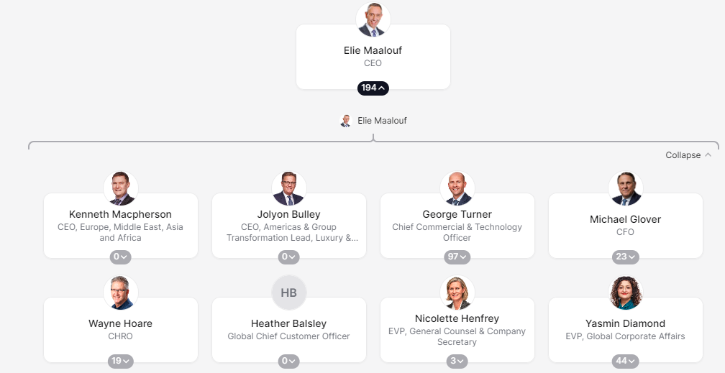
Figure 1: Organisational structure of IHG
(Source: Theorg, 2024)
The above figure demonstrates that IHG has a distinctive organisational structure leading to the roles and responsibilities among the individuals. In alignment with a theoretical perspective, Max Weber's Bureaucracy theory focuses on clearly defined roles, hierarchy, division of responsibility and labour along with a set of rules and regulations in an organisation that must be maintained (Sager and Rosser, 2021). It is mainly holding the aspect of maintaining the balance in the overall business organisation and providing a fair position to people in the business organisation as well. Relating to the IHG organisation also aligned with Max Weber's Bureaucracy theory showcasing a positive aspect of ensuring a fair organisational role and responsibilities for the people. Therefore, it can be stated that the organisational structure of IHG is efficient to get better efficiency by treating people within effectively. On the contrary, Max Weber's Bureaucracy theory has its disadvantages as well involving extensive rules and regulations. Due to this, it hinders or restricts the creativity of people following this overall innovation and the creativity of the organisation gets limited (Jenel, 2021). On the other hand, organisational culture is another important aspect of a business. The organisational culture is determined as the values, expectations and practices which direct the actions of the people in the organisation. Following this organisational culture reflects the behaviour of employees, vendors, and stakeholders who experience the brand and organisation (Cadden et al., 2020). Concerning IHG has a positive organisational culture which promotes and supports diversity, equity and inclusion (ihgplc, 2024). Following this IHG operates in different regions which allows them to develop the organisational culture based on the local culture of the region leading to better workplace development and higher engagement among the workforce. In this context, Charles Handy's organisational culture model is suitable which involves four different types of culture Power culture, Task culture, Person culture and Role culture (Handy, 2020). All these categories of culture have their significant features and values that get incorporated into the overall organisational culture practice. In alignment with IHG, it gets matched with personal culture as the company values its employee base and their cultural background along with being highly focused on inclusion and diversity. Similarly, person culture is where employees are valued and feel they are important to the organisation.
It is the reason IHG gets the positive aspect of higher efficiency and employee engagement leading to greater productivity. In contrast, this type of culture has its limitations in some contexts employees take everything for granted which costs the overall business adversely.
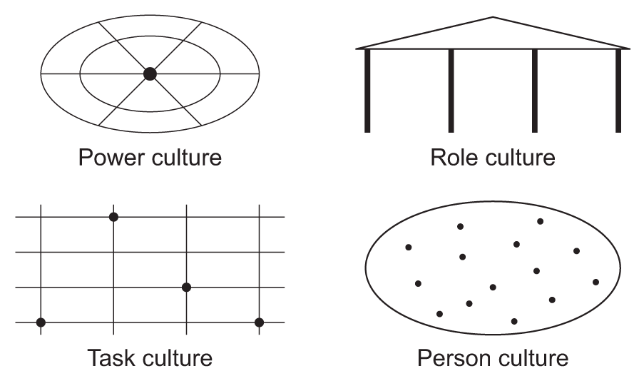
Figure 2: Handy’s Organisational culture model
(Source: aqa, 2024)
In terms of IHG's goals, it has involved being true hospitality for the good followed by shaping the company culture. Equally, bringing the brands to life and presenting a commitment to creating a difference for the guests, colleagues and communities involving safeguarding the world around it (ihgplc, 2024). In conclusion, it can be stated that IHG is a responsible and committed hotel group to positive aspects for everyone related to the business. As a result, the company is performing great in the competitive market of the hospitality sector and gaining higher growth and success from the overall business running across the globe.

“Recent change initiatives, their impact and how well these were managed”
Considering the recent report gathered from IHG hotel officials, it has been found that the business organisation has focused on using “Confirmable Suite upgrade” vouchers for the guests which can be used for booking hotels (IHG, 2024). For a very long time, the business organisation has focused on introducing this particular reward system for the customers willing to book suites for them. To offer good and hassle-free facilities and room services to the guests this service was introduced by the company. It has been found that to avail of this offer customers need to apply between 14 days to 24 hours before the stay begins. Apart from that, this particular voucher can also be used for a maximum of five-night stays. However, a customer in case of using this reward needs to grant support from IHG one reward customer service as it cannot be accessed from online booking. Further, it has been obtained that while using this particular voucher no other previous cash vouchers are permitted to be used.
This particular new approach is going to create a positive impact on the target audiences or guests of the company. Through this voucher support customers can get a huge discount during their hotel booking. That will help them in saving up excess expenditure which can be used for other purposes. Therefore, visitors or guests will remain satisfied with this particular service which will enhance their overall experiences and thus they will remain connected with the company as loyal customers.
Another service which has been introduced by the company is the Milestone Reward Option. That is also known as Food and Beverage Rewards (IHG, 2024). This particular rewards system can be used in the case of purchasing food from the hotel while staying or booking a room (Nickel-D'Andrea, 2024). Specifically depending upon the milestone reward acquired by an individual visitor, they will either get two food and beverage rewards or else five food and beverage rewards. That can be used for purchasing any food and beverage item from the hotel for self-satisfaction. However, this particular reward usually expires after 12 months (Nickel-D'Andrea, 2024). Thus, individual guests visiting this restaurant need to use this reward within 12 months so that it does not get wasted. This particular reward is useful for every customer as through its support they can get free food and beverages and enjoy their leisure time while staying at the hotel.
This will create a positive impact on the visitors or guests as they will get more food and beverage items during their stay by using this particular reward and during their previous visit. This will help the visitors to remain satisfied with the services offered by the company. Therefore, a good experience will be acquired by the visitors while staying at this hotel which will make them engage and thus they will take more services from the company in the future which will be beneficial for the business organisation on a large scale.

“The organisation’s strategic direction and current business performance”
From the gathered information obtained from the official website of IHG Hotel, it has been found that their digital-first approach is one of the well-known strategic directions that is helping customers to stay connected and in control of the company. It has been obtained that in 2022 the company discovered a more sophisticated and targeted way through which yes experience can be transformed. That will also ensure that hotels operate more efficiently to meet the desires of the customers and their demands so that high performance can be achieved. It has been also obtained that since 2022 the company has made strategic investments which have helped it drive business performance (IHGPLC, 2024). Moreover, it also helps in strengthening the entire enterprise and has contributed to enhancing the entire brand so that guests' demands can be fulfilled field which will help in achieving a good competitive advantage in the market. In this particular case, the company has also focused on hiring talented and experienced employees from the market who may help in enhancing business profitability with a greater performance which will be beneficial for the company in the upcoming years.
Further, enhances the corporate social responsibility or CSR value of the company it focuses on investing in such approaches which are eco-friendly and will help in protecting the environment from harmful hazards. Similarly, also focuses on working collaboratively with such stakeholders who may help them in receiving different eco-friendly materials that can be used for protecting the ecosystem from hazards (IHGPLC, 2024). Therefore, the implementation of that eco-friendly applications environment will be protected from negative impacts which will be beneficial for the company in enhancing its CSR value over time. Thus, it will get more customers who will enhance business profitability and therefore, it will achieve greater performance in the upcoming year.
Considering the annual report of IHG Hotel it has been obtained that since the past few years company has performed well wherein, it earned good revenue from global sales. In 2019 the company earned annual revenue of around 0.3% of profit which gradually increased by 52.5% in 2020. However, in 2021, because of the impact of COVID-19 sales volume decreased by 46.0%, thus, the company may have encountered a little loss which might impact its financial value (IHGPLC, 2024). This percentage gradually increased by +36.6% in 2022 which has had the company in enhancing its financial value. In 2023, is volume increased by 24.1% which allowed the company to secure good profitability that has been used for maintaining other business operations (IHGPLC, 2024). Thus, from this, it can be said the company in the last few years have performed extremely well which helped the company enhance its financial value.

Conclusion
This report has mainly highlighted the organisation behaviour and management strategy considered by IHG Hotel. It has presented an overview of the company by offering the background of the company and different data and information. It has also highlighted the organisational structure followed by the company. Along with that, the organisational culture considered by the hotel business has been also highlighted in this report. The future pose established by the company has been also presented in this report. Moreover, the recent change initiative acquired by the company and how it is impacting the business has been reflected. Lastly, the strategic initiative considered by the business and the current performance of the company has been highlighted through the support of this report.

Reference List
aqa. 2024. Teaching guide: Handy's culture. [Online] Available at: <https://www.aqa.org.uk/resources/business/as-and-a-level/business-7131-7132/teach/teaching-guide-handys-culture> [Accessed on 15 February 2024]
Cadden, T., Millar, K., Treacy, R. and Humphreys, P., 2020. The mediating influence of organisational cultural practices in successful lean management implementation. International Journal of Production Economics, 229, p.107744.
Cross, C. and Carbery, R., 2022. Organisational Behaviour. Bloomsbury Publishing.
Handy, C.B., 2020. Gods of management: The four cultures of leadership. Profile Books.
IHG. 2024. 19 IHG One Rewards. [Online] Available at: <https://www.ihg.com/onerewards/content/us/en/tier-benefits> [Accessed on 21 February 2024]
IHG. 2024. 19 SEE ALL THE WAYS YOU CAN BE REWARDED. [Online] Available at: <https://www.ihg.com/onerewards/content/us/en/tier-benefits> [Accessed on 21 February 2024]
Ihg. 2024. 19 hotel brands. 6,000+ destinations. One loyalty program. [Online] Available at: <https://www.ihg.com/content/us/en/about/brands> [Accessed on 15 February 2024]
IHGPLC, 2024. Half Year Results for the year to 30 June 2023. [Online] Available at: <https://www.ihgplc.com/en/news-and-media/news-releases/2023/interim-results-for-the-year-to-30-june-2023> [Accessed on 15 February 2024]
IHGPLC, 2024. Our strategy. [Online] Available at: <https://www.ihgplc.com/~/media/Files/I/Ihg-Plc/investors/annual-report/our-strategy-2022.pdf> [Accessed on 15 February 2024]
ihgplc. 2024. Our culture of Diversity, Equity and Inclusion. [Online] Available at: <https://www.ihgplc.com/en/about-us/what-we-stand-for#:~:text=Our%20culture%20of%20Diversity%2C%20Equity%20and%20Inclusion&text=Together%2C%20we%20create%20a%20diverse,who%20choose%20to%20join%20us.> [Accessed on 15 February 2024]
ihgplc. 2024. Our History. [Online] Available at: <https://www.ihgplc.com/en/about-us/our-history> [Accessed on 21 February 2024]
ihgplc. 2024. What we stand for. [Online] Available at: <https://www.ihgplc.com/en/about-us/what-we-stand-for#:~:text=Simple%20but%20powerful%2C%20our%20purpose,protecting%20the%20world%20around%20us.> [Accessed on 15 February 2024]
JeneI, G., 2021. The Impact of the Theory of Max Weber on Bureaucracy to our Present Day. POLGÁRI SZEMLE: GAZDASÁGI ÉS TÁRSADALMI FOLYÓIRAT, 17(Spec.), pp.218-240.
Nene, S.W. and Pillay, A.S., 2019. An investigation of the impact of organisational structure on organisational performance. Financial Risk and Management Reviews, 5(1), pp.10-24.
Nickel-D'Andrea, J., 2024. IHG maximizes hospitality with multicloud. [Online] Available at: <https://www.forbes.com/advisor/credit-cards/travel-rewards/ihg-milestone-rewards/> [Accessed on 15 February 2024]
Organ, C. 2023. 7 Organizational Structure Types (With Examples). [Online] Available at: <https://www.forbes.com/advisor/business/organizational-structure/> [Accessed on 15 February 2024]
Sager, F. and Rosser, C., 2021. Weberian bureaucracy. In Oxford research encyclopedia of politics.
Schermerhorn Jr, J.R. and Bachrach, D.G., 2023. Management. John Wiley & Sons.
statista. 2023. Revenue of the InterContinental Hotels Group 2007-2022. [Online] Available at: <https://www.statista.com/statistics/273254/revenue-of-the-intercontinental-hotels-group/> [Accessed on 15 February 2024]
Theorg. 2024. IHG. [Online] Available at: <https://theorg.com/org/ihg> [Accessed on 15 February 2024]

