Ground works Assignment

Desk Study:
The site is located next to the car park for the Marriot hotel in Swansea very close to the beach.

Google (2020) Google Maps. Available at: https://www.google.com/maps/place/Swansea/@51.6133065,-3.945541,150m/data=!3m1!1e3!4m5!3m4!1s0x486e45555a4e97b1:0x3d77128e2fe7cb74!8m2!3d51.62144!4d-3.943646 (12/11/20)

Local history of the site
The location of the site has been used for various different purposes from at least the 1890’s. at this time there was a timber yard located on the site. During the 1950’s the site swapped from a timber yard to a ‘cannister works’. Close by to the site there has been a railway and an engine shed for locomotives that would have used the railway, the engine shed was removed during the 1960’s.
The previous occupations of the site show importance from a contamination perspective of the site. during the early 1900’s due to the proximity of the site to a railway would most probably use the cut timber to manufacture of railway sleepers.
Railway sleepers (up until recently) have been manufactured by cutting them to length with a saw then dipped into a tank of creosote, the creosote is to protect the sleepers from the elements. creosote is a toxic substance and as the sleepers age the creosote leaks into the ground causing the soil to be contaminated with creosote.
The Engine shed based close by can also be a concern for the soil as maintenance and cleaning of steam locomotives can cause a huge amount of contamination. Due to the different standards of waste disposal at the time waste oil from steam locomotives could have been disposed of by pouring or burning outside on the ground. Brake dust cleaned off locomotives in most cases contained large amounts of asbestos that could be left outside in poorly contained waste piles. Smoke and soot from the engines can also carry large amounts of sulphur that can make its way into the soil causing contamination. As the Engine Shed was not located on the site, but close by, means that the possibility of contamination from this area is low but as the water table is close to the surface in the area it should be noted.
When the cannery was built in the 1950’s over the old timber yard this is a cause for concern as cans and containers at the time would have been made out of tin and soldered together with lead solder. Tin and lead especially are toxic, tin is known to be toxic to humans if consumed in excess.
Adjacent to the cannister works is the paint factory that seems to have been constructed at the same time. Paint during that period would have been manufactured containing large amounts of lead and other noxious and dangerous chemicals such as solvents and in some cases arsenic.
Lead is more toxic than tin and it is well documented the negative health effects on the human body and wildlife. It is therefore safe to assume that the ground is more than likely to be contaminated with various different contaminants this also classes the ground as Anthropogenic ground.
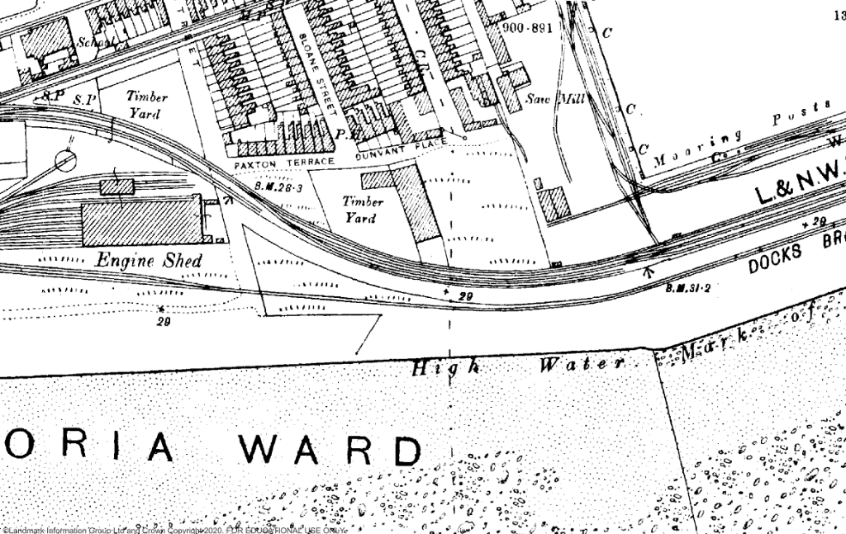

Up: Digimaps (year published 2020) Swansea 1890’s . Available at: URL (https://digimap.edina.ac.uk/roam/map/historic) (15/11/20)
Down: Digimaps (year published 2020) Swansea 1910’s . Available at: URL (https://digimap.edina.ac.uk/roam/map/historic) (15/11/20)

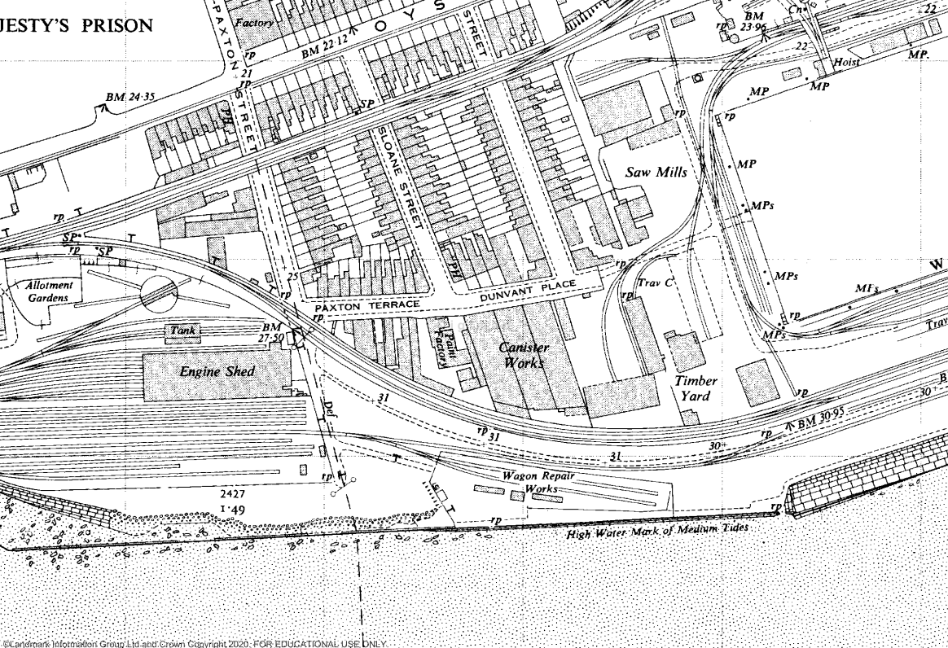

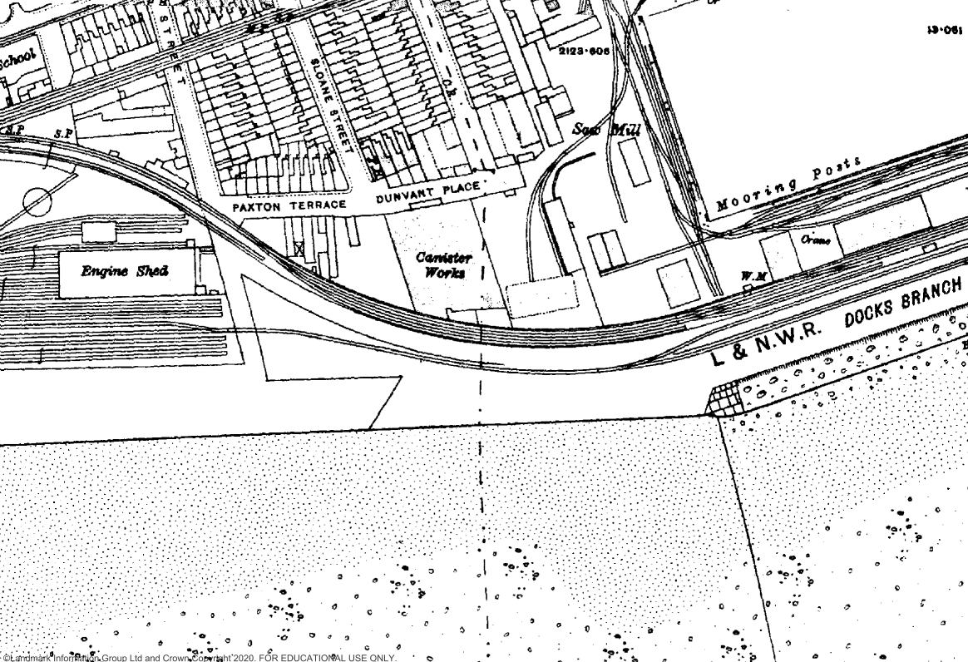

Up: Digimaps (year published 2020) Swansea 1950’s . Available at: URL (https://digimap.edina.ac.uk/roam/map/historic) (15/11/20)
Down: Digimaps (year published 2020) Swansea 1960’s . Available at: URL (https://digimap.edina.ac.uk/roam/map/historic) (15/11/20)

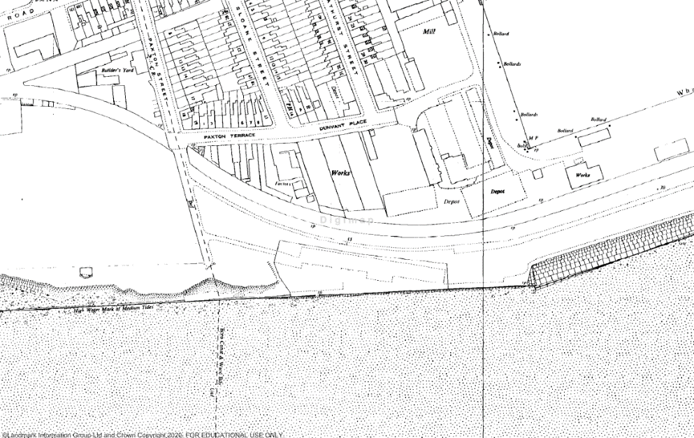

Bore hole Records
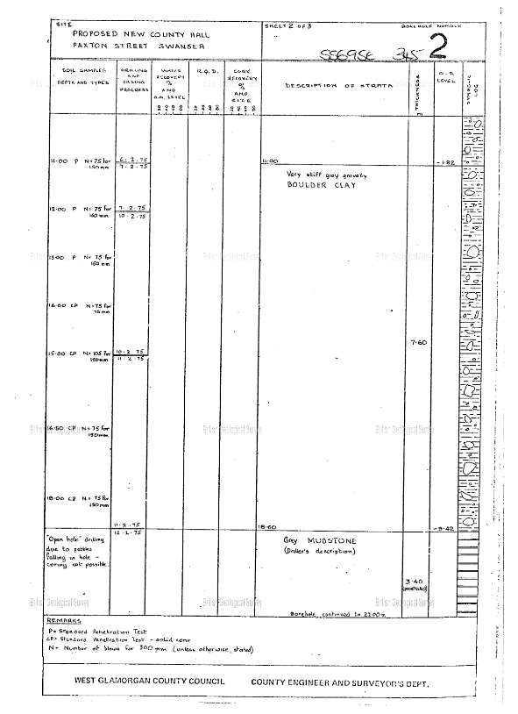
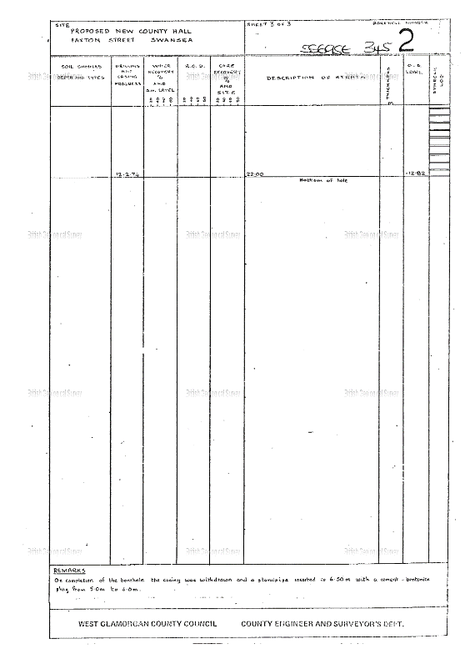
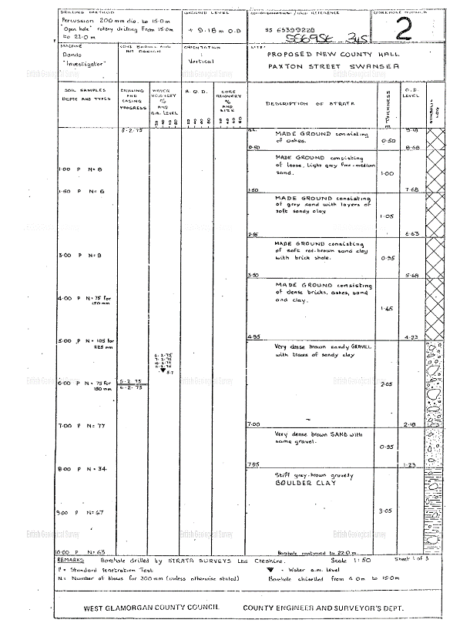
Local geology is reflected in the bore hole records. The top layer of strata is extremely loose, consisting of ash and sandy gravel. Below the top layers there appears to be a fair amunt of brick shale and dense bricks, these could well have been from the demolition of cannery. Below the dense brick are layers of “ brown sand with some gravel” until a depth of 7 meters. the soil sample then becomes a lot more dense still consisting of sand and gravel. The soil then stays similar until a depth of 11 meters, the soil then becomes stiffer and lerger boulders are described. At a depth of 18.6 meters the soil is described as grey mudstone until the sample stops at 22m.

Geo Index (1975) Geo Index.
Available at: http://scans.bgs.ac.uk/sobi_scans/boreholes/370246/images/10677923.html (12/11/20)

Site Investigation
Due to the extensive history of the site the main concern of the site is that of contamination as highlighted previously the site has been used for a number of heavy industries that lacked safety and quality control standards rather than that of today. This means that there is a high probability of contamination and further site studies should be taken into account for this. The site study I would recommend is trial pitting in and around where the cannery and the paint shop were previously located, soil samples taken from the site should be sent to a laboratory to test for lead and other toxicants within the soil. A decision can then be made to treat the contamination. A number of risk assessments should also take place to understand the danger of the possible contamination on the ground.
Further bore hole testing should also take place to get a better understanding of the geology of the site as only one bore hole record currently exists on the site currently (17/11/20). Bore holes would have to be dug with a hollow stem auger due to the very loose nature of the soil. Bore holes can also be used to find the level of the water table which can then affect the soil dynamic later on.
Due to the distance of the site from the sea it should be taken into account the likely hood of flooding in extreme conditions.
When the soil is excavated and tested it should be handled with the greatest of care due to the possibility of its chemical content. PPE should be worn at all times when handling the soil until we are sure of the chemical make up of the samples. Due to the consistency of the soil trial pitting will have to be supported, from the borehole information the soil is described as “ made ground consisting of ashes (0.5 metres)” to “made ground consisting of soft red brown sandy clay with brick shale” at 3.5 metres.
Surveying should be done on the site to identify the environmental responsibilities on the site, the contamination of the site should be examined due to how close it is to the water. This may provide a hazard on site as contaminated ground could leak pollutants into the sea if disturbed. Other environmental items to consider would be local wildlife and vegetation.
Local utility companies should be contacted to make sure all underground utilities are accounted for and marked so that there will be less likelihood of an incident. Cable detection should also be incorporated during the exploratory phase of the site investigation for the same reason.
Soil samples could also be tested for compressive and shear strength through the use of a static cone penetration test. This would be important as the dense brick layer of the soil sample indicates that the demolition refuse was used as back fill, this could well cause varying settlement during the build and after especially mixed with the loose soil.
As there are a line of trees through the centre of the site they should be examined to check if they are not endangered, smaller trial pits should also be dug to examine the root structure of the trees to see if they could cause damage to the build or delay in construction.

Building regulations and codes of practice
Due to the history of the land previously there will be a need for the involvement of the local environment agency to inspect and assess the state of the soil and advise further on the contamination if the soil, according to the government -
“If the land is legally considered ‘contaminated land’, the person who caused or allowed the contamination to happen is responsible for dealing with it, unless:
- they can’t be identified
- the local council or environment agency investigating the issue decides they’re exempt”

This would then become the responsibility of the contractors or owners of the land as finding the responsible party may become difficult
(Gov.uk (year published unknown)-contaminated land .Available at: https://www.gov.uk/contaminated-land/dealing-with-contamination (Accessed: 13/11/20))

During the investigation and preliminary investigation it is important to adhere to strict CoCP regulations that would be outlined in the planning application or implemented as conditions for the planning permission. The location of the site is very close to a residential area and a hotel so working hours must be kept within reasonable times as to not disturb the local population. It is recommended to not begin work before 6am, starting more noisy work after 8am. The working day should finish at around 5pm.
Negotiations should occur with the local council for the increased road traffic in the area during the construction. This can cause large amounts of dust pollution. It is usually the responsibility of the contractor to enact dust control measures. Maintenance of the local roads can also fall on the contractor if the roads are adversely affected by road traffic as a direct result of the site. waste developed by the site should be disposed of by a licenced local waste carrier.
Decibel levels should be monitored when heavy plant or loud tools are being used as they can disrupt the local population and cause long term hearing damage to workers and visitors on site. if the noise levels reach over 85 decibels workers must be provided with hearing protection. Work should follow the rules set by the ‘Control of Noise at Work regulations 2005’.
Due to the danger of contamination on the site, combined with the location of the site being so close to the sea, Part 2a of the ‘environmental protection act of 1990’ can be enforced by the environment agency if the contamination is not dealt with in the correct manner. This means that all contaminated soil has to be treated or disposed of in the correct manner. Any contamination caused by the site should also be dealt with.
Bore holes and trial pits should be capped or fenced as necessary to prevent any accidents or injuries as a result of a fall from height.

Foundations
Due to the soft and poor shear strength of the soil consistency I would recommend that the foundations are to be pile foundations as they provide the least amount of settlement problems during the course of the build and post construction. There are many options to consider in choosing the right pile foundation for the job. Due to the consistency of the soil the foundations should be driven in.
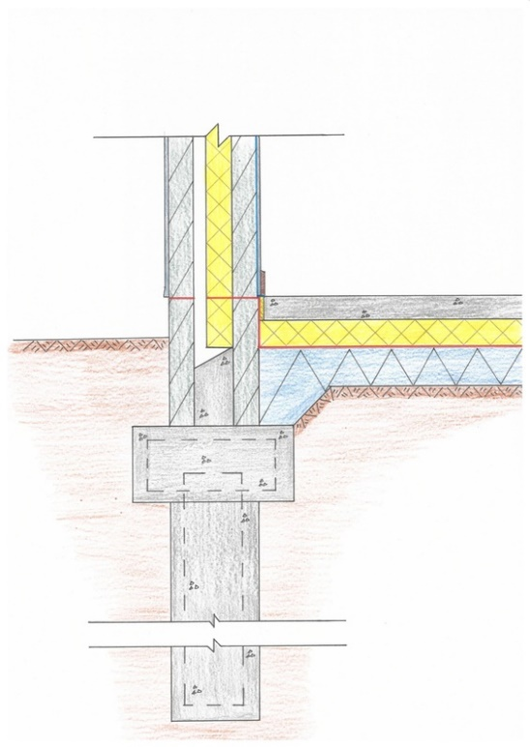
Unfortunately as a consequence of this it may cause disturbance to the hotel and the council building close by. The vibrations from a driven pile would cause a large amount of noise disturbance and vibration may cause other issues to the local buildings if used in excess. But the driven element of the foundation is vital as it compacts the soil underneath producing a much stronger base for the foundation.
There are two options to consider for the pile foundations themselves, friction and preformed. Friction piles use the friction force between the soil and the foundation to support the superstructure above so that not all of the force is directed straight down. This reduces the effect of settlement in areas of little soil strength. After the pile is compacted concrete is poured in with a steel frame to reinforce the concrete pile.
Preformed pile foundations are usually constructed off site, they are usually made of either concrete or steel. They are most effective for soft soil that becomes denser and firmer deeper down. Care has to be taken driving the sections in as they can fracture if driven in with too much force.
To assist in the support of the structure the piles should not be capped with a raft foundation on top. This allows a large proportion of the foundation spread the weight on the surface also combining the effect of the piles to reduce the amount of settlement the building experiences.
Colm Flynn (2013) Piled foundation Available at: URL (Accessed: 14/11/20)

