UNIVERSITY OF WALES TRINITY SAINT DAVID
LONDON CAMPUS
Assignment 2
Learning in the Digital Era
Video Link: https://www.youtube.com/watch?v=02tIuIAv7HI
Please be sure to give unrestricted access to your video presentation so that your work can be marked by the examiner.

Module Name: Learning in the Digital Era
Module Code: ACCA 4025

Student Name: Daniel Bolanos Alvarez
Student ID:2512075
Group: 3

Lecturer’s Name: Suneth Fernando

Table of Contents
Introduction 2
Main Body 2
Conclusion 9
References 9

Introduction
This document will cover a PowerPoint presentation for the LDE module. It will address topics such as self-assessment, a professional work plan based on the SMART method, Gibbs' Reflective Cycle, and learning to learn, which was the topic I chose for Unit 4.

Main Body
The main task of this project was to create a presentation with a table of contents and upload it to the YouTube platform.
Video Link: https://www.youtube.com/watch?v=02tIuIAv7HI
Slide 1

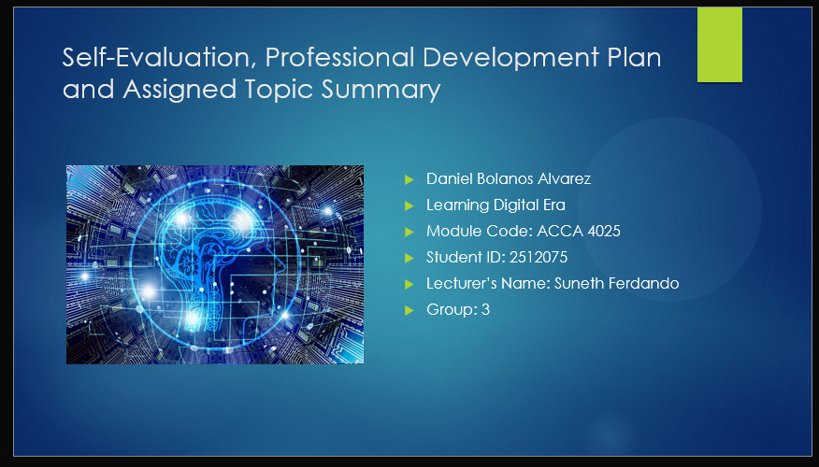

Slide 2

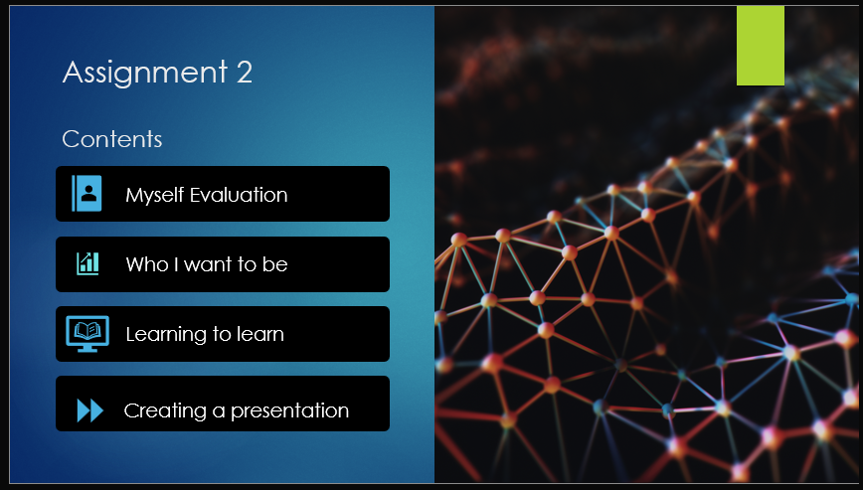
Slide 3

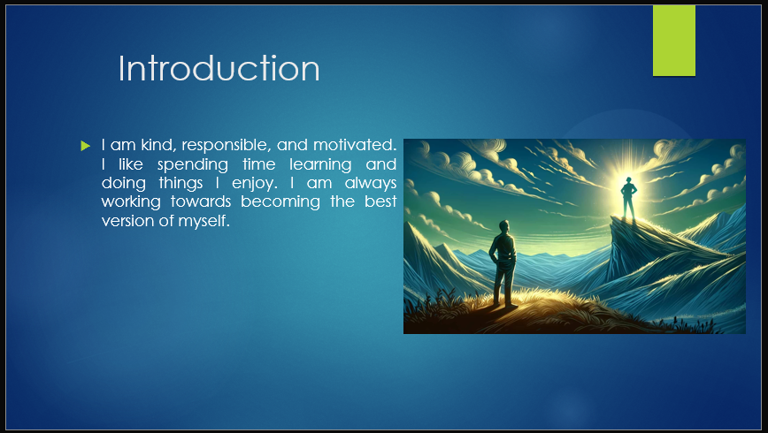

Slide 4

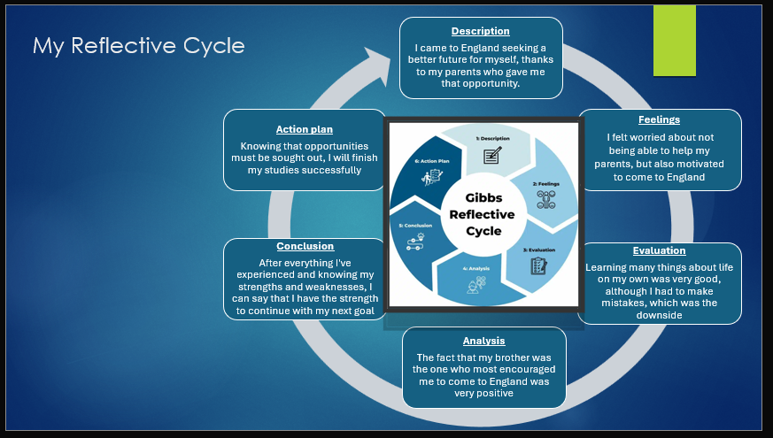
Brief explanation: The Gibbs' Reflective Cycle is a six-stage structured framework designed to help individuals learn from experiences, particularly repetitive ones. By moving through Description, Feelings, Evaluation, Analysis, Conclusion, and Action Plan, it fosters deep reflection, self-awareness, and improved future practice [1].
I used the GISS method to integrate it into me, and step by step I adapted it to my experience in various areas of my life.
Description: I came to England seeking a better future for myself, thanks to my parents who gave me that opportunity.
Feelings: I felt worried about not being able to help my parents, but also motivated to come to England.
Evaluation: Learning many things about life on my own was very good, although I had to make mistakes, which was the downside.
Analysis: The fact that my brother was the one who most encouraged me to come to England was very positive.
Conclusion: After everything I've experienced and knowing my strengths and weaknesses, I can say that I have the strength to continue with my next goal.
Action Plan: Knowing that opportunities must be sought out, I will finish my studies successfully [1]

Slide 5

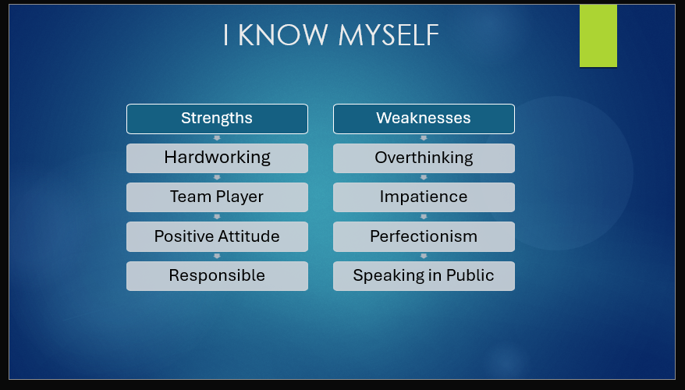
Brief explanation: I consider myself a hardworking and responsible individual who consistently puts effort into achieving my goals. I work well as part of a team, contributing positively and supporting others to create a collaborative environment. I also maintain a positive attitude, which helps me stay motivated and adapt to challenges. Because of this and couple of other strengths, i believe i can successfully complete my studies.

At the same time, I recognise some areas for improvement. I tend to overthink situations, which can slow down my decision-making. I can also be impatient at times, especially when I am focused on achieving results quickly. My perfectionism sometimes leads me to spend more time than necessary on tasks, and I occasionally feel nervous when speaking in public. However, I am actively working on these areas to continue developing both personally and professionally.

Slide 6
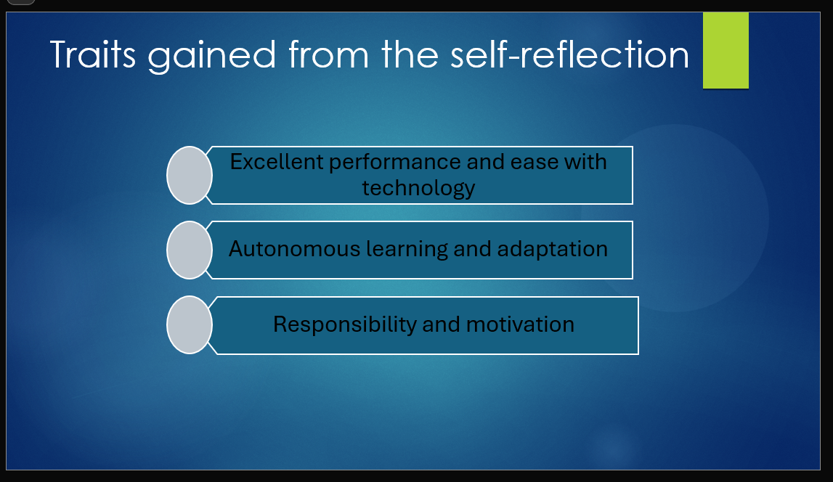

Brief explanation: I have demonstrated strong technological aptitude from a young age, developing a keen interest in technology, particularly video games. Which helped me understand how systems work and how to navigate their settings effectively. Driven by curiosity, I have built my skills through autonomous learning and trial and error, allowing me to adapt quickly and gain knowledge independently across different areas. I approach my responsibilities with commitment and determination, consistently achieving the goals I set for myself, and each accomplishment further strengthens my motivation to continue improving and reaching higher objectives [2].

Slide 7

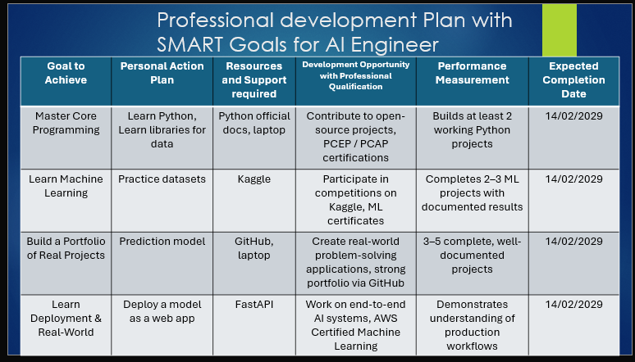
Brief explanation: Based on a professional development plan structured around the SMART goals methodology, I have developed a framework consisting of four key objectives aligned with the AI engineering profession. For each objective, I have identified the most relevant steps required to achieve them effectively. By implementing a clear action plan, supported by appropriate resources and essential requirements, I aim to acquire the professional qualifications necessary to expand my career opportunities. Furthermore, through a combination of academic study, internships, and practical work experience, I anticipate that by the completion of my university studies, I will be well-positioned to secure an opportunity to begin my career as an AI engineer.

Slide 8
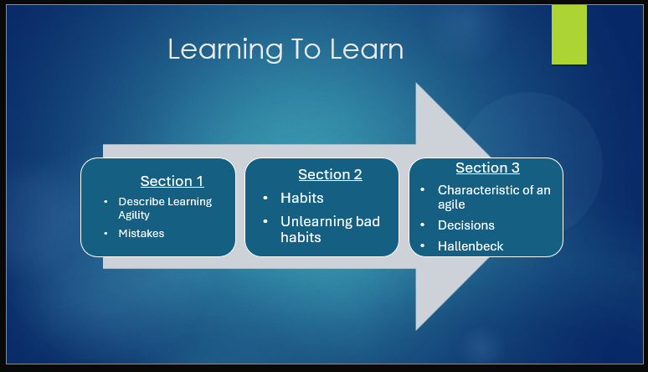
Brief explanation: Section 1: Agile learning is your able to take risk in attempting to deal with a novel situation when not knowing exactly what to do. Agile learners reject the idea of embarrassment because they not feel scared about it.
Mistakes: usually people said we can learn from our mistakes and we find out our mistakes when we asking for a feedback

Section 2: Habits are automatic reflexes we develop throughout our lives through our routines.
Bad habits cause our brain to release dopamine, making learning very difficult. To break bad habits, you have to step outside your comfort zone. [2]

Section 3: Agile learners know how to manage a lack of stimulation in new situations so that their learning isn't negatively impacted [3]. The desire to avoid stress and risk in learning negatively affects the learning process. Hallenbeck identified four practices for greater learning: Seeking - expresses that the more courage you have to experience new things, the more you will learn; Sense Making - says that the best way is to put aside what you already know and continue demonstrating that you are curious; Internalising - taking criticism positively and listening to feedback is where you will learn the most from your mistakes; Applying - trying to apply similar situations in the past to new challenges and having the ability to see other options.

Slide 9

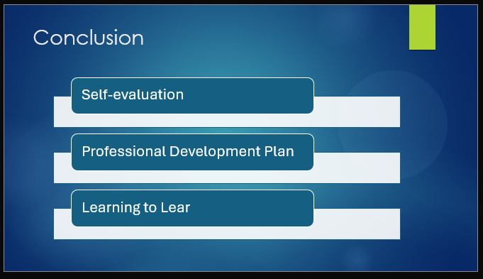

Brief explanation: My presentation provided a self-evaluation, identifying key strengths, weaknesses, and personal traits through reflection and assessment tools.
A Professional Development Plan (PDP) was developed using a reflective model and SMART goals to support continuous growth.
Progress towards one development goal was demonstrated with evidence and reflection.
Learning to learn were explored, highlighting the importance of ongoing learning and self-improvement. I learned about how to become a better learner.
Overall, the tasks emphasise the value of reflection, structured planning, and continuous professional development in achieving future career goals.

References

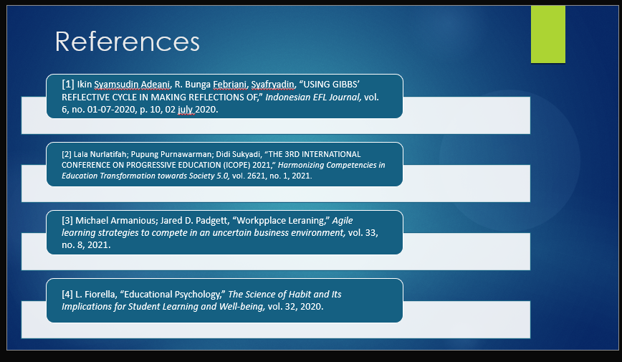

References

[1] | Ikin Syamsudin Adeani, R. Bunga Febriani, Syafryadin, “USING GIBBS’ REFLECTIVE CYCLE IN MAKING REFLECTIONS OF,” uniku, vol. 6, no. 2, p. 10, 2, July 2020.
[2] | Lala Nurlatifah; Pupung Purnawarman; Didi Sukyadi, “THE 3RD INTERNATIONAL CONFERENCE ON PROGRESSIVE EDUCATION,” AIP Conf. , vol. 2621, no. 1, 2021.
[3] | Michael Armanious; Jared D. Padgett, “Agile learning strategies to compete in an uncertain business environment,” Journal of Workplace Learning, vol. 33, no. 8, p. 635–647., 4 October 2021.
[4] | L. Fiorella, “The Science of Habit and Its Implications for Student Learning and Well-being,” Springer Nature Link, vol. 32, p. 603–625, 2020.

IEEE referencing style must be followed.
In-text citations need to be used in the slide as well as in brief explanation section in this report.

