Dynamic stress-strain investigation
Josh Gourlay

2111487@student.uwtsd.ac.uk
Physics – ACDA4007

Contents
Abstract
1. Introduction
2. Simulation setup
3. Results and discussion
4. Limitations of software
5. Conclusion
References

Abstract
A high strain rate investigation was carried out of a bullet striking a steel and aluminium laminated target utilising the Johnson-Cook damage and plasticity parameters input into Abaqus. Three simulations were carried out based on a pre-populated simulation file axi_ballistics2.cae (AB2), with materials changed to aluminium and steel. Two of the simulations also featured an enhanced mesh, one with element deletion and one without. It was found that although the greater mesh density resulted in a more accurate simulation, varying damage values propagating throughout individual elements suggested that the enhanced mesh was still too coarse. There were also several limitations to the software, primarily of which was the inability to run a simulation without crashing when element deletion was removed.

- Introduction
There is ongoing research within the defence industry to enhance the effectiveness and reliability of ballistic armour; either light armour such as body armour or personnel helmets [1], or heavier armour used to protect vehicles in combat [2]. One such process currently used in various types of armour is a process of lamination, in which multiple layers of material are sandwiched together. Chaichuenchob et al [3] have presented an example of transparent armoured glass using laminated sheets of soda-lime glass and polyvinyl butyral (PVB) films, resulting in good ballistic protection performance whilst keeping thickness and weight to a minimum. Similarly, many armoured fighting vehicles (AFVs) utilise lamination to excellent effect, such as roll bonding a layer of rolled homogenous armour (RHA) with high-hardness armour (HHA) creating a single composite armour plate. By combining the projectile fragmentation qualities of HHA and the absorber qualities of the RHA, this lamination technique produced a composite armour 78% more effective than RHA alone [4].
To evaluate the effectiveness of new types of armour, simulation trials could be carried out in which several material models can be used to characterise the behaviour of materials under stress and strain. This is diagrammatically represented on a stress-strain curve such as figure 1.1.
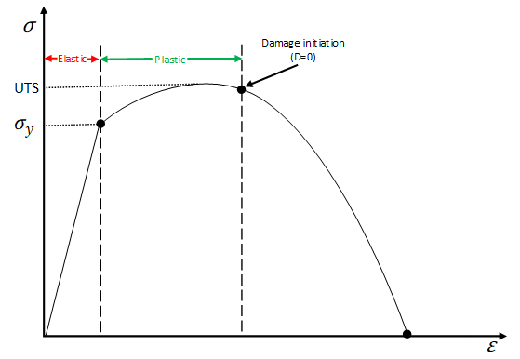

Figure 1.1 – Generic stress-strain curve representing the elastic and plastic regions of a ductile material under a tensile load [11] [13].

Direct stress (σ); defined as the force (F) exerted per unit area, is plotted against direct strain (ε), defined as the change in length of the material relative to the original length [5]. As stress is applied, strain is increased proportionally to a point known as yield stress ($σ_{y}$). If a stress is applied to a material but removed before reaching$σ_{y}$, the material will deform but still return to its original shape. This is known as the elastic region of a stress-strain curve, the gradient of which is represented by Young’s modulus (E), as shown in equation 1.
$$E=\frac{σ}{ε}$$
Equation 1 – Equation to calculate Young’s modulus (E). σ is stress, ε is strain. [5]
If a stress is applied such that strain becomes greater than$σ_{y}$, the material will enter the plastic region of the stress-strain curve. At this point, the material will become irreversibly deformed, never returning to its original shape. As depicted by fig 1.1, initially beyond Y the strength of the material increases in a process known as strain hardening [6] to a maximum, known as the ultimate tensile strength (UTS). If further stress is applied, the strength of the material decreases to the point at which it fails.
There are several models to describe material properties for high strain rate applications, one of which is the Johnson-Cook (JC) plasticity model. Developed in 1983 [7] and still one of the most influential models today, it is used to model materials in the plastic region of a stress-strain curve, such as in figure 1.1. The JC formula is shown in equation 2 [8].
$$σ=\left[A+B({\dot{ε})}^{n}\right]\left[1+Cln\left(\frac{\dot{ε}}{{\dot{ε}}_{0}}\right)\right]\left[{\left.1-\left(\frac{θ-θ_{T}}{θ_{M}-θ_{T}}\right)\right.}^{m}\right]$$
Equation 2 – Formula for the Johnson-Cook plasticity model.
The formula consists of flow stress (σ), plastic strain ($\dot{ε}$), initial plastic strain ($\dot{ε_{0}}$), temperature ($θ$), transition temperature ($θ_{T}$) and melting temperature ($θ_{M}$) of the material. The remaining constants, calculated from various experiments [6] are yield stress (A), strain hardening constant (B), strengthening coefficient of strain rate (C), strain hardening coefficient (n) and thermal softening efficient (m) [9].
Johnson-Cook also proposed a model to define the mode in which materials fail, from damage initiation to complete material failure [10]. The equation for the Johnson-Cook dynamic failure model is shown in equation 3.
$${\dot{ε}}_{f}=\left[D_{1 }+ D_{2} Exp \left(D_{3}\frac{p}{q}\right)\right]\left[1+D_{4}ln\left(\frac{\dot{ε}}{{\dot{ε}}_{0}}\right)\right]\left(1+D_{5}θ\right)$$
Equation 3 – Formula for the Johnson-Cook dynamic failure model. [10] [11]
Equation 3 consists of fracture strain ($\dot{ε_{f}}$), plastic strain ($\dot{ε}$), initial plastic strain ($\dot{ε_{0}}$), mean stress ($p$), Mises stress ($q$) and temperature ($θ$). Also included are 5 damage constants, D1-D5 [10] [11]. The JC failure model is used to represent how ductile materials behave at the point at which damage starts to occur as represented by the stress-strain curve in figure 1.2. $ε_{ip}$ represents the initial plastic strain, $ε_{f}$ is the failure strain value.

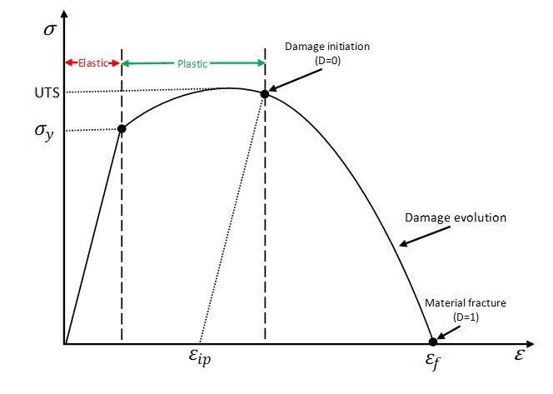
Figure 1.2 – Typical stress-strain curve, including damage evolution curve represented by JC dynamic failure model [11] [13].
The rest of this report will detail simulated examples of a projectile hitting a laminated target, using values for both Johnson-Cook plasticity and dynamic failure models programmed into Abaqus software.

- Simulation setup
To investigate a high strain rate problem, a simulation of a projectile hitting a laminated metal target was conducted using Abaqus simulation software. The simulation was based on a predefined simulation file named axi_ballistics2.cae (AB2), with the materials changed to steel and aluminium, as opposed to copper and plastic. Three simulations were conducted in total, as summarised below:
- Aluminium and Steel with element deletion using enhanced mesh – Referred to as AS100K in this report.
- Aluminium and Steel with NO element deletion using enhanced mesh – Referred to as ASND in this report.
- Aluminium and Steel with element deletion using original mesh from AB2 – Referred to as ASAB2 in this report.
Shown in figure 2.1 is use of the material manager in the ‘Property’ module, which was used to create the materials chosen for the simulation of aluminium and steel (labelled target steel to differentiate between the target and projectile).

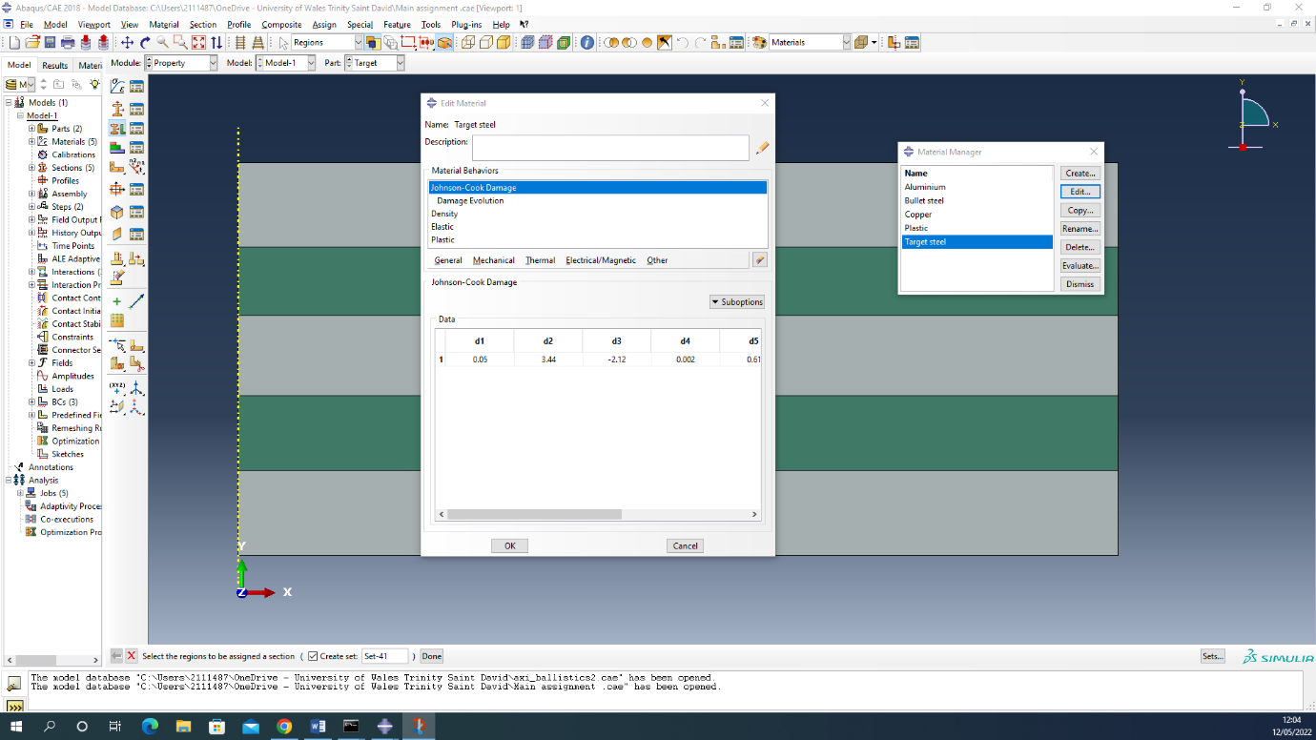
Figure 2.1 – Screenshot of material manager in 'Property' module used to create materials and assign material properties from literature research. The grey layers were assigned as target steel and green layers assigned as aluminium.
Material properties were assigned by selecting ‘Edit’ on the chosen material. These properties include the JC plasticity and damage parameters, density and elastic properties, a summary of which is listed in figure 2.2.
 | Aluminium | Target steel
JC plastic
A (Pa) | 546000000 | 792000000
B (Pa) | 678000000 | 510000000
C | 0.024 | 0.014
n | 0.71 | 0.26
m | 1.56 | 1.02
Melting temperature (K) | 925 | 1520
Transition temperature (K) | 293.2 | 293.2
JC damage
D1 | -0.068 | 0.05
D2 | 0.451 | 3.44
D3 | -0.952 | -2.12
D4 | 0.036 | 0.002
D5 | 0.697 | 0.61
Melting temperature (K) | 925 | 1520
Transition temperature (K) | 293.2 | 293.2
Reference strain rate | 1 | 1
Fracture energy | 10000 | 100000
Density (kg m⁻³) | 2810 | 7850
Elastic
Young’s Modulus (Pa) | 71700000000 | 205000000000
Poisson’s ratio | 0.33 | 0.33
Figure 2.2 – Table of material properties for JC plastic and damage models, density, and elastic. These values were input into the relevant section in the materials manager [10] [14].

Once the material has been created, the corresponding section for which the material was assigned to was also created using the ‘Create section’ button on the ‘Property’ module. For both aluminium and target steel, the solid/homogeneous type was used. The materials created in an earlier step were then assigned to the corresponding sections as shown in figure 2.3.

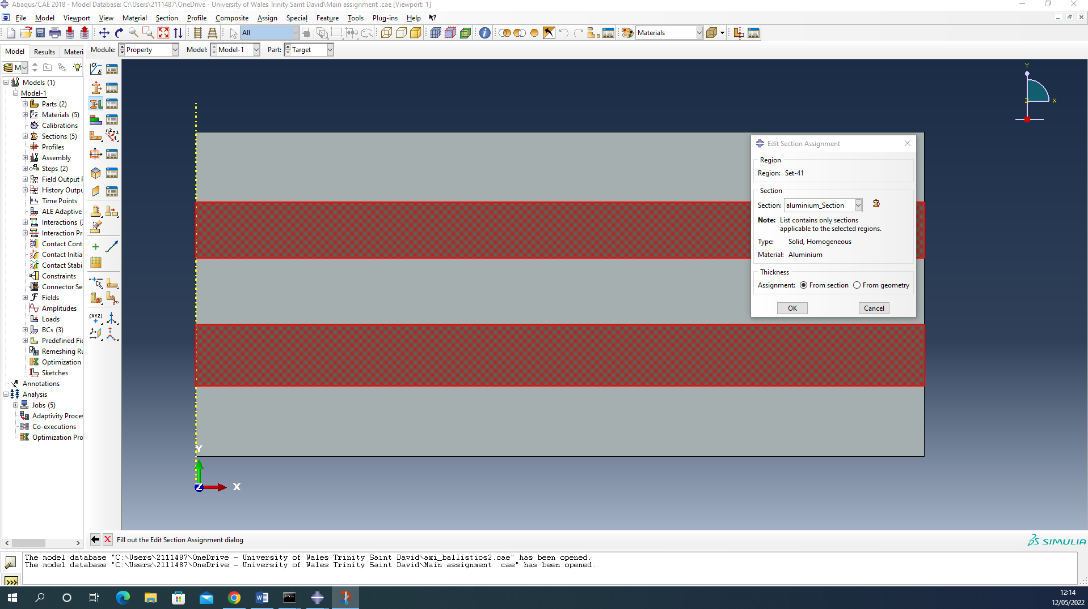
Figure 2.3 – Screenshot of assigning material to corresponding section in simulation setup. In this screenshot, the aluminium material properties from figure 2.2 were assigned to the aluminium section.
An improvement to AB2’s mesh was carried out by increasing the number of seeds on each edge of the target plate. Firstly, on the mesh module, all horizontal layers were highlighted and ‘Seed edges’ was selected. The minimum size was reduced from 0.0015 in AB2, to 0.0005 in the enhanced simulations, with the maximum size staying constant between the two mesh types. Conversely, on the vertical edge, rather than adjusting the size, the number of seeds was increased from 2 on ASAB2 simulation to 8 seeds on the enhanced simulations. Figures 2.4 and 2.5 compare the mesh of ASAB2 vs AS100K and ASND.
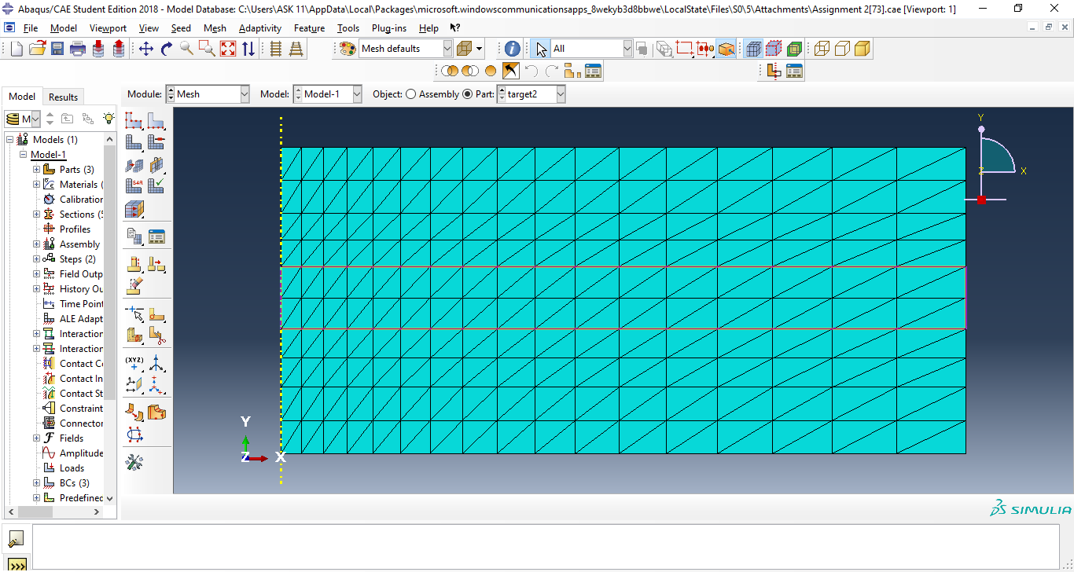
Figure 2.4 - Screenshot detailing ASAB2's mesh before the enhancement was made.

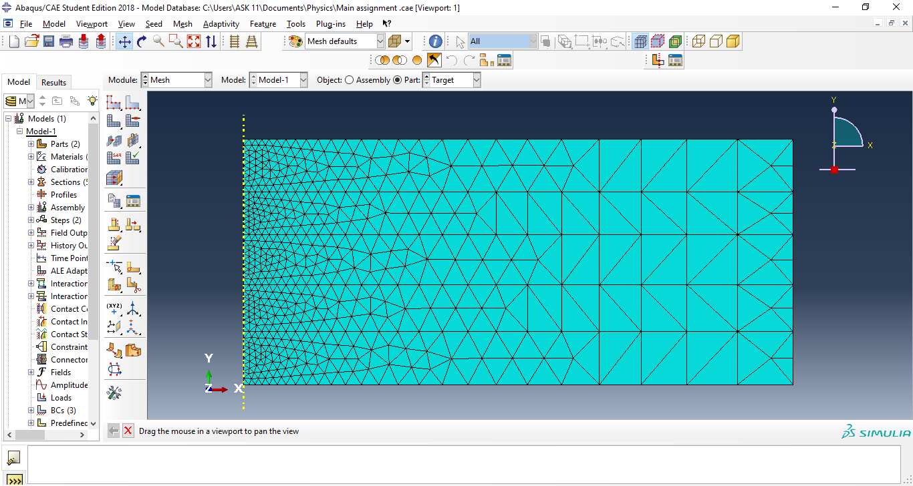
Figure 2.5 - Screenshot of enhanced mesh used in AS100K and ASND. The number of seeds were increased from 2 to 8 on vertical edge and reducing minimum size on horizontal layers.
The final step in enhancing AB2 simulation was to set the interaction of the projectile with the target. Without this vitally important step, the projectile would pass through the target as if it was never there. Figure 2.6 details this interaction step.

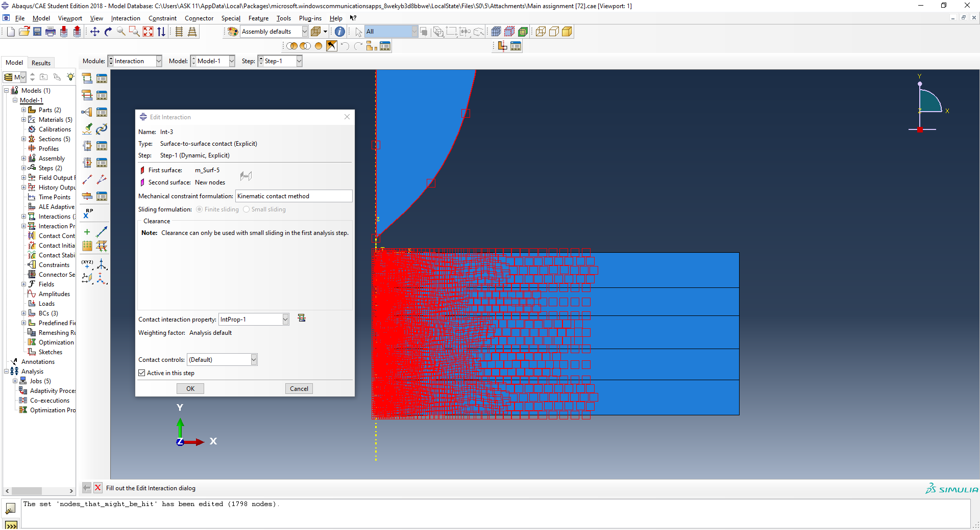
Figure 2.6 - Screenshot highlighting the nodes within the target that will interact with the projectile as it passes through.
As shown in figure 2.6, the first surface set was ‘m_Surf-5’ which represents the surface of the projectile. The second surface set was ‘New nodes’ which represents the nodes within the target layers, that were most likely to interact with the projectile on impact.

Following the adjustments as described in this section (for the 2 simulations with enhanced mesh), the simulation can then be run in the ‘Job’ module. In the ‘Job manager’ menu, a job is created, assigned a short description to differentiate different simulations and submitted. Once the simulation has completed, the results can be viewed using the ‘Results’ button within Job manager as shown in figure 2.7.

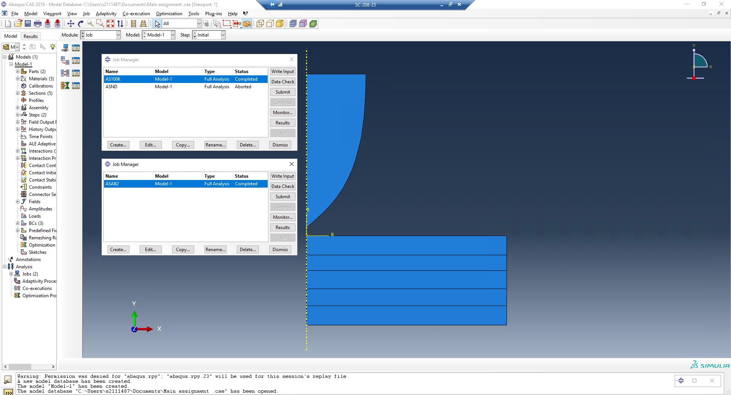
Figure 2.7 - Screenshot detailing the various simulations that were run.
Simulation ASAB2 was carried out on a separate simulation file, hence the presence of two ‘Job manager’ menus in figure 2.7.

- Results and discussion
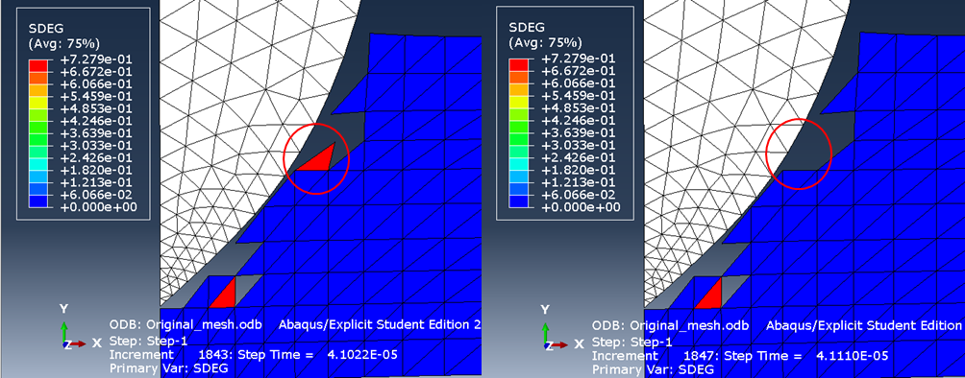
The simulation results comparing AS100K and ASAB2 simulations have supported the theory of finite element analysis (FEA) in that a finer mesh will result in a more accurate simulation compared with coarser mesh [12]. One of the inaccuracies highlighted with the coarse mesh of ASAB2 is depicted in figure 3.1 and 3.2.

Figure 3.1 shows damage occurring to the highlighted element of the ASAB2 mesh, despite the surrounding elements showing no damage and a lack of contact between the bullet surface nodes and
Figure 3.1 – Screenshot of damage evolution taking place within an element (circled red) in the ASAB2 simulation.
Figure 3.2 – Screenshot of the same element as figure 3.1 post deletion in a consecutive step.

Figure 3.1 highlights an element undergoing significant damage at approx. 0.73 despite no interaction from the projectile or surrounding elements. Figure 3.2 is the same element post deletion in the consecutive step suggesting all nodes within that element have surpassed the fracture energy required for the element to delete.
However, there was evidence to suggest that even the enhanced mesh in AS100K was still too coarse as depicted in figure 3.3.
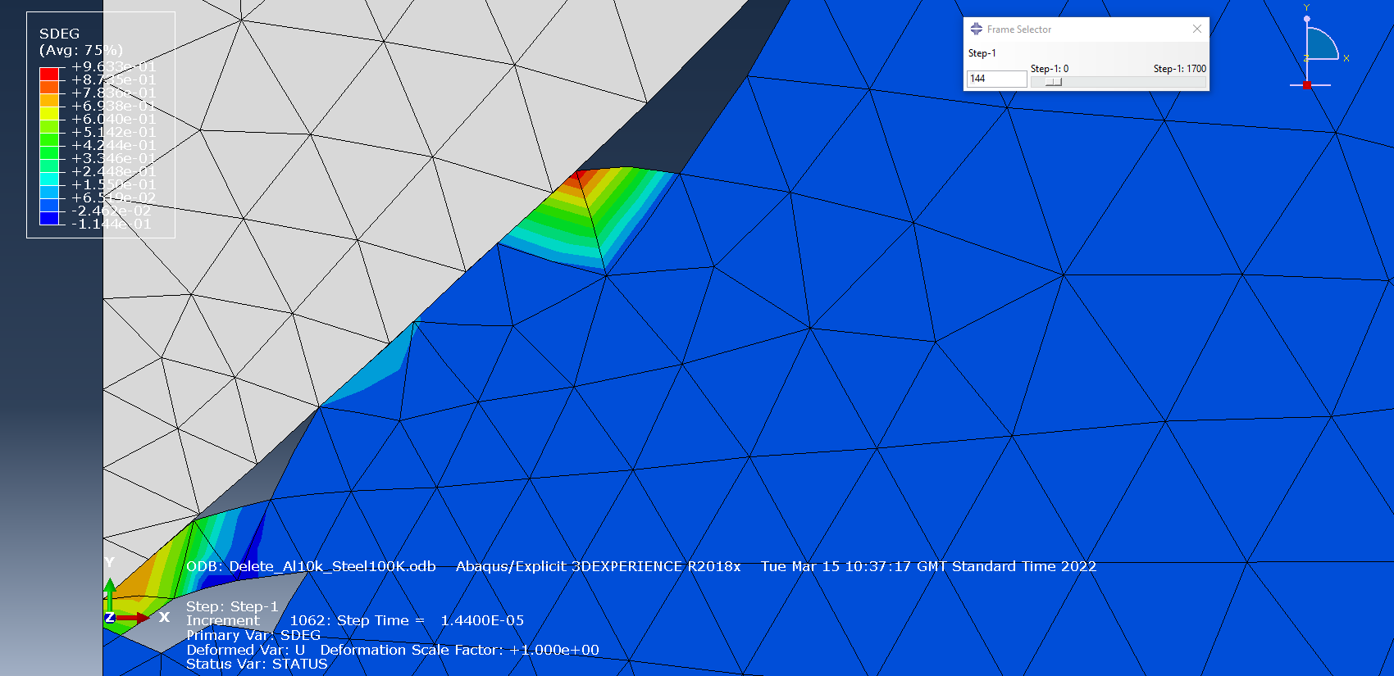
Figure 3.3 – Elements circled have highlighted varying damage values within the same element in the AS100K simulation.
The highlighted elements show damage propagating through the elements, from a low damage value of approx. 0.1 at the base of the elements, to a near fully damaged value of approx. 0.96 at the tip of the elements. With a finer mesh, the area between the 3 nodes of the triangular elements would be far smaller and hence would be reaching the fracture energy at approximately the same time, allowing more consistent damage values across the element. Currently with this mesh, the element can’t delete until all 3 nodes have met the fracture energy criteria, but due to the larger area of the element, the nodes at the base of the element have not reached the required fracture energy, whereas the node at the tip has almost, hence inconsistency of damage values.
The elements highlighted in figures 3.3 and 3.4 below do however support both the Jonhson-Cook damage and plasticity models. Figure 3.4 below shows the same elements during the same step of simulation but depicting plastic strain as opposed to damage.
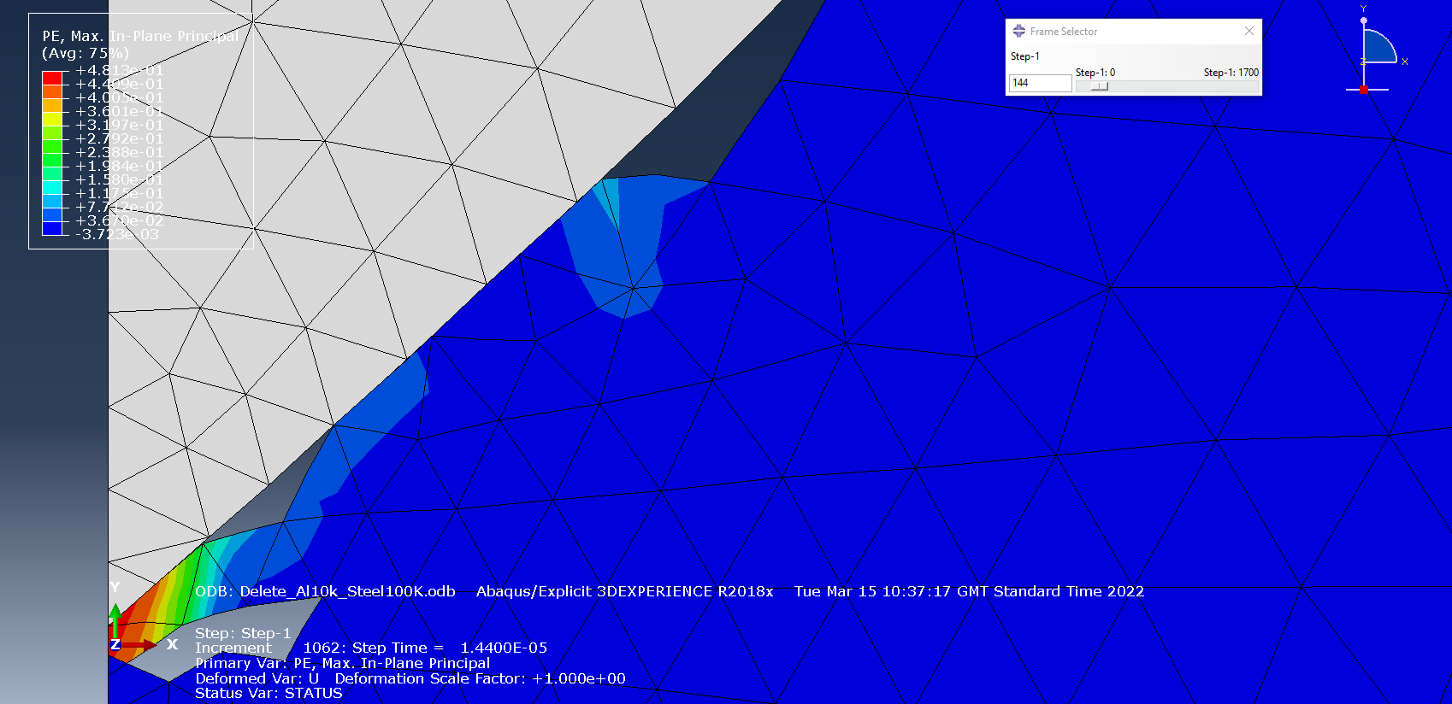
Figure 3.4 – Screenshot of elements undergoing plastic strain as the projectile hits the target in the same step as depicted in figure 3.3 during the AS100K simulation.
As highlighted in figure 3.4, the elements are showing a lower value of plastic strain at the base, but higher plastic strain at the tip. This suggests that that as the tip of the elements are subjected to further stress from the projectile, there is greater plastic deformation compared with the base of the elements. On a typical stress-strain curve such as figure 1.2, the damage value shown in figure 3.3 indicate that the tip of the elements has already passed damage initiation (D=0) and are very close to total material failure (D=1), at which point the fracture energy will have been met and the elements would be deleted.
An analysis of bullet velocity was also performed to compare how the mesh density would affect the bullet velocity as it penetrates the target. Figure 3.5 is the velocity plot for the ASAB2 simulation and figure 3.6 is the velocity plot of the AS100K simulation.
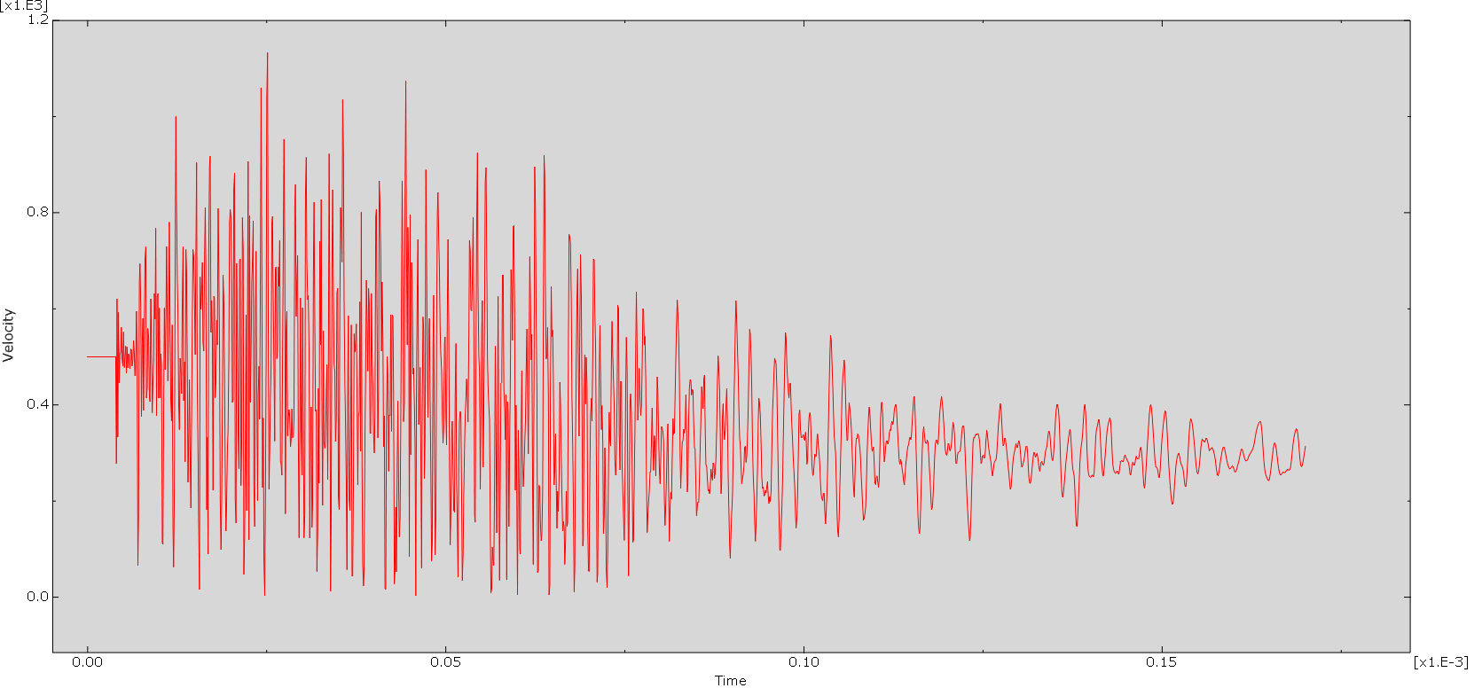
Figure 3.5 – Velocity plot of projectile hitting the target in ASAB2 simulation.
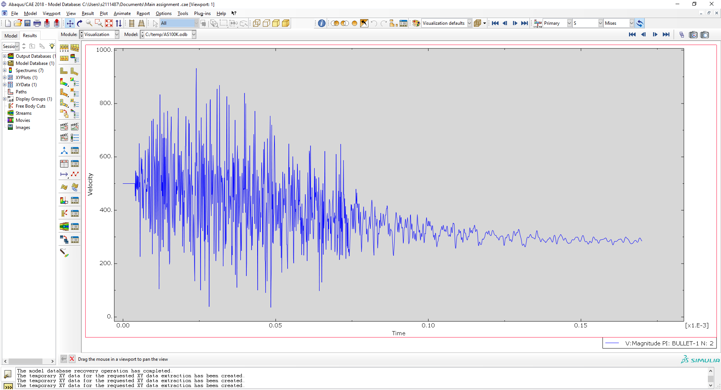
Figure 3.6 – Velocity plot of projectile hitting the target in AS100K simulation.
The bullet velocity was measured from a single point at the tip of the projectile. As this point encounters a node it is compressed causing a reduction in bullet velocity. The tensile stress acting on the elements within the target increase until the element reaches the fracture energy, causing element deletion which subsequently caused the projectile to immediately accelerate due to the lack of resistance from the now deleted element. This accounts for the wayward velocity pattern shown in both figure 3.5 and 3.6. However, there is evidence to suggest that the finer mesh in the AS100K simulation reduced the ‘noise’ recorded on the velocity plot, particularly when comparing post 0.10 milliseconds on figures 3.5 and 3.6. The difference between upper and lower peak velocity values are lower in figure 3.6 in comparison to figure 3.5. It can be theorised that increasing the nodes within the target mesh even further than has been carried out in AS100K, there would be far less variation in velocities measured as the projectile passes through the target.

- Limitations of the software
Whilst using Abaqus it has been determined that there are several limitations to the software. Firstly, the output results are very much dependant on the accuracy and credibility of the input data, either taken from academic sources, or practically calculated. For example, whilst researching material parameters, it was difficult to find the fracture energy of Aluminium; there were few sources that also ranged greatly from as low as 90 up to 10,000 J m⁻². As fracture energy determines at which point the elements fail and subsequently delete (if selected), it’s important for this data to be accurate.
There were also multiple examples of the individual layers of materials not recognising each other, causing the layers to ‘float’ past without any interaction, as highlighted in figure 4.1 and 4.2.
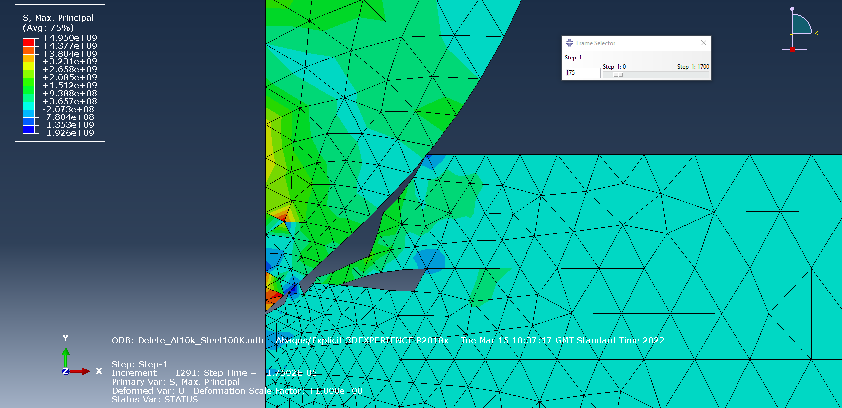
Figure 4.1 – Limitation to the software as the layer of steel is not interacting with the layer of aluminium in the AS100K simulation.
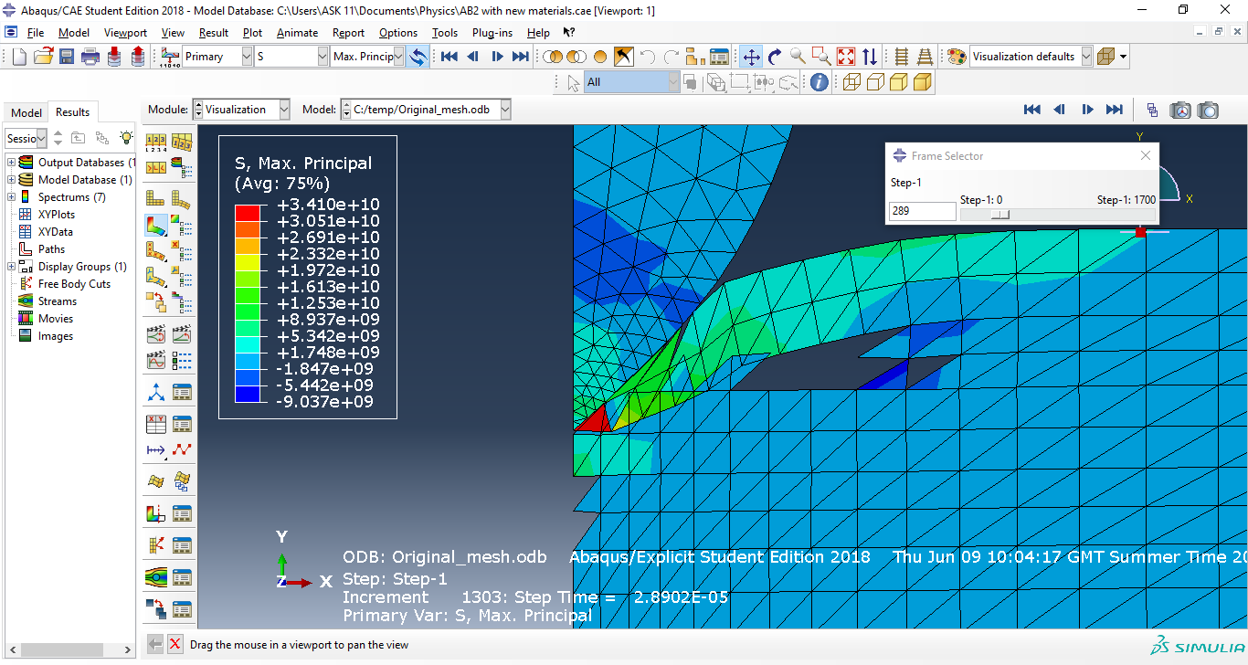
Figure 4.2 – Another example of the layers within the target ‘floating’ past each other during the ASAB2 simulation.
For most of the simulations carried out in this report, element deletion was active however this is not a realistic representation of a projectile hitting a target as it does not take into consideration the Law of Conservation of Mass. However, a simulation was run in which element deletion was not active named ASND to address this inaccuracy as depicted in figure 4.3.
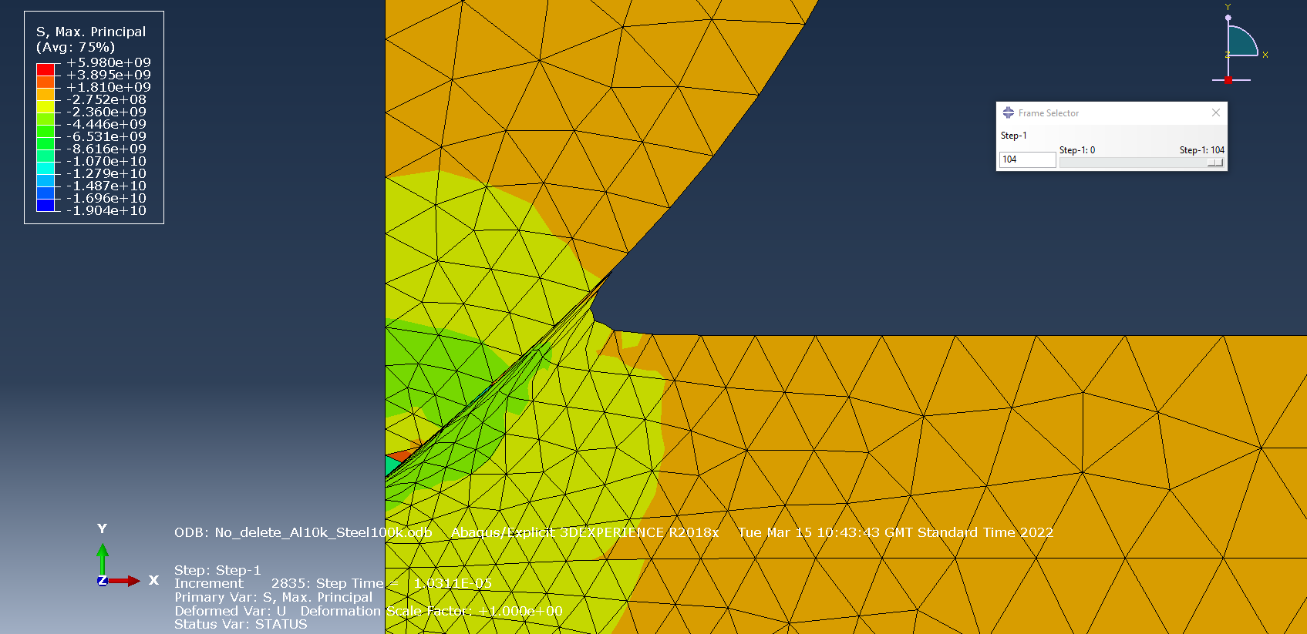
Figure 4.3 – Bullet hitting target in ASND simulation showing elemental stretching causing the simulation to be aborted.
Figure 4.3 highlights the stretching of the elements within first steel target layer. Due to the removal of element deletion, once elements have reached the required fracture energy, the software prevents the simulation from running and is aborted after just 104 steps, compared to the 1700 steps of a fully completed simulation.

- Conclusion
The high strain rate simulation of a projectile hitting a steel and aluminium laminated target as described in this report has led to the following conclusions:
- The enhancement of the mesh within the laminated target led to more accurate simulation results when compared with the standard mesh in the ASAB2 simulation.
- The varying damage values within the same elements as highlighted in figure 3.3 suggests that even the enhanced mesh was still too coarse.
- The results support the Johnson-Cook damage and plasticity models.
- The finer mesh in the AS100K simulation resulted in less ‘noise’ on the bullet velocity plot, although further improvements to the mesh would likely result in even less variation on such plots.
- There are several limitations to Abaqus including the heavy reliance on accurate data, a lack of interaction between individual layers of material and the inability of the simulation to run fully when considering conservation of mass and removing the ability of the elements to delete.

References

[1] | M. V. Z. a. V. V. Drahobetskyi, "New Methods of Obtaining Materials and Structures," in International Conference on Military Technologies (ICMT), 2015.
[2] | F. C. a. G. D. N. Nsiampa, "Numerical investigation of the bodywork effect (K-effect)," pp. 1561-1566, 2009.
[3] | C. C. a. S. Sinchai, "The Damaged Analysis from Ballistic Threats on," Asian Conference on Defence Technology (ACDT), 2015.
[4] | D. L. e. al, "A review of the integrity of metallic vehicle armour to projectile attack," Institute of Mechanical Engineers Journal of Materials: Design and Applications, vol. 233, pp. 73-94, 2019.
[5] | P. K. a. R. Dickson, "Evaluation of Process Mechanism and Parameters for Automated Streching Line," in 10th International Aluminum Extrusion Technology Seminar ET 2012, 2012.
[6] | H. S. a. J.-B. Kim, "A Phenomenological Constitutive Equation to Describe Various Flow Stress Behaviours of Materials in Wide Strain Rate and Temperature Regimes," Journal of Engineering Materials and Technology, Transactions of the ASME, 2010.
[7] | G. R. J. a. W. H. Cook, "A Constitutive Model and Data for Metals Subjected to Large Strains, High Strain Rates and High Temperatures," Materials Science, 1983.
[8] | L. T. e. al, "The Influence of Tool Flank Wear and Depth of Cut on Temperature Fields Based on Johnson-Cook Model in Dry Hard Machining," in 2010 International Conference on Electrical and Control Engineering, 2010.
[9] | M. M. a. D. W. Jung, "Johnson Cook Material and Failure Model Parameters Estimation of AISI-1045 Medium Carbon Steel for Metal forming Applications," Materials, 2019.
[10] | B. A. G. &. A. B. Suresh Kumar Sundaram, "Influence of Target Dynamics and Number of Impacts on Ballistic Performance of 6061-T6 and 7075-T6 Aluminum Alloy Targets," Mechanics Based Design of Structures and Machines, vol. 50, no. 3, pp. 993-1011, 2022.
[11] | A. P. e. al, "Effect of Strain Rate Sensitivity on Fracture of Laminated Rings under Dynamic Compressive Loading," Materials, vol. 15, 2022.
[12] | Y. L. a. G. Glass, "Effects of Mesh Density on Finite Element Analysis," SAE International, 2013.
[13] | M. S. e. al, "Numerical and Experimental Validation of a New Damage Initiation Criterion," Journal of Physics: Conference Series , 2017.
[14] | A. R. e. al, "Investigation on high-velocity impact performance of multi-layered aluminia ceramic armors with polymetirc interlayers," Journal of Composite Materials , 2015.

