BA (Hons) Business Management

LCBB6000 Dissertation

The Role of Digital Marketing Strategies in Shaping Consumer Behaviour: A Study on UK-based Online Retailers

Student Name: Florina Madalina Gugoi
Student ID: 2111163

Module Leader: Dr. Piyumika K. Gamage

Abstract
The study measures the effect of digital marketing strategies on consumer behaviour within online stores operating in the UK by analysing secondary sources of data. The research is based on a positivist philosophy and deductive approach, but a qualitative exploration design is adopted, and thematic analysis of industry reports, academic literature, and market research is used.
The investigation reveals three critical findings. To begin with, UK retailers show high levels of search marketing integration, and synergistic search engine optimisation and paid search efforts can increase conversion rates by 30% relative to single-channel strategies, but consumer confidence in organic search results over paid search results. Second, social media marketing has become more than transactional advertising and a community-building process that creates emotional brand loyalty, with the UK social commerce sales projected to reach £7.4 billion in 2024 and user-created content attaining 28% more engagement than brand-created content. Third, when it is correctly segmented and automated, personalised email marketing offers outstanding retention value, bringing a £36 return per £1 invested.
The analysis has found a strategic imperative of integrated omnichannel approaches, with 71% of the UK consumers requiring a seamless cross-platform experience, yet only 29% of consumers actually get one currently. A trust-effectiveness paradox arises in which personalisation requirements collide with privacy expectations. The research adds theoretical knowledge of integrated strategy efficacy and offers evidence-based suggestions to retailers operating in a changing consumer behaviour in the digital market.
Keywords: digital marketing, consumer behaviour, UK retail, omnichannel strategy, social commerce, personalisation,

Table of Contents
Abstract 2
Chapter 01: Introduction 6
1.2 Research Aim, Objectives, and Research Questions 6
1.2.1 Research Aim 6
1.2.2 Research Objectives 6
1.2.3 Research Questions 6
1.3 Problem Statement 7
1.4 Significance and Rationale of the Study 7
1.5 Outline of the Study 7
1.6 Summary of the Chapter 7
Chapter 2: Literature Review 8
2.1 Introduction 8
2.2 Theoretical Frameworks of Consumer Digital Behaviour 8
2.3 Digital Marketing Strategies and Their Influence on Consumer Behaviour 9
2.4 Critical Gaps and Emerging Patterns in the UK Context 10
2.5 Summary of the Chapter 11
Chapter 03: Research Methods and Methodology 12
3.1 Introduction 12
3.2 Research Philosophy 12
3.3 Research Approach 13
3.4 Research Design 13
3.5 Data Sources and Collection 14
3.6 Sampling Technique 14
3.7 Data Analysis Method 14
3.8 Ethical Considerations 15
3.9 Time Horizon 15
3.10 Summary of the Chapter 15
Chapter 4: Data Analysis and Discussions 16
4.1 Introduction 16
4.2 Thematic Analysis of Digital Marketing Tactics and Consumer Behaviour 16
4.2.1 The Duality of Search Marketing in Driving Initial Consideration and Trust 16
4.2.2 Fostering Engagement and Loyalty through Social Media Ecosystems 16
4.2.3 Driving Retention with Personalised Email Marketing 17
4.3 Discussion: The Strategic Imperative of an Integrated Omnichannel Approach 18
4.4 Critical Discussion: Navigating the Evolving Landscape of UK Consumer Trust 18
4.5 Summary of the Chapter 19
Chapter 5: Conclusion, Limitations & Recommendations 20
5.1 Introduction 20
5.2 Accomplishment of Research Aim and Objectives 20
5.3 Summary of Key Research Findings 20
5.4 Original Contribution to Knowledge 21
5.5 Limitations of the Study 21
5.6 Recommendations for Practice 22
5.7 Suggestions for Future Research 22
5.8 Chapter Summary 23
References 24
Appendix: AI Declaration: 29

List of Figures
Figure 1: COVID-19 and Digital Transformation in UK Retail 6
Figure 2: Integrated Frameworks of Consumer Digital Behaviour. 9
Figure 3: Digital Marketing Strategies and Their Influence on Consumer Behaviour. 11
Figure 4: Critical Gaps and Emerging Patterns in the UK Context. 12
Figure 5: Research Methodology Framework (Research Onion Applied). 13

Chapter 01: Introduction
Digital marketing has now become a fundamental component of the contemporary retailer, particularly in the UK online retail market, which is very competitive. The digital marketplace has now taken hold of all parts of the consumer behaviour process, including product discovery and post-purchase loyalty. As consumers spend more time on digital platforms, the knowledge of how various digital marketing actions affect consumer decision-making is of utmost importance (Gabhane et al., 2023). The study explores how the search engine optimisation (SEO), social media marketing, email campaigns, and the use of pay-per-click (PPC) advertising influence buying choices, customer interactions and long-term loyalty.

1.2 Research Aim, Objectives, and Research Questions

1.2.1 Research Aim
To evaluate how digital marketing strategies influence consumer behaviour in the context of UK-based online retailers using secondary data sources.

1.2.2 Research Objectives
- To identify the key digital marketing strategies commonly used by UK-based online retailers.
- To explore patterns of consumer behaviour in response to these digital strategies using existing studies and reports.
- To analyse the relationship between specific digital tactics (e.g., social media, email marketing, SEO, PPC) and consumer purchasing decisions.
- To assess the effectiveness of digital marketing in customer engagement, loyalty, and retention.
- To suggest recommendations for online retailers to optimise digital strategies based on observed trends in secondary data.

1.2.3 Research Questions
- What are the most commonly used digital marketing strategies among UK-based online retailers?
- How do these strategies impact consumer behaviour, such as search, choice, and purchase decisions?
- Which digital channels (e.g., social media, email, SEO) appear most effective in influencing customer engagement and loyalty?
- What secondary data trends show a shift in consumer expectations or responsiveness to online marketing tactics?
- How can UK online retailers refine their digital strategies based on current consumer behaviour insights?

1.3 Problem Statement
There is an increasing pressure on UK online retailers to incorporate digital marketing strategies that are in line with the fast-changing consumer expectations. Although there is a high adoption of digital tools, numerous approaches do not transform attention into a valuable or meaningful result, such as loyalty or purchases (Pattanayak et al., 2023). The study fills the gap in understanding of the best-returning strategies when it comes to engagement and trust through the analysis of trends in the literature and industry statistics.

1.4 Significance and Rationale of the Study
This study is of theoretical and practical value. It not only adds academic knowledge to digital strategy performance in regional markets but also provides retailers with evidence-based information to improve performance. The results will help marketing practitioners develop more responsive and data-driven marketing campaigns that can help ensure sustainable growth and customer loyalty (Purcărea, 2018; Singh et al., 2024).

1.5 Outline of the Study
The dissertation has five chapters:
- Chapter One presents the scope of the research, objectives, and importance.
- Chapter Two reviews key theories and empirical studies on digital marketing and consumer behaviour.
- Chapter Three explains the research methodology with attention paid to secondary data and thematic analysis.
- Chapter Four contains the results and thematic knowledge.
- Chapter Five wraps up the study with discussions, recommendations and suggestions for future research.

1.6 Summary of the Chapter
The chapter presented the research problem, its background in the UK retail environment and theoretical motivation. It defined the research purpose, described objectives and questions, and emphasised the theoretical and practical implications of the study. In the following chapter, the relevant literature will be critically dealt with to establish the conceptual background of the study.

Chapter 2: Literature Review

2.1 Introduction
Digital marketing has taken centre stage in customer interaction, conversion, and loyalty in the UK online retailing. With the influence of the digital platform on the purchasing decision-making process, the interaction between the marketing strategies and consumer behaviour has become an increasingly popular academic topic. The present literature review critically analyses the classical and contemporary theoretical frameworks and summarises empirical studies in the field of SEO, PPC, social media and email marketing. It judges the impact of these strategies on the consumer decision-making process of product discovery through to post-purchase behaviour. The theoretical tensions and gaps are also identified in the review, especially in the context of the UK, hence it offers a strong conceptual basis for analysing the research aim and objectives.

2.2 Theoretical Frameworks of Consumer Digital Behaviour
Several frameworks underpin how digital strategies influence consumer behaviour. AIDA (Attention, Interest, Desire, Action) is still central to digital marketing, and it provides a stepwise perspective of engagement. As an illustration, PPC campaigns are mainly crafted to attract attention and create action (Belch and Belch, 2021). Critics claim, however, that AIDA heavily simplifies the way people purchase in modern society, which is non-linear and emotion-based (Masfer and Helmi, 2025).
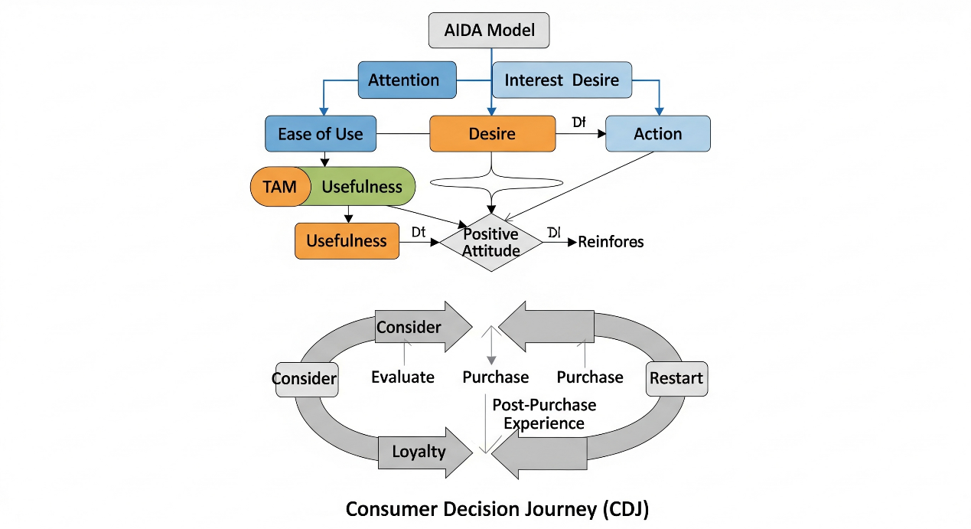
Figure 2: Integrated Frameworks of Consumer Digital Behaviour.
The Technology Acceptance Model (TAM) offers an understanding of how consumers accept online retailing platforms on the basis of perceived ease of use and usefulness (Davis, 1989). TAM can be applied especially in mobile optimisation and personalised email marketing, which enhance usability and positive user attitudes (Pillai, Holla and Srinivas, 2021).
Last, the Consumer Decision Journey (CDJ) questions linear models with a bi-directional dynamic circle in which post-purchase experiences are used to construct future decisions (Court et al., 2009). This model is very congruent with the influence of social media on brand loyalty and peer-influenced decision-making. According to Singh et al., it is possible to apply the Customer Decision Journey (CDJ) in digital ecosystems as well, where content and community become the factors that facilitate repetitive cycles of behaviour 2024. By extension, the results obtained through these frameworks provide a subtle understanding of how consumers react toward digital marketing campaigns.

2.3 Digital Marketing Strategies and Their Influence on Consumer Behaviour
Pay-Per-Click (PPC) and Search Engine Optimisation (SEO) also contribute considerably to the attraction of potential consumers in the initial stage of information searching. Whereas consumers who buy using SEO will be served by organic visibility, PPC serves high-intent consumers (Chaffey & Ellis-Chadwick, 2019). However, despite the speed of recouping investment, PPC generally does not provide the same level of trust and loyalty that organic search provides (Gibson, 2018). In addition, consumers in the UK do not trust ads that seem either too generic or intrusive (79%) (GumGum Team, 2022), which implies they prefer content-based SEO.
SMM has reinvented consumer brand attachment at an emotional level. This can be seen in the case of Instagram and TikTok, which allow narrative branding and partnership with influencers, which improves the sense of authenticity (Gabhane et al., 2023). Singh et al. (2024) discovered that visual material is a significant way to increase engagement, particularly in millennials and Gen Z. However, emotional appeal without other elements does not necessarily translate into purchases, which is why it is so necessary to have integrated strategies.
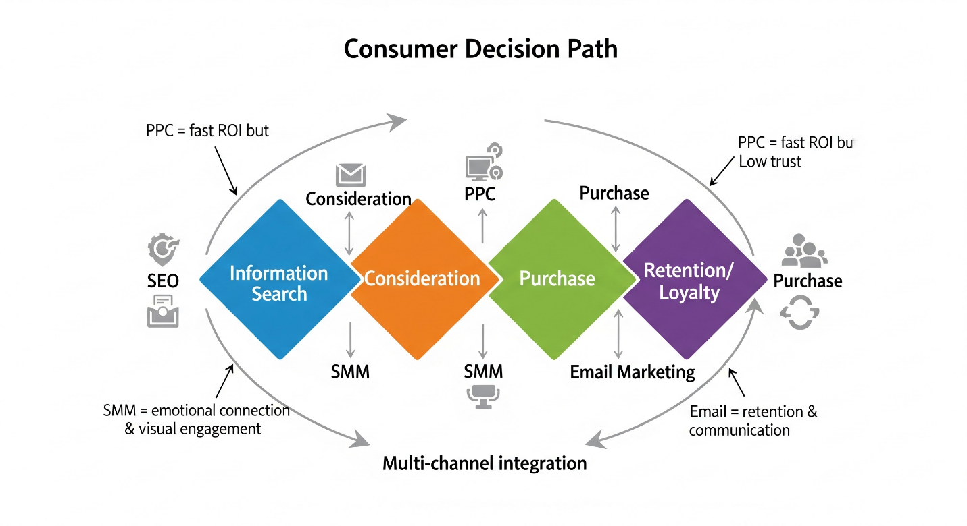
Figure 3: Digital Marketing Strategies and Their Influence on Consumer Behaviour.
Email Marketing is still among the most economical retention tools. It allows personalisation, meaning personalised messages depending on the previous browsing or purchase history. Purcărea (2018) states that the rate of transactions can be more than 760% with segmented email campaigns, particularly when it comes to consumer intent and timing. Nevertheless, it stops working when it is overused or does not fit the user's preferences (Pattanayak et al., 2023).
There is a growing trend in the integration of multi-channel amongst online retailers who use a combination of SEO, SMM, PPC, and email to lead consumers through the decision path. As a case in point, companies such as ASOS and Boohoo coordinate social advertisements with retargeted emails and personalised content on the websites in order to increase conversion (Butler, 2024; Sheridan, 2024). Cross-platform improvement generates a brand experience, which improves engagement and retention. Yet there are not many studies that examine these integrated strategies as a whole, especially within a UK-based retail environment, which is an opportunity that this dissertation can help fill.

2.4 Critical Gaps and Emerging Patterns in the UK Context
Despite rich global literature, several UK-specific gaps persist. First, the majority of the research addresses the effectiveness of single channels, and little is known about the influence of integrated campaigns on the building of loyalty and trust (Masfer and Helmi, 2025). Second, there is no adequate research on the regional consumer trends, even though it is clear that UK consumers put more emphasis on sustainability, transparency, and brand ethics than their foreign peers (Deloitte, 2023). Third, a lot of literature is not segmented by demographics, so it does not differentiate behaviour based on age, device usage, or purchase intention (Singh et al., 2024).
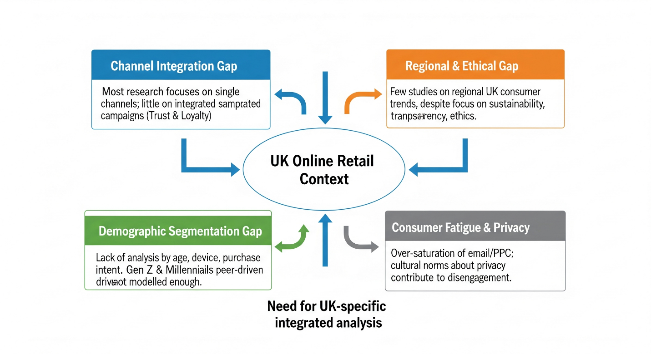
Figure 4: Critical Gaps and Emerging Patterns in the UK Context.
Gen Z and younger millennials are emotional and peer-driven, which is also not modelled enough. Finally, consumer fatigue can be contributed to by cultural norms regarding privacy and over-saturation regarding messaging, particularly in the email and PPC approaches (Zhou, 2021). This dissertation will deal with these limitations by analysing various tactics in terms of the UK online retail industry-specific secondary data, contributing to theoretical and practical studies.

2.5 Summary of the Chapter
The chapter was a critical review of theories and existing literature on the role of digital marketing in shaping consumer behaviour. It emphasised the importance of multi-channel strategies and assessed different tools individually, such as SEO, social media, and email, and found gaps that were specific to the UK. The review forms a strong basis for analysing strategic effectiveness within UK online retail.

Chapter 03: Research Methods and Methodology

3.1 Introduction
This chapter describes the methodology that has been incorporated by the researcher to conduct the research on the role of digital marketing strategies in influencing consumer behaviour in UK-based online retailers. The discussion is based on Saunders, Lewis and Thornhill's (2023) "research onion" framework in order to be coherent and rigorous. Every layer is looked into critically, such as the research philosophy, approach, design, data sources, sampling, analysis methods, ethical issues and time horizon. The methodological decisions can be said to be in line with the purpose of the study in assessing the effectiveness of digital marketing strategies on consumer behaviour through the sources of secondary data.
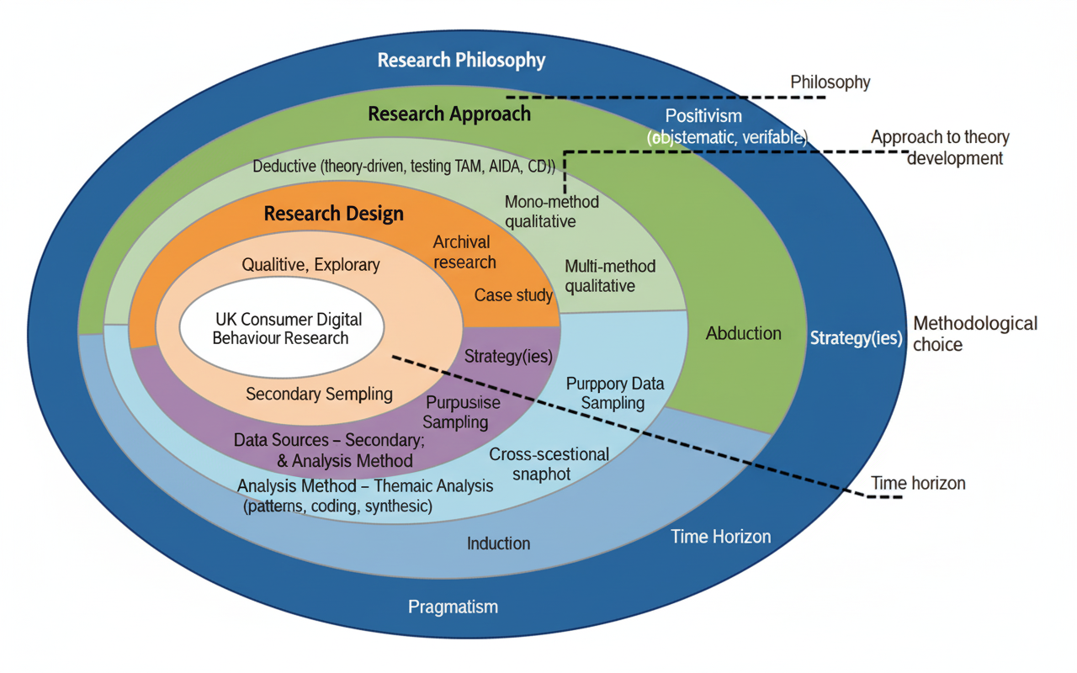
Figure 5: Research Methodology Framework (Research Onion Applied).
Source: (Saunders, Lewis and Thornhill, 2023)

3.2 Research Philosophy
The dissertation is based on the positivist research philosophy, which presupposes the objectivity of reality and its observation and measurement based on systematic analysis. Positivism is the most effective approach to use in research that relies on published facts because the method places a lot of emphasis on using verifiable evidence, as opposed to subjective interpretation (Briggs and Coleman, 2012). The research is based on the existing reports, government statistics and peer-reviewed literature, which is a positivist view that there are observable patterns and causality between digital marketing strategies and consumer behaviour.
Other philosophies were taken into consideration. The approach of interpretivism, which focuses on personal viewpoints and meanings (Collis & Hussey, 2021), was considered inappropriate because this study does not imply conducting primary interviews or using ethnographic techniques. Pragmatism was also discussed, but considering that this problem-solving approach is based on subjective and objective data, such information is not required because this investigation is secondary-data orientated. Therefore, the choice of positivism was based on how it can be systematically used to test known theories in the field of consumer behaviour and marketing.

3.3 Research Approach
A deductive approach was used, starting with known theories of the Technology Acceptance Model (Davis, 1989), the AIDA model and the Consumer Decision Journey (Court et al., 2009), and then applying them to the secondary data in order to examine their applicability. Deduction is suitable since the research will evaluate the effectiveness of digital tactics such as SEO, PPC and social media in terms of consumer decision-making channels (Woiceshyn and Daellenbach, 2018).
In comparison, it would have necessitated primary empirical research using an inductive approach, which creates theories based on data. Abduction, a combination of deduction and induction, was also taken into consideration but was dismissed because it normally takes place in the form of iterative fieldwork. Deduction was thus the most formal avenue to assess causal relationships in the current data sets and literature on the subject.

3.4 Research Design
The study design is a qualitative and exploratory study utilising analysis of secondary data. The qualitative design fits the situation because the research aims to understand how consumers react to marketing tactics, where the patterns in behaviour emerge, and no numerical correlation is to be tested (Bell, Bryman and Harley, 2022). The exploratory design was selected to fill the gaps related to UK-specific research as found in the literature review, especially regarding integrated multi-channel marketing.
The research is cross-sectional as well, with secondary data at one point in time. Although a longitudinal design would yield more detailed data about the change in behaviour over time, the limitations of this dissertation did not allow it. A cross-sectional design permits a snapshot picture of the extent to which digital marketing is currently influencing consumer decisions in the UK.

3.5 Data Sources and Collection
Only secondary sources were used to collect data, and they included:
- Peer-reviewed journal articles on consumer behaviour and digital marketing strategies.
- Industry and market research reports (e.g., Deloitte, PwC, Statista).
- Trade publications focusing on UK e-commerce performance.
- Government reports (e.g., Office for National Statistics) on consumer spending and digital adoption.
The inclusion criteria favoured sources published in the past five years to be relevant, and older seminal sources were retained only when theoretically important. The materials were peer-reviewed and industry-checked, which made them reliable (Johnston, 2017). This methodical sourcing will reduce bias and make the findings representative of the current UK retail dynamics.

3.6 Sampling Technique
Since secondary sources were utilised, purposive sampling was used. This implies the intentional choice of the sources that offer the most applicable and trustworthy information (Palinkas et al., 2015). As an illustration, the industry reports targeting the UK retail market were favoured over global reports. Purposive sampling will align the data with the research objectives and, therefore, the noise of irrelevant materials will be minimised.
Although purposive sampling can be associated with selection bias, it was also reduced through the triangulation of various types of data (academic, industry and government) to confirm patterns. This improves the validity and external validity.

3.7 Data Analysis Method
The analytic method selected is the thematic analysis that includes identifying, coding, and synthesising common patterns in various data sets (Braun & Clarke, 2019). Themes were based on the objectives of the research: effectiveness of sales, engagement, and loyalty strategies. As an illustration, one of the themes was the ability of SEO and PPC to affect purchase decisions, and the other theme was the emotional power of social media campaigns.
Thematic analysis has the benefit of enabling subtle interpretation of qualitative patterns, without being limited by numerical measures. Other approaches, including content analysis or meta-analysis, were taken into consideration. Nonetheless, content analysis was considered too strict in terms of counting frequencies, and meta-analysis presupposes standardised quantitative data, which they never had. Thematic analysis thus provided the greatest freedom and richness to this study in the qualitative orientation.

3.8 Ethical Considerations
Despite the fact that this study only employs secondary data, the issue of ethics is very important. To avoid plagiarism, the academic integrity and appropriate use of all sources were facilitated (Resnik, 2018). Misrepresentation and taking data out of context were avoided, and thus, the findings are true to the sources. No proprietary or confidential data were used in the study, either; only the publicly available or authorised materials were used. Transparency in methodology further supports ethical rigour.

3.9 Time Horizon
The study follows a cross-sectional time horizon, as secondary data are analysed at one point in time. This is explained by the time and scope constraints in the dissertation. Nevertheless, it is accepted that consumer behaviour is dynamic, and it is possible that future studies take a longitudinal approach, which monitors changing trends in digital marketing effectiveness.

3.10 Summary of the Chapter
Overall, this chapter supported the approach utilised to investigate the role of digital marketing strategies in developing consumer behaviour within the UK online retail industry. The study followed a positivist philosophy and deductive approach guided by a research onion of Saunders that involved a qualitative exploratory design and purposive sampling of secondary data. Ethical and cross-sectional considerations favoured thematic analysis as the best analytic tool. Such methodological decisions will make the study academically rigorous and cover the aims of the research.

Chapter 4: Data Analysis and Discussions

4.1 Introduction
The chapter is a thematic analysis of secondary data to determine the influence of the digital marketing strategy on consumer behaviour within the UK online retail industry. With special attention to search marketing, social media and personalised communication, it indicates their contribution to trust, loyalty and retention with a final note on the strategic value of omnichannel integration and consumer trust in behavioural outcomes.

4.2 Thematic Analysis of Digital Marketing Tactics and Consumer Behaviour

4.2.1 The Duality of Search Marketing in Driving Initial Consideration and Trust
The secondary data analysis supports the idea that Search Engine Optimisation (SEO) and Pay-Per-Click (PPC) advertising are still the main strategies used by UK online retailers for defining the early information search and consideration phases of the consumer journey. Yet, they have a clearly dualistic influence on consumer behaviour. PPC also provides instant visibility, and UK companies invest heavily in ensuring that they are ranked first in the search (Spray, 2025). It is a successful strategy at attracting consumers with a lot of intent to buy. However, its effectiveness is moderated by consumer attitudes; a notable share of UK consumers report that they prefer content and organic results to paid ads, which they regard as intrusive (Ologunebi, Taiwo and Alli, 2025; Kapoor, Dwivedi and Piercy, 2016).
SEO, on the other hand, builds authority and trust in the long run. This means that the websites that are shown on the first page of Google receive nearly 92% of search traffic, which is a tremendous influence of organic visibility on consumer attraction (Spray, 2025). A strong SEO presence is considered by consumers as a sign of credibility and dominance in the market (Artios, 2023). Statistics have shown that even the most developed retailers do not consider SEO and PPC mutually exclusive strategies anymore. They instead use a complementary dual-presence approach, where obtaining paid and organic ranking of important search terms increases the overall click-through and conversion rates by as much as 30% (Spray, 2025). Such a combined strategy makes search marketing a customer acquisition engine and a powerful tool for boosting brand credibility, which directly responds to issues of consumer trust and thus, the likelihood of a purchase decision improves.

4.2.2 Fostering Engagement and Loyalty through Social Media Ecosystems
Social media marketing has ceased to be merely an advertising method, and it currently plays the key role in building brand communities and developing emotional loyalty. The leading platforms used by UK consumers, especially younger groups, to explore products and interact with brands are TikTok and Instagram (Sprout Social, 2025). This change is also reflected by the growing social commerce, as it is estimated that sales in the UK will top £7.4 bn in 2024, and almost half of all UK consumers are expected to have bought products directly via a social platform (Connolly, 2025; Parcelhub, 2024).
Critical reflection of the information shows that the role of social media in loyalty is less transactional and more relational. Although discounts and promotions also play an important role, long-term loyalty is becoming co-created in brand communities (Jibrial et al., 2023). Customers become more attached to brands that provide two-way communication, promote the creation of user-generated content (UGC), and are authentic (Chowdhury et al., 2024). An example is UGC, which is 28 per cent more likely to be engaged with than the content created by the brand, indicating that the consumer base is more interested in peer validation rather than corporate communication (Connolly, 2025). This dynamic indicates that brand loyalty is no longer defined by the retailer only and is negotiated and cemented in a community environment. Retailers who effectively develop these communities, who convert passive consumers into active members, are in a better position to develop the emotional loyalty that is deep-rooted beyond the price competition and results in sustained engagements.

4.2.3 Driving Retention with Personalised Email Marketing
Although newer channels attract a lot of attention, one of the most effective approaches to influence repeat purchase behaviour and cause customer retention among UK online retailers is personalised email marketing (Sayeed, 2023). This channel has a very high return on investment (ROI), and according to industry reports, the average return can be up to £36 for every £1 spent (Taheer, 2020). This will be effective only when personalisation and segmentation are used strategically. Mass-market generic emails are becoming less effective, but campaigns based on past purchase behaviour or browsing history are much more effective in terms of open rates (14.31% and 100.95% respectively) than unsegmented campaigns (Brodie, 2025).
As the analysis shows, the most effective use of this strategy is in behaviour-triggered automation. Automated email messages, including abandoned-cart messages, boost response by 320% relative to non-automated messages and recapture 5% to 11% of sales that would otherwise be lost (Taheer, 2020; Brodie, 2025). These results confirm a direct, quantifiable connection between individualised, timely communication and purchase decisions by consumers. Notably, this mechanism not only acts as a conversion tool but also as a powerful tool for increasing customer lifetime value. After purchase, retailers have the opportunity to develop the customer relationship through providing relevant and value-added content that validates the purchase decision, thus significantly boosting future loyalty and retention opportunities.

4.3 Discussion: The Strategic Imperative of an Integrated Omnichannel Approach
Pragmatic evidence has shown that search, social media and email marketing have unique effects on consumer behaviour. However, the main conclusion that can be drawn based on the existing information is that the efficacy of each of the channels is increased significantly with the incorporation into the framework of an omnichannel. Instead of viewing their experiences with retailers as a series of unrelated, single episodes on various platforms, UK consumers now demand a continuous experience (Santharam, 2023). The statistics presented by Higgins and Wallis (2024) show a strong discrepancy: 71% of UK interviewees want to have a consistent experience in all touchpoints, but only 29% admit to receiving it. This kind of disconnect is a considerable motivator of brand switching, with 73% of the respondents noting that they would change to a competitor if they did not get a seamless experience.
This requires a change in strategy among retailers, from focusing on maximising individual channels to creating a customer experience. A successful omnichannel strategy uses all touchpoint data to build a complete consumer portrait. As an example, a personalised product recommendation through email, activated by insights on the browsing behaviour of a particular consumer on social media and followed by retargeted search ads, can be used. This makes the channels a strong, synergistic circle that strengthens each other, and the consumer feels read and appreciated (Richter, 2024). Customers using the omnichannel spend more (10% more online) and are more loyal (Higgins and Wallis, 2024). As such, adoption of digital marketing strategies is not just an ideal practice but a strategic necessity that only the surviving and growing firms can adopt in the competitive UK online retail sector.

4.4 Critical Discussion: Navigating the Evolving Landscape of UK Consumer Trust
The precarious and dynamic consumer trust is the foundation of all digital strategies. This data presents a big contradiction in the UK market: consumers, on the one hand, expect hyper-personalisation that data-driven marketing can provide, but, on the other hand, they are increasingly anxious about the manner of data collection and utilisation. In 2024, a report commissioned by Mintel reported that 46% of consumers in the UK were not comfortable because they saw an online advert that involved a personal conversation, which was a deep-seated concern about privacy (Mintel, 2024). This is compounded with an overall loss in brand loyalty, which dropped by 8% in 2024, caused by price sensitivity as well as poor customer service, among other factors (Customer Loyalty Index, 2024).
This setting implies that technical expertise in either SEO, social media or email marketing cannot be a long-term success. These strategies work through the retailer being able to build and sustain trust. The UK is one of the countries where consumers are becoming more and more sensitive to other factors besides product and price, including the sustainability and ethical use of data by a brand (Customer Loyalty Index, 2024; Ologunebi, Taiwo and Alli, 2025). Thus, the elements of transparency and value exchange should be implemented in digital marketing strategies. Retailers who disclose their information practices and apply personalisation to provide authentic value, but not merely intrusion, have better chances of establishing the trust needed to build long-term customer relationships (Hassan, Abdelraouf and El-Shihy, 2025). After all, trust is the currency in the UK online retail environment that transforms the digital interaction into sustainable brand commitment.

4.5 Summary of the Chapter
The thematic analysis of secondary data in this chapter brought out important information on how consumer behaviour in the UK online retail is influenced by digital marketing. The analysis has determined the complementary relationship between the use of SEO and PPC, the power of social media in building communities, and the high value of personalised email marketing in terms of its retention power. These findings were synthesised in the discussion, which argued that an integrated omnichannel strategy is the strategic need and that consumer trust is the ultimate mediator of strategic achievement. These results directly answer the research questions and give a very strong analytical basis to the conclusions and recommendations as given in the last chapter.

Chapter 5: Conclusion, Limitations & Recommendations

5.1 Introduction
The study explored the impact of business digital marketing strategies on the consumer behaviour of the online stores in the UK by conducting thorough research based on secondary data. The paper used a positivist philosophy and an approach that is deductive to investigate how SEO, PPC, social media marketing, and email marketing influence consumer decision-making processes, engagement behaviour, and loyalty formation in the modern digital retail environment in the UK.

5.2 Accomplishment of Research Aim and Objectives
The study has been able to achieve its main objective of assessing the effects of digital marketing strategies on consumer behaviour among UK-based online retailers with the help of secondary data sources. Thematic analysis of authoritative industry reports, scholarly sources, and market research data helped to tackle each research objective in a systematic manner.
The initial purpose outlined some of the essential digital marketing tactics regularly used by online stores in the UK, which included a major emphasis on the integrated strategies that incorporate search marketing, social networking, and personalised communication mediums. The second goal investigated the behaviour of consumers, in which it was established that consumers in the UK were increasingly demanding seamless omnichannel experiences without a reduction in their level of privacy (Deloitte, 2025). The third aim examined the links between particular online strategies and purchase behaviours and determined that personalised email marketing can provide superior ROI, as social media channels can trigger emotional brand associations. The fourth goal measured customer engagement and retention effectiveness and found that channel strategies are more effective when integrated than when separated. Lastly, the fifth objective produced evidence-based recommendations on strategy optimisation based on current insights into consumer behaviour.

5.3 Summary of Key Research Findings
The thematic analysis discovered three decisive results that answer the research questions in detail. First, UK internet retailers exhibit an advanced use of search marketing with a combination of synergistic SEO and PPC strategies, and integrated strategies boost conversion rates by up to 30 per cent over the use of a single channel. Nevertheless, the considerations of consumer trust prefer organic visibility to paid advertising, which is also indicative of more general apprehensions related to intrusive marketing practices (Mintel, 2024).
Second, social media marketing has become more than a transactional advertising approach; it is now a community-building medium that creates emotional brand loyalty. In 2024, UK social commerce sales hit £7.4 billion, and almost half of consumers directly purchase on social platforms, especially in younger demographics that place greater importance on genuine peer-to-peer suggestions than on branded content (Adams, Alldredge and Kohli, 2025). This analysis showed that user-generated content is more effective by 28 per cent in terms of engagement rates than brand-created content, which means that consumers have become more interested in validation by communities.
Third, personalised email marketing is the most cost-efficient retention strategy, with returns of £36 per £1 invested when it is well segmented and automated. Especially high performance is observed in behaviour-driven campaigns, where abandoned cart reminders recover 5-11% of lost sales and help to cement customer lifetime value with thoughtful follow-up communications after purchases.

5.4 Original Contribution to Knowledge
This study adds fresh understanding to the digital marketing body of knowledge, as the study offers a UK-based analysis of integrated strategy efficacy at a time of fundamental change in consumer behaviour. The investigation has shown that synergistic multi-channel strategies generate compounding effects greater than the aggregate of the individual channel effects, unlike other prior studies, which have been conducted on isolated channels.
The research contributes to the development of theory as the existing consumer behaviour models (TAM, AIDA, Consumer Decision Journey) are transferred to the modern realities of the UK retail setting, and the old patterns are being modified to reflect the reality of non-linear and community-driven consumer purchasing patterns. Moreover, the study has presented empirical evidence of the trust-effectiveness paradox in digital marketing, where the demands of personalisation clash against privacy expectations to cause strategic tensions that retailers have to carefully address.

5.5 Limitations of the Study
There are a number of limitations that limit the generalisability and depth of the findings. Such a dependence on secondary data sources limits analysis to what is publicly accessible and may omit proprietary knowledge that individual retailers hold on their respective consumer groups (Theodorakopoulos and Theodoropoulou, 2024). Such a methodological limitation does not allow the analysis of causal relations that could be determined through primary research approaches.
A cross-sectional time horizon represents consumer behaviour at one time as opposed to longitudinal change, which is especially critical in the face of swiftly evolving digital marketing technology and consumer privacy laws. Also, the study is constrained by the fact that it was focused on UK markets and thus might not apply to international markets where cultural orientations towards privacy, social commerce, and brand relations vary substantially.
Although the thematic analysis method is rich in qualitative data, it is not as statistically rigorous as quantitative meta-analyses may be in terms of measuring the extent of effects of various strategies. Lastly, the scope of the study did not cover the emerging technologies, i.e. artificial intelligence-based personalisation and augmented reality applications, which are gaining more and more influence on the effectiveness of digital marketing in the present (Deloitte, 2025).

5.6 Recommendations for Practice
The most important aspect that UK online retailers should aim to accomplish is to build an integrated omnichannel strategy to ensure that there is a seamless consumer experience at every touchpoint. This is supported by the fact that 71% of UK consumers demand uniform cross-platform experiences, and currently, only 29% of consumers have them, which can be a strong competitive advantage in the hands of retailers that can bridge this gap successfully.
The retailers should embrace open data gathering methods that are able to relay value exchange propositions to consumers in an open manner. As 46% of consumers in the UK reported feeling uncomfortable with personalised advertising on the basis of private conversation, companies need to address the trade-off between the benefits of personalisation and privacy issues by introducing explicit consent and policies on data use (Mintel, 2024). This necessitates the investment in first-party data collection mechanisms that develop trust and, at the same time, facilitate personalisation.
The social media plans must be aimed at community building as opposed to transactional advertising, especially among younger populations who connect better with genuine peer-to-peer recommendations as compared to brand content. Retailers are advised to invest in user-generated content programmes and partnerships with influencers that are consistent with their brand values, but with authenticity.
Behavioural triggers and advanced segmentation should be used in email marketing automation to achieve the highest retention impact. The outstanding ROI of personalised email campaigns is worth investing in sophisticated marketing automation tools that will be able to provide the relevant content at the most suitable time, depending on the consumer journey of individuals.

5.7 Suggestions for Future Research
The future studies need to utilise longitudinal study designs in order to monitor the changing effectiveness of digital marketing as privacy laws, technological capabilities, and consumer demands keep changing. The combination of quantitative surveys and qualitative interviews as primary research would have given more information about the consumer motivations and the process of making decisions that cannot be described with secondary data.
A study exploring how consumer behaviour is affected by the emerging technologies, including artificial intelligence, voice commerce, and augmented reality, would apply findings of this study to changing digital environments. Also, cross-country research would be beneficial in establishing the cultural aspects that moderate the effectiveness of digital marketing in various European markets (Sharabati et al., 2024).
The sustainability implications of digital marketing strategies, especially on environmental issues and ethical consumption patterns, are an important research area that needs further exploration in the future, since UK consumers are becoming more concerned about corporate social responsibility in their buying behaviours.

5.8 Chapter Summary
The chapter has outlined the results of the study in such a way that shows the enormous influence of digital marketing practices on consumer behaviour in the UK online retail sector, and the effectiveness of integrated strategies that balance the need to personalise the needs of consumers with their privacy concerns. The contributions of the study to theory and practice are made at the same time, but methodological limitations are also mentioned that should be considered in future research. Actionable advice is offered on how retailers can improve the performance of digital marketing in a changing consumer environment, and how trust, integration, and genuine community building are essential elements to developing sustainable competitive advantage.

References
Adams, C., Alldredge, K. and Kohli, S. (2025). State of the Consumer 2024: What's Now and What's Next. [online] McKinsey & Company. Available at: https://www.mckinsey.com/industries/consumer-packaged-goods/our-insights/state-of-consumer.
Artios (2023). SEO Agency Statistics, Trends & Predictions for 2023/24 ⁄ Artios. [online] Artios. Available at: https://artios.io/seo-agency-statistics/.
Belch, G.E. and Belch, M.A. (2021). Advertising and promotion: An integrated marketing communications perspective. Boston, Mass: McGraw-Hill/Irwin.
Bell, E., Bryman, A. and Harley, B. (2022). Business Research Methods. 6th ed. Oxford: Oxford University Press.
Braun, V. and Clarke, V. (2019). Reflecting on Reflexive Thematic Analysis. Qualitative Research in Sport, Exercise and Health, 11(4), pp.589–597. doi:https://doi.org/10.1080/2159676X.2019.1628806.
Briggs, A.R.J. and Coleman, M. (2012). Research Methods in Educational Leadership and Management. 3rd ed. Los Angeles: Sage Publications.
Brodie, I. (2025). Email Marketing ROI: 2025 Stats That Prove Its Business Value. [online] Ian Brodie. Available at: https://www.ianbrodie.com/email-marketing-roi/.
Butler, K. (2024). Integrating SEO with Other Marketing Channels. [online] Online Optimism. Available at: https://onlineoptimism.com/blog/integrating-seo-with-other-marketing-channels/.
Chaffey, D. and Ellis-Chadwick, F. (2019). Digital Marketing: Strategy, Implementation and Practice. 7th ed. Harlow, England: Pearson.
Chowdhury, S.N., Faruque, M.O., Sharmin, S., Talukder, T., Mahmud, A., Dastagir, G. and Akter, S. (2024). The Impact of Social Media Marketing on Consumer Behaviour: A Study of the Fashion Retail Industry. Open Journal of Business and Management, 12(03), pp.1666–1699. doi:https://doi.org/10.4236/ojbm.2024.123090.
Collis, J. and Hussey, R. (2021). Business research: A practical guide for students. 5th ed. London: Red Globe Press.
Connolly, C. (2025). How TikTok and Social Commerce Are Transforming UK Small Businesses. [online] ProfileTree Web Design and Digital Marketing. Available at: https://profiletree.com/how-tiktok-and-social-commerce-statistics-trends/.
Court, D., Elzinga, D., Mulder, S. and Ole Jørgen Vetvik (2009). The consumer decision journey. [online] McKinsey & Company. Available at: https://www.mckinsey.com/business-functions/marketing-and-sales/our-insights/the-consumer-decision-journey?utm_source=chatgpt.com [Accessed 29 Aug. 2025].
Customer Loyalty Index (2024). Customer Loyalty Index 2024. [online] Available at: https://cbgmanagementcoaching.co.uk/wp-content/uploads/2024/10/Customer-Loyalty-Index-2024-UK.pdf.
Davis, F.D. (1989). Perceived usefulness, perceived ease of use, and user acceptance of information technology. MIS Quarterly, [online] 13(3), pp.319–340. doi:https://doi.org/10.2307/249008.
Deloitte (2023). Deloitte’s Digital Consumer Trends: UK Insights. [online] Deloitte United Kingdom. Available at: https://www.deloitte.com/uk/en/Industries/tmt/research/digital-consumer-trends-2023.html.
Deloitte (2025). Retail Trends. [online] Deloitte. Available at: https://www.deloitte.com/dk/en/Industries/consumer/perspectives/retail-trends.html.
Gabhane, D., Varalaxmi, U., Rathod, A., Ghaffar, B., Hamida, B., & Anand (2023). Digital Marketing Trends: Analysing The Evolution Of Consumer Behaviour In The Online Space. [online] Available at: https://www.rgcms.edu.in/wp-content/uploads/2023/10/52_TITLE126.pdf.
Gibson, C. (2018). The Most Effective Digital Marketing Strategies & Approaches: A Review of Literature. www.ijsrp.org, [online] Volume 8(Issue 2). Available at: https://www.ijsrp.org/research-paper-0218.php?rp=P747171.
GumGum Team (2022). 79% of UK Consumers Want to See Contextually Relevant Ads. [online] gumgum.com. Available at: https://gumgum.com/blog/79-of-uk-consumers-want-to-see-contextually-relevant-ads.
Hassan, N., Abdelraouf, M. and El-Shihy, D. (2025). The moderating role of personalised recommendations in the trust–satisfaction–loyalty relationship: an empirical study of AI-driven e-commerce. Future Business Journal, [online] 11(1). doi:https://doi.org/10.1186/s43093-025-00476-z.
Higgins, S. and Wallis, C. (2024). UK Retail Trends 2024. [online] Bearingpoint.com. Available at: https://www.bearingpoint.com/en-gb/insights-events/insights/uk-retail-trends-2024/.
Jibril, A.B., Kwarteng, M.A., Chovancova, M. & Pilik, M. (2019). The impact of social media on consumer-brand loyalty: A mediating role of online-based brand community. Cogent Business & Management, [online] 6(1). doi:https://doi.org/10.1080/23311975.2019.1673640.
Johnston, M.P. (2017). Secondary Data analysis: a Method for Which the Time Has Come. Qualitative and Quantitative Methods in Libraries, [online] 3(3), pp.619–626. Available at: https://www.qqml-journal.net/index.php/qqml/article/view/169.
Kapoor, K.K., Dwivedi, Y.K. and Piercy, N.C. (2016). Pay-per-click advertising: A literature review. The Marketing Review, 16(2), pp.183–202. doi:https://doi.org/10.1362/146934716x14636478977557.
Masfer, H.M. and Helmi, M.A. (2025). THE ROLE OF DIGITAL MARKETING IN SHAPING CONSUMER BEHAVIOR IN E-COMMERCE PLATFORMS. International Journal of Professional Business Review, 10(3), p.e05420. Doi:https://doi.org/10.26668/businessreview/2025.v10i3.5420.
Mintel (2024). UK Digital Lives of Consumers Report 2024 | Trends Analysis. [online] Mintel Store. Available at: https://store.mintel.com/report/uk-digital-lives-of-consumers-market-report-2024.
Ologunebi, J., Taiwo, E.O. and Alli, K. (2025). Digital Consumer Behaviour in E-commerce: A Study of Amazon and Temu’s Customer Purchase Decision-Making Processes in the UK and the USA. SSRN.
Palinkas, L., Horwitz, S., Green, C., Wisdom, J., Duan, N. and Hoagwood, K. (2015). Purposeful Sampling for Qualitative Data Collection and Analysis in Mixed Method Implementation Research. Administration and Policy in Mental Health and Mental Health Services Research, 42(5), pp.533–544. doi:https://doi.org/10.1007/s10488-013-0528-y.
Parcelhub (2024). Social Commerce Trends In The UK for 2024 | Parcelhub. [online] Parcelhub. Available at: https://www.parcelhub.co.uk/news/social-commerce-trends-uk.
Pattanayak, M., Shankar, A.U., Rathod, M.K., Srinivas, A. and Tyagi, S. (2023). Analysing the Effect of Digital Marketing on the Expansion of the Retail Sector. Rivista Italiana di Filosofia Analitica Junior, [online] 14(1), pp.996–1005. Available at: https://rifanalitica.it/index.php/journal/article/view/178.
Pillai, R., Holla, N. and Srinivas, D. (2021). A study on Digital marketing and its impact on Consumer behaviour. PalArch's Journal of Archaeology of Egypt / Egyptology, [online] 18(09), pp.78–85. Available at: https://www.researchgate.net/publication/363653567_A_study_on_Digital_marketing_and_its_impact_on_Consumer_Behavior.
Purcărea, T. (2018). Retail digital marketing strategies. [online] 9(2), pp.30–40. Available at: https://www.researchgate.net/publication/327574322?utm.
Resnik, D.B. (2018). The Ethics of Research with Human Subjects. International Library of Ethics, Law, and the New Medicine. Cham: Springer International Publishing. Doi:https://doi.org/10.1007/978-3-319-68756-8.
Richter, S. (2024). 4 Omnichannel Trends for Retail in 2024. [online] Emarsys. Available at: https://emarsys.com/learn/blog/omnichannel-retail-trends/.
Santharam, V. (2023). "Omnichannel Retail Brand Experience: An investigation into the concept and its influence on Consumers' Brand Loyalty Behaviour. Santharam, Viveka. [DOCTORAL THESIS] Available at: https://pure.roehampton.ac.uk/portal/files/18951700/Santharam_Viveka_Final_Thesis.pdf [Accessed 2023].
Saunders, M., Lewis, P. and Thornhill, A. (2023). Research Methods for Business Students. 9th ed. Pearson.
Sayeed, D.I. (2023). EMAIL MARKETING-ROLE IN IMPROVING CUSTOMER RETENTION RATES. EPRA International Journal of Economics, Business and Management Studies (EBMS), [online] 10(2), pp.1–1. Available at: https://eprajournals.com/IJHS/article/10150.
Sharabati, A.-A.A., Ali, A., Allahham, M.I., Hussein, A.A., Alheet, A.F. and Mohammad, A.S. (2024). The Impact of Digital Marketing on the Performance of SMEs: An Analytical Study in Light of Modern Digital Transformations. Sustainability, [online] 16(19). doi:https://doi.org/10.3390/su16198667.
Sheridan, N. (2024). ASOS Digital Marketing Strategy (2024). A Case Study – Latterly.org. [online] Latterly.org. Available at: https://www.latterly.org/asos-digital-marketing-strategy/.
Singh, P., Khoshaim, L., Nuwisser, B. and Alhassan, I. (2024). How Information Technology (IT) Is Shaping Consumer Behaviour in the Digital Age: A Systematic Review and Future Research Directions. Sustainability, [online] 16(4), p.1556. doi:https://doi.org/10.3390/su16041556.
Spray, B. (2025). SEO vs PPC: A Comprehensive Guide to Digital Marketing Success in 2025. [online] We Are Marketable. Available at: https://wearemarketable.co.uk/seo-vs-ppc-a-comprehensive-guide-to-digital-marketing-success-in-2025/ [Accessed 29 Aug. 2025].
Sprout Social (2025). 50+ of the Most Important Social Media Marketing Statistics for 2023. [online] Sprout Social. Available at: https://sproutsocial.com/insights/social-media-statistics/.
Taheer, F. (2020). 40+ Email Marketing Statistics You Need to Know for 2021. [online] OptinMonster. Available at: https://optinmonster.com/email-marketing-statistics/.
Theodorakopoulos, L. and Theodoropoulou, A. (2024). Leveraging Big Data Analytics for Understanding Consumer Behaviour in Digital Marketing: a Systematic Review. Human Behaviour and Emerging Technologies, 2024(1), pp.1–21. doi:https://doi.org/10.1155/2024/3641502.
Woiceshyn, J. and Daellenbach, U. (2018). Evaluating Inductive Vs Deductive Research in Management Studies. Qualitative Research in Organisations and Management: an International Journal, [online] 13(2), pp.183–195. doi:https://doi.org/10.1108/QROM-06-2017-1538.
Zhou, J. (2021). How Consumer Behaviours Shape Digital Marketing. Proceedings of the 2021 3rd International Conference on Economic Management and Cultural Industry (ICEMCI 2021). doi:https://doi.org/10.2991/assehr.k.211209.118.

Appendix: AI Declaration:
Acknowledgement of Not Using Any AI Tools
RESEARCH | For this assessment, you can use Generative AI to support you in research, including searching for a bibliography and using tools to summarise, compare and interrogate materials. | Yes ☐  No ☐✔
STRUCTURE | For this assessment, you can use Generative AI to support you in structuring your submission, including creating a draft argument structure, identifying parts and headings, etc. | Yes ☐  No ☐✔
PROOFREADING | For this assessment, you can use Generative AI to check your text/creation for grammatical and syntactical mistakes, including rephrasing your work within specific standards. | Yes ☐  No ☐✔
WRITING | For this assessment, you can use Generative AI to create text for submission. | Yes ☐  No ☐✔
CREATIVE | For this assessment, you can use Generative AI to create creative materials, such as images. | Yes ☐  No ☐✔
PROGRAMMING | For this assessment, you can use Generative AI to create and check code. | Yes ☐  No ☐✔
NONE | For this assessment, you are not allowed to use any Generative AI support. This includes research support, structural support, writing and proofreading support, as well as creative support. | Yes☐  No ☐✔
I acknowledge the use of Grammarly (https://www.grammarly.com/) on 30th August 2025 to check my work using the prompt(s):
  - Report
  - UK English
I certify that no artificial intelligence (AI) tools were used in the research or development of this assignment. I certify that I have not claimed any content generated by AI as my own. I affirm that I have copies of the notes, drafts, and other materials I utilised; I have been said to present these as proof.

