The impact of ADHD on child’s family and well-being

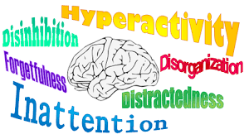
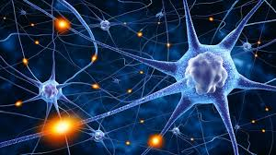
In many cases of individuals with ADHD, abnormal activity of neurotransmitters and abnormalities in the frontal-lobe regions of the brain have been identified (Brown, 2005).
ADHD is a behavioral disorder and the symptoms are usually being noticed at an early stage between 6 and 12 years old (NHS, 2018).

Attention Deficit/Hyperactivity Disorder is a neurodevelopmental disorder characterized by inattention, impulsivity and hyperactivity (American Psychiatric Association, 2013).
What are the symptoms of ADHD in children?

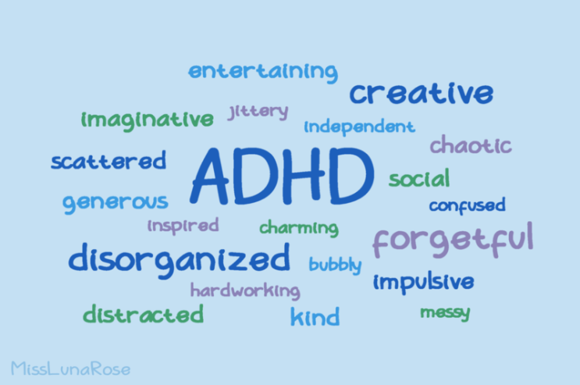
Many children are hyperactive from their nature; this does not mean they have ADHD.
Many people with ADHD develop symptoms that fall into 2 categories:
- Inattentiveness
- Hyperactivity and impulsiveness
(NHS, 2018)
If there are 6 of the following signs for at least 6 months:
(NHS, 2018)
If there are 6 of the following signs of hyperactivity-impulsivity for at least 6 months:

(NHS, 2018)
Causes of ADHD:
ADHD usually runs in families and is possible to inherit genes that are responsible for the development of the condition. Also, outcomes of relevant to the object studies reveal that individuals with ADHD have abnormal neurotransmitters.
There are groups that are believed to be in a great risk of ADHD such as:
- Individuals who were born prematurely
- People with epilepsy
- People that have brain damage (before or after birth).
(NHS, 2018)
According to a parent survey in 2016 (Danielson et al, 2018) young individuals with ADHD had at least one more disorder; behavioral or emotional:
- about 5 in 10 children had ADHD and a behavior problem
- about 3 in 10 children had ADHD and anxiety disorder
(CDC, 2019)
●●●
According to a survey in 2016, 6.1 million (9.4%) U.S. children aged 2-17 estimated to have received an ADHD diagnosis from which 5.4 million had ADHD.
- 388,000 children aged 2-5 years
- 4 million aged 6-11 years
- 3 million aged 12-17 years
Boys have more chances to be diagnosed with ADHD with prevalence of 12.9% and 5.6% respectively.
(CDC, 2019)
●●●


ADHD is a common disorder and the prevalence in the UK in 1999 shows that boys are being affected more than girls with 3.6% and 0.9 respectively, using the criteria from DSM-IV (Ford, Goodman, Meltzer 2003, as cited in Holden et al,2013).
Parents themselves may notice that family members do not wish to care for the child and conflicts are occurring. Family relationships quite often break down causing negative feelings to the children such as sadness or aggressive behaviors.
(Harpin, 2005)
Having a child with ADHD effects the family functioning as parents may face difficulties controlling them (Kasaei, 2013). It results in an increase of usual disturbances, disrupts the relationships between parent and child, marital functioning, parents stress reaches a high level, parenting effectiveness can be decreased as well (Harpin, 2005).
Coghill et al (2008) conducted a study among 10 European countries and included parents with ADHD children and parents with children without a disorder. The ADHD sample included 910 parents and the normative population sample 995 parents. The outcomes showed that comparing both groups; parents from the first group reported that their children displayed more challenging and demanding behaviors such as;
- Excessive noise
- Disorganization
- Disruption
- Impulsion
- Lack of motivation
- Not following family routines.
(Coghill et al, 2008)

…impact of ADHD on family continue
Siblings’ relationships can be affected as well as they are in a great risk for emotional disorders. It has been recorded that siblings are being targeted by their ADHD siblings and feel victimized as quite often they will go through physical violence, control and manipulation.
(Harpin, 2005)
A comparative study was conducted on 30 families with ADHD children and 30 control families. The outcomes showed a big difference between the two groups in general functions. The families of children with ADHD scored lower than the other group in problem solving scale. The families of children with ADHD scored higher regarding unhealthy general functioning. Control parents of were found to be healthier than the other group with a better family functioning.
(Kasaei, 2013)
The fact that young individuals with ADHD have to face a number of disadvantages of the disorder such as; unable to concentrate for long, not able to follow instructions, cannot complete a task without getting distracted appear to affect major, their life-style and future development. They have increased risks to be dropping out of school or college, academic failure and teenage pregnancy.
(Harpin, 2005)
Did you know?
Over 65% (Holden et al, 2013) of individuals with ADHD can have one or more disorders such as dyslexia and development coordination disorder (Harpin, 2005), mood or anxiety problems, cigarette and substance use disorders (Biederman et al, 2006).

Due to poor sleep or lack of it, children with ADHD will show more challenging behaviors during the day that affect more their quality of life (Harpin, 2005).
Children with ADHD quite often suffer from social isolation due to their disorder with cases to not receiving party invitations by their schoolmates. This isolation will possibly lead to low confidence.
(Harpin, 2005)


IPSEA
https://www.ipsea.org.uk
Helpline: 0808 808 3555
https://www.contact.org.uk
Parenting Special Children
parentingspecialchildren.co.uk

ADDISS
Phone: 020 8952 2800
http://www.addiss.co.uk
ADHD Foundation
https://www.adhdfoundation.org.uk
The Mental Health Foundation
https://www.mentalhealth.org.uk
Young Minds
Parents information Service: 0808 802 5544
https://www.youngminds.org.uk
References:
American Psychiatric Association (2013). Diagnostic and statistical manual of mental disorders (5th ed.). Arlington, VA: American Psychiatric Association.
American Psychiatric Association. (2000). DSM-IV text revision. Washington, DC: Author.

Biederman, J., Monuteaux, M. C., Mick, E., Spencer, T., Wilens, T. E., Silva, S. M., Snyder,L. E., and Faraone, S. V. (2006). Young adult outcome of attention deficit hyperactivity disorder: a controlled 10-year-follow up study. Psychological medicine, 36(2), 167-179.

Brown, T. E. (2005). Attention deficit disorder: The unfocused mind in children and adults. New Haven: Yale University Press.
Centers for Disease Control and Prevention (CDC) (2019). Attention-Deficit/Hyperactivity Disorder (ADHD). https://www.cdc.gov/ncbddd/adhd/data.html Date accessed 19.02.20.
Danielson, M. L., Bitsko, R. H., Ghandour, R. M., Holbrook, J. R., Kogan, M. D., & Blumberg, S. J. (2018). Prevalence of Parent-Reported ADHD Diagnosis and Associated Treatment Among U.S. Children and Adolescents, 2016. Journal of clinical child and adolescent psychology : the official journal for the Society of Clinical Child and Adolescent Psychology, American Psychological Association, Division 53, 47(2), 199–212. https://doi.org/10.1080/15374416.2017.1417860
Harpin, V. A. (2005). The effect of ADHD on the life of an individual, their family, and community from preschool to adult life. Archives of disease in childhood, 90(suppl 1), i2-i7.
Holden, S. E., Jenkins-Jones, S., Poole, C. D., Morgan, C. L., Coghill, D., & Currie, C. J. (2013). The prevalence and incidence, resource use and financial costs of treating people with attention deficit/hyperactivity disorder (ADHD) in the United Kingdom (1998 to 2010). Child and adolescent psychiatry and mental health, 7(1), 34. https://doi.org/10.1186/1753-2000-7-34
Kasaei, F. (2013). Family functioning in children with attention-deficit/hyperactivity disorder. Procedia-Social and Behavioral Sciences, 84, 1864-1865.
NHS (2018). Attention deficit hyperactivity disorder (ADHD). https://www.nhs.uk/conditions/attention-deficit-hyperactivity-disorder-adhd/ Date accessed 19/02/20.

