University of Wales Trinity Saint David
Wales Institute of Science & Art


Application of Computer Aided Engineering Processes
Structural Design and Fluid Analysis ACHA6010

Elliot Woodhouse

Student ID: 1908452
Date: 12/2023

Contents
List of Figures ii
List of Tables iii
1. Introduction 1
2. Validation of the Software 2
2.1 – Ansys Workbench 2
2.2 – Methodology 2
2.2.1 – Validation Models 2
2.2.2 – Applied Load Static Structural Validation 3
2.2.3 – Applied Thermal Conditions Validation 11
3 - Methodology 17
3.1 – Internal Combustion Engine Model 17
3.2 – Materials Selection 17
3.3 - Ansys Workbench Linked Setup 18
3.3.1 – Overview 18
3.3.2 – Rigid Dynamics 18
3.3.3 – Steady-state Thermal 19
3.3.4 – Static Structural 21
3.4 – Assumptions Made 22
4 - Results 23
5 - Improving the Design 25
5.1 – Iteration 1 25
5.2 – Iteration 2 27
6 – Conclusion 30
7 - Reference List 31

List of Figures
Figure 1 – Cantilever Beam Validation Model………………………………………………………………………….2
Figure 2 - Custom Material Properties for the Cantilever UDL Validation Study……………………...3
Figure 3 - Static Structural Study Setup for Validation Case…………………………………………..…….….4
Figure 4 - Cantilever Beam with 10mm Elements……………………………………………………………….……5
Figure 5 - Cantilever Beam with 0.5mm Elements…………………………………………………………….……..5
Figure 6 - Beam Stresses with 10mm Element Size………………………………………………..……….……….6
Figure 7 - Beam Stresses with 0.5mm Element Size………………………………………………..…….…………6
Figure 8 - Beam Deformation with 10mm Element Size…………………………………………..………………6
Figure 9 - Beam Deformation with 0.5mm Element Size…………………………………………..……………..7
Figure 10 - Change in Maximum Stress…………………………………………………………………………………...9
Figure 11 - Change in Minimum Stress………………………………………………………………………………….…9
Figure 12 - Change in Average Stress…………………………………………………………………………………..…10
Figure 13 - Static Structural Study with Thermal Loads Applied…………………………………………..…11
Figure 14 - Bimetallic Strip 4mm Mesh………………………………………………………………………………..…12
Figure 15 - Bimetallic Strip 0.125mm Mesh……………………………………………………………………….…..12
Figure 16 - Bimetallic Strip Deformation with 4mm Element Size…………………………………….…….12
Figure 17 - Bimetallic Strip Deformation with 0.125mm Element Size…………………………….……..13
Figure 18 - Change in Maximum Deformation……………………………………………………………….……….14
Figure 19 - Change in Average Deformation………………………………………………………………….……….14
Figure 20 - Simple Internal Combustion Engine Model…………………………………………………………..16
Figure 21 - Fully Linked System Overview………………………………………………………………………………17
Figure 22 - Rigid Dynamics Analysis of the force acting between the gudgeon pin and piston.18
Figure 23 - Piston Thermal Characteristics……………………………………………………………………………..19
Figure 24 - Piston Mesh for Thermal Study…………………………………………………………………………….20
Figure 25 - Inertial forces acting on the piston……………………………………………………………………….20
Figure 26 - Imported Temperature Profile in final Static Structural study……………………………….21
Figure 27 - Simulated Pressure due to combustion acting on the piston crown……………………..22
Figure 28 - Piston Deformation………………………………………………………………………………………………22
Figure 29 - Piston Deformation Bottom View…………………………………………………………………………23
Figure 30 - Piston Stress…………………………………………………………………………………………………………23
Figure 31 - Piston Stress Bottom View……………………………………………………………………………………24

Figure 32 - Modified Piston Temperature Profile…………………………………………………………………...25
Figure 33 - Modified Piston Deformation……………………………………………………………………………….25
Figure 34 - Modified Piston Deformation Bottom View………………………………………………………….25
Figure 35 - Modified Piston Stress………………………………………………………………………………………….25
Figure 36 - Modified Piston Stress Bottom View…………………………………………………………………….26
Figure 37 - Further Modified Piston……………………………………………………………………………………….26
Figure 38 - Further Modified Piston Bottom View………………………………………………………………….26
Figure 39 - Further Modified Piston with a 45° Section View………………………………………………...26
Figure 40 - Further Modified Piston Mass Properties…………………………………………………………….27
Figure 41 - Further Modified Piston Temperature Profile……………………………………………………..27
Figure 42 - Further Modified Piston Temperature Profile Bottom View………………………………..27
Figure 43 - Further Modified Piston Deformation…………………………………………………………………27
Figure 44 - Further Modified Piston Deformation Bottom View……………………………………………27
Figure 45 - Further Modified Piston Stress……………………………………………………………………………28
Figure 46 - Further Modified Piston Stress Bottom View………………………………………………………28

List of Tables
Table 1 - Stresses and Deformation of the Cantilever Beam across Decreasing Element Sizes​​.7
Table 2 - Change in Stresses and Deformation as Element Size is Decreased​​…………………………8
Table 3 - Invar Validation Material Properties​​……………………………………………………………………..10
Table 4 - Copper Validation Material Properties​​………………………………………………………………….11
Table 5 - Deflection of Strip at Increasing Mesh Densities…………………………………………………..13
Table 6 - Change in Deflection as Mesh Density Increases………………………………………………….13

Introduction
As computing power has increased significantly over the past few decades, the use of Computer Aided Engineering (CAE) tools, such as Finite Element Analysis (FEA) and Computational Fluid Dynamics (CFD) have proved to be incredibly useful tools to engineers in the workplace when designing and testing components, where analytical solutions cannot be obtained. Despite their proven utility, CAE systems are not without limitations.
This report aims to examine the advantages of employing CAE tools, specifically FEA, in engineering processes. It will explore their application, the methods used for result validation, and the inherent constraints of these tools. The focal point of this analysis is a CAE examination of a piston of an internal combustion engine (ICE), contextualized within a broader assembly of components such as the gudgeon pin, connecting rod, and crankshaft. The analysis includes a series of studies, including rigid dynamics, steady-state thermal, and static structural analyses, to replicate the different types of loadings experienced by a piston in real-world scenarios.
Following the preliminary analysis, the piston design will undergo design changes through an iterative approach, guided by the results gained from previous FEA results, with an aim of enhancing the design to reduce the overall mass of the piston without compromising on component strength. Through this methodical approach, the report seeks to demonstrate the efficacy and limitations of CAE tools in modern engineering practices.

Validation of the Software

– Ansys Workbench
The software used for this investigation is Ansys Workbench R1 2021. Validation cases are extremely important when using CAE tools, as stated by Almeida & Completo (2020), to ensure that the calculated results are representative of real-life scenarios. Two major methods of validation are experimental and analytical validation.

– Methodology

– Validation Models
In this investigation, two validation models are employed to verify the software’s solution accuracy. The first model involves a simple cantilever beam, anchored at one end, with a uniformly distributed load (UDL) applied across its top surface. This model is appropriate for comparison, as it mirrors the conditions in the piston study, where the piston is fixed and subjected to a uniformly distributed load on its crown, simulating combustion pressure.
The second validation model focuses on a thermal study. It examines the deformation of two beams made of different materials when exposed to temperature.

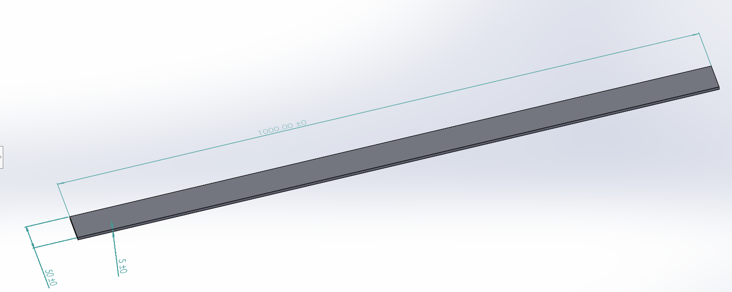
2.2.2 – Applied Load Static Structural Validation
Figure 1 - Cantilever Beam Validation Model
Figure 1 above shows the 1000x50x5mm beam used for the cantilever validation case. It is vital that the same material properties are used for both the FEA study and the analytical study so that the results can be compared accurately. For this reason, a custom material was built in Ansys with the correct material properties, as shown in Figure 2 below.
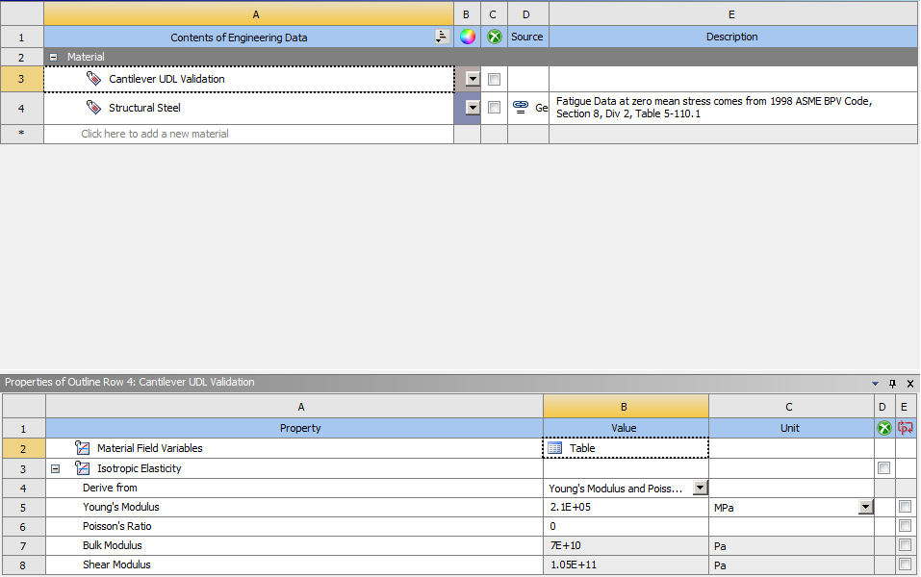
Figure 2 - Custom Material Properties for the Cantilever UDL Validation Study

2.2.2.1 – Analytical Study
Due to the simple nature of the validation case, the analytical study is a straightforward calculation. To calculate the deformation of the beam, the following equation can be used:
$$V_{max}= -\frac{wL^{4}}{8EI}$$
Where:
V_{max} =Maximum deformation (m)
w =uniformly distributed load (N/m²)
L =Beam length (m)
E =Young’s Modulus of Elasticity (Pa)
I =Moment of inertia (kg.m²)
To calculate the moment of inertia of the beam, the following equation can be used:
$$I= \frac{w*t^{3}}{12}$$
Where:
w = Beam width (m)
t = Beam depth (m)

2.2.2.2 – FEA Study
The system used in Ansys to validate the software in this case is the static structural study. As stated by Ansys (2023), a static structural study determines the effects (such as stress, strain and deformation) of steady loadings on a structure.
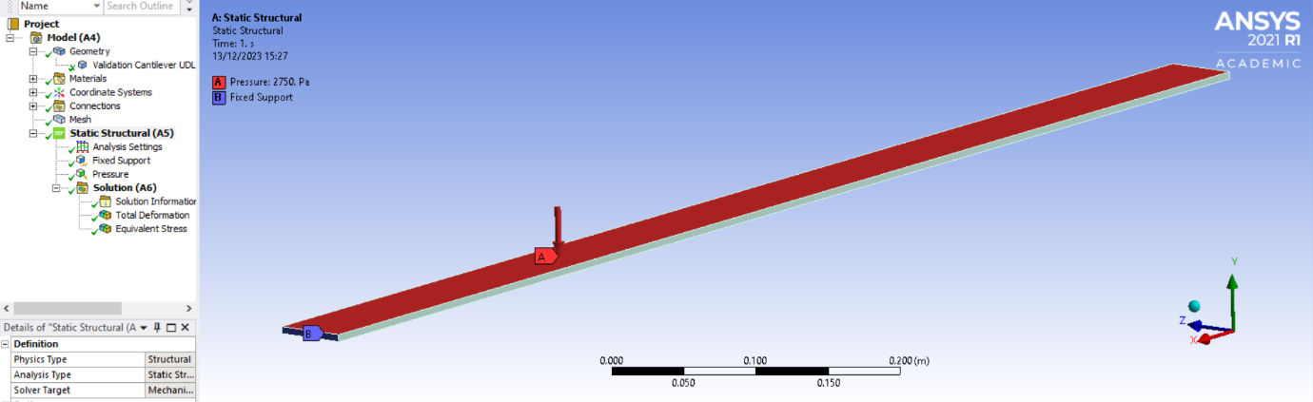
The general procedure for setting up the validation case is relatively simple. The beam is imported into the static structural study, assigned the correct material (being the previously mentioned custom material), meshed and the correct boundary conditions are set. In this relatively simple case, the boundary conditions are assuming that the bar is fixed at one end and a uniformly distributed load is applied across the top surface of the beam.
Figure 2 - Static Structural Study Setup for Validation Case

– Mesh Independence Study
Mesh density, critical in CAE simulations like FEA and CFD, significantly influences model accuracy, as noted by Liu, Y. & Glass, G. (2013). Therefore, a mesh independence study is conducted to assess the impact of varying mesh densities on simulation accuracy. The study ranges from a coarse 10mm element size (notably large given the model's 5mm thickness) to a much finer 0.5mm size.

2.2.2.4 – Analytical Study Results
Using the previously mentioned equation and the same boundary conditions applied to the FEA study, the following results have been calculated:
$$I = \frac{0.05*{0.005}^{3}}{12} = 5.20833*{10}^{-10} kg.m^{2}$$
$V_{max}= -\frac{2750*0.05*1^{4}}{8*2.1*{10}^{11}*5.20833333333* {10}^{-10}}$ = 0.157143m to 6 significant figures
= 157.143mm maximum deformation.

– Applied Load Validation & Mesh Independence Results
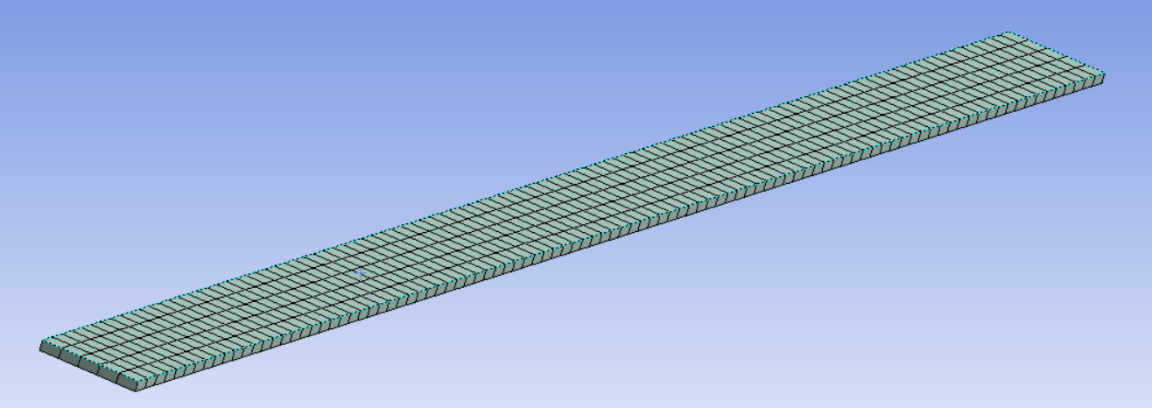
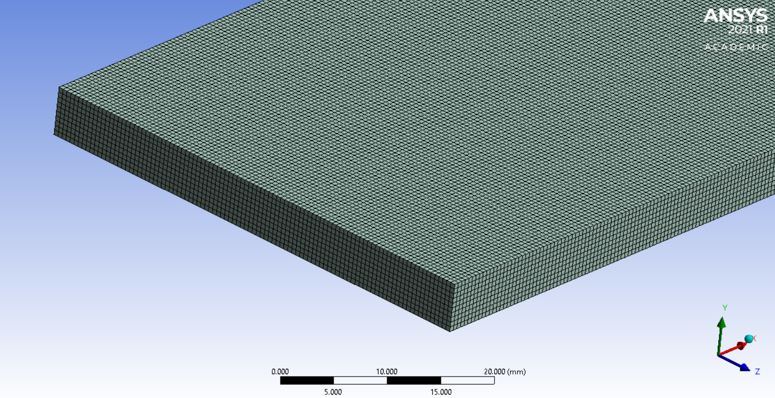
The figures below show the difference in mesh sizes between the coarsest mesh and the finest mesh, and comparing their respective results.
Figure 5 - Cantilever Beam with 0.5mm Elements
Figure 4 - Cantilever Beam with 10mm Elements
As can be seen in figures 4 and 5 above, the differences in mesh density are significant, with the coarsest mesh only being able to fit half of an element within the beams thickness (vertically), whilst the finest mesh can fit 10 elements vertically. Ansys was given control of the element types and in this specific case, hexahedral elements are the most appropriate as there is no complex geometry.

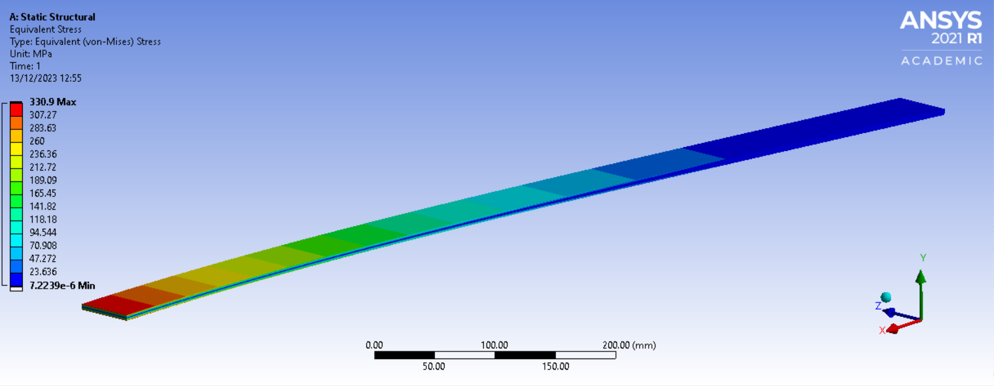
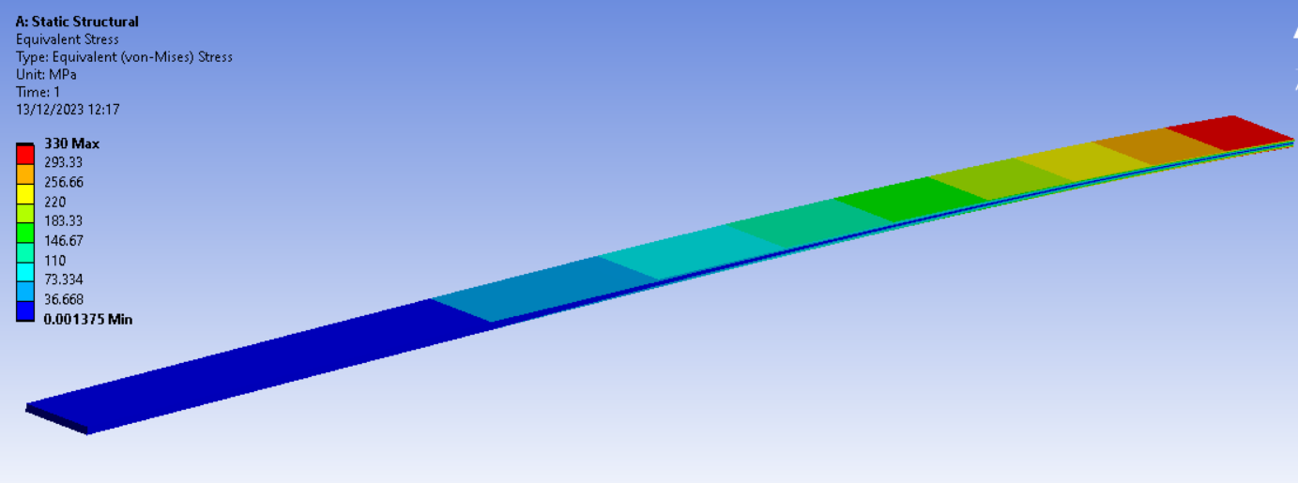
Figure 7 - Beam Stresses with 0.5mm Element Size
Figure 6 - Beam Stresses with 10mm Element Size
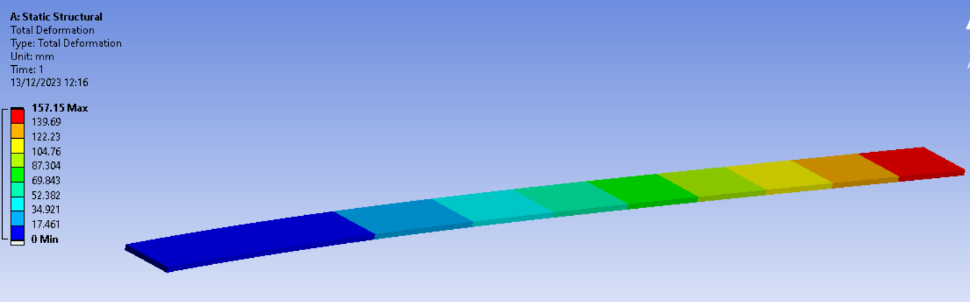
It can be observed that with the finer mesh, the maximum stress is increased by 0.9MPa, only increasing by 0.273%. The minimum stress has decreased significantly, however (theoretically) the centre line through the middle of the beam should experience zero stress.
Figure 8 - Beam Deformation with 10mm Element Size

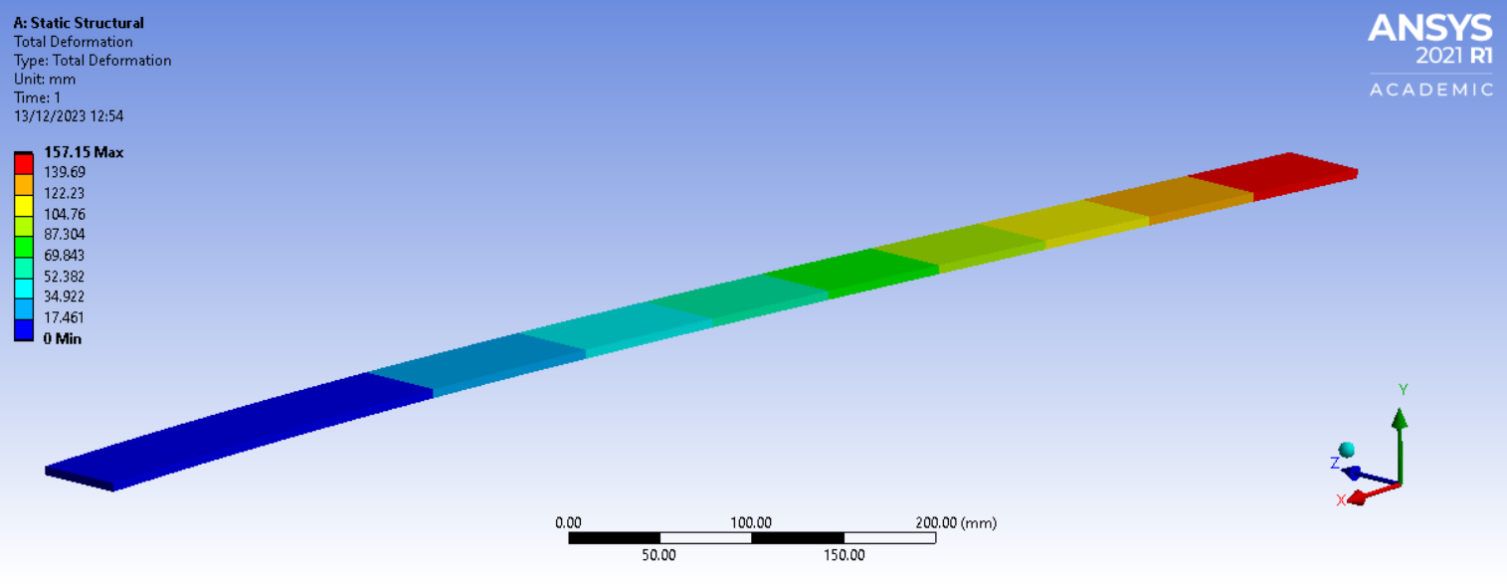
Solely observing the figures above, it’s apparent that changing the element size has had no effect on the deformation of the beam, suggesting that if the goal was to calculate deformation, using a 10mm element size would be the most efficient way of doing so to reduce computing power and time in this case.
Figure 9 - Beam Deformation with 0.5mm Element Size
The following tables below show the results of the static structural simulation on the cantilever beam, focusing on the stresses and deformation of the beam, whilst also looking at the difference in these results as the element size is decreased.
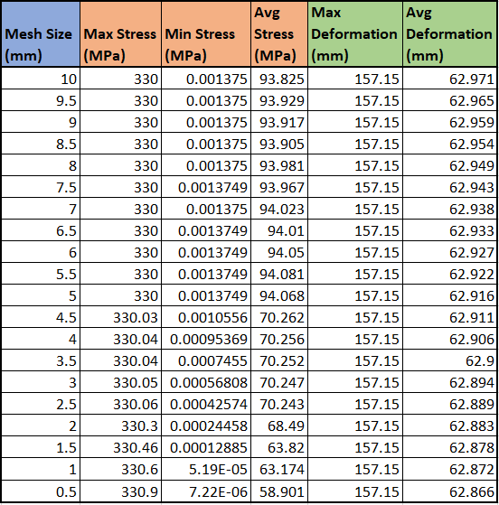

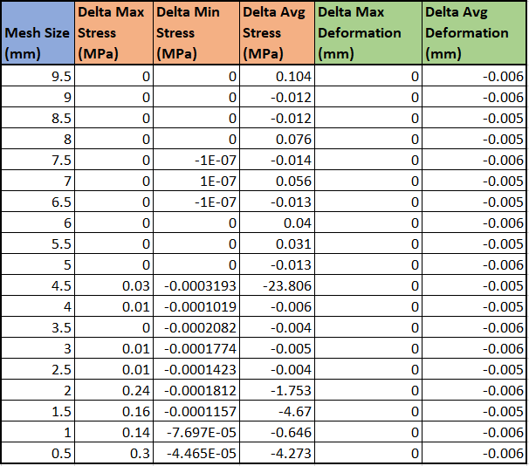
Table 2 - Change in Stresses and Deformation as Element Size is Decreased

Tables 1 and 2 show that element size doesn’t affect the beam's maximum deformation. Minor variations in maximum, minimum, and average stresses, as well as average deformation, are noted with decreasing mesh size. Notably, reducing element size from 5mm to 4.5mm leads to a marked decrease in average stress and fluctuations in maximum stress. This change is likely because the beam's 5mm thickness accommodates multiple elements when the size falls below this threshold, thereby impacting accuracy. This trend becomes evident in plotted data, with a similar pattern observed for Delta Max Stress when element size drops below 2.5mm.

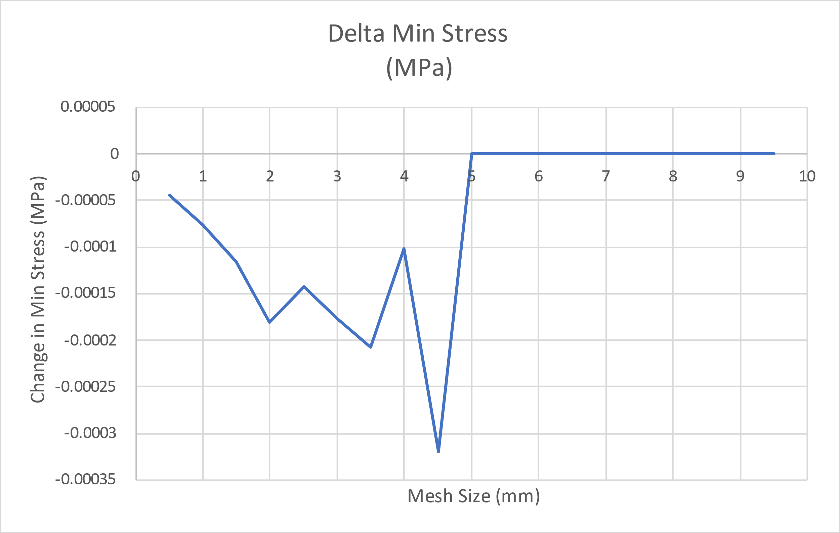
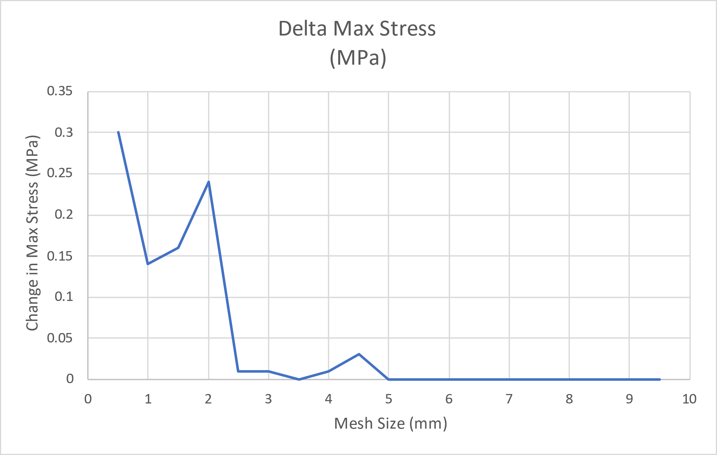
Figure 11 - Change in Minimum Stress
Figure 10 - Change in Maximum Stress

Figure 12 - Change in Average Stress
Overall, comparing the deformation values obtained via Ansys to the maximum deformation calculated using an analytical method, the simulated results are only 0.004455% greater than the analytically obtained results, which is well within the margin of error.

– Applied Thermal Conditions Validation
This validation, as previously stated, is to simulate the deformation of a bimetallic strip (with both metals having different coefficients of expansion) when temperature is applied to the assembly. The details of the custom material properties can be seen in Tables 3 and 4 below.
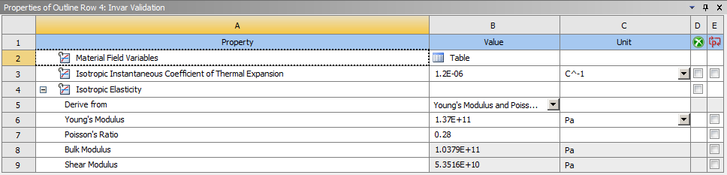
Table 3 - Invar Validation Material Properties

Table 4 - Copper Validation Material Properties
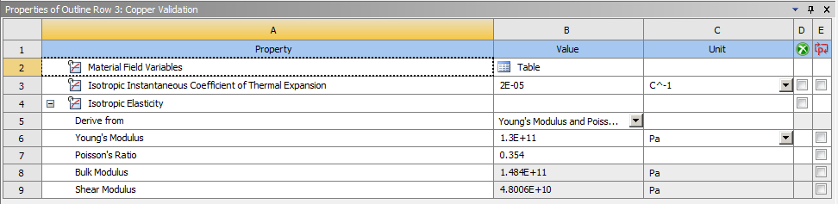

2.2.3.1 – FEA Study Setup
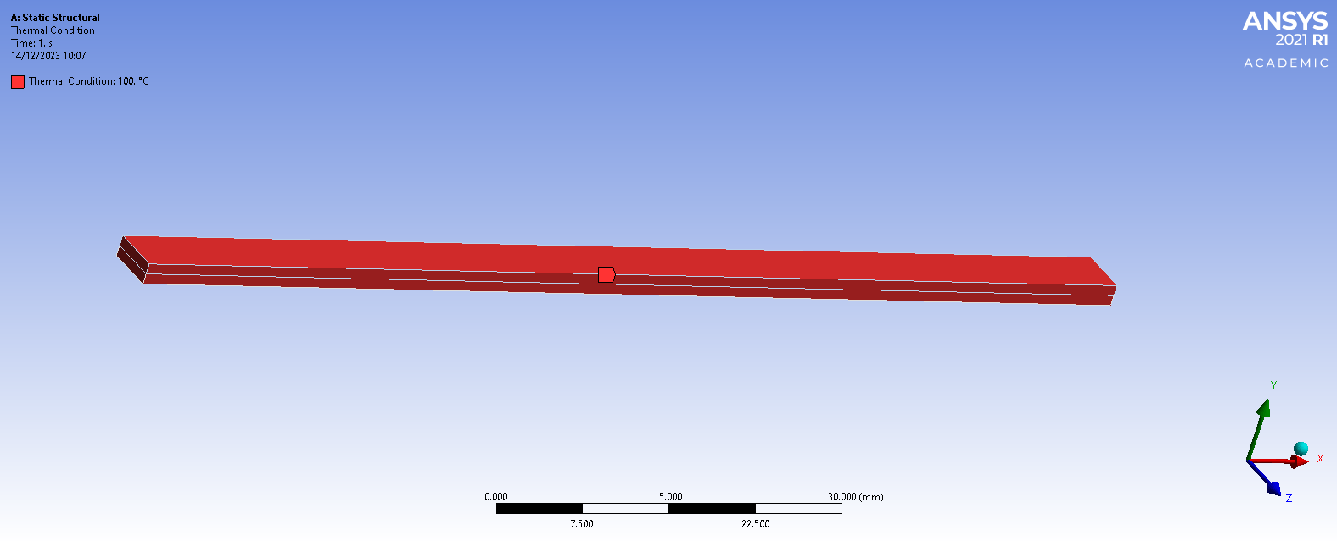
Figure 13 - Static Structural Study with Thermal Loads Applied
Setting up the boundary conditions in the static structural solver, one end of the beam is fixed whilst the entire beam has a thermal condition of 100°C applied to it.

2.3.3.2 – Results and Mesh Independence Study
Like the previous validation study, a mesh independence study has been conducted to investigate the effects of varying mesh densities on the deformation of the strip. The element sizes have been reduced from 4mm to 0.125mm, as the simulation wouldn’t run with a coarser mesh.

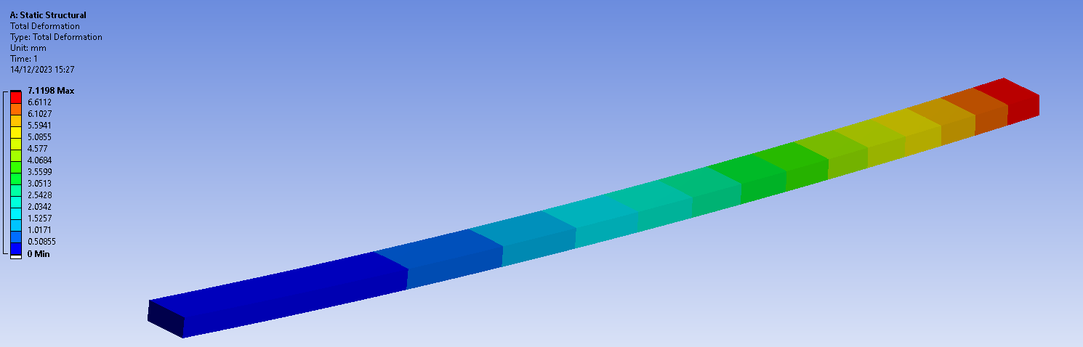
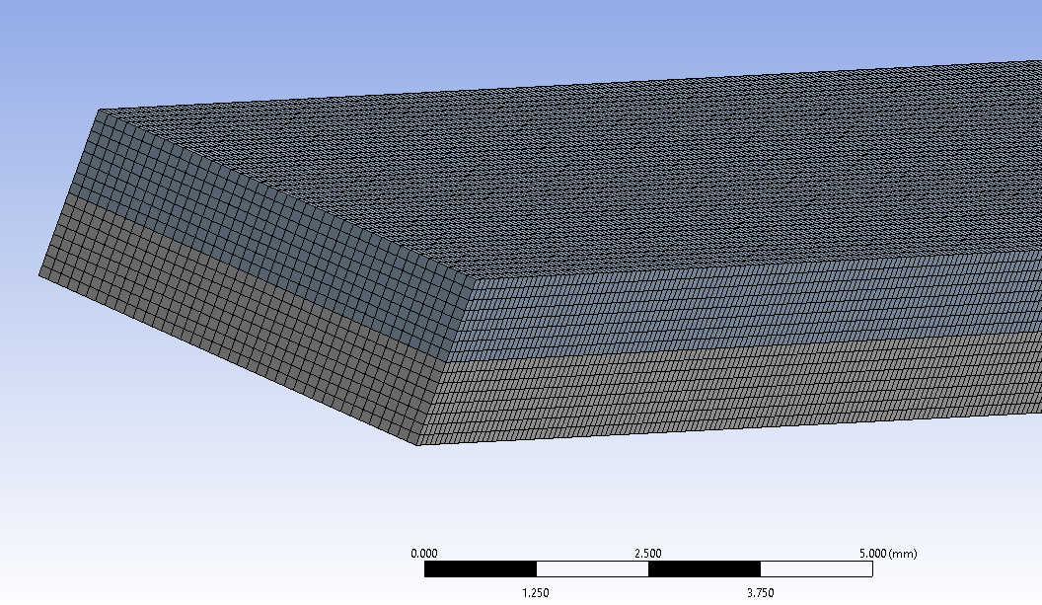
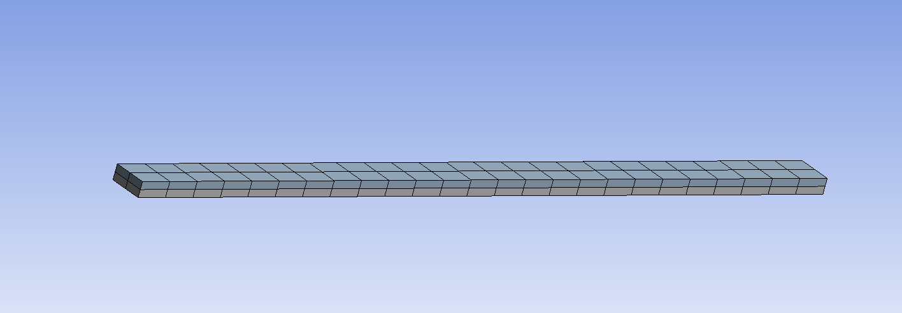
Figure 16 - Bimetallic Strip Deformation with 4mm Element Size
Figure 15 - Bimetallic Strip 0.125mm Mesh
Figure 14 - Bimetallic Strip 4mm Mesh

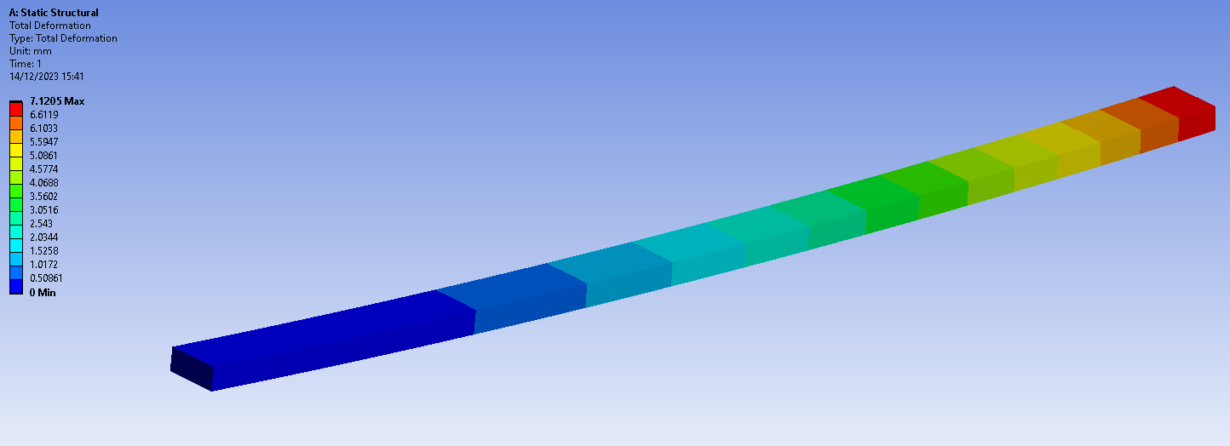
Figure 17 - Bimetallic Strip Deformation with 0.125mm Element Size
Observing Figures 16-17 above and Tables 5-6 below, the maximum deformation of the strip is fluctuating around 7.12mm depending on the mesh density. Tables 5 and 6 below display the deformation and the change in deformation as element size is decreased.
Table 5 - Deflection of Strip at Increasing Mesh Densities

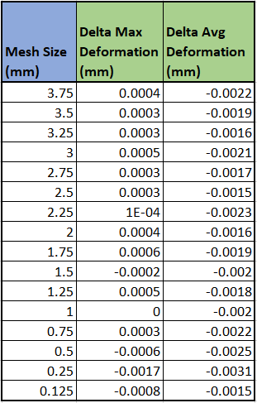
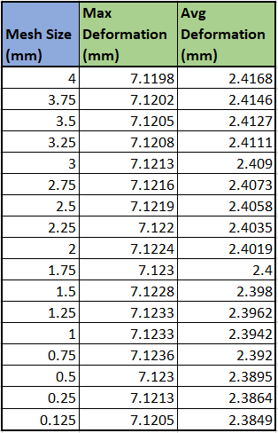
Table 6 - Change in Deflection as Mesh Density Increases

The changes in both maximum deformation and average deformation have been plotted and are displayed below.

Figure 19 - Change in Average Deformation
Figure 18 - Change in Maximum Deformation

Figures 18 and 19 show that as the mesh is decreased from 4mm to 0.75mm, there are no large changes in maximum deformation, and only very small changes in average deformation. However, when the element size is reduced from 0.75-0.125mm, the results begin to vary significantly. This shows that, reducing element size usually increases the accuracy of the results, however if the elements are made small enough, inaccuracies may be introduced.

2.2.3.3 – Comparing Analytical and Simulated Results
This solution is calculated using the analytical method described by Warren Y. et al. (2012), where:
$$K_{1}=4+6\frac{t_{c}}{t_{i}}+4{\left(\frac{t_{c}}{t_{i}}\right)}^{2}+\frac{E_{c}}{E_{i}}{\left(\frac{t_{c}}{t_{i}}\right)}^{3}+\frac{E_{i}t_{i}}{E_{c}t_{c}}$$
$$u_{z,max}=\frac{6\left(α_{i}-α_{c}\right)\left(t_{i}+t_{c}\right)T_{c}}{t_{s}^{2}K_{1}}\frac{L^{2}}{2}$$
When this method was performed by Dlubal (2017) with the same material values used in this validation case, a maximum deflection result of 7.049mm was calculated. The minimum deviation from this occurred at an element size of 4mm, with a percentage difference of 1.004%, whilst the maximum deviation from the analytical result of 1.058% occurs at an element size of 0.75mm. Whilst the percentage difference between the analytical result for this study is much greater than that of the applied load study, the simulated result is still deemed accurate enough as it is still over 98% accurate.

- Methodology

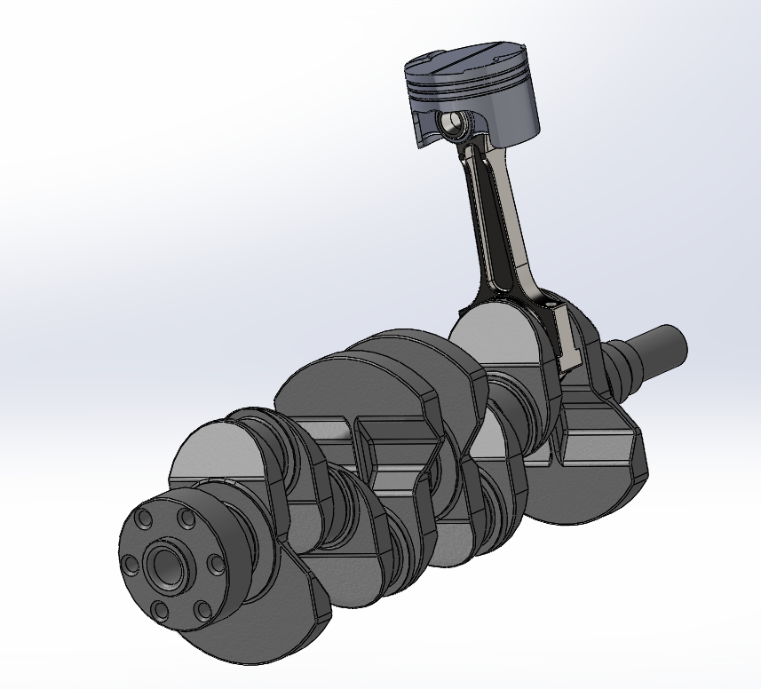
– Internal Combustion Engine Model
Figure 20 - Simple Internal Combustion Engine Model
Figure 1 above shows the model that will be used for this CAE analysis. It is a relatively simple model containing four of the major components in an ICE:
- Piston (the focus of this study)
- Gudgeon pin
- Connecting rod
- Crankshaft
The inclusion of various components in the simulation is essential to accurately model the loads experienced by the piston, particularly the reciprocating inertial forces during crankshaft rotation. These forces become significant at higher engine speeds (Heywood, 2018) as Bari K. et al. (2017, pp.9-16) found in their study on connecting rod failure in a motorcycle engine. Their FEA research revealed that maximum tensile inertial loads occur at Top Dead Centre (TDC), contributing to con-rod failure along with fatigue cycling.

– Materials Selection
Material choice is crucial in piston design, significantly affecting mass and thermal responsiveness. For example, a steel piston would incur higher inertial forces than an aluminium one due to steel's higher density. This study opts for aluminium 6061 T6, a common choice for engine pistons. Rashmita et al. (2023) investigated optimal materials for piston fabrication, finding Al 6061 the most suitable due to its lower deformation and mechanical stress.

- Ansys Workbench Linked Setup

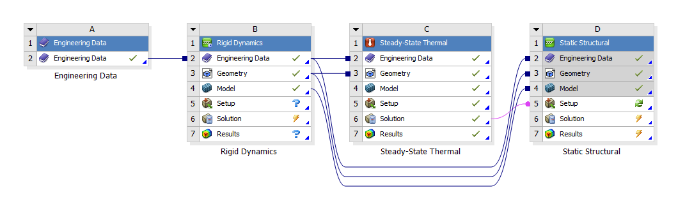
– Overview
Figure 21 - Fully Linked System Overview
Figure 2 above shows the overview page of the full analysis and how each section are linked to each other.
The final results of equivalent stress and displacement are calculated in the static structural section once all other analysis sections have been complete, and their results have been used as boundary conditions for the static structural analysis.

– Rigid Dynamics
In the rigid dynamics analysis, engine motion and resultant forces on the piston are simulated. The model's components are connected via body-body revolute joints, allowing rotational freedom, except for a body-ground joint that limits the piston to vertical movement only, simulating its operation inside a cylinder, and a body-ground revolute joint applied to the crankshaft to allow it to rotate. This introduces an assumption of no friction or horizontal movement between the piston and cylinder wall, which is not entirely accurate (Courtney-Pratt, J.S. & Tudor, G.K., 1946). The impact of these assumptions will be further discussed.
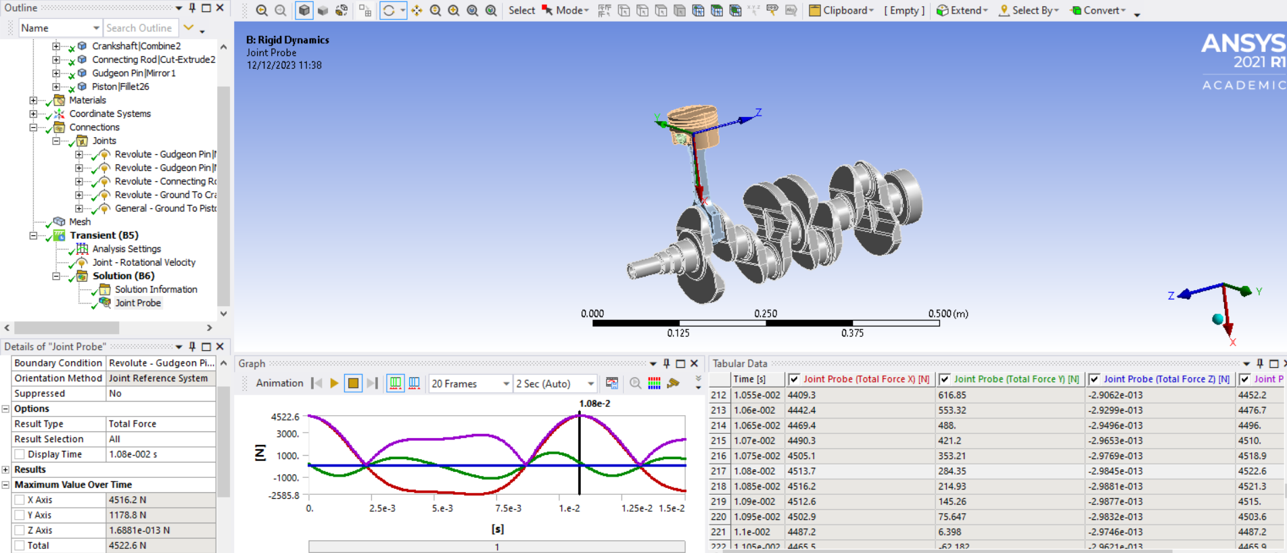
In the simulation, the crankshaft was set to rotate at 5500 RPM, replicating the highest loads near a typical automotive engine’s redline. A small time-step was essential to capture sufficient data for a comprehensive representation of forces acting on the piston. Since the study focuses on a "worst case scenario," the time step corresponding to the peak load of 4522.6N—a clear indication of the significance of inertia forces in an Internal Combustion Engine (ICE)—was selected for use as a boundary condition in the subsequent static structural analysis.
Figure 22 - Rigid Dynamics Analysis of the force acting between the gudgeon pin and piston.

– Steady-state Thermal
The steady-state thermal analysis calculates the piston's temperature profile and material property changes due to temperature change, serving as a boundary condition for the static structural study. It involves assigning accurate convection inputs over the piston's geometry to model heat transfer coefficients and temperatures, as depicted in Figure 23. A mesh, shown in Figure 24, is essential for this analysis.
This study uses a fine mesh for detailed component representation, balancing 2.5mm elements for overall computing efficiency and a finer 2mm mesh for critical areas like the gudgeon pin hole and crown, ensuring geometric accuracy. A slow transition in mesh settings is used to minimize skewed elements.
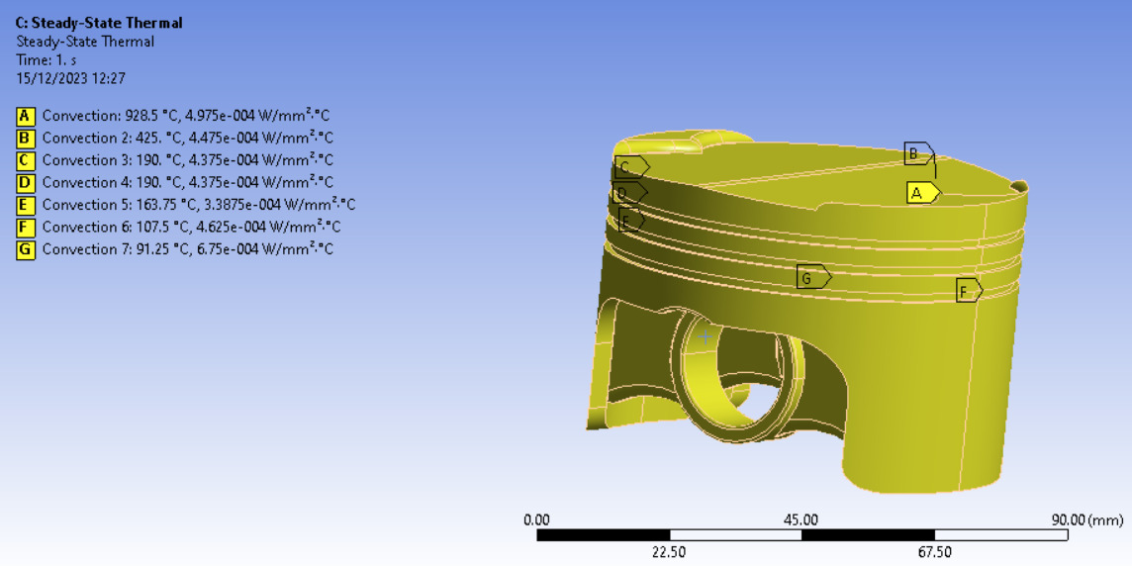
Figure 23 - Piston Thermal Characteristics
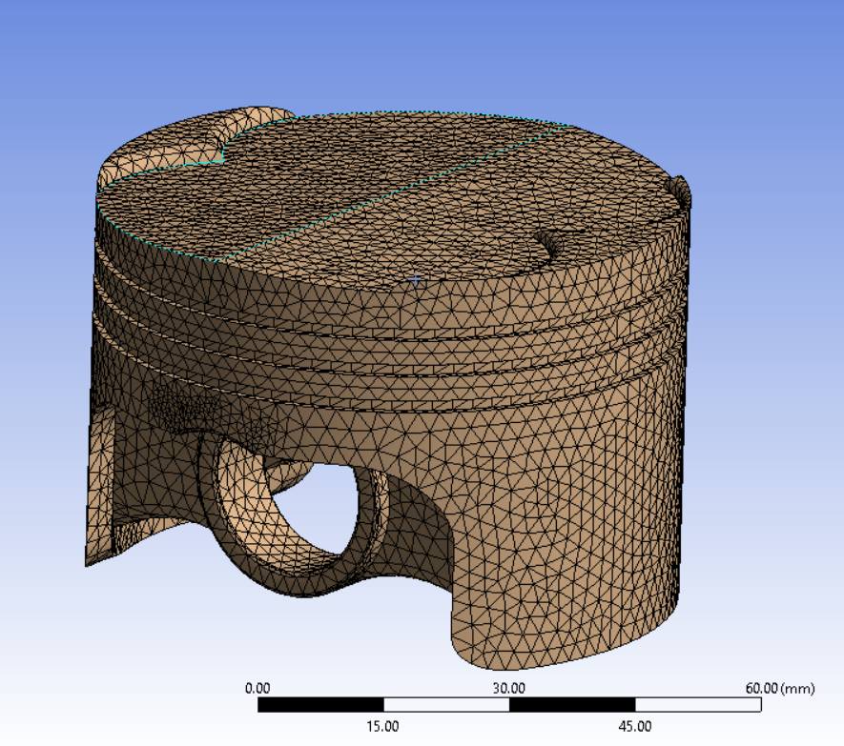
Figure 24 – Piston Mesh for Thermal Study

– Static Structural
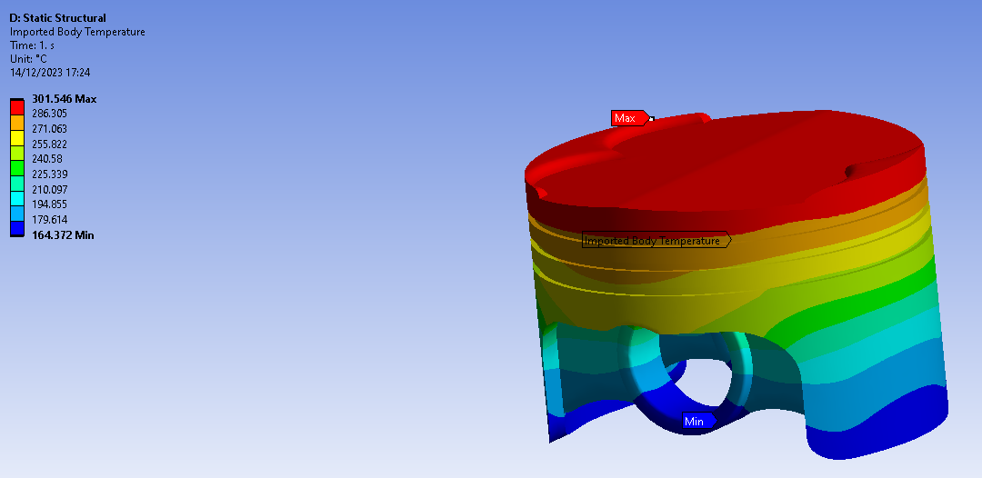
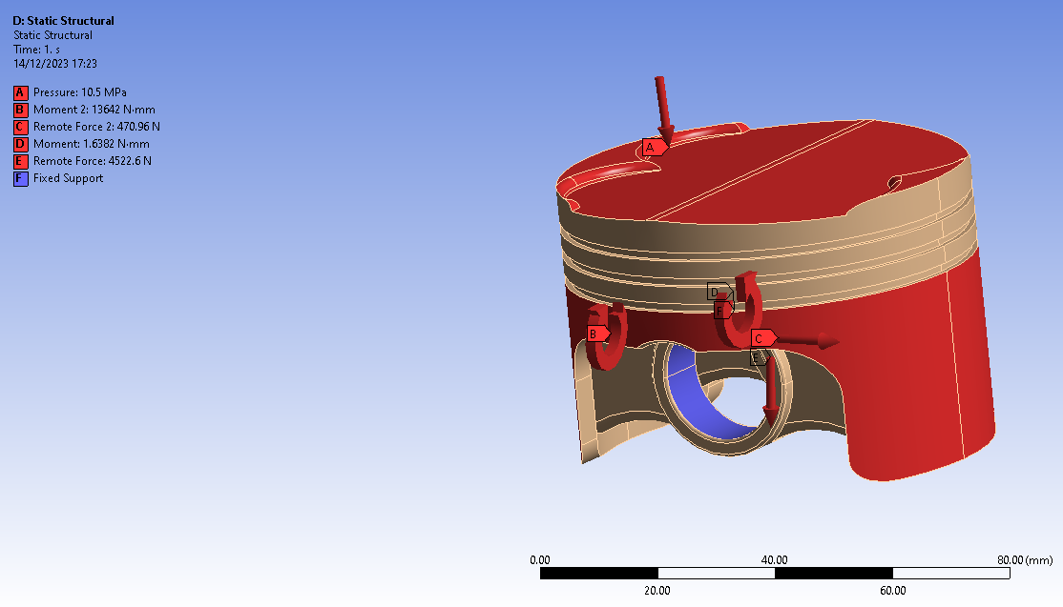
The final segment of the simulation, the static structural study, utilizes the outcomes from the rigid dynamics and steady-state thermal analyses as boundary conditions. These conditions are essential for computing the piston's stress and deformation. Additionally, a boundary condition simulating a constant 10.5MPa combustion pressure on the piston crown is applied.
Figure 25 – Inertial forces acting on the piston.
Figure 26 - Imported Temperature Profile in final Static Structural study.

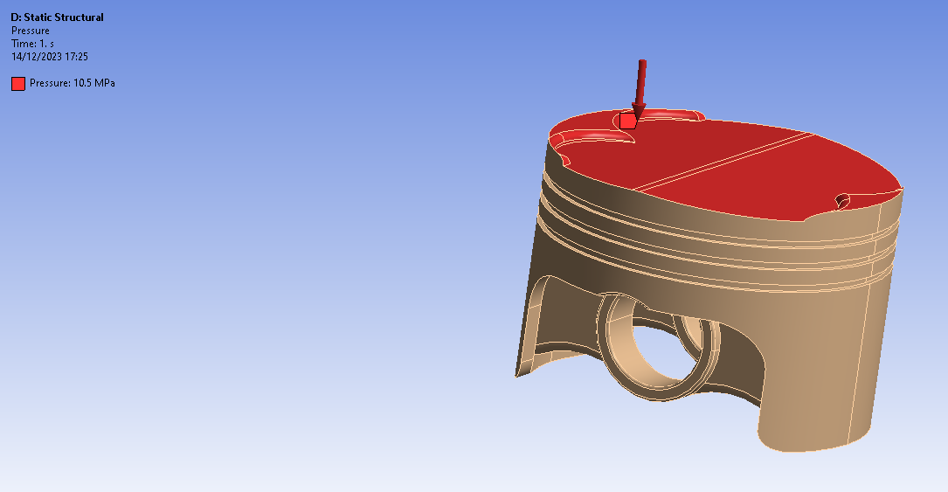
Figure 27 - Simulated Pressure due to combustion acting on the piston crown.
For continuity reasons and to avoid any errors, the element size of the mesh in the static structural study must be the same size as the one used in the steady-state thermal study.

– Assumptions Made
This study incorporates several assumptions that could impact its accuracy compared to real-life experimental tests. Bahari et al. (2021) conducted a related study, examining the influence of initial boundary conditions on simulation outcomes versus experimental results. They reported an initial error margin of 45.12%, which was subsequently reduced to 6.28%, highlighting the significance of initial conditions in the accuracy of such studies.
- Fixed Piston Support: The study uses fixed supports in the gudgeon pin hole to stabilize the piston in the simulation, but this prevents deformation inside the hole, possibly skewing results since it's unrepresentative of real-life behaviour. An attempt to use "weak springs" for a softer hold failed, as the loadings were too great, preventing solution convergence.
- Perfect Material Properties: The study presumes the material is defect-free with uniform grain structure. In reality, material properties vary due to factors such as fabrication methods (e.g., casting or forging), affecting grain structure and overall component performance.
- Types of Loading – The loads in this study are assumed to be uniformly distributed across the surfaces of the selected faces, which may not be representative of real-life scenarios. As the temperature study is also steady state, this assumes that the temperature is constant, which again is not the case in real life.

- Results
Figure 29 - Piston Deformation Bottom View
Figure 28 - Piston Deformation
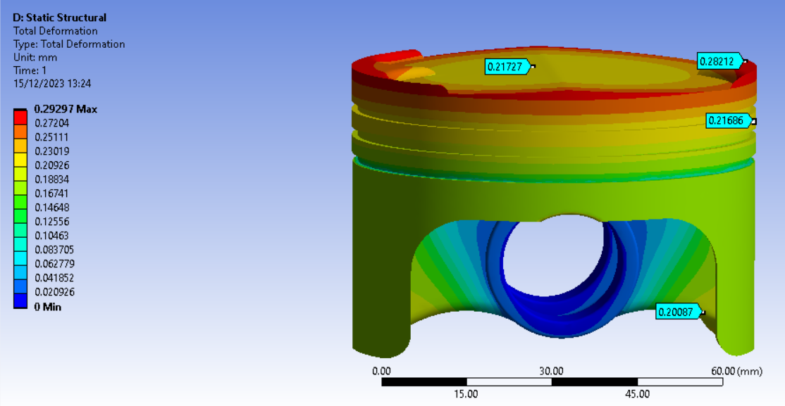
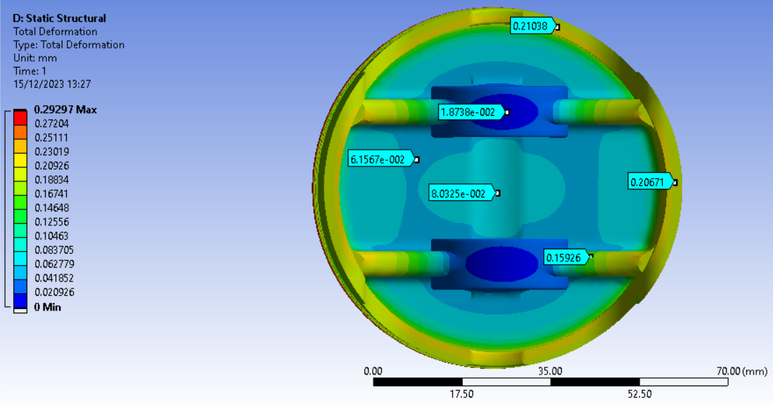
Figures 28 and 29 display the piston's deformation under applied loads. Due to fixed constraints, the piston bore shows no deformation, possibly affecting accuracy. The highest deformation, at 0.29297mm, occurs around the piston crown's edge, with the underside experiencing comparatively less deformation.

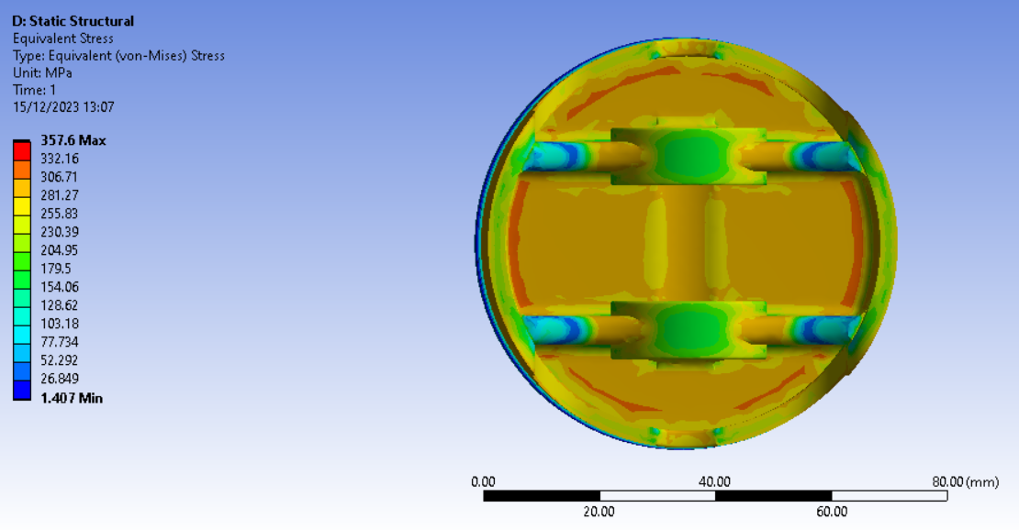
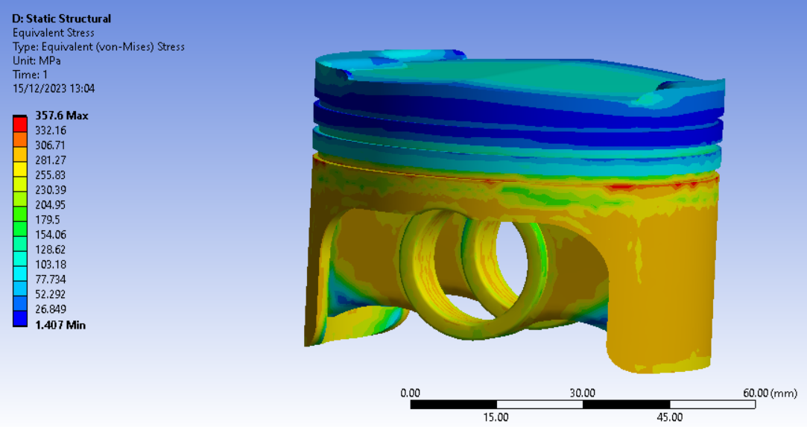
Maximum stress is noted at the oil groove's top edge, possibly due to its sharp corner. Lower stress on the piston's underside suggests potential for material removal without compromising strength. Whilst there is minimal stress near the crown's side and top groove, material removal is challenging here considering their design significance.
Figure 31 - Piston Stress Bottom View
Figure 30 - Piston Stress

- Improving the Design
This section of the report focuses on using the result of the previous stress & deformation analysis to remove material from the piston where there are areas of low stress. The final goal is to reduce the mass of the piston by 20g from an initial mass of 255.77g (measured in SolidWorks using the 6061-T6 aluminium material applied) without significantly affecting the structural integrity of the piston, similar to the study performed by Feher, D. et al. (2022).

5.1 – Iteration 1
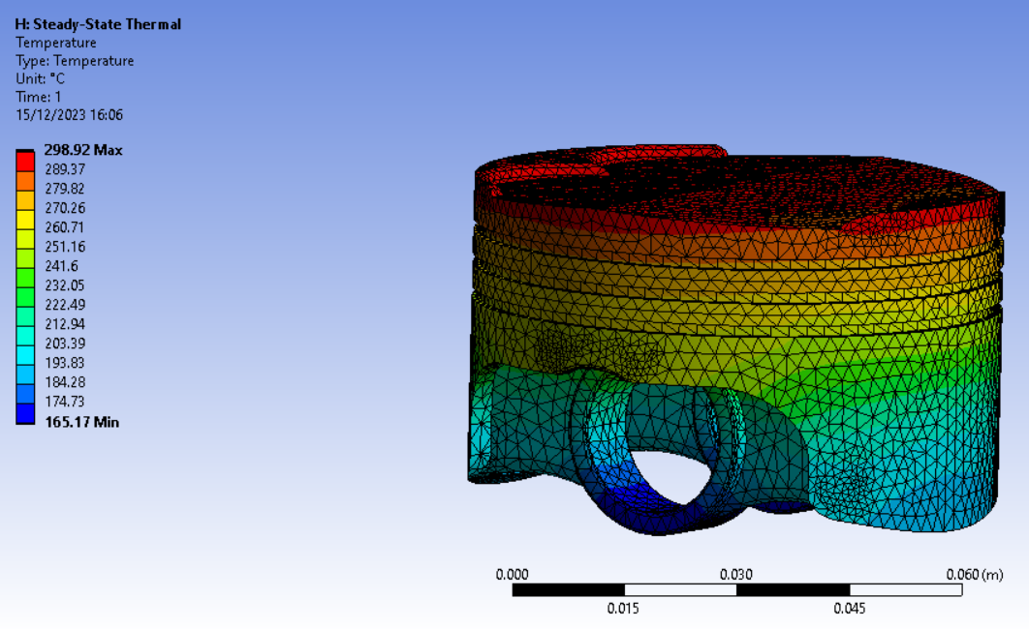
The first iteration differs from the original design by having an enlarged and extended cutout at the bottom, where lower stress levels were noted. This reduced the piston mass to 248.96g.
Figure 32 - Modified Piston Temperature Profile
Figure 32 above displays the modified piston’s temperature profile. Comparing this to the original piston’s temperature profile, it can be observed that the maximum temperature of the piston has decreased by slightly over 2.5°C, whilst the general temperature throughout the entire component has slightly increased, but not by a significant amount.
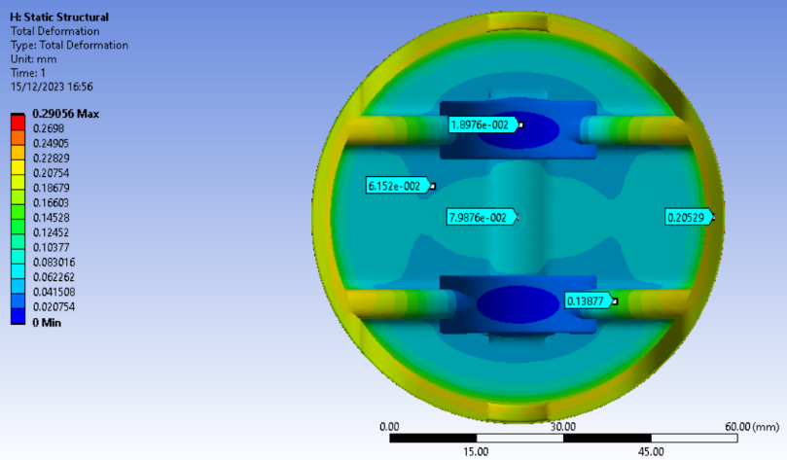
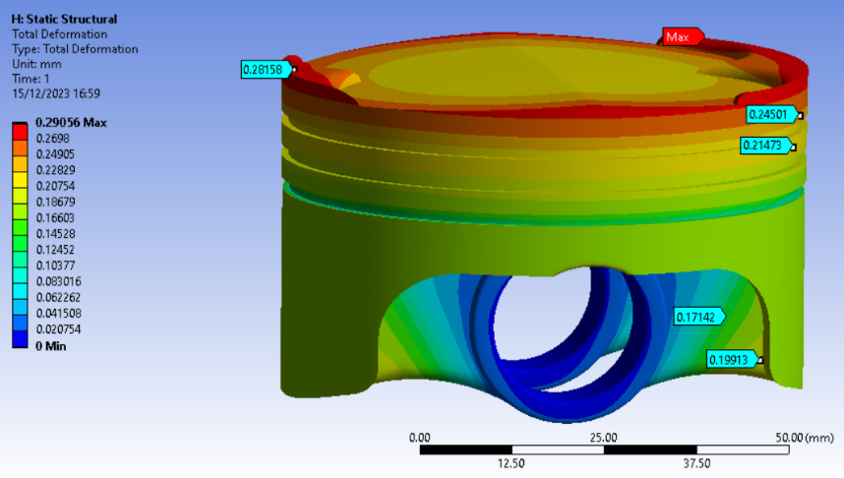
Figure 34 - Modified Piston Deformation Bottom View
Figure 33 - Modified Piston Deformation
Figures 33 and 34 show the deformation of the modified piston. The modifications have resulted in a slight reduction in maximum deformation and a lower deformation across the component. However, assessing the deformation accuracy around the gudgeon pin hole remains challenging due to the fixed support in that area.
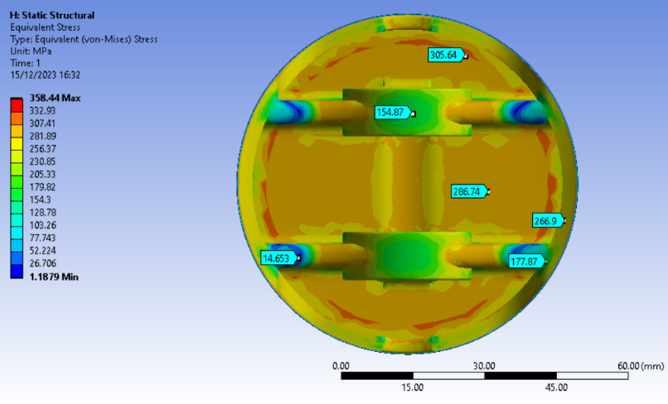
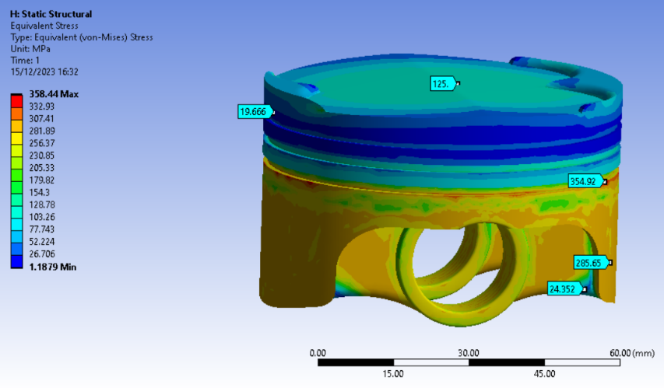
Figures 35 and 36 display the stress distribution in the modified piston. Compared to the original design, the stress pattern on the outer/top is similar, with a slight increase in maximum stress. The bottom view reveals decreased areas of stress, but also orange-coloured areas where the design could be improved upon to reduce stress further. The dark blue regions indicate extremely low-stress areas, suggesting potential for further material reduction.
Figure 36 - Modified Piston Stress Bottom View
Figure 35 - Modified Piston Stress

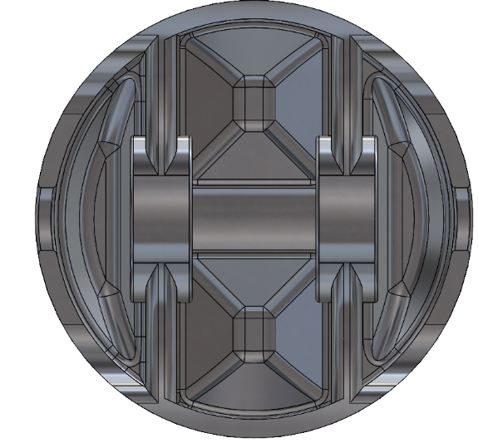
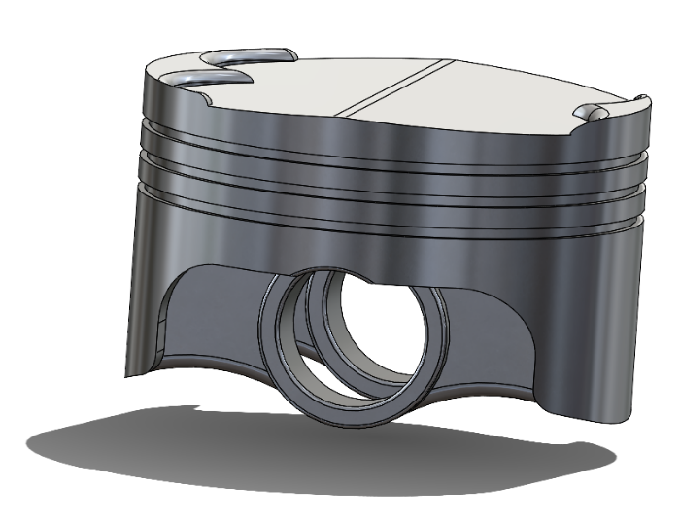
5.2 – Iteration 2
Figure 37 - Further Modified Piston
Figure 38 - Further Modified Piston Bottom View
Figures 37 and 38 showcase the final piston iteration, with major changes being reduced underside mass. This version includes 5mm deep holes (displayed in Figure 39), chamfered and filleted to prevent high-stress concentrations. The cuts are shallow to maintain strength. This iteration reduces the piston weight to 235.08g, achieving a 20.69g reduction overall.
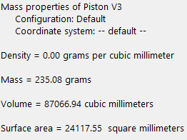
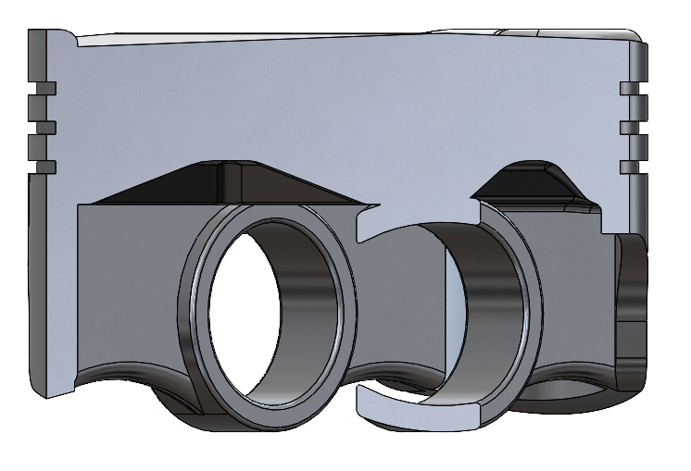
Figure 40 - Further Modified Piston Mass Properties
Figure 39 - Further Modified Piston with a 45° Section View

Comparing FEA study results, notable reductions in maximum inertia forces across piston iterations are displayed: from 4522.6N in the original design to 4379.7N in the second design, and further down to 4135.2N in the final design due to reduced piston mass. These decreases may assist significantly in alleviating stress and deformation in the design.

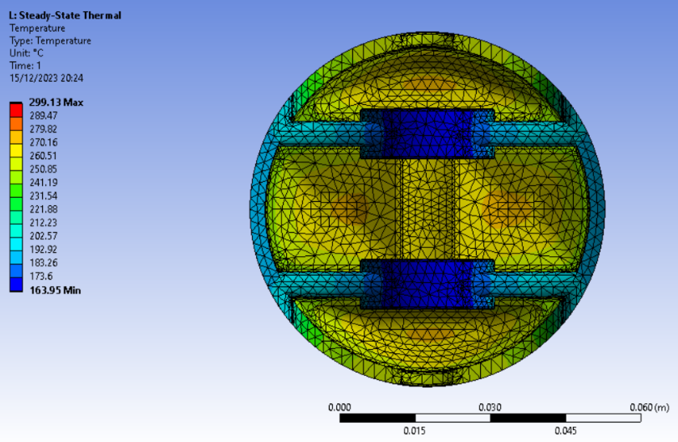
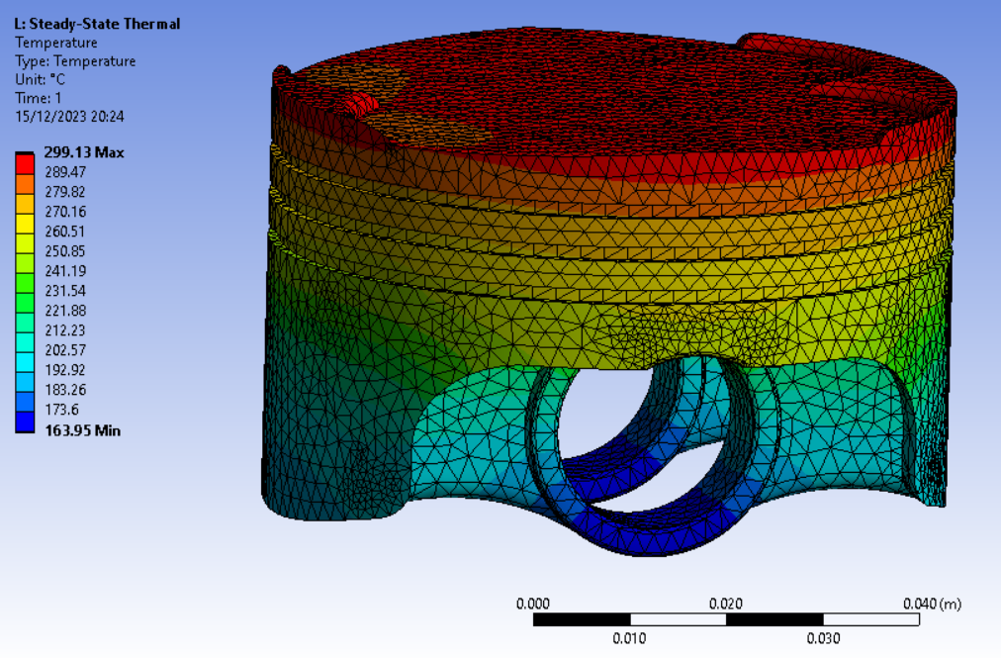
Figures 41 and 42 depict the temperature profile of the final piston design. As expected, a slight temperature increase is observed on the underside where cutouts were made, though not substantially.
Figure 42 - Further Modified Piston Temperature Profile Bottom View
Figure 41 - Further Modified Piston Temperature Profile
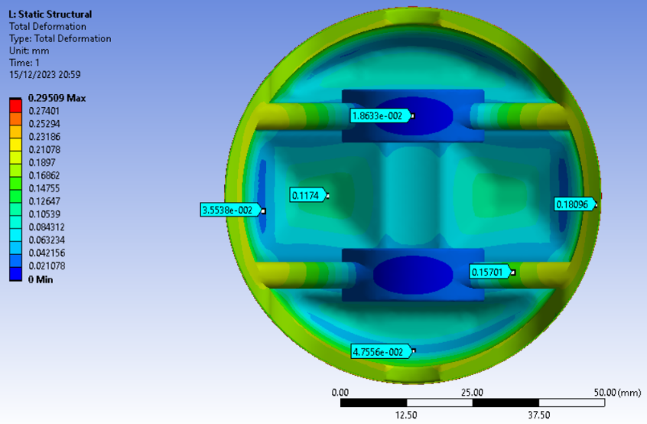
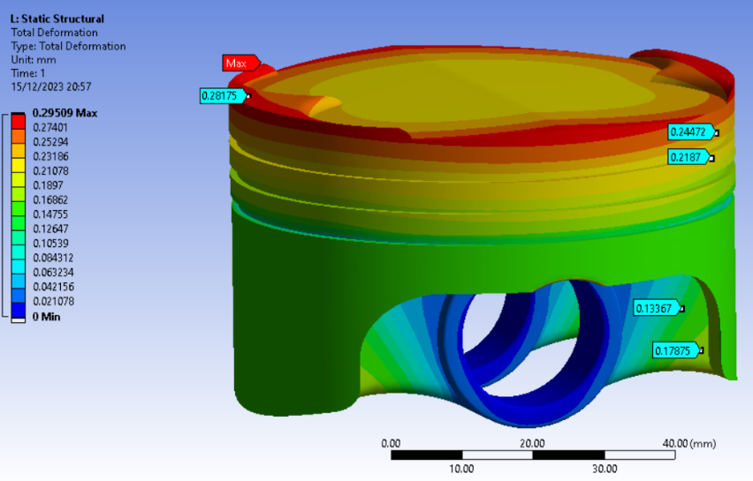
Figure 43 - Further Modified Piston Deformation
Figure 44 - Further Modified Piston Deformation Bottom View

Figures 43 and 44 show that the piston's underside deformation has increased as a result of the cutouts, with maximum deformation rising from approximately 0.0799mm to 0.1174mm, an increase of about 47%. However, this stress is still within acceptable limits. Overall, deformation across the entire component has remained relatively stable, with variations in displayed values primarily attributable to changes in probe position between iterations.
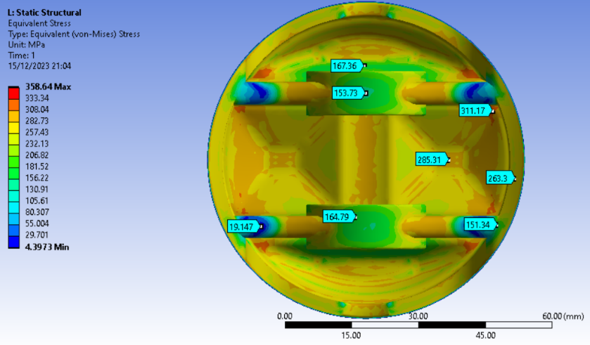
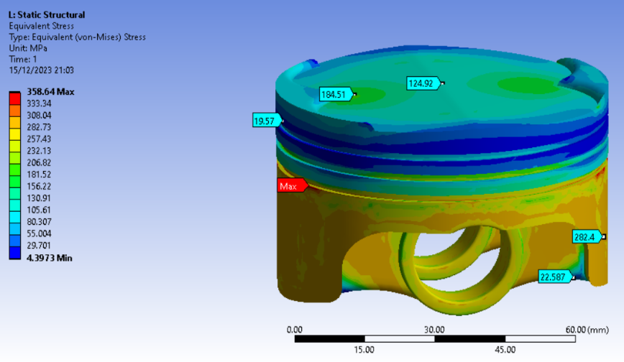
Comparing Figures 45 and 35, there's a notable stress increase in areas of the crown, rising to 184.51MPa from about 124MPa, due to underside cutouts. Figure 46, contrasted with the prior iteration's underside in Figure 36, shows these cutouts significantly lower underside stress, changing most orange areas to yellow and green, and reducing red sections around the perimeter. This is likely a result of more fillets on the underside and lower inertial loads between the piston and gudgeon pin.
Figure 45 - Further Modified Piston Stress
Figure 46 - Further Modified Piston Stress Bottom View

– Conclusion
The study underscores the effectiveness of Computer-Aided Engineering (CAE) tools, particularly Finite Element Analysis (FEA), in the efficient design and testing of components within simulated environments. Despite their utility, these tools have limitations, notably in the assumptions in boundary condition setup and mesh refinement, which can significantly impact results. However, with careful configuration to represent real-life scenarios as much as possible, and treating results as accurate estimations rather than absolutes, CAE becomes a powerful asset. This emphasizes the need for rigorous validation and meticulous simulation preparation.
In the specific context of the piston case study, FEA has demonstrated its value in identifying design improvements efficiently and effectively. It enabled the iterative refinement of the model based on simulation feedback until predetermined objectives were met. The study reveals potential for further enhancements, such as additional material removal and stress/deformation optimization. Overall, CAE tools have proven to be a time and cost-effective approach in component design and testing, reducing the need for experimental testing and thus conserving resources. This conclusion highlights CAE's role not only as a predictive tool but also as a strategy for cost-effective engineering solutions.

- Reference List
Almeida, F.M.P & Completo, A.M.G (2020) ‘Finite Element Analysis of Bone and Experimental Validation’, The Computational Mechanics of Bone Tissue, Lecture Notes in Computational Vision and Biomechanics, Volume 35, Springer, pp. 179-202
Ansys (2021) Workbench User’s Guide, ‘Static Structural’, Canonsburg, PA: ANSYS
Bahari A.R. et al. (2021) ‘Finite Element Modelling and Updating of a Thin Plate Structure using Normal Mode Analysis’, IOP Conference Series: Materials Science and Engineering, Volume 1062
Bari, K. et al. (2017) ‘Forensic Investigation of a failed connecting rod from a motorcycle engine’, Case Studies in Engineering Failure Analysis, Volume 9, Elsevier Ltd., pp. 9-16
Courtney-Pratt, J.S. and Tudor, G.K. (1946) ‘An Analysis of the Lubrication between the Piston Rings and Cylinder Wall of a Running Engine’, Proceedings of the Institution of Mechanical Engineers, Volume 155, no. 1, p.293-299
Dlubal (2017) ‘Verification Example: 0078 – Bimetallic Strip’, Dlubal Software GmbH
Feher, D. et al. (2022) ‘Application of the Finite Element Method for Analysis of Piston Characteristics.’, Machine and Industrial Design in Mechanical Engineering, Mechanisms and Machine Science, Volume 109, Springer, pp. 491-497
Heywood, J. (2018) ‘Internal Combustion Engine Fundamentals’, Second Edition, McGraw Hill, pp. 965-966
Liu, Y. & Glass G. (2013) ‘Effects of Mesh Density on Finite Element Analysis’, SAE Technical Paper, https://doi-org.ezproxy.uwtsd.ac.uk/10.4271/2013-01-1375
Rashmita et al. (2023) ‘Optimization of piston material with aluminium alloy-based metal matrix composites’, Materials Today: Proceedings, https://doi.org/10.1016/j.matpr.2023.09.019.
Young, W. et al. (2012) ‘Roark’s Formulas for Stress and Strain’, 8th Edition, McGraw-Hill Education.

