HND Civil Engineering Environmental management
Geology and Soil Mechanics
Assignment 1

A report focusing on:
Soil Mechanics (practical)

Lecturer: Allan Nantel
Report By: Thomas Hinder (1701670)

Contents

1.0 Sieve Analysis…………………………………………………………….3

1.1 Preparation………………………………………………………………..3
1.2 Equipment……………………….………………………………………...3
1.3 Procedure………………………………………………….....……………3
Figure 1: Securing the set of sieves using the screws………..……………4
1.4 Sieve Results……………………………………………………………..5
1.5 Particle Size Distribution Graph………………………………………...5
Figure 2: Graph to show sieve size percentage against passing…….…….5
1.6 Gradation………………………………………………………………….6
1.6.1 A Dense gradation………………..…………………………………6
1.6.2 Narrow gradation…………………………………………………...6
1.6.3 Gap gradation……………………………………………………….6
1.6.4 Open gradation……………………………………………………..6
1.6.5 Rich gradation………………………………………………………6
1.7 Properties………………………………………..…………………………6
2.0 Atterberg limits……………………………………………………………7

2.1 Plastic limit………………………………………………………………...7

2.2 Liquid limit…………………………………………………………………7
2.3 Shrinkage limit…………………………………………………………….8

2.4 Plasticity index……………………………………………………………8
2.5 Equipment…………………………………………………………………8
Figure 3: Testing equipment…………………………………….………..8
2.6 Liquid limit Procedure……………………………………………………9
Figure 4: Soil after adding water…………………………………………9
Figure 5: Soil sample after the groove been closed half an inch…………...10
2.6.1 Liquid Limit graph…………………………………………………10
Figure 6: Liquid Limit flow chart………………………………………………...10
2.7 Plastic Limit Procedure…………………………………………………11
Figure 7: Using the palm of the hand to roll out the soil……………………..11
Figure 8: The soil starting to crumble………………………………………….11
Figure 9: Placing the samples in the oven……………………………....12
2.8 Liquid and Plastic Limit Results……………………………………….12
2.9 Soil Texture………………………………………………………………13
Figure 10: Triangular graph of Soil Texture…………………………….13
Figures………………………………………………………………………..14
References…………………………………………………………………...14
1.0 Sieve Analysis

The sieve analysis test is the most commonly used practice in civil engineering. This procedure is used to assess the gradation of a soil. A particle size distribution is made by allowing the granular material to pass through a number of sieves with a large mesh size at the top and a smaller mesh size at the bottom and also weighing the amount of soil that has stopped at each sieve.

This soil size distribution is very important to the materials performance when in use. The sieve analysis can be used on any type of organic or non-organic material including soil, granite, clays, sands, crushed rock. This analysis is probably the most common as it is a simple particle sizing technique.

1.1 Preparation

To perform the test there must be a good sample size of the aggregate. For the sample to be prepared all the aggregates should be mixed and then reduced to a size suitable for testing. The sample weight must be given before starting.

1.2 Equipment

- Soil Sample
- Scale Pan
- Scale
- Brush
- Set of Sieves Including Pan
- Mechanical Shaker
- Steel Lock Bar with Plastic Locks

1.3 Procedure

This test is to determine the grain size distribution in a sample of soil. This is important to know as a coarse grained soils like sands and gravels have different properties than fine grain soils like silt and clay. We will need to filter the soil samples through a series of progressively smaller sieves. Sieves are simple metal meshes of a particular size framed by a round rim.

You will need a soil sample of approximately 1kg. To obtain the sample weigh the scale pan first then record the weight with the soil. Place the set of sieves with the sieve at the top being the largest and the sieve at the bottom is the smallest. There are many different sieve sizes available, you will need to make sure that the stack of sieves are correct. Pour the soil sample into the top sieve, secure the stack onto the vibration machine using the two screws and vibrate the soil sample for two minutes.

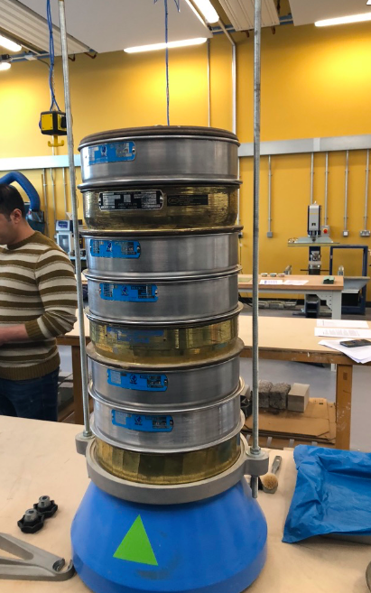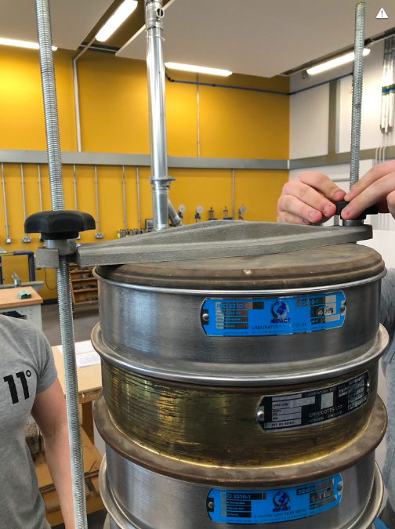

Figure 1: Securing the set of sieves using the screws.

Once the shaker has stopped loosen the screws and remove the stack. One by one carefully remove each sieve. To ensure no material is lost use the brush to remove any particles clinging to the sieve and brush them into the next lower sieve.

Record the retained weight of the aggregate on each sieve to the nearest 0.1g to determine the individual weights. Pour the aggregates regained into the plastic covered tray before carefully transferring the aggregates to the pan on the scale. Record the weight. Repeat this process for the next set of sieves.

This process will be repeated until each weight of material on the sieves have been recorded. For each size of aggregates retainers on the sieves record the percentages to the nearest 0.1%. Be extremely carefully to prevent any loss of material during the test. However if there if there is a small difference which is less than 0.2% between the sum of weights of the sizes and the original dry weight, take the smallest amount as particles passing the smallest sieve and use the original weight. If the difference is larger than 0.2% check the weights again or with a new sample re-run the test to correct the errors.

Plot on the graph sieve size percentage against percentage passing.

1.4 Sieve Results

Sieve Size (mm) |  | Mass (g) | % On Sieve | %Passing
4mm |  | 193.35 | 19.335 | 80.665
2.36mm |  | 188.06 | 18.806 | 61.859
1.6mm |  | 99.15 | 9.915 | 51.944
600um |  | 152.31 | 15.231 | 36.713
300um |  | 148.91 | 14.891 | 21.822
160um |  | 120.20 | 12.02 | 9.802
80um |  | 66.90 | 6.69 | 3.112
Pan |  | 29.85 | 2.98 | 0.127
Total (1kg) | Difference  1,000-0.127=99,873

1.5 Particle Size Distribution Graph

The British Standard for this test is 410-1.

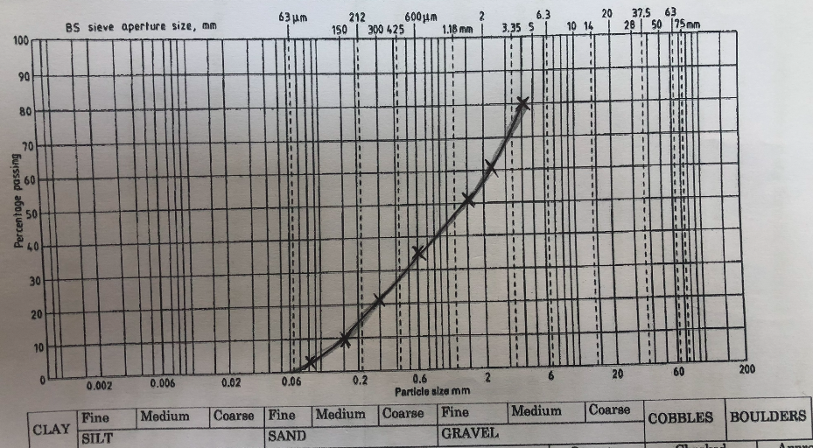

Figure 2: Graph to show sieve size percentage against percentage passing.
1.6 Gradation

1.6.1 A Dense gradation

A dense gradation is a sample that has roughly equal amounts of different aggregate sizes. When there is a dense gradation, the air voids between the soil are filled with particles. A curve on the gradation graph will be the result of this gradation.

1.6.2 Narrow gradation

This gradation is also knows as a uniform gradation. A narrow gradation is a sample that has aggregates roughly the same particle size. The result of this will show a very steep curve on the gradation graph.

1.6.3 Gap gradation

A gap gradation is when a sample doesn’t contain many aggregates in the medium size range with the result of only fine and coarse grained aggregates. On the graph the size range is in the medium with the curve horizontal.

1.6.4 Open gradation

An open gradation is an aggregate sample with hardly any fine aggregate particles which results in air voids because there are no smaller particles to fill them. On the graph the size range is small with a horizontal curve.

1.6.5 Rich gradation

A rich gradation is a soil sample with many of the aggregate particles being small.

1.7 Properties

There are many properties of an aggregate that gets affected by gradation. It affects permeability, physical stability and bulk density. It is possible to achieve low permeability, high physical stability and high bulk density when carefully selecting the gradation. For example with pavement design it is important to have a workable and stable mix with resistance to water. Due to the lack of fine particles with an open gradation the bulk density is low, also the permeability is high and the physical stability is moderate. With a rich gradation, there is a low permeability. Low physical stability and low bulk density. The different gradation can be managed to achieve the correct properties for the particular engineering application.

2.0 Atterberg limits

The Atterberg limit is a measure of the water content within a soil, its plastic limit, its liquid limit, and shrinkage limit. This is the water content at the point soil changes from one state to another. Swedish agriculturists Albert Atterberg was the creator of these limits in 1911 but was later refined by Arthur Casagrande.

Soils for engineering use are mainly based on properties for foundation support or how they may perform in earthworks and under pavements.

When a moisture content of a clay soil increases its consistency changes. The four states of consistency are solid, semi solid, plastic, and liquid. Each of these states is a change in strength, behaviour and consistency and the Atterberg Limit test can accurately pin point where the physical changes occur using moisture content.

Some soils when wet expand in volume as well as retain water. Expansion of a soil is down to the ability of a soil to take in water. Clayey and silty soils are mainly used for these test as due to moisture content they expand and shrink. As clays and silts react with water they have a varying shear strength and they change sizes

These test are mainly used at the preliminary design stage of a structure to ensure the shear strength of a soil is at the correct amount and there is not much change in the volume as with different moisture contents it can shrink and expand.

The knowledge of these values helps to predict behaviour of soils in embankments and fills and also foundation design. These values is also beneficial to estimate prediction of settlement, shear strength and permeability, and to identify of potentially expansive soils.

2.1 Plastic limit

To determine the plastic limit of a sample a fine thread of the sample is rolled out on a flat, non-porous surface. If the soils moisture content is at a plastic behaviour, the thread will keep its shape down the a very small diameter. The test can be repeated after the sample has been remoulded. The thread will begin to break apart when the diameter is large due to the moisture content falling because of evaporation.

Where the thread brakes apart at a diameter of 3.2mm, the plastic limit of the soil is defined as the moisture content. At any moisture possible if the thread cannot be rolled out down to 3.2mm the soil is then considered non-plastic.

2.2 Liquid limit

The liquid limit of a soil is when water contents behaviour of a clayey soil changes from a plastic to a liquid. However over a range of water contents the change in behaviour from plastic to liquid is gradual. Also the shear strength of the liquid limit soil is not actually at zero.

2.3 Shrinkage limit

Shrinkage limit is when there is loss of moisture in the water content there will not be any more volume reduction. The shrinkage limit is not as commonly used as the plastic and liquid limits.

2.4 Plasticity index

Plasticity index is range of water content where the soil leave plastic properties. Plasticity Index is the liquid and plastic limit (Plasticity Index = Liquid Limit – Plastic Limit). Soil with high plasticity index are the clays where as those with low plasticity index are the silts. Those with a plasticity index of 0 they have neither silt or clay and are non-plastic.

2.5 Equipment

- Casagrande apparatus
- Spatula
- Grooving tool
- Moisture cans
- Soil specimen
- Water bottle
- Scale
- Oven
- Glass plate

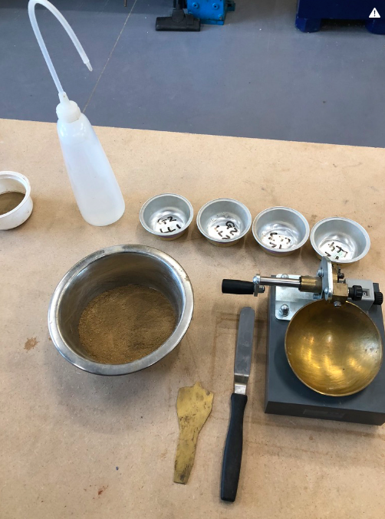

Figure 3: Testing equipment.
2.6 Liquid limit Procedure

In order to produce the flow curve four liquid limit test must be conducted. One test between the blow count of 10 – 20, another between the blow counts 20 – 30, a third between the blow counts 35 – 45, and finally one between 50 – 60. As the soil dries out the moisture content is reduced, this results in a stiffer soil.

To perform the liquid limit test weigh out about 150g of the passing air dry soil. Add 20% of water from the water bottle and mix thoroughly until it appears uniform and the surface looks creamy. Determine and record the weights of the four moisture cans.

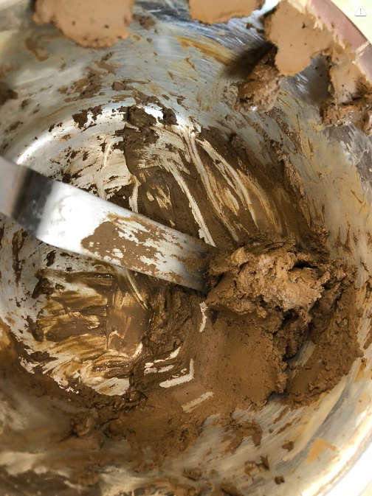

Figure 4: Soil after adding water

The Casagrande Apparatus is easily knocked out of calibration so it’s important that calibrate the devise often.

Evenly spread a moderate amount of soil into the cup to make a soil pad. Using the grooving tool create a straight groove through the centre of the soil pad. The shoulders of the grooving tool should just scrape the surface of the soil pad. If the shoulders does not contact the soil pad surface too little soil has been placed in the cup and the test should be restarted. Once the groove has been made rotate the handle 120 revolutions per minute (2 cycles per second) and count the number of blows it takes to close the groove in the soil pad by half an inch. Scoop out some of the soil and place in one of the pre weighed moisture cans and weigh the new weight of the can for moisture content determination. Place the can with the soil in the oven and reweigh it again in 24 hours.

If the number of blows falls below mix the soil to dry it out, clean and dry the cup and repeat the test. If the number of blows above, add moisture to the soil, mix it, clean and dry the cup and re test. Repeat the procedure to get test between 10 – 20, 20 – 30, 35 – 45, and 50 – 60.
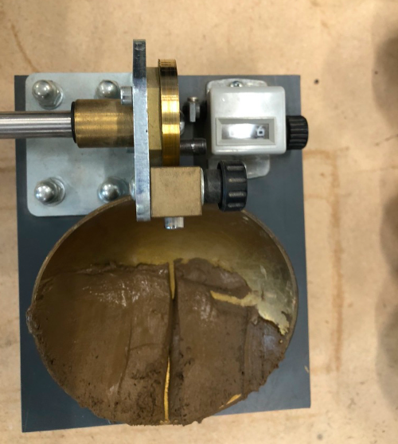

Figure 5: Soil sample after the groove been closed half an inch

Plot the moisture content versus blow counts and determine the liquid limit from the flow chart. With the moisture content plotted on the vertical axis and the blow counts plotted on the horizontal axis and log scale a linear regression can be established through the data and the liquid limit can be interpolated.

2.6.1 Liquid Limit graph

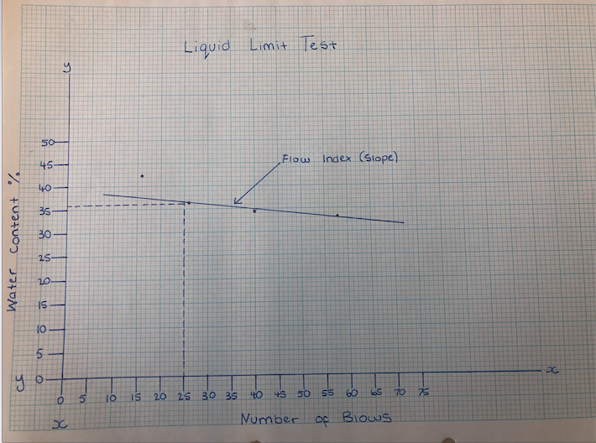

Figure 6: Liquid Limit flow chart.
This graph shows that at the blow count of 25 the liquid limit is at 36%.

2.7 Plastic Limit Procedure

The Plastic limit is the average of the moisture content when the soil starts to crumble when it is being rolled into a 3 millimeter thread. Take a 25 to 30 gram sample and spread it out on the glass plate to dry it out. When it gets to a workable state start rolling the soil into a thread. Roll the soil until the diameter of the soil is reduced to 3mm. The metal rod can be used as a gage to determine whether the soil has reached the 3mm diameter. If the soil does not crumble when rolled down to 3mm further dry out the soil and try again. Once the soil crumbles at 3mm collect samples of the crumbling soil and place them in the pre weighed moisture cans.

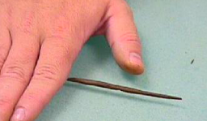

Figure 7: Using the palm of the hand to roll out the soil.

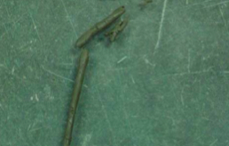

Figure 8: The soil starting to crumble
Repeat the test a second and third time. Record the wet weights of the moisture content samples and place in the oven. Re weigh the samples again in 24 hours. The average of the moisture contents is the Plastic Limit.

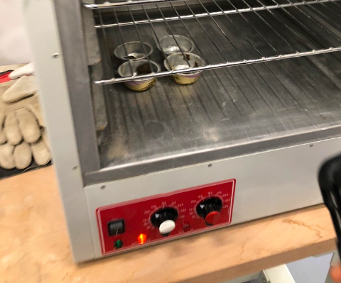

Figure 9: Placing the samples in the oven

2.8 Liquid and Plastic Limit Results

 | 1 | 2 | 3 | 4 | 5 | 6 | 7
Type of test | LL | LL | LL | LL | PL | PL | PL
Container Number | 1 | 2 | 3 | 4 | 1 | 2 | 3
Weight of wet soil + Container | 12.65 | 13.05 | 17.30 | 16.74 | 6.65 | 7.46 | 12.07
Weight of dry soil + Container | 10.52 | 10.57 | 14.06 | 13.71 | 6.36 | 6.85 | 10.41
Weight of Container | 4.71 | 4.71 | 4.71 | 4.69 | 4.72 | 4.74 | 4.81
Weight of Moisture | 2.13 | 2.48 | 3.24 | 3.03 | 0.29 | 0.61 | 2.29
Weight of dry soil | 5.81 | 5.86 | 9.35 | 9 | 1.64 | 2.11 | 5.6
Moisture Content | 36.6 | 42.3 | 34.6 | 33.4 | 17.6 | 28.9 | 40.9
Number of Blows | 26 | 16 | 40 | 58 | n/a | n/a | n/a

Plastic Limit is the average of all 4 moisture contents.

17.6 + 28.9 + 40.9
------------------------- = 29.13%
3

Plasticity Index is the Plastic Limit – Liquid Limit = 6.87%

2.9 Soil Texture

The textual Classification of soil is based on the distribution of grain size and is arranged into three groups. They are sand, silt and clay. As our sample is not suitable for this soil identification there is no need for this.

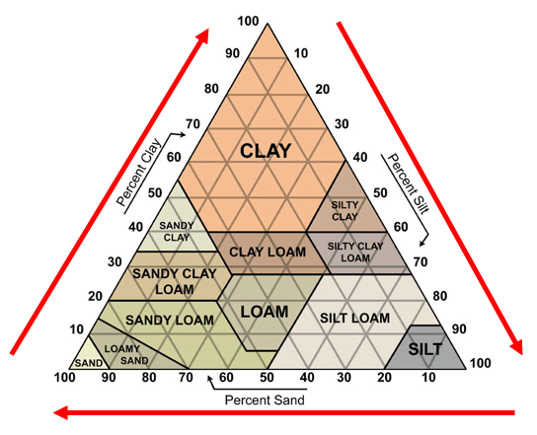

Figure 10: Triangular graph of Soil Texture

Particles are:

- Clay: less than 0.002mm
- Silt: 0.002mm – 0.063mm
- Sand: 0.063mm – 2mm

Figures

- Figures 1 – 9 are my own photos I took in the lab.

- Figure 10: Triangular graph of Soil Texture

(30/11/2016). Soil Texture: Sand, Silt and Clay. Retrieved from https://thinkingcountry.com/2016/11/30/soil-texture-sand-silt-and-clay/

References

Gilson. (2019). Atterberg Limits: A Quick Reference Guide. Retrieved from https://www.globalgilson.com/atterberg-limits-a-quick-reference-guide

(02/06/2012) Atterberg Limit Tests (LL and PL). Retrieved from https://www.youtube.com/watch?v=EcXJ961qjGA

(04/06/2012). Particle Size Analysis (Sieves and Hydrometer). Retrieved from https://www.youtube.com/watch?v=QqxfwpUtEoQ

Basic Civil Engineering. (04/07/2015). Atterberg Limit Test Soil Mechanics. Retrieved from http://www.basiccivilengineering.com/2015/07/atterberg-limit-test-soil-mechanics.html

(30/11/2016). Soil Texture: Sand, Silt and Clay. Retrieved from https://thinkingcountry.com/2016/11/30/soil-texture-sand-silt-and-clay/

