Student Name: Sabina Kauser
Student Number: 2212416
Lecturer Name: Chloe Harries
Module Code: BMHP6020_BIRM
Changemakers: Independent Project

Element 2&3

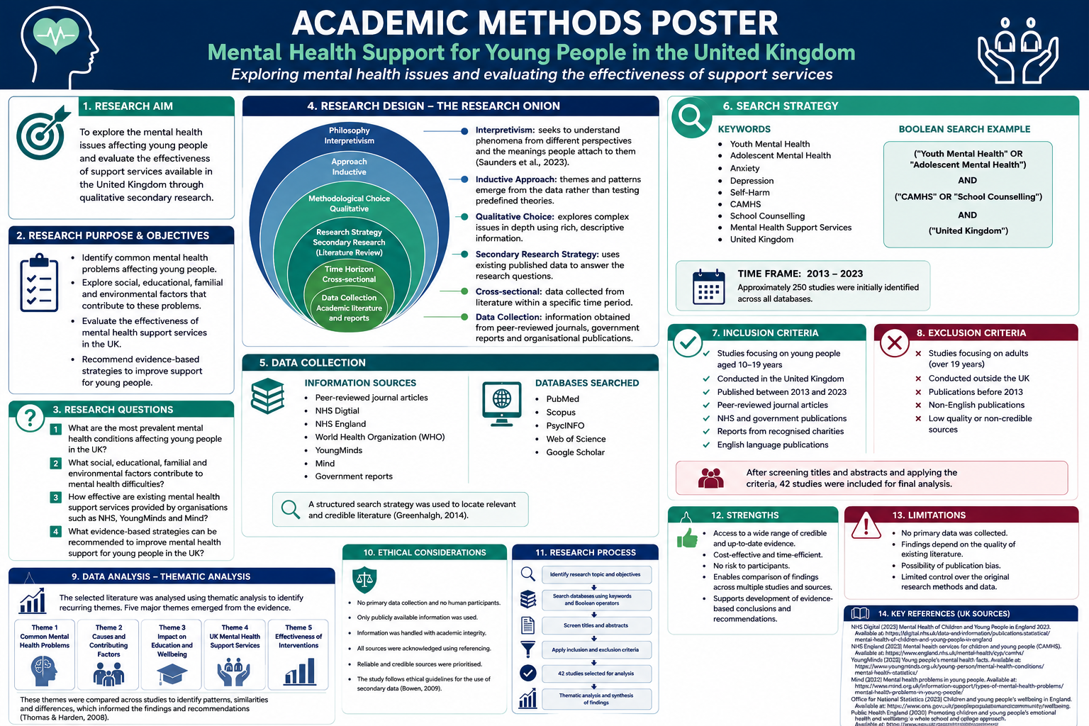

Chapter 3: Methodology
3.1 Introduction
This chapter explains the research methodology used to investigate mental health support for young people in the United Kingdom. It outlines the research approach, research design, search strategy, inclusion and exclusion criteria, data analysis method, ethical considerations, and the limitations of the study. The methodology was carefully selected to ensure the research was
Criteria | Inclusion | Exclusion

Population | Young people aged approximately 10–19 years | Adults over 19 years unless included for comparison

Location | Studies conducted in the United Kingdom | Studies conducted outside the UK unless internationally recognised

Publication Type | Peer-reviewed journal articles, NHS publications, government reports and recognised charity reports | Opinion articles, blogs, newspapers and unpublished research

Language | English | Non-English publications

Publication Date | 2013–2024 | Studies published before 2013 unless considered seminal literature

Topic | Youth mental health, anxiety, depression, self-harm, CAMHS, school mental health and early intervention | Studies unrelated to adolescent mental health or support services
, reliable and appropriate for answering the research aim and objectives.

3.2 Research Approach and Design
This study adopted a qualitative secondary research design. Secondary research involves collecting and analysing existing information rather than gathering new data directly from participants (Bowen, 2009). This approach was considered appropriate because the study aimed to examine existing evidence on mental health support for young people rather than investigate personal experiences through interviews or questionnaires.
A qualitative approach was chosen because it allows for a detailed exploration of published research, government reports and policy documents. Unlike quantitative research, which focuses mainly on statistical analysis, qualitative research enables a deeper understanding of the factors influencing young people's mental health and the effectiveness of support services (Greenhalgh, 2019). This approach also allows findings from different studies to be compared and interpreted to identify common themes and evidence gaps.
Secondary research was particularly suitable because it provided access to a wide range of reliable information from peer-reviewed journals, NHS publications, government reports and recognised mental health organisations such as YoungMinds and Mind. It also avoided the ethical challenges of collecting primary data from children and young people, who are considered a vulnerable population. Although secondary research offers many advantages, it also has limitations. The researcher has no control over how the original studies were conducted, and differences in research methods or sample characteristics may affect comparisons between studies. To reduce these limitations, only credible and up-to-date sources were included within the review.
3.3 Search Strategy
A structured literature search was undertaken to identify relevant studies and policy documents relating to mental health support for young people in the United Kingdom. Electronic databases including PubMed, Scopus, PsycINFO, Web of Science and Google Scholar were searched because they contain peer-reviewed literature within healthcare, psychology and social sciences.
Grey literature was also included to ensure the research reflected current UK policy and practice. This included publications from NHS England, NHS Digital, the Department of Health and Social Care, Young Minds, Mind and the Children's Commissioner for England.
The following keywords and Boolean operators were used:
- "Young people" OR "adolescents"
- "Mental health" OR "mental wellbeing"
- "Anxiety" OR "depression" OR "self-harm"
- "Mental health services" OR "CAMHS"
- "School counselling"
- "United Kingdom" OR "UK"
The search was limited to English-language publications published between 2013 and 2024 to ensure that the findings reflected recent evidence, policies and service developments. Reference lists of key articles were also examined to identify additional relevant studies.
3.4 Inclusion and Exclusion Criteria
To improve the quality and relevance of the literature review, predefined inclusion and exclusion criteria were established.
Inclusion criteria
- Studies focusing on young people aged approximately 10–19 years.
- Research undertaken within the United Kingdom.
- Peer-reviewed journal articles.
- Government reports and NHS publications.
- Publications from recognised mental health charities.
- Studies examining anxiety, depression, self-harm or mental health support services.
- English-language publications published between 2013 and 2024.
Exclusion criteria
- Studies focusing primarily on young people and adults.

- Research conducted outside the UK unless widely recognised internationally.
- Opinion articles without supporting evidence.
- Publications lacking clear methodology or credibility.
- Duplicate studies.
3.5 Data Analysis
The selected literature was analysed using thematic analysis, which is widely used in qualitative research to identify recurring patterns and themes across multiple sources (Thomas and Harden, 2008).
After reviewing the selected literature, the findings were organised into several key themes:
- Common mental health conditions.
- Factors contributing to poor mental health.
- The impact of mental health on young people's wellbeing.
- Current UK mental health support services.
- Barriers to accessing support.
- Recommendations for improving mental health services.
Using thematic analysis enabled similarities and differences between studies to be identified while supporting a critical evaluation of the existing evidence.
3.6 Ethical Considerations
Although this study did not involve direct contact with participants, ethical principles remained important throughout the research process.
Only credible and trustworthy sources were used, including peer-reviewed journal articles and official publications from NHS organisations, government departments and recognised charities. All information was paraphrased appropriately and referenced using the Harvard referencing system to avoid plagiarism and acknowledge the work of original authors.
No confidential or personal information was collected because all data were obtained from publicly available sources. Consequently, formal ethical approval was not required. Nevertheless, the research was conducted honestly, objectively and in accordance with accepted academic standards.
3.7 Reliability and Limitations
Using evidence from multiple high-quality sources increased the reliability of the findings by allowing information to be compared across different studies and organisations. Including peer-reviewed research alongside government reports also strengthened the credibility of the evidence.
However, several limitations should be acknowledged. Secondary research depends on previously published information, meaning the researcher cannot verify how the original data were collected. Some studies also used different research methods and participant groups, making direct comparison more difficult. Furthermore, rapidly changing mental health policies and service developments mean that newer evidence may become available after completion of this dissertation.
Despite these limitations, the systematic search strategy, predefined selection criteria and use of recognised sources helped ensure that the findings presented in this dissertation are reliable and relevant.
.

References

Mars, B., Heron, J., Klonsky, E.D., Moran, P., O'Connor, R.C., Tilling, K., Wilkinson, P. and Gunnell, D. (2019) ‘Predictors of future self-harm among adolescents’, The Lancet Psychiatry, 6(7), pp.573–581.
Mental Health Foundation (2022) Children and Young People's Mental Health. London: Mental Health Foundation.
Mind (2023) Children and Young People's Mental Health. London: Mind.
NHS Digital (2023) Mental Health of Children and Young People in England 2023. Leeds: NHS Digital.
NHS England (2019) The NHS Long Term Plan. London: NHS England.
NHS England (2023) Children and Young People's Mental Health Services. London: NHS England.
Office for National Statistics (2023) Exploring the UK's Digital Divide. Newport: Office for National Statistics.
Odgers, C.L. and Jensen, M.R. (2020) ‘Annual Research Review: Adolescent mental health in the digital age’, Journal of Child Psychology and Psychiatry, 61(3), pp.336–348.
Patel, V., Flisher, A.J., Hetrick, S. and McGorry, P. (2007) ‘Mental health of young people: A global public-health challenge’, The Lancet, 369(9569), pp.1302–1313.
Reiss, F. (2013) ‘Socioeconomic inequalities and mental health problems in children and adolescents: A systematic review’, Social Science & Medicine, 90, pp.24–31.
Singh, S.P., Paul, M., Ford, T., Kramer, T. and Weaver, T. (2010) ‘Transition from child to adult mental health services: The challenge of continuity of care’, British Journal of Psychiatry, 197(4), pp.305–312.
Thomas, J. and Harden, A. (2008) ‘Methods for the thematic synthesis of qualitative research in systematic reviews’, BMC Medical Research Methodology, 8, 45.
Twenge, J.M. and Campbell, W.K. (2018) ‘Associations between screen time and lower psychological well-being among children and adolescents’, Preventive Medicine Reports, 12, pp.271–283.
World Health Organization (2022) World Mental Health Report: Transforming Mental Health for All. Geneva: World Health Organization.
YoungMinds (2023) Young People's Mental Health. London: YoungMinds.
Department of Health and Social Care (2019) NHS Long Term Plan.
National Institute for Health and Care Excellence (NICE) (2013) Social and Emotional Wellbeing for Children and Young People (QS31).
National Institute for Health and Care Excellence (NICE) (2022) Depression in Children and Young People: Identification and Management (NG134).
National Institute for Health and Care Excellence (NICE) (2019) Depression in Children and Young People: Identification and Management (updated guideline).

Bowen, G.A. (2009) ‘Document analysis as a qualitative research method’, Qualitative Research Journal, 9(2), pp. 27–40.
Braun, V. and Clarke, V. (2006) ‘Using thematic analysis in psychology’, Qualitative Research in Psychology, 3(2), pp. 77–101.
Bryman, A. (2021) Social Research Methods. 6th edn. Oxford: Oxford University Press.
Creswell, J.W. and Creswell, J.D. (2023) Research Design: Qualitative, Quantitative, and Mixed Methods Approaches. 7th edn. Thousand Oaks, CA: Sage.
Google Scholar (2026) Google Scholar. Available at: https://scholar.google.com (Accessed: 22 July 2026).
National Institute for Health and Care Excellence (NICE) (2025) Mental health: NICE guidance and quality standards. Available at: https://www.nice.org.uk (Accessed: 22 July 2026).
NHS England (2025) Mental health services. Available at: https://www.england.nhs.uk/mental-health/ (Accessed: 22 July 2026).
PubMed (2026) PubMed. Available at: https://pubmed.ncbi.nlm.nih.gov (Accessed: 22 July 2026).
Saunders, M., Lewis, P. and Thornhill, A. (2023) Research Methods for Business Students. 9th edn. Harlow: Pearson.
Thomas, J. and Harden, A. (2008) ‘Methods for the thematic synthesis of qualitative research in systematic reviews’, BMC Medical Research Methodology, 8(1), p. 45.

