

Assessment 1 – Reading Task Template
Upload your photo of your A3 in-class notes here:
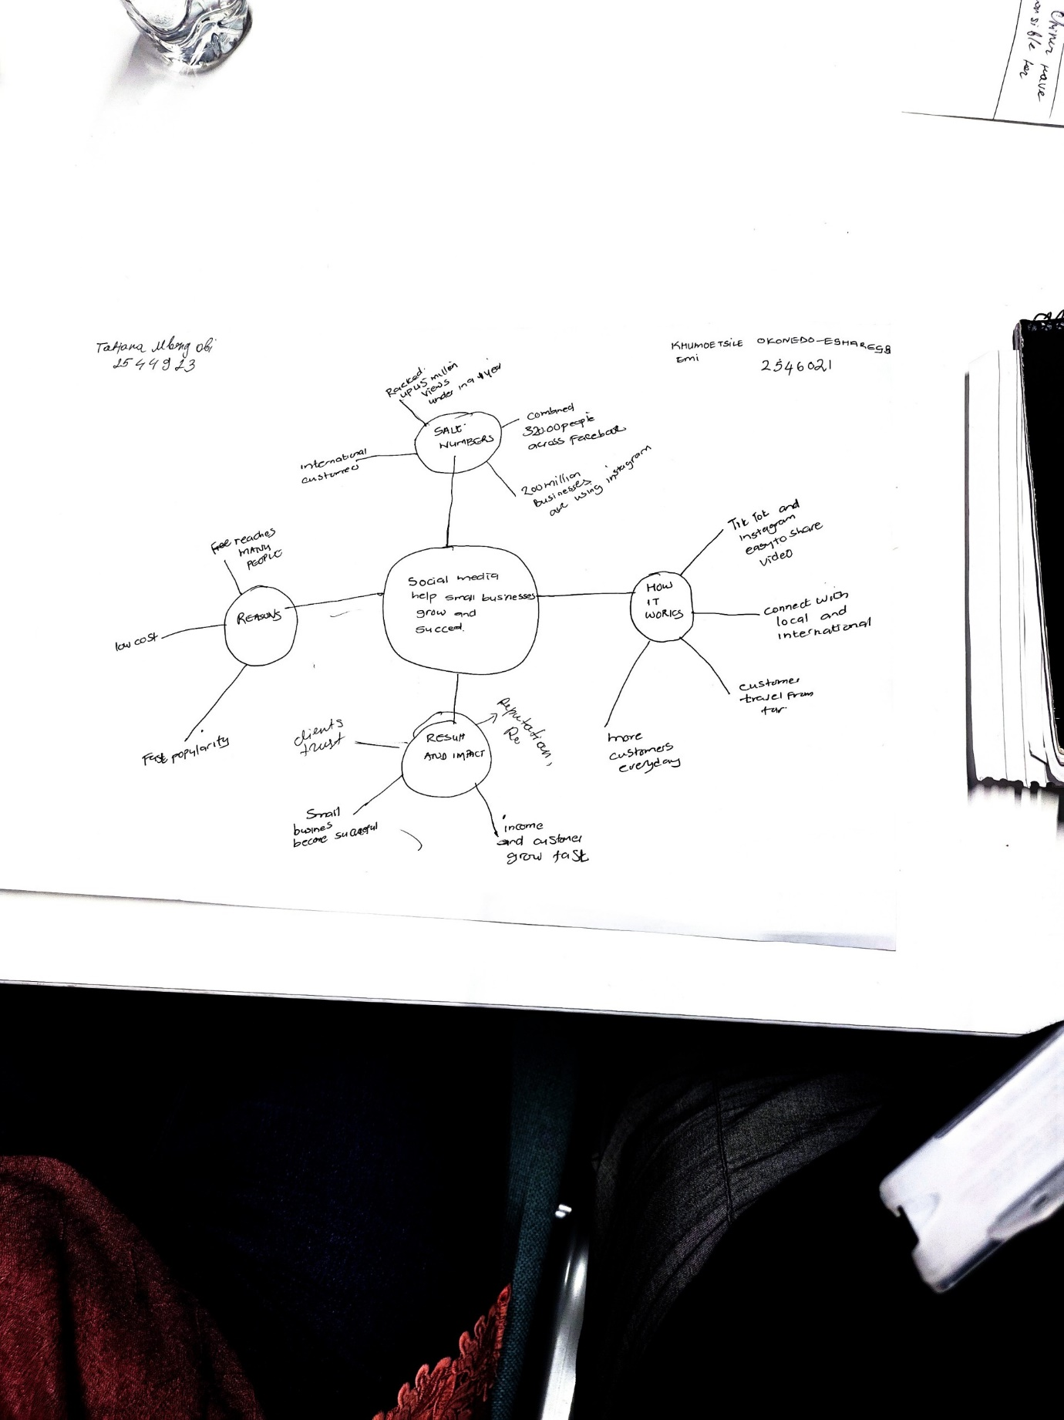

1. Answer these questions using the sentence starters below
a. What is the main idea of the text?
The main idea is that social media helps small businesses to grow very quickly.
These include videos from Instagram, TikTok and Facebook
It increases sales in small business-such as Binley Mega Chippy of tenfold
It increases patronage of local and internation customers. Chantel Island and Cyprus
b. What are two key points?
One key point is that it grows patronage for businesses and referrals through brand awareness. Faye Martins work, sharing videos in TikTok, Facebook and Instagram
Another key point is
Ben Neman’s jacket potato stall besieged with customers.
c. What part of the text did you find most important? Why?
The most important part is that Social media useage help business to grow especially small businesses. This includes:
45 million viewers in less than a year
320,000 Facebook followers
1.5 million UK businesses are using instagram
Why
Customers travelling 4-5 hours to patronise business
Increased sales for small business.
Allows internation business with customers.
d. Was anything unclear or difficult to understand?
I was not sure skimming and scanning.
e. How did your group help you understand the text better?
My group helped me by sharing ideas with me and made it easier for me.
2. One sentence reflection
Question: What did you find challenging about this task?
The hardest part was interpretation of BBC publication.

