Dimensional Modelling / ETL

Northwind Incremental ETL Plan

The relational diagram below (figure 1) shows the structure of the new Northwind data warehouse’s order star schema.

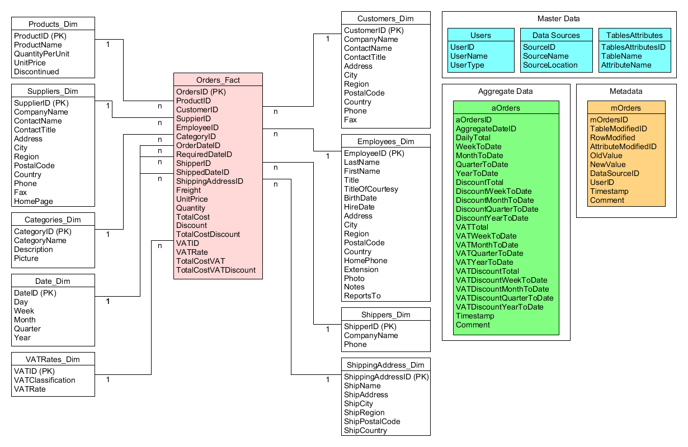
Figure 1: Northwind data warehouse ‘Orders’ star schema

The plan for the initial build of the data warehouse has been completed, and the data has been cleaned ready to be loaded into the new schema. The next problem is to develop a further ETL plan for the incremental update of the new system. Your task is to generate the initial sketch of the process that will be needed. The structure of the source systems is given in figure 2 (over).

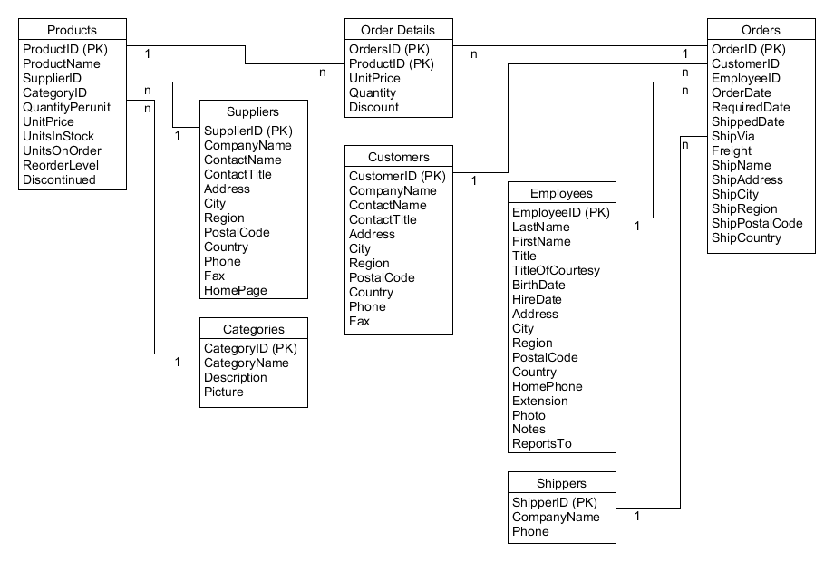

Questions
- Identify the data dependencies for the incremental build process. You will need to consider the following things:
  - Which source tables feed data into which data warehouse tables?
  - How do you identify the data that needs to be transferred every night?
  - Which data warehouse tables need to be linked together using foreign keys?
  - When do you need to create a record in the metadata table?
  - When do you need to create a record in the aggregate data table?
- Create a diagram showing the flow of data between the tables.
- Use the diagram to identify the main phases required for the incremental build operation.

An UMLet starter file for the diagram is available on Moodle, as is the full initial build ETL plan.

