Advanced Cybersecurity
Research, Analysis and Synthesize a solution to a potential real life scenario

Lauren Davies
1805950
Contents
Abstract 3
Introduction 3
Part 1: Research 5
Seyfather Shaw: Ransomware Attack 6
Conclusion 6
Telegram Hijack attack 7
Conclusion 8
Analysis of Lab Exercises 9
Phishing 9
Prevention Methods 11
Parameter tampering 12
Prevention Methods 12
Synthesize A Solution To A Potential Real-Life Scenario 13
Conclusion 15
Part A: 15
Part B: 15
References 16

Abstract
This research project is aimed towards cyber-attacks that have happened in recent months along with carrying out a more in-depth investigation towards two specific attacks that have been carried out in Cybersecurity lab environments. While the provided introduction details the surge of cyber-attacks due to the current pandemic with use of malware against WHO and other business firms and which country has suffered the most with the plague of cybercriminals.
The first element of this research is regarding two recent cyber-attacks, which lists the motive, the method used by the hackers along with the weak point of the organisations system which was found. A focus of this element of the research is to analyse the attacks from other perspective points and then apply it to a scenario which would make a successful attack.

After the research element of the assignment is using previous cybersecurity labs in order to design counter measures against cyber attacks using a software of choice and discuss what tools would be deployed in order to bulk up the security to defend the systems in use.

Introduction
During 2020 whilst the pandemic was happening there was an excessive surge of use on the internet due to everyone beginning to work from home, following this an increase of cyber attack reports which cases were doubled in comparison to 2019 and causing high amounts of damage to organisations systems and gathering ‘secured’ data stored on servers. As reported by WHO, and further detailed within the research aspect of this assignment, there was and still is a vast amount of cybersecurity attacks against firms within the health sectors that are aiding research on COVID-19. Further detailed is the most popular cyberattack used in 2020, being Phishing attacks, while the country that suffered more direly than others was America.

Behind these attacks are usually a group of individuals who work together in order to cause large scale Ddos and most often hacking to disrupt a multitude of services. In the cyber world there are different types of hackers, ethical and unethical. Ethical hackers, also known as ‘White Hats’, are often hired in order to apply their knowledge to help secure and improve the networks of organisations around the world, their services are needed to hunt for any possible vulnerabilities such as any back doors that could be accessed by hackers leading to a security breach, once they have identified any possible areas of concern and make a report of their findings in order to improve them.

On the other hand, Ethical hacking leads to unethical hackers who are often referred to as ‘Black Hats’, unlike the ethical hackers, target organisations with them being unaware and look for all sorts of vulnerabilities in order to gain access to damage by using malware or even placing a virus onto the network, the hackers most often steal information on their networks [3].

Lastly there are ‘Grey Hats’, these types of hackers often hold a combination of aspects from both ‘White’ and ‘Black’ hats. These types of hackers will sometimes hunt vulnerabilities with organisations systems and not gain permission from them, once they have found these vulnerabilities, the hacker will typically aim to get a reward for finding these flaws. If the organisation were to decline giving them this reward or just not respond the hacker will typically end up exploiting those vulnerabilities out of spite. Even if they do receive a reward, due to them not receiving permission to access the systems their work is considered illegal, just like the work of the ‘Black Hats’, even if they do manage to aid organisations to improve and get rid of any vulnerabilities in a system [3].

Part 1: Research
In organisations today the internet is heavily relied on along with other services such as the cloud, to have remote access to documents needed for work, with this video communications, due to the ongoing global pandemic all services which provide remote access and allow the businesses to interact with their employees face to face due to the ‘ban’ of human interaction.
The pandemic has led to an increase of cybercrimes, due to sensitive information now also being stored on employees' home devices, during the pandemic alone there has been a vast increase of attacks by 238% most of these attacks being aimed at banks, firms have seen 80%. The most popular cyberattack of this year that has taken a sharp increase of 600% is Phishing attacks since the pandemic had begun back in February [4]. There has been a statement made by WHO (World Health Organisation) which has stated that over 450 of staff email addresses and passwords have been leaked and targeting those who are working on the Coronavirus response, meaning that cyber-attacks are becoming more aggressive and are not just putting brand organisations at risk.
In this part of the assignment, two cyber-attacks which have happened this year (2020), and what the attackers were trying to achieve along with how they were able to get access to the business’s secure servers. Both of these reported incidents will be looked into by using resources which holds reports about the events, by using the information provided by various sources, a discussion of how these organisations can implement security to prevent these attacks.

Seyfather Shaw: Ransomware Attack
Seyfarth Shaw is a law firm based in Chicago, Illinois, with 900 lawyers as employees and 19 offices scattered in the US. On October 10th, 2020, they were faced with a malware attack which was described as ‘sophisticated and aggressive’ but also appeared to be ransomware. The company stated that their implemented monitoring systems had detected unauthorized activity on the network which the IT team had been made aware of and had tried to minimize the spread from the attackers causing further damage [5]. Like most ransomware attacks, cybercriminals use the software against firms that will have important sensitive information in order to get a substantial profit from the suffering systems, as of late statistics have shown that the demands from ransomware have increased from amounts around $2,000 up to $200,000 during the pandemic which is a great increase in comparison to previous years.
The hackers of this ransomware attack were trying to obtain a pay-out from the Seyfarth law firm, but the company was not certain if the attackers were able to gather any of their clients details or if they had deleted the files. Despite their IT team finding no trace of evidence if the client’s details had been tampered with or if any of the firms’ internal information had been accessed or removed due to the computer systems being heavily encrypted, they were eventually forced to shut down all the servers to further prevent spread of damage as a ‘precautionary measure’ [6]. The law firm has since provided updates stating that they have been unable to bring their systems back online due to the possible spread happening again but are working with the FBI to locate the culprits, the IT team were continuing to fix the issues. Although there are no reports stating what the hackers were after, hackers always pursue organisations which are most likely to have the most sensitive information available in order to reap and gain more lucrative pay-outs.

Conclusion
After further investigation of the attack carried out on this firm, it was stated by law news outlet, that due to the pandemic Seyfarth Shaw employees were mostly working from their homes. With this information, the hackers could have gained access to the servers via any of the employee’s devices as this would have granted them back door entry, by just simply sending malware to any of these employees if they had opened it. The best option that can be suggested is to educate their employees on spotting potential threats/malware, by doing this the chances of systems being compromised will remain low, the IT department can also advance this by ensuring all security implementations are kept updates and in certain cases upgrade them.

Telegram Hijack attack
The Telegram Hijack Attack took place in September 2020. Hackers had been able to gain unrestricted access to Telegram's messenger & email data of those who are considered high-profile members of the ‘cryptocurrency’ industry [8]. Cryptocurrency is a digital form of currency and is frequently invested in by many people around the world and then traded to profit from the different types of currency. The currency provides a ledger that is based online and has strong cryptography that allows a constant flow of online transactions; however, it is possible to search and track all the transactions being made and prevents corruption which is the opposite of what happens when in possession of physical currency [9].
This specific attack had meant the hackers who had access to SS7 (Signalling System 7) which is used in order to connect mobile networks which are placed throughout the world and was able to access to a messenger (Telegram) and then send emails that held data of individuals that were considered ‘high-profile’ due to their standing in cryptocurrency. The hackers had made a targeted attack and were aiming to gain two-factor authentication codes that were being delivered over the messaging systems to the victim’s mobile provider. Because the hackers were able to do the SS7 attack, this meant that they were able to have access to all text messages and listen to calls of all recipients, they were able to do this due to updating the location of their own device as if it were registered to a different mobile network, which is called a roaming scenario [1].
The co-founder of ‘Pandora Security’ was tasked with investigating the cyberattack and restoring those who had lost access to their accounts to gain their information back again, Tsachi Ganots’ company ensures that digital areas are maintained are kept secure for those who are considered high-profile members, typically those who are considerably wealthy members, making them candidates for malicious attacks from hackers [1].The way the attack was orchestrated was clear, the hackers had spoofed, where the attacker pretends that the area, they are communicating from is considered a trusted area but, it is the untrusted source, these attacks often spoof IP addresses and DNS servers, in this case they spoofed a messaging service of a mobile network which asked for a ‘update location request’ to the mobiles of the high-profile members. It was stated that the hackers had a very clear understanding of the members that they were gaining highly sensitive information about, including their different accounts alongside their personal subscriber identity numbers to various businesses [1].
The main goal that the hackers had set out to achieve was gathering cryptocurrency for their own personal gain, those who investigated also noted that some of the inboxes of the members had been compromised and had acted as a possible backup method for any other accounts which held more sensitive data, which meant, either way, the attackers would be able to have a lucrative outcome.

Conclusion
After doing appropriate research to gain more insight onto this attack on the hijack attack. The hackers were targeting high profile members through their mobile networks and gain their two-factor authentication codes in order to gain access to these cryptocurrency accounts. There are ways in which hijacking can be prevented, but recommendations to this scenario would be as followed:

- Remove the displaying of progress which different cryptocurrency holders are making

By not showing which members in the community are producing / holding the most cryptocurrency, profiles can be kept private to prevent others from wanting to possess those accounts for their own personal gain.

- Use of different Session ID
Session sniffing is typically used in order to hijack sessions, software such as Wireshark could be used in order to obtain Session ID of users which are using their software and connected to the business’ network. A prevention method for this aspect is to use different Session IDs, an example being Random Session ID, by doing this it can make it complicated for the hacker to gain access, and if the Session ID created is ‘long’ enough, then it can aid in providing an extended amount of security to prevent the session from a ‘Brute force attack’[2].
This specific attack had meant the hackers who had access to SS7 (Signalling System 7) which is used in order to connect mobile networks which are placed throughout the world and was able to access to a messenger (Telegram) and then send emails that held data of individuals that were considered ‘high-profile’ due to their standing in cryptocurrency. The hackers had made a targeted attack and were aiming to gain two-factor authentication codes that were being delivered over the messaging systems to the victim’s mobile provider. Because the hackers were able to do the SS7 attack, this meant that they were able to have access to all text messages and listen to calls of all recipients, they were able to do this due to updating the location of their own device as if it were registered to a different mobile network, which is called a roaming scenario.

Analysis of Lab Exercises
For this part of the assignment, two methods that assist with gathering information to gain access will be discussed, the chosen two for this area will be Phishing and Parameter Tampering, by using a created scenario to discuss how these two methods could be used to attack the hypothetical organisation. Further talked about in the two methods used will be how these attacks operate and how they can be used to protect the organisations, such as increasing employees' knowledge to detect these exploits.

Phishing
Phishing is one of the most common attacks used in cybercrime and typically sent via emails & text messages. The attackers can make the messages sent look incredibly realistic, containing what seems to be sent from a legitimate company, meaning many people trust what they are being sent and fall for these and end up clicking the attached link and providing details, most often their bank details. Currently, there are many types of ways in which Phishing attacks can happen, to name a few, Spear Phishing, Link Manipulation, and Content Injection, which can inflict a lot of damage.

With this hypothetical scenario that has been created, there are many factors that need to be considered including:
- Do the employees have a strong understanding of cyberattacks?
- Do they know the dangers of cyberattacks?
- Are they able to identify a phishing email? Will they report it?

In this scenario, the employees may not have a strong knowledge of what happens in the event of a cyberattack and do not know about phishing emails. An employee receives an e-mail, what seems to be from their CEO telling them that they are receiving a pay rise and will have to click on the provided link and fill it with their employee details in order to make sure it is successfully put through; however, it is an ex-employee who is looking to install malware onto the servers in the organisations network due to losing their job and wanting ‘revenge’ as a result.

By following the labs which were provided, the ability to replicate a phishing attack is as displayed.

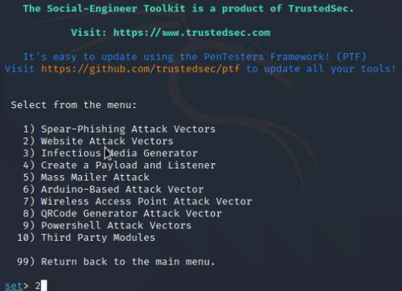
(1.Screenshot from Kali Linux)

In this screenshot, Kali Linux is displaying a menu, from the Social Engineering tools, in this selection, option 1 will be chosen to access the Social Engineering Attacks.

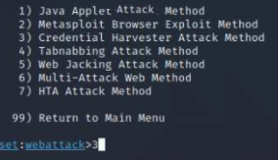
(2.Screenshot selecting the ‘Credential Harvester Att. Method’ - Option 3)

By using the Credential Harvester selection, this attack will be able to clone a website, in this scenario, it will be the hypothetical organisations login page, where the employee who received the email with the attached link, will enter their credentials and then be ‘harvested’ by the hacker.
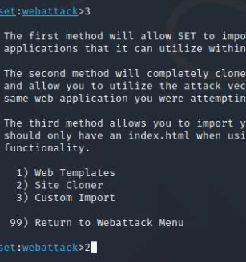
(3.Screenshot selecting ‘Site Cloner’’ - Option 2)

After the attacker has selected the Credential Harvester option, by using the Site Cloner they enter the web address that they wish to clone, this time being the organisation's login, where the victim will log into the server and the hacker will obtain the victim’s credentials along with access to the companies’ servers.

Prevention Methods
After analysis of how Phishing has been carried out on this hypothetical company, it showed that anyone can accidently click on a phishing email without realising the implications that will follow it. There are multiple ways in which this attack could be prevented in the future to avoid this security breach.
An implementation that can be placed to secure the system is to install a firewall onto the networks devices, this can act as the first part of the security that will be implemented to the network, this is a standard form of security that has the ability to monitor and control network traffic, based on a set of rules that are provided, its main purpose is to form a ‘barrier’ between networks which are considered trusted and untrusted, the untrusted network example is often the internet .

The organisation's IT department can ensure that the security is at a high standard by implementing updates on company devices. All software and hardware companies advise that any devices which have the installations are kept up to date, as some previous patches could have vulnerabilities, for example, an OS needing an update due to the company finding a few security vulnerabilities then issuing a new ‘patch’ to avoid any breaches in security. Furthering this, creating a ‘Two Factor Authentication’ method, to the organisations login system, can stop the hacker from gaining too much access, unless they can use SS7, allowing them to see messages on the victim’s phone.

A third part that the organisation can implement to ensure security on the network, is to provide education on how to identify possible attempts of phishing/malware. By developing the organisation's overall understanding of all possible threats to the network (cybercrime-wise), it will have a great impact when one is identified as it can be reported to the IT department who are able to handle it from that point.

Parameter tampering

This attack is used in order to manipulate data which is often exchanged between two sources, clients and servers, the most common being username and passwords on websites. When it comes to Parameter tampering in some instances SQL injection attacks occur, which contains malicious code with the intent on retrieving information, such as company databases, and even making changes to it.

In this instance for Parameter tampering, the scenario will be like the previous organisation discussed, the assumption of employees, except for the IT Department, have no understanding of malware or the various malware which can cause damage to networks and its devices. In this example, a recent environment issue led the company to contract a freelance worker to maintain the server, due to their original IT tech being off work ill, this hired individual creates a SQL Injection onto a company website and waits for an employee to use their staff ID to login on the website, after an employee has logged onto what appears to be a safe login interface, but their data is then sent to the ‘trusted’ individual acts what is referred to as a ‘middle-man’, giving them full access to the database and constant access to the staff ID.

For an example of how SQL Injection works, below details using Metasploit to perform SQL Injections.

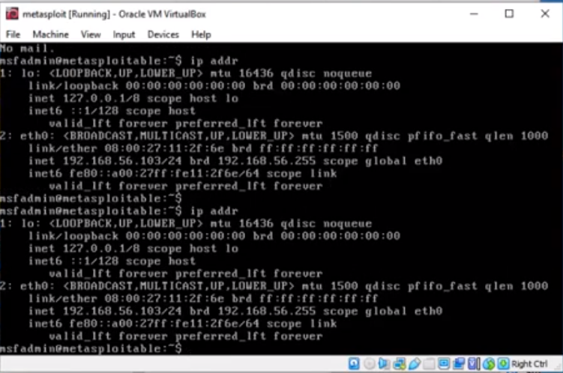
(Checking the IP address to prepare for SQL Inj.)

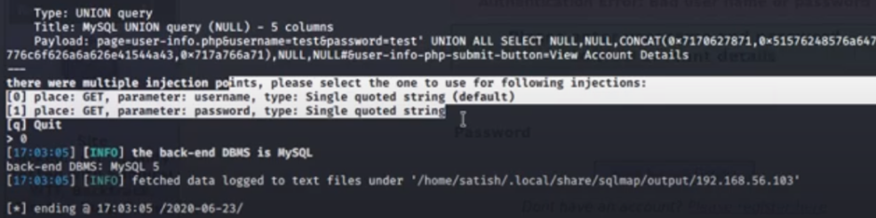
(Screenshot- showing multiple points for SQL Injection)
Checks whether SQL Injection can be completed on this.
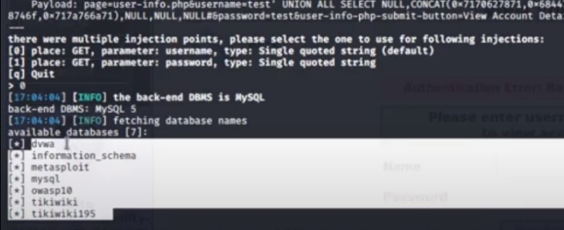
(Screenshot- Displays databases available)
Shows that it can be SQL injected.
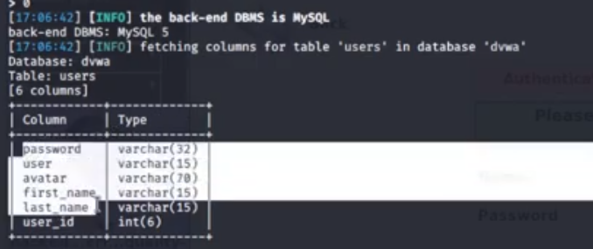
(Screenshot-Shows data stored in DVWA database)
Displays database names/information.
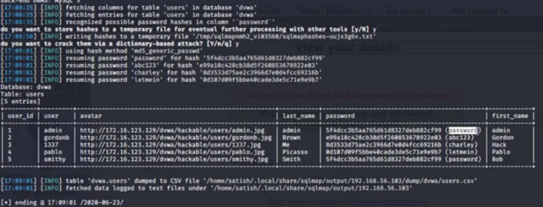
(Screenshot-Displaying all information stored on the database)
By using SQL injection attacks, it will display all information which is stored in the database, it will show the encryption of the passwords stored, along with the unencrypted version. Making it easy for hackers to gain all information stored.

Prevention Methods
After discussing the threats of parameter tampering and its effects, this part will discuss available prevention methods for this scenario. The first step which this company could take is to invest in a SQL Detection software, this will allow to protect the company from any possible data breaches and keep all information secure, as research done whilst creating SQLProb, detection software, it has maintained a complete detection rate when presented with a multitude of tests [12].
The following steps can be taken in order to help prevent Parameter Tampering:

- Inspect website code to detect any vulnerabilities.
Most often, due to human error, there are gaps left in the coding used to store data on the database, by using basic developer tools such as Regex, it can help find any possible gaps in security. [14]

- Use of Prepared Statements
By using prepared statements, it allows the database to see the difference between what code and data is when users supply an input. The use of this also helps to make sure that attackers are not able to make changes to queries made, even if SQL Injections are made.

- Use Stored Procedures
Despite not always being protected from SQL Injections, some standards of this have an effect of using parameterised queries when they are implemented safely. Both Stored and Prepared procedures present an equal level of effectiveness in the chances of preventing SQL Injections [13].

Synthesize A Solution To A Potential Real-Life Scenario
The scenario presented for this part of the project is called Che-si. Che-si is a construction company which has multiple offices based over the world, due to this they need to be able to connect with these offices online consistently to allow their work to progress. As stated, this company will require features such as Video conferencing along with cloud storage in order to store all work data. With this information, by updating any existing security policies they may have in order to enforce to their employees about keeping their network, network devices and personal devices secure to avoid any possible chances of compromise to the company. It is important to note that even the basic security must be maintained, along with the staffs’ personal data, client’s data must be integrated with the security element. The owner of Che-si, is looking for a network design which is secure with evidence of this.
The first thing that was done in order to create this scenario, was to create a network with two of Che-Si offices, which can be used as an example. As shown below, there are multiple PCs connected to each office to replicate to sites interacting with each other.
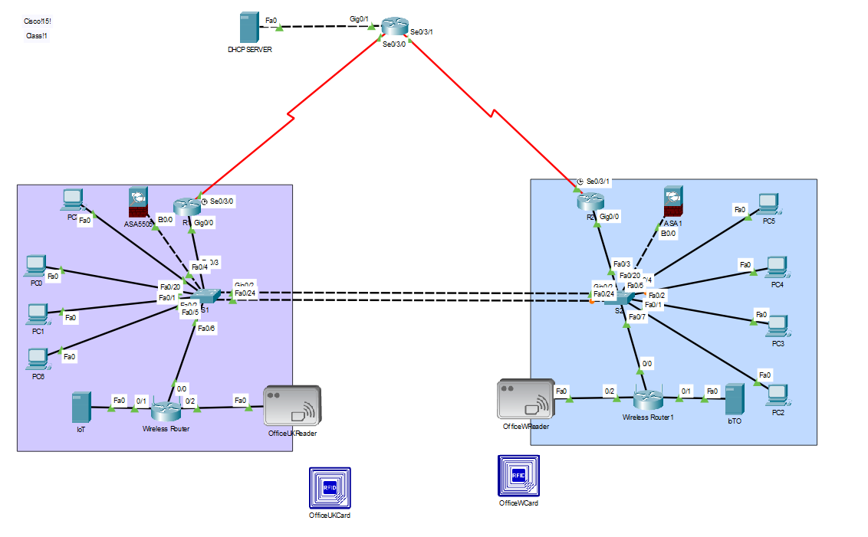
(4.Screenshot of PKT- Che-si Office Network)
Within this network, the element of physical security is also important, for this aspect the use of RFID cards will enforce this, Che-si will provide their staff with staff cards, which will give them different levels of access privileges, based on their roles within the organisation, for example the site manager in the OfficeUK building will be presented with the highest level of security and will be able to access all areas within the building, but a contractor will have standard access, meaning they will only have access into their building and the designated office room that the company has provided them with. Following this idea, the company can implement a policy in which that staff are not permitted to ask other members of staff with higher access levels for their card to access rooms which they do not possess access to, to ensure that this policy is followed, setting up CCTV at this access point card scanners to ensure that it is the card holder rather than a person who may be a threat to the network.
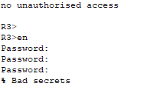
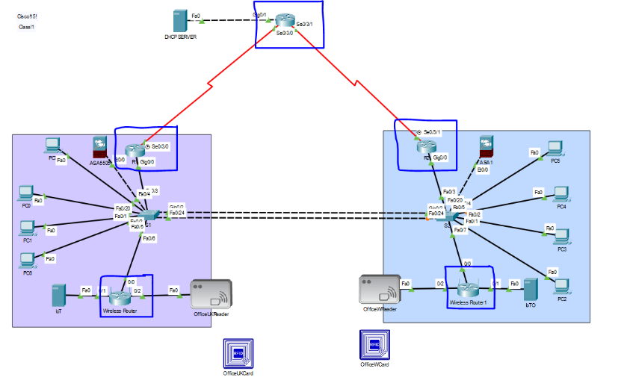
(5.Screenshot PKT Tracer - Routers Highlighted) (6.Router CLI-Incorrect Password)
On the routers, which have been highlight in the image above, as standard they each possess an encryption method and a password in order to gain access to their interface, first the router displays a message ‘No Unauthorised Access’ to give warning, next is if the password that someone has entered is wrong 3 times consecutively then the following message will be displayed, as stated in the previous element of security, the RFID cards, will be able to restrict access to the routers and only allow those who are employed to maintain them. With that said, some employees may attempt to access these routers to gain access to all connected devices, in order to ensure this isn’t done onsite or even from a staff members home, by issuing recording software to be installed on all company devices to monitor work progress and access of content whilst working from home. Che-si can also only authorise access to the network only by using company devices and forbid the use of personal devices such as employees’ mobiles, laptops etc. whilst on site.

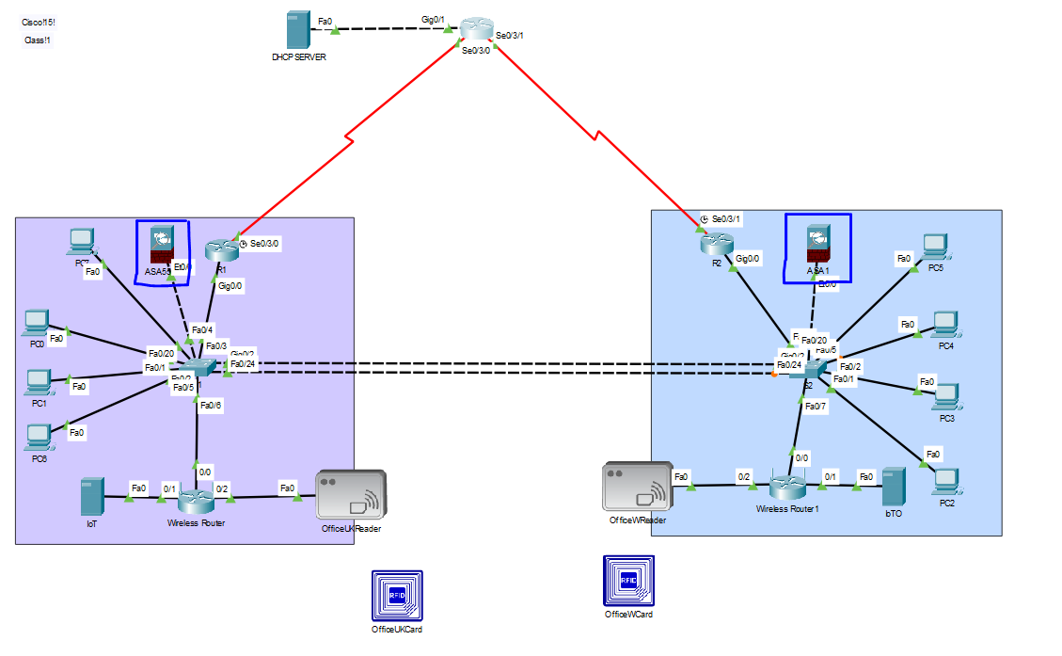
As shown in the image above, the switches in both offices have the implementation of Firewall and SSH (this is implemented on the routers). SSH is a protocol which will allow the use of network devices to communicate with other devices to access things such as HTTP, whilst Firewall, will be able to protect the company devices when accessing these particular web pages, the routers do have certain web pages restricted. A policy that Che-si can implement when it comes to the company routers in all offices, is that if any suspected malicious activity performed by any employees, legal action will be pursued due to damage of organisations property, following this policy, the company can issue warnings which do not allow the improper use of the network whilst working, such as accessing inappropriate web pages, and social networking websites, by issuing bans of accessing the internet when in breach of this policy it can ensure that only safe and appropriate use is in place.

Conclusion

Part A:
After discussing two of the most recent attacks that have taken place towards the end of 2020, it is clear that due to the pandemic this may only be the beginning of even more hostile attacks towards networks taking place. As most recent statistics declared, these attacks are only increasing in numbers, with the attacks causing nearly $6 trillion in damages. Within the research it shows that in order to adapt to this situation there are a multitude of things which need to be updated or even upgraded to protect as much as possible, as declared by AccentureSecurity not many companies are choosing to put more of their budget into their technology department leading to hacks, in a report created at least 84% of the companies they were inspecting were spending more than 20% of their budget on their IT dept. which is a sharp increase when compared to previous years where only 41% of companies were paying 20% of their budget [11]. The overall conclusion of this part is that each individual industry plays a big part in ensuring that they do not fall foul to these malicious cyber-attacks, as long as devices are maintained and upgraded/updated and the IT Dept. is receiving as much support as possible, it can help tackle ongoing issues stated.

Part B:
Whilst creating this network, to gain a form of insight to how the network could be made secure, even though virtual security is of the most importance, physical security still makes up for a large portion. By implementing the above suggestions, it can ensure a tough form of security, an option that was discovered whilst doing research for Parameter tampering, making a Random Session ID is also another beneficial implementation that can be considered in this. In a future adaption of the Che-Si network model layout, could include an employees home network which is able to access work data remotely given the current pandemic, as stated previously, Che-Si will provide their staff members with devices which have the appropriate software and lock specific access to specific content in order to prevent any chances of threats.
By ensuring that employees retain their understanding of potential threats that they will face on a daily basis whilst using the internet it will help reinforce other elements of security so that accidental damage is caused. The IT Department can remind the staff of key policies which need to be followed and have a ‘terms & conditions’ application which all staff using organisation devices must sign, to even login to their systems.

References
[1]I. Ilascu, "Hackers hijack Telegram, email accounts in SS7 mobile attack", BleepingComputer, 2021. [Online]. Available: https://www.bleepingcomputer.com/news/security/hackers-hijack-telegram-email-accounts-in-ss7-mobile-attack/. [Accessed: 08- Jan- 2021].
[2]A. Baitha and S. Vinod, International Journal of Engineering & Technology, vol. 7, no. 26, p. 197, 2018. Available: https://www.researchgate.net/publication/325117343_Session_Hijacking_and_Prevention_Technique. [Accessed 08 January 2021].
[3]R. Teimoor, Ethical Hacking and Knowledge about Hacking. 2017, pp. 5 / 6.
[4]S. Kimathi, "2020 Review: Top five outages, data breaches & cyber-attacks this quarter - FinTech Futures", FinTech Futures, 2020. [Online]. Available: https://www.fintechfutures.com/2020/04/2020-review-top-five-outages-data-breaches-cyber-attacks-this-quarter/. [Accessed: 08- Jan- 2021].
[5]D. Weiss, "Seyfarth Shaw is in 'restoration phase' after malware attack", ABA Journal, 2020. [Online]. Available: https://www.abajournal.com/news/article/seyfarth-shaw-is-in-restoration-phas-after-malware-attack. [Accessed: 30- Dec- 2020].
[6]"Seyfarth Shaw Targeted in Ransomware Attack", Lawyer Monthly | Legal News Magazine, 2020. [Online]. Available: https://www.lawyer-monthly.com/2020/10/seyfarth-shaw-targeted-in-ransomware-attack/. [Accessed: 25- Jan- 2021].
[7]L. Irwin, "List of data breaches and cyber attacks in October 2020 – 18.4 million records breached", IT Governance Blog, 2021.
[8]S. Das, "5 Biggest Cyber Attacks of 2020 (So Far)", Kratikal Blog, 2020.
[9]A. Berentsen and F. Schär, A Short Introduction to the World of Cryptocurrencies. St. Louis, 2018, pp. 10-12.
[10]"Seyfarth Shaw Targeted in Ransomware Attack", Lawyer Monthly | Legal News Magazine, 2020. [Online]. Available: https://www.lawyer-monthly.com/2020/10/seyfarth-shaw-targeted-in-ransomware-attack/. [Accessed: 13- Dec- 2020].
[11]K. Bissell, R. LaSalle and P. Cin, INNOVATE FOR CYBER RESILIENCE. Accenture Security, 2020, pp. 8/9.
[12] A. Liu, Y. Yuan, D. Wijesekera and A. Stavrou, "(PDF) SQLProb: a proxy-based architecture towards preventing SQL injection attacks", ResearchGate, 2009. [Online]. Available: https://www.researchgate.net/publication/221002296_SQLProb_a_proxy-based_architecture_towards_preventing_SQL_injection_attacks. [Accessed: 08- Jan- 2021].
[13]"SQL Injection Prevention - OWASP Cheat Sheet Series", Cheatsheetseries.owasp.org. [Online]. Available: https://cheatsheetseries.owasp.org/cheatsheets/SQL_Injection_Prevention_Cheat_Sheet.html. [Accessed: 07- Jan- 2021].
[14]"Prevent Parameter Tampering | Web Application Testing", Qualitrix. [Online]. Available: https://qualitrix.com/blog/testing-web-applications-for-security-vulnerabilities/. [Accessed: 07- Jan- 2021].

