

Programme: Master of Business Administration
Module: Marketing Management
Module code: LCMB7024

MACRO MARKETING ENVIRONMENT AND COMPETITIVE STRATEGIES: A COMPARATIVE ANALYSIS OF OCADO PLC (PIONEER) AND TESCO PLC (FOLLOWER) IN THE UK GROCERY SECTOR

STUDENT ID:2522475

STUDENT NAME :

SONAL ARJAN KHISTARIYA

LECTURER : TOLA ODUGBESAN

Table of Contents
1. Introduction 3
TASK 1 - MACRO ENVIRONMENT ANALYSIS 4
2. Industry Overview and Pioneer vs Follower Concept 4
3. Macro Environmental Force 1: Technology 5
3.1 Technological Developments in Grocery Retail 5
3.2 Impact on Ocado (Pioneer) 6
3.3 Impact on Tesco (Follower) 7
4. Macro Environmental Force 2: Social Trends 8
4.1 Changing Consumer Behaviour 8
4.2 Impact on Ocado (Pioneer) 9
4.3 Impact on Tesco (Follower) 9
TASK 2 - STRATEGIC RESPONSES 10
5. Strategic Responses Using Porter’s Generic Strategies 10
5.1 Ocado Strategy 11
5.2 Tesco Strategy 12
5.3 Critical Comparison 12
6. Growth Strategies Using Ansoff Matrix 12
6.1 Ocado Growth Strategy 13
6.2 Tesco Growth Strategy 14
6.3 Evaluation 14
7. Conclusion 14
References 16

1. Introduction
This report compares the industry leaders with the follower companies, Ocado Group and Tesco in the grocery retail industry. This report is aimed at assessing the impact of the macro environmental forces on strategic decision-making within the grocery retail industry. Technological innovation, the rise of digital shopping, and the development of consumer behaviour are causing fast changes in the grocery industry (Stecuła, Wolniak and Aydın, 2024). The first-mover companies usually present new technologies and business models, which transform the competition in the industries.
The report outlines an analysis of the grocery retail industry in the beginning and states the meaning of pioneer and follower strategies. It further discusses two important macro environmental forces, which include technology and social trends. These forces have a great impact on the way grocery retailers shape operations, logistics system and customer experiences. The analysis helps consider the opportunities and threats which these forces present to both Ocado and Tesco.

TASK 1 - MACRO ENVIRONMENT ANALYSIS

2. Industry Overview and Pioneer vs Follower Concept
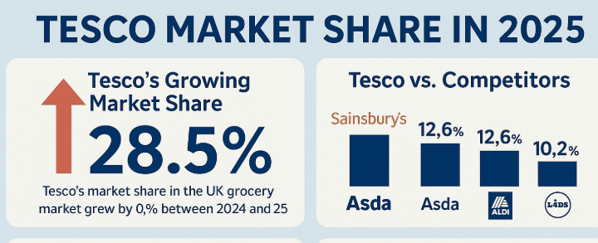
Figure 1: Market Share of TESCO IN 2025
(Source: Westernbusiness.co.uk, 2025)
As market data shows, large retailers like Tesco control the UK grocery market, where Tesco controls about 28.5% of the total share in the UK grocery market and thus is the market leader in the country (Westernbusiness.co.uk, 2025). The online grocery shopping and digital transformation have altered the industry structure in recent years considerably.
Meanwhile, online grocery app stores have gained greater significance as a result of the increase in consumer needs towards convenience services and delivery to their homes. Ocado Group is one of the greatest innovators in this field. The company has grown tremendously, and Ocado Retail's revenue in 2024 is about 2.685.8billion and this represents growth of 13.9 % over the preceding year (Ocado Group, 2024). Ocado is largely known as one of the pioneers in online grocery retailing due to its introduction of sophisticated automated warehouses, robots, fulfilment centres, and artificial intelligence-based logistics solutions.
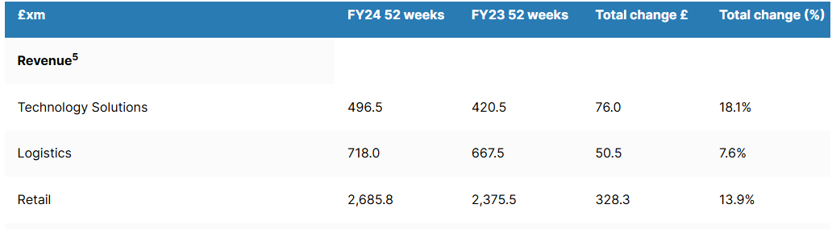
Figure 2: Financial Table of Ocado Group 2023 and 2024
(Source: Ocado Group, 2024)
The first organisations to bring about new technologies or business models are pioneer companies. These companies spend a lot of money on research, innovation, and infrastructure in order to have a first-mover advantage. Ocado has more than 1 million active customers and thousands of online orders each week that are made using its automated distribution system (Ocado, 2024). Followers are able to scale innovations rapidly and lead the market in the industry, since the follower firms have high brand recognition. Though Tesco has been concentrating on brick-and-mortar supermarkets only, it has quickened the growth of online operations and online delivery platforms to become a rival of the pioneers (IMD.org, 2024).

3. Macro Environmental Force 1: Technology

3.1 Technological Developments in Grocery Retail
Significant change in the retailing sector especially for the grocery segment, can be seen due to the technological advancement that has enhanced operational efficiency, supply chain management, and customer experience. Retailers have been empowered by digital technologies, including artificial intelligence (AI), automation of warehouses and others to fulfil orders quicker and faster and control inventory in a better way (Viswanathan, 2024). Automated fulfilment centres, data analytics and predictive demand systems are part of the automated operations many companies currently use in order to make the best use of stock levels and minimise operational costs. Moreover, online grocery sales with the help of the last-mile delivery boosted the UK grocery sales and the automation market in the warehouse is projected to grow to $59.52 billion by 2030 (Grandview Research, 2024). Such technological changes impact Tesco and Ocado as grocery firms by offering opportunities and threats to the companies.
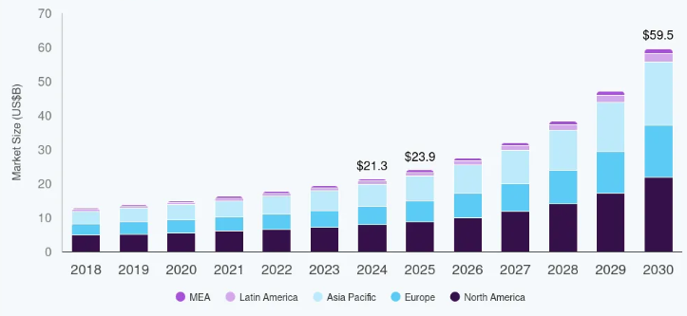
Figure 3: Warehouse Automation Market Size
(Source: Grandview Research, 2024)

3.2 Impact on Ocado (Pioneer)
Opportunities
Ocado is an online grocery store that is currently technologically inclined and has had a staggering competitive advantage due to innovation. Advancement stance enlisted by the firm with its high-tech automated fulfilment centres is based on the operation of robotics and artificial intelligence to ensure thousands of robots can work simultaneously to meet the customer orders (Ocadogroup, 2026). International companies such as Kroger and Sobeys can also access the global logistics and technology of the company via the Ocado Smart Platform (OSP) that makes the world open to the company (Sawers, 2020). These technologies enable the company to process orders more quickly with accuracy of stock but operational expenses are high.
Threats
Even with such benefits, technological leadership is also a liability to Ocado. The creation of automated warehouses is extremely expensive with respect to research, the robotics infrastructure as well as data systems (Dabic-Miletic, 2024). This kind of capital-intensive operations leads to the company facing a financial risk that is in the event of failure of such investments to yield anticipated returns. Again, other companies can adopt the same automation technologies and this can decrease the first-mover advantage of Ocado.

3.3 Impact on Tesco (Follower)
Opportunities
Tesco, popularly the most notable grocery chain in the UK has progressively embraced digital technologies in order to enhance its online service. The company provides in its Tesco online channel home delivery, click-and-collect and fast delivery choices to improve the convenience of the customers (Tesco, 2026). In the UK, Tesco accepts over one million online order placements in its grocery operations per week, which is indicative of the rising significance of digital retailing operations. An additional fact to notice is that the company has 5040 physical outlets that enable it to incorporate online and offline retailing using an omnichannel strategy (Statista, 2025). This integration is essential in that Tesco is able to complete online orders with ease through the use of stores as the distribution centre hence minimising delivery time and making it conveniently available to customers.
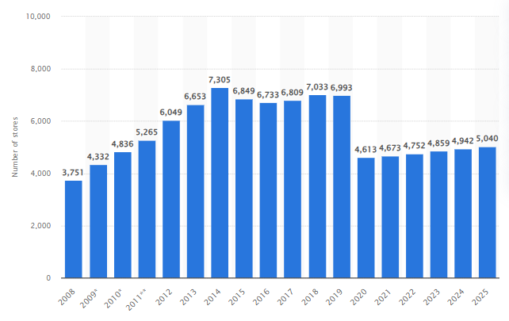
Figure 4: Number of Stores in Tesco
(Source: Statista, 2025)
Threats
Tesco also has to contend with a high rate of change in technology despite of the opportunities that exist. Tesco does not have a monopoly as a follower company since it is competing with technology oriented firms such as Ocado, Amazon who have already developed highly automated logistics systems (Retail-week, 2023). Digital infrastructure, delivery technology and data analytics should therefore be constantly invested in so as to remain abreast with the competition. Such categories of investment can increase the cost of operation and may result in reduced profit margins.

4. Macro Environmental Force 2: Social Trends

4.1 Changing Consumer Behaviour
The society is now very modern and technology became its intrinsic part of it. It renders big impact on consumer behaviour in the grocery retail market, especially with the expansion of online shopping and the demand for convenience. Excessive dependence of a significant number of customers on online grocery stores can be seen due to the need for flexibility and convenience in terms of ordering goods via mobile applications and having them delivered at home (Moodley and Buthelezi, 2023). Necessity of transitioning to digital channels by consumers with changing trends in the UK has surged the count by 20.6% among total household purchases (Zuke, 2025). Demand for online grocery soared during the COVID-19 pandemic with online grocery sales making up over 13% of all UK grocery sales (Meister et al., 2023). Such changing tastes and preferences have compelled grocery stores to redesign their logistical systems, online facilities, and service models to ensure that they are competitive in the UK market.

4.2 Impact on Ocado (Pioneer)
Opportunities
The social trends are greatly favourable to the online-only grocery approach of Ocado. Increasing consumer demand to deliver products to their homes and comfortably, coincides with its digital platform. State of the art analytics is used to provide individualised shopping recommendations and enhance customer satisfaction and loyalty. During COVID-19, the demand was high, and the number of active customers of Ocado grew 22% from 2020 to 2022 (Ocado, 2022). Larger size of baskets and ultimate delivery time also align with consumer expectations and give Ocado a better chance to grow its online grocery services, which are based on technology.
Threats
It is also hard to change consumer behaviour. Most consumers have been sensitised to price by economic pressures, which forces them to compete with the low cost retailer chains such as Aldi and Lidl (Obshta, 2026). It is more likely for Ocado to raise the costs of delivery and logistics, since Ocado is an online supermarket, and it is inherent to regular supermarkets. The increase in consumer needs to be met in a short time frame also means that it will invest heavily in logistics and technology continuously and, consequently, will increase the operational costs and decrease the profit margin, hence, obvious.

4.3 Impact on Tesco (Follower)
Opportunities
Due to its powerful omnichannel retail strategy Tesco is in a good position to leverage the social trends. Because of this, the retailer uses over one million online groceries per week. Tesco has also launched fast delivery facilities like Tesco Whoosh which has provided the customers with the capability to deliver their groceries in a duration of about one hour (Tesco, 2026). These services are directly aimed at meeting the consumer demand of convenience and rapid delivery.
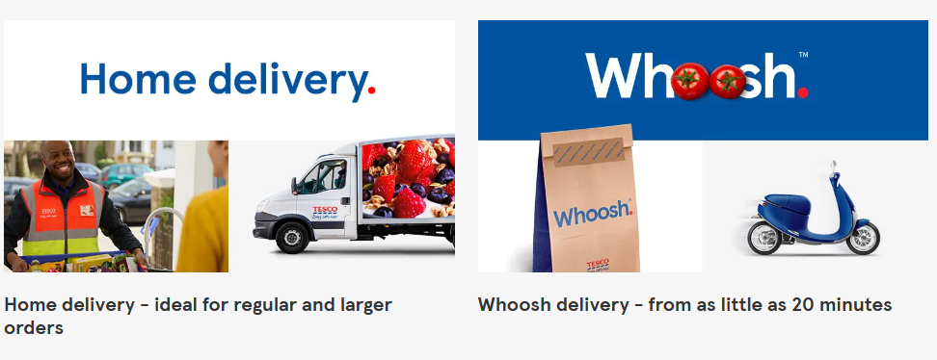
Figure 5: Tesco Online Delivery Channels
(Source: Tesco, 2026)
Threats
Surge in vulnerability can be found even for the case of Tesco especially with the increased presence of digital retailing and fast-commerce sites such as Amazon Fresh. The expectations of the consumers are low prices, faster delivery and enhanced digital experiences (Nair and Manohar, 2024). The cost of such standards is quite costly in terms of the considerable investment in both technology and logistic infrastructure and customer service to ensure such standards.

TASK 2 - STRATEGIC RESPONSES

5. Strategic Responses Using Porter’s Generic Strategies
Porter’s Generic Strategies
The framework named Porter's Generic Strategies entails the establishment of how an organisation can achieve a competitive advantage in an industry. Competition can also be beaten in three main strategies which organisations can adopt such as cost leadership, focus and differentiation (Vasiliadis et al., 2023). Cost Leadership is focused on ensuring the lowest operational costs, at the cost of not compromising on quality. In differentiation, an individual offers differentiated products or services which appear better to the customers. Cost leadership and differentiation are directed to a specific segment of the market. Such strategic measures can help companies to gain a competitive edge, positioning and respond well to the competition in the market.
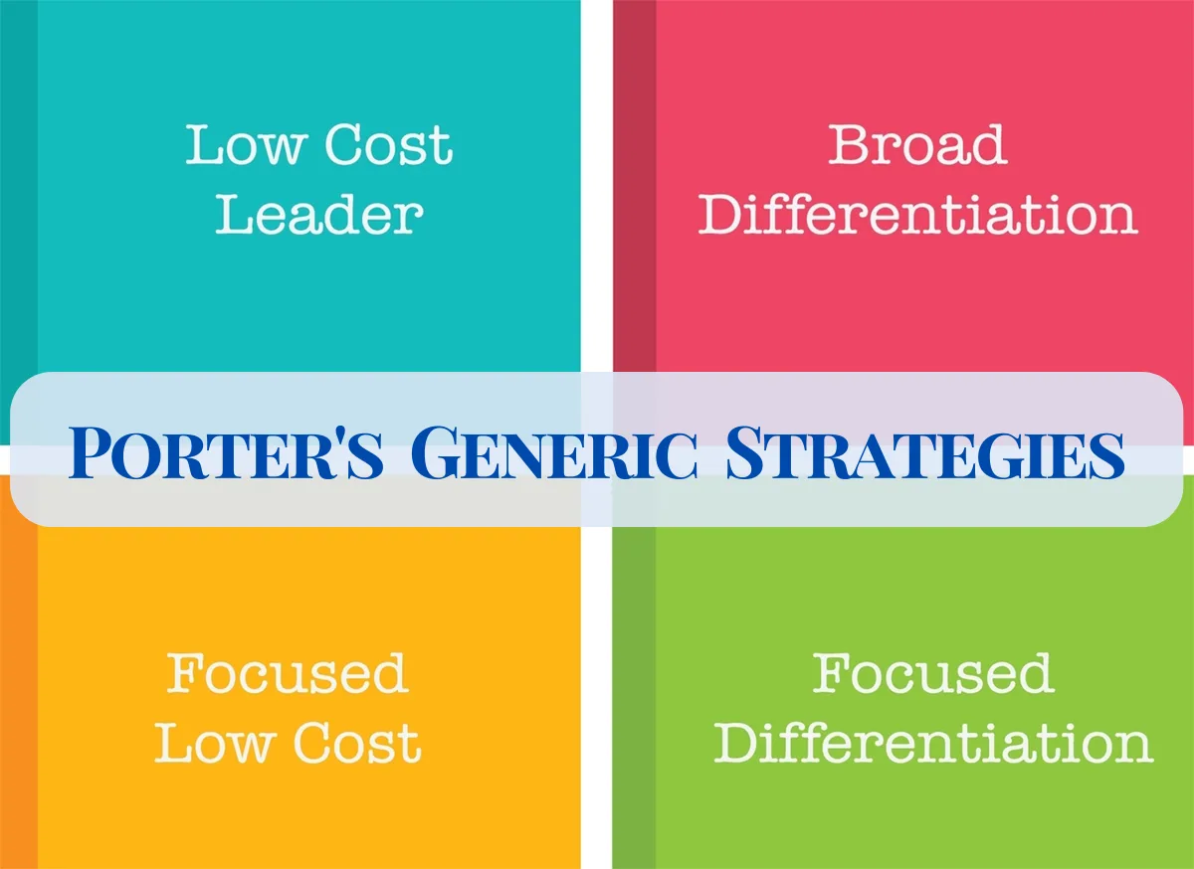
Figure 6: Porter’s Generic Strategy
(Source: Jurevicius, 2025)

5.1 Ocado Strategy
The primary approach that Ocado takes is differentiation, focusing on technological leadership and high tech digital grocery infrastructure. Ocado is an online retailer with highly automated logistics systems as opposed to traditional supermarkets. The firm spends a lot of its money in robotics, data analytics, and artificial intelligence to maximise the effectiveness of inventory management and delivery (Ocadogroup, 2026). The Ocado Smart Platform that offers automated fulfilment solutions and grocery operations software, is one of the most prominent ones (Sawers, 2020). The robots are used in world fulfilment centres to collect, pack and ship orders faster and with better accuracy. Such capabilities will enable Ocado to provide high-quality service with a reliable delivery time slot and customised digital proposals. The use of innovation and automation distinguishes the company against traditional retailers and creates a high level of technological competitive advantage in the online grocery sector and reduces customer experience and operational efficiency, long term growth potential on a global basis.

5.2 Tesco Strategy
The primary strategy Tesco has adopted is cost leadership with wide market coverage. Economies of scale enjoyed due to its large stores network and wide supply chain operations favour the company. Tesco buys in bulk quantities supplied by farmers who it can negotiate with them for better prices and deliver the same to the customer at even lower prices than other brands. Products of own level such as Tesco's own brands that are of good quality but less expensive than the national brands also offer an added advantageous stance (Ndlovu, 2024). The Tesco Clubcard programme also provides the retailer with the data that helps it to provide discounts and tailor-made offers for most varieties of products (Tesco Plc, 2025). Distribution networks of grocery stores accommodated Tesco in the UK to facilitate the free flow of products and its extensive distribution channel at stores and online. With the help of this scale, Tesco has been able to preserve price competition and leadership.

5.3 Critical Comparison
There is a critical comparison between the two companies and there exists a presence of strategic differences. Ocado focuses on differentiation with automation of technology and digital innovation (Ocadogroup, 2026). Its competitive edge is in superior fulfilment systems data entailed logistics and high-quality online services experiences. On the other hand Tesco is emphasising on cost leadership that is backed by enormous purchasing power in huge scale and national chain of stores (Sikos and Kovács, 2022). Such measures assured Tesco to sustain its competitive ground in terms of prices and at the same time have a very wide clientele. Therefore Ocado competes with efficiency of innovation and specialised competencies but Tesco uses brand presence in terms of operational scale and price accessibility. The two strategies are competent and indicative of different competitive priorities in the market environment in the UK grocery retail business in general and in strategy selection.

6. Growth Strategies Using Ansoff Matrix
Ansoff Matrix
Ansoff Matrix is a strategic plan method of comprehending areas of business growth by examining the markets and the products. It provides four key strategies namely, market penetration, market development, product development and diversification (Aditiya and Kirana, 2025).
Market penetration aims at boosting the sales of the existing products in the existing markets. Market development involves existing products in new markets in terms of geography or to new customers.
Product development is the development of new products for the already existing customers. The risky one that involves the diversity of new products and the new markets in growth is known as diversification.
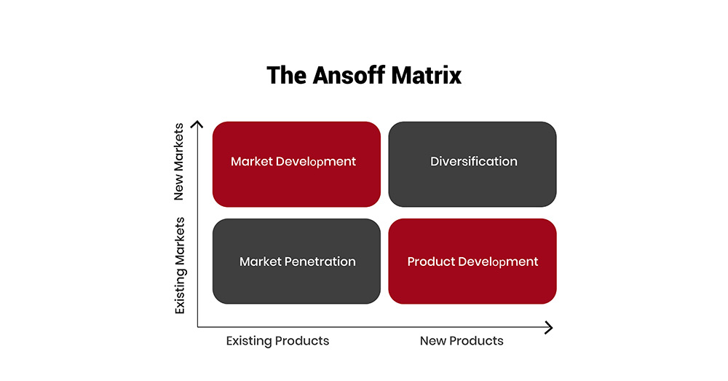
Figure 7: Ansoff Matrix
(Source: The Strategy Institute, 2026)

6.1 Ocado Growth Strategy
Ocado mainly adopts the policies of market development and product development. Market development enables the company to extend its operations to other countries around the world by licensing its Ocado Smart Platform to international grocery stores (Ocadogroup, 2026). Collaborations with the Canadians, Japan and the United States Supermarkets allow entering new markets aside from allowing the firm to gather funds to spend on technology. Development of its products is directed toward automating warehouse robots and an artificial intelligence logistics system to accelerate efficiency and ensure accuracy of order in addition to facilitating a scalable grocery business.

6.2 Tesco Growth Strategy
Tesco largely has a strategic dependence on market penetration and diversification as market support strategies. Market penetration consolidates its ground in the UK grocery market by enhancing its stores using digital platforms and diversified online grocers such as home delivery and click and collect. Fast services such as Tesco Whoosh appeal to the convenience-based customers (Tesco, 2026). These financial services can be found under diversification. It includes payment insurance or banking where Tesco Bank has developed more income sources and closer customer devotion in the country.

6.3 Evaluation
The business analysis indicates the divergent paths of growth of the two companies. Ocado focuses on innovation partnerships through technology and expansion of global platforms. The brands of Tesco are dependent on size and brand strength and diversified services. Ocado has long term technological potential whereas Tesco has a greater market in the present.

7. Conclusion
Competition in grocery retail is being changed by technology and evolving social trends. The existence of online shopping digital platforms and the demand for convenience force retailers in the direction of new strategies. Ocado enjoys the first mover technological advantage when Tesco enjoys economies of scale and integration into the omnichannel. These are the strategic differences explained by Porter and Ansoff. The only thing which can make it successful in the future will be innovation, efficient distribution and excellent customer experience across markets.

References
Aditiya, S. and Kirana, D.H.K. (2025) ‘Smarteye. id’s Business Expansion Strategy for Global Market Penetration through the Ansoff Matrix’, International Journal of Management and Business Economics, 3(2), pp.60-65. Available at: https://doi.org/10.58540/ijmebe.v3i2.705
Dabic-Miletic, S. (2024) ‘The challenges of integrating AI and robotics in sustainable WMS to improve supply chain economic resilience’, Journal of Industrial Intelligence, 2(2), pp.119-131. Available at: https://doi.org/10.56578/jii020205
Grandview Research (2024) Warehouse Automation Market (2024 - 2030). Available at: https://www.grandviewresearch.com/industry-analysis/warehouse-automation-market-report (Accessed: 02 March 2026)
IMD.org (2024). Tesco and Ocado: Contrasting online grocery supply chain models - IMD business school for management and leadership courses. Available at: https://www.imd.org/research-knowledge/operations/case-studies/tesco-and-ocado-contrasting-online-grocery-supply-chain-models/ (Accessed: 4 March 2026)
Jurevicius, O. (2025) Porter's (Three) Generic Strategies Explained - SM Insight. Available at: https://strategicmanagementinsight.com/tools/porters-three-generic-strategies/ (Accessed: 6 March 2026)
Meister, A., Winkler, C., Schmid, B. and Axhausen, K. (2023) ‘In-store or online grocery shopping before and during the COVID-19 pandemic’, Travel Behaviour and Society, 30(1), pp.291-301. Available at: https://doi.org/10.1016/j.tbs.2022.08.010
Moodley, P. and Buthelezi, M. (2023) ‘Enhancing the online grocery shopping experience for South African consumers: A study of challenges, preferences and strategies’, The Retail and Marketing Review, 19(2), pp.70-86. Available at: https://zenodo.org/doi/10.5281/zenodo.10220622
Nair, A.J. and Manohar, S. (2024) ‘Green service consumption: unlocking customer expectations on technological transformations enhancing purchase experience in retail store’, International Journal of Information Management Data Insights, 4(2), pp.1-13. Available at: https://doi.org/10.1016/j.jjimei.2024.100277
Ndlovu, S.G. (2024) ‘Private label brands vs national brands: new battle fronts and future competition’, Cogent Business & Management, 11(1), p.2321877. Available at: https://doi.org/10.1080/23311975.2024.2321877
Obshta, I. (2026) ‘Comparative Effect of Promotions (Discounts, 1+ 1, Coupons, Gifts) on Sales and Brand Margins in Different Retail Formats (Supermarket, Discounter, E-Commerce)’, Universal Library of Business and Economics, 3(1), pp.1-7. Available at: https://doi.org/10.70315/uloap.ulbec.2026.0301004
Ocado (2022) FY21 Results Presentation. Available at: https://cdn.prod.website-files.com/667974bf1bf45146cf81ef19/66c34a300482f48cbb0a6fca_224d7dcb-1ef4-4a96-923f-a7c9efc9328c.pdf (Accessed: 4 March 2026).
Ocado (2024). About Us. Available at: https://ocadoretail.com/about-us/ (Accessed: 3 March 2026)
Ocado Group (2024). Ocado Group FY2024 Results. Available at: https://www.ocadogroup.com/investors/results-and-presentations/full-year-results-2024 (Accessed: 6 March 2026)
Ocadogroup (2026) Ocado's AI-powered robotic arms: Levelling efficiency. Available at: https://www.ocadogroup.com/newsroom/stories/ocado-robotic-arms (Accessed: 7 March 2026).
Retail-week (2023) Amazon and Tesco have 'best in class' supply chain strategies. Available at: https://www.retail-week.com/supply-chain/amazon-and-tesco-have-best-in-class-supply-chain-strategies/7043552.article (Accessed: 04 March 2026)
Sawers, P. (2020) Ocado shops its way to a robotics platform for groceries and beyond. Available at: https://venturebeat.com/technology/ocado-shops-its-way-to-a-robotics-platform-for-groceries-and-beyond (Accessed: 7 March 2026).
Sikos, T.T. and Kovács, C.J. (2022) ‘The competition between discount stores and Coop in Northern Hungary: A case study’, Geographica Pannonica, 26(4), pp.1-12. Available at: https://doi.org/10.5937/gp26-39642
Statista (2025) Tesco's global number of stores 2025| Statista. Available at: https://www.statista.com/statistics/238667/tesco-plc-number-of-outlets-worldwide/ (Accessed: 7 March 2026).
Stecuła, K., Wolniak, R. and Aydın, B., (2024). ‘Technology development in online grocery shopping—From shopping services to virtual reality, metaverse, and smart devices: A review’. Foods, 13(23), pp.3959. Available at: https://doi.org/10.3390/foods13233959
Tesco (2026) Tesco grocery delivery services. Available at: https://www.tesco.com/groceries/en-GB/zone/tesco-delivery?srsltid=AfmBOopFo3g7wYdSNg1gKupK6A_VZTHxUafK23mA0RNdkeIZQQFGC3qp (Accessed: 7 March 2026).
Tesco Plc (2025) Tesco Annual Report 2025. Available at: https://www.tescoplc.com/media/ky0bfwpo/tesco_ar25_interactive.pdf (Accessed: 02 March 2026)
The Strategy Institute (2026) The Ansoff Matrix: A Powerful Tool for Business Strategy and Growth. Available at: https://www.thestrategyinstitute.org/insights/the-ansoff-matrix-a-powerful-tool-for-business-strategy-and-growth (Accessed: 03 March 2026)
Vasiliadis, L., Gavalas, D. and Tsitsakis, C. (2024) ‘Competitive strategies and integration expanses in the large shipping container industry during an era of consecutive global crises’, Maritime Technology and Research, 6(1), pp.1-20. https://doi.org/10.33175/mtr.2024.266413
Viswanathan, J. (2024) ‘Artificial intelligence: Transforming the future of retail’, International Journal of Science and Research (IJSR), 13(9), pp.174-178. Available at: https://dx.doi.org/10.21275/SR24901234506
Westernbusiness.co.uk (2025). Tesco Market Share: Understanding Its Growth and Market Position in 2025. Available at: https://westernbusiness.co.uk/tesco-market-share/ (Accessed: 5 March 2026)
Zuke, E. (2025) One in five UK households place online grocery orders. Available at: https://www.thegrocer.co.uk/news/one-in-five-uk-households-place-online-grocery-orders/713107.article (Accessed: 7 March 2026).

