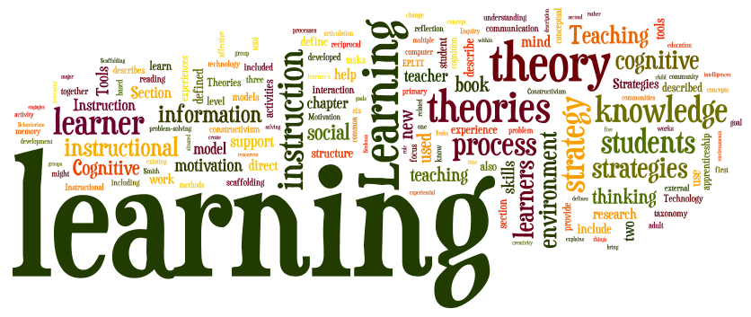

How Rosenshine’s Principles of Instructions Make an Effective Approach in Mainstream Classrooms.

Introduction

In this Literature Review, I will be researching ethically about Rosenshines Principles of Instructions and how they make an effective approach in the Mainstream Classroom, this includes children with all needs. If Rosenshines Principles of Instructions have a positive approach in the classroom; making sure they include children of all needs – this includes children with ALN, what help there are for children with behavioral issues and what support they have, if they are any support for teachers and teaching assistants and also what support there is for the teaching staff and what are the advantages and disadvantages of the ten principles. I will also include a conclusion, thinking critically about the principles and being ethically correct throughout.

I will be comparing and contrasting previous research articles but will not be conducting research. I will just be researching journal articles, books, web pages – which will be academically correct.

During my research, I will recite on the background of the approach, what support is out there currently for the children and staff combined. I will also analyse the effectiveness of the approach, to keep the children engaged in the classrooms and help the children with ALN needs. I will also interpret the 1986 paper of Rosenshine and Stevens Paper on “Teaching Functions”. This Research Paper depicts on the limitations of the Principles of Instructions; thinking critically throughout the time of research – I will then come to a conclusion to my question and also depict whether there is enough support there for all children, whether there needs to be improvements throughout the education system.

Introduction to Rosenshine’s Principles in Action

Rosenshine’s Ten Principles in Action have recently evolved over time to help the teachers and children, it also focuses on the aspects of teaching which are universal. The Ten Principles in Action have been worked on since the 1980’s, Rosenshine and his colleague published a paper in 1986 called Teaching Functions.
The Rosenshine’s Principles in Action has teacher-center authenticity, it depicts that Rosenshine understood what was occurring during the time of being in a classroom – supporting teachers and the children throughout.

While reading Tom Sherrington – Rosenshine’s Principle in Action published in 2019, it stated that “in the last year, Rosenshine’s Principles of Instruction has been circulating increasingly rapidly around schools in the UK as more teachers discover its insights, sharing via social media and the growing array of grassroots teacher conferences.”

Rosenshine’s principles provide a clear guide to evidence-informed teaching, his principles have an insight to an effective instruction. Some teachers may argue that the principles have not always been evident in their practice. Even though the principles are simple; the way the teachers deliver the principles can be complex to support each child in the classroom.

Rosenshine’s Ten Principles in Action
Rosenshine’s Principles of Instruction is now widely recognized, amongst teachers seeking to engage with cognitive science.

The Principles of Instructions come from three sources, which include: -
- Research in Cognitive Science (how our brains acquire information)
- Research on Master Teachers (high achievements in tests)
- Research on Cognitive Supports (scaffolding, modelling etc)

Research in Cognitive Science focuses on how our brains acquire and use the information. The cognitive research also provides suggestions on how we might overcome the limitations of our working memory.

Research on Master Teachers are those teachers whose classrooms made the highest gains on achievement tests. In a series of studies, a wide range of teachers were observed as they were taught, during this they seen how they presented new material, how and whether they checked for student understanding (which can be scaffolding), the types of support they provide to the students. During this, they were able to identify in which the more and less effected teachers differed throughout.

Research on Cognitive Support can be depicted to help students learn in complex ways, these can be complex tasks such as thinking aloud, providing students with scaffolds (which is Jerome Bruners way of teaching, whether it can be monitoring students in any task given and if they need help; they can help them and slowly pull away with the scaffolding.

These four sources provide support by teaching new material in manageable amounts, modelling guiding student practice, helping students when they make errors, and providing for sufficient practice and review.

Barak Rosenshine depicts seventeen principles that overlap into ten sections, the seventeen principles that overlap are –
- Begin a lesson with a short review of previous learning.
- Present new material in small steps with student practice after each step.
- Limit the amount of material students receive at one time.
- Give clear and detailed instructions and explanations.
- Ask a large number of questions and check for understanding.
- Provide a high level or active practice for all students.
- Guide students as they begin to practice.
- Think aloud and model steps.
- Provide models of worked-out problems.
- Ask students to explain what they had learned
- Check the response of all students.
- Provide systematic feedback and corrections.
- Use more time to provide explanations.
- Provide many examples.
- Re-teach material when necessary
- Prepare students for independent practice.
- Monitor students when they begin independent practice.

Throughout these principles, it can be said that Jerome Bruners Scaffolding can interlink with these principles – such as preparing students for independent practice and also monitoring them when they begin the independent practice. It can also be said that limiting the amount of material that you give students can also be scaffolding, as you are giving them work piece by piece; giving them as much support as possible, instead of “throwing them in the deep end”.

Providing many example, re-teaching the material when necessary, guide students as they begin to practice and also asking students what they have learned – this can be another teaching mechanism of Zone of Proximal Development; giving the children from all ages the tools they need to undertake tasks given, reteaching the models if it is necessary and then asking them to depict what they have learnt throughout the module.

From the Procedures that Rosenshine formulated, he then depicted the ten principles that came from the procedures and also came from the three sources: -

- “Begin a lesson with a short review of previous learning.
- Present new material in small steps with student practice after each step.
- Ask a large number of questions and check responses of all students.
- Provide models.
- Guide student practice.
- Check for student understanding.
- Obtain a high success rate.
- Provide scaffolds for difficult tasks.
- Require and monitor independent practice.
- Engage students in weekly and monthly review.”

(Rosenshine, 2012 )

What Effectiveness Does The Ten Principles Have In Mainstream Classrooms?

Throughout the Research of Rosenshines Ten Principles – he suggests that the more effective teachers recognise the need to deal with the limitations of working memory and succeed in breaking down concepts and procedures into small steps.

Before applying the ten principles in mainstream classrooms – as a teacher; you have to realise as a teacher; children learn in different ways. Effective teachers are sensitive to such differences and take action to accommodate them.

Bibliography
Rosenshine, B. (2012 ). Research - Based Strategies That All Teachers Should Know . Principles of Instruction , 9 .
Sherrington, T. (2019 ). Rosenshine's Principles in Action . Woodbridge : John Catt Educational LTD .

