Dynamic Stress-Strain Investigation
Martyn McGinlay
L4 OME (ACDA4007) Physics
University of Wales Trinity St David
16 May 2022

Declaration page
The work of this report completed under the supervision of Prof Kelvin Donne. I declare that this report is the product of my own work and is not being submitted for any other degree etc.
M.McGinlay (Signed Electronically)

Abstract
This reports details information on how certain materials react when they undergo various stresses and strains when used in a ballistics environment. The aim was to discuss the basics of material properties used for armour plating and then carry out simulations within the simulation software Abaqus which represented a projectile colliding with a laminated plate. The projectile was made of steel and laminated plates throughout three different simulations carried out comprised of Inconel718, Steel and Plastic. Based on the three simulations carried out it was found that Inconel718 laminated plates combined with steel laminated plates provided the best results of stress and strain compared to laminated plates made of Inconel718 and plastic which when underwent stress and strain damaged easily and more so when the velocity of the projectile was increased from 500m/s to 1000m/s.

Contents
 | Page number
- Introduction | 1
- Simulation Setups | 2
- Results | 8
3.1 Simulation First Setup Results | 8
3.2 Simulation Second Setup Results | 11
3.3 Simulation Third Setup Results | 14
- Discussion | 17
- Conclusion | 19
- References | 20

- Introduction
As a projectile travels at high speed and then hits a target made of a certain material what happens to the target will depend on how the target has been created using various materials and at which speed the projectile is travelling. There may also be damage created to the projectile as it hits the target. As the projectile hits the target at high speed the target can react in various ways due to stress & strain caused by the impact. Depending on what materials have made up the target it can react in various ways.

Armour plating can be used to stop a projectile piercing through and is used in body armour, vehicles, tanks and even used within banks. Armour plating is designed to be resistive to shock and the steel should be strong enough to withstand blasts [1]. Rolled Homogenous Armour (RHA) is a type of configuration of armour plate steel. RHA consists of “a single steel composition, that is hot-rolled to improve its material properties” [1].

Armour plating is used in body armour and its main aim is to stop the projectile without causing serious injury to the human body. Hard Armour Plate (HAP) is said to normally contain two types of materials. “Strike-face which is designed to blunt, erode or shatter an incoming round, and a laminated, polymeric backing material which is designed to support the strike-face material, during the initial impact, and then act as an efficient absorber” [2].

Another type of armour plating is a fibre-reinforced polymer matrix system which has been developed for its high energy absorption. The material Kevlar is regarded as a “high toughness” material that plays a major role in helping to absorb the energy of an incoming projectile [3].

Other materials that are used for armour plating are aluminium (which holds good strength and ballistic properties), Quenched and tempered steel (tough & structural integrity) and magnesium alloys (light but strong material) [3].

Ceramics are also used to create armour and the following materials are used [4]:
- Boron carbide;
- Aluminium oxide;
- Silicon carbide;
- Titanium boride aluminium nitride; and
- Syndite.

The benefits of ceramic armour are said to provide a high amount of protection, lightweight and hard-wearing, reliable, and capable of taking the impact of high-velocity projectiles [4].

Multi-layered armour systems (MAS) will provide personal protection against high kinetic energy projectiles. It is made up consisting of a ceramic front, a second layer which is made up of a non-woven curaua fabric composite or aramid with a final back layer of an aluminium alloy [5]. “The fibre named curaua, which is extracted from the Ananas erectifolius plant, is promising for these applications,
due to its high young’s modulus, high strength and high toughness of their composites” [5].

Titanium alloy is regarded as another excellent armour material as it is found to have low density and high strength properties and when it is struck with a projectile the alloy will show signs of macroscopic damage [6]. A common failure within titanium alloy is a conoidal fracture which is described as a failure with the dynamic tensile of the material property under strong impact loads [6]. When this occurs “a cone crack that initially runs around the contact surface upon the impact of a projectile on the target plate at a high speed, rapidly spreads downward through the material, shearing out a complete cone of separated material” [6].

- Simulation Setups
As part of this report, a simulation was carried out where a projectile hits a laminated plate and then the results were compared as the projectile hits and passed through the laminated plate. The laminated plate consisted of different materials which represented armour plating. Various simulations were carried out and the following setups are below:
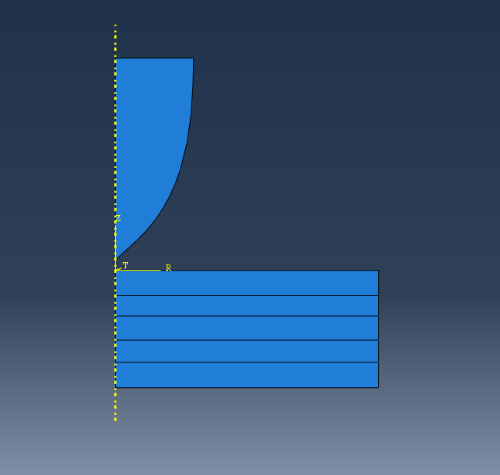
Figure 1 - Abaqus simulation projectile & laminated plate
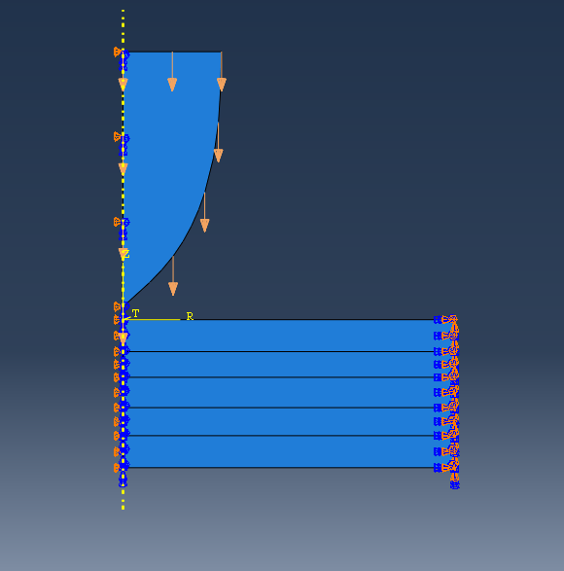
Figure 2 - Projectile direction
[Fig. 1] shows the basic setup of the simulation with the projectile and the laminated plate which is the intended target. [Fig. 2] shows the direction of the projectile prior to hitting the laminated plate. From [Fig. 1,2] you can see the target is made up of 5 laminated plates.
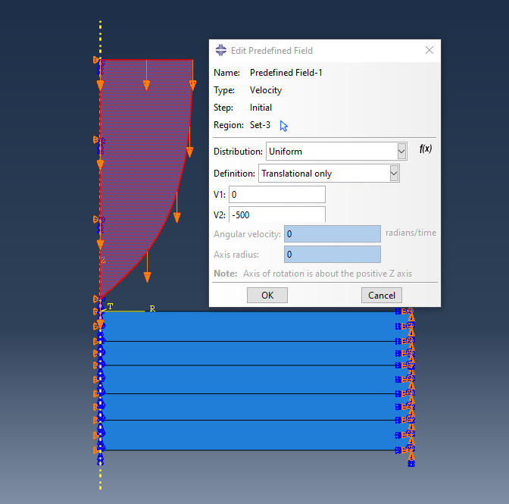
Figure 3 - Projectile Velocity
[Fig. 3] shows that the velocity of the projectile is designed to hit the target of laminated plates at 500 m/s.
As part of the assignment, it was advised to carry out various simulation setups which involved changing the materials of the laminated plates and reporting how each setup withstood being hit by the projectile and report on the stress and strain effects that occur. After conducting research online on materials that could be used as part of the laminated plate it was decided that a nickel-based Inconel alloy would be an excellent material to use as a laminated plate as it is known for its toughness and strength [7]. Nickel Inconel alloys are made up of “nickel, chromium and molybdenum composition” which all help to reduce “corrosion and pitting” [7].
After searching online for a suitable nickel Inconel alloy to use within the simulation as a laminated plate it was found the easiest material to find all properties required for the simulation was Inconel 718. Inconel 718 is used regularly within the aerospace industry due to its high strength and very high temperatures [8]. Inconel 718 is described as having a “High strain-hardening tendency, low thermal conductivity, Inconel 718 is characterised as a difficult-to-cut material” [9].
The Inconel 718 alloy was then created within Abaqus to then be assigned to a laminated plate. The figures to allow the Inconel laminated plate to be created within Abaqus came from an article “Determination of Johnson-Cook Plasticity Model Parameters for Inconel 718” [10]. Figure 4 shows the material parameters for Inconel 718 [10].
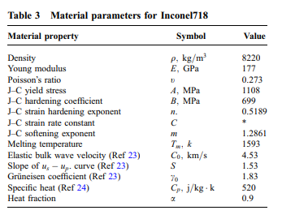
Figure 4 – Material parameters for Inconel 718
Johnson-Cook method is used to “capture strain rate sensitivity of metals” [11].
Youngs Modulus is when the elastic property of a solid material undergoes either tension or compression only in the one direction [12].
Poisson’s ratio is when “a material constant that relates stress in one direction to elastic strain in another. Stress describes an external force applied to a material and strain measures the change in shape as a result of that force” [13]
The first simulation took place using a steel projectile [Fig. 5] colliding with the laminated plate [Fig. 6] at 500 m/s. The Laminated plate is made up of three Inconel718 laminated plates with two plastic laminated plates in-between each Inconel plate.
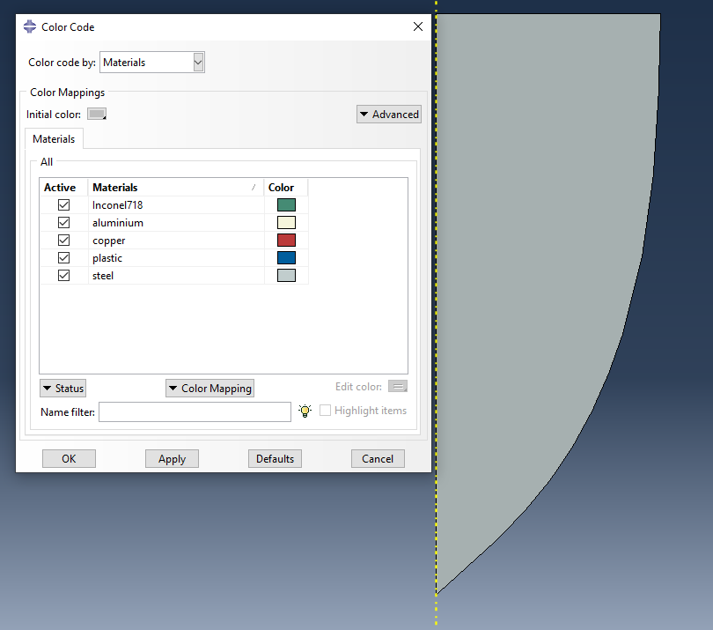
Figure 5 - Steel projectile
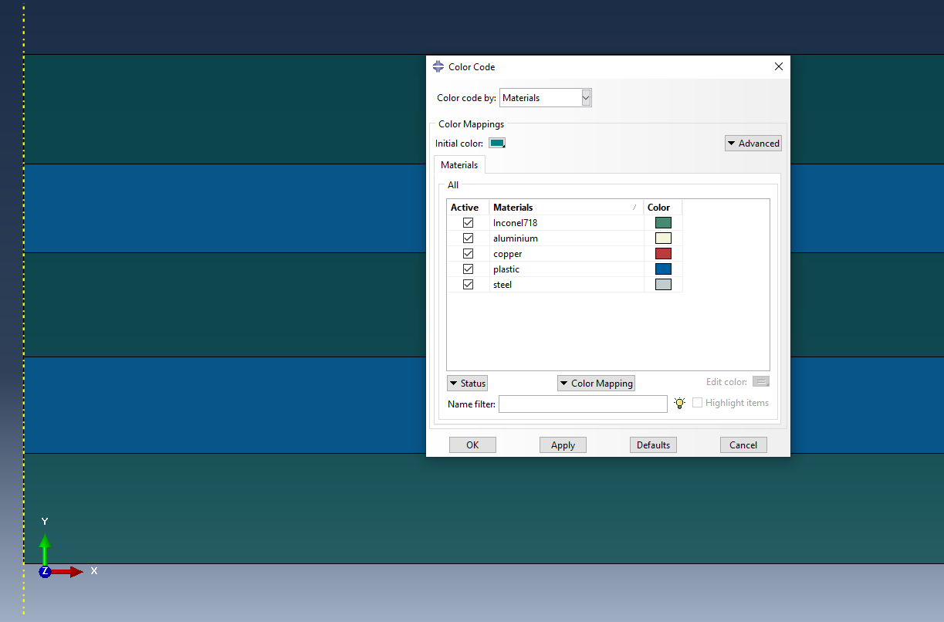
Figure 6 - Inconel/Plastic laminated Plates

The second setup consisted of a similar setup from the first with a steel projectile [Fig. 5] colliding with a laminated plate at 500 m/s and the laminated plates consisted of three Inconel plates with two steel plates in-between [Fig. 7].
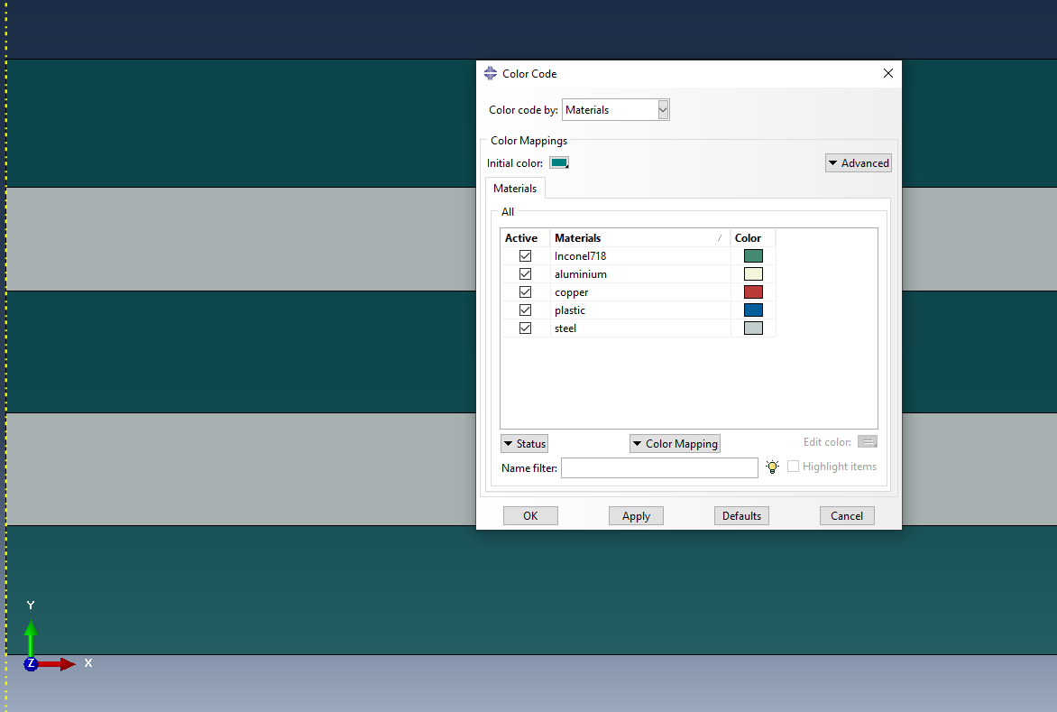
Figure 7 - Inconel/Steel laminated plates

The third and final setup consisted of a steel projectile [Fig. 5] although the velocity of the projectile was increased to 1000 m/s [Fig. 8] and the laminated plates consisted of the same set up in [Fig. 6] with Inconel and Plastic laminated plates.
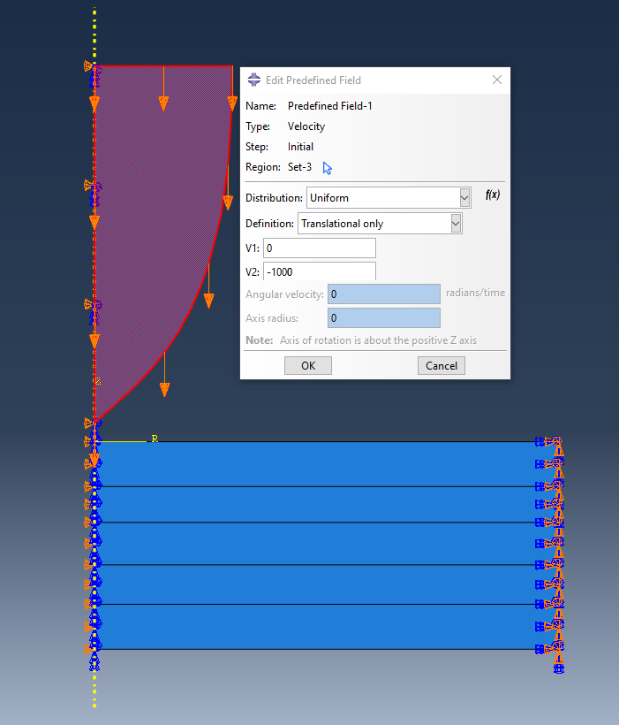
Figure 8 - Projectile Velocity 1000 m/s
- Results
The results for the 3 simulated setups will now be shown. Please note the following:
- S Max Principle within Abaqus is when the maximum principal stress in a system is greater than or equal to the yield stress (maximum strength at elastic limit), then failure will occur.
- S12 within Abaqus is sheer stress which is caused by sheer force.

3.1 Simulation First Setup Results
Max Principal Images
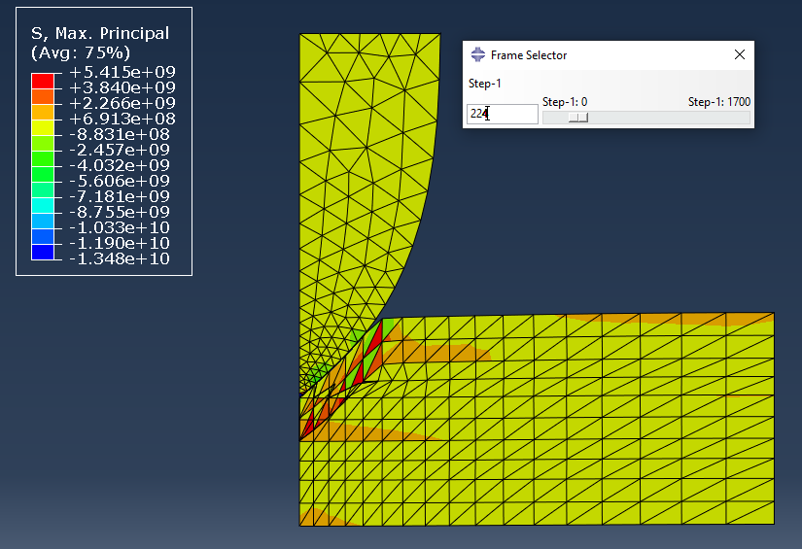
Figure 9 - Projectile hitting laminated plate
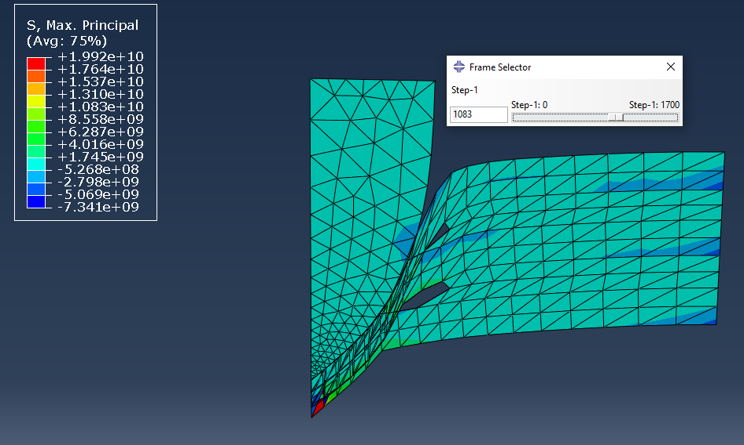
Figure 10 - Projectile nearly through laminated plate
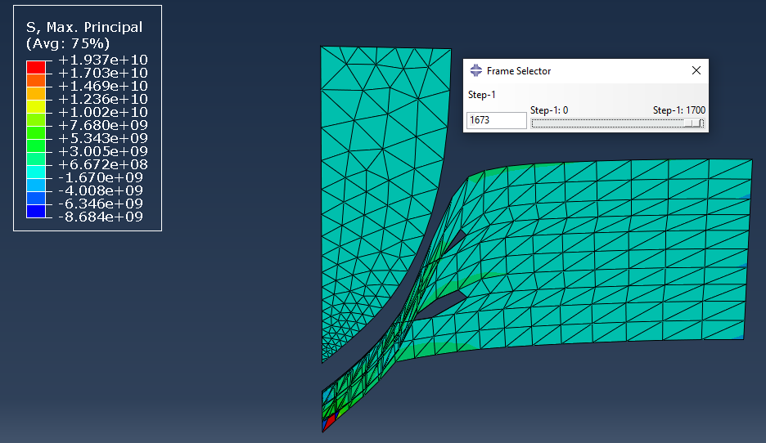
Figure 11 - Projectile bouncing back
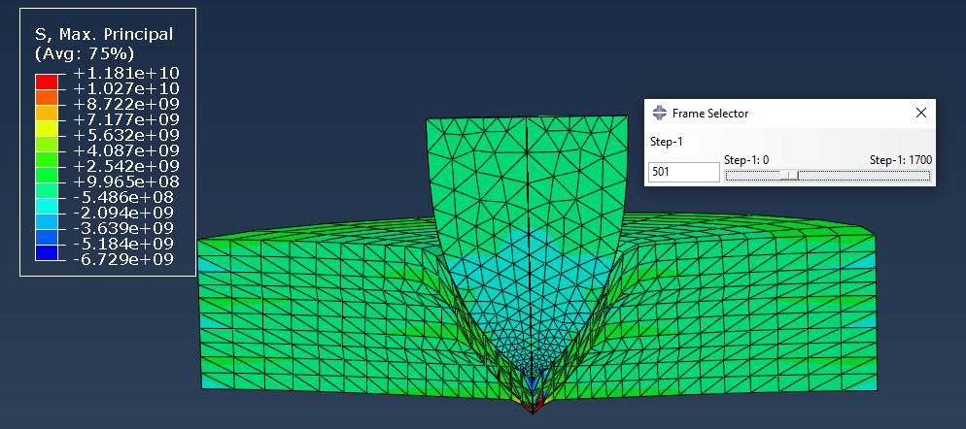
Figure 12 - Projectile going through laminated plate (Alternative View)
S12 Images
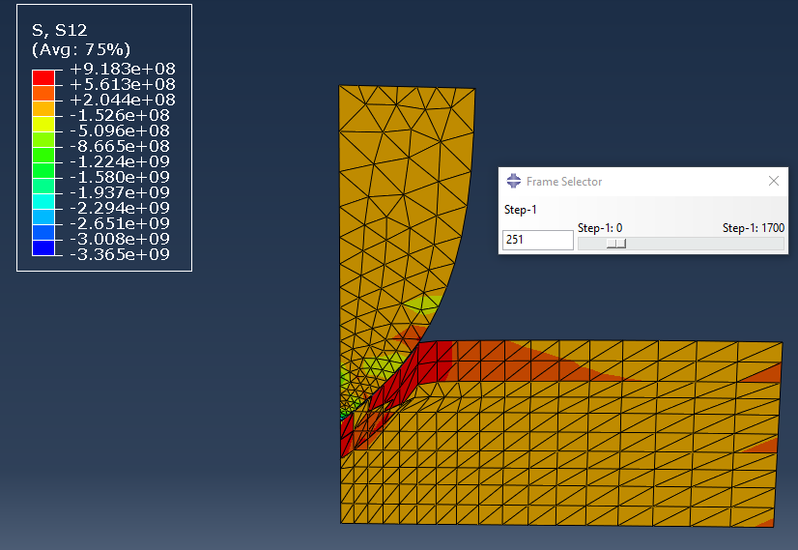
Figure 13 - Projectile hitting laminated plate
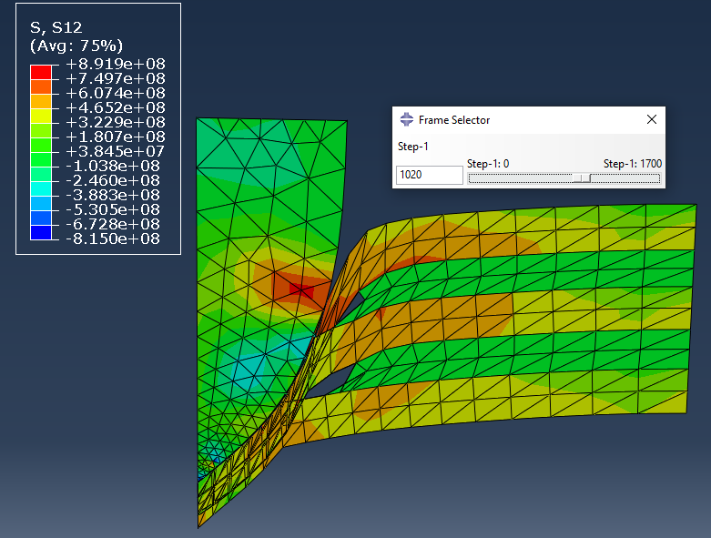
Figure 14 - Projectile nearly through laminated plate
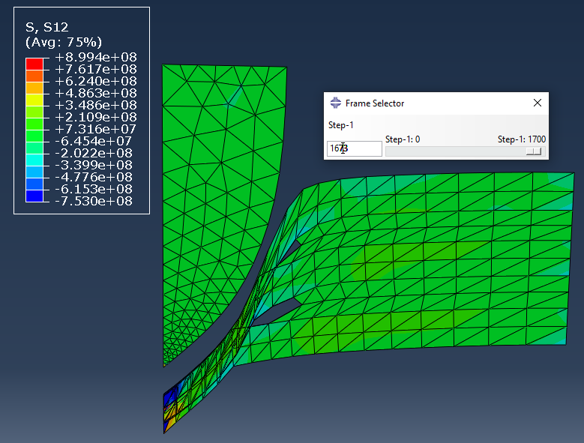
Figure 15 - Projectile bouncing back
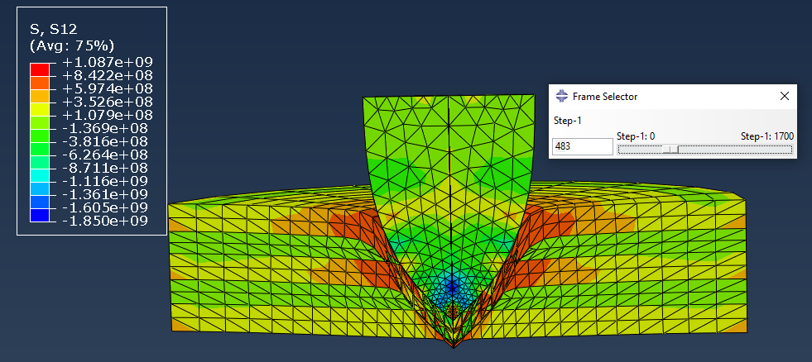
Figure 16 - Projectile going through laminated plate (Alternative View)
From the first set up it shows the projectile hitting the laminated plate then passing through the laminated plates until it nears the end, and it bounces back.
3.2 Simulation Second Setup Results
Max Principal Images
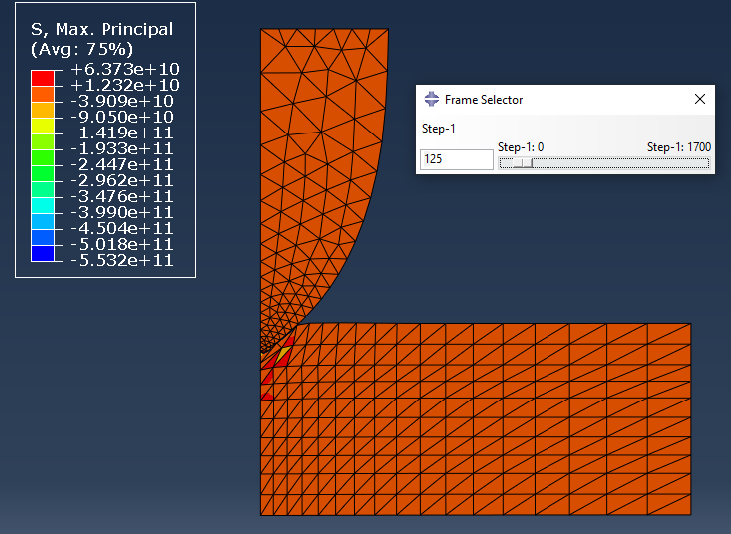
Figure 17 - Projectile hitting laminated plate
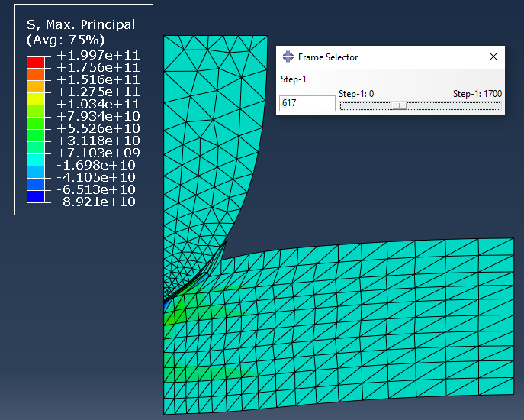
Figure 18 - Projectile on way through laminated plate
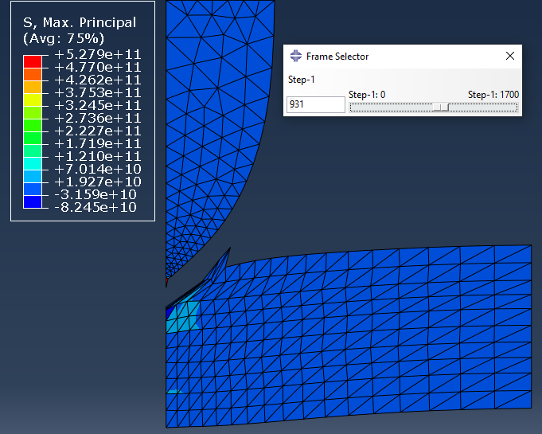
Figure 19 - Projectile bouncing back

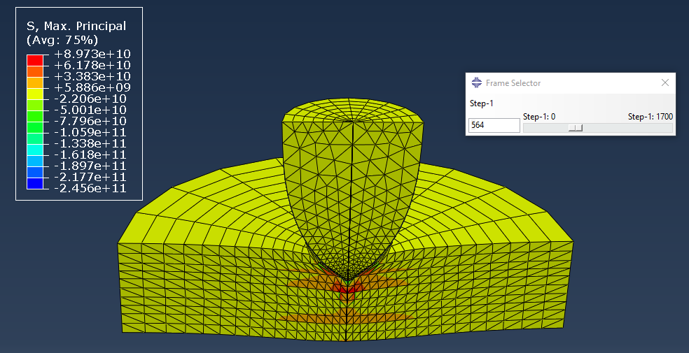
Figure 20 - Projectile going through laminated plate (Alternative View)

S12 Images
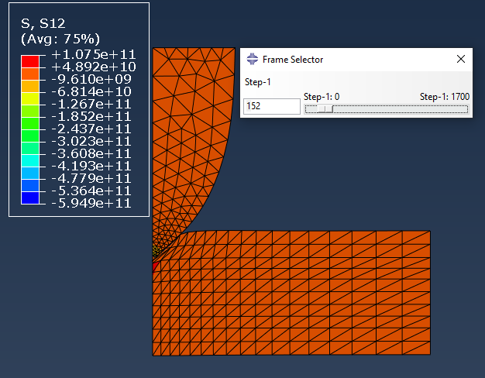
Figure 21 - Projectile hitting laminated plate
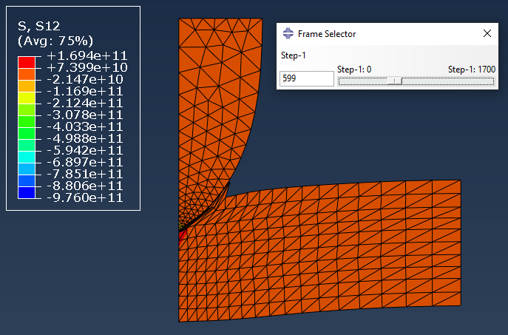
Figure 22 - Projectile on way through laminated plate
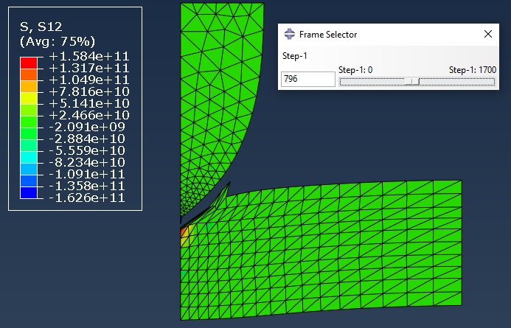
Figure 23 - Projectile bouncing back
Figure 24 - Projectile going through laminated plate (Alternative View)
From the second setup it shows the projectile hitting the laminated plate, but the projectile does not travel through the laminated plate. Instead, not long after impacting it bounces back.

3.3 Simulation Third Setup Results
Max Principal Images
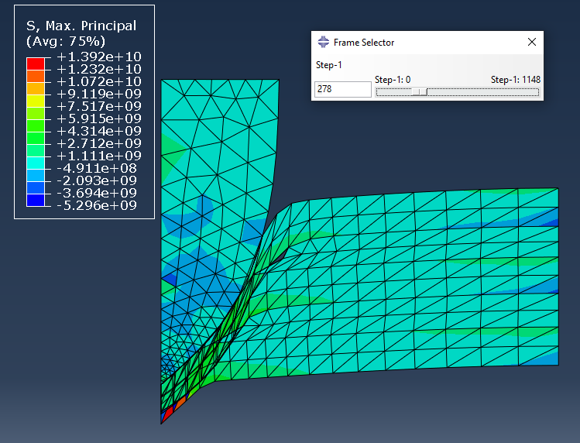
Figure 25 - Projectile hitting laminated plate
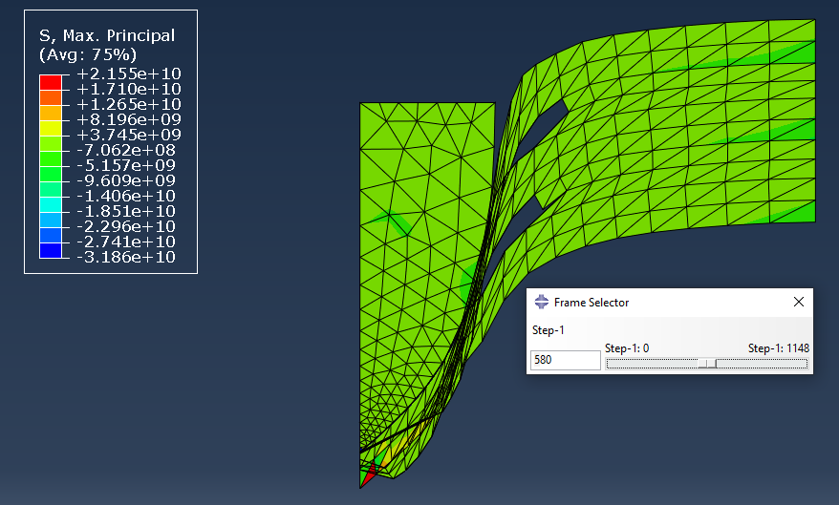
Figure 26 - Projectile passing through laminated plate
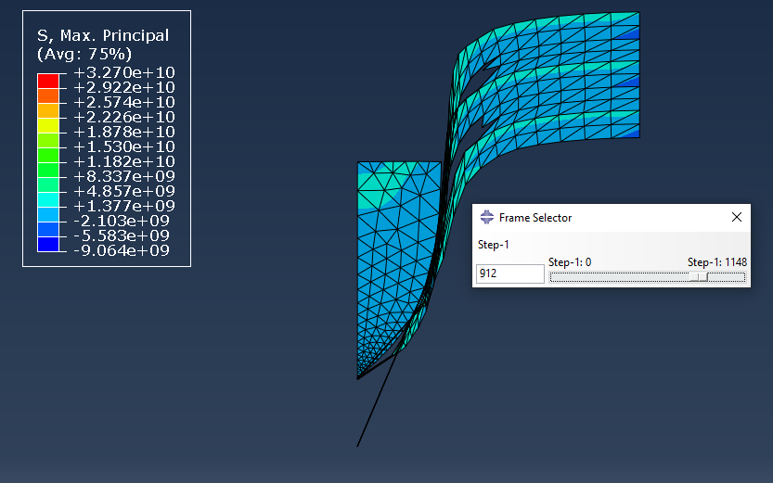
Figure 27 - Projectile smashing through laminated plate

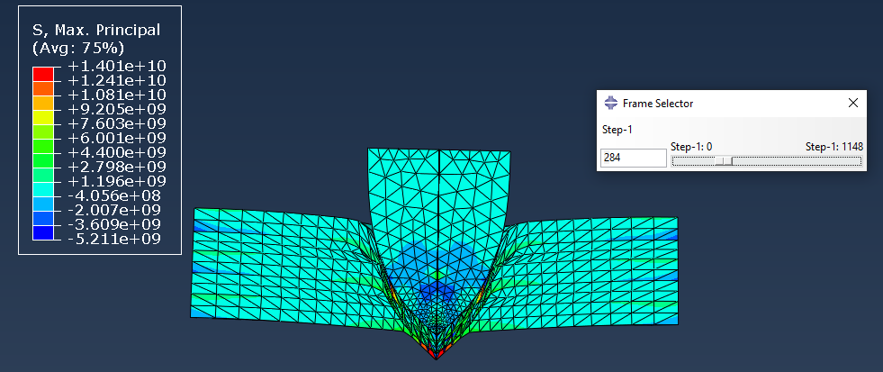
Figure 28 - Projectile going through laminated plate (Alternative View)
S12 Images
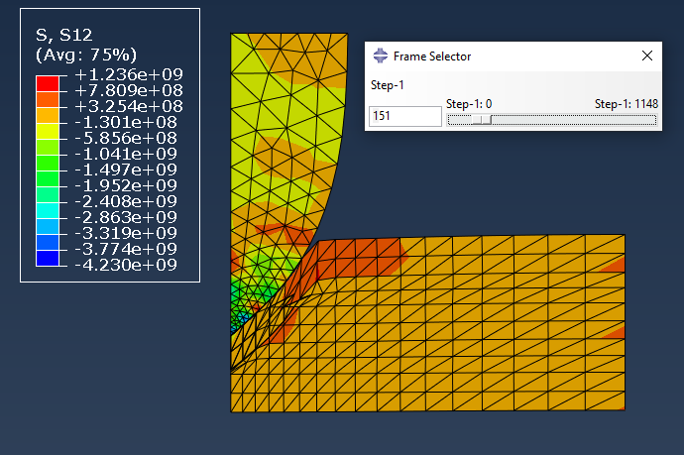
Figure 29 - Projectile hitting laminated plate
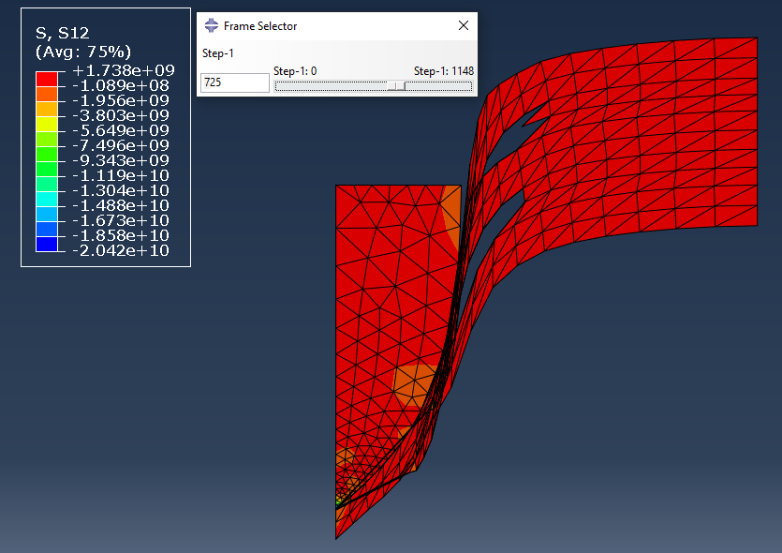
Figure 30 - Projectile passing through laminated plate
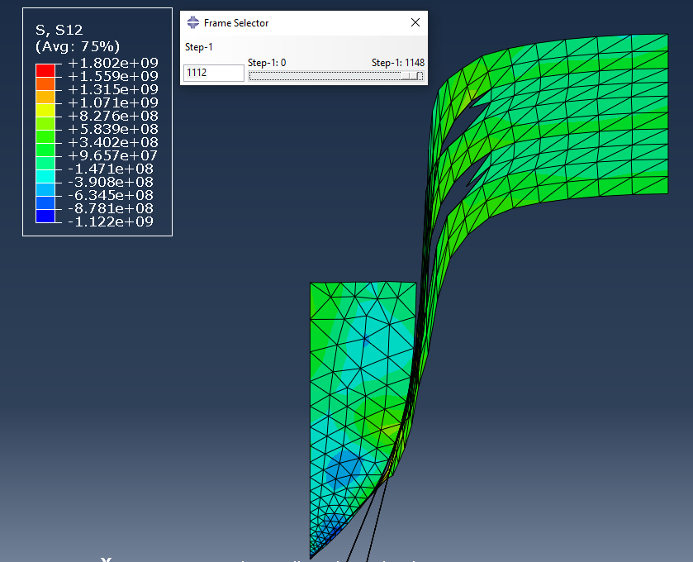
Figure 31 - Projectile smashing through laminated plate
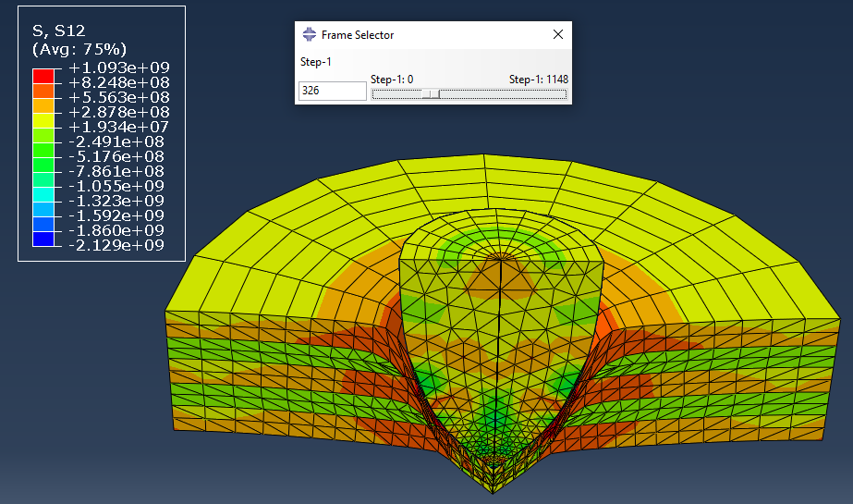
Figure 32 - Projectile going through laminated plate (Alternative View)
From the third and final setup it shows the projectile hitting the laminated plate and going through the laminated plates. Towards the end of the simulation, you can see the projectile ultimately passing through all layers and coming out the end of the final plate.

- Discussion
Simulation setup one shows the steel projectile travelling at 500 m/s and striking the laminated plates. As it hits the laminated plates [Fig. 9] it shows the first Inconel plate experiencing a high stress rate although failure has not occurred with the laminated plate still intact apart from it bending in the direction the projectile is travelling. [Fig. 10] shows that the projectile has travelled through most of the laminated plates although no failure has occurred on the Inconel plates, they have just been subjected to a high-stress rate and compressed. As they have compressed you can see mesh has been deleted from the plastic laminated plates and disappeared. [Fig. 11] shows the projectile bouncing backwards with the Inconel plates compressed together and a very high-stress rate on the very end of the compressed plates. [Fig. 13] as the projectile hits the first laminated plate the sheer impact of the collision on the laminated plate is extremely high. The stress can be seen making its way along the Inconel plate. [Fig. 14] demonstrates the high-stress rate caused by the sheer impact of the projectile although the Inconel plates remain intact although you can see the stress on the Inconel plates towards the opposite side of the impact. The plastic plate around the side of the impact can be seen as damaged as the mesh has disappeared showing no further damage along the plate as the damage has been done and no further stress can be seen. [Fig. 16] shows the projectile going through the laminated plate and the stress and strain on the Inconel plates spreading evenly along the plates starting off at a high rate around the impact of the projectile although becoming less towards the outside. The projectile itself shows a high-stress rate at the tip due to impact but no damage or failure occurs due to the steel being a tough and endurable material.

Simulation setup two shows the steel projectile travelling at 500 m/s and striking the laminated plates. [Fig. 17] shows the projectile hitting the laminated plate with a very high-stress rate on both the projectile and laminated plate. [Fig. 18] shows the stress rate majorly decreases on both the projectile and plates. A higher stress rate can be seen on the steel plates although only small. [Fig. 19] shows the projectile bouncing back without much damage being done to the plates apart from the Inconel plate at the beginning is slightly damaged. [Fig. 21, 22] shows the sheer stress caused by the sheer force of the impact and remains constant throughout the projectile and laminated plate. The highest damage can be seen on the laminated plate where the tip of the projectile has collided with it. [Fig. 23] shows as the projectile bounces back and very limited damage has occurred to the laminated plates. The first Inconel plate has taken the force of the projectile although the steel plate underneath has stopped the projectile in its path and caused it to bounce back. [Fig. 24] shows just before the projectile begins to bounce back there is a high-stress area created from the impact but no failure of the materials.

Simulation setup three is the exact same setup as the first simulation apart from the velocity of the bullet has been increased from 500 m/s to 1000 m/s. [Fig. 25] shows the projectile hitting the laminated plates but due to the higher velocity, less stress has occurred compared to [Fig. 9] on the projectile and plates. [Fig. 26] shows the projectile passing through the plates with the Inconel plates compressing heavily but not able to stop the projectile from travelling through each layer. The plastic mesh can be seen as being deleted more heavily compared to [Fig. 10] showing more of the plastic has been damaged due to the higher velocity of the projectile. [Fig. 27] shows the projectile has made its way through all layers of the laminated plates. [Fig. 30] shows the sheer stress caused by the sheer force of the projectile as it passes through the laminated plates and the damage caused. The projectile itself is suffering from a high-stress rate but remains intact and doesn’t suffer damage as it makes its way through the layers of laminated plates. The result of the projectile travelling at a higher velocity has shown that more damage will occur compared to the first simulation where the projectile was travelling at a lower velocity.

- Conclusion
From the simulations carried out in Abaqus, it can be assumed from the results given that for armour plating to be successful in stopping a projectile from causing damage it has to be made of materials that can withstand the force it will face. The Inconel718 material within the Abaqus simulations showed that layered with steel it could withstand a projectile incoming at 500 m/s with minor damage caused to the plates themselves. Although further simulations would need to be carried out at higher velocities to see at what point they could fail to provide such protection. The Inconel paired with plastic showed in simulation one that it prevented the projectile from penetrating fully through the laminated plates although it did show signs of heavy damage and compression to the Inconel layers. As the velocity of the projectile was increased in simulation three to 1000m/s it proved fatal that it could not be recommended to be used as the projectile smashed its way through all the layers coming out the other end of the plates. Based on all three simulations carried out the Inconel718 material combined with steel proved to be the strongest and could be said to represent a suitable combination within armour plating although various other simulations and tests would need to be carried out to prove this to be a true reflection. All three simulations showed stress caused by the projectile and the sheer force it had on the materials used and showed the differences within each material (Inconel718/plastic/steel) react when put under the stress and strain caused by the simulations.

- References

References

[1] | Masteel, "The History of Armour Plate Steel," 02 February 2018. [Online]. Available: https://masteel.co.uk/news/history-armour-plate-steel/. [Accessed 04 April 2022].
[2] | I. G. Crouch, "Body armour - New materials, new systems," Defence Technology, pp. 241-253, 2019.
[3] | A. Bhat, J. Naveen, M. Jawaid, M. Norrahim, A. Rashedi and A. Khan, "Advancement in fiber reinforced polymer, metal alloys and multi-layered armour systems for ballistic applications - a review," jmr&t, pp. 1300-1317, 2021.
[4] | G. Thomas, "Ceramic Armor – Materials, Properties and Uses," AZO Materials, 28 January 2013. [Online]. Available: https://www.azom.com/article.aspx?ArticleID=8092. [Accessed 04 April 2022].
[5] | F. d. O. Braga, L. T. Bolzan, F. S. d. Luz, P. H. L. M. Lopes, E. p. L. Jr and S. N. Monteiro, "High energy ballistic and fracture comparison between multilayered armor systems using non-woven curaua fabric composites and aramid laminates," jmr&t, pp. 417-422, 2017.
[6] | P.-r. Li, Q.-b. Fan, X.-j. Zhu and H.-c. Gong, "Study of high-speed-impact-induced conoidal fracture of Ti alloy layer in composite armor plate composed of Ti- and Al-alloy layers," Defence Technology , pp. 1434-1443, 2021.
[7] | T. S. &. Materials, "Nickel Inconel Alloys," [Online]. Available: https://www.techsteel.net/alloy/nickel/inconel-alloys#:~:text=What%20is%20Inconel%3F,performance%20capabilities%20under%20high%20temperatures.. [Accessed 06 April 2022].
[8] | D. Forni, F. Mazzucato, A. Valente and E. Cadoni, "High strain-rate behaviour of as-cast and as-build Inconel 718 alloys at elevated temperatures," Mechanics of Materials, vol. 159, 2021.
[9] | F. da Silva, L. Denguir and J. Outeiro, "Residual stresses prediction in machining of Inconel 718 superalloy using a constitutive model considering the state of stress," pp. 527-532, 2020.
[10] | H. Farahani, M. Ketabchi and S. Zangeneh, "Determination of Johnson-Cook Plasticity Model Parameters for Inconel 718," Journal of Materials Engineering & Performance, vol. 26, no. 11, pp. 5284-5293, 2017.
[11] | A. Banerjee, S. Dhar, S. D. D. Acharyya and N. Nayal, "Determination of Johnson cook material and failure model constants and numerical modelling of Charpy impact test of armour steel," Materials Science & Engineering, pp. 200-209, 2015.
[12] | T. e. o. E. Britannica, "Young's Modulus," Britannica , [Online]. Available: https://www.britannica.com/science/Youngs-modulus. [Accessed 06 April 2022].
[13] | N. Rogers, "Poisson's Ratio: Definition & Equation," Study.com, [Online]. Available: https://study.com/academy/lesson/poissons-ratio-definition-equation.html. [Accessed 06 April 2022].

