Management & Organisational Behaviour
BMIH5004
Syeda Samia Begum
2130491
Charlotte Joyner

Table of Contents
Introduction 1
Company overview 1
Organisational structure, culture and goals 2
Organisational structure 2
Organisational culture 4
Goals 5
Change initiatives, their impacts and how well these were managed 6
Change initiatives and their impact 6
How well these changes have been managed 8
Organisational strategic direction and current business performance 10
Conclusion 11
References 12

Introduction
Management and organisational behaviour are essential paradigms for any business organisation, especially for the hotel businesses in the hospitality industry. Here, management is the process through which companies direct and organise their operations, workflows and employees to achieve predetermined organisational goals (Rollinson, 2008). On the other hand, organisational behaviour refers to the analysis of people’s behaviour within an organisational setting, what principles they follow and the way they interact with their surroundings (Robbins, Judge and Campbell, 2008). Here, the purpose of this written essay is to conduct an audit on Hyatt Hotel Group to analyse and critically evaluate its organisational elements with relevant theories and models. For this, its structure, culture, goals, and recent change initiatives are going to be highlighted along with their impact and how well the changes have been managed. At the end, this paper will discuss Hyatt’s strategic direction and current business performance critically.

Company overview

Figure 1: Corporate logo of Hyatt Hotel Group.
Source: (Hyatt Corporation, 2024).
Hyatt Hotel Group, commonly recognised as Hyatt Hotels and Resorts, is a multinational hotel and resort chain operating in the hospitality industry, competing with other organisations like InterContinental, Premier Inn and others. This hotel group initiated its journey in 1957 and now operates from its main headquarters in Illinois, USA (Portman, 2023). Besides, the organisation has worldwide operations with over 1,350 hotels with almost 3,50,200 rooms to serve its wide range of customer demographics (Hyatt Corporation, 2024). Now, this public limited company with 66 years of experience is housing approximately 1,89,000 talented employees (Portman, 2023). As of the latest information, Hyatt Hotels has generated over £475 million as net income in 2023 (Hyatt Corporation, 2024). Based on the statistics, Hyatt is now operational in over 75 countries over 6 continents targeting travellers and tourists from upscale, luxury and all-inclusive upscale which has made it able to secure an overall 11.86% of the global hospitality market share (Portman, 2023).

Organisational structure, culture and goals

Organisational structure
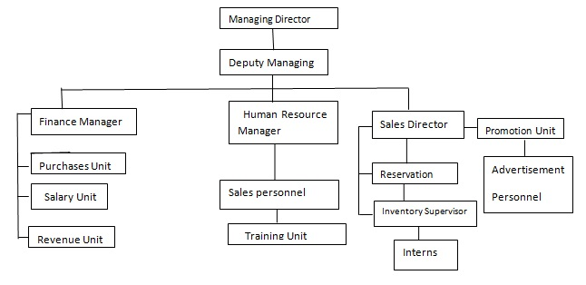
Figure 2: Organogram of Hyatt Hotel Group.
Source: (Hyatt Corporation, 2024).
Out of several types of organisational structures with different sets of benefits, Hyatt, as a hotel chain, practices a hierarchical organisational structure for a more organised flow of information and command (Parnham, 2023). Through this structural practice, the hotel has ensured proper order in the organisational premises where each working individual reports and seeks decisions from their superiors. As employees are clear about their duties and reporting stations, employees work with full engagement with specific aims assigned by their heads (Nandy, 2020). Besides, this kind of structure also motivates its employees with a clear career path as they know their next promotion in the corporate ladder. Each of its hotels and resorts is managed by individual deputy managers to whom Finance Managers, HR Managers, Sales Directors and others report. On the other side, the organisation is also facing delays in decision-making due to increased bureaucracy which also slows down any chance for innovation as decisions must always be made by the higher officials (O’Connor, 2022). Moreover, the employees working in the lower level of the organogram often feel like they cannot contribute new ideas and only act in the interest of their respective departments, not the overall company. In short, due to the implementation of a hierarchical structure, Hyatt’s decision-making process has been slowed by 26%, yet it has also increased operational clarity and control by 47% (Parnham, 2023).

Organisational culture
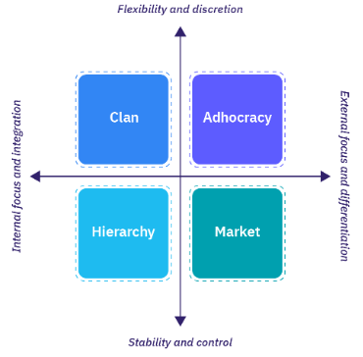
Figure 3: Types of organisational culture.
Source: (Nandy, 2020).
From organisational culture such as adhocracy, market, clan and hierarchy, Hyatt, as an organisation dedicated to thriving in the hospitality industry with a growing concern for its people, practices culture like clan culture. The organisation applies human-centric approaches where everyone is treated like a part of its extended family (Mullins and Dossor, 2013). Besides, it believes in teamwork and participation. For this instance, the organisation focuses mostly on training and motivating its employees to develop them and improve their efficiency in the operational process of Hyatt. Apart from this, the hotel has been able to establish clear communication and a healthier working environment which is now assisting it in fostering productivity, ideas and feedback (Mullins, 2020). On the downside, due to nurturing clan culture, over-collaboration and personality clashes are occurring frequently creating challenges during people management. As for the overall comment, clan culture is advocating development and growth for Hyatt’s people, but still, it also creates a bit of turbulence in workforce management (Jackson, 2021).

Goals
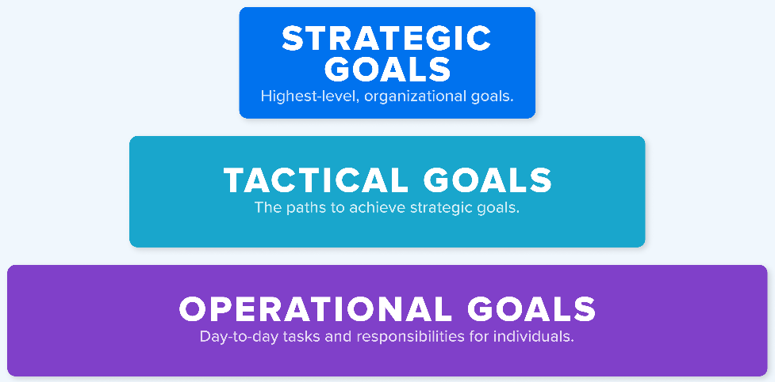
Figure 4: Levels of organisational goals.\
Source: (Mullins, 2016).
Strategic goal: This type of goal is the business objective an organisation is willing to achieve in the long term (Huczynski and Buchanan, 2013). Hyatt’s current strategic goal is to develop an ideal future-state experience within the next 10 years by caring for the planet and people for more sustainable and profitable business (Hyatt Corporation, 2024).
Tactical goal: Tactical goals narrow down the scope of the strategic goal that consists of short-term attainable objectives to support the organisation’s overall strategy (Mullins, 2016). Hyatt to provide an ideal future-state experience has taken initiatives to transform 70% of its existing hotels across the globe into green hotels within the shorter period of the next 5 years (Hyatt Corporation, 2024).
Operational goal: Operational goals are attainable operation-focused objectives set to accomplish over a much shorter course of time which can take one to two years or can be even executed as day-to-day operations (Armstrong, 2012). Hyatt as a hotel and resort chain is currently focused on shifting to renewable energy from biofuel, managing 91% of its waste through recycling and decreasing operational costs within a marginal point of 34% to provide a more affordable and eco-friendly experience to its guests to achieve the mentioned strategic goal (Hyatt Corporation, 2024).

Change initiatives, their impacts and how well these were managed

Change initiatives and their impact
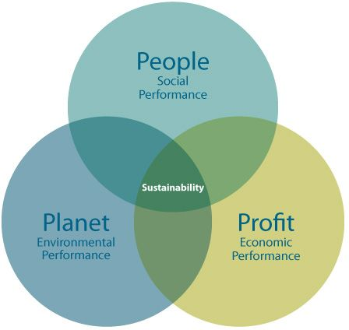
Figure 5: 3Ps of sustainability.
Source: (Holyoak, 2022).
People: Hyatt, as a multinational hotel chain, is working to improve the human lives of both its customers and employees. The organisation with a vision to uphold diversity has taken initiatives to care for people and maintain human rights (Jackson, 2021). Here, the business has introduced an INSPIRIT mentoring program to welcome equality and empower females within its workplace. Besides, the organisation now populates people from every gender, race and culture and has a zero-tolerance policy against any kind of discrimination and harassment. As a result, the workforce productivity of Hyatt has increased by 34% as people working there feel valued and fairly treated (Portman, 2023).
Profit: As for profit, the organisation has shifted to a fair pay policy where its people are being paid according to their performance through fair evaluation (Boddy, 2014). This helps the company by identifying the productive workforce and dismissing the rest to cut costs. Moreover, the organisation now has changed most of its perishable packages into non-perishable but eco-friendly mediums where most of its plastic bottled commodities like shampoos and paper tissues have been replaced with glass bottles and towels (Gill, 2020). This initiative has not only proven eco-friendly but also economical as these items can be reused and recycled easily to reduce costs. Through these changes, the organisation currently has been able to save 23% of its initial operational budget and is now willing to introduce more initiatives like these in the future (Portman, 2023).
Planet: Hyatt currently has an aim to become a responsible business through caring for the planet. Due to rapid climate change and rising energy costs, the hotel chain management has shifted most of its operations to a Green-e Energy certified renewable power source to offer more carbon-neutral business (Gill, 2020). Besides, the business has initiated internal policies for water conservation, waste management and environment protection which have helped the organisation increase its brand value. This change might have increased its operational costs a bit but has increased customer satisfaction and engagement which is 31% more than its previous years (Holyoak, 2022).

How well these changes have been managed
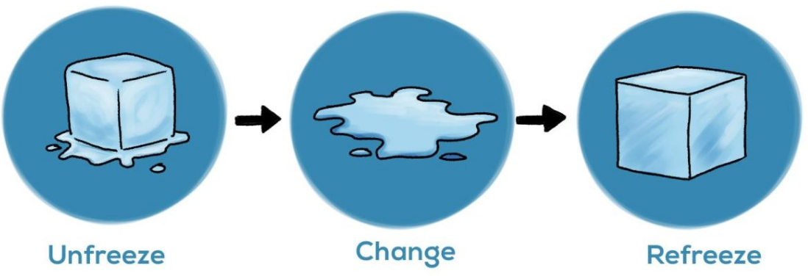
Figure 6: Lewin’s change management model.
Source: (Adair, 2009).
Unfreeze: To deliver on how well these change initiatives have been managed, it can be acknowledged that Hyatt’s management team through thorough investigation and evaluation has identified the sources where they needed to change. After the COVID-19 pandemic, the business analysed the market situation and found that it needs to optimise its operational costs and make the business more customer-friendly through eco-friendly and renewable initiatives (O’Connor, 2022). For this, the organisation has laid off ineffective employees from its operation. Besides, the organisation later thought of alternatives to plastic, Styrofoam and others to eliminate their usage for more greener approach. Moreover, the organisation identified that most hotels are implementing renewable energies to save their costs and the planet which motivated Hyatt to use it too.
Change: To properly initiate the change, the organisation trained its effective officials and workers on how to work efficiently using technology and work collaboratively regardless of their differences of race, gender or ethnicity. Communication, culture and teambuilding exercises have been given to improve relations among its people and their productivity (Bloisi, Cook and Hunsaker, 2007). Besides, the hotel chain has installed solar panels and food waste management plants to utilise solar energy for electricity and biofuel for cooking purposes. It has also established a water purification system to reuse the water used or wasted. As mentioned earlier, Hyatt has replaced most of its paper and plastic-based commodities with glass and cloth-based products for zero carbon emission (O’Connor, 2022).
Refreeze: Hyatt now closely monitors its implemented changes within its overall operations and investigates for newer, economic and eco-friendly approaches to sustain its business without compensating its quality service provision (Parnham, 2023). The HR team is deliberately working to ensure each working member is performing at their best and the operations team is making sure optimum functions through ecological approaches (Arnold, 2005).
Based on this, it can be stated that the organisation’s change initiatives have been continuously being managed by following appropriately and keeping the concern for its people, profit and the plant in mind.

Organisational strategic direction and current business performance
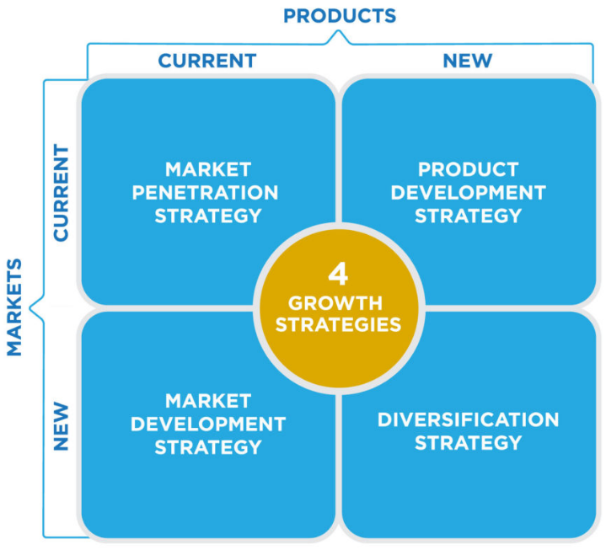
Figure 7: Ansoff’s strategic growth matrix.
Source: (Armstrong, 2012).
Hyatt, from the choice of penetrating the market, developing product and market, and implementing a fully diversified strategy, has chosen and has been following market penetration strategy as its strategic direction (Parnham, 2023). Hotels and resorts are not something new and all the services provided within the hospitality industry are mostly the same and followed by all hotels. So, the organisation has been working to increase its market share through service improvisation where its services are deliberately being modified based on customers’ demands and industry needs. This process may be slow and the organisation has been dealing with lots of competition from the existing businesses within the existing market, yet, it is gradually reaching its intended goal (O’Connor, 2022). As for its current business performance, Hyatt has increased its revenue by 5% from the last year and is currently planning to open 66 new hotels in the UK for its larger market expansion (Jackson, 2021). Almost 55% of the customers in the UK are aware of the Hyatt brand and the hotel chain is on the top 10 lists of tourist preferences in terms of hospitality and quality services (Holyoak, 2022).

Conclusion
In sum, management in organisations, especially hospitality businesses is essential and Hyatt from the audit has been found to manage its operations with swiftness. From the study, it has been identified that the business implements a hierarchical structure, nurtures clan culture and has very clear goals reflecting environmental concerns. Furthermore, the organisation has initiated changes like waste management and others and has been managing it well with mostly positive impacts. Finally, Hyatt has been found going in the strategic direction of market penetration to grab larger market shares through market expansion.

References
Adair, J. (2009) The Inspirational Leader: How to motivate, Encourage & Achieve Success. 2nd edn. London: Kogan Page.
Armstrong, M. (2012) Armstrong’s Handbook of Management and Leadership: a Guide to Managing for Results. 3rd edn. London: Kogan Page.
Arnold, J. (2005) Work Psychology: Understanding Human Behaviour in the Workplace. 4th edn. Harlow: Prentice Hall.
Bloisi, W., Cook, C. and Hunsaker, P.L. (2007) Management and Organisational Behaviour. 2nd edn. Maidenhead: McGraw-Hill.
Boddy, D. (2014) Management: An Introduction. 6th edn. Harlow: Pearson.
Buchanan, D.A. and Huczynski, A. (2007) Organizational Behavior: An Introductory Text. 6th edn. Harlow: Prentice Hall.
Gill, R. (2020) ‘Change management--or Change leadership?’, Journal of Change Management, 3(4), pp. 307–318.
Holyoak, L. (2022) ‘Organisational Culture: Organisational Change?’, Leadership & Organization Development Journal, 23(6), pp. 354–355.
Huczynski, A. and Buchanan, D.A. (2013) Organizational Behaviour. 8th edn. Harlow: Pearson.
Hyatt Corporation (2024) About Hyatt, Hyatt. Available at: https://about.hyatt.com/ (Accessed: 24 January 2024).
Jackson, A.J. (2021) ‘Adopting Change Initiatives during Economic Downturns’, SSRN Electronic Journal, 2(5).
Mullins, L.J. (2016) Management & Organisational Behaviour. 11th edn. Harlow: Pearson.
Mullins, L.J. (2020) Organisational Behaviour in the Workplace. 12th edn. Harlow: Pearson.
Mullins, L.J. and Dossor, P. (2013) Hospitality Management and Organisational Behaviour. 5th edn. Harlow: Pearson.
Nandy, R. (2020) ‘Understanding Organisations through Perceptions of Organisational Goals’, Indian Journal of Public Administration, 26(4), pp. 1076–1088.
O’Connor, M. (2022) ‘Entropy, structure, and Organisational Change’, Ecological Economics, 3(2), pp. 95–122.
Parnham, M.J. (2023) ‘Recent Organisational Changes’, Inflammation Research, 53(8).
Portman, J. (2023) ‘Hyatt Regency’, Informes De La Construcción, 28(275), pp. 3–10.
Robbins, S.P., Judge, T.A. and Campbell, T.T. (2008) Organizational Behaviour. 5th edn. Harlow: Pearson Education Ltd.
Rollinson, D. (2008) Organisational Behaviour and Analysis: An Integrated Approach. 4th edn. Harlow: Addison-Wesley Longman.

