

Foreign Languages and Cultural Awareness
LEVEL 5
Student Name: Elena Daniela Gavril
Student ID: 2207241
Tutor: Lisa Bassler
Executive Summary
This report has produced a cultural difference between Germany and the UK. Diversity Hotel & Spa is aiming to expand its business in Germany and this report has recommended some strategies to avoid cultural conflicts. The Globe project has been analyzed in this report. Along with this the cultural overview and PESTLE analysis of Germany have been demonstrated here as well.

Table of Contents
1. Introduction 4
2. Description 4
2.1 Globe Project Analysis between the UK and Germany 4
2.3 Cultural Overview 6
2.4 Country Analysis 7
2.5 Why cultural intelligence and sensitivity are essential for hotel personnel in Germany 8
3. Recommendations 9
4. Conclusion 9
References 11

1. Introduction
The aim of this paper is to produce an intercultural competence report to analyse the cultural differences and external factors between the UK as well as Germany. Diversity Hotel & Spa is a 5-star hotel in London which is trying to expand its market in Germany. This report will analyse the comparative factors between the two countries and provide recommendations to train hotel personnel of Diversity Hotel & Spa.

2. Description

2.1 Globe Project analysis between the UK and Germany
According to the Globe Project, there are nine cultural dimensions such as power distance, uncertainty avoidance, institutional collectivism, in-group collectivism, future orientation, performance orientation, gender egalitarianism, assertiveness and humane orientation. The performance orientation and future orientation score is medium for both countries, but Germany is the most assertive country. This is a highly decentralized country and most of the population is in the middle-income group. The power distance score of Germany and the UK is low as both of them consider that there are inequalities in society (Globe Project, 2023). Similarly, both of these countries also consider the privacy and individualism of their populations. Germany and Britain both are decisive societies which are highly success oriented. Employees work to enhance their professional careers and have proper performance ambitions. The uncertainty avoidant rate is medium for Germany as the Germans prefer to avoid any type of uncertainty and plan the whole day before (Globe Project, 2023). On the other hand, the rate of the UK is low in uncertainty avoidance as the British population have a risk-taking mindset. They are not interested in planning and are flexible according to situations. The institutional collectivism rate is also quite similar for both countries where people plan for long-term achievements and future consequences as well (Deresky, 2017). People's actions in Germany are restricted by social norms and they consider investing time in achieving their goals rather than leisure time.
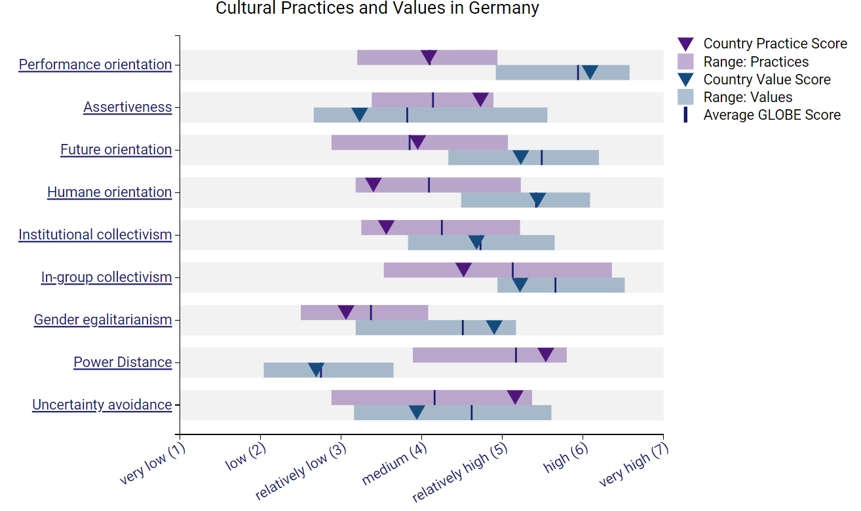
Figure 1: Cultural values and practice in Germany

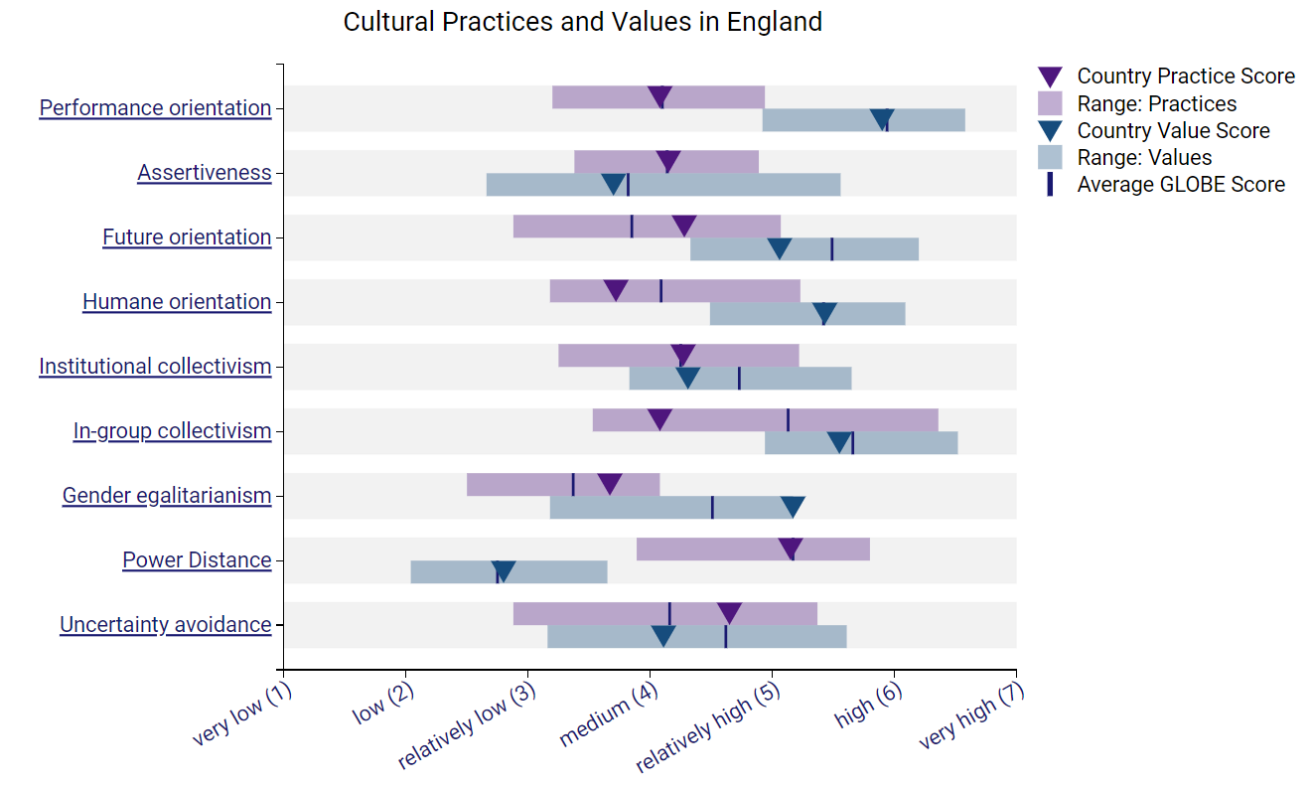
Figure 2: Cultural values and practice in England

2.3 Cultural Overview
Germany has a rich history of art, music and food which denotes the overall German culture. There are various cultural values and traditions which businesses must respect to operate their businesses in Germany. Germans are very punctual, and they value their time efficiently (Expatrio, 2022). Eventually, they are also particular about their privacy and prefer to maintain a proper balance with their personal as well as professional lives. Higher education is one of the common things among Germans as they are very efficient in technology. On the other hand, Germany is the land of celebrations. There are several festivals and carnivals in Germany which attract global tourists. Along with this, gender equality and LGBT rights are other important considerations in Germany for overseas businesses (Expatrio, 2022). Germans follow a particular food culture which includes bread, potatoes and meat. Including this, beer, cakes and coffee are other must-haves for Germans (Expatrio, 2022). They also enjoy home-cooked meals which are rich with salad, vegetables and noodles. Shaking hands, welcoming guests and human eye contact are the key considerations for German guests (Expatrio, 2022).

2.4 Country Analysis

Factors | Analysis | Impact
Political | - Germany is a Federal and Democratic Republic where the chancellor is the head of the government.  - Due to Brexit, the political stability of Germany was affected, and political landscapes were also changed. | High
Economic | - Germany is the 4th largest global economy, but the manufacturing and industrial production is falling here.  - The current corporate tax rate is 15.82% in Germany and businesses have to pay 5.5% of their tax as a solidarity surcharge (GTAI, 2023). | Moderate
Social | - The current population of Germany is 84 million and it is the second most popular European country (Worldometers, 2023).  - It is a cosmopolitan country where 70% of people are Christian and 4.4% are Muslim. A huge number of migrants are also there. | High
Technical | - Germany is the 5th technically advanced country in the EU.  - It has 14% of the global market share in eco-friendly businesses.  - Companies use AI, robotics, Automation, drones, cloud technology and blockchain technologies in their operations.  - The German government has provided €3 billion for AI development. | Low
Legal | - The German government provides various benefits to foreign investors and businesses.  - The Working Time Act, the Federal Vacation Act, the Maternity Protection Act and other employment laws need to be considered by employers in Germany (L&E Global, 2023). | Moderate
Environmental | - Tourism is a vital industry in Germany which contributes 4.5% of the national GDP.  - It is the land of architecture, monuments, palaces, cathedrals, mountains and forests.  - Germany is facing various environmental challenges such as acid rain, air pollution, plastic wastage and other issues. | High
Table 1: PESTLE analysis of Germany
(Source: Author)

2.5 Why cultural intelligence and sensitivity are essential for hotel personnel in Germany
Cultural intelligence and sensitivity enhance cultural awareness among employees (Christiansen et al., 2020). Employees of Diversity Hotel & Spa will be aware of German etiquette and can improve their work quality. They will learn the guests' welcoming behavior, especially for German guests which will improve the brand's reputation. Cultural intelligence also promotes effective communication (Abramson and Moran, 2018). Hotel personnel of Diversity Hotel & Spa can help customers resolve their queries and will provide a great hotel service as well. Cultural sensitivity also improves the sense of empathy and leads to proper professional behavior for employees.

3. Recommendations
- Diversity Hotel & Spa need to consider German etiquette properly for welcoming guests and providing customer services. The management can hire local professionals for guest service which will promote the brand's reputation in Germany (Maheshkar and Sharma, 2018).
- The management needs to be aware of the reaching and appointment times of German guests.
- They can organize cultural training for existing employees to enhance their cultural knowledge about Germany (Maheshkar and Sharma, 2018).
- Diversity Hotel & Spa have to create a local supply chain in Germany to reduce the supply chain costs.
- Considering competitors' pricing and functional policies will help Diversity Hotel & Spa develop its own competitive strategies.

4. Conclusion
This report has demonstrated the cultural similarities and differences between the UK and Germany through the Globe project. A cultural overview of Germany has been also projected here. This report has analyzed the external factors of Germany which can affect the business expansion of Diversity Hotel & Spa in the German market. The importance of cultural intelligence for hotel personnel and some recommendations for Diversity Hotel & Spa have been evaluated at the end of this report.

References
Abramson, N.R. and Moran, R. (2018) Managing Cultural Differences: Global Leadership for the 21st Century. 10th Ed. Abingdon: Routledge.
Christiansen, B., Branch, J.D. and Karmowska, J. (2020) Cultural Factors and Performance in 21st Century Businesses. Hershey : IGI Global.
Deresky, H. (2017) International Management: Managing Across Borders and Cultures: Text and Cases. 9th Ed. Harlow: Pearson Education Ltd.
Expatrio, (2022). German Etiquette - Do's and Don'ts. Available at: https://www.expatrio.com/blog/2022-03/german-etiquette-dos-and-donts [Accessed 16 October 2023]
Globe Project, (2023). England. Available at: https://globeproject.com/results/countries/GBR?menu=list#country [Accessed 16 October 2023]
Globe Project, (2023). Germany. Available at: https://globeproject.com/results/countries/DEU?menu=country#country [Accessed 16 October 2023]
GTAI, (2023). Corporate Taxation. Available at: https://www.gtai.de/en/invest/investment-guide/corporate-taxation#:~:text=All%20corporations%20are%20liable%20to,taxable%20profits%20of%20the%20company. [Accessed 16 October 2023]
L&E Global, (2023). Employment Law Overview Germany. Available at: https://leglobal.law/countries/germany/employment-law/employment-law-overview-germany/#:~:text=The%20main%20sources%20of%20German,part%20of%20the%20legal%20framework. [Accessed 16 October 2023]
Maheshkar, C. and Sharma, V. (2018) Handbook of Research on Cross-Cultural Business Education. Hershey: IGI Global.
Worldometers, (2023). Germany Population. Available at: https://www.worldometers.info/world-population/germany-population/ [Accessed 16 October 2023]

