

MODULE NAME: UNDERSTANDING AND ENGAGING IN THE CUSTOMER EXPERIENCE
MODULE CODE: BMSW 5103
LECTURER NAME: MOHAMMAD RAHMAN
STUDENT NAME: BIANCA AGRIPINA SZTAN
STUDENT ID: 2115858

Executive Summary
The purpose of the report is to make a discussion on engaging customers by online organisations for impeding customer experience. In doing so, the first task of the report has provided several internal as well as external factors influencing the eBay organisation's quality systems through suitable theoretical models and analyses in detail. Also, it has identified the systems for supporting the quality process within the organisation and made a critical understanding of the effectiveness of those systems. The task two of the report has provided an overview of the application of proper levels of the quality process by eBay. It has thereafter presented models, methods and techniques to analyse the experiences of customers within eBay. The report has also provided an overview of the benefits and challenges that eBay is facing or is likely to face as it develops a good customer relationship.

Table of Contents
Introduction 4
Task 1 4
Critical analysis of internal and external factors, which influence the organisation’s quality Systems 4
Internal factors 4
External factors 5
Discussion on marketing theories for ensuring 24-hour customer service 6
Marketing mix 6
Ansoff Matrix 8
Stakeholder mapping 9
Porter's Five Forces 11
Communication mix 12
Identification of systems for supporting quality processes 13
Critical understanding of how those systems are effective for the organisation 14
Task 2 15
Demonstrate the application of an appropriate level of critical understanding of quality processes, relating to customer service in the workplace 15
Identify relevant marketing services to analyse the customers' experiences of an organisation 16
Critically evaluate the benefits and challenges of developing and maintaining good customer relationships 17
Conclusion 18
Reference list 19

Introduction
This particular report will discuss the aspect of customer expectations with regard to the eBay organisation in the UK in detail. Moreover, it will ist internal and external factors that influence the quality systems and control for customers in ensuring 24-hour customer service. The illustration will be based on a discussion of marketing models and theoretical approaches. The second task will illuminate how the firm would deal with new customer demands and achieve its necessary business objectives by listing the quality process and benefits and challenges of good customer relationships.
Overview of the Organisation
The eBay is a popular e-commerce organisation in the UK which has nearly “22 million active users” in the country. It has been observed that 80 percent of products, as well as items which are sold on this particular platform, belong to new. It is “the ninth most visited website” in the country, which estimates for nearly 280 million visits per month (eBay UK, 2021). It was established in 1999. From then onwards the organisation has been specific in providing effective service to customers. It sells a range of products like “electronics”, “clothing”, “home and garden”, “collectables”, “Health and Beauty” products and others. All these are very much popular in the country.

Task 1

Critical analysis of internal and external factors, which influence the organisation's Quality Systems

Internal factors
- Employees
Employees are taken to be an important aspect of the eBay organisation of the UK. As of 2022, the organisation operates with nearly 12000 employees (11,600 to be exact). It was an increase of 7.41 per cent from 2021 when it was 10,800 employees (eBay UK, 2021). They take full responsibility for ensuring the quality system of the organisation by providing instant delivery of necessary orders given by customers. Moreover, they make necessary decisions which would be helpful for eBay in doing other activities.
- Leadership
It is also a useful aspect of maintaining a high-quality system of the organisation. Murray Lambell, who is the new CEO of eBay UK likes to follow “The Relationship Marketing Theory” which comes under the “Customer Relationship Management” aspect. Using this theory, leaders of the eBay organisation provide instructions to their members so that they can be more effective. Also, this enables the firm in being more proactive with regard to enduring effective customer service.
- Nature of business
eBay is a popular e-commerce marketplace in the Uk that connects buyers with sellers. The online presence of the organisation strives for its members to improve themselves to assure the efficacious quality of products and services. As per recent statistics, the brand awareness of the organisation is “96 per cent”, followed by “eBay popularity-72 per cent”, “eBay usage-70 per cent,” “eBay loyalty- 64 per cent” and “eBay buzz -54 per cent” (Statista, 2021). This is mostly attributed to the business nature, which influences the quality system.
- Human Resources and Technology
This tends to be the most significant internal factor for eBay organisation in providing its services to customers. Primarily eBay uses “Artificial Intelligence” technology with the hope of cultivating increased speed and agility in its business operations. Based on this, the quality system of the firm can be improved effectively.

External factors
- Political factors
The political stability prevailing in the Uk with an efficient administrative system has been helpful for eBay in executing its regular activities accordingly. However, as per Brexit e-commerce reforms, the organisation would charge a significant amount of money to UK businesses on specific transactions.
- Economic factors
In this case, aspects including “GDP rate”, and “inflation rate” are necessary for the organisation to consider. In 2020 the GDP was “1.7 trillion pounds” which changed to “1.85 trillion pounds” in 2021 (Statista, 2021). Also, the inflation rate in the pandemic year was “0.85%” which increased to “2.59 %” (Statista, 2021). These fluctuations are necessary for the Ebay organisation to take into account, which would help it in approaching affordability of the price of items.
- Social factors
Population and diversified market are necessary factors for the organisation that make them think of improving the quality improvement system. As per ONS statistics, the UK population is likely to “reach 74 million” by 2039 (ONS, 2021). This would help the organisation in two ways, firstly through recruitment of workers, and secondly by increasing customer numbers.
- Technological factors
Apart from AI, the management of the organisation would need to use “Machine learning”, and "Blockchain” to enhance business speeds through which quality systems of the form can be strengthened systematically. Moreover, it would help in taking quick decisions for enhancing income generation activity.

Discussion on marketing theories for ensuring 24-hour customer service

Marketing mix
At the time of doing operational activities through the online platform, Ebay likes to focus on the marketing mix aspect which helps the organisation in being more tactical. Below is listed the marketing mix of eBay in detail:

Elaboration on marketing mix for eBay UK
Sl no | Aspects | Discussion
1. | Product | Significant products of eBay include “collectables”, “furnishings”, “decor”, “appliances”, “clothing accessories” and others (eBay UK, 2021). Besides this, the organisation owns, “Skype”, “Stubhub” and “PayPal” which are also very popular in the contemporary marketplace of the country.
2. | Price | Regarding pricing, eBay looks for adopting a competitive pricing strategy which helps the organisation in staying competitive in the online platform. The primary reason for which the organisation adopts this strategy is customer switching tends to be very high and using that they can buy at any moment.
3. | Place | The availability of eBay in online portals makes it more endearing in the country. Anyone featuring an online connection can access Ebay with ease. Moreover, customers have the opportunity of using this site for making a comparison of products, long for specifications and pricing.
4. | Promotion | In order to promote itself Ebay uses advertisements on websites, blogs, and social media networks so that it can reach more and more people. Besides this, “Search Engine Optimisation” is also used by customers for searching purposes.
5. | People | The working people of the organisation are very dedicated to satisfying the needs of customers. Using the multichannel inventory it makes the employment of logistics depart from the organisation.
6. | Process | In terms of process, eBay uses an “auction format” which provides the scope for buyers in bidding products and items. These bids generally tend to be time bound in nature after the completion of the bidding, and selection of the product, the product gets shipped for buyers. In this way, it provides a convenient platform related to selling as well as buying products.
7. | Physical evidence | Regarding this, the people of the UK can identify this by seeing the logo, and online website presence which serves as physical evidence for the firm.
Table 1: Elaboration on marketing mix for eBay UK
(Source: Self-created)

Ansoff Matrix
It is a useful marketing tool, which was formulated by H.Igor Ansoff in the year 1957. This tool is popularly known as the growth strategy matrix, which has four significant aspects such as:
Market penetration
It is considered to be the “least risky strategy” which is used by organisations to sell existing products and items in existing markets. It helps forms in enhancing marketing efforts to streamline the distribution process (Alfarisi, 2023). If eBay shows willingness in adopting this strategy then it would require to lessen the prices of its items for its customers in the market by applying 24X7 service.
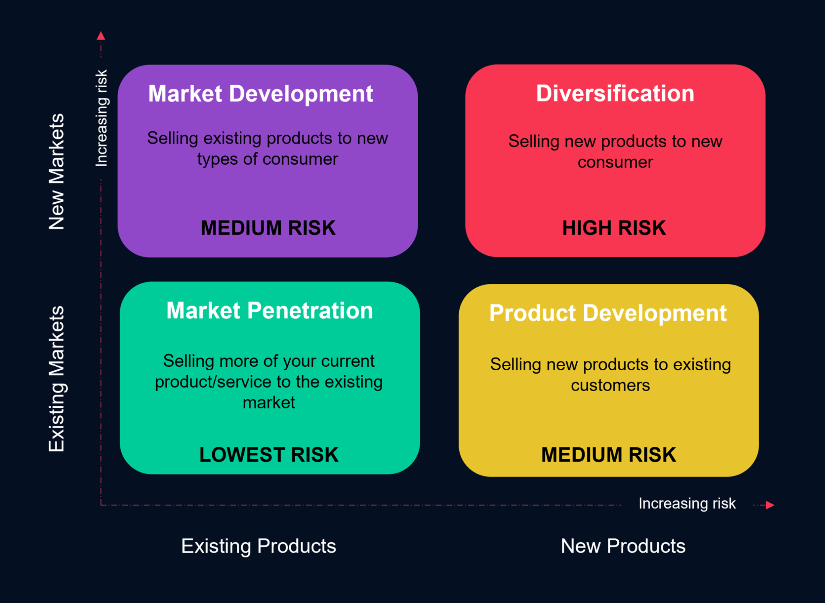
Figure 1: Ansoff matrix model for eBay UK
(Source: Kalogiannidis and Mavratzas, 2020)
Market development
This is the “next least risky strategy” using which organisations look to sell existing products into new markets. This particular strategy does not need considerable investment in “Research and Development”. This particular strategy can be beneficial for eBay in enlarging its online presence both regionally as well as internationally (Kalogiannidis and Mavratzas, 2020).
Product development
This particular strategy is riskier compared to the earlier two ones where business firms like to introduce new products in existing markets. The objective of firms applying this strategy is to get connected to customers. In this aspect, eBay might need to create an offering of a new product or service to adopt this strategy in the market.
Diversification
This is the “riskiest” of all the strategies through which business firms need to introduce new products into new markets. It is true that his strategy opens the door for generating high revenue but at the same time, if organisations fail to meet the needs of customers then it would not be an effective one for firms.
Evaluation
From the earlier steed strategies, the “Market Development” and “Product Development” strategies would be useful for eBay organisations to carry out its online shopping. Successful adoption of the “Market Development Strategy” would enable eBay to gain new customers available online, build organisational resilience, and get more business leads and others. The “Product Development Strategy” would help the organisation to meet goals, selling more products to customers, which would enhance profitability.

Stakeholder mapping

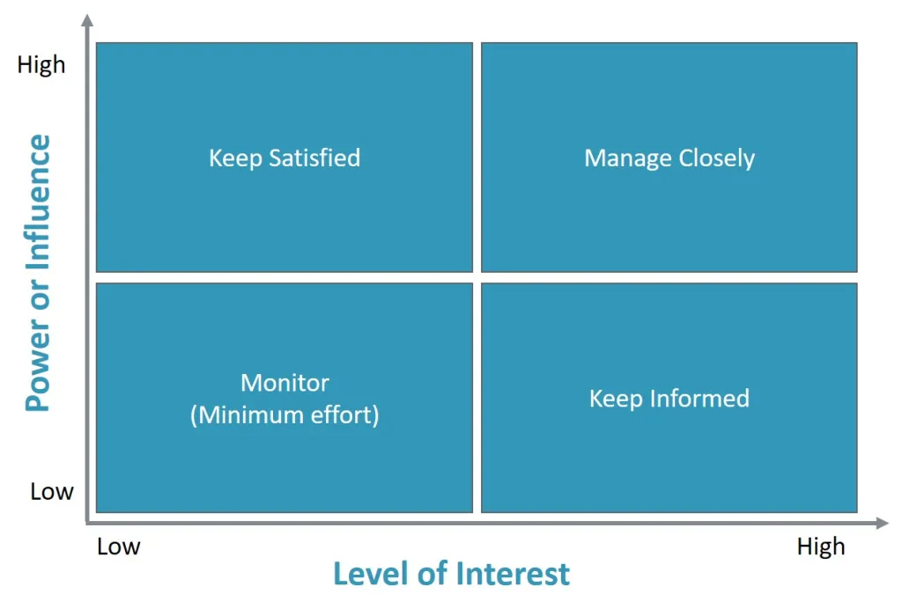
Figure 2: Stakeholder Power Grid Matrix for eBay
(Source: Micheaux and Bosio, 2019)
It is also a useful tool for the eBay organisation to manage its stakeholders while conducting operational activities on online platforms. In this regard, the organisation can use a stakeholder power grid matrix for categorising their stakeholders as per their power and interest which is provided below:
- High Power-High Interest
These are thought to be the “most important stakeholders’ for the eBay organisation in the UK who are required to be “managed closely” in the above image. Instances of these stakeholders are its shareholders like “The Vanguard Group”, “Geode Capital Management”, “Blackrock Fund Advisors” and others. They have the necessary power to utilise which they look to formulate business policies for the betterment of the organisation (Micheaux and Bosio, 2019).
- High Power- Low Interest
These stakeholders also are important for the organisation whom they may not need all the time. Investors, and customers, are examples of these stakeholders. Ebay would need in prioritising these stakeholders using which the organisation can exercise a significant competitive edge in online activities. It is important for eBay to “Keep Satisfied” them in its operations.
- Low Power- High-Interest
Stakeholders of this aspect need to be considered as “Keep Informed” by the Ebay organisation according to the movie picture. These working individuals and suppliers need to be looked after by the management of the firm. The organisation if needed then can make use of their advice for business growth in the market (Roxas et al., 2020).
- Low Power - Low Interest
These are the “lowest priority stakeholders” for eBay organisation in its online operational activities. These stakeholders are associated with the branding aspect of the eBay organisation. Efficacious satisfaction of them ensures the trust and credibility of eBay in its online presence. For this reason, they are needed to be “Monitored” effectively.

Porter's Five Forces
It is a renowned competitive model, which helps business organisations in understanding the nature or extent of competition prevailing in the marketing domain. The model has five saint aspects that would be necessary for the eBay organisation during its operations such as:

Description of Porter's five forces
Sl no. | Forces | Discussion
1. | The threat of new entrants | In the UK, this force is “medium” for the Ebay organisation. It becomes relatively easier for new players to make an entry into the market. However new entrants would need a considerable marketing budget for competing extensively. At the same time, excited players such as Apple, Amazon and others can create issues for eBay against which it would have to be mindful (Anastasiu et al., 2020).
2. | Substitute threats | This is ‘Low’ for the organisation in the Uk as it sells a wide range of products stated earlier. Furthermore, the range of products continues to expand where eBay can make an introduction of different kinds of products to be used by customers in the country.
3. | Bargaining power of suppliers | This threat ranges from “Low’ to “Medium'' for the Ebay organisation in the UK. thousands of seals carry on listing their products for eBay, which makes the power restricted in nature. Search engines exercise considerable leverage for creating more than 20% of traffic. Also, “slickdeals.net”, “dealnews.com” and others carry considerable traffic in its operations.
4. | Bargain power of buyers | This is “high” for Ebay in the UK because of the presence of huge competition perceived in the country. Customers have the option of choosing a significant number of online sites due to which the organisation focuses on controlling the switching cost of customers by providing attractive discounts on its products and items (Björk, 2021).
5. | Competitive rivalry | It fluctuates from medium to high for the organisation in the contemporary marketplace. The organisation experiences competition from “Amazon”, “Etsy”, “Argos”, “Aliexpress”, “Picclick” and others. For this reload, all the time the organisation lists to be strategic by formulating customer-specific products and items to increase customer base.
Table 2: Description of Porter's five forces
(Source: Self-created)

Communication mix
It is a significant aspect for the eBay organisation in the country which helps the organisation to enlarge its number of customers. Due to the communication mix, in spite of covid 19 pandemic eBay was successful in generating a significant amount of revenue in its operations. For example, in 2020, the revenue was “£1.6 billion”, in 2021 it was “£8.8 billion”, and in 2021 it reached “£10 billion” which clearly shows the growing popularity of the organisation in the country (Statista, 2021). Regarding communication mix, the organisation primarily prefers the following two aspects such as:
Advertising
The “eBay Ads” is a popular display network, which makes integration of e-commerce platforms where it advertises its products. Also, there is a “Promoted Listings advertising scheme” which is used by the organisation for promotional purposes (eBay UK, 2021). Besides this, the organisation uses radio, newspaper, and TV ads for promoting its products so that it can communicate with its customers.
Digital Marketing
In this case, the organisation looks to use social media networks such as “Facebook”, “WhatsApp”, “Instagram”, and “Twitter” for promoting its products. Recent statistics have shown that in the UK, customers having an age range of 16-24 (nearly 28 per cent) prefer to engage themselves in social media platforms, which has helped organisations like eBay to consolidate their online presence in a systematic manner. Rests are “25-34 age-16 per cent”, “35-44 age-12 per cent”, “45-54 age-9 per cent”, “55-64 age-4 per cent” and “65 plus age-2 per cent” (Statista, 2021). This has increasingly helped the organisation to expand its online presence.
Sales promotion
In this aspect, the organisation prefers to provide discounts on its products and offerings to customers. The use of codeless coupons becomes helpful for the eBay organisation to promote its sensing activities for increasing customers in a systematic manner (eBay UK, 2021). This communication mix enables the organisation in bringing fast and rapidity to offline inventory, boosting long-term loyalty based on which the organisation can become more effective in understanding customers' demands.

Identification of systems for supporting quality processes
Supply chain management system
This system is necessary for ensuring an improved quality process within the eBay organisation of the country. The effective implication of the system helps the organisation to handle the necessary flow of goods as well as services from the manufacturer to the consumer (Zeraati et al., 2020). This system has several useful components for the eBay organisation such as “Planning”, “Sourcing”, “Inventory”, “Production” and “Transportation”. The top management of the firm looks to make synchronisation of these aspects for providing improved customer service.
Statistical process control System
It is a beneficial system which is used to measure control as well as quality. In this system data through measurement of products or processes is collected for setting control limits. These are fixed by the ability of the manufacturing process of products. The primary reason for using this system is to ensure the quality process is to find errors and correct those so that later there should not be any issues for the organisation (Jiang et al., 2019). If there is observed any issue in the process of manufacturing within the organisation then this system aids in detecting it and taking corrective measures to overcome it.
Advanced product quality planning System
Through this system, the eBay organisation can assure quality as well as performance by means of formulating beneficial plans. Being a structured process, this helps in providing satisfaction to customers by enhancing customer experience significantly. This system is used at the time of designing any particular product or item by the eBay organisation through communicating with suppliers (Lu et al., 2020). It becomes effective in maintaining smooth transparency in rendering quality service to customers.

Critical understanding of how those systems are effective for the organisation
Effectiveness of Supply chain management system
This system aids the eBay organisation in reducing the requirement for maintaining inventory. Also, it cuts down overhead costs related to storage and security. The supply chain magnet system used by the firm is proved to be an economical solution to maintain uniformity as well as accuracy in keeping the detail of products (Zeraati et al., 2020). Furthermore, this system helps the organisation to utilise multiple sales channels for maintaining a smooth customer experience available 24X7.
Effectiveness of Statistical Process Control System
This system is also going to be effective for the eBay organisation in reducing waste and improving productivity. Moreover, it would help the organisation in generating an organised channel of communication with its customers every time for developing its product and service offerings to them (Jiang et al., 2019). It would facilitate the use of “Artificial Intelligence”, “Machine Learning”, “Blockchain” and other technologies that would aid the organisation in formulating real-time decisions for the welfare of the firm.
Effectiveness of Advanced product quality planning System
Regarding the effectiveness of this system, it can be stated that this system assures on-time delivery of quality products and services for the organisation. Moreover, it intensifies improved collaboration between suppliers and company members using which the planning process gets streamlined accordingly (Lu et al., 2020). Using this system the organisation can easily be able to maintain good relationships with its customers in its online platform which would have an impact on increasing profitability.

Task 2

Demonstrate the application of an appropriate level of critical understanding of quality process, relating to customer service in the workplace
Application of quality processes relating to customer service in EBay's workplace requires considering the significance of customer satisfaction, efforts of continuous improvement and implementing quality management systems. The way these elements align with ebay's workplace are as follows:
i) Customer satisfaction: Evidently, eBay identifies the importance of customer satisfaction in the company's business model. Since it is an online marketplace, its success is dependent on providing the best quality customer service and experiences (Baker and Kim, 2020). Ebay's understanding in this aspect is well reflected through its seller performance standards, policies along with buyer protection programs. Moreover, ebay focuses on considering and resolving consumer issues quickly. It also makes sure that there are fair transactions and a trusted platform is maintained for sellers and buyers.
ii) Quality Management Systems: The company has employed quality management systems which helped it to make sure of its consistent operational excellence and customer service. With that, eBay has also established guidelines, processes, policies and frameworks to govern different aspects of its operations. The operations of eBay here includes seller performance metrics, listing standards, dispute resolution processes and so on (Dewnarain et al., 2018). All these systems have aided maintaining reliability and quality of eBay in the marketplace.
iii) Continuous improvement: Over the years, eBay too has started seeking more opportunities to ensure continuous improvement. This way, it has enhanced its customer's service as well. EBay actively collects feedback from its sellers and buyers, conducts surveys and thereby analyse the collected data to recognise areas of improvement. Hence, it follows a feedback-driven approach that has enabled it to recognise customer pain points, make iterative changes and address concerns of the customers regarding eBay's platform and services (eBay, 2019).
For example, eBay analyses feedback of the customers linked to shipping delays and opt for corrective actions accordingly. For actions in this aspect, eBay forms partnerships with different logistics providers and implements modern shipping options. It has also leveraged its data analytics that has helped eBay to recognise patterns and trends in customer behaviour. This has enabled the company to make more sound decisions and improve user experience.
- Training and support: Over these years, eBay has invested in support and training programs to empower the staff and sellers in delivering best customer service. EBay also provides guidelines, resources, training materials etc to educate all its sellers regarding best practices, customer engagement and product knowledge (Elia et al., 2022). As eBay equipped its workforce with required knowledge and skills, it could aim in providing consistent delivery and maintaining higher levels of customer service.
- Metrics and performance monitoring: EBay actively tracks and monitors Key performance metrics to make sure about its customer service. It uses KPIs such as resolution rates of its customers, seller ratings, rates of customer disputes, response times and so on. This helps eBay to measure the effectiveness of customer service. If eBay monitors these metrics closely, it can recognise areas that need improvement and thereby can implement effective targeted actions to improve customer satisfaction (Elia et al., 2022).

Identify relevant marketing service to analyse the customers' experiences of an organisation
To effectively analyse the customer's experiences of eBay, the following marketing service models, theories or methods can be used:
1. SERVQUAL Model: This model is a broadly implemented framework to measure service quality of organisations. This method has five dimensions such as reliability, responsiveness, tangibility, assurance and empathy. EBay can incorporate this model, which can help it to assess perceptions of its customers regarding these dimensions. This way, it can recognise the gaps between expectations of customers and actual experience. For instance, eBay may evaluate the reliability of the platform initially (Joung and Kim, 2023). Besides, eBay can also assure customers about providing transaction security, tangible like proper website design along with responsiveness and empathy of its customer support.
2. Customer satisfaction surveys: EBays conducts this survey which has enabled it to gather valuable feedback regarding preferences of customers, their satisfaction levels and areas that need more attention. This method of surveys include questions on ease and convenience on funding goods, seller communication, checkout process, satisfaction levels with the platform and so on. If eBay can properly analyse these data it can get useful insights into weakness and strengths of customer experience of eBay.
3. Customer journey mapping: This is a method that is used in comprehending and analysing the different touchpoints along with interactions the customers will have with eBay. Hence, eBay needs to continually map the customer journey along different touchpoints such as browsing the products, placing orders, making a purchase, interacting with sellers along with post sale queries and support. This way eBay can gain useful insights into preferences and experiences of customers and also recognise areas of improvement (Kamalaldin et al., 2020).
4. Net promoter score: Net promoter score (NPS) is a metric that is used widely to measure consumer satisfaction and loyalty. The company can use net promoter score surveys if it wants to gauge likelihood of customers in recommending eBay's platform to others. Moreover, by analysing the collected responses, it can recognise passives, promoters, detractors and thereby focus more on addressing concerns that are mostly raised by detractors. Detractors usually raise the concerns while leveraging the positive experiences of promoters.
5. Reviews and customer feedback: Analysing the reviews and feedback on the platform of eBay, the company can get useful insights into preferences of customers. EBay then requires analysis of all the contents of feedback and reviews by customers, which can help the company to recognise pain points, common themes and further areas of improvement (Schallehn et al., 2019). With this information, eBay can get adequate guidance into strategic decision-making and aid prioritising initiatives with the aim to improve customer experiences.

Critically evaluate the benefits and challenges of developing and maintaining good customer relationships
EBay maintains a good customer relationship round the clock, which comes with both benefits and challenges. The benefits and challenges of developing and maintaining good customer relationships are as follows:
Benefits for eBay:
- EBay depends on having a positive word-of-mouth to get new customers. Hence, if it can successfully deliver excellent customer experiences, it can encourage the customers to share the experiences with other people. This can lead to an increase in potential new users and referrals.
- Maintaining a good customer relationship, 24*7 can help eBay to get useful customer insights. For that, it needs to engage with all the customers and gather valuable feedback. This way, eBay can get a better understanding of customers' behaviour, market trends and customer preferences (Schallehn et al., 2019). The information can also guide in making strategic decisions, improve the online platform and focusing on product development.
- Another benefit is that it can enhance trust and reputation as it will keep a good relationship round the clock. If customers have more positive interactions, it would help developing a trusted online marketplace and platform, attracting more customers and fostering security in all online transactions (Zhang et al., 2022).
Challenges for eBay:
- One of the challenges can be handling disputes and customer complaints. Since eBay has larger volumes of transactions that take place on its platform, it faces challenges of effectively and promptly resolving all disputes.
- Another challenge is to balance the needs of the seller and buyer. For that, eBay must try to balance meeting the needs of both sellers and buyers so that it can have a healthy marketplace. Here, it is required to face transparent and fair transactions, foster good relationships and resolve conflicts which can be challenging for eBay (Zhang et al., 2022).
- Another challenge is to maintain a consistent positive user experience. There are multiple offerings from sellers on ebay's platform and there eBay must have to ensure delivering consistent user experience across varied sellers, categories and products listings.

Conclusion
Thus the report has demonstrated the aspect of engaging customer experience in light of the eBay organisation of the UK. It would be relevant for the organisation to make a significant analysis of internal as well as external factors that have been forecasted above to analyse while making operational activities. The application of quality processes associated with customer service with benefits as well as challenges stated above would have to be kept in mind by the organisation for becoming more proliferative in the future.

Reference list
Alfarisi, O. (2023). Cloud Service Marketing Strategy Framework for Higher Value Customer-Segments Deployment.
Anastasiu, L., Gavriş, O., and Maier, D. (2020). Is human capital ready for change? A strategic approach adapting Porter’s five forces to human resources. Sustainability, 12(6), 2300.
Baker, M.A. and Kim, K. (2020). Dealing with customer incivility: The effects of managerial support on employee psychological well-being and quality-of-life. International Journal of Hospitality Management, 87, p.102503. doi:https://doi.org/10.1016/j.ijhm.2020.102503.
Björk, B. C. (2021). Why is access to scholarly journal literature so expensive?. Portal: Libraries and the academy, 21(2), 177-192.
Dewnarain, S., Ramkissoon, H. and Mavondo, F. (2018). Social customer relationship management: An integrated conceptual framework. Journal of Hospitality Marketing & Management, [online] 28(2), pp.172–188. doi:https://doi.org/10.1080/19368623.2018.1516588.
eBay (2019). Electronics, Cars, Fashion, Collectibles, Coupons and More | eBay. [online] eBay. Available at: https://www.ebay.com/ [Accessed on: 28.06.2023]
eBay UK (2021). “Best Selling Items.” Export.ebay.com, Available at: www.export.ebay.com/en/marketing/analytics/top-selling-categories/. [Accessed on: 28.06.2023]
eBay UK (2021). “Electronics, Cars, Fashion, Collectibles, Coupons and More | EBay.” EBay, 2019, Available at: www.ebay.co.uk/. [Accessed on: 28.06.2023]
eBay UK (2021). “Employees - EBay Inc.” Www.ebayinc.com, Available at: www.ebayinc.com/impact/ebay-foundation/employees/. [Accessed on: 28.06.2023]
Elia, G., Raguseo, E., Solazzo, G. and Pigni, F. (2022). Strategic business value from big data analytics: An empirical analysis of the mediating effects of value creation mechanisms. Information & Management, p.103701. doi:https://doi.org/10.1016/j.im.2022.103701.
Forbes UK. “EBay through the Lens of Porter’s Five Forces.” Forbes, Available at: www.forbes.com/sites/greatspeculations/2014/11/24/ebay-through-the-lens-of-porters-five-forces/?sh=38d2764edd14. [Accessed on: 28.06.2023]
Jiang, Q., Yan, X., and Huang, B. (2019). Review and perspectives of data-driven distributed monitoring for industrial plant-wide processes. Industrial and Engineering Chemistry Research, 58(29), 12899-12912.
Joung, J. and Kim, H. (2023). Interpretable machine learning-based approach for customer segmentation for new product development from online product reviews. International Journal of Information Management, 70, p.102641. doi:https://doi.org/10.1016/j.ijinfomgt.2023.102641.
Kalogiannidis, S., and Mavratzas, S. (2020). Impact of marketing mix strategies effective product development issues in MNCs/Retail. International Journal of Business Marketing and Management (IJBMM) Volume, 5, 118-125.
Kamalaldin, A., Linde, L., Sjödin, D. and Parida, V. (2020). Transforming provider-customer relationships in digital servitization: A relational view on digitalization. Industrial Marketing Management, 89, pp.306–325. doi:https://doi.org/10.1016/j.indmarman.2020.02.004.
Kukartsev, V. V., Fedorova, N. V., Tynchenko, V. S., Danilchenko, Y. V., Eremeev, D. V., and Boyko, A. A. (2019, August). The analysis of methods for developing the marketing strategies in agribusiness. In IOP Conference Series: Earth and Environmental Science (Vol. 315, No. 2, p. 022107). IOP Publishing.
Lu, Y., Xu, X., and Wang, L. (2020). Smart manufacturing process and system automation–a critical review of the standards and envisioned scenarios. Journal of Manufacturing Systems, 56, 312-325.
Micheaux, A., and Bosio, B. (2019). Customer journey mapping as a new way to teach data-driven marketing as a service. Journal of Marketing Education, 41(2), 127-140.
ONS (2021). “Office for National Statistics.” Ons.gov.uk, 2022, Available at: www.ons.gov.uk/. [Accessed on: 28.06.2023]
Roxas, F. M. Y., Rivera, J. P. R., and Gutierrez, E. L. M. (2020). Mapping stakeholders’ roles in governing sustainable tourism destinations. Journal of Hospitality and Tourism Management, 45, 387-398.
Schallehn, H., Seuring, S., Strähle, J. and Freise, M. (2019). Customer experience creation for after-use products: A product–service systems-based review. Journal of Cleaner Production, 210, pp.929–944. doi:https://doi.org/10.1016/j.jclepro.2018.10.292.
Statista (2021). “EBay Brand Profile UK 2022.” Statista, Available at: www.statista.com/forecasts/1252312/ebay-second-hand-apparel-online-shops-brand-profile-in-the-uk. [Accessed on: 28.06.2023]
Statista (2021). “EBay UK Revenue from 2013-2021.” Statista, Available at: www.statista.com/statistics/1048213/ebay-net-revenue-in-the-united-kingdom-uk/. [Accessed on: 28.06.2023]
Statista (2021). “Gross Domestic Product of the United Kingdom from 1948 to 2021.” Statista, 17 Aug. 2021, Available at: www.statista.com/statistics/281744/gdp-of-the-united-kingdom/. [Accessed on: 28.06.2023]
Statista (2021). “Social Media Engagement with Ebay by Demographic UK 2014.” Statista, Available at: www.statista.com/statistics/305877/social-media-engagement-with-ebay-by-demographic-uk/. [Accessed on: 28.06.2023]
Statista (2021). “Topic: EBay Inc.” Statista, Available at: www.statista.com/topics/2181/ebay/#topicOverview. [Accessed on: 28.06.2023]
Statista (2021). “UK Core Inflation Rate 2023.” Statista, Available at: www.statista.com/statistics/1317058/uk-core-inflation-rate/#:~:text=In%20March%202023%20the%20core. [Accessed on: 28.06.2023]
Zeraati, H., Rajabion, L., Molavi, H., and Navimipour, N. J. (2020). A model for examining the effect of knowledge sharing and new IT-based technologies on the success of the supply chain management systems. Kybernetes, 49(2), 229-251.
Zhang, H., Zang, Z., Zhu, H., Uddin, M.I. and Amin, M.A. (2022). Big data-assisted social media analytics for business model for business decision making system competitive analysis. Information Processing & Management, [online] 59(1), p.102762. doi:https://doi.org/10.1016/j.ipm.2021.102762.

