Patisserie Valerie
corporate reporting and social responsibilityBMBM6004
Saghar Abed
1707252

Table of Contents
Executive Summary 1
Introduction 2
Earnings Management Definition 2
Window Dressing 3
Internal Targets 3
Income Smoothing 3
External Expectations 4
Incentives and Pressure 4
Group Incentives 4
Bonuses on Financial Metric 4
Personal Incentives 5
Equilibrium Definition Theory in Earnings Management Prevalent in Patisserie Valerie Case 5
UK Corporate Governance Structure in Constraining Earnings Management 6
Recommendations 9
Conclusion 10
References 11

Table of figures

Figure 1 earning management. (Mahrani, and Soewarno, 2018). 2
Figure 2 (Eley, 2019). 6
Figure 3(Farooque, Suyono, and Rosita, 2014). 8

Executive Summary
The earnings management is a key player in looking into the frauds made by different companies from their financial reporting. Financial frauds help the corporate governance to critically analyze companies to look for any form of breaches. Patisserie Valerie is used as a case study company. This paper examines earnings management and its definition from what is provided by the company. Through the definition of the earnings management, the company would be able to look into its own intrinsic values and how the same can be used to bring along the incentives and the pressures of a company. The analysis of how corporate governance together with corporate social responsibility leads to earnings management and the eventual financial reporting. Also, the incentives and pressures are analyzed and their relationship with the Patisserie Valerie. The role and the structure of the UK corporate governance and its significant concepts in understanding financial frauds has also been discussed. The UK corporate governance has a structure in which the companies need to follow their accounting and financial reporting to avoid the Patisserie Valerie’s kind of fraud and other discrepancies that may emanate from the earnings management has been reflected upon. Finally, the recommendations on how to operate efficiently in bringing out their eventual financial reporting. Including the state of federal law to come for the companies that commit financial frauds is one major recommendation for future financial reporting.

Introduction
Earnings management is one strategy used by the management and its company to manipulate the earnings of the company. Companies with abusive earnings management are always deemed by the Securities and Exchange Commission as having misinterpretation of results. This paper discusses how Patisserie Valerie recorded the highest level of fraud as far as earnings management is concerned. There will also be a concise analysis of the Incentives and pressures together with the UK Corporate Governance Structure and how all these have had clear indicators of fraud in Patisserie Valerie.

Earnings Management Definition
Earnings management is the use of accounting techniques to come up with financial statement that present an overall positive view of the company and its business activities and financial position (Tuovila, 2019, pp.1). The definition places the earnings management as a gray area where the overall activities of accounts is perverted (Yang, Chi, and Young, 2011, p. 89). Financial reporting gives the managers some kind of freedom to come up with accounting policies for their companies (Van Keymeulen, 2016, p. 24). As a result, misusing this freedom in altering the entire reported earnings for them to receive bonuses and also to avoid violation of debt covenants is sometimes practiced (Priharta, and Rahayu, 2019, p. 24).
The figure below shows how the mechanism and the structure of corporate governance and the corporate social responsibility leads to earnings management.
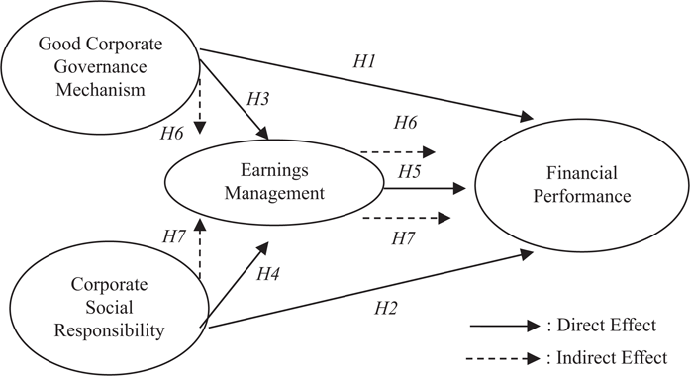
Figure 1 earning management. (Mahrani, and Soewarno, 2018).

The best way to come to terms with legal and illegal things is through the use of the common acronym WISE; window dressing, internal targets, and income smoothing and external expectations.

Window Dressing
Window dressing is the decision of the company to dress up all the financial statement for the creditors and the potential investors to have a positive image of the company. The primary aim of this is to ensure that the company stays to be attractive every time.

Internal Targets
Internal targets are what the companies choose to make use of the earnings management techniques. Many times, the company need to have a set of their own internal goals.

Income Smoothing
This happens due to the potential investors who are ready to invest in those companies that are doing well financially (Study.com. n.p para 7). This allows a smooth growth in terms of the pattern to be realized.

External Expectations
This is when the company has already made their own projection on what their profits will be and that the investors also expect the same to be happening in such a company (Study.com. n.p, para 8).

Incentives and Pressure
The earnings management behavior has been defined by the agency theory. This is simply the existing relationship between the shareholders and the management (Alexander, 2010, p. 31). When the agent and the principal are considered to be utility maximizers, the agent would not act in the best interest as expected by the principal. As a consequence, the two conflict of interest between the two leads to agency problem. These problems usually arise due to asymmetric information taking place between the management and the shareholders and other stakeholders (Chapman, 2011, p. 35). There are three main types of incentives used by companies in their financial reporting.

Group Incentives
In most companies, the managers are always entitled to the share options and the bonuses in achieving the predetermined reported earnings (Li, 2019, p 411). It is usually common for the management to have employment contracts to include the accounting-based constraints that bring the determination of compensation opportunities like annual salary increase, the bonuses and other performance evaluation to order (Shabeeb, Ismael, and Ahmed, 2020, p. 105).

Bonuses on Financial Metric
The revenues and the net income are the commonly used financial metrics used by companies. The bonuses from these companies are usually based on the creation of pressure created by the financial metrics and directed to its employees. The employees are then put in pressure to meet the targets of the company (Yaping, 2005, pp. 23).

Personal Incentives
This include an individual yearning to earn more money. Some of the reasons why personal incentives appear in a company include striving to earn more to pay personal bills and other personal issues (Yaping, 2005, pp. 17). Some of the approach’s individuals put in place to earn extra money include merit-based compensation, the bonuses of various sorts and the commissions (Yaping, 2005, pp. 19).

Issues of the Earnings Management Prevalent in Patisserie Valerie Case
Subanidja and Breton came out with the most concise difference between fraud and earnings management (Subanidja et al., 2016, p. 4). They claimed that fraud is outside the limits of the GAAP and only takes place when one commits illegal act. On the other hand, earnings management is taken to be within the GAAP and is also a form of accounts manipulation. Therefore, this can be linked to Patisserie Valerie since according to these scholars, earnings management is the entire process of taking some deliberate actions within the constraints of GAAP for them to achieve the desired standards of reported earnings. This theory by these scholars has also been agreed by Almasarwah (2015), where he claims that the earnings here involve the use of flexible means within the accounting to come up with and manage the accounts to deliver the predetermined profit and achievement of particular goals (Almasarwah, 2015, p. 99).
Patisserie Valerie once attained so much hype and profits from their activities, but after looking into their main activities and shares, their audit was suspended. Their suspension has become one of the biggest collapses of the recent times. The scandal revolved around a significant and potentially fraudulent irregularities in accounting. It led to company’s accounting practices being suspended.
Different irregularities were arrived at after several audit processes done to the company (Subanidja, et al., 2016, p.2). The attention of the directors was directed to the unpaid tax bill, hence, it resulted in freezing the company accounts. The extent of the entire irregularities is assessed and investigated by the PwC to bring the financial black hole which would take some time to untangle the challenge. A statement provided by Patisserie Valerie indicated that the future irregular findings could bring major loses (Ruwanti, Chandrarin, and Assih, 2019, p. 92). Through this, the investors, the suppliers and the lenders would be following closely on what is happening within the company for them to be aware of the next move to be taken.
The figure below is a bar graph indicating how Patisserie Valerie has been increasing their revenues over the years between 2012 to 2017.
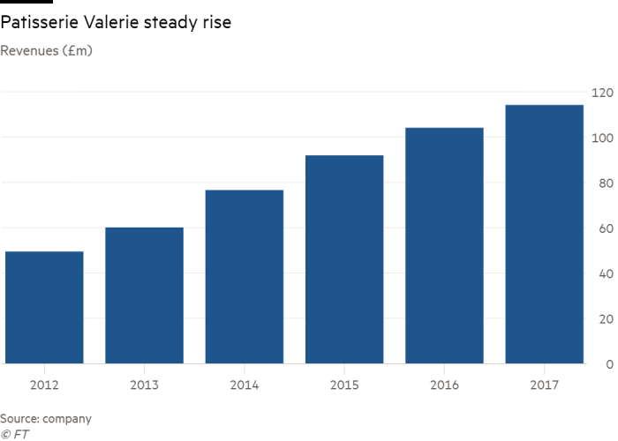
Figure 2 (Eley, 2019).

UK Corporate Governance Structure in Constraining Earnings Management
The UK corporate governance has its approach in its key position in the means of improving the board of directors and their abilities to manage the efficiencies of the firms (Ruwanti, Chandrarin, and Assih, 2019, p. 339). The major role of the corporate governance is to align the board structure, the board operations, the audit and the overall responsibilities of the shareholders in the preparation of the financial reports (Can, 2017, p. 23). The corporate governance provides the codes and principles under which the companies need to observe in their activities.
Both the internal and the external corporate governance are always established through the senior managers when they improve the efficiency of the operations and also make reductions of all the incidences and errors or any discrepancies or manipulation in the accounting systems (Almasarwah, 2015, p. 9). The internal audit managers, the financial managers and the entire general managers have had a comprehensive information on the corporate governance issues and also linking it to the firm’s earnings management (Almasarwah, 2015, p. 12).
The first element of the UK corporate Governance Structure in constraining the earnings management is the strength of the board of directors including the leadership of the corporate governance usually constrains the earnings management (Can, 2017, p. 23). Also, the UK Corporate governance Structure enlightens the firms on the different technics of accounting that may be used in the process of constraining earnings management. It also believes that there are ways in which the legitimate results may be gotten using credible means other than the earnings management (Ruwanti, Chandrarin, and Assih, 2019, p. 339). They also provide accountability to the shareholders of the companies within its jurisdiction.
The second element is the role of UK Corporate Governance in monitoring the earnings management. The financial statements are reviewed to look into the actual work of the earnings management. The financial reports given by the firms are not entirely relied on (Almasarwah, 2015, p. 114). The validity and the credibility of the operations are considered to be imperative for boards of directors to achieve the overall objectives of the shareholders and also be able to protect their rights (Almasarwah, 2015, p. 113).
The chart below indicates the relationship between the earning management and the earning quality.
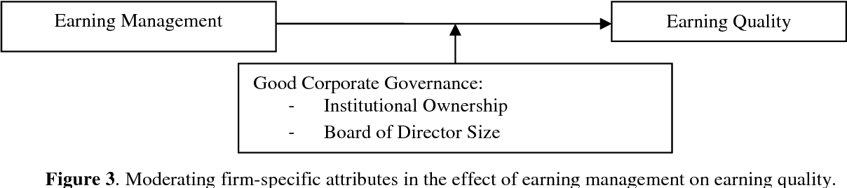
Figure 3(Farooque, Suyono, and Rosita, 2014).

Recommendations
One of the major recommendations is to include the state of federal law in all the companies that commit financial frauds. The violators such as the Patisserie Valerie may eventually find themselves in civil and criminal penalties. These companies may face both monetary and jail penalties (Marchini, Mazza, and Medioli, 2018, p. 125). This follows the most stringent laws that came to being between the 1933 and 1934 on the security exchange commission acts. The act provided considerable powers to the financial markets and other financial reporting to all the SEC (Marchini, Mazza, and Medioli, 2018, p. 125). This is the main reason why the SEC plays a key role in the promotion of the GAAP. This makes their use to be compulsory for all the annual reports and the financial statements (Bekiris, and Doukakis, 2011, p. 439).
The shareholders and the overall management of the organization need to make best practices of the corporate governance to avoid frauds like what was experienced by the Patisserie Valerie (Latif, and Abdullah, 2015, p. 136). Also, to improve the firm’s economic efficiency, the corporate governance need to become one major element of the company that gives guidance to the financial departments within the company. Lastly, heavy cost can always been incurred when there is a major failure to execute good governance (Yang, Chi, and Young, 2011, p. 89). For the companies such as Patisserie Valerie, there are various proofs with suggestions that such companies did not implement or follow the relevant corporate governance measures (Johnson, et al., 2012, p. 914). This failure leads to risk in public market at a time when the company is competing for limited capital.

Conclusion
Given the key significance of the earnings management, companies need to have relevant interests in the financial reporting. Earnings management and the corporate governance share a common understanding of the frauds committed by the companies when trying to come up with their financial reporting of their audits. These companies including the Patisserie Valerie are always hiding their means of acquiring the audits, mostly involving the directors, executives and other shareholders of these companies.

References
Aerts, W., Cheng, P. and Tarca, A., 2013. Management's Earnings Justification and Earnings
Management under Different Institutional Regimes. Corporate Governance: An
International Review, 21(1), pp.93-115.
Ajay, R. and Madhumathi, R., 2015. Institutional Ownership and Earnings Management in India.
Indian Journal of Corporate Governance, 8(2), pp.119-136.
Ajina, A., Lakhal, F. and Ayed, S., 2019. Does Corporate Social Responsibility Reduce Earnings
Management? The Moderating Role of Corporate Governance and Ownership.
Management international, 23(2), pp.45-55.
Alexander, D., 2010. Corporate governance and earnings management: going beyond agency
theory and secondary data. International Journal of Corporate Governance, 2(1), p.31.
Almasarwah, A. 2015. Earnings Management and its Relationship with Corporate Governance
Mechanisms in Jordanian Industrial Firms, pp. 1-345
Bekiris, F. and Doukakis, L., 2011. Corporate Governance and Accruals Earnings Management.
Managerial and Decision Economics, 32(7), pp.439-456.
Can, G., 2017. Turkish Listed Manufacturing Companiess Audit Structure and Its Effect on
Earnings Management. SSRN Electronic Journal, pp. 1-45
Chapman, C., 2011. The Effects of Real Earnings Management on the Firm, its Competitors and
Subsequent Reporting Periods. SSRN Electronic Journal, pp. 34-56
Eley, J., 2019. How Patisserie Valerie’S Recipe Turned Sour. [online] Ft.com. Available at:
<https://www.ft.com/content/78c1d05a-0c1c-11e9-acdc-4d9976f1533b> [Accessed 17
March 2020].
Farooque, O., Suyono, E. and Rosita, U., 2014. Link Between Market Return,
Governance And Earnings Management: An Emerging Market
Perspective. Corporate Ownership and Control, 11(2).
Issacs, R. (2019) Toppled from the top – The risk of fraud. AccountancyAge, pp. 1-12
Johnson, E., Fleischman, G., Valentine, S. and Walker, K., 2012. Managers’ Ethical Evaluations
of Earnings Management and Its Consequences*. Contemporary Accounting Research,
29(3), pp.910-927.
Li, V., 2019. The effect of real earnings management on the persistence and informativeness of
earnings. The British Accounting Review, 51(4), pp.402-423.
Mahrani, M. and Soewarno, N., 2018. The effect of good corporate governance mechanism and
corporate social responsibility on financial performance with earnings management as
mediating variable. Asian Journal of Accounting Research, 3(1), pp.41-60.
Marchini, P., Mazza, T. and Medioli, A., 2018. Related party transactions, corporate governance
and earnings management. Corporate Governance: The international journal of business
in society, 18(6), pp.124-146.
Masri, I., 2018. The role of corporate governance in the relationships of family company with
real earnings management. Jurnal Akuntansi, 22(1), pp. 78-99
Nuswantara, D., 2018. Re-Examining the Role of Corporate Governance in Controlling
opportunistic Earnings Management. Account and Financial Management Journal, 3(4),
pp. 54-56
Priharta, A. and Rahayu, D., 2019. Determinants of Earnings Management and Its Implications
on the Integrity of the Financial Statements. KnE Social Sciences, pp. 23-26
Ruwanti, G., Chandrarin, G. and Assih, P., 2019. CORPORATE SOCIAL RESPONSIBILITY
AND EARNINGS MANAGEMENT: THE ROLE OF CORPORATE GOVERNANCE.
Humanities & Social Sciences Reviews, 7(5), pp.338-347.
Sanad, Z., Shiwakoti, R. and Kukreja, G., 2019. The Role of Corporate Governance in
Mitigating Real Earnings Management: Literature Review. KnE Social Sciences, pp. 89-
98
Shabeeb Ali, M., Ismael, H. and Ahmed, A., 2020. Equity incentives, earnings management and
corporate governance: Empirical evidence using UK panel data. Corporate Ownership
and Control, 17(2), pp.104-123.
S. Latif, A. and Abdullah, F., 2015. The Effectiveness of Corporate Governance in Constraining
Earnings Management in Pakistan. THE LAHORE JOURNAL OF ECONOMICS, 20(1),
pp.135-155.

Study.com. n.p. Earnings Management: Definition, Techniques & Examples. Retrieved 16 April 2020, from https://study.com/academy/lesson/earnings-management-definition-techniques-examples.html
Subanidja, S., Rajasa, A., Suharto, E. and Atmanto, J., 2016. The Determinants Of Firm
Value: The Role Of Earnings Management And Good Corporate
Governance. Corporate Ownership and Control, 13(4), pp. 1-4
Tuovila, A. 2019. Earnings Management. Corporate Finance & Accounting Investopedia, pp. 1-
8
Van Keymeulen, K., 2016. Een website voor patisserie Bloch. Brood & Rozen, 13(4), pp. 23-34
Yang, J., Chi, J. and Young, M., 2011. A Review of Earnings Management in China and its
Implications. SSRN Electronic Journal, pp. 89-91

