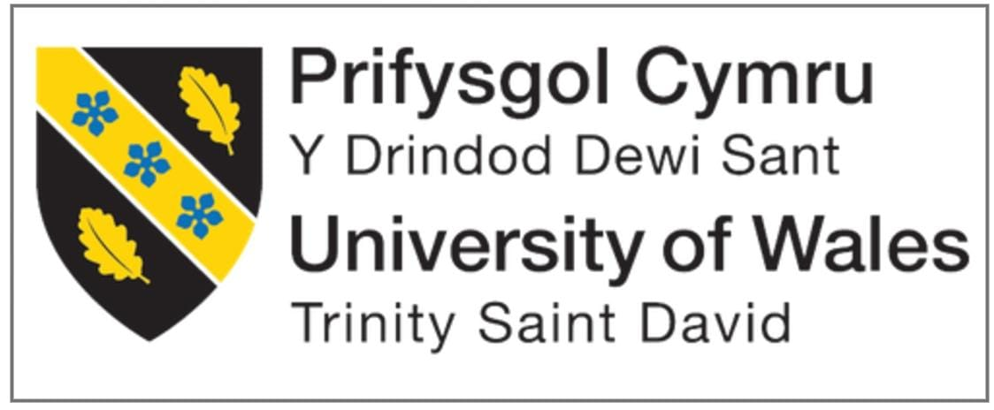

Program Name | MBA
Module Name | International Business Concept
Module Code | LCMB7034
Assessment | Report
Title  Company Name | Emerging Market  TOYOTA
Lecturer | JEAN WANG
Student Name | Arth Bhaveshkumar Patel
Student ID | 2436570

Table of Content
1. Introduction 3
2. Benefits and Challenges of International Operations 3
2.1 Why Toyota qualifies as an MNC/TNC 3
2.2 Nature of Toyota’s global operations and value chain 4
2.3 Benefits from international operations 6
3. Critical Discussion of Entry Mode and OLI factor for Toyota Emerging Economy Pair 7
3.1 Identification of Toyota’s entry modes and dominant mode 7
3.2 Ownership (O) 8
3.3 Location (L) 9
3.4 Internalisation (I) 10
3.5 Resulting Entry Mode Decision 11
4. Critical evaluation of cultural differences and their impact 13
4.1 Comparison between Toyota’s home culture (Japan) and emerging market of India 13
4.2 Implications for Toyota’s market entry strategy 14
4.3 Impact on potential for success 15
5. Critical Discussion and Recommendation of Three SOP Adjustments 16
SOP Adjustment 1: Localisation of Operational Processes 16
SOP Adjustment 2: Culturally Adaptive HR and Management Practices 17
SOP Adjustment 3: Market-Specific Product and Marketing Adaptation 18
6. Conclusion 19
References 20

1. Introduction
The present consultancy report focuses on critically discussing the international business strategy of Toyota with special focus on its business expansion in emerging markets. As one of the world's top multinational automotive manufacturers, Toyota has a complex global value chain of production, R&D, sourcing, and distribution in many regions. This report examines the advantages and disadvantages of the international operations of Toyota, examines the influence of Ownership Location Internalisation (OLI) determinants in such market entry decisions made by Toyota, and explores the cultural implications of expansion in India as the chosen emerging economy. Based on these analyses, the report suggests three strategic SOP changes that will help improve Toyota's ability to operate effectively and achieve long-term success in the Indian market.

2. Benefits and Challenges of International Operations

2.1 Why Toyota qualifies as an MNC/TNC
Toyota most definitely fits all these criteria and is a Multinational Corporation (MNC) or Transnational Corporation (TNC) with its global operations in terms of its size, spread and integration. An MNC is characterised by value creating activities that transcend multiple national environments in conjunction with strategic coordination across national boundaries (Duhaime, Hitt and Lyles, 2021). Toyota meets these requirements with its far-reaching global presence in more than 170 countries, including manufacturing facilities and research and development centres, regional headquarters and sophisticated supplier networks (Toyota, 2024). Its production system is transnational, with its different components coming from all over the world and assembled in different places to optimise costs, access to technology and responsiveness to the markets. Moreover, Toyota owns and controls dozens of foreign subsidiaries that have allowed it to internalise key technological, managerial and operational capabilities while protecting its proprietary Toyota Production System (TPS) (Toyota, 2025).
In addition, the decision making structure of Toyota provides the attributes of being a TNC (Bhattacharyya et al., 2024). Although global strategic direction comes from the headquarters in Japan, operational autonomy is decentralised down to regional units, but the firm can balance global integration with local responsiveness. Toyota's global value chain - linking inbound logistics, operations, outbound logistics, marketing and after-sales services - is configured and coordinated across different countries reflecting levels of deep interdependence typical of transnational organisations (Burciu et al., 2025). The firm's participation in cross-border investment, long-term joint ventures and market specific adaptations further strengthens itself as an MNC/TNC. Finally, Toyota's capacity to take advantage of the diversity of cultures, as well as the ability to manage the political and economic risks as well as exploit the opportunities of the international markets, falls within its operational maturity as a transnational enterprise. Its long-lasting presence around the world, centralised but adaptable governance and integrated global production system collectively confirm Toyota's identification as a leading MNC/TNC in the international business environment.

2.2 Nature of Toyota’s global operations and value chain
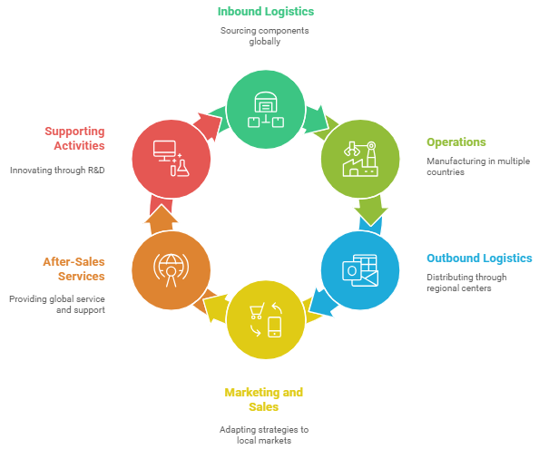
Figure 1: Toyota’s global operation value chain
(Self-developed)
Toyota's global businesses are organized according to a highly integrated and dispersed geographic value chain that allows the firm to be efficient, productive in terms of quality, and responsive across international markets. Its value chain starts with inbound logistics globally, with Toyota within its web of suppliers located in Japan, North America, Europe, and Asia sourced components, raw materials, and highly advanced technologies (Toyota, 2023). Strategic relationships with suppliers, longer-term contracts and just-in-time procurement systems guarantee little waste and high reliability. In the sense of operations, Toyota has production plants in over 25 nations, which include Japan, the United States, United Kingdom, Thailand, and India (Toyota, 2025). These facilities are run under the Toyota Production System (TPS) which harmonises global standards of lean manufacturing, while permitting local adaptation to labour skills and market demands and regulatory environments. This ensures the cost optimisation and product quality consistency at regional levels.
Toyota's outbound logistics use a globally integrated distribution network with regional centres and a vast dealership network to control inventory flows and customer delivery (Toyota, 2025). Its marketing and sales activities are adapted to the regional consumers preferences and competitive situations by combining both global brand positioning and localised promotional strategies. Within after-sales services, Toyota's global service centres, warranty programmes and customer support platforms underscore the reliability of the brand and foster long-term loyalty levels (Amro, Rehman and Ali, 2025). The firm's supporting activities, such as R&D centres in Japan, the United States and Europe, continuously involve innovation in the product development process especially in the fields of hybrid and electric vehicles technologies. Overall, Toyota's value chain is one that manifests a perfect equilibrium between global standardisation and strategic localisation and underlies its competitive advantage in the areas of efficiency, quality control and adaptability to the market.

2.3 Benefits from international operations
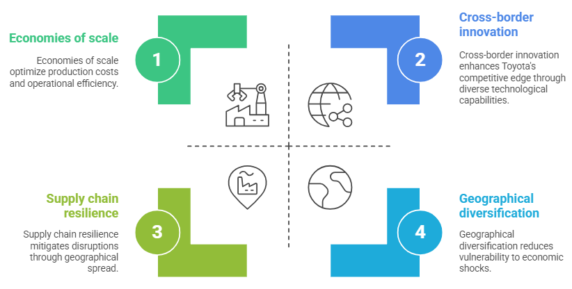
Figure 2: Toyota’s benefits from international operations
(Self-developed)
The advantageous effects of the large amount of international operations that Toyota has are that this adds a lot of strategic and operational value to the company, which adds to the overall competitive edge of the company, its ability to innovate and its overall resilience over time. Market diversification is one of the main advantages since by being present in over 170 countries, Toyota will not be tied down to a single market (Toyota, 2024). This geographical diversification assists in smoothing out the declines in a single geographical area by increasing in another and thus making it less vulnerable to economic shocks (Chen, Li and Zhu, 2023).
International operations also enable Toyota to enjoy high economies of scale especially in manufacturing, procurement and research and development. Through standardisation of production processes by the Toyota Production System (TPS) and by taking advantage of global sourcing networks, the company ensures that unit costs are minimised, and operational efficiency is optimized (Toyota, 2025). Access to low-cost labour, raw materials and specialised suppliers in different locations also add to the cost optimisation and price competitiveness (Moradlou et al., 2023).
In addition, Toyota enjoys worldly knowledge transfer. Its global R/D locations in Japan, North America, and Europe promote cross-border innovation, which allows the company to employ a wide range of technological capabilities and consumer insights to new car platforms, hybrid technologies, and safety technologies (Toyota, 2025a). This kind of continuous learning strengthens the Toyota leadership in sustainable mobility. The presence in the international markets also enhances the brand awareness and customer base of Toyota since it can customize its products and marketing strategies based on the local cultural and regulatory environments (Zulfikar, 2023). The risk to emerging economies like India, Brazil and Southeast Asia also contribute to the long term growth with the potential to increase the demand of middle classes. Lastly, the global location will increase the ability of Toyota to manage risks, as it can spread production across geographical locations to reduce a disruption impact in the supply chain, natural disasters, or political turmoil (Shih, 2022). A combination of these advantages supports the success and strategic health of Toyota across the world.

3. Critical Discussion of Entry Mode and OLI factor for Toyota Emerging Economy Pair

3.1 Identification of Toyota’s entry modes and dominant mode
The internationalisation of Toyota into India has been one that has involved the conglomeration of entry modes that each have been strategically chosen to balance on strategic control, responsiveness, and risk mitigation in the internationalisation. The key channels used are joint venture (JV), wholly owned subsidiary (FDI) and strategic alliances among supplier systems. Most notable of them is Toyota-Kirloskar Group long time joint venture, known as Toyota Kirloskar Motor (TKM) (Toyota, 2018). This type of joint venture will allow Toyota to have a high degree of managerial control and use the institutional knowledge, regulatory avoidance and business networks of the local partner (Hidayatullah and Novica, 2025). This is particularly beneficial in an emerging market such as India which is quite complicated with regional differences in policy, labor, as well as market specifications and thus high barriers to entry to a completely foreign owned establishment.
Another form of investment by Toyota has been in wholly owned subsidiaries particularly where rigorous quality checks or R&D compliance or specialised component production are needed. These subsidiaries fully guarantee the safety of intellectual property and make it possible to directly implement the Toyota Production System (TPS) without complexities. Yet, the success of localisation might not be achieved through wholly owned subsidiaries due to regulatory and cultural distance differences between India and Japan only (Röell, Arndt and Kumar, 2022).
Most importantly, the joint venture model has been the most dominant entry mode of Toyota into India (Das, 2020). This is supported by OLI considerations: the benefits of ownership practiced by Toyota have to be controlled, the territorial conditions in India support the partnerships at the local level, and internalisation benefits support the equity-based governance. joint will present an ideal balance whereby Toyota will be able to protect its technology and way of operation as it enjoys the local expertise of Kirloskar. Therefore, the joint venture continues to be the most successful and preferred entry mode by Toyota in ensuring long term competitiveness in the Indian automobile market.

3.2 Ownership (O)
The Ownership (O) benefits of Toyota, which are based on its home country in Japan, are relative and decisive in determining the strategy of internationalisation of the company in India. Nevertheless, such factors of ownership have strengths and limitations, which affect a positive or a negative influence on Toyota entry mode.
On the positive, Toyota has very distinctive firm-specific resources that encourage investing to enter India. Toyota Production System (TPS) is based on the organisational culture of Japan, which provides impeccable efficiency, quality controllability and ability to carry out continuous improvement (Toyota, 2025b). This, coupled with the high-technological capability of Toyota in hybrid engines and safety engineering, gives it a good competitive distinction in the growing automobile industry in India (Times of India, 2024). The world-renowned brand name of Toyota, which is based on quality and durability, contributes to the increased confidence of consumers and the minimised market opposition. The combination of these ownership benefits also stimulates high-control forms of entrances, i.e. joint ventures or wholly owned subsidiaries, so as to protect intellectual property, quality standards and brand equity (Fu et al., 2021).
Nonetheless, there are also major drawbacks associated with the ownership issues in the process of applying Japanese assets to the Indian environment (Mygind and Poulsen, 2021). Most of the TPS principles are founded on tacit knowledge, work culture, and routines that are highly entrenched into Japan's socio-cultural environment. Expanding all of these capabilities to India is a process that takes a lot of training, adaptation, and investment within organisations, which will hike the cost of operation and the learning curve (Ng, 2022). Moreover, high technologies of Toyota require rigorous process control, but the institutional environment in India can be a threat associated with the protection of intellectual property and the possibility of imitation (Shailesh, 2018). The differences in cultures between the Indian and Japanese managerial practices may also present barriers to instilling the organisational philosophy of Toyota and this would be a limit to the transfer of knowledge (Muniz et al., 2022).

3.3 Location (L)
The Location (L) benefits that India has to offer make the Toyota company consider the choice of investment based entry modes as quite beneficial, but also pose considerable challenges that will need strategic adjustments. On the positive side one may find India, which is providing one of the fastest-growing automotive markets in the world, fuelled by increased incomes, rapid urbanisation and young demographic market structure (Miglani, 2019).
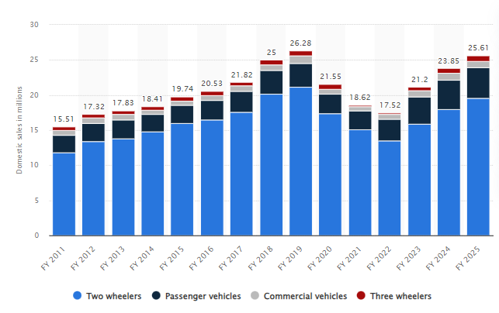
Figure 3: Automobile sales of India
(Source: Statista, 2025)
The Indian market is highly profitable to Toyota as its size and long-term viability is also in tandem with its global objectives, local production becomes cost effective to the company and economies of scale are achieved (Statista, 2025). Moreover, India offers reception of cost-effective labour, a rising pool of engineers and an emerging higher component suppliers, which assist in manufacturing the production within the country in an efficient manner (Bhattacharjea, 2020). Government subsidies through programs like the Make in India initiative add more appeal to the cost of setting up the manufacturing process particularly in recent industries like hybrid and electric mobility (Pib.gov.in, 2022).
Nevertheless, location-specific weakness is equally exerting pressure on the entry decisions of Toyota in India. Regulatory complexity, bureaucratic delays and inconsistencies in policies on the federal and state levels can be taken as examples of characterising the institutional environment (Williams, 2020). This uncertainty adds to the transaction costs of conducting business in India and requires that it is done in partnerships such as the need to bypass the institutional arrangements. Infrastructure shortcomings, especially logistics, road conditions, energy availability as well as ports connectivity represent further operational dangers to a business based on exact supply chain harmonisation (Sadiq et al., 2021). Besides, the competition on the market by both the domestic and active foreign players makes the market entry easier.
The differences in cultural and labour management also make it difficult to apply the Toyota philosophy of operation that is based in Japan (Vanichchinchai, 2022). Combined, the factors of mixed locations in India are factors that will lead Toyota to pursue a joint venture and FDI-based strategy that would balance the control factor with the requirement to localize and institutional support and cultural responsiveness.

3.4 Internalisation (I)
The influence of internalisation (I) factors has been decisive in the choice of the preferred entry mode to be used by Toyota entry into India because it results in an understanding that critical activities can be better coordinated within the firm than the market mechanisms (Li, Gao and Wang, 2021). At its best, the fundamental advantages of Toyota, like the Toyota Production System (TPS), in-house hybrid innovations, manufacturer development methods, and strict quality control measures are deep-rooted into routine that demands firsthand manorial management (Toyota, 2025b). Foreign direct investment or joint venture operations can allow Toyota to preserve its tacit knowledge and reduce the risk of imitation and also help Toyota to ensure the uniform application of the TPS principles in the plants in India (Hsiao and Lin, 2022). It is also a good internal governance framework to sustain ability to develop capability over a long period of time as Toyota is able to instill its cultural background, operational discipline and the spirit of continuous improvement within the workforce of the country in which it operates (Al Astal et al., 2024). Also, internalisation assists Toyota to incorporate the Indian operations smoothly into its worldwide network of supply and production to facilitate knowledge transfer and unified production standard in real-time (Quttainah et al., 2024).
Nevertheless, internalisation has its setbacks as well limiting the expansion strategy of Toyota. Incorporating and operating wholly owned subsidiaries or equity-based ventures in India come with high financial investments, exposure to regulatory risk, and resources in terms of managerial (Singh and Gaur, 2021). Close operational control may further aggravate the difficulties in integrating TPS with the cultural, institutional and labour diversity in India, and lead to the long training periods and possible resistance to Japanese managerial approaches (Ashta, 2021). Moreover, internalisation increases the susceptibility of Toyota to local shocks like labour conflicts, infrastructural setbacks or sudden shifts in policy which do not so readily have a solution when there is complete internalisation of its operations (McDougall and Davis, 2024). Nonetheless, Toyota arrives at these conclusions that internalisation entails more strategic advantages than the modes of contractual as internalisation safeguards the core competencies, and helps to maintain competitive advantage at longer terms in India changing automotive environment.

3.5 Resulting Entry Mode Decision
The decision that Toyota based on entry mode into India represents a balance between the requirement of the firm to have a certain level of control over its operations, and the reality of the situation that is characterized by the emerging economy. Toyota uses joint ventures along with select wholly owned subsidiaries guided by the OLI framework since neither of the two modes excelled enough to complement the opportunities and risks existing in India (Das, 2020). This mixed strategy has a number of strengths. On the positive side, the joint venture with the Kirloskar Group offers Toyota with the necessary local market intelligence, institutional manoeuvering, as well as, existing business networks, which are priceless in a regulatory framework that is defined by procedural complexity and regional diversity (Toyota, 2018). The JV organization is also not as risky to both political and operational risks and enables Toyota to retain a high degree of control over the production, assurance of quality and deployment of technologies. In the meantime, wholly owned subsidiaries allow making delicate technological processes strictly controlled, protecting intellectual property, and adhering to the Toyota Production System (TPS) strictly (Toyota, 2025b).
Nonetheless, the decision has its flaws that Toyota has to strive to cope with. The joint ventures may cause strategic inadequacy, resource variance of organisational culture and slower decision making due to joint governance (Zhao and Stiles, 2023). Differences in Japanese and Indian managerial culture can make it hard to get coordinated, influencing productivity and communication (Chau and Nacharoenkul, 2023; Kadam, Niersbach and Ivens, 2022). Wholes owned subsidiaries, even though they will give greater control also comes at a very high financial cost and increase exposure to infrastructural issues, labour issues and policy risks in India (Mirzaye and Mohiuddin, 2025). Additionally, the complete ownership makes the firm more responsible about the operational risks such as supply chain breakdowns and changes in environmental laws (Ngo et al., 2023). All in all, the entry mode adopted by Toyota can be qualitatively defined as a viable compromise. It combines advantages of each style and also helps to avoid location-specific weaknesses, which allows Toyota to build a strong and flexible presence in the Indian dynamic market of automobile manufacturing.

4. Critical evaluation of cultural differences and their impact

4.1 Comparison between Toyota’s home culture (Japan) and emerging market of India
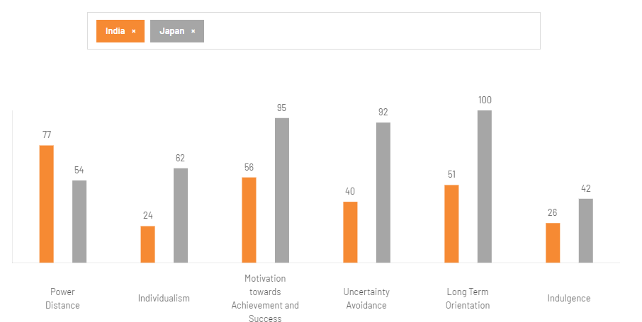
Figure 5: Cultural comparison of India and Japan
(Source: Theculturefactor.com, 2025)
An analysis of the home culture of Japan and India as an emerging market displays both favorable trends and unfavorable trends of Toyota that will affect the management practice and coordination of the workforce, as well as adapting the operations.
The fact that India has a high power distance (77) compared to Japan (54) may provide a good influence towards the deployment of effective hierarchical organizations by Toyota since employees in India relatively welcome top-down decision-making and a robust leadership (Theculturefactor.com, 2025; Goyal et al., 2025). But this also presents a drawback as the Japanese culture of Toyota is based on consensus-building (ringi-sho) and group contribution that might not always conform easily to the demands of an Indian and organization to capitalize on directive leadership which can potentially slow the harmonization process between teams. The extreme dissimilarity in individualism (Japan 62, India 24) has both positive and negative impacts (Theculturefactor.com, 2025). The collectivist culture in India has the potential to positively impact teamwork, loyalty and grouping in the Indian Toyota operations that is facilitate long term employee retention (Dutta and Rangnekar, 2023). On the other hand, individual accountability in collectivist environments is low and this could be opposite to requirements of Toyota that focuses more on individual accountability and disciplined compliance to TPS routines (Or and Berkovich, 2021).
High uncertainty avoidance (92) of Japan compared to low structure tolerance (40) of India poses problems (Theculturefactor.com, 2025). The philosophy that guides the operations of Toyota is very precision-driven, risk-averse, and process standardisation based; the flexibility and casual approach to issues that India prefers might compromise the use of TPS strictly. However, such flexibility can prove to be beneficial in a dynamic market, allowing faster conformities to the local conditions (Rebenaque et al., 2023). The difference in long-term orientation (Japan 100, India 51) also has two effects. Toyota also takes advantage of the readiness of India to enter long-term corporate relations but Indian partners might be more concerned about short-term and medium-term gains, which may cause strategic pacing (Zhang et al., 2025). Lastly, the below indulgence of India (26) compared to that of Japan (42) is quite consistent with the workers focused disciplined culture of Toyota though it might hinder tolerance to workplace innovations. In general, these cultural differences constitute both beneficial complementarities to Toyota and at the same time require specific localisation and management reorientation.

4.2 Implications for Toyota’s market entry strategy
The cultural variations between Japan and India have a long-lasting implication in the entry strategy of Toyota into these markets, where the company will organize its governance, management of people, and adjust operations to the expectations of the local markets. The power distance in India is high, which implies that top-down decision making and authoritarian leadership style will be more successful compared to Japan, which is consensus-based (Youssef et al., 2025). In the case of Toyota, this would have the implication of having to deploy strong local managerial leadership and cut down channels of decision within Indian subsidiaries or joint ventures. Such an adaptation can aid quicker operational harmonisation, but it may as well establish strain with culturally ingrained participatory style of Toyota when not well balanced.
The collectivist orientation of India makes cross-border relationships based on long-term more achievable, which makes joint ventures an entry mode that fits well in the cultural context of India (Durand, Lamotte and Thomas, 2024). This also strengthens the existing partnership between Toyota and the Kirloskar Group whose relationship is founded on trust and obligation towards each other. Nonetheless, collectivism can also delay the adoption of TPS principles that are dependent on individual responsibility and controlled self-motivation that demands Toyota to enhance training and supervisory control. Aspects of uncertainty avoidance differences also have strategic impacts (Kalasin, 2020). The ambiguity comfort which is found in India implies that Toyota has to invest in more powerful, standardised processes and constant checks to maintain TPS integrity. Simultaneously, India is more flexible, which facilitates adaptive strategies, so Toyota can be able to change its production schedules, products portfolios, and supply networks in a more dynamic way than in Japan.
The difference in the long-term orientation implies that Toyota needs to align the long-term strategic vision with the more balanced time perspective in India (Alipour, 2021). Toyota prefers building capabilities gradually, whereas the Indian partners will want faster returns, which will affect negotiation, the pace of investment, and performance indicators. All these cultural implications suggest that to successfully enter the Indian market, Toyota should adopt a hybrid approach, i.e. keeping its fundamental Japanese operations philosophy intact and at the same time incorporating culturally-responsive leadership/partnership arrangement/workforce management practices.

4.3 Impact on potential for success
The cultural differences between Toyota and India have significant implications, both positive and negative, on the tool of entering the other country into the market. On the good side, India has a greater power distance that fits properly with the well-organized managerial frameworks used by Toyota, which allows having a more established supervision and more authoritarian leadership at the initial stages of market penetration (Ayele and Singh, 2024). This enables effective operational standards implementation more so in the manufacturing units. The collectivist culture of India also suggests that group cohesion, loyalty and long term employment bonds have a good support which favors Toyota focus on teamwork, sharing of knowledge and monitoring of improvement (Siddiqui, 2025). More so, the ambiguity tolerance in India offers Toyota some leeway in trying out market-specific adjustments, especially in the marketing policies and local supplier chains.
Also, these cultural distinctions, however, present considerable issues that define the strategic direction of Toyota. This extreme difference in uncertainty avoidance makes it difficult to transfer the Toyota Production System (TPS) that presupposes strict routines, high coordination, and customer quality requirements. Such rigid structures may not be accepted at Indian workplaces and Toyota had spent a lot of money on cultural training and establishment of capability (Ranganathan, 2021). The cultural differences in the level of individualism can also have an impact on the level of performance assessment and accountability; consequently, Toyota may not adapt the examples of the cultures of Japan and self-motivated problem-solving (Endrawes, Leong and Matawie, 2021). Moreover, medium long-term orientation of India could cause the incongruence of the strategic horizons as the local partners/stakeholders can be focused on the short-term business advantages which are opposite in terms of the multi-decade-investment philosophy of Toyota (Coffay et al., 2024). The difference in communication due to hierarchical norms can further hinder the decision-making process, cause overload in the coordination processes and create miscommunication in the course of the joint venture negotiations (Sao and Rohilla, 2025). Toyota, therefore, combined culturally aware leadership, specific employee training, flexibility in its operations, and decrees in terms of granting proper selection to partners to balance all this upside and limitations (Benkarim and Imbeau, 2022).

5. Critical Discussion and Recommendation of Three SOP Adjustments

SOP Adjustment 1: Localisation of Operational Processes
Localisation of operational processes of Toyota in India is key to balancing both global standards of production and cultural, and institutional realities of the host countries. One of the beneficial outcomes of localisation is that localisation will allow Toyota to match the Toyota Production System (TPS) to the capacity of the local workforce, the infrastructural environment and maturity of the suppliers in India. Localisation of TPS elements such as standardised work patterns, visual control systems and problem-solving systems leads to greater operational efficiency and lowers resistance in employees who are potentially foreign to the high precision and disciplined process culture in Japan (Simonsen, Herrera and Atencio, 2023). Localisation will also enable Toyota to incorporate the additions of flexibility and the ability to improvise as practiced in India in the day-to-day activities, enhancing responsiveness in the face of unforeseen market shocks and better resilience of the supply chain.
Nonetheless, there are also problems with localisation. The problem with over-adaptation is that the main principles of TPS may be diluted and eventually affect the quality, productivity, and stability of the process (Subramanya, 2016). The low uncertainty avoidance and other work-related norms in India can be a cause of mixed compliance with the established standard operating procedures unless Toyota makes extensive investments in constant training and quality control systems (Toyota, 2024b). Additionally, localisation will escalate the managerial load; Toyota will also need to create India-specific workflow, supervisory mechanisms as well as programme of supplier development whilst remaining consistent with the world performance standards (Mulder, 2023).

SOP Adjustment 2: Culturally Adaptive HR and Management Practices
Culturally adjustive HR and management is essential in the successful incorporation of Toyota in the Indian market (Benkarim and Imbeau, 2022). On the bright side, the fact that India has a higher power distance and collectivist orientation could be used to tailor its HR systems can ensure high levels of employee acceptance, engagement, and performance. Indian workers tend to embrace strict directions, systems of leadership hierarchies, and leadership visibility. By adjusting the style of supervision, types of communication, and other decision making processes to suit these expectations, the implementation of Toyota Production System (TPS) will proceed with less resistance, as well as decreasing the level of cultural friction. In addition, the focus on incentives and teamwork, establishing relationships and low-stress workplaces also meets with the Indian high collectivist setting, developing loyalty and preventing turnover in a very competitive labour market (Glenn et al., 2021).
Toyota also uses culturally adaptive HR practice as a specific beneficiary of its leadership development initiatives (Liker and Hoseus, 2025). The inclusion of local standards in the training programmes will enable the employees to learn the Japanese management philosophy of Toyota whilst remaining culturally-compatible. This twofold strategy empowers cross-cultural competence or India managers to be more responsible in the global Toyota network. These have disadvantages, though. Efforts to change the HR systems to suit the local demands and expectations could also unwittingly undermine the main organisational culture of Toyota that focuses on consensus, empowerment and continuous improvement. The hierarchical system in India can be over-reliant, which can hinder the solution of an issue based on kaizen and diminish the problem-taking ability of the staff members (Sukardi, Hamamah and Karim, 2025). Moreover, adaptive practices that are culturally adaptable demand significant investment on training, change management and upskilling of managers to facilitate consistency in their application across different regions. Communication barriers could also exist because of the issues of indirect communication style, risk-taking, and norms of feedback. Toyota should therefore strike a balance between global HR benchmarks and the local cultural realism, whereby adaptation improves and does not affect organisational congruency and operational efficiency.

SOP Adjustment 3: Market-Specific Product and Marketing Adaptation
Remaking the Toyota products and marketing strategies according to the distinctive features of the Indian market is necessary in order to reach the better stages of consumer resonance and competitive positioning. The good side is that the product is market-specific so Toyota can match the design of its vehicles, pricing policies, fuel efficiency limit, and feature setups with the needs of the Indian customers who generally value economy, durability, and low service fees. Adding new local innovations like ground clearance, small size to that of a city car, and hybrid technology to fit within the congested areas, amplifies the strength of Toyota in the main areas (William, 2021). Marketing modification also enables Toyota to communicate in a better manner through the use of culturally familiar stories, local language and value-based messages that indicate Indian socio-cultural standards, which means a strong brand loyalty is achieved (Hartoyo et al., 2023).
This localisation strategy, however, has its disadvantages. Localising products in India may necessitate a diversion towards the Toyota world-standardisation of production, compounding the production lines, and drive economies of scale down. Massive market research, re-designing, and modification of supply chains are extra expenses and can extend product development timelines (Reitsma, Hilletofth and Johansson, 2021). The marketing messages specific to India should also be well developed to prevent misinterpretations along the lines of the different cultural and linguistic backgrounds. Also, the localisation can cause a weakness in globalisation of Toyota brand image leading to discrepancies in quality or brand image.

6. Conclusion
In conclusion, this report has established that the internationalization of Toyota in India is influenced by an intricate combination of strategic, cultural, and operational variables. The OLI framework draws attention to the fact that the good ownership benefits of Toyota, the mixed location factors in India and the necessity of internalised control all explain why the entry mode should focus on the joint venture complemented by a few wholly-owned subsidiaries. Cultural comparison between Japan and India also creates significant implications to leadership, coordination of the workforce, and operational implementation whereby careful adaptation of the same is affected to facilitate alignment with global standards as is with Toyota. The suggested SOP revisions, namely: the localisation of operational processes, the culture adaptive HR practices, and localisation of products and marketing in accordance with the expectations of Indian consumers, can provide effective channels towards enhancing the long-term performance of Toyota. Finally, the capacity to manage the consistency on an international scale combined with the local responsiveness of Toyota will define its potential to be competitive and attain sustainable growth in the dynamic Indian automotive market.

References
Al Astal, A.Y.M., Ateeq, A., Milhem, M. and Shafie, D.I. (2024). Corporate Governance and Internal Control Mechanisms: Developing a Strategic Framework. Studies in Systems, Decision and Control, pp.551–564. doi:https://doi.org/10.1007/978-3-031-71318-7_51.
Alipour, A. (2021). What matters for the future? Comparing Globe’s future orientation with Hofstede’s long-term orientation. Cross Cultural & Strategic Management, 28(4). doi:https://doi.org/10.1108/ccsm-08-2020-0163.
Amro, A., Rehman, A.U. and Ali, A. (2025). Service quality and price perception as catalysts for customer engagement and experience in automotive aftersales. Cogent Business & Management, 12(1). doi:https://doi.org/10.1080/23311975.2025.2514939.
Ashta, A. (2021). National Identity, Othering and Resistance: Host Country Manager’s Experience at a Japanese Multinational Enterprise in India. Global Business Review, p.097215092110476. doi:https://doi.org/10.1177/09721509211047649.
Ayele, N.F. and Singh, M. (2024). Integrating sustainability with performance: Effect of social and environmental dimensions of the balanced scorecard on the performance of financial institutions in Ethiopia, moderated by management commitment. Business Strategy & Development, 7(3). doi:https://doi.org/10.1002/bsd2.414.
Benkarim, A. and Imbeau, D. (2022). Investigating the Implementation of Toyota’s Human Resources Management Practices in the Aerospace Industry. Merits, [online] 2(3), pp.126–145. doi:https://doi.org/10.3390/merits2030010.
Bhattacharjea, A. (2020). Labour Market Flexibility in Indian Industry: A Critical Survey of the Literature. International Labour Review. doi:https://doi.org/10.1111/ilr.12194.
Bhattacharyya, K., Shah, S.A., Sapre, A.A. and Singh, S. (2024). Regulation of Transnational Corporations (TNCs) in International Law. Advances in public policy and administration (APPA) book series, [online] pp.301–312. doi:https://doi.org/10.4018/979-8-3693-1742-6.ch017.
Burciu, A., Alexandra, C., Prunău, N.-F., Kicsi, R., Chifan, D.-A., Băeșu, C. and Danileț, A.M. (2025). Strategy, Structure and Systems: Sun Tzu’s Thinking and the Holonic Network of the Toyota Dealer System (TDS)—A Romanian Case Study. Systems, [online] 13(8), pp.723–723. doi:https://doi.org/10.3390/systems13080723.
Chau, V.S. and Nacharoenkul, T. (2023). Japanese business communication practices in Thailand: tales from an electronic components manufacturer. Management Decision, 61(8), pp.2467–2490. doi:https://doi.org/10.1108/md-08-2022-1092.
Chen, J., Li, X. and Zhu, Y. (2023). Shock absorber and shock diffuser: the multiple roles of industrial diversity in shaping regional economic resilience after the Great Recession. The Annals of Regional Science, 72(3), pp.1015–1045. doi:https://doi.org/10.1007/s00168-023-01233-2.
Coffay, M., Ragnar Tveterås, Bocken, N. and Bogers, M. (2024). Sustainable business model innovation, dynamic capabilities, and organizational design: Insights from Norwegian aquaculture. Business strategy and the environment. doi:https://doi.org/10.1002/bse.3762.
Das, M. (2020). What pans out for Maruti Suzuki from Toyota-Suzuki partnership? - ET Auto. [online] ETAuto.com. Available at: https://auto.economictimes.indiatimes.com/news/what-pans-out-for-maruti-suzuki-from-toyota-suzuki-partnership/77848973 [Accessed 11 Dec. 2025].
Duhaime, I.M., Hitt, M.A. and Lyles, M.A. (2021). Strategic management : state of the field and its future. New York, Ny: Oxford University Press.
Durand, M., Lamotte, O. and Thomas, M. (2024). The individual nature of cultural friction in cross-border M&As: exploring the role of face when working with Asian counterparts. Journal of Asia Business Studies, 18(4), pp.946–963. doi:https://doi.org/10.1108/jabs-04-2023-0148.
Dutta, A. and Rangnekar, S. (2023). Promoting concern for team members in Indian enterprises through personal interaction: mediating through a preference for teamwork and co-worker support. Journal of Organizational Effectiveness: People and Performance, 10(4). doi:https://doi.org/10.1108/joepp-05-2022-0103.
Endrawes, M., Leong, S. and Matawie, K.M. (2021). The moderating effect of culture on the relationship between accountability and professional scepticism. Meditari Accountancy Research, 31(2). doi:https://doi.org/10.1108/medar-08-2020-0986.
Fu, X., Buckley, P.J., Sanchez-Ancochea, D. and Hassan, I. (2021). The world has a unique opportunity: Accelerating technology transfer and vaccine production through partnerships. Journal of International Business Policy. doi:https://doi.org/10.1057/s42214-021-00124-7.
Glenn, J., Moucheraud, C., Payán, D.D., Crook, A., Stagg, J., Sarma, H., Ahmed, T., Epstein, A., Luies, S.K., Rahman, M., Kruk, M.E. and Bossert, T.J. (2021). What is the impact of removing performance-based financial incentives on community health worker motivation? A qualitative study from an infant and young child feeding program in Bangladesh. BMC Health Services Research, 21(1). doi:https://doi.org/10.1186/s12913-021-06996-y.
Goyal, K., Lim, W.M., Nigam, A. and Goyal, N. (2025). How to promote employee engagement? A comparison of top-down versus bottom-up approaches. Asia-Pacific Journal of Business Administration. doi:https://doi.org/10.1108/apjba-10-2024-0551.
Hartoyo, H., Manalu, E., Sumarwan, U. and Nurhayati, P. (2023). Driving Success: A Segmentation of Customer Admiration in Automotive Industry. Journal of Open Innovation: Technology, Market, and Complexity, [online] 9(2), p.100031. doi:https://doi.org/10.1016/j.joitmc.2023.100031.
Hidayatullah, A.F.R. and Novica, D.A. (2025). JOINT VENTURE VS. WHOLLY OWNED SUBSIDIARY: STRATEGIC ADAPTATION OF TOYOTA MOTOR CORPORATION. [online] 3(2), pp.67–82. doi:https://doi.org/10.33474/percipience.v3i2.24415.
Hsiao, Y.-C. and Lin, J.-Y. (2022). Knowledge management and innovation: evidence of international joint venture. Scientometrics. doi:https://doi.org/10.1007/s11192-022-04562-9.
Kadam, N., Niersbach, B. and Ivens, B.S. (2022). The cultural factors in global account management: the case of Indian buyers and German suppliers. Journal of Business & Industrial Marketing, 38(2), pp.353–366. doi:https://doi.org/10.1108/jbim-12-2021-0594.
Kalasin, K. (2020). Strategic change: the impact of senior foreign managers, firm size and uncertainty avoidance. Review of International Business and Strategy, ahead-of-print(ahead-of-print). doi:https://doi.org/10.1108/ribs-03-2020-0023.
Li, Y., Gao, R. and Wang, J. (2021). Determinants of EMNEs’ Entry Mode Decision with Environmental Volatility Issues: A Review and Research Agenda. Journal of Risk and Financial Management, 14(10), p.500. doi:https://doi.org/10.3390/jrfm14100500.
Liker, J.K. and Hoseus, M. (2025). Human Resource development in Toyota culture. International Journal of Human Resources Development and Management, [online] 10(1), p.34. doi:https://doi.org/10.1504/ijhrdm.2010.029445.
McDougall, N. and Davis, A. (2024). The Local Supply Chain during Disruption: Establishing Resilient Networks for the Future. Journal of cleaner production, [online] 462, pp.142743–142743. doi:https://doi.org/10.1016/j.jclepro.2024.142743.
Miglani, S. (2019). The Growth of the Indian Automobile Industry: Analysis of the Roles of Government Policy and Other Enabling Factors. Innovation, Economic Development, and Intellectual Property in India and China, [online] pp.439–463. doi:https://doi.org/10.1007/978-981-13-8102-7_19.
Mirzaye, S. and Mohiuddin, M. (2025). Digital Transformation in International Trade: Opportunities, Challenges, and Policy Implications. Journal of Risk and Financial Management, [online] 18(8), p.421. doi:https://doi.org/10.3390/jrfm18080421.
Moradlou, H., Boffelli, A., Mwesiumo, D., Benstead, A., Roscoe, S. and Khayyam, S. (2023). Building Parallel Supply Chains: How the Manufacturing Location Decision Influences Supply Chain Ambidexterity. British Journal of Management. doi:https://doi.org/10.1111/1467-8551.12757.
Mulder, F. (2023). The paradox of externally driven localisation: a case study on how local actors manage the contradictory legitimacy requirements of top-down bottom-up aid. Journal of International Humanitarian Action, 8(1). doi:https://doi.org/10.1186/s41018-023-00139-0.
Muniz, J., Popadiuk, S., Batistela, G.C., Nakanishi, F.K. and Rodriguez, I.A. (2022). Toyota’s knowledge-sharing intention in Brazil and Japan: does organisational cross-culture matter? Knowledge Management Research & Practice, 22(2), pp.1–15. doi:https://doi.org/10.1080/14778238.2022.2136546.
Mygind, N. and Poulsen, T. (2021). Employee ownership – pros and cons – a review. Journal of Participation and Employee Ownership, ahead-of-print(ahead-of-print). doi:https://doi.org/10.1108/jpeo-08-2021-0003.
Ng, D.T.K. (2022). Online aviation learning experience during the COVID‐19 pandemic in Hong Kong and Mainland China. British Journal of Educational Technology. doi:https://doi.org/10.1111/bjet.13185.
Ngo, V.M., Quang, H.T., Hoang, T.G. and Thi, A. (2023). Sustainability‐related supply chain risks and supply chain performances: The moderating effects of dynamic supply chain management practices. Business Strategy and the Environment, [online] 33(2). doi:https://doi.org/10.1002/bse.3512.
Or, M.H. and Berkovich, I. (2021). Participative decision making in schools in individualist and collectivist cultures: The micro-politics behind distributed leadership. Educational Management Administration & Leadership, 51(3), p.174114322110013. doi:https://doi.org/10.1177/17411432211001364.
Pib.gov.in (2022). Initiatives taken by the government to boost manufacturing. [online] Gov.in. Available at: https://www.pib.gov.in/PressReleaseIframePage.aspx?PRID=1882145®=3&lang=2 [Accessed 11 Dec. 2025].
Quttainah, M.A., Jain, P., Goyal, R., Kanwal, P. and Kumar, A. (2024). Digitalization and Knowledge Management in Entrepreneurial Supply Chains. Advances in Logistics, Operations, and Management Science, [online] pp.237–260. doi:https://doi.org/10.4018/979-8-3693-3386-0.ch009.
Ranganathan, A. (2021). Identification and Worker Responses to Workplace Change: Evidence from Four Cases in India. ILR Review, 74(3), p.001979392198968. doi:https://doi.org/10.1177/0019793921989683.
Rebenaque, O., Schmitt, C., Schumann, K., Dronne, T. and Roques, F. (2023). Success of local flexibility market implementation: A review of current projects. Utilities Policy, [online] 80, p.101491. doi:https://doi.org/10.1016/j.jup.2023.101491.
Reitsma, E., Hilletofth, P. and Johansson, E. (2021). Supply chain design during product development: a systematic literature review. Production Planning & Control, [online] 34(1), pp.1–18. doi:https://doi.org/10.1080/09537287.2021.1884763.
Röell, C., Arndt, F. and Kumar, V. (2022). A Blessing and a Curse: Institutional Embeddedness of Longstanding MNE Subsidiaries in Emerging Markets. Journal of Management Studies, 61(2). doi:https://doi.org/10.1111/joms.12817.
Sadiq, M., Ali, S.W., Terriche, Y., Mutarraf, M.U., Hassan, M.A., Hamid, K., Ali, Z., Sze, J.Y., Su, C.-L. and Guerrero, J.M. (2021). Future Greener Seaports: A Review of New Infrastructure, Challenges, and Energy Efficiency Measures. IEEE Access, [online] 9, pp.75568–75587. doi:https://doi.org/10.1109/ACCESS.2021.3081430.
Sao, A. and Rohilla, N. (2025). Impact of Input Matrix Variation on Communication and Collaboration in Construction. pp.1105–1132. doi:https://doi.org/10.1007/978-981-96-7631-6_37.
Shailesh, M. (2018). IP Environment In India - An Insight On Opportunities And Threats. [online] Mondaq.com. Available at: https://www.mondaq.com/india/patent/703108/ip-environment-in-india-an-insight-on-opportunities-and-threats [Accessed 11 Dec. 2025].
Shih, W. (2022). What really makes Toyota’s production system resilient. [online] Harvard Business Review. Available at: https://hbr.org/2022/11/what-really-makes-toyotas-production-system-resilient [Accessed 11 Dec. 2025].
Siddiqui, R.N. (2025). Diversity, Cultural Bonding and Social Resilience. Building a Resilient and Responsible World, pp.87–97. doi:https://doi.org/10.1007/978-981-96-0108-0_5.
Simonsen, E.M., Herrera, R.F. and Atencio, E. (2023). Benefits and Difficulties of the Implementation of Lean Construction in the Public Sector: A Systematic Review. Sustainability, [online] 15(7), p.6161. doi:https://doi.org/10.3390/su15076161.
Singh, D. and Gaur, A.S. (2021). Risk mitigation strategies in international B2B relationships: Role of institutions and governance. Journal of Business Research, 136, pp.1–9.
Statista (2025). India: automobile industry sales by type 2025| Statista. [online] Statista. Available at: https://www.statista.com/statistics/608392/automobile-industry-domestic-sales-trends-india/?srsltid=AfmBOoqo9ReK_U3GoqqmCfkI0KDRAjuipyf1EZvO-9WiW06ugb6k_akA [Accessed 11 Dec. 2025].
Subramanya, S.R. (2016). Adapting some Rules and Principles of TPS (Toyota Production System) to Software Development. International Journal of Computer Applications, (8), pp.36–41.
Sukardi, D., Hamamah, F. and Karim, A. (2025). Cooperatives based on the values of dignified justice in Indonesia and comparison with USA, Sweden, South Korea and India. Cogent Social Sciences, 11(1). doi:https://doi.org/10.1080/23311886.2025.2573153.
Theculturefactor.com (2025). Country comparison of India and Japan. [online] Theculturefactor.com. Available at: https://www.theculturefactor.com/country-comparison-tool?countries=india%2Cjapan [Accessed 11 Dec. 2025].
Times of India (2024). Toyota set to benefit from hybrid sales surge as electric vehicle excitement wanes. [online] The Times of India. Available at: https://timesofindia.indiatimes.com/auto/cars/toyota-set-to-benefit-from-hybrid-sales-surge-as-electric-vehicle-excitement-wanes/articleshow/109922238.cms [Accessed 11 Dec. 2025].
Toyota (2018). Toyota Kirloskar Motor becomes the first automobile manufacturer in India to get the ISO 22000:2005 Certification. [online] www.toyotabharat.com. Available at: https://www.toyotabharat.com/news/2018/toyota-kirloskar-motor-becomes-the-first-automobile-manufacturer-in-india-to-get-the-iSO-22000-2005-certification.html [Accessed 11 Dec. 2025].
Toyota (2023). Japan | global operations | facilities | profile | company. [online] Toyota Motor Corporation Official Global Website. Available at: https://global.toyota/en/company/profile/facilities/manufacturing-worldwide/japan.html [Accessed 5 Dec. 2025].
Toyota (2024a). Toyota in the World | Toyota Ireland. [online] Toyota IE. Available at: https://www.toyota.ie/discover-toyota/about-us/toyota-in-the-world [Accessed 5 Dec. 2025].
Toyota (2024b). Toyota Industries Report Toyota Industries Report. [online] Available at: https://www.toyota-industries.com/investors/item/TICOReport2024_E_full_print.pdf [Accessed 11 Dec. 2025].
Toyota (2025a). Innovation at Toyota | Toyota Europe. [online] Toyota EU. Available at: https://www.toyota-europe.com/innovation [Accessed 11 Dec. 2025].
Toyota (2025b). Toyota Production System. [online] Toyota Motor Corporation Official Global Website. Available at: https://global.toyota/en/company/vision-and-philosophy/production-system/ [Accessed 5 Dec. 2025].
Vanichchinchai, A. (2022). The relationships between soft and hard factors of the Toyota way: a socio-technical perspective. Operations Management Research, 16. doi:https://doi.org/10.1007/s12063-022-00318-z.
William, C. (2021). Enhancing Urban Transport Environmental Performance with Technology and Innovation. Journal of Energy and Environmental Policy Options , [online] 4(3), pp.28–33. Available at: http://resdojournals.com/index.php/JEEPO/article/view/259 [Accessed 11 Dec. 2025].
Williams, M.J. (2020). Beyond state capacity: bureaucratic performance, policy implementation and reform. Journal of Institutional Economics, 17(2), pp.1–19. doi:https://doi.org/10.1017/s1744137420000478.
Youssef, M.H., Kleindienst, I., Khalife, D. and Salameh-Ayanian, M. (2025). Enacting discretion in a low discretion environment: an interview with Carlos Ghosn. Critical Perspectives on International Business, pp.1–30. doi:https://doi.org/10.1108/cpoib-12-2024-0162.
Zhang, X., Li, J., Li, Y., Zhu, K., Xu, J. and Wang, S. (2025). U.S. Trade Policy and the Restructuring of Global Production Networks: A Case Study of Industrial Relocation from China to India. Structural Change and Economic Dynamics, [online] 76. doi:https://doi.org/10.1016/j.strueco.2025.11.009.
Zhao, X. and Stiles, D.R. (2023). Stuck in Limbo: how sensemaking discrepancy over strategy-related performance leads to disjointed collaboration in an international joint venture. Asia Pacific Journal of Management. doi:https://doi.org/10.1007/s10490-023-09877-6.
Zulfikar, I. (2023). Building a Strong Brand: Marketing Strategy to Increase Brand Awareness and Consumer Loyalty. Neo Journal of economy and social humanities, 1(4), pp.280–284. doi:https://doi.org/10.56403/nejesh.v1i4.79.

