A Study on the impact of Salary & Promotion on Employee Engagement and Retention in Premier Inn Kingston

Student Name: Mohammed Shamsul Mridha
Student ID: 2013213
Module: Personnel Resourcing and Development
Lecturer: Kathryn Roberts
Words: 2034
Table of Contents
Introduction 3
1.0 Introduction 3
1.1 Background 4
1.3 Scope of Study 4
2.0 Methodology 5
2.1 Concept of Employee Involvement 5
2.2 The Significance of Employee Engagement 5
2.3 Employee Engagement Framework 6
2.4 Method of Collecting Information: Primary and secondary research 7
2.4.1 Method of Primary Research 7
2.4.2 Method of Secondary Research 8
2.4.3 Survey Form 8
2.4.4 An in-depth conversation with some of Premier Inn's staff members 9
2.4.5 Approaches to Secondary Investigation 9
3.0 Research Method Evaluation 10
3.1 Primary research methods: advantages and disadvantages 10
3.2 Secondary Research Advantages and Disadvantages 11
Conclusion 12
References 13

Introduction

1.0 Introduction
Many businesses, including those in the travel, tourism, and hotel management industries, have been severely impacted by the Covid-19 outbreak, (Morrison, 2021). It was incredibly difficult to maintain commercial operations when they had to shut down all of their hotels and motels owing to constant lockdowns and safety procedures. Because of this, the World Tourism Organization (WTO) marked that 2020 was the worst year in the history of world tourism. As many as 100-120 million tourists and hotel guests could be at risk due to an estimated $1.3 trillion in losses, (Deloitte, 2021). Many hotel managers had to work from home since they couldn't get to work because of travel restrictions. These initiatives increased job instability.

1.1 Background
The fast-service luxury hotel chain in the United Kingdom, Premier Inn has more than 74,000 suites and 700 properties in the United Kingdom, (Dickens, 2021). Cities, suburbs, and ports are all served by the hotels managed by this organisation. It wasn't until 1987 that Whitbread established Travel Inn as a counter-attack against Travelodge. Because of this, many of Premier Inn's hotels in the UK are located in rehabilitation project office buildings that would otherwise be torn down. Premier Inn made an early foray into popular television advertising in the United Kingdom with this ad. The combination of Travel Inn and Premier Lodge was publicised on television through cartoons. Over a third of all reservations are now made via traditional and mobile means. As a result, Premier Inn has spent a lot of money developing both its official website and its Android reservation app, (Nasef and Abouraia, 2022). Online advertising is another way that Premier Inn keeps visitors from other websites coming to the hotel's website. Besides the primary brand, Premier Inns has two more brands with limited engagements. Guests at the Hub by Premier Inn, a city-centre hotel with modest rooms, have access to in-room technology including tablet computers, (Premier Inn, 2022).
The company cited Covid-19 restrictions for a 39% drop in statutory sales to £661.6 million in the first six months, (Statista, 2022) of the 2022 financial year so far.

1.3 Scope of the Study
Despite Premier Inn's best efforts, the epidemic has had a major psychological and financial impact on the employees. The result is a greater likelihood of job dissatisfaction among workers. As many as 43% of workers are on the lookout for new positions as a result of their current workplace's unhappiness, (Haile, 2021). In light of the current post-pandemic context, the research will address the following issues:
- Salary increases can have an impact on employee morale.
- Promoted employees may have a higher level of productivity.
- culture and principles of the organisation impacting employee commitment
- Job satisfaction on the long-term retention of critical individuals
- An employee's sense of belonging has a significant impact on their level of engagement.
This study will explore the impact of these factors on employee engagement at the Premier Inn London Kingston upon Thames using primary and secondary data sources.

2.0 Methodology

2.1 Concept of Employee Involvement
When a worker feels appreciated and respected by their employer, they are more likely to be engaged in their work, (Truss, 2018). Higher levels of employee engagement led to a 4x increase in profit for companies. It is common knowledge that excessive turnover is a direct result of a lack of employee engagement. A majority of workers (57 percent) in the United States and the United Kingdom are disengaged with their careers, (Byrne, 2015). Since the outbreak of covid-19, thousands of hotel workers have been laid off or given time off due to the epidemic, (Wahab, 2021). As a result, all of these factors are likely to have an impact on hotel staff engagement levels.

2.2 The Significance of Employee Engagement
At the end of the day, engaged employees are more focused on the task at hand. Working in an open environment fosters innovation, creativity, and the generation of fresh ideas and approaches to problems, (Albrecht, 2019). An organization's costs can be considerably reduced even when its employees are highly engaged. The following are the benefits of employee engagement:
- An understanding of the purpose, objective, and goals of the organisation
- Employees felt energised and recognised after receiving correct feedback from their managers, (Albrecht, 2019).
- To solve problems and come up with fresh ideas, communication is the most important factor.
- The ability to perform better thanks to better preparation and development.
- Rewarding oneself with the right amount of money and other perks.
- A feeling of safety in one's workplace.

Highly engaged employees have a 43 percent lower rate of absenteeism than disengaged workers, (Woodruffe, 2021). As they are being judged, they have a strong urge to prove themselves. For organisations with a high turnover rate, recruiting new employees costs an average of $6,000-$8,000 each year. Hotels, which are service enterprises that place a high value on customer service, are notorious for having high employee burnout rates, (Woodruffe, 2021). Because of this, it is imperative to establish a healthy work environment where hotel staff feel at ease.

2.3 Employee Engagement Framework
Aon Hewitt's employee engagement model takes into mind the company's bottom line. In terms of metrics like customer satisfaction, earnings, and more, it recognises that employee engagement directly influences them, (Mitchell, 2017). As part of the Aon Hewitt approach, employee engagement outcomes are incorporated. Thus, managers can utilise this data to gauge the level of dedication of their employees.
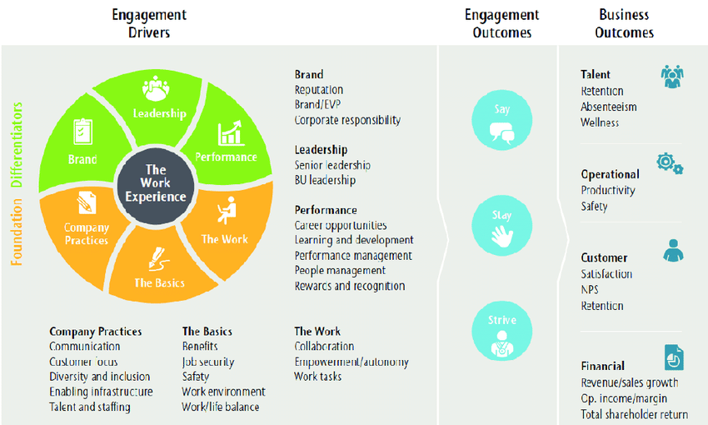
Figure 1: Aon Hewitt's employee engagement model
Source: (Mitchell, 2017)
"Say," "remain," and "strive" are the three most common ways to gauge employee commitment, (Stephanie and Gustomo, 2019). These are the qualities of employees who are engaged. Coworkers, friends, and clients can all benefit from employees who are enthusiastic about their work and satisfied in their roles. This person's top priority is retaining his or her current team. Instead of just collecting their paychecks, members of this group are invested in the firm, have strong relationships with their coworkers, and are content with their employment, (Stephanie and Gustomo, 2019).
Finally, motivated workers try to achieve their full potential on the job. In many cases, they go above and above the call of duty. Employee involvement is primarily driven by the basic needs, practices, and labour of the organisation, while its brand, image, and management style serve as distinctive characteristics, (Coulaty, 2016).

2.4 Method of Collecting Information: Primary and secondary research
Employee engagement can only be assessed as a whole by collecting data. This can be accomplished by utilising both primary and secondary data. These two methods can also be combined to get the best results. Before we get into the nitty-gritty of these approaches:

2.4.1 Method of Primary Research
Since all of the information is gathered by the researcher, this method is time-consuming, (Martins and Serra, 2018). Consequently, the fundamental objective of this study is to develop and implement a research-specific questionnaire. The following primary research approaches are employed in this investigation:
- Workers' Opinions and Suggestions
- In-person conversation with the interviewer
- Observation over a period of three months
The questionnaire takes the longest time and costs the most money, (Gillham, 2015). Observation is the most effective strategy for increasing productivity.

2.4.2 Method of Secondary Research
This study's data was compiled from previously published studies. Government websites, conference papers, journals, and other scholarly publications are some of the places where these numbers can be found, (Beaton, 2017).
To better understand the workers' views on compensation, promotion possibilities, company culture, and values in light of the recent Covid-19 outbreak in relation to their engagement and retention in London Kingston, Premier Inn conducted a survey. A combination of primary and secondary data will be used to get the best results.

2.4.3 Survey Form
Researchers can use this strategy to get objective responses. Even though this approach is more expensive than the others, researchers commonly use it to ensure that employees feel comfortable doing the survey and offering their answers without having to think too much about it in their thoughts, (Lowrance, 2016). Likert Scale Questions can be included in a survey form for Premier Inn Kingston's staff, making it easy for them to answer honestly. Employees can rest confident that their personal information will not be sold or given away. Below is a sample of the Likert scale survey form.
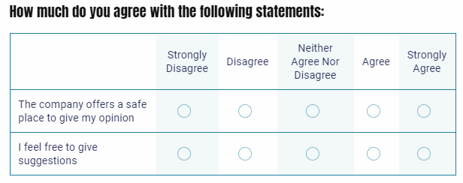
Figure 2: Survey Form
Source: Author

2.4.4 An in-depth conversation with some of Premier Inn's staff members
The major purpose of the interview is to acquire insight into the most effective strategies that the hotel used for increasing the morale of its employees. In addition to this, it will investigate whether or not the employees at the hotel are happy with their jobs. In this context, it is essential to note that the privacy of those who responded to the survey will be respected in compliance with the General Data Protection Regulation (GDPR), (Chirban, 2017).The following is a list of the most important questions that should be asked during the interview process for potential employees:
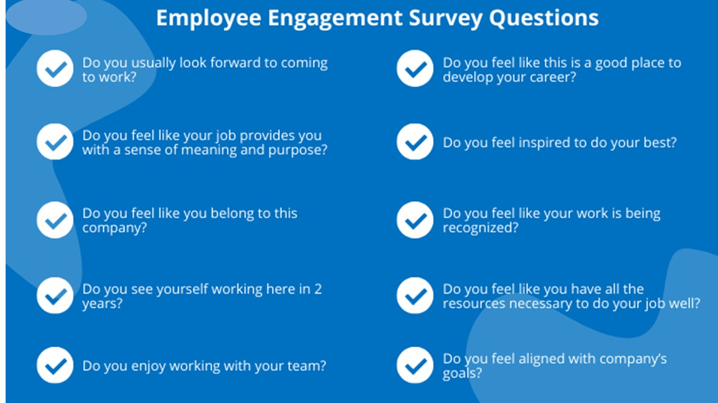
Figure 3: Sample Interview Equations
Source: Author

2.4.5 Approaches to Secondary Investigation
One can learn about current employee engagement levels by conducting the secondary research. It is possible to discern several trends in job satisfaction and preferences, the impact of engagement in retention, and future job security from various journals, publications, and research studies, (Rabinovich and Cheon, 2016). We may deduce a lot about hotel employees' sentiments from these findings, which is useful for future research. To better understand employee satisfaction at Premier Inn Kingston, the following secondary data can be analysed:
- Survey results show that the majority of employees want a flexible work environment.
- Significant changes in organisational policy were made after Covid-19.
- Changes in human resources policies and their impact on employee loyalty
- To find out what's wrong and what can be done to fix it, you should ask these questions in a survey.
Since these data may be utilised to get the most recent trends and changes in the hotel industry's employee retention sector around the world, this study will be completed.

3.0 Research Method Evaluation
Employees may be reluctant to share their thoughts on HR policy and employee engagement techniques. There are advantages and downsides to both systems.

3.1 Primary research methods: advantages and disadvantages
There are pros and disadvantages to conducting primary research (personal interview).
- Responses from the respondent go into great detail.
- The interviewer may elaborate on the questions, (Lowrance, 2016).
- If done effectively, interviews may be both simple and collaborative.
- It's expensive.
- Interviewees' responses can be influenced by the interviewer's style, (Lowrance, 2016).
There are both advantages and disadvantages to using a survey form for employee evaluations.
- Individually specific questions
- Participants will have the opportunity to respond.
- More efficient techniques for gathering data
- As a result, interviewer prejudice is reduced.
- It's a lot of money

3.2 Secondary Research Advantages and Disadvantages
- The ability to develop essential questions is a huge asset, (Beaton, 2017).
- Informing a business's present status
- Readily available information
- Economical and time-saving.
Disadvantages:
- Data from one trial is missing from the database.
- Facts and figures that are misleading, (Beaton, 2017).
- A lack of significance
It will be fairer if data are gathered both in-person and from secondary sources.

Conclusion
Premier Inn Kingston, needs a retention analysis and strategy recommendation path that is individually tailored to the hotel. Using both primary and secondary data, researchers can identify the specific data needed for this study. It will be necessary to use secondary data to provide the charts, graphs, and statistical/qualitative support necessary to appropriately address present and future difficulties in this study on employee engagement and salary & job Promotion. After the initial study has been conducted through secondary research, a list of particular questions must be compiled. At the time of the interview, we'll bring up these questions and record the responses on surveys. Primary research is the most effective method for identifying the most fundamental needs, preferences, and views of hotel personnel. Data gathered from a hotel's entire employee engagement scenario will be used to recommend any essential changes in the hotel's culture and surroundings.

References
Albrecht, S.L. (2019). Handbook of employee engagement: perspectives, issues, research and practice. Cheltenham: Edward Elgar.
Beaton, A.A.E. (2017). Comments on Secondary Analysis. Educational Research and Evaluation, 5(2), pp.237–239. doi:10.1076/edre.5.2.237.6945.
Byrne, Z.S. (2015). Understanding employee engagement: theory, research, and practice. New York; London: Routledge, Taylor & Francis Group.
Chirban, J.T. (2017). Interviewing in-depth: the interactive-relational approach. 11th ed. Thousand Oaks, Calif.: Sage Publications.
Coulaty, B. (2016). The new deal of employee engagement: a sustainable body-and-mind engagement model. Singapore: Mcgraw-Hill Education (Asia.
Deloitte (2021). Impact of COVID-19 on the Hospitality Industry. [online] Deloitte Netherlands. Available at: https://www2.deloitte.com/nl/nl/pages/consumer/articles/impact-of-covid-19-on-the-hospitality-industry.html.
Dickens, M. (2021). Productivity Performance in UK Hotels. Tourism and Hospitality Research, 1(2), pp.187–190. doi:10.1177/146735849900100209.
Gillham, B. (2015). Developing a questionnaire. London: Bloomsbury Academic.
Haile, G.A. (2021). Workplace Job Satisfaction in Britain: Evidence from Linked Employer-Employee Data. LABOUR, 29(3), pp.225–242. doi:10.1111/labr.12054.
Lowrance, D. (2016). Primary Data Collection and Monitoring System. International Journal of Science and Research (IJSR), 5(6), pp.1787–1790. doi:10.21275/v5i6.21061604.
Martins, F.S. and Serra, F.A.R. (2018). Primary Data in Research – Uses and Opportunities. PODIUM Sport, Leisure and Tourism Review, 7(3), pp.I–IV. doi:10.5585/podium.v7i3.316.
Mitchell, D. (2017). 50 Top Tools For Employee Engagement: A Complete Toolkit For Improving Motivation And Productivity. London, United Kingdom: Kogan Page.
Morrison, J. (2021). Apocalypse and the Perception towards the Hospitality Industry during Covid 19. Journal of Contemporary Issues in Business and Government, 27(3). doi:10.47750/cibg.2021.27.03.249.
Nasef, A. and Abouraia, M. (2022). The Effect of Internal Marketing on Innovation in Hotels. Journal of Tourism, Hotels and Heritage, 4(1), pp.37–54. doi:10.21608/sis.2022.127022.1042.
Premier Inn (2022). Kingston upon Thames Hotels | Premier Inn. [online] www.premierinn.com. Available at: https://www.premierinn.com/gb/en/hotels/england/greater-london/london/london-kingston-upon-thames.html [Accessed 15 Jun. 2022].
Rabinovich, E. and Cheon, S. (2016). Expanding Horizons and Deepening Understanding via the Use of Secondary Data Sources. Journal of Business Logistics, 32(4), pp.303–316. doi:10.1111/j.0000-0000.2011.01026.x.
Statista (2022). Whitbread revenue by business segment 2022 so far. [online] Statista. Available at: https://www.statista.com/statistics/739891/revenue-whitbread-united-kingdom-uk-by-segment/ [Accessed 15 Jun. 2022].
Stephanie, L. and Gustomo, A. (2019). Proposal to Improve Employee Engagement by AON Hewitt Model and Mercer Model. Procedia - Social and Behavioral Sciences, 169(33), pp.363–370. doi:10.1016/j.sbspro.2015.01.321.
Truss, C. (2018). Employee engagement in theory and practice. London; New York: Routledge, Taylor & Francis Group.
Wahab, K. (2021). Impact of COVID – 19 on the Hospitality Industry: Climbing Towards Recovery. SSRN Electronic Journal, 34(23). doi:10.2139/ssrn.3737702.
Woodruffe, C. (2021). The crucial importance of employee engagement. Human Resource Management International Digest, 14(1), pp.3–5. doi:10.1108/09670730610643891.

Appendix
This survey has been designed to get the ideas about employee engagement in Premier Inn Kingston, London. Please be assured that, your response will be kept secret and none of the responses will be provided to the hotel authority.
- Self-Capacity

Particulars | Strongly Disagree | Disagree | Neutral | Agree | Strongly Agree | N/A
Coworkers have taught me a great deal.
It's because of my supervisor that I'm able to see possible issues and contribute ideas.
When I'm at work, my team has access to all the essential resources and support.
My place of employment, I am confident, will continue to assist me with my requirements.
B. Team Culture, Work Relationships and Cultures

Particulars | Strongly Disagree | Disagree | Neutral | Agree | Strongly Agree | N/A
As a member of the hotel's team, I believe that my efforts help the establishment realise its goals
I think my workload is appropriate for my position.
my work has given me a sense of accomplishment.
My job makes me happy, and I'm grateful for that.
Motivated by my managers' comments, I'm working harder.
I'm satisfied with my salary/wage arrangement.
In meetings, I'm not afraid to voice my thoughts.
My bosses don't mind me asking them questions.
My boss encourages and cares about my well-being.

- Safety & Security and Covid-19 Situation

Particulars | Strongly Disagree | Disagree | Neutral | Agree | Strongly Agree | N/A
I was helped by my employer throughout the pandemic.
Layoff/furloughed: I was terminated
During the epidemic, I believe that my company took care of me.
My place of employment, I am confident, will continue to assist me with my requirements.
I'm at ease working here.
During my time at work, I have not encountered any harassment, bullying, or discrimination.

D. Any Recommendation

………………………………………………………………………………………………………………………………………………………………………………………………………………………………………………………………………………………………………………………………………………………………………………………………………….

We are extremely grateful for your participation. Every one of your responses will remain anonymous and secure from prying eyes.

