Programme: | BSc (Hons) Health and Social Care
Module: | Psychopathological Classifications and Provisions
Module code: | BMHP6029
Lecturer: | Neale Haddon
Assignment: | Component 2:
Student number: | 2322062
Student name: | Ana Gomes

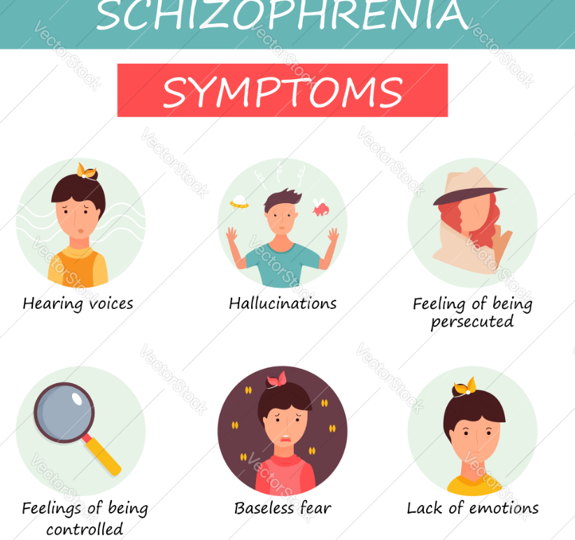

Contents
- Introduction
- Classification and Diagnosis
- Treatment Approaches
- Rehabilitation and Long-Term Managemental
- Current Debates and Emerging Issues
- Policy and Legal Framework
- Recommendations
- Conclusion
- Reference list

Schizophrenia: Classification, Treatment and Policy Context in the United Kingdom
Introduction
Schizophrenia is a profound and enduring mental health illness marked by disruptions in cognition, perception, affect, and conduct. Individuals diagnosed with schizophrenia may exhibit symptoms like hallucinations, delusions, disorganised thought processes, and social disengagement, all of which profoundly impact daily functioning and overall quality of life. The World Health Organization reports that schizophrenia impacts 1% of the global population, rendering it one of the most debilitating psychiatric conditions globally (WHO, 2024). Schizophrenia in the United Kingdom constitutes a considerable public health issue owing to its chronic nature, substantial treatment expenses, and effects on individuals, families, and healthcare systems.
Recent figures from the UK reveal that hundreds of thousands of patients obtain treatment for psychotic disorders via NHS mental health services annually (NHS England, 2023). The condition typically manifests in late adolescence or early adulthood and frequently necessitates lifelong care. The economic and social burden of schizophrenia is substantial, encompassing expenses related to hospitalisations, community support, unemployment, and social marginalisation (House of Commons Library, 2024). Moreover, stigma and discrimination persistently impact individuals with schizophrenia, restricting their access to job, housing, and social assistance.
In the UK healthcare system, schizophrenia is treated by the National Health Service (NHS) using a combination of medication, psychosocial therapy, and community-based rehabilitation. The National Institute for Health and Care Excellence (NICE) formulates clinical guidelines that offer evidence-based recommendations for diagnosis and treatment. These guidelines aim to enhance early detection, advocate for recovery-oriented therapy, and guarantee fair access to mental health services.
This research carefully analyses schizophrenia in relation to UK healthcare and policy. It examines the classification and diagnosis of the disease according to the International Classification of Diseases (ICD-11), assesses treatment modalities endorsed by NICE, and analyses rehabilitation programs implemented within NHS facilities. The research examines contemporary scholarly discussions on schizophrenia and evaluates the influence of UK legislation and policy frameworks, including the Mental Health Act (1983) and the Care Act (2014), on the provision of mental health services. Suggestions are put forth to enhance care, accessibility, and long-term outcomes for those diagnosed with schizophrenia.

Classification and Diagnosis
Schizophrenia is categorised in the International Classification of Diseases, 11th Revision (ICD-11) as a psychotic condition marked by disruptions in perception, cognition, emotion, and behaviour (WHO, 2024). The diagnosis requires the presence of fundamental symptoms, including hallucinations, delusions, disorganised thinking, and unpleasant symptoms, for a substantial duration, lasting a minimum of one month. Hallucinations frequently entail perceiving noise that are inaudible to others, whereas delusions consist of firmly held convictions that lack a basis in reality. Negative symptoms, such as emotional suppression, diminished drive, and decreased verbal communication, can severely hinder social functioning.
Historically, schizophrenia was categorised into categories including paranoid, catatonic, and disorganised schizophrenia. ICD-11 eliminated these classes because to their restricted diagnostic reliability and inadequate clinical value. Clinicians now evaluate symptom patterns and severity across many dimensions, facilitating a more adaptable and personalised diagnostic approach (Gaebel et al., 2020).
In the United Kingdom, diagnosis is often performed by psychiatrists within NHS mental health facilities. The diagnostic approach involves a thorough clinical evaluation, comprising psychiatric interviews, medical history, and behavioural observation. Mental health experts also evaluate differential diagnoses, including bipolar illness, major depressive disorder with psychotic symptoms, or substance-induced psychosis. Timely diagnosis is crucial as early management relates with enhanced long-term outcomes (NICE, 2014).
The NHS offers professional Early Intervention in Psychosis (EIP) services designed to detect and address psychotic diseases at an initial phase. These services target patients encountering their initial episode of psychosis and offer comprehensive care, encompassing medicine, psychological therapy, and social assistance. Studies indicate that early intervention services can decrease hospital admissions, enhance recovery outcomes, and assist persons in sustaining employment or education (NHS England, 2023).
Despite these advancements, diagnostic problems persist within the UK healthcare system. Delays in obtaining mental health assessments can be considerable, especially in regions with scarce mental health resources. The Care Quality Commission (2024) has shown a rising demand for mental health services, exerting strain on physicians and potentially delaying diagnosis and treatment. Cultural differences and stigma may affect the reporting and interpretation of symptoms, potentially impacting diagnosis accuracy.
A persistent issue relates to the vocabulary employed to characterise schizophrenia. Certain researchers contend that the designation "schizophrenia" may perpetuate stigma and misconceptions, prompting suggestions for alternative terminology such as "psychosis spectrum disorder" (Bentall, 2019). Critics contend that merely altering words may fail to confront the underlying societal stigma linked to severe mental illness.

In summary, although the ICD-11 framework offers a systematic method for diagnosing schizophrenia, accurate diagnosis in the UK necessitates well-funded mental health services, culturally attuned assessments, and proactive intervention techniques.

Treatment Approaches
Schizophrenia treatment often involves a blend of pharmaceutical and psychosocial therapies. The NICE recommendations advocate for antipsychotic medication as the principal intervention for addressing psychotic symptoms, specifically hallucinations and delusions (NICE, 2014). Antipsychotic drugs function by modifying dopamine activity in the brain, which is thought to contribute to the emergence of psychotic symptoms.
Frequently prescribed antipsychotics in the UK comprise a medication called olanzapine, quetiapine, and aripiprazole. These drugs may effectively relieve the positive symptoms of schizophrenia; however, they may also induce side effects including weight gain, drowsiness, and metabolic abnormalities. Clozapine is frequently advised for persons with treatment-resistant schizophrenia whose symptoms do not respond to conventional antipsychotic therapy (NICE, 2014). Clozapine has demonstrated significant efficacy; nonetheless, it necessitates meticulous monitoring owing to possible adverse effects, including agranulocytosis.
Alongside pharmacotherapy, psychosocial interventions are essential in facilitating recovery. NICE advocates for Cognitive Behavioural Therapy for Psychosis (CBTp), which assists patients in comprehending and managing their symptoms by contesting uncomfortable ideas and formulating coping strategies. Family interventions are advised, especially for persons residing with relatives or caretakers. These interventions seek to enhance communication, diminish recurrence rates, and assist family members in comprehending the condition (NICE, 2014).
The UK healthcare system provides therapy via various NHS services, such as community mental health teams, crisis resolution teams, and inpatient psychiatric hospitals. Community-based care is prioritised to assist persons in preserving independence and minimising hospital admissions. Nevertheless, access to psychological therapy can differ markedly among regions. Despite the NHS's expansion of mental health services via initiatives like Improving Access to Psychological Therapies (IAPT), several individuals with serious mental illness continue to encounter restricted access to professional therapy.
A further problem concerns to drug compliance. Certain patients cease medicine owing to adverse effects, societal stigma, or insufficient awareness of their condition. Long-acting injectable antipsychotics are occasionally employed to enhance adherence and mitigate relapse risk. Nonetheless, ethical concerns emerge regarding to patient autonomy and informed consent.

In summary, although existing treatment methods can significantly reduce symptoms and enhance quality of life, effective management of schizophrenia necessitates comprehensive care that encompasses both clinical symptoms and social requirements.

Rehabilitation and Long-Term Managemental
Schizophrenia is frequently a chronic disorder need continuous assistance and rehabilitation. Recovery-oriented methodologies prioritise enhancing quality of life, fostering social inclusion, and promoting independence, rather than merely concentrating on symptom alleviation. In the UK, rehabilitation services are provided by community mental health teams and specialised rehabilitation programs.
The NHS Long Term Plan emphasises the significance of community-oriented mental health services and seeks to enhance assistance for those with severe mental illnesses (NHS England, 2019). These services involve supported housing, vocational rehabilitation, and peer support programs. Supported employment efforts have proven particularly beneficial in assisting individuals with schizophrenia in securing and sustaining employment, thereby enhancing self-esteem and social integration.
Charitable organisations significantly contribute to the provision of support services. Organisations such as Mind, Rethink Mental Illness, and Samaritans provide counselling, advocacy, and community support programs. These organisations assist patients in moving through the healthcare system and obtaining practical support, such as housing and financial counsel.
Throughout these initiatives, individuals with schizophrenia frequently encounter obstacles to social integration and academic recovery. Stigma continues to pose a significant obstacle, impacting prospects for job, education, and housing. Studies demonstrate that public misunderstandings regarding schizophrenia might result in discrimination and social ostracism (Corrigan et al., 2016).
A further concern concerns to differences in physical health. Individuals with schizophrenia exhibit a significantly diminished life expectancy relative to the general populace, primarily attributable to cardiovascular illness and other physical health problems (NHS England, 2023). This underscores the significance of integrated care that involves both mental and physical health requirements.

Current Debates and Emerging Issues
Schizophrenia continues to be a subject of much scholarly discourse. A significant controversy pertains to the legitimacy of the diagnosis itself. Certain scholars contend that schizophrenia constitutes a wide range of illnesses rather than a singular condition. Progress in neuroscience and genetics indicates that psychotic diseases may be situated on a spectrum rather than classified as distinct diagnostic categories (Bentall et al., 2019).
A further growing concern is to the concept of neural diversification, which underscores the diversity of human cognitive experiences. Some supporters contend that specific experiences linked to psychosis should not necessarily be diagnosed but rather comprehended within wider social and cultural frameworks. Critics, however, warn that this viewpoint may undervalue the significant functional impairment faced by numerous individuals with schizophrenia.
Discussions on policy in the UK also emphasise funding for mental health and the accessibility of services. Despite augmented investment in mental health care in recent years, demand persists in surpassing existing resources. The Care Quality Commission (2022) has shown a growing demand for mental health services and escalating pressure on NHS personnel.
Digital technology is revolutionising mental health care. Digital therapy platforms, mobile applications, and electronic monitoring technologies are progressively utilised to assist patients with psychotic diseases. Although modern technologies present prospects to enhance access to care, apprehensions persist around data privacy, efficacy, and digital disparity.

Policy and Legal Framework
Mental health care in the UK is influenced by various significant legal and policy frameworks. The Mental Health Act 1983 (amended 2007) establishes the legal framework for the detention and involuntary treatment of individuals with severe mental illness who present a danger to themselves or others. This legislation seeks to safeguard individuals and the public, although it has faced criticism for limiting patient autonomy.

Recent policy deliberations have suggested amendments to the Mental Health Act aimed at improving patient rights and diminishing the reliance on involuntary incarceration. The suggested revisions underscore enhanced patient participation in treatment decisions and strengthened protections for at-risk populations.
The Care Act 2014 also plays a crucial role in supporting individuals with schizophrenia. This legislation creates a legal structure for social care in England, mandating local authorities to evaluate and address the care requirements of individuals with disabilities or chronic health issues. The Care Act provides individuals with schizophrenia assistance in housing, daily living tasks, and community engagement.
The Equality Act 2010 offers better protection against discrimination in work, education, and housing. Individuals diagnosed with schizophrenia are acknowledged as having a handicap under the Act, obligating employers and service providers to implement appropriate accommodations to facilitate their involvement.

Collectively, these legal frameworks seek to safeguard the rights of individuals with mental illness while facilitating access to suitable care and assistance.

Recommendations
Many improvements may improve the standard of care for individuals with schizophrenia in the UK. Firstly, increasing investment in early intervention services may enhance long-term outcomes and diminish hospital admissions. Prompt intervention has demonstrated a substantial enhancement in recovery rates and a decrease in the intensity of psychotic episodes.

Secondly, enhancing access to psychological therapy is crucial. While medicine is the principal treatment, numerous individuals derive advantages from therapy that targets the cognitive and emotional dimensions of the disease. Boosting financial support for psychological therapy may enhance recovery outcomes and diminish dependence on medication only.

Third, public education initiatives should seek to diminish the stigma surrounding schizophrenia. Enhanced public comprehension could foster social inclusion and motivate individuals to seek assistance sooner.

Enhanced integration of mental and physical healthcare is needed. Individuals diagnosed with schizophrenia exhibit elevated incidences of physical ailments, and integrated care strategies may effectively mitigate these disparities.

Conclusion
Schizophrenia is a broad and severe mental health illness necessitating extensive and prolonged therapy. In the United Kingdom, diagnosis and treatment are directed by frameworks such as ICD-11 and NICE recommendations, which prioritise evidence-based care and early intervention. Pharmacological interventions and psychosocial therapies are crucial in symptom management, but community-based rehabilitation facilitates long-term healing.

While progress in therapy and policy, considerable challenges persist. Mental health services are encountering heightened demand, yet numerous persons with schizophrenia persist in facing stigma, social marginalisation, and obstacles to obtaining care. Legal frameworks, including the Mental Health Act and Care Act, offer essential protections; yet continuous revisions are necessary to reconcile patient rights with effective treatment.
Improving mental health care necessitates continuous investment, increased accessibility to therapy, and heightened public understanding of mental disorders. By confronting these issues, the UK healthcare system can assist individuals with schizophrenia in achieving recovery, autonomy, and enhanced quality of life.

Reference list
Bentall, A., Smith, B.H., Gonzales, M.M., Bonner, K., Park, W.D., Cornell, L.D., Dean, P.G., Schinstock, C.A., Borrows, R., Lefaucheur, C., Loupy, A. and Stegall, M.D. (2019). Modeling graft loss in patients with donor-specific antibody at baseline using the Birmingham-Mayo (BirMay) predictor: Implications for clinical trials. American Journal of Transplantation, 19(8), pp.2274–2283. doi:https://doi.org/10.1111/ajt.15312.
Care Act (2014). Care Act 2014. [online] Legislation.gov.uk. Available at: https://www.legislation.gov.uk/ukpga/2014/23/contents [Accessed 24 Mar. 2026].
Corrigan, P.W., Schomerus, G., Shuman, V., Kraus, D., Perlick, D., Harnish, A., Kulesza, M., Kane-Willis, K., Qin, S. and Smelson, D. (2016). Developing a research agenda for reducing the stigma of addictions, part II: Lessons from the mental health stigma literature. The American Journal on Addictions, [online] 26(1), pp.67–74. doi:https://doi.org/10.1111/ajad.12436.
CQC (2022). Care Quality Commission. [online] https://www.cqc.org.uk/. Available at: https://www.cqc.org.uk/ [Accessed 23 Mar. 2026].
Department of Health and Social Care (2019). NHS Long Term Plan Launched. [online] GOV.UK. Available at: https://www.gov.uk/government/news/nhs-long-term-plan-launched [Accessed 24 Mar. 2026].
for, D. (2025). Annual Libraries Report 2024 to 2025. [online] GOV.UK. Available at: https://www.gov.uk/government/publications/annual-report-to-parliament-on-public-libraries-activities-from-april-2024-to-march-2025/annual-libraries-report-2024-to-2025 [Accessed 20 Mar. 2026].
GOV.UK (2010). Equality Act 2010. [online] Legislation.gov.uk. Available at: https://www.legislation.gov.uk/ukpga/2010/15/contents [Accessed 24 Mar. 2026].
Gov.uk (2007). Mental Health Act 2007. [online] Legislation.gov.uk. Available at: https://www.legislation.gov.uk/ukpga/2007/12/contents [Accessed 24 Mar. 2026].
Health, M. (2026). Care Act 2014 - Mental Health Law Online. [online] Mental Health Law Online. Available at: https://www.mentalhealthlaw.co.uk/Care_Act_2014 [Accessed 23 Mar. 2026].
McElroy, E., McIntyre, J.C., Bentall, R.P., Wilson, T., Holt, K., Kullu, C., Nathan, R., Kerr, A., Panagaki, K., McKeown, M., Saini, P., Gabbay, M. and Corcoran, R. (2019). Mental Health, Deprivation, and the Neighbourhood Social Environment: A Network Analysis. Clinical Psychological Science, 7(4), pp.719–734. doi:https://doi.org/10.1177/2167702619830640.
Mental Health Act (1983). Mental Health Act 1983. [online] Legislation.gov.uk. Available at: https://www.legislation.gov.uk/ukpga/1983/20/contents [Accessed 20 Mar. 2026].
NHS England (2023). NHS England» 2023. [online] www.england.nhs.uk. Available at: https://www.england.nhs.uk/2023/ [Accessed 20 Mar. 2026].
NICE (2024). NICE Guidance. [online] NICE. Available at: https://www.nice.org.uk/guidance [Accessed 20 Mar. 2026].
Stein, D.J., Szatmari, P., Gaebel, W., Berk, M., Vieta, E., Maj, M., de Vries, Y.A., Roest, A.M., de Jonge, P., Maercker, A., Brewin, C.R., Pike, K.M., Grilo, C.M., Fineberg, N.A., Briken, P., Cohen-Kettenis, P.T. and Reed, G.M. (2020). Mental, behavioural, and neurodevelopmental disorders in the ICD-11: an international perspective on key changes and controversies. BMC Medicine, [online] 18(21). doi:https://doi.org/10.1186/s12916-020-1495-2.
World Health Organization (2024). World health statistics 2024: monitoring health for the SDGs, sustainable development goals. [online] www.who.int. Available at: https://www.who.int/publications/i/item/9789240094703 [Accessed 23 Mar. 2026].
Microsoft picture

