Gabriel Lacatusu Id number:2322893
Lecturers name: Rexon Nting

 |  | 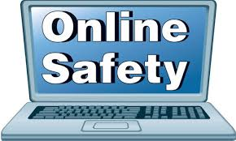 | Digital Safety
 |  |  | Ways to stay safe
 |  |  | ways to stay safe
Our lives, jobs, education, and social interactions are changing as a result of digital technologies in general and the Internet in particular. Seeing how the Internet is improving the world is exciting. It has steadily evolved from a research and instructional platform to a global powerhouse in commerce and healthcare that is available to everyone, everywhere, at any time. Many significant services are now available to everybody with an Internet connection. When it comes to using the Internet, there are basically no restrictions. While the Internet is a great resource for education, communication, and amusement, it also presents some concerns, including malware, spam, and scams. If safety procedures are not performed, it may be dangerous. Also, unsafe surfing might result in other threats.
Introduction
Digital safety
Tolulope Joshua Ashaolu on 08 October 2021
Internet safety”, Wikipedia, the free encyclopedia https://en.wikipedia.org/wiki/Internet_safety

Reference
WHAT IS DIGITAL SAFETY?

As people are eager to use mobile solutions that facilitate anywhere/anytime access, cyber criminals are constantly looking for ways to capitalize on this trend by taking advantage of unsecure wireless networks. Digital safety is learning how to safeguard your privacy and protect yourself from predators as we connect in this new digital age. Digital safety in variably known as Internet safety, media safety, online safety, e-safety, or cyber safety. It may include being aware of the risks associated with online activities and employing some strategies to prevent the risks or threats. Common threats to online safety include, internet scams, malware, cyberstalking.
Today, children use tablets, laptops, and smartphones at school and at home. They learn virtually, watch YouTube, play games, do research, communicate with teachers and other children. As a result, they have more information at their fingertips than any generation before. As the number of Internet users continues to grow around the world, governments, organizations, and parents are concerned about the online safety of children and teenagers. This has led to various regulations, like the Children’s Online Privacy Protection Act (COPPA), to protect children when online.
Through the Internet, we have unprecedented access to information, more than earlier generations. Today one can work, check bank balances, book travel, communicate with friends and family members, order books, and buy and sell online. As more and more children use the Internet in general and social media in particular, so do concerns about their online safety. Online safety or digital safety is becoming important, especially for children. Safety relates to a range of activities including online privacy, cyberbullying, exposure to violent content, contact with strangers online, and coarse language.
Conclusion
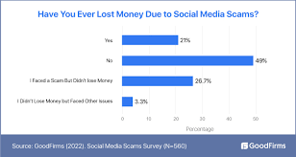
1.Protect Your Personal Information.
3.Practice Safe Browsing.
4.Be Alert Online.
5.Choose Strong Passwords

