Student Name: Yusuf Khan
Student ID Number: 2433537
Module Name: Employability and Career Development
Module Code: LCLM4005_BIRM
Lecturer Name: Essa Bah
Assignment Title: Job Interview

CV
Yusuf Khan
07480194377
y2khan@hotmail.co.uk

PROFILE

I am currently studying CertHE Level 4 in Business Skills for the Workplace. I have over 20 years of experience in retail, customer service and warehouse operations. I am a reliable individual with a strong work ethics and a genuine desire to learn. I work well in groups, have excellent communication skills, and like a fast-paced environment. I am optimistic, punctual, and produce excellent results.
EDUCATION & QUALIFICATIONS

University of Wales Trinity Saint David’s (May 2025 – Present)
- CertHe Level 4 Business Skills for the Workplace
New Vic College (Sep 1992 – Aug 1993)
- NVQ Level 1 Performing Arts
Little Ilford School (Sep 1988 – Aug 1992)
- 2 GCSEs
EMPLOYEMENT HISTORY/VOLUNTEER WORK

Mobile Bitz | Retail Assistant 2022- 2024
- Selling mobile phones and accessories to customers
- Carried out basic mobile phone repairs and troubleshooting
- Provided high-quality customer service and product advice
- Handled payments and maintained shop displays
- Built strong customer relationships to encourage repeat business

Faceoff Mobile Business | Sales Assistant 2015 – 2022
- Took customer orders accurately and efficiently
- Packed and prepared products for dispatch
- Organised and sent out deliveries on time
- Assisted with stock handling and inventory checks
- Worked as part of a team to meet daily target
ADDITIONAL INFORMATION

Languages

- English - fluently written and verbal communication
- Urdu
- Arabic
- Mandarin
Skills

- Customer service & sales
- Communication and interactive skills
- Order processing & packing
- Basic mobile phone repair
- Time management
- Teamwork
- Problem-solving
- Cash handling & Banking
- Opening & Closing
- REFERENCES

Available on Request

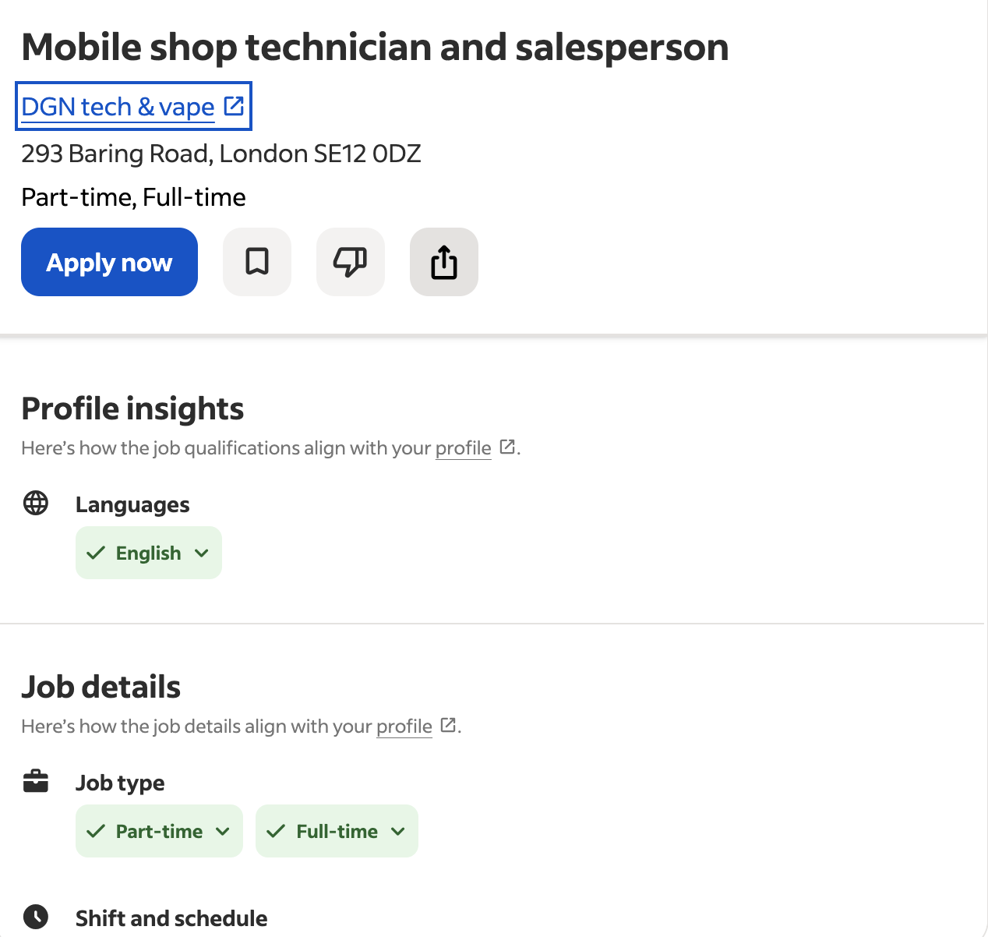

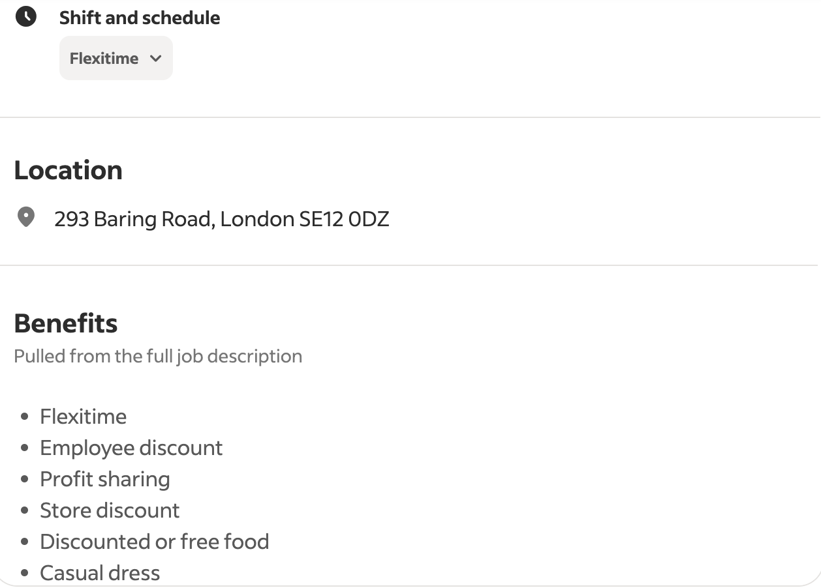
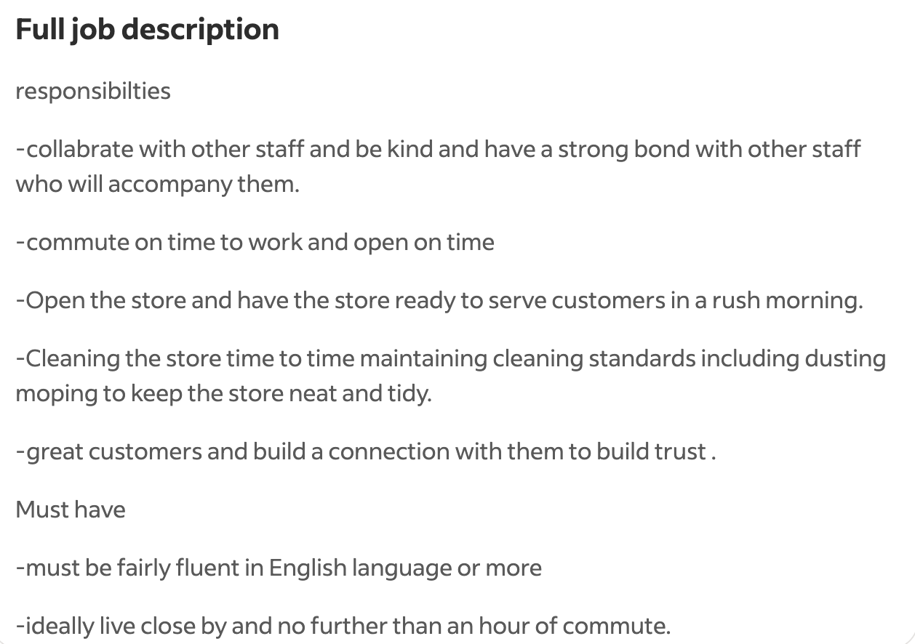
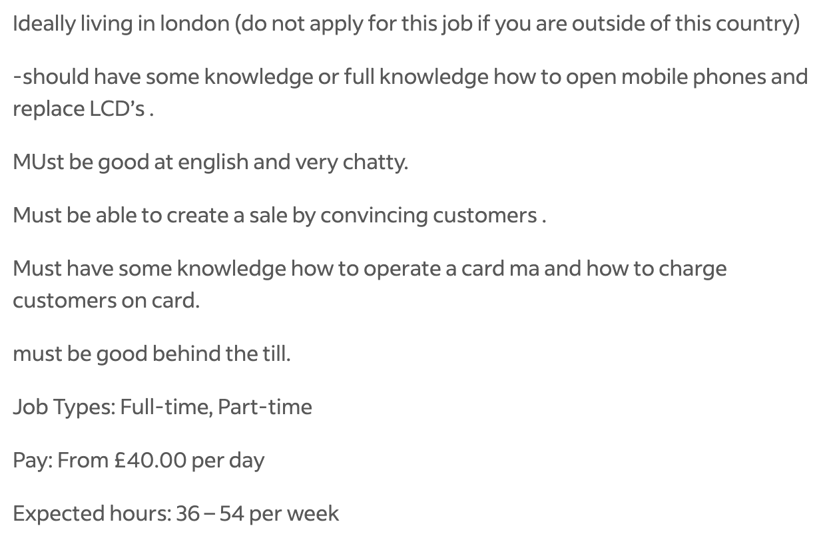



Yusuf Khan
07480194377
y2khan@hotmail.co.uk

DGN Tech & Vape
293 Baring Road
London
SE12 0DZ

Dear Hiring Manager,
I am writing to express my interest in the Mobile Shop Technician and Salesperson employment at DGN Tech & Vape on Baring Road that was advertised in Indeed. I am a good fit for this position because I am presently pursuing CertHE Level 4 in Business Skills for the Workplace and have practical experience in mobile phone sales, customer service, and maintenance.

I worked as a retail assistant at Mobile Bitz, where I took card payments, sold mobile phones, accessories, gave customers advice, performed mobile phone repairs such as screen replacement and device opening. In order to turn enquiries into sales, deliver top-notch customer service, this position required me to be self-assured, talkative and convincing. I feel at ease using credit/debit card machines, working behind the counter and handling cash payments.

Additionally, working in a warehouse sales atmosphere has improved my organisational skills, timekeeping and cooperation abilities. I am aware of how crucial it is to arrive on time, open the business right away, and make sure it is spotless and prepared to serve clients during peak hours. I take great satisfaction in upholding strict hygiene regulations and fostering a friendly atmosphere for clients.

I enjoy interacting with customers, establishing trust and creating lasting partnerships. I speak English fluently. I believe that a successful workplace requires kindness, cooperation, and solid staff relationships. I work effectively both individually and in a team. I can consistently commute to the store from my base in London.

The chance to contribute my technical expertise, sales abilities and upbeat outlook to DGN Tech & Vape excites me. I would be delighted to have the opportunity to support your team, increase sales and provide exceptional customer service.

I would be honoured if you could set up an interview. Please use the phone number and email address at the top of this page to contact me if you need any more information. My CV is attached. I look forward to the opportunity to discuss this role further.

Yours sincerely,
Yusuf Khan

