CLAUDIU MARIAN ISPAS
STUDENT ID: 2441737

Module title : Employability and Career Development
Assignment tile: Mock interview

Job Advertisement
For this assignment, I selected the position of Shipping Logistics Coordinator advertised by ASC Connections. I chose this role because it represents a realistic progression from my current position as a Delivery Driver. The role is closely related to my existing experience within the logistics and delivery sector while also offering increased responsibility in areas such as shipment coordination, communication with customers and suppliers, record keeping, and planning.
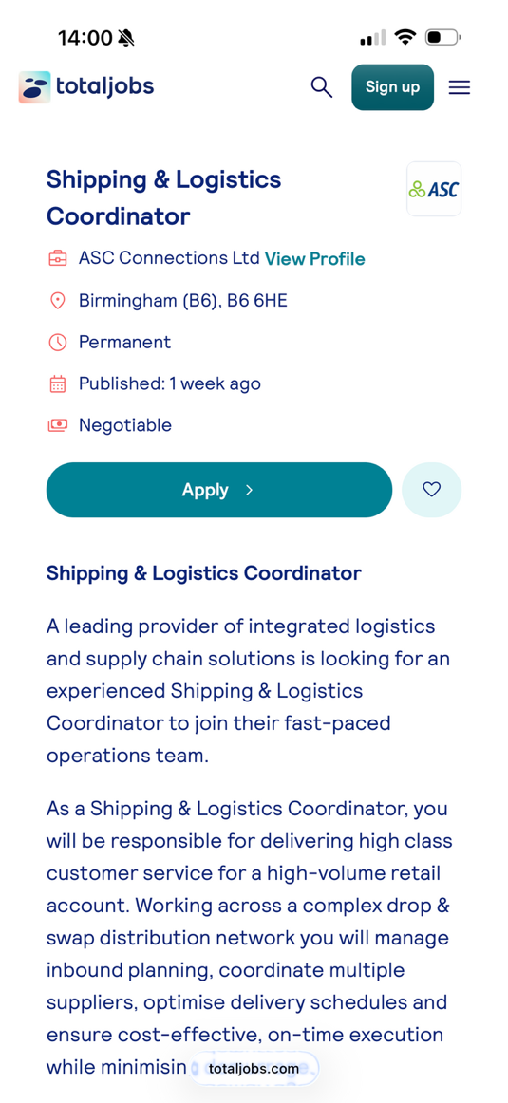
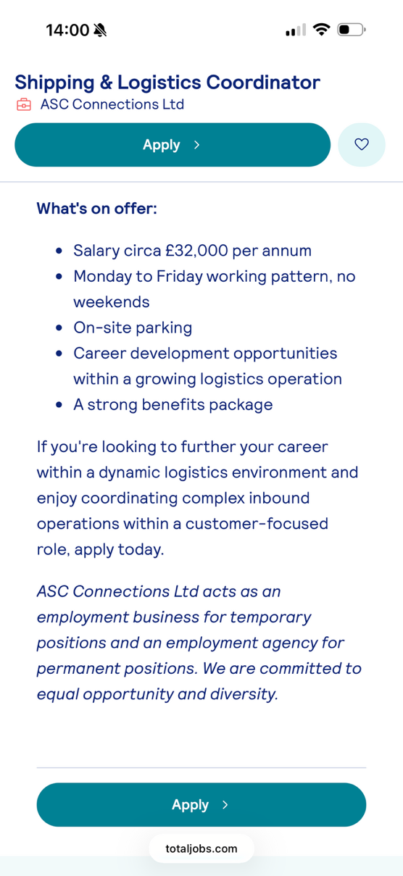
,m

CV

Claudiu Marian Ispas
Address: 9 Tiddington Close, Birmingham, B36 9EG
Mobile 0777812811:
Email: claudiumarian012@gmail.com

Personal Profile
A reliable and hardworking logistics professional with several years of experience in delivery operations, customer service, and route planning. Currently studying CertHE Business Skills for the Workplace at the University of Wales Trinity Saint David and seeking to progress into a Logistics Coordinator role. Strong organisational, communication, and problem-solving skills developed through experience with leading delivery companies. Able to work effectively under pressure, manage competing priorities, and keep high standards of customer service.

Education

2025 – 2026 (Expected), University of Wales Trinity Saint David, CertHE Business Skills for the Workplace
- Business Communication
- Professional Development
- Introduction to Management
- Workplace Skills
- Business Operations
2018 – 2021, Colegiul Economic “Virgil Madgearu”, Romania, Business Administration and Economics
- Business Studies
- Economics
- Accounting
- Information Technology
- Communication Skills

2014 – 2018, Școala Gimnazială Nr. 8, Romania, Secondary Education

Employment History
June 2025 – Present, Delivery Driver, Daals Ltd
- Deliver customer orders efficiently while maintaining excellent service standards.
- Plan routes effectively to ensure on-time deliveries.
- Complete delivery documentation accurately.
- Communicate with customers about delivery schedules and issues.
- Maintain vehicle safety and compliance standards.
- Resolve customer queries professionally and efficiently.
- Consistently meet delivery targets while working independently.
March 2023 – May 2025, Delivery Associate, Amazon Logistics
- Delivered parcels across designated routes while meeting strict delivery targets.
- Used handheld technology to manage deliveries and update tracking systems.
- Maintained correct delivery records and proof-of-delivery documentation.
- Provided excellent customer service and resolved delivery issues.
- Worked independently while managing time effectively.
- Demonstrated strong organisation and time management skills.
August 2021 – February 2023, Courier Driver, DPD
- Collected and delivered parcels within scheduled timeframes.
- Ensured safe handling and transportation of customer packages.
- Maintained delivery records and completed daily reports.
- Assisted customers with delivery enquiries.
- Worked effectively in a fast-paced logistics environment.
- Consistently achieved performance and delivery targets.
July 2019 – July 2021, Administrative Assistant, Local Business, Romania
- Managed filing systems and administrative records.
- Responded to customer enquiries via telephone and email.
- Assisted with scheduling appointments and maintaining calendars.
- Entered and updated information on company databases.
- Supported day-to-day office operations.
- Maintained confidential records and documentation.

Key Skills
- Logistics Coordination
- Route Planning
- Communication Skills
- Working Under Pressure

Additional Information
- Full UK Driving Licence
- Fluent in English and Romanian

References
Available upon request.

COVER LETTER
18th June, 2026
Daals, Bayton road, CV7 9EJ, UK
Dear Hiring Manager,
I am writing to apply for the Logistics Coordinator position advertised by ASC Connections.
I am currently employed as a Delivery Driver with Daals Ltd and have previous delivery experience with Amazon and DPD. Through these roles, I have developed strong logistics, planning, and customer service skills while working in fast-paced environments where meeting deadlines and maintaining accuracy are essential.
In my current role, I am responsible for managing daily delivery schedules, ensuring timely deliveries, communicating with customers, and maintaining accurate delivery records. These responsibilities have strengthened my organisational skills and my ability to work effectively under pressure. I understand the importance of efficient transport operations and ensuring that goods reach their destination safely and on time.
Alongside my work experience, I am currently studying Business Management at university. This has helped me develop a broader understanding of business operations, communication, problem-solving, and organisational management. I am eager to apply both my practical logistics experience and academic knowledge to a Logistics Coordinator role.
I am particularly interested in this opportunity because it offers the chance to progress within the logistics industry and further develop my coordination, planning, and transport management skills. I am confident that my delivery experience, attention to detail, strong work ethic, and commitment to excellent customer service would allow me to make a positive contribution to your team.
Thank you for considering my application. I would welcome the opportunity to discuss my suitability for the role further and look forward to hearing from you.
Yours faithfully,
Claudiu Marian ISPAS

