
Career Development & Report
Personal Development Plan

November 15, 2019
Charlene Morgan
1906685

Contents:

1. Contents
2. Introduction and PDP
3/4 SWOT Analysis
5. SWOT Continue Leading into TOWS Analysis
6. TOWS Analysis following SMART
7. Go MAD Johari and Maslow
8. Learning styles
9. Learning styles continue following conclusion
10. Appendices SWOT and Go MAD diagram
11. Johari and Maslows diagram
12. PDP skill sheet
13/14/15 VARK questionnaire
16/17/18 Honey and Mumford
19. Myres and Briggs
20/21/22 References

This report will show my in-depth journey for a goal I desire in the forthcoming future which will be to go on to furthering my education and eventually becoming a Councillor. An honest account of my learning skills to date, whilst using various methods to show a great understanding of my key areas using Swot analysis to highlight my strengths, weakness, opportunities and threats and all of these will amount to then using a Smart analysis to determine a realistic outcome. Using go mad theory I will uncover obstacles that have challenged me whilst being a student for the first time in almost 15 years, having one to one and group discussions whilst managing a various deadlines, planning ahead, being in the right frame of mind and most importantly achieving an aspiration that I can see myself getting to the finish line.
Being in business school is not where I imagined I would be yet in my early 20’s I found myself starting out as a bar server and gradually within 3 years worked my way up to management level which I thoroughly enjoyed, I understood how to manage a business, learn profit and loss, how to be part of a team and so much more. Now starting a course in business skills, it has shown me a new way of learning various expertise to make a concept of business into a success checking my smart goal. I now can learn in great detail how communication is a huge part of any walks of life especially in business as it can give drive, determination and focus to do anything I set my mind to, and that is how I feel when I started this course. Displaying a SWOT analysis created by (Humphrey A.1970’s) will show the four key areas that I can develop and improve on whilst also learning a variety of skill and knowledge within the workplace.

The key factors of strength here will show that these goals I already believe I possess as an individual and I am confident I can relay this in and out of the workplace. Having good Time Management and being punctual shows that I can plan and that I am reliable when needed this could lead to further career success. It also gives me the ability to gain control when it comes to tasks so that stress levels are manageable. I also can use my Public Speaking abilities by allowing to talk to people effectively. I show an understanding of my audience and how to communicate well in the right manner, being clear and concise helps me to get a point across as well as open gestures and engaging what the other person may want to say. When performing under pressure at times it helps me to focus on the importance of improving myself and learning to strive for better outcomes. If I can set a goal and work towards it with the right frame of mind, then I will achieve what I set out to do. Persistence is the key to being a hard working person. Being approachable and using this trait will allow me to get along with my peers, making work life enjoyable. It will give me a chance to learn more about the business from my fellow colleagues who have worked there longer and will give me insight to more knowledge while showing I can listen and take on their experiences and opinions.
A weakness may not always be a negative point, I believe it can be managed or nurtured with the right guidance, if I can identify my disadvantages and make them more manageable I will then be able to apply them to the workplace without letting it become a inconvenience. I fear that my gap in knowledge will show times when I was only good enough to be a mother, education was far from being a goal or even a reality, but to strengthen this over time I can plan, use my time, have the right mind set and have a determination to make this become a success. To be certain I can eventually turn my self-doubt from weakness into a strength, it will take time and effort on my part. Questioning my abilities has always been an Achilles heel of mine. But with the right guidance and support anything is possible.
“The human will is an amazing thing.”
Covey, Stephen R. The 7 Habits of Highly Effective People : Powerful Lessons in Personal Change. 25th Anniversary ed. London: Simon & Schuster, 2013. Print. Pg 157

Technology is an indispensable tool in businesses today and my I.T skills can somewhat be quite hard to keep up to date with changes, I feel that I need to familiarise myself with the basics of a computer and become more hands on in practical way. “Technology, especially in the form of computers, is very important to the education system, both in terms of supporting educational matters as well as enhancing the learning process of the students. With computers, students can do research much more efficiently, and some have suggested that this actually leads to better student performance.” (Unknown in Ref works)

Allowing me to have opportunities in life will give me goals to work towards, open new doors and give me experiences which I can learn from, it will also help me engage with others who I may never have crossed paths with. Networking with different people will help me enormously in gathering information that has become invaluable at times, this will hopefully continue by making sure I surround myself with the right people and focus on the importance of other values and opinions. I will continue to grow in my education and follow this into my workplace giving myself the chance for any opportunity that may present itself to climb the ladder further and give myself the best chance for promotion.

A threat can comprise of other people who see you as competition within the workplace , whether that can be a promotion, socially connected to your fellow peers or not wanting you to succeed in general, but I must believe in myself in order to stand a chance in becoming on the same par as anyone who may think they are just as good enough. Showing my worth to others will relieve any negativity that can be pushed towards my accomplishments. Illness can have a damaging affect too, I would not be able to personally foresee this outcome, but it most definitely apposes as a threat. It could be several days weeks or months I may be off work or even a detrimental end to my profession.

To achieve my smart goal, I will convert my weaknesses to strengths and my threats into opportunities by using Tows analysis developed by Weirich H. 1970 I can see positive ways in changing my experiences that can have a negative effect on me and turn it in to a much better outcome.
“Have a fierce resolve in everything you do. Demonstrate determination, resiliency and tenacity. Do not let temporary setbacks become permant excuses. Use mistakes and problems as opportunities to get better – not reasons to quit” Dimon J.

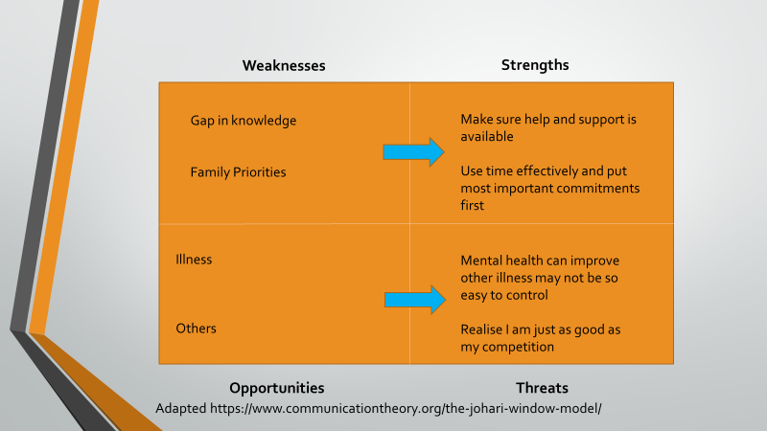

My smart adjective is to firstly pass this course so I can further my education and go on to achieve my dream job of becoming a counsellor. I am going to ensure that not only will I attend each lesson, engage, participate, listen intently to gain the most from this course but if stay on track by using all materials available to me I can then refer to my swot analysis and use the right tools to embrace change and knowledge as it can be different all the time. I believe my mindset will give me a clear and concise direction for my desired result and using a variety of methods I will eventually reach my target goal. In the next 8 months I plan to revise so I can allow for any errors or mistakes and rectify them so I can always give my very best.

My research into the Go Mad framework created by Gilbert A and Chackrovaity I. 1999, helped me to take the thinking model and use it in a way that can benefit myself by showing me a more focused path. If I can define my whys, goals, actions, priorities and sacrifices I can obtain an effective way of processing my thoughts in a more definitive way. (See appendices …)

My understanding of the Johari theory shows an understanding of self-awareness, “we hide what we do not like about ourselves” Morgan P. It intrigued me in how such a small diagram can have a huge impact. Developed by Luft J. and Ingram H. (1955) These are 4 areas which show a personal comprehension of my own relationship to others as well as being able to shed light on myself. (see appendices….)

Maslows theory is a tower of needs, by putting in order of importance to myself. It was developed by Maslow A. (1943) it gives me an opportunity to deliver what I physically need to survive and what growth needs which I must take on board in order to climb higher up the triangle. (See appendices ……. )

I was introduced to three main learning styles by undertaking two questionnaires VARK Fleming N. and Mills 1992 , Honey P. and Mumford A. 1986 and a personality test by Myres I. and Briggs K. 1944 The first one I took part in was VARK this shows a personal way of showing how best we learn whether that maybe Visual, Aural, Read/Write or Kinaesthetic. I always believed that I work best being a visual learner, so I was slightly surprised to find that in fact I was a kinaesthetic, which means I learn best through practical guidance and with a hands on approach. (See appendices…..)
My second learning style I undertook was Honey and Mumford this questionnaire comprised of 80 questions for a result to see what my outcome of two combinations was. Activist, reflector, theorist or a pragmatist. (see appendices….)

I am an Activist/Pragmatist to show understanding of this I read the learning styles questionnaire and briefly I can explain that being an activist means I am open minded, I will act first rather than considering the consequences. Including being a pragmatist shows I am a practical person who likes to try out new ideas to see if they work well.

Lastly, I completed a personality test by Myers-Briggs this was to show a self - awareness of the characteristics within inside myself. My results showed

Extrovert – Introvert
Sensing – Intuitive
Thinking – Feeling
Judging – Perceptive
So, what does this mean to me? Being an extrovert shows I like being part of groups and making things happen I also tend to jump into decision making a little too quickly without thinking about the consequences. I am quite a factual person who likes to work through things before solving problems I also tend to miss other possibilities, so sensing was where I fit. I have never been one to deviate or shy away from my thinking I much prefer to tell the truth than trying to be more tactful and unfortunately I can be consumed in tasks too much rather than taking time out to show my more caring side. Being perceptive allows me to approach my work with a playful mindset, complicated plans are a no-go area and I prefer a simple arrangement instead. (See appendices……)
In conclusion to my journey this far it has made me realise how important now more than ever I really want to make this outcome a reality and to make myself proud. Undertaking various questionnaires, personality tests, analytical and theory modules, it has given me a great depth of knowledge and a firm grasp on who I am and what I want from life. It has taught me that life works in mysterious ways and the path may not always be in one straight line, it is ok to divert, if you reach your destination then what does it matter how you got there.
“You are only one decision away from a totally different life”
Batterson M.

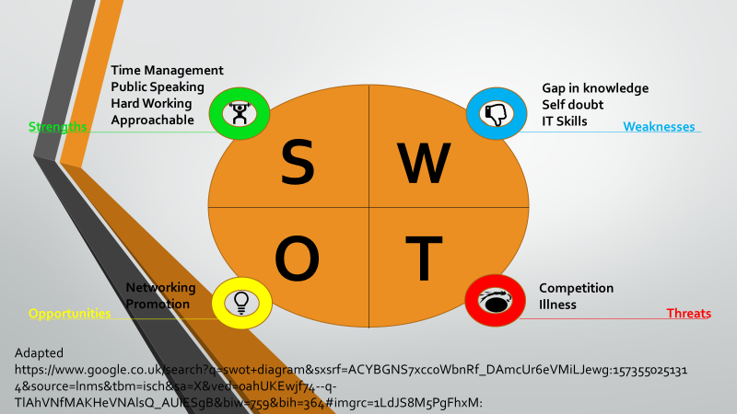

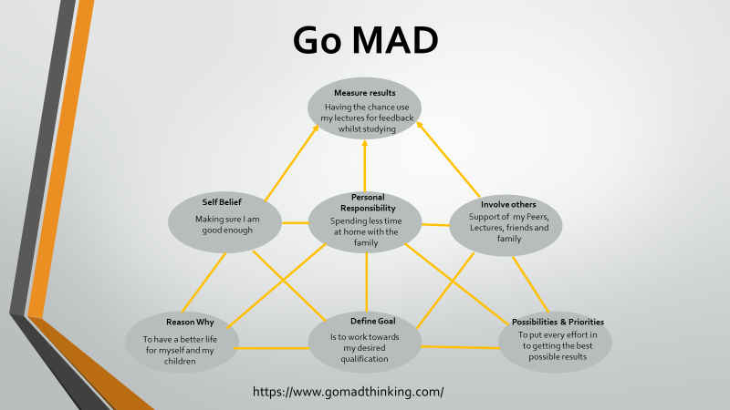

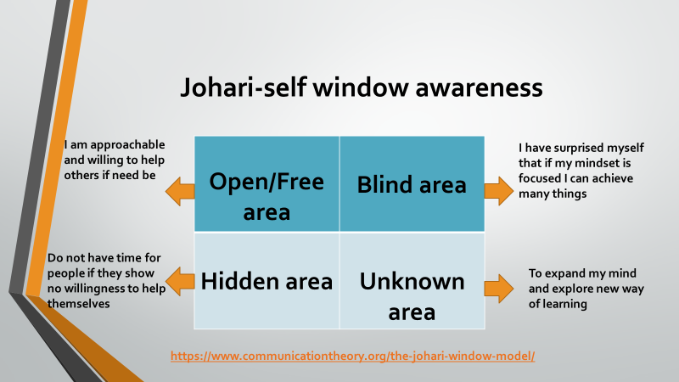

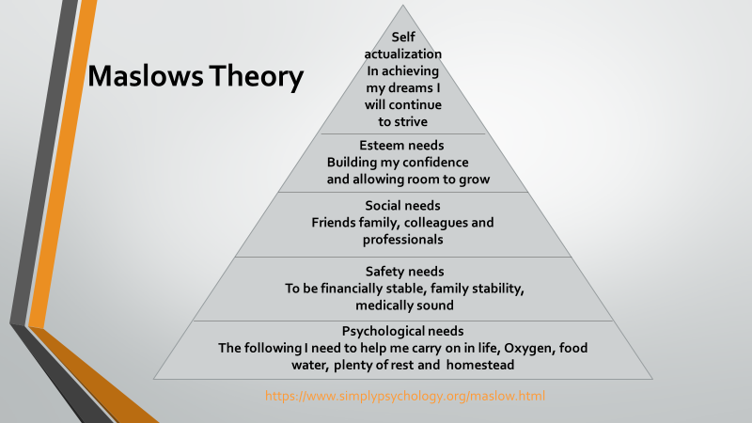

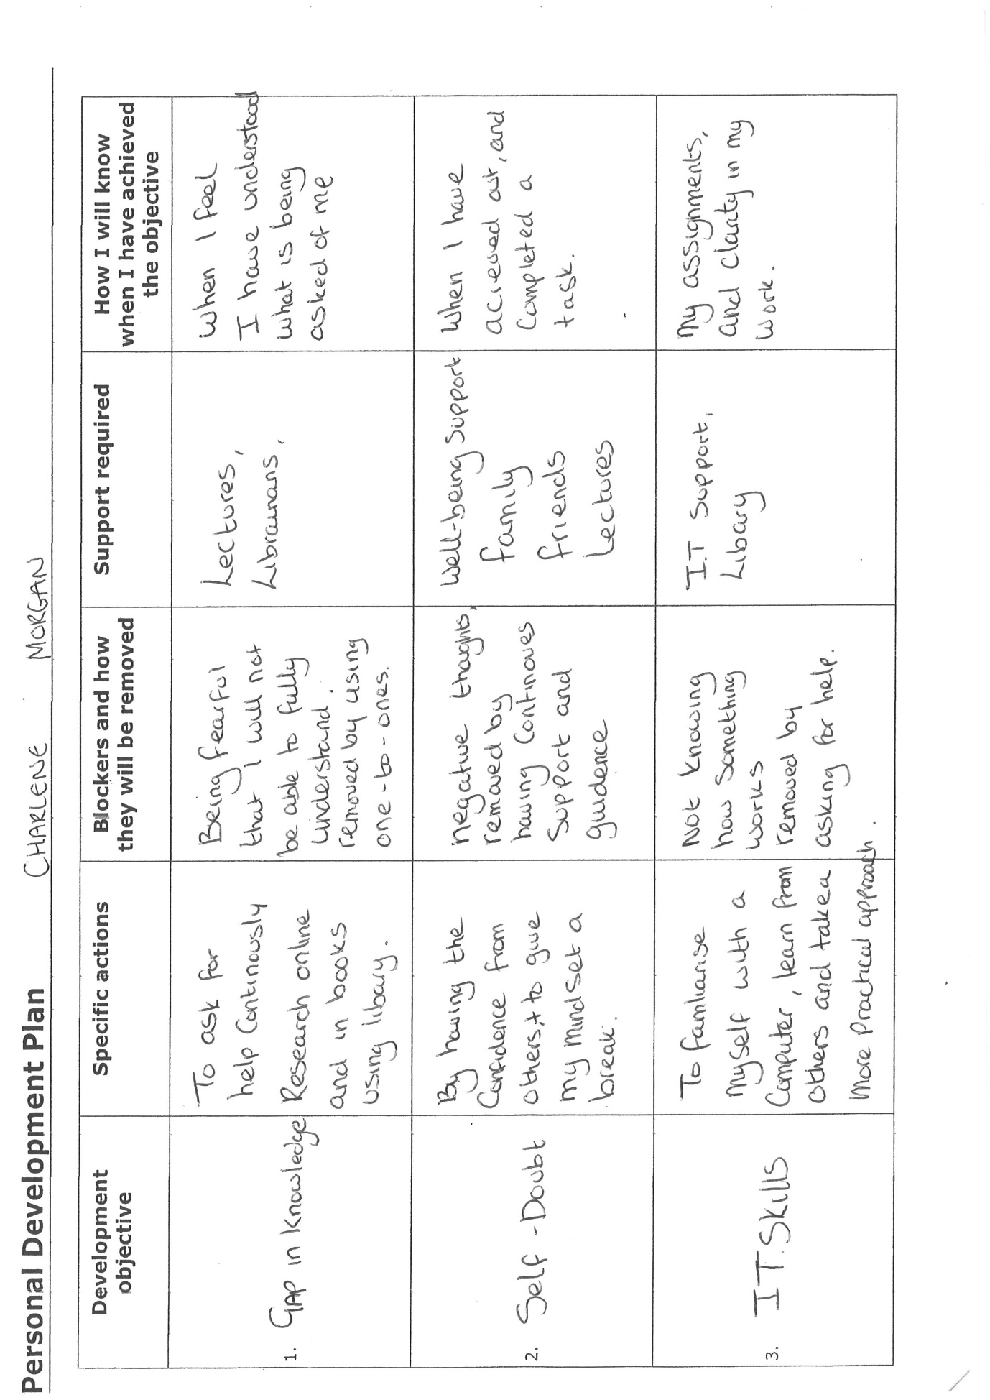

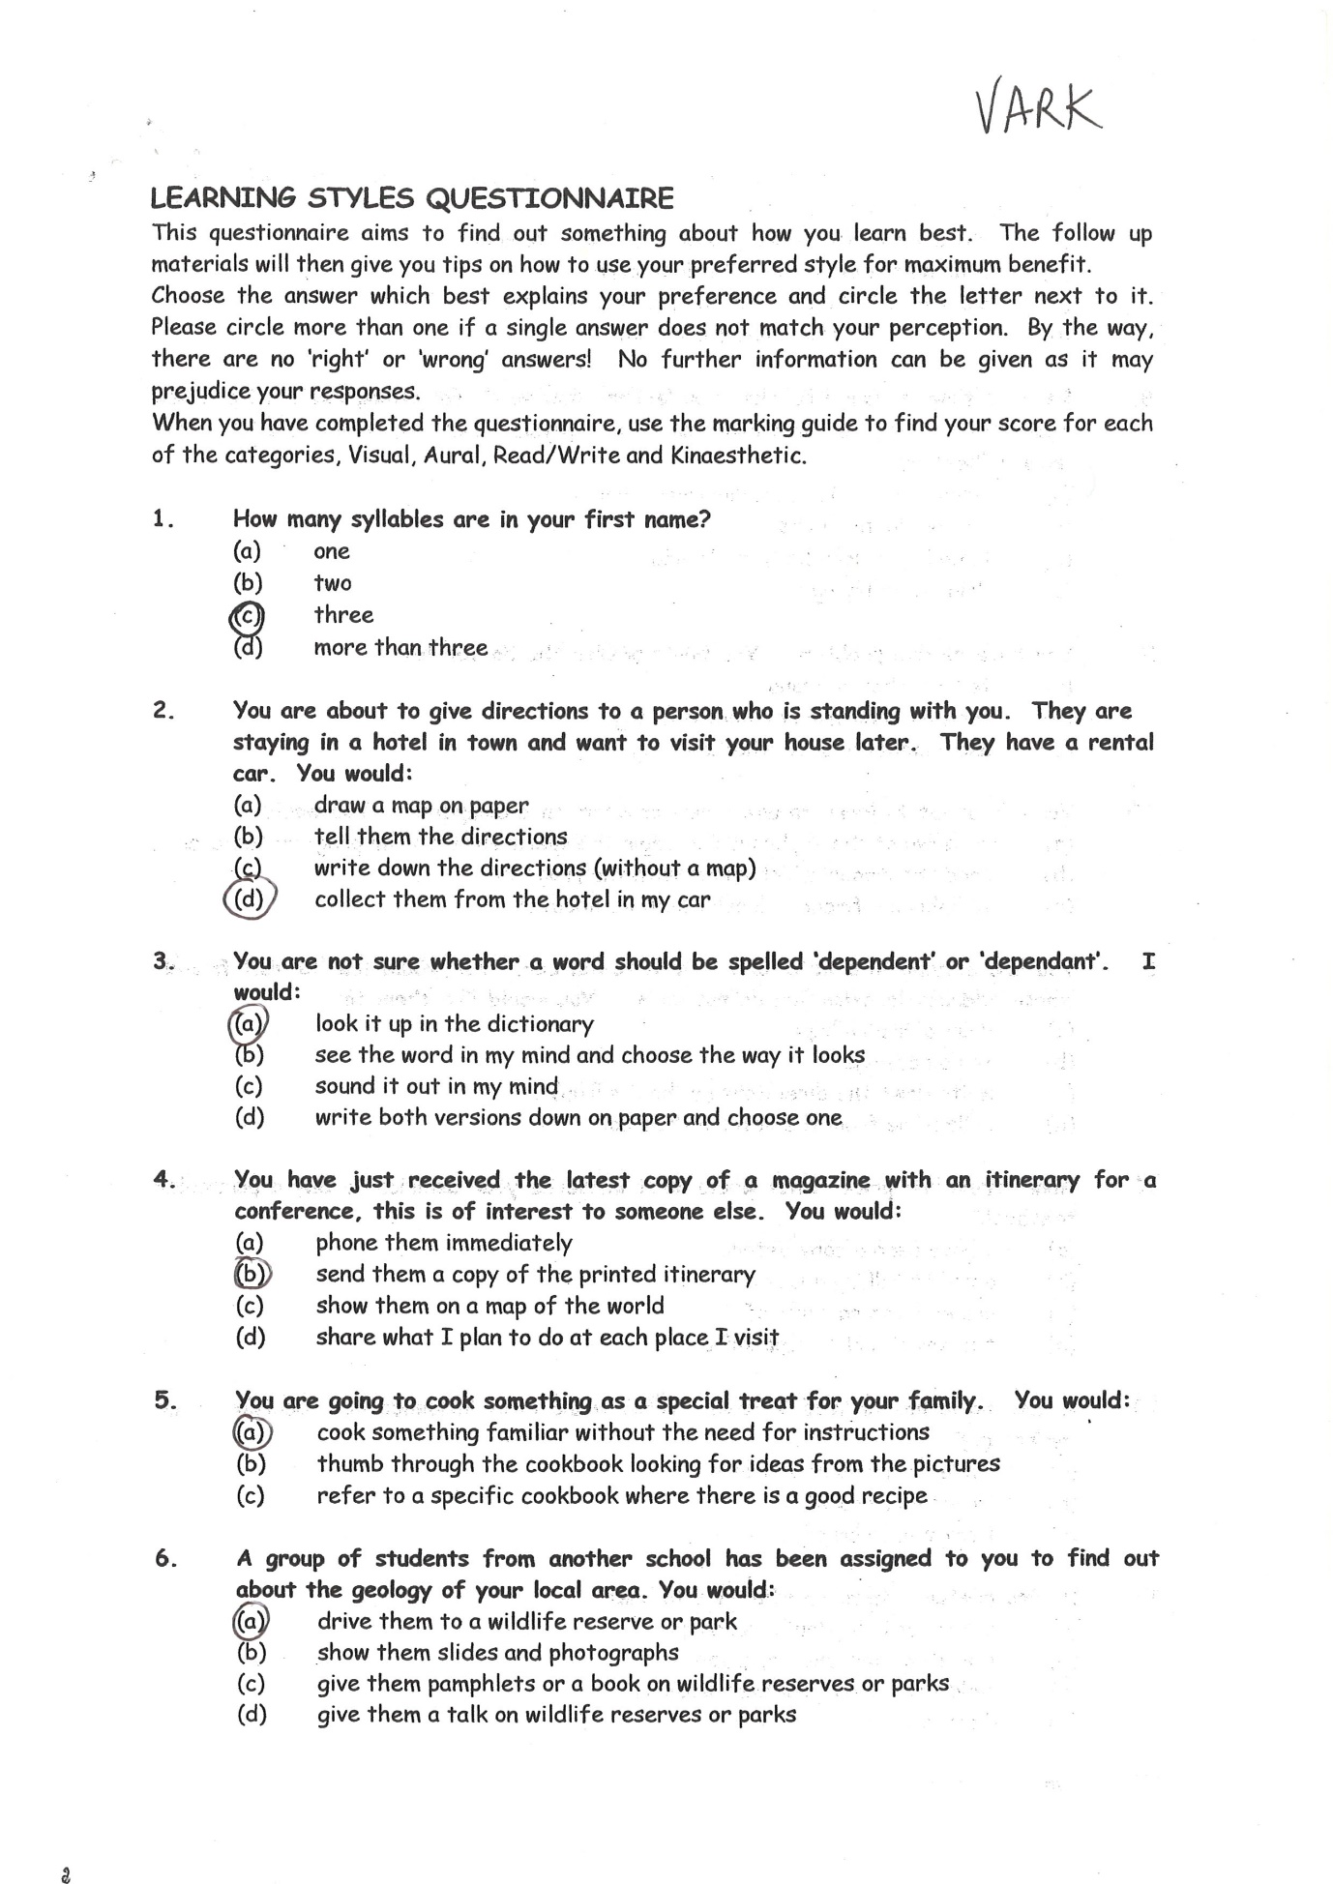

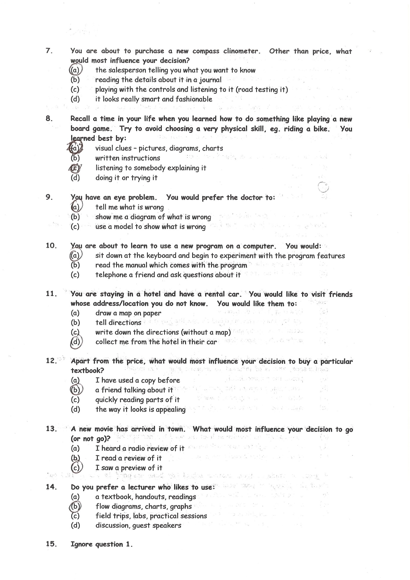

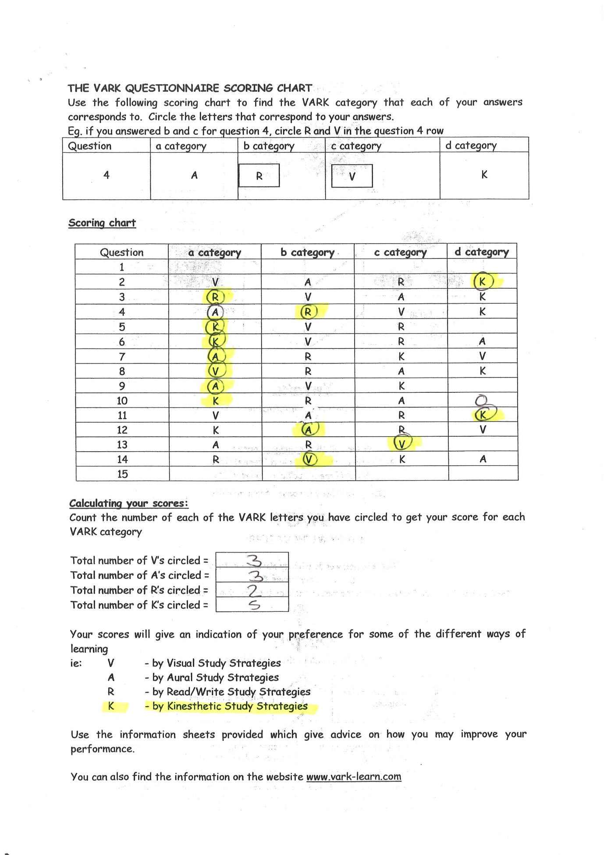

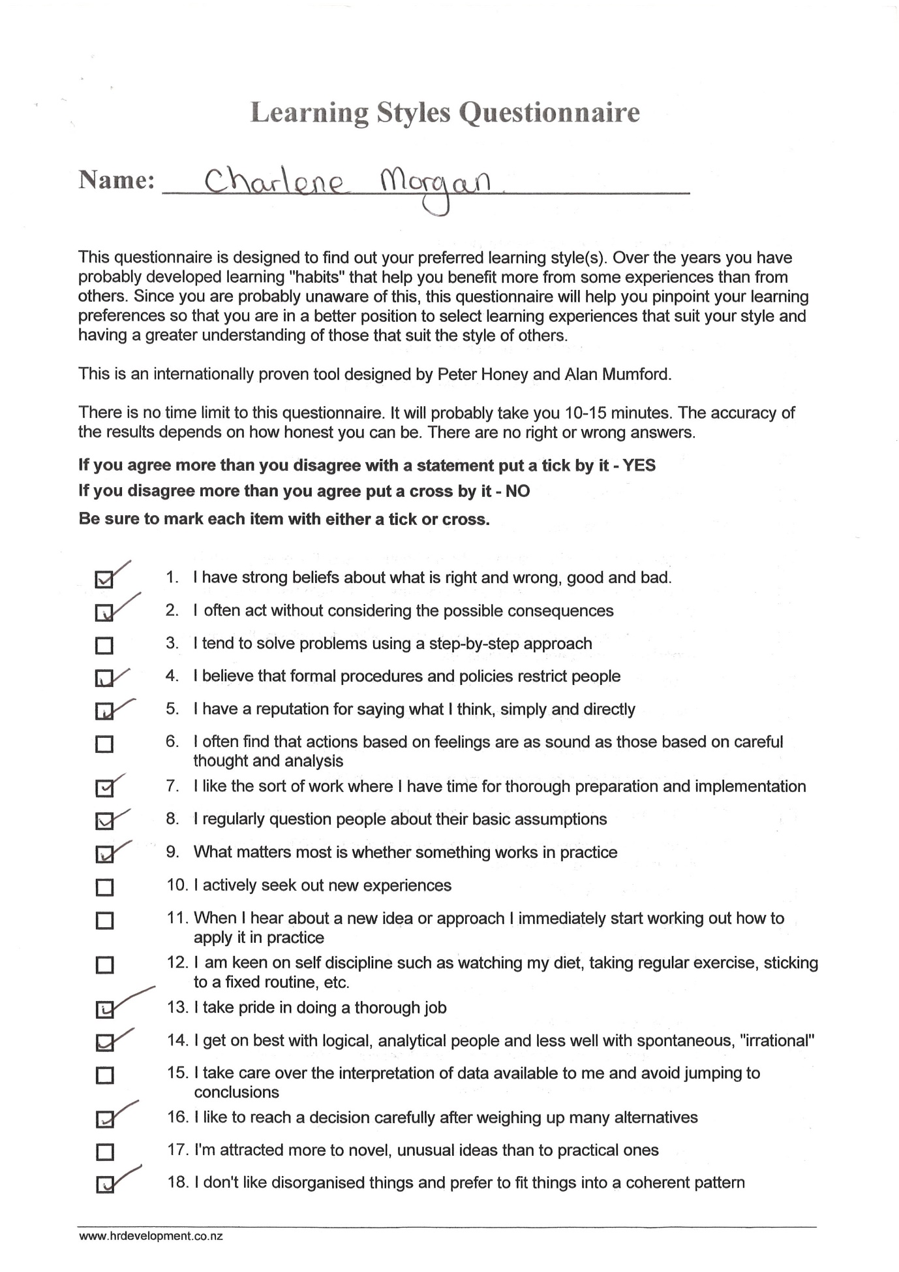
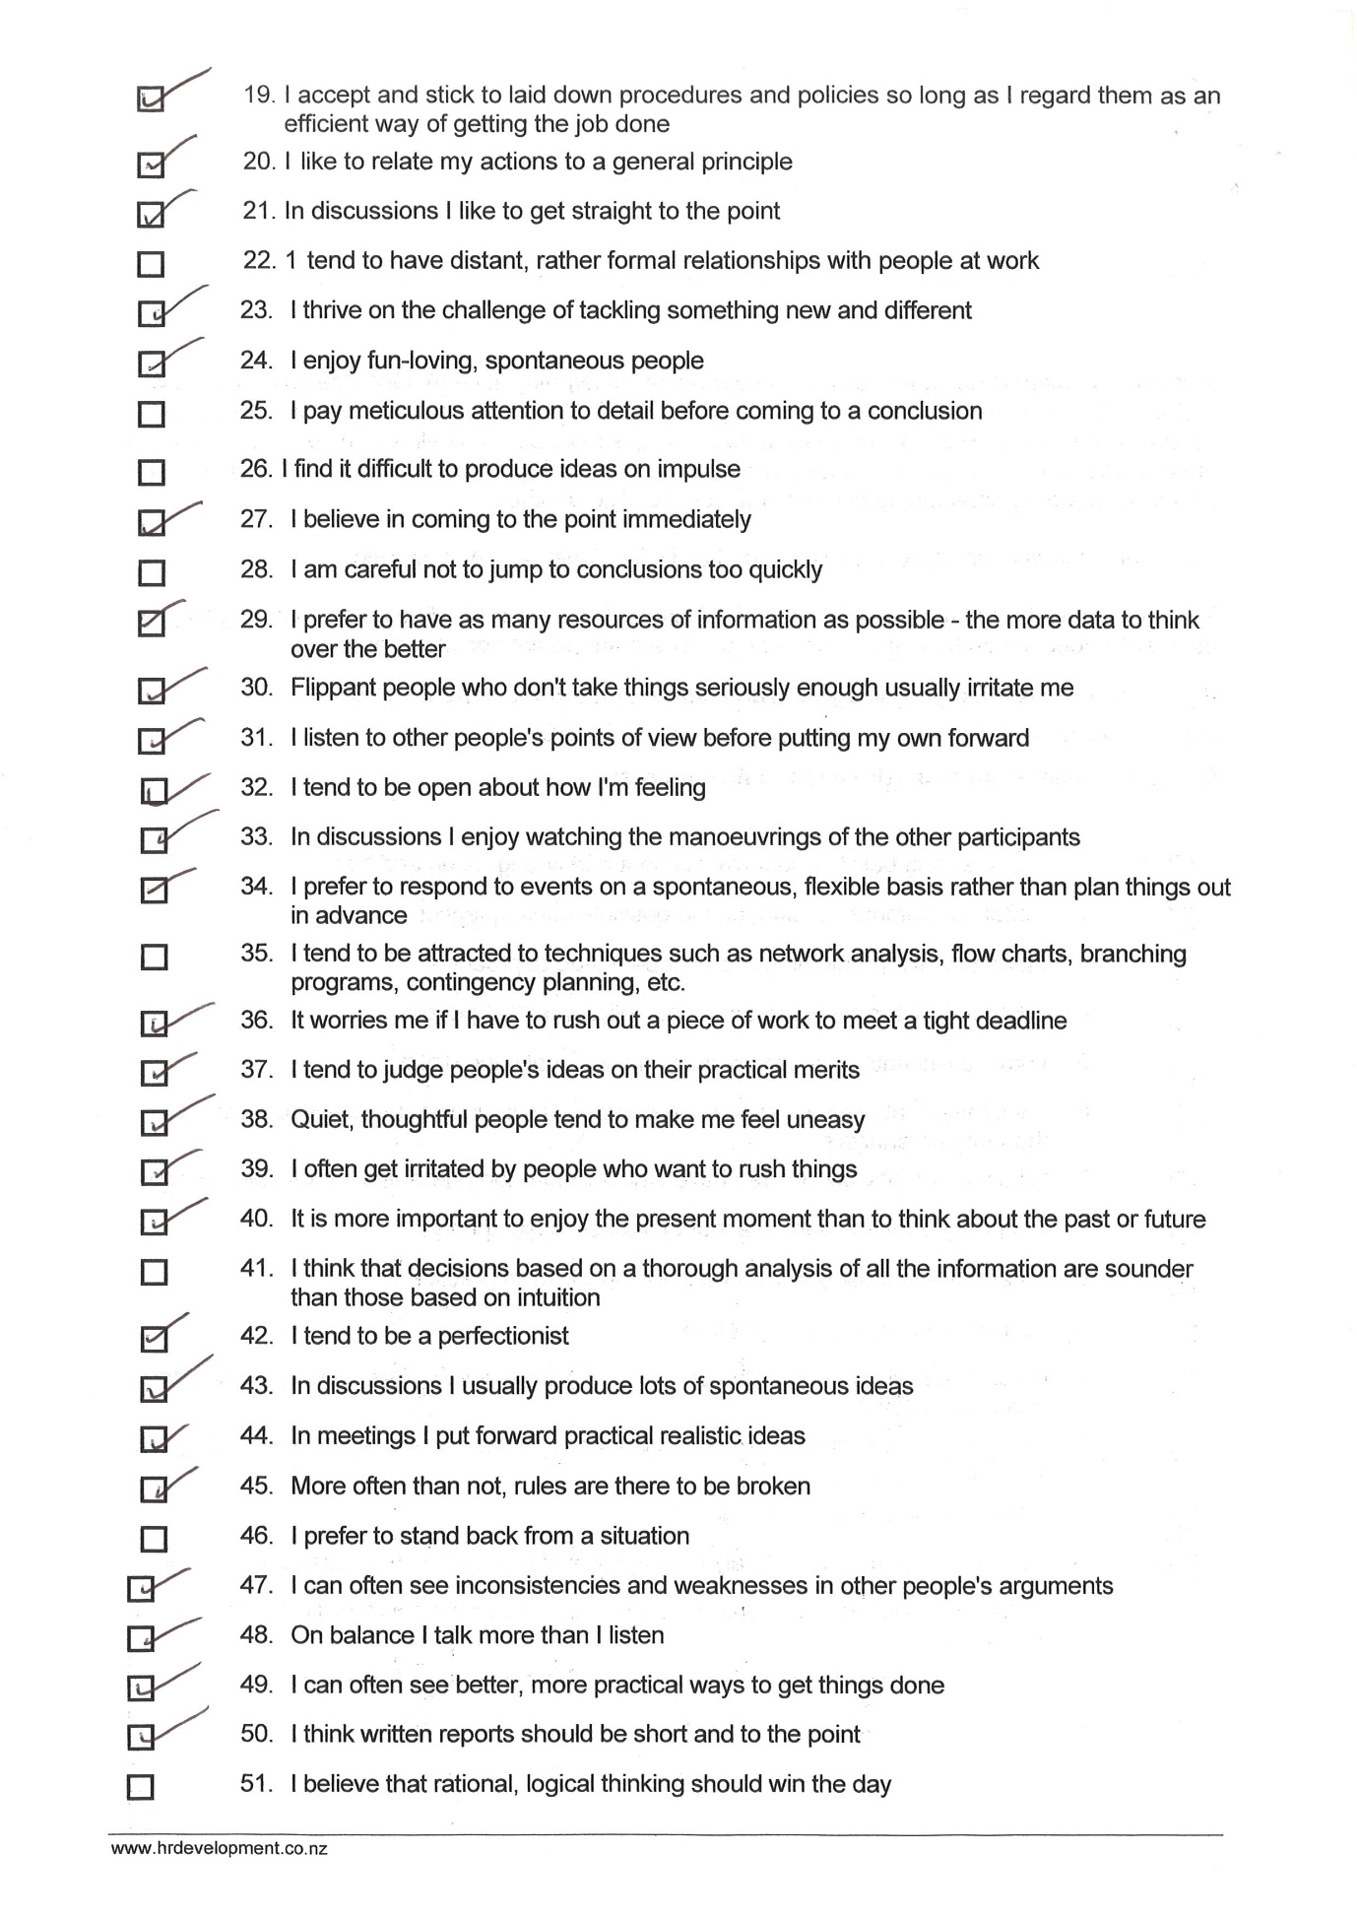
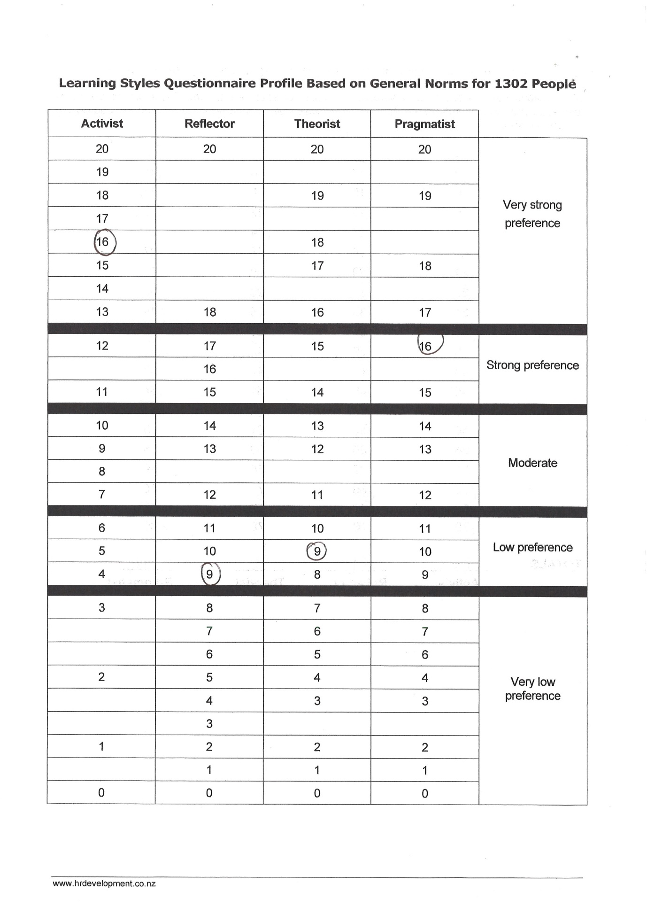

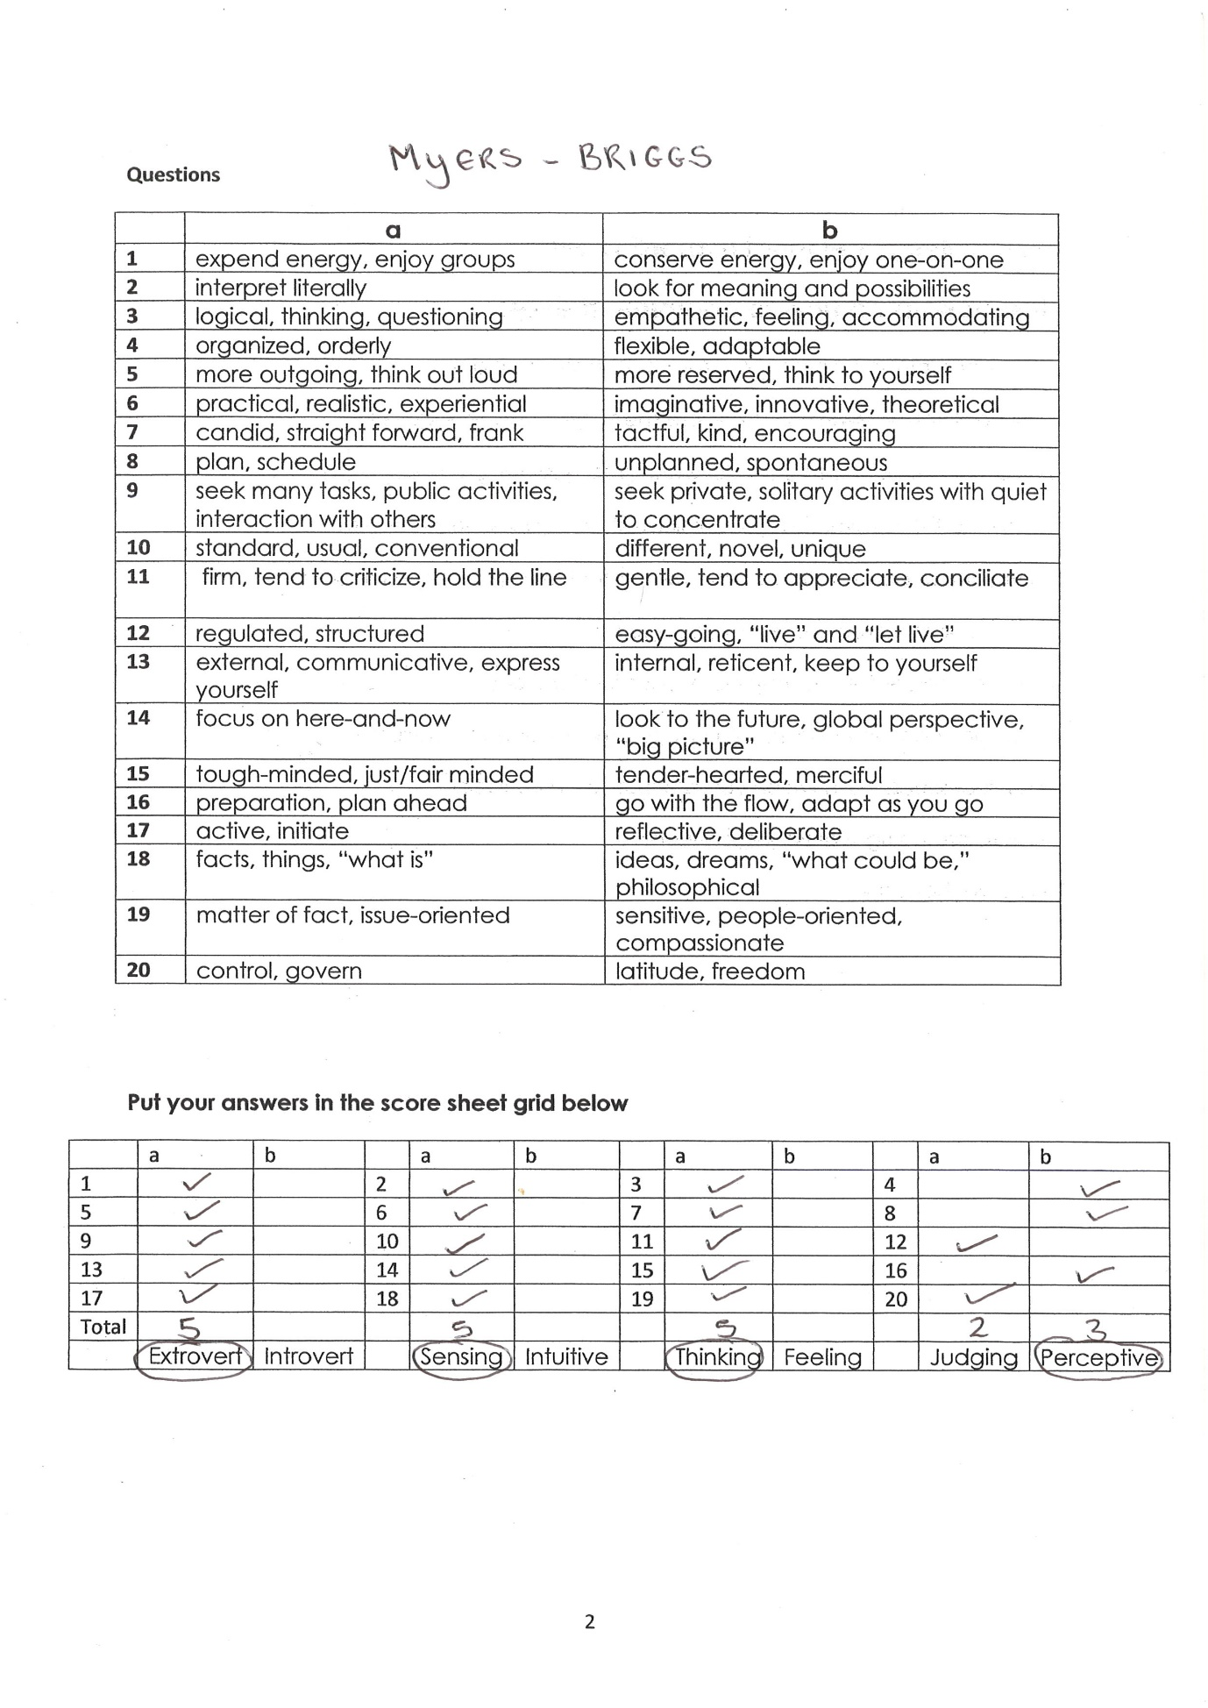

Reference List

Anonymous Swot Diagram Template https://www.google.co.uk/search?biw=759&bih=364&tbm=isch&sxsrf=ACYBGNR5SfkxbaQPho_P2iUCkpI-iC51Jw%3A1573550253620&sa=1&ei=rXjKXfOyJcyE1fAPuMa14Ao&q=swot+diagram&oq=&gs_l=img.1.0.35i362i39l10.419644.422018..495901...2.0..0.74.602.11......0....1..gws-wiz-img.....10..35i39j0i67j0.sGz0dpuolr8#imgrc=1LdJS8M5PgFhxM: Accessed on 12th November 2019
Batterson M. You are one decision away from a totally different life 2013 https://www.bing.com/search?q=All+In%3a+You+Are+One+Decision+Away+From+a+Totally+Different+Life+Mark+Batterson&filters=ufn%3a%22All+In+You+Are+One+Decision+Away+From+a+Totally+Different+Life+Mark+Batterson%22+sid%3a%22608312ed-22c7-5a79-5ba2-7426d13dfec7%22&FORM=SNAPST
Accessed on 13th November 2019
Covey, Stephen R. The 7 Habits of Highly Effective People : Powerful Lessons in Personal Change. 25th Anniversary ed. London: Simon & Schuster, 2013. Print.
Accessed 12th November 2019

Dimon J.
https://www.google.com/search?sxsrf=ACYBGNQYNyqlQ5OZFGUpCwu_eK_DFqOV8A:1573739182085&q=jamie+dimon+quotes+have+a+fierce+resolve+in+everything+you+do&tbm=isch&source=univ&client=ms-android-huawei-rev&sxsrf=ACYBGNQYNyqlQ5OZFGUpCwu_eK_DFqOV8A:1573739182085&sa=X&ved=2ahUKEwj1gKun6-nlAhW9VRUIHeWLAqUQsAR6BAgJEAE&biw=2102&bih=1008#imgrc=R5UpSBkIvuLINM:
Accessed on 14th November 2019

Gilbert A. Chackrovaity I. (2001)
https://www.gomadthinking.com/
Accessed on 9th November 2019

Luft J. Ingam H.(1955)
https://www.communicationtheory.org/the-johari-window-model/
Accessed on 11th November 2019

Maslow A. (1943)
https://www.simplypsychology.org/maslow.html
Accessed on 13th November 2019

Morgan P. (2017) The Business students guide to study and employability London pg 29
Accessed on 14th November 2019

Myres I. Briggs K. (1962) https://eu.themyersbriggs.com/en/tools/mbti/myers-briggs-history
Accessed on 12th November 2019
Unknown Why is technology important today?
https://www.reference.com/technology/technology-important-today-5febb9b1db08f6b
Accessed on 14th November 20219

