ASSESSMENT 1 – ORGANISATIONAL
STRUCTURE & CULTURE IN AIRLINES
INDUSTRY

Table of Contents

Introduction: 3
Organisation overview: 3
The reliance of the organisational performance on its culture: 3
The importance of the structure of an airline company to achieve its organisational goals: 5
On basis of the behavioural approach, the impact of multiple factors in influencing the behaviour of individuals at an airlines organisation: 6
- Behavioural approaches of an organisation: 7
B. Impact of multiple factors of behavioural approach that affect the behaviour of workers: 7
C. Discussion on the organisational behavioural approach being practised at British Airways: 8
Conclusion: 9
References: 10

Introduction:
This report has two aims. One is how organisational performance is reliant on a suitable/appropriate culture and structure for the accomplishment of set organisational goals in an airline-in this case, airline workers work closely together and therefore have different beliefs, values, rituals and symbols in the cultural paradigm within the organisational force. And the second one is based on the behavioural approach, how different factors can influence individual behaviour in the workplace in an airline?-There are many internal and external factors that influence the behaviour of airline employees, like-leadership, job responsibility, work culture, effective communication, family and personal life, relationship at work etc.

Organisation overview:
British Airways is chosen for discussion here. British Airways is a UK airline; with its headquarters situated in London, England, near Heathrow Airport. The airline is the UK's second largest passenger airline, IAG is the world's third largest airline group by annual revenue and Europe's second largest. British Airways is the first passenger airline to exceed US$1 billion in revenue in a single flight year. These aircraft are the largest international airlines in terms of size and carried 34.6 million passengers as of 2008. British Airways work as the flag carrier airline in the UK while performing as the largest airline by number of passengers in the nation too (Statista, 2022). The net revenue of British Airways reached 13290 million GBP in 2019. However, the harsh impact of the pandemic has helped the aviation company generate only a 3.7billion British pounds in revenue in 2021 (Statista, 2022).

The reliance of the organisational performance on its culture:
Organisational or company culture can be defined as the ways people within it maintain a behavioural trait, attitude and beliefs that ultimately inform those forms of behaviours (Harvard Business Review, 2021). An organisation's culture is usually defined by good leadership and employees must imbibe it. Culture can include language used, attitudes and goals, written and unwritten rules, rewards earned, etc. Organisational culture is the key to success for any airline company, especially a British airline company. If at large, how a society progresses depends on the behaviour of its people, just as how a British airline company rises to the top depends on its organisational culture. There are some organisational culture requirements for British airline companies and they are:
- It gives the organisation a new identity that differentiates it from other organisations and helps maintain it.
- The culture of an organisation plays a key role in determining its success by influencing shared beliefs backed up by structure and strategy (SHRM, 2022).
- Organisational culture helps retain the best-talented employees.
- It makes the workplace a peaceful workplace for the employee.
- It stabilises the employees of the organisation and keeps them disciplined.
- It keeps employees engaged at work and thereby increases their productivity.
Airlines should discuss it with their employees before making any changes. If they are comfortable in this organisational culture, start with their opinion because ultimately employee cooperation plays a major role in driving the airline towards success.
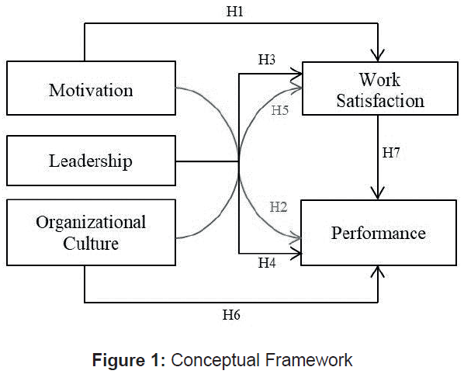
Figure 1: Concept Of Organisational Culture And Its Effect On Employee Performance
(Source: Paais and Pattiruhu, 2020, pp.577-588)
Organisational culture is generally a combination of practices, values and behaviours that employees need to experience in the workplace (Obeidat et al. 2018, p. 261). The matter that makes British Airways special is how precisely they organise themselves, their beliefs, rules and procedures. Their work follows a certain rhythm and even each work is supervised by a supervisor in a disciplined way at every moment. The data is then forwarded to the legal authority and they determine what needs to be corrected. The actual structure of the organisational culture is to work through team building and every member of the team should be aware of their work, employees should be praised occasionally so that they are committed to the work. British Airways' social practice of non-discrimination means providing service to people irrespective of caste, creed, age, or colour which gives their organization high standards (British Airways, 2022). Customers are assured of safety when they fly and British Airways' health insurance is of the highest standard. Crew members try to make customers feel comfortable inside the aircraft. Even the culture of British Airways ensures that the flight program is double-checked before passengers board the aircraft for their safety and that customers are given the best service in the ranger. This organisational culture of British Airways promotes its growth.

The importance of the structure of an airline company to achieve its organisational goals:
Organisational structure influences the work of employees and helps to increase the quality of their work. The performance of an employee in the case of both financial and non-financial grounds has a direct connection with the performance of the organisation and its achievements (Nosike, Okoye, and Afodigbueokwu, 2021, p.35). The organisational structure is the only way to reorganise any organisation and it is proven by researchers. The organisational structure separates the work of all employees. An organisational structure helps employees to clearly define, get authority and responsibility, helps to create better team spirit, helps in clear promotion and helps to be motivated.
British Airways is managed by a team of 6 members. These leadership positions are commercial director, the officer of chief information, engineering director, investment and alliances director, people and organisational effectiveness director, and general counsel. These leaders mainly make important executive decisions. The management hierarchy helps British Airways to have a compact organisational structure (Hierarchy Structure, 2020).
- Current Organisational Structure: There are some problems with this structure and that is it. In this case, it is necessary to appoint a leader in a team because communication problems can make any work worse and it is very important to have a bond between the rest of the team members. In order to avoid this type of problem, British Airlines should choose a specific leader for a specific team depending on the position.
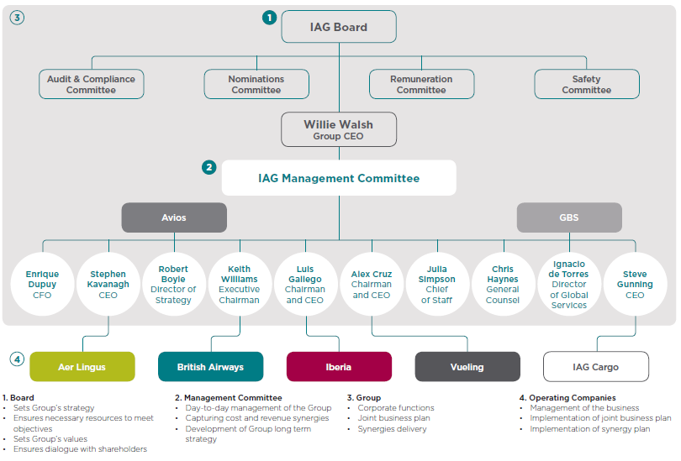
Figure: Organisational Structure Of British Airways
(Source: Business Research Methodology, 2018)
- Alternative Organisational Structure: Although this process will solve the problem of understanding, it will create problems in integration between different teams because each team will want to work independently and therefore will not have a sense of each other. The solution to this problem is the use of technology to move communication between all levels of the business to a larger store rather than a lean store.

On basis of the behavioural approach, the impact of multiple factors in influencing the behaviour of individuals at an airlines organisation:
This unit will provide an understanding of the fundamental concepts of constructive use of organisation and its impact on the airline industry and also on personality, learning, capability, professional attitude, perception, motivation and approach to respecting organisational behavioural goals and commitment. understanding the behaviour of an organisation is a huge managerial task standing there as a huge challenge for people to understand individual behaviour.

Behavioural approaches of an organisation:
There are four different approaches to what influences human behaviour and the various factors that influence one's thoughts and emotions are -the approach of human resources, the approach to contingency, the approach to productivity, and the system approach. Employee empowerment through a behavioural approach is an important mission to follow (Sys Rev Pharm, 2020).
- The human resource approach: This approach recognizes the fact that central resources are and should be developed towards higher levels of competence, creativity and perfection. People contribute to the success of the organisation. The manager's role changes from controlling employees to actively supporting their growth and performance.
- Contingency approach: These methods or behaviours work effectively in one situation but fail in another. For example; Organisation development (OD) programs, in a way, work brilliantly in one situation but fail miserably in another. In this case, the results differ because the situation is different, it is the manager's job to identify which method will best contribute to the achievement of the organisation's goals in a particular situation, in a particular situation, and at a particular time. In this case, employees are made aware of the work process prior to work for better performance.
- Productivity approach: In the case of the productivity approach, the higher the amount of production, the higher the total profit of the industry. How well the manager knows about the use of the produced products is also known in this case.
- The system approach: The approach gives managers a way to see the organisation as a whole, the whole, the individual, the whole group and the whole social system. In this case, the system view tells us that all sectors of an organisation are influenced by each other.

B. Impact of multiple factors of behavioural approach that affect the behaviour of workers:
Effect of human resource management on employees: Managers work closely with employees at this level. Managers' behaviour has many effects on employee performance, be it positive or negative. Undoubtedly, many people in the 19th and early 20th centuries recognized the importance of the human factor to the success of an organisation. In this case, managers should focus more on employees than their products, because without employees, the product cannot be created or the company can run (Aburumman et al. 2020, pp.641-652). Since managers are company officials to employees, employee morale and willingness to work depend on their use. The industry earns a reputation for its products and their use towards employees so managers should be tolerant towards employees.
Effect of contingency approach: The strength of the behavioural approach lies in its capability to work with multiple perspectives (Hallsworth and Kirkman, 2020, p. 40). By using a contingency management style, managers can respond to an individual problem causes without overreacting to the problem itself. Those who understand this theory can work on themselves without embarrassing others e.g. A warehouse keeper can solve warehouse problems but cannot do the work of a manager whereas a manager cannot do the work of a warehouse keeper i.e. solve his own work without embarrassing others.
Effect of Productivity approach: Most companies focus more on productivity than employee engagement, but they should understand that if there are more employees or if existing employees are aware of the advantages and disadvantages, the employee will focus more on their work. One of the most important aspects of organisational structure and behaviour is the capability to provide ‘direct incentives’ (Horch, 2018, pp. 55-72). By building a dynamic, focused, and efficient workforce, that workforce will focus on work and thus improve their performance.
Effect of system approach: System theory is the theory of employee bonding with the owner, the owner needs to understand the value of human resources as the most valuable asset of the company. If the owner is indifferent towards the employee, the employee will also show indifference towards the work which is never good for the company. Thus, maintaining the bond between owner and employee is very important for the company to thrive.

C. Discussion on the organisational behavioural approach being practised at British Airways:
The organisational behaviour of British Airways follows,
- Leadership effort to organise the activities of an organisation. In today's competitive environment, British Airways needs the right leader to guide it and that leader must be more competent than the leaders in the new emerging airline companies. Of all the company leaders, the leaders of British Airlines are the ones who have started- Treating customers and employees with tolerance and respect for success, creating structures for customers to interact directly with leaders, created a leadership development portfolio, aimed at existing and potential leaders at each level of the business, including developing leaders etc (Srinivasan, AlAsaadi and Brennan, 2019, pp.e92-e93).
- The company has made a contribution to workplace improvement is not applying the same old motivation theory as motivation is creating motivation for employees and using leaders to motivate employees.
- British Airlines creates a work environment that recruits and nurtures employees and even teaches them to take responsibility for their own work (British Airways, 2022).
- Being a very large business company, British Airlines knows how important rewards are to the motivation to work, so it rewards its employees based on performance.
In order to improve the company, its employees need to perform better work that's why British Airline trains its employees to keep them updated according to the demand to improve performance.

Conclusion:
From the above review, it can be concluded that the basic needs of running an airline industry are workplace behaviour, productivity, human resource management skills etc. Building relationships with employees and customers is very necessary for the company's growth, not only that the company need to recruit managers who are more competent than other emerging or existing companies. Provide customer safety assurance and high-quality health insurance along with their services as per demand. Only then can airline companies maintain their flights in the sky.

References:
Aburumman, O., Salleh, A., Omar, K. and Abadi, M., (2020) ‘The impact of human resource management practices and career satisfaction on employee’s turnover intention,’ Management Science Letters, 10(3), pp.641-652. DOI: http://dx.doi.org/10.5267/j.msl.2019.9.015.
British Airways (2022) Working with us. Available at: https://careers.ba.com/working-with-us. (Accessed: 15th July 2022).
Business Research Methodology (2018) British Airways Organizational Structure. Available at: https://research-methodology.net/british-airways-organizational-structure/. (Accessed: 13th July 2022).
DOI: http://data.doi.or.kr/qr/10.13106/jafeb.2020.vol7.no8.577.
Hallsworth, M. and Kirkman, E., (2020). Behavioural insights. MIT Press.
Harvard Business Review (2021) Company Culture Is Everyone’s Responsibility. Available at: https://hbr.org/2021/02/company-culture-is-everyones-responsibility. (Accessed: 12th July 2022).
Hierarchy Structure (2020) British Airways Management Hierarchy. Available at: https://www.hierarchystructure.com/british-airways-management-hierarchy/. (Accessed:16th July 2022).
Horch, H.D., (2018) ‘The intermediary organisational structure of voluntary associations’, Voluntary Sector Review, 9(1), pp.55-72. DOI: https://doi.org/10.1332/204080518X15199961331653.
Nosike, Chukwunonso J., Okoye, Nonso J., and Afodigbueokwu, Hillary E. (2021) ‘EFFECT OF ORGANIZATIONAL STRUCTURE ON EMPLOYEE PERFORMANCE OF COMMERCIAL BANKS IN NIGERIA’, Research Journal of Management Practice, 1(7), pp. 35. DOI: 10.46654/RJMP.1719.
Obeidat, A.M., Abualoush, S.H., Irtaimeh, H.J., Khaddam, A.A. and Bataineh, K.A., (2018) ‘The role of organisational culture in enhancing the human capital applied study on the social security corporation’ International Journal of Learning and Intellectual Capital, 15(3), pp.258-276. Available at: https://www.researchgate.net/profile/Shadi-Habis-Abualooush/publication/327640785_The_role_of_organisational_culture_in_enhancing_the_human_capital_applied_study_on_the_social_security_corporation/links/5ba8c38f45851574f7e20592/The-role-of-organisational-culture-in-enhancing-the-human-capital-applied-study-on-the-social-security-corporation.pdf. (Accessed: 11th July 2022).
Paais, M. and Pattiruhu, J.R., (2020) ‘Effect of motivation, leadership, and organizational culture on satisfaction and employee performance,’ The Journal of Asian Finance, Economics and Business, 7(8), pp.577-588.
SHRM (2022) Understanding and Developing Organizational Culture. Available at. https://www.shrm.org/resourcesandtools/tools-and-samples/toolkits/pages/understandinganddevelopingorganizationalculture.aspx. (Accessed: 17th July 2022).
Srinivasan, B., AlAsaadi, Z. and Brennan, P., (2019) ‘Safety and culture at workplace-Out-of-the-box approach,’ British Journal of Oral and Maxillofacial Surgery, 57(10), pp.e92-e93. DOI: https://doi.org/10.1016/j.bjoms.2019.10.269.
Statista (2022) British Airways - statistics & facts. Available at: https://www.statista.com/topics/5372/british-airways/#topicHeader__wrapper. (Accessed: 14th July 2022).
Statista. (2022). British Airways Plc's worldwide revenue from FY 2010 to FY 2021. Available at: https://www.statista.com/statistics/264296/british-airways-worldwide-revenues-since-2006/. (Accessed: 18th July 2022).
Sys Rev Pharm (2020) Effect of Human Resource Management Practices on Employee Performance Mediating by Employee Job Satisfaction. Available at: https://www.sysrevpharm.org/articles/effect-of-human-resource-management-practices-on-employee-performance-mediating-by-employee-job-satisfaction.pdf. (Accessed: 21st July 2022).

