
Control Technology – ACMA6001
Control Technology

September 29, 2023
University of Wales Trinity Saint David

Adam Evans 2005959

Table of Contents
Adam Evans 2005959 0
Table Of Figure 1
Task 1 2
Task 2 4
PID Controller 4
Bits 6
Tunning the PID 7
MATLAB Program 11
Bibliography 16

Table Of Figure
Figure 1- Furnace zones 2
Figure 2 - Thermal couples 2
Figure 3 - temp display 3
Figure 4 – Oscillation 3
Figure 5 - Machine Interface 4
Figure 6 - PID in MATLAB 4
Figure 7- diagram of cruise control 5
Figure 8 - P control 5
Figure 9 - PI control 5
Figure 10 - PID control 6
Figure 11- bit selection 6
Figure 12- 8 bit 6
Figure 13- 32 bit 6
Figure 14 - I = 0.5 9
Figure 15 - I = 1 9
Figure 16 - I = 2 9
Figure 17 - D = 0.1 9
Figure 18 - 32 bit 10
Figure 19 - 16 bit 10

Task 1

A PID system can control a variant of operations within engineering, these range from regulating temperature, speeds of equipment, pressure and flow along with other process variables. These will all have one thing in common and that is they have a control loop feedback system which control the process variables to provide accuracy to the controller and the desired outcome.
Within MLUK there is a PID control system which is the heart of the operation and dominates the shop floor, this is in the form of the brazing furnace which runs 100 meter long and is split into different operating zone which do different process shown in Figure 1 - furnace zones.
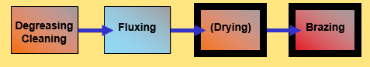
Figure 1- Furnace zones
These compile of a de-oiling section which burns off any excess oil on the product, spray fluxing section which coats the product in flux to assist in the brazing operation, drying oven which dries off the flux before it enters the main furnace. This is due to the atmosphere in the main furnace must be inert. But the largest section is the main brazing furnace which must be kept at a constant temperature within the tolerance band.
This tolerance band ensures that the filler material will melt and braze the product correctly, if the temperature falls below the tolerance band the core will experience lack of bonding on the main core matrix, cold cores where the furniture hasn’t brazed to the product and generally appearance of the core. If the temperature goes over the tolerance, then the core can experience concerns like silicon erosion, burnt airways and contamination. These are only a few of the failure mode which can accrue if there was no control. When these accrue the core must then be scrapped as it is away from customer specification and not fit for purpose.
To control the temperature with on this area of the furnace there are thermal couples running the full length of this section placed at different heights to ensure the correct thermal atmosphere is maintained.
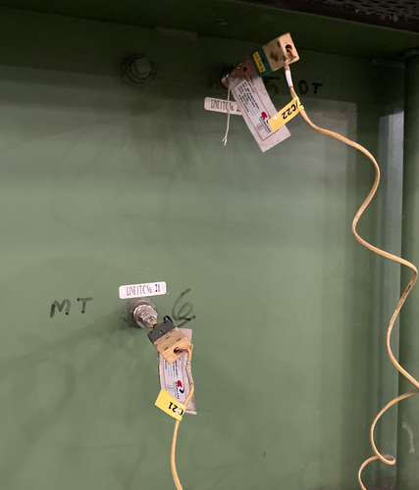
Figure 2 - Thermal couples
The reading from these thermal couples is fed back to the main PLC control board that has individual PID control units which continuously calculates a value from the current temperature inside the furnace against the setpoint values. The PID controllers will then adjust the heat within the furnace to ensure a constant steady temperature between the set points is achieved.
The PID controllers which are used at MLUK are shown in Figure 3 - temp display
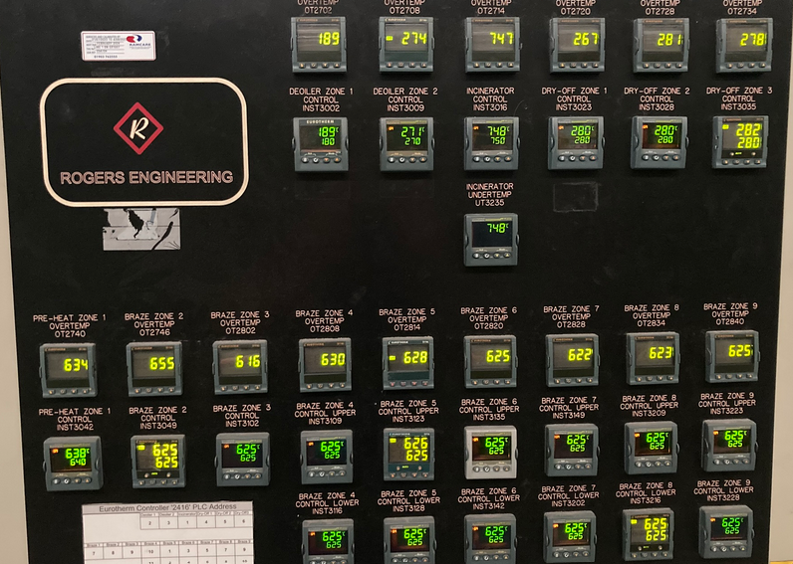
Figure 3 - temp display

This type of PID controller provides a highly visible screen so that anyone can check the temperature easily, have a precis 0.1% sample rate of 50ms, with a fast response that delivers minimal overshoot and oscillation which is key when controlling temperature. (https://uk.rs-online.com/, 2023)
Having a PID sensor which has minimal temperature overshoot and oscillation is key to the MLUK furnace application as reducing the temperature is very difficult as the furnace has a nitrogen filled atmosphere which needs to be maintained.
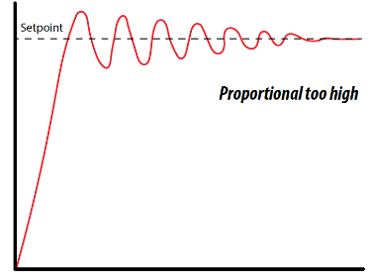
Figure 4 – Oscillation
It would also mean that due to the variant of product traveling down the furnace the temperature would be constantly oscillating producing potentially both defects which have been effected by high temperature expose and not enough temperature.
The response time in which the PID react to temperature change is also very important due to the number of products that travel along the belt, these them selves change in size and density drawing in different amount of temperature. To help the furnace maintain a steady temperature the size of the runs of products is controlled leaving gaps between each run and the load pattern meaning large core followed by small cores no to draw large amount of heat.

Along side the visual display of the PID controllers there is also a machine interface which gathers information allowing analysis to be performed and integrated. This system will also trigger alarms alerting people of any sudden changes to the temperature.
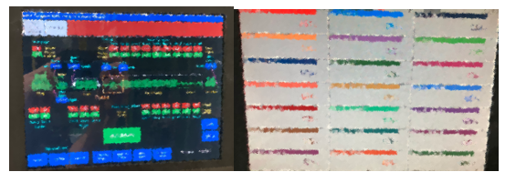
Figure 5 - Machine Interface

Task 2
A code has been written within MATLAB and has been witnessed running by Jordan Jenkins 28/07/2023, the purpose of this code was to understand the relationship and effect of adjustments made within a PID controller which is linked to a cruise control system, full MATLAB scrip has been added to the end of this documented under the header MATLAB Program.

PID Controller

When defining the PID controller in MATLAB it is broken down into each element this allows us to change the input values and is displayed as the following. Figure 6 - PID in MATLAB
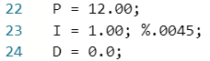
Figure 6 - PID in MATLAB
Adjusting each of the PID values will alter the effect on the amount of oscillation and overshoot which will be experienced when operating the cruse control system.
The cruise control system operator when someone selects the function within the car and sets a set point at a particular speed, the car then must maintain this speed without the drivers input from the throttle to speed up or break to slow the car down. This is done by the PID control knowing the setpoint set by the user and monitoring the input being supplied from the speed senor to know if to speed up or slow down atomically. This is displayed in Figure 7- diagram of cruise control
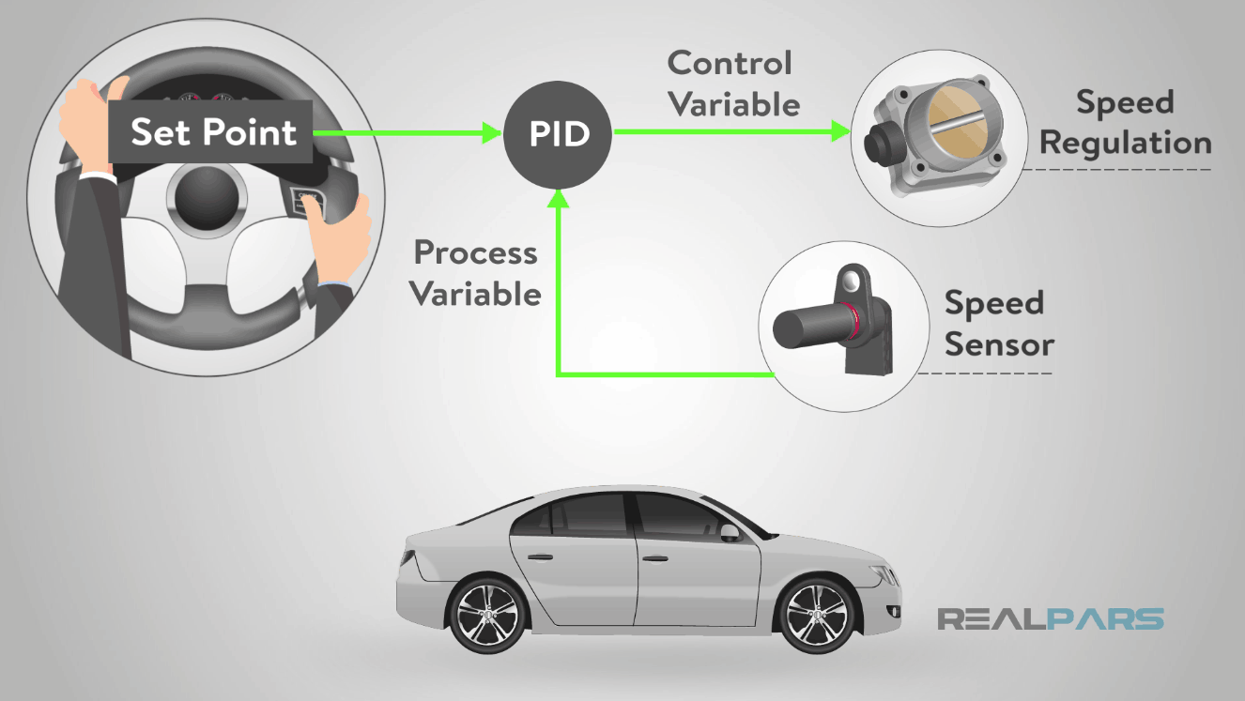
Figure 7- diagram of cruise control
But before altering any figures within the MATLAB program you need to understand what each part of the PID does and how it can affect the operation of the cruise control system.
P which stands for Proportional is how the controller responds to the error which is being received, when this is related to a cruise control system it is how much throttle is being given in compared against the set point it is wanting to achieve. This means the further you are away the more throttle is given but as you reach the set point the throttle is instantly stopped being pressed which start to slow you down. This will result in inaccuracy and a offset to the desired set point shown in Figure 8 - P control
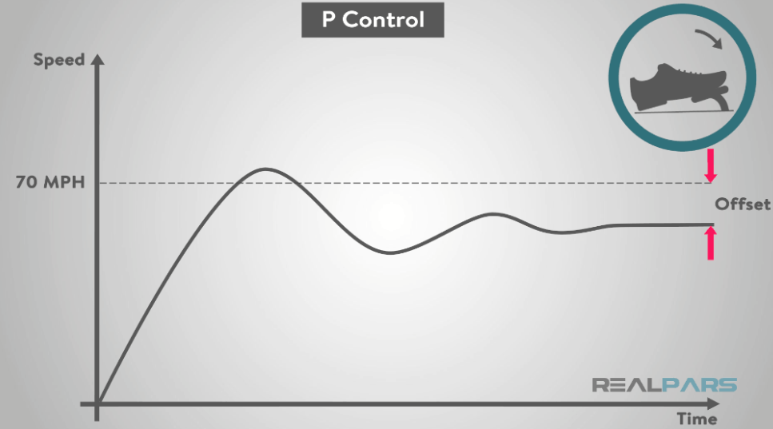
Figure 8 - P control
I which stand for Integral and deals with the accumulation of errors when combined with the P element of the PID controller. This mean that when the speed has reached the set point and the throttle has been realised and the speed starts decreasing in will start to increase the throttle lightly until the set point is achieved. This has now made the PI Control system accurate however the time it takes to reach the set point is not quickest. This is shown in Figure 9 - PI control
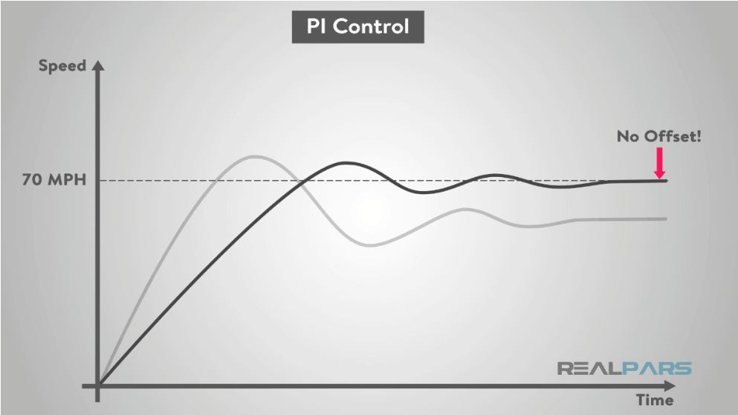
Figure 9 - PI control

D which stands for derivative, and this focuses on the rate of change in the error, which when added to the control system makes the PID complete. This now means that the reaction time to sudden changes within the system for examples the car going up a different incline the system will now respond with little to no overshoot and maintain the set point. This is shown in Figure 10 - PID control
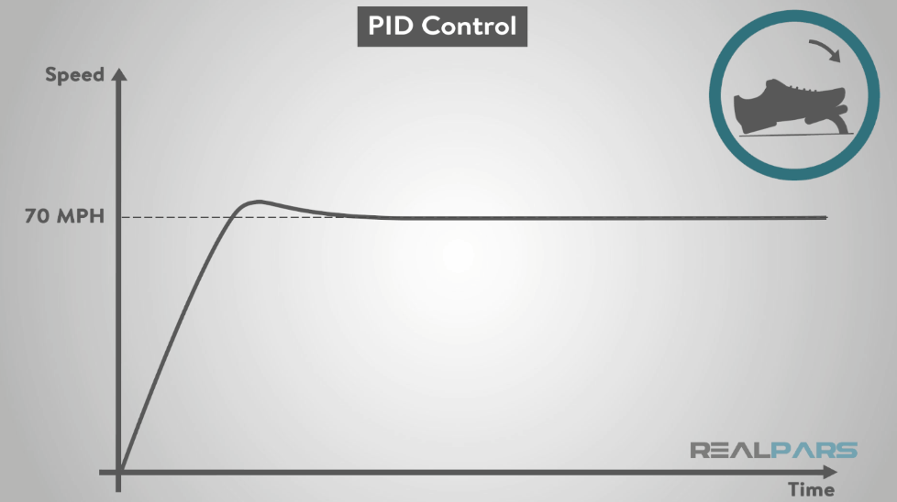
Figure 10 - PID control
(Gastreich, 2019)

Bits

A binary digit or more commonly known as a bit is the smallest unit of data that a computer process and store. (Sheldon, 2022)
When setting up the cruise control system the number of bits which is chosen can affect the controller’s precision, the resolution and the range of numbers it can represent. Which mean the lower number of bits you select the less numbers it can deal with, for example an 8-bit controller can only manage 0 to 255 bits but a 32-bit controller can handle 0 to 4294967295 bits. (Kimna, 2022)
Within the MATLAB program the bit selection can be changed shown below Figure 11- bit selection
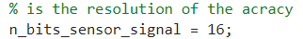
Figure 11- bit selection
This will effect how the graphs are displayed.
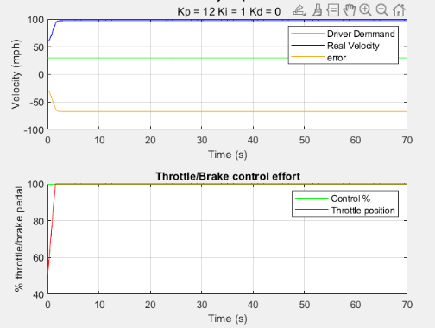
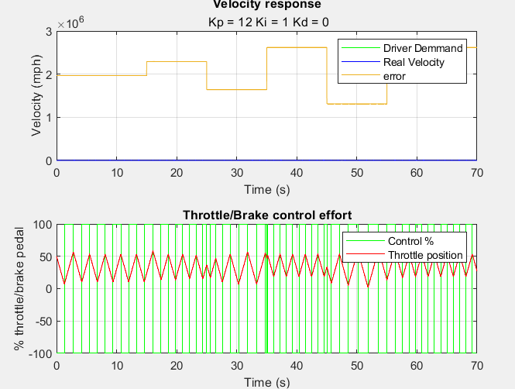
Figure 12- 8 bit

v

Figure 13- 32 bit

Tunning the PID

To Tune the PID you firstly must set the I and the D to 0 then you increase the proportional gain until you start to get oscillation in you graph, the p then should then be reduced to roughly half this value.
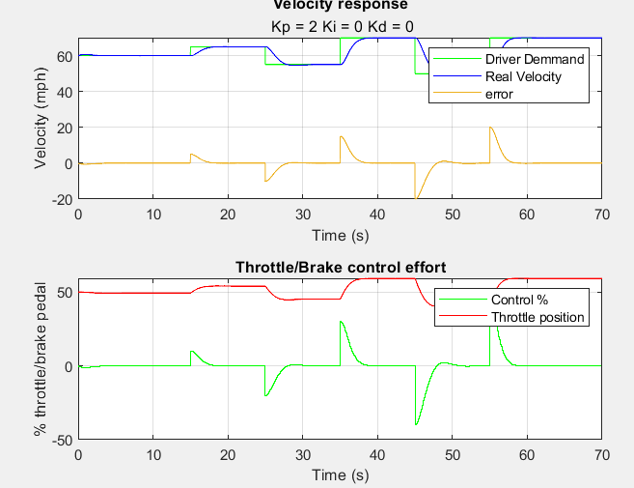 Set at P = 2
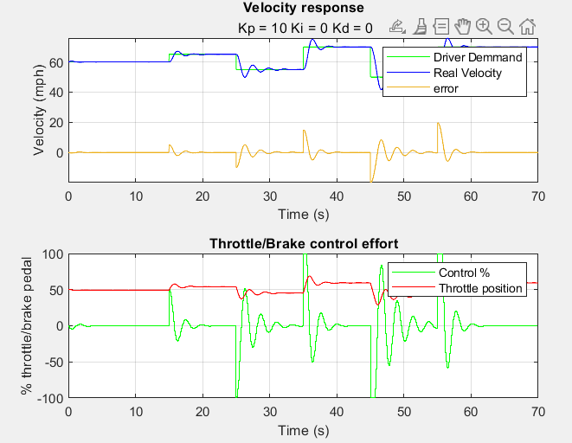 Set at P = 10
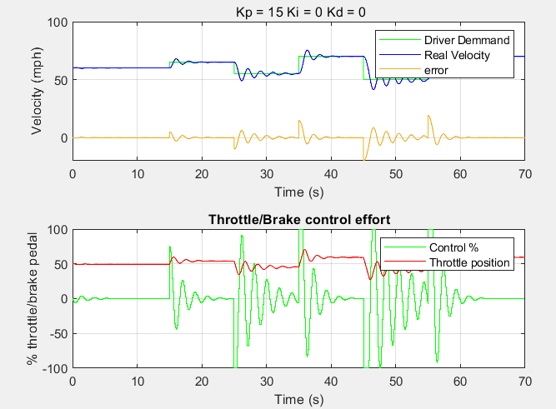 set at P = 15
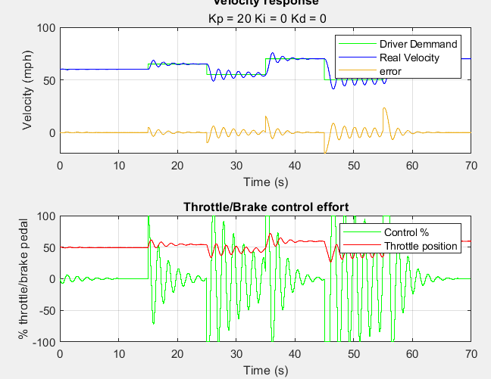set at P = 20
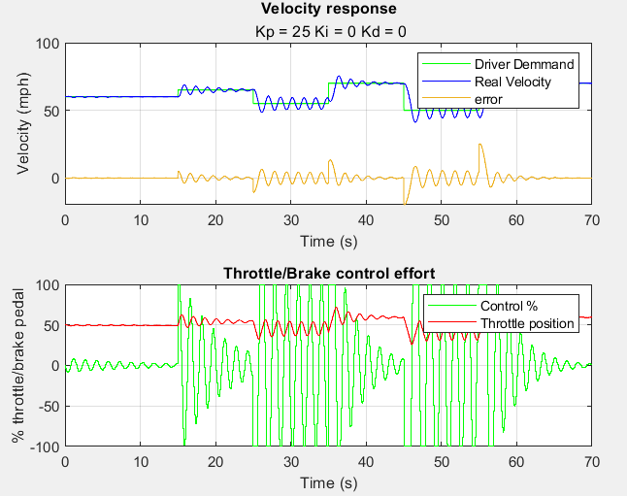set at P = 25
From the examples above full oscillation is shown when the P is equal to 25 so dropping it back down to 12.5 which is half will give the result below.
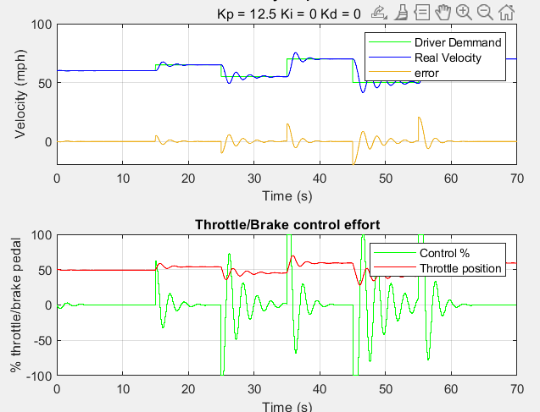
This gives an over shoot with minimal oscillation, now by adjusting the I and the D this should be able to reduce further.
Firstly the I is increased to 0.5 shown in Figure 14 - I = 0.5 which has almost eliminated the the second bump of oscillation.
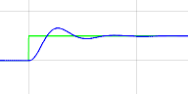
Figure 14 - I = 0.5
By increasing the I this time to 1 the over shoot is reduced and the second over shoot bump has gone.
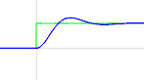
Figure 15 - I = 1
Increasing the I to two has almost eliminated the overshoot completely. Figure 16 - I = 2
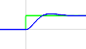
Figure 16 - I = 2
By altering the D from zero to zero point 1 it increases the time and also the overshoot slightly. Figure 17 - D = 0.1
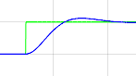
Figure 17 - D = 0.1
From this I have determined the optimum setting for the PID controller is P = 12.5, I = 2 and D = 0

Using this setting I increased the bit from 16 to 32 to see if there was a dramatic change in the graph being produced.

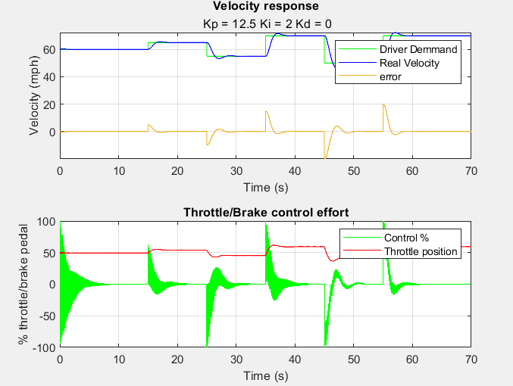
Figure 18 - 32 bit
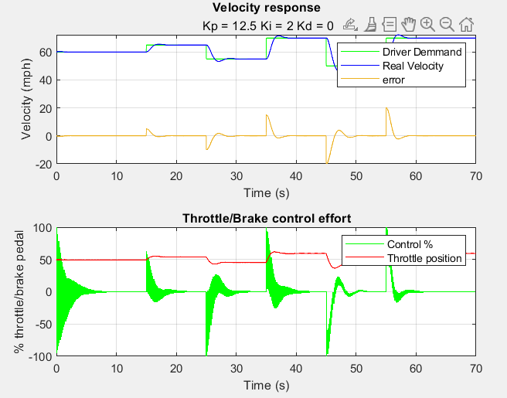
Figure 19 - 16 bit
From these graphs a 16-bit controller would be okay to use to operate this cruise control system providing accurate data and control.

MATLAB Program

%% MAIN FILE FOR CRUISE CONTROLLER SYSTEM %%

% decsribe from binarty to normal numbers

% (1) initialize
% (2) set implementation parameters
% (3) set simulation parameters
% (4) simulation loop
% (5) plot results

%% (1) Initialize %%

clc
clear all
close all % house keeping

% define global variables
global sim_step u j u_vec
% initialize vector where to store results for plots
d_vec = []; u_vec = []; y_vec = [];e_vec = [] ; T_vec = [];
% these are what needs to be changed P I D
P = 12.5;
I = 2; %.0045;
D = 0.0;

%% (2) set implementation parameters %%

% sampling time must be an integer multiple of sim_step
% this time can changed - the responce rate the contrler takes a reading
Ts = 0.05; %sim_step.*5; %0.05;

% number of bits used to encode velocity sensor signal. velocity sensor
% range in mph [0,150]
m_velocityS =0;
M_velocityS = 150;
% this can be changed but you need to change all the Bit readings - a bit
% is the resolution of the acracy
n_bits_sensor_signal = 16;

% number of bits used to encode velocity demand signal. demand
% range in mph [30,110]
m_demand = 30; M_demand = 110;
n_bits_demand_signal = 16;

% number of bits used to encode throttle/brake actuator signal. actuator
% range in mph [-100,100] where [-100,0) is percentage of braking and
% (0,100] is percentage of throttle
n_bits_actuator_signal = 16;
R = 2.^n_bits_actuator_signal;

%% (3) set simulation parameters %%

sim_step = 0.01; % simulation time step in seconds
sim_time = 70; % simulation time length in seconds
T = 0:sim_step:sim_time; % simulation steps vector
throttle_setting = 50; % initialize control action (throttle/brake setting)

% communication delay between controller and actuator in seconds.
% must be an integer multiple of sim_step
% do not do %
actuator_signal_delay = 0.00;

%% remove when in function
m_ControlSig = -100;
M_ControlSig = 100;
u = 50;
control = 50;

%% (4) simulation loop %%
velocity_real = 60;

for j = 1:length(T) % for every simulation step

loops_remaining = length(T)-j % display progression

% get vehicle raw veocity sensor measurement from the communication bus
[velocity_raw, velocity_real,throttle_setting] = getRawVelocity(n_bits_sensor_signal,velocity_real,P,throttle_setting);

% decode raw bus signal (from x-bit binary to mph)
velocity = ((bin2dec(velocity_raw).*(M_velocityS-m_velocityS))/R)+m_velocityS;

if mod((j-1)*sim_step,Ts) == 0 % every sampling time

% get driver's velocity demand raw signal from the communication bus
demand_raw = getRawVelocityDemand(n_bits_sensor_signal);

% decode raw signal (from x-bit binary to mph)
demand = ((bin2dec(demand_raw)*(M_demand-m_demand)/R)+m_demand);

% calculate control signal (range [-100,100])
[control, error] = calcController(velocity,control,demand,P,I,D);

% encode control signal into x-bit binary number

control_raw = dec2bin(((control-m_ControlSig)/(M_ControlSig-m_ControlSig)).*R);

% send control command to throttle/brake actuator via communication bus
sendControlCommand(control_raw,n_bits_actuator_signal,actuator_signal_delay);
end

% store values for plotting
e_vec = [e_vec error];
d_vec = [d_vec demand];
u_vec = [u_vec control];
y_vec = [y_vec velocity_real];
T_vec = [T_vec throttle_setting];
end

%% (5) plot results %%

figure

% plot velocity response
subplot(2,1,1)
plot(T,d_vec,'g-');hold on
plot(T,y_vec,'b-');
plot(T,d_vec-y_vec); grid;
title('Velocity response');
subtitle([' Kp = ', num2str(P),' Ki = ', num2str(I),' Kd = ',...
num2str(D)]);
ylabel('Velocity (mph)'); xlabel('Time (s)');
legend('Driver Demmand','Real Velocity','error')

% plot throttle/brake actuator effort
subplot(2,1,2)
stairs(T,u_vec,'g-');
hold on;
plot(T,T_vec,'r-'); grid;
title('Throttle/Brake control effort');
ylabel('% throttle/brake pedal'); xlabel('Time (s)');
legend ('Control %','Throttle position')

Bibliography
Gastreich, W., 2019. https://realpars.com. [Online]
Available at: https://realpars.com/pid-loop/
[Accessed 2 9 2023].
https://uk.rs-online.com/, 2023. https://uk.rs-online.com/web/p/temperature-controllers/1449296?cm_mmc=UK-PLA-DS3A-_-google-_-CSS_UK_EN_Automation_%26_Control_Gear_Whoop-_-Temperature+Controllers_Whoop-_-1449296&matchtype=&pla-493196710992&gclid=CjwKCAjwyNSoBhA9EiwA5aYlb2StVpA-UYRh2eJ3oW. [Online]
Available at: https://uk.rs-online.com/
[Accessed 2 september 2023].
Kimna, 2022. https://www.utmel.com. [Online]
Available at: https://www.utmel.com/components/8-bit-vs-32-bit-which-bit-size-is-the-superior-choise?id=1843
[Accessed 2 9 2023].
Sheldon, R., 2022. https://www.techtarget.com. [Online]
Available at: https://www.techtarget.com/whatis/definition/bit-binary-digit
[Accessed 2 september 2023].

