A report focussing on:

Why I have chosen Construction

Prepared for:

R. Thomas

Created by:
L. Hunt

Date completed:
October 27th, 2022

Word count: 949

Table of Contents
Page Number

1.0 Executive Summary 3

2.0 Terms of Reference 3

3.0 Procedure 3

4.0 Findings 4 - 5

5.0 Discussion 5

6.0 Conclusion 6

7.0 References 7

8.0 Appendices 8

1.0 Executive Summary
This report proposes an investigation into my reasoning behind choosing construction as a sector to work in, looking at what inspired me into this line of work and what my motivations are for becoming qualified in construction management. My findings will provide an insight into this, using research as a method of comprehension, with a conclusion then detailing an overall view of my experience.

2.0 Terms of Reference

2.1 – Focus Principles:
2.1.1 – To identify why I have chosen construction as a sector to work in.
2.1.2 – Use information to show that I have researched the extent of construction management as a profession.
2.1.3 – To come to a conclusion based on my research.

3.0 Procedure
Identification of research sources used:
3.0.1 – Blended learning from previous education information and research, and websites – both set out in pages 6 and 7 (references and appendices).

4.0 Findings
4.1 – The course I am currently studying is a BSc in Construction Management, a career that has a blended structure of both practical and detail-based scenarios that entails a list of specific qualities.
I have always had inspiration from my grandfather, an electrical engineer, and very practical man, from a young age, which sparked interest into work within the construction industry. Being exposed to site and project plans and drawings as early as twelve, I always felt as though I could follow in his footsteps. Alongside this, I was shown more practical experiences by aiding my grandfather in building little projects from scratch, repairing anything damaged, and learning that we both had a good eye for detail. I began to explore the career of architecture, due to my ability to draw, and fascination with buildings during my GCSE period, and worked with a local architect for a brief period to develop an understanding of the job.

4.2 - After my A-levels, I decided to go to Pembrokeshire College to study “Construction within the Built Environment.” This gave me the opportunity to explore a variety of career options. However, due to Covid-19 my learning experience was limited, and the traditional forms of education were unavailable. This set me back as I could not partake in practical experiences, such as going on site, that would have developed my understanding for different career paths. However, through the alternative learning process and necessary research, I obtained enough of an insight into the different options available, that I was then able to filter out over two years, landing on the career of construction management. Gaining an understanding of this career choice, and my experience of working in retail, I was able to match my working qualities to those of Construction Management.
Running parallel to my time at college, I began working in Tesco. Within a year, I was given the opportunity to begin management training. Doing this allowed me to broaden and develop my leadership skills, amongst others, in a working environment. Studying construction and working in retail generated a correlation between what career I wanted and my characteristics. This led me to Construction Management.

4.3 – To further my passion and understanding of the more hands-on construction environment, I spent time during the summer of 2021 working with a college friend renovating an old stone cottage, stripping away the limestone plaster, old wooden ceilings, roof tiles and felt and batten and exposing the ancient old wooden beams, along with the replastering of the walls and modernising the structure.
This experience was eye opening as began to understand the labour that had to be put into such a project. As much as I relished the experience, and gained knowledge along the way, it helped me to decide that such a physically demanding career was not an option and guided me towards the management side of construction.
4.4 – Construction Management is a crucial part of any project, overseeing each element, but with the clients’ best interests at heart. This job requires precision focus on “schedule, cost, quality, safety, scope and function.” CMAA (2022). This job role requires specific qualities in order to be successful and understanding and relating to this has given me motivation in finding a career that I enjoy.
There are several qualities in one’s personality that defines a good construction manager; Leadership; Delegation; Organisation; Working under pressure; Problem Solving; Willingness to learn; Communication; Team Builder; Honesty; Humility; Negotiation. Bellevue University (2020). A variation of these characteristics reflects my own day to day thought processes both at home and in work and so decided to apply for the BSc Construction Management course.

5.0 Discussion
5.1 – The findings that I have provided in this report are of significant importance because it has allowed me to explore the reasons behind why I have chosen construction as a sector to work in. The report has given me the opportunity to research into the profession in greater detail and find a correlation between what inspired me to begin with and why I have chosen construction management as a degree, and choice of career.
Being able to structure my findings in order of life choices, I have been able to pinpoint why such experiences have led me to this final decision.

6.0 Conclusion
In this report, I aimed to identify the reason behind why I chose construction and to use research methods to collate information to show that I have researched my answer, and to finally come to a conclusion based on my research.
After spending time with a chartered architect, I found that architecture did not suit my personality or characteristics and felt that I needed a more hands on and busy career in order to reap the benefits.
Further down my educational route, I obtained knowledge of the construction industry and the different careers which pointed me in the direction of management and that there are specific qualities and characteristics needed. Whilst also working in retail I found that I had various characteristics that collated with that of construction management, which only made me want to investigate further.
In addition to this, I gained experience of renovating a cottage which I found rewarding. However, I also found it to be physically demanding which I then concluded to not be a career option, and to be kept as a hobby.
Each of these experiences has allowed me to conclude the reasons behind why I chose construction, and more specifically, construction management, as I have been able to get a taster of various career paths and gauge a decision as to whether they were the right options. This is primarily what led me to applying for the BSc Construction Management course.

7.0 References

Luke Hunt (2021) Stone Cottage Renovation

10 Qualities of a Construction Project Manager. Available at: https://pmcenter.bellevue.edu/2020/01/01/10-qualities-of-a-construction-project-manager/ (Accessed: 31st October 2022).

What is Construction Management. Available at: https://www.cmaanet.org/about-us/what-construction-management (Accessed: 30th October 2022)

8.0 Appendices

8.1 – Appendix A
Below are pictures of the stone cottage renovation:
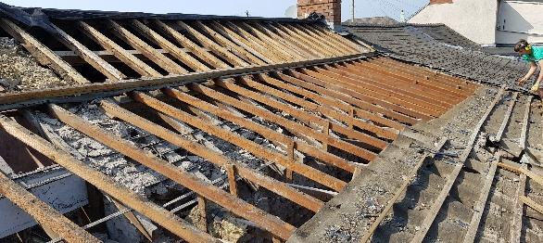
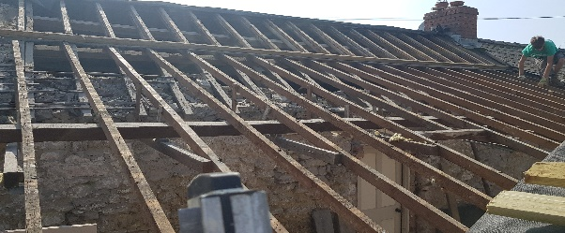
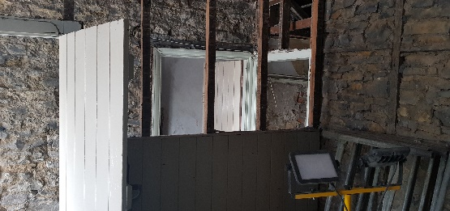
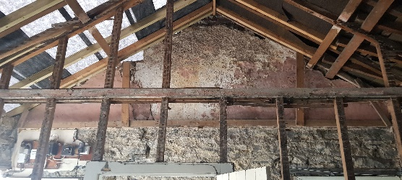
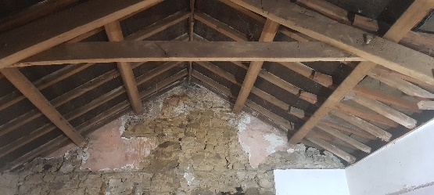
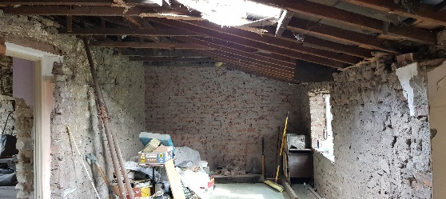

Luke Hunt (2021) Stone Cottage Renovation

