
Entrepreneurship

Assessment 1

Student Name: Iva Pavlova-Minkova

Student ID: 1919329

Lecturer: Malani Gunaratnam

Table of Contents
Introduction 4
Traits of a successful Entrepreneur 5
Vision and Passion 5
Strong work ethic 6
Creativity 6
Determination 6
Competitiveness 7
Self-Starter 7
Resourcefulness 7
Self-Motivated 7
Confident 7
Flexible 8
Risk-Taker 8
Motivations of entrepreneurs 9
Internal Factors: 10
Need for self-actualization: 10
Optimism 10
Positive attitude 10
Enthusiasm 11
Background 11
External Factors: 11
Influence 11
Availability of resources 11
Changing tastes and preferences 12
Government policies 12
Differentiation between ‘for profit’ and ‘not for profit’ Small Organizations – Drawing on the Entrepreneurs’ Values and Beliefs 12
Formation of For Profit and Not for Profit Organisation 13
Financial Perspective of For Profit and Not for Profit Organisation 13
Managerial Perspective of For Profit and Not for Profit Organisation 14
Legal Perspective of For Profit and Not for Profit Organisation 14
Entrepreneurs Perspective of For Profit and Not for Profit Organisation 16
Conclusion 18
References 19

Introduction
Entrepreneurship is the ability and readiness of an individual to develop, organize and run a business enterprise, along with any of its uncertainties for making profit in future. The most prominent example of entrepreneurship is the starting of new businesses or come up with a new idea of business.
On the other hand an Entrepreneur is a person who creates and manages any business by identifying a need and benefiting from the opportunity. This usually requires taking risk, personal sacrifice, and initiative. It is usually seen the entrepreneur as an individual who innovates and produces new ideas, goods, or services. They are also at risk of losing their capital.
This paper will cover the characteristics of entrepreneurs. It also contains which traits make differences between a common man and an entrepreneur. And then the paper going to cover some motivations which are responsible for making a person entrepreneur.

Traits of a successful Entrepreneur
An entrepreneur is a risk taker. Taking risk requires courage.so entrepreneur must have some rare characteristics which is not common to all. Those attributes make him different from other. Some common traits of entrepreneur are as follows:

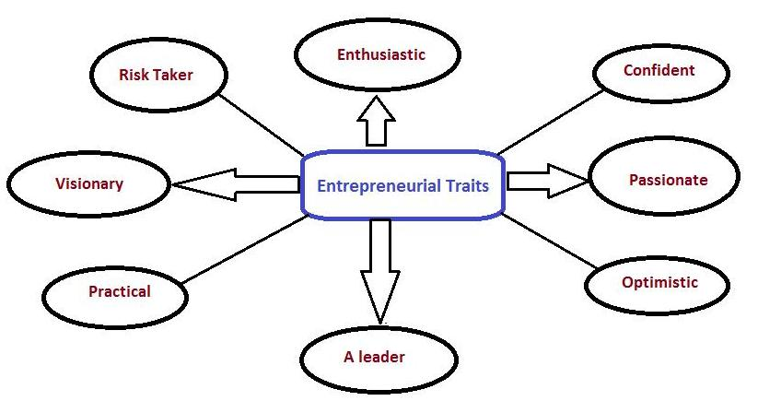

Figure: Traits of entrepreneurs (Source:bizclub.com, 2020)

Vision and Passion
A clear vision is required for every entrepreneur regarding his business operation. So he must have the ability to plan out his long term and short term goals and objectives. He must have to be able to carry out his future plans in an articulate and efficient way (Babb and Babb,1996).
Another very important trait necessary in an entrepreneur is that he must be passionate about his work. Entrepreneurship is hard work and long hours, so he must be passionate about what he is doing. Such passion can translate into hard work and success.

Strong work ethic
Entrepreneurs who are successful make sure that they are always the one who is first to the office and the last one to leave.
According Giacomin, Janssen, Guyot, and Lohest (2011) these people are those who ensure that they usually come to the office during their off days, if required, just to ensure that the outcomes meet their expectations. The successful entrepreneurs are those who always have their mind in their work, even if they are not present in their workplace.
Strong interpersonal skills
An excellent communication skill for selling the products to customers and motivating the employees is always a powerful trait of all successful entrepreneurs. Yes, most entrepreneurs who have the power to motivate their employees can see their business grow within few time (. These entrepreneurs are also great at instructing others to be successful and highlighting the advantages of any situation.

Creativity
Creative mind is always the sore house of new ideas. New ideas allow an individual to innovate something new or something out of the box. Those who are creative can find out solutions easily for any difficult situation.

Determination
The successful entrepreneurs are never greatly impacted by the defeats they encounter. For them, failure is like an opening for a success story, and hence, they try again and again just till they get the success they are expecting. Moreover, these entrepreneurs are not wired to believe that some things are not possible and cannot be done.

Competitiveness
The number of companies formed are increasing every month and every year, as every entrepreneur feels that they can do a much better job than others. They run with the aim that they need to win at the sport they play and win the business that they are creating or have created. It is an entrepreneur that highlights the track record of success of their company.

Self-Starter
It is known to every successful entrepreneur that if something has to be done, it needs to be done by themselves. They set parameters, and they ensure that the projects are following that path. They are proactive in nature.

Resourcefulness
Many entrepreneurs are faced with tasks and challenges they have never faced before, that means an entrepreneur has to face different challenges daily. In this case the ability to be resourceful is a mindset that helps entrepreneurs reach lofty goals without a clear way to achieve them.
When an entrepreneur who is able to work resourcefully, he can effectively solve problems and grow and scale his businesses without having all of the answers or resources to do so. A can-do attitude and willingness to work required being a resourcefulness entrepreneur. It also requires to be creative and effective to manage a business without having the immediate know-how.

Self-Motivated
By the trait, it is meant that when you’re your own boss you have to be able to keep yourself motivated to work effectively and consistently. An entrepreneur must have to a self-motivated person which will help him to work in difficult situation or unfavorable working condition. As he is the boss of his own business, he must need to be a fast mover for the betterment of his business. This starts with knowing what drives an entrepreneur to keep going and drawing upon necessary inspiration when his motivation is low.

Confident
High level of confidence is a must for every entrepreneur. An entrepreneur needs to be confident on his capability to run a business, to come up with new ideas. If you have an idea you want to bring to life and share with others, you have to have the confidence to see it through. Whether an entrepreneur is introducing a new product to market, or are seeking outside funding for his business, he must be able to speak to what he offers clearly and confidently. It can be said that, if you don’t believe yourself, if you are not enough confident on your ideas then how can you assume that the customer will accept your ideas and business!!

Flexible
To have a sustainable business and see long-term success, entrepreneurs must be willing to flexible when necessary. The successful entrepreneurs are always ready to accept the changes. If he is not flexible enough to accept those changes, maybe he is going to destroy his business in near future. If it is required reformulating a product to make it better, or revising a business strategy to remain competitive, entrepreneurs who are too rigid and afraid to embrace change are at a disadvantage.
A flexible entrepreneur can easily take the sudden opportunities as they come which can pay off in the long run. The rigid business owners who are slow to adapt to change can miss out on valuable opportunities to innovate and adapt to their customer’s needs.

Risk-Taker
A calculated risk taker is always a winner. It is one of the most valuable skills for an entrepreneur. Willingness to take risk can teach valuable lessons in business that can help their company in the long run.
Taking risks also helps businesses to differentiate themselves from the competition, which is especially helpful in competitive markets. If any risk taking action fails to make estimated profit, from this an entrepreneur can learn and make better plan for future operations.

Motivations of entrepreneurs

Entrepreneurs take major financial risks, work long hours and practically torture themselves trying to stay afloat and build a business and make it successful. What the reasons behind this? Why they sacrifice so many things to be an entrepreneur? Why would anybody want to go through with it? There are some factors. They motivate them to become entrepreneur.

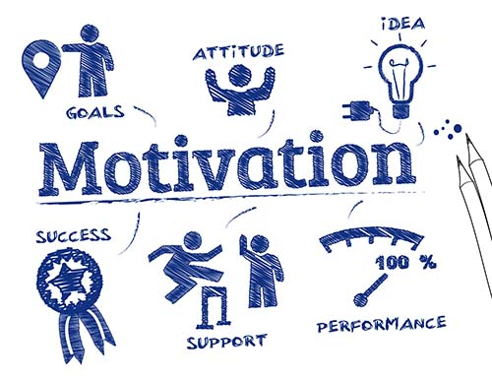

Figure: Motivation for Entrepreneurs (Source: myventurepad.com, 2020)
We can find out two types of motivation factors for the entrepreneurs and these are:
1. Internal Factors
2. External factor

Internal Factors | External Factors
Need for self-actualization  Optimism  Positive attitude  Enthusiasm  To Become independent  Background | Influence  Availability of resources  Product’s demand  Government policies  Technological advancement  Changing tastes and preferences
Table: Motivation Factors for Entrepreneurs (Benzing et al., 2019)

Internal Factors:

Need for self-actualization:
According to Maslow, need for self–actualization motivates an individual to see himself at the top of the organization. This encourages him/her to start his own business. Need for freedom and self-fulfillment makes the individuals motivated to be an entrepreneur.

Optimism
Individuals having positive mindset get motivated by finding opportunities during critical situations also motivate to become an entrepreneur. Positive attitude and perception motivate an individual to find out positive result from any action or situation which is not favorable. They learn from failure and make better decision for future. They can work out for the best even during unfavorable and tough situations also.

Positive attitude
Most of the successful entrepreneurs in the business history have positive attitude. It is the most important factor which motivates the individuals to become successful entrepreneurs. Positive attitude can lead an individual to develop constructive thinking and better planning; it motivates them to become powerful entrepreneurs, finally, the positive attitude is always confident which makes them winner in future.

Enthusiasm
If you want to find a better solution, you need to be enthusiastic. It stabilizes the ideas and makes them become creators and innovators which result in successful entrepreneurs. Enthusiastic people are always wants to innovate something new. They see opportunity in problems which leads them to become entrepreneur.

Background
Family background, occupational background, educational background and a person’s own experience in a job motivates him/her to become an entrepreneur. These types of entrepreneurial backgrounds act as a clear path to becoming a successful and powerful entrepreneur.

External Factors:
As we have seen some internal factors which influence a person to become an entrepreneur, there are some external factors which also do the same job. They are as follows:

Influence
Family members, friends, and society are the strong influencers for the individuals to become entrepreneurs. People also motivated to become entrepreneur after seeing the success of existing entrepreneurs around them. In many cases, it is seen that people become motivated to be entrepreneur after joining workshop or conference of successful business person.

Availability of resources
If a person sees that he has enough resources like land, labor, money, materials and other resources, it can motivate him to use those resources and become an entrepreneur. Though there is creativity, intelligence, commitment and enthusiasm in the individuals, but the unavailability of resources becomes an obstacle for new entrants or entrepreneurs. So, availability of resources is a factor in this case.
Products Demand
In many cases it is seen that the higher demand for a particular product motivates an individual to be an entrepreneur. It leads them to make and produce innovative products or substitute products. Producing complementary products to fulfill the demand some entrepreneurs fulfill the market demand motivates people to become entrepreneur.

Changing tastes and preferences
Customers taste and preference change over the time. So this factors motivates the entrepreneur to produce and innovate new products and services to meet the changing taste and preferences of customers,

Government policies
Government helps people by giving subsidies and benefits to make more entrepreneurs. It motivates entrepreneurs to produce new products or motivates individual to become entrepreneurs.

Differentiation between ‘for profit’ and ‘not for profit’ Small Organizations – Drawing on the Entrepreneurs’ Values and Beliefs
Entrepreneurs are supposed to be innovative and they have the capability to create any organisation whether it is for profit or not for profit. The type of organisation depends on the motive of the entrepreneur.
For Profit Organisation
According to TopManagementDegrees (2019), for profit organisation refers to that type of organisation where the key aim of the organisation is to generate profit whether it is by profit maximisation or by wealth maximisation. All the business organisations are for profit organisations. For example- McDonald’s is a for profit organisation whose primary business is food selling.
Not for Profit Organisation
Not for profit organisation refers to those organisations whose primary purpose is to serve the society and the community in order to make the world a better place (Market Business News, 2020). In most of the case these sorts of organisations do not focused on generating profit. Public hospitals, Club, Trust, society, etc. are the forms of non-profit organisations. For example, WHO, UNICEF etc. non-profit organisations who are looking for the betterment of the people (Market Business News, 2020).

Formation of For Profit and Not for Profit Organisation
Profit based organisations are formed based on sole proprietorship, partnership firm or company (Surbhi S, 2018). In order to form such organisation, there is a proper written contract which is done based on the number of owners or partners and there are some rules and regulation in generating such written deeds (Surbhi S, 2018).
Not for profit-based organisations are formed based on social needs or government initiative like club, trust, public hospitals, etc. where there is no partnership or ownership, and which is why there is company contract or ownership papers. Rather there is a set of proper rules and regulation on how these organisations will run and how they will be developed and maintained (Surbhi S, 2018).

Financial Perspective of For Profit and Not for Profit Organisation
For profit-based organisations, the key source of revenue is generated by selling products and services to the customers. The capital of forming such organisations is initiated based on the contribution of the business owners or the partners in the business. The financial statement of such organisation are mainly the traditional business statements that are balance sheet cash flow statement and income statement. It is the aim of the organisations to earn profit or else the organisations would not survive in the long run. Sustainability and long-term profitability are the goal of every profit-based organisation since the competition is more intense now a days in this information age (Surbhi S, 2018). Another thing about profit-based organisations is that profit based organisations have to pay taxes based on their income and their assets too (TopManagementDegrees, 2019).
Not for profit-based organisations mainly run by the funds raised from donation or government grants. These types of organisations can generate some revenue through subscription too. This subscription is done based on the products and services they are offering which is for the betterment of the community aka the whole society. Non-profit organisations do not aim for achieving profit, which is why, in most the case, the subscription fee or the price of product and service is less, affordable and consumers friendly so that the organisations can attract more people in the society and keep doing their job (Surbhi S, 2018). on another note non-profit based organisations do not have to pay taxes based on their income rather they have to pay taxes based on their assets only (TopManagementDegrees, 2019).

Managerial Perspective of For Profit and Not for Profit Organisation
Profit based organisations are managed by the owner aka sole proprietorship or by partnership. In big perspective these organisations are run in the form of a firm or a company which depends on the size of the organisation. Before forming such organisations, owners have to earn license for doing the business and there is a proper written contract among the owners based on company law (Singh, 2019).
Non-profit based organisations are managed by the committee, governing bodies or the trustees who are assigned based on their past activities and public recommendations. The members of such organisations do not have any ownership over the organisation, but they hold some authority which is provided for the betterment of the organisation or in bigger perspective for the betterment of the society. There is might have no contract between the trustees but there is proper rules and regulations of such organisations where it is properly stated on how these organisations will run, how they would serve the society and how they can develop for the further (Singh, 2019).

Legal Perspective of For Profit and Not for Profit Organisation
In case of for-profit based organisations, the company or the organisation can shut down or stop their operation after there is proper written documentation which will act as a proof for all the owners. All the payments must be cleared among all the owners of the business. If any of the owners would like to start the same business, there must have some proper rules and regulations and written contracts among the past owners so that the motive of all the owners is properly preserved and not one single owner can take the advantage of it.
Increase of non-profit based organisations the organisations may shutdown or stop their operation when there is some legal reasoning or government impose some rules and regulations over the organisation. sometimes even based on social needs this sort of organisations can stop their operations. if there is some asset or property left in the organisation it will be distributed to the society or else it can be preserved and serve the needy people in that society.

Entrepreneurs Perspective of For Profit and Not for Profit Organisation
Entrepreneurs are the key contributors for any nation. Whether it is for profit her non-profit partners can play a significant role. In case of profit-based organisation the entrepreneur must be innovative and keep continuing the nonstop developing process so that the organisation can achieve sustainability and long-term profitability which is a must in such competitive market in this information era where the competition is more intense since the information is quite easy to avail and everyone can make the use of it (SlideHunter, 2013).
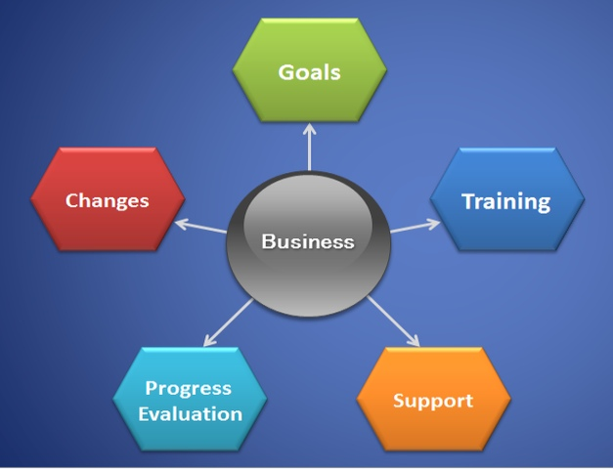
Figure: Entrepreneur Business Model. Source: (SlideHunter, 2013).
In case of non-profit based organisation, the entrepreneur can follow social entrepreneurship model. Here the entrepreneur must find out what are the needs and necessities of the people in the society which can be served easily, and it will bring betterment in the whole society. Here the key motive also entrepreneur will be to serve the society by doing betterment of the community aka the whole society. the entrepreneur may not search for profit in such case but he or she will try to develop the society for good and it can be effective in the long run (WordPress, 2012).
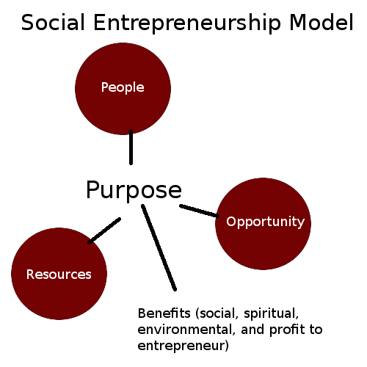
Figure: Social Entrepreneurship Model. Source: (WordPress, 2012).

Conclusion
In order to bring economic salvation, economic sustainability, and the betterment for the society aka the whole nation entrepreneurs can be very effective. Because entrepreneurs are supposed to be innovative and bring changes to the society for good which will be beneficial for the society and the nation in the long term. Which is why, it is a must for every country to encourage the practice of entrepreneurship so that the development and sustainability can be ensured.

References
Babb, E.M. and Babb, S.V., 2012. Psychological traits of Successful entrepreneurs. The Journal of Socio-Economics, 21(4), pp.353-362.
Benzing, C., Chu, H.M. and Kara, O., 2019. Entrepreneurs in Europe: A factor analysis of motivations, success factors, and problems. Journal of small business management, 47(1), pp.58-91
Boluk, K.A. and Mottiar, Z., 2014. Motivations of social entrepreneurs. Social Enterprise Journal.
Edelman, L.F., Brush, C.G., Manolova, T.S. and Greene, P.G., 2010. Start‐up motivations and growth intentions of minority nascent entrepreneurs. Journal of Small Business Management, 48(2), pp.174-196.
Giacomin, O., Janssen, F., Guyot, J.L. and Lohest, O., 2011. Opportunity and/or necessity entrepreneurship? The impact of the socio-economic characteristics of entrepreneurs.
Market Business News (2020). What is a for-profit organization? Examples. [online] Market Business News. Available at: https://marketbusinessnews.com/financial-glossary/for-profit-organization/#:~:text=A%20for%2Dprofit%20organization%20is.
Sexton, D.L. and Bowman-Upton, N., 1990. Female and male entrepreneurs: Psychological characteristics and their role in gender-related discrimination. Journal of business venturing, 5(1), pp.29-36
Singh, J. (2019). For Profit vs Nonprofit Organizations | Top 7 Differences (with infographics). [online] Wallstreetmojo.com. Available at: https://www.wallstreetmojo.com/for-profit-vs-nonprofit-organizations/.
SlideHunter (2013). Some Tips For An Effective Entrepreneur Business Model. [online] SlideHunter.com. Available at: https://slidehunter.com/tips-effective-entrepreneur-business-model/ [Accessed 8 Jan. 2021].
Surbhi S (2018). Difference Between Profit and Non-Profit Organisation (with and Comparison Chart) - Key Differences. [online] Key Differences. Available at: https://keydifferences.com/difference-between-profit-and-non-profit-organisation.html.
TopManagementDegrees (2019). What is the difference between nonprofit and for-profit companies? - Top Management Degrees. [online] Top Management Degrees. Available at: https://www.topmanagementdegrees.com/difference-between-nonprofit-for-profit-companies/.
WordPress (2012). social-entrepreneurship-model. [online] The Nature of Business. Available at: https://thenatureofbusiness.org/2012/12/21/social-entrepreneurship-and-generation-y-a-match-made-in-heaven/social-entrepreneurship-model/ [Accessed 8 Jan. 2021].

